Topics in Stochastic Optimization
Strategy Report

1. General Goal
In this project, all groups work on the same game. The input of the game is a set of points in the plane. Each point has two coordinates: x and y.
A point is said to beat another point if it is larger in both coordinates.
A sequence of points is called a chain if every point in the sequence beats the point before it. In simple words, along the chain, both x and y must increase.
During the game, each point has a weight. The weight can only be 1 or 3. At the beginning of the game, all points have weight 1.
The weight of a chain is the sum of the weights of all points in that chain. We mark by W the maximum weight of any chain at the beginning of the game, when all weights are 1. Since all weights are 1 at the beginning, W is also the maximum length of a chain in the set of points.
One move in the game is to increase the weight of one point from 1 to 3. However, this move is allowed only if, after the increase, the maximum chain weight is still W. This means that the move must not make the maximum chain weight larger than it was at the start.
The game ends when there is no point that can still be changed from weight 1 to weight 3 without breaking this rule. The weights at the end of the game are called the terminal state.
The goal of our algorithm is to reach a terminal state where the total sum of all point weights is as large as possible.
The project is tested on 10 input files. Each file contains 10,000 points in an Excel file with two columns, x and y. The output should be the same file with a third column called Weight, where each row gets the final weight of the point, either 1 or 3.

2. Main Optimization Idea
The main idea is to check if a point can safely be upgraded from weight 1 to weight 3.
When a point is upgraded from 1 to 3, every chain that goes through this point becomes larger by 2, because:
3 - 1 = 2
So, a point can be upgraded only if the best chain that passes through it, plus 2, is still not bigger than W.
The condition is:
through[i] + 2 <= W
Here, through[i] means the best weighted chain that passes through point i.
If this condition is true, the upgrade is legal. If it is false, upgrading this point would break the constraint.
This idea is used while building the solution, and also later when checking that the final solution is valid.

3. Chain Computation Strategy
The project uses dynamic programming to calculate chain values.
For each point, the algorithm calculates three values:
L[i] = best weighted chain ending at point i
R[i] = best weighted chain starting at point i
through[i] = best weighted chain passing through point i
The value through[i] is calculated like this:
through[i] = L[i] + R[i] - weight[i]
We subtract weight[i] because the point is counted twice: once in L[i] and once in R[i].
These calculations are very important and can take a lot of time. Because of that, they are implemented in C++ instead of only Python. The Python code sends the points and weights to the C++ code, and the C++ code returns the chain values.

4. GRASP Strategy
The solver uses a method called GRASP.
GRASP means:
Greedy Randomized Adaptive Search Procedure
In simple words, this means that the algorithm builds several possible solutions. Each solution is built using both greedy choices and random choices.
A greedy choice means choosing something that looks good at the current step. A random choice helps the algorithm try different solutions instead of always doing the exact same thing.
After several attempts, the algorithm keeps the best solution it found.
The solver has several parameters, such as:
- iterations
- rcl_size
- seed
- time_limit_seconds
- candidate_sample_size
These parameters control how many times the algorithm runs, how much randomness it uses, and how many candidates it checks at each step.

5. Initial Candidate Selection
Before the algorithm starts building a solution, it first checks which points can possibly be upgraded.
At the start, all points have weight 1. The algorithm calculates the through value for each point. Then it keeps only the points that satisfy:
through[i] + 2 <= W
These points become the initial candidates.
If a point does not satisfy this condition at the beginning, then it cannot be upgraded, because it would already break the maximum chain constraint.
This step helps the algorithm work faster because it removes points that are clearly not possible to upgrade.

6. Building One Solution
Each GRASP iteration builds one solution from the beginning.
The algorithm starts with all weights equal to 1. Then, as long as there are still candidate points, it repeats these steps:
1. Recalculate the current chain values.
2. Choose a random sample of candidate points.
3. Check which of them can legally be upgraded.
4. Sort the legal candidates by how good they are.
5. Randomly choose one candidate from the best candidates.
6. Upgrade this point to weight 3.
The expensive part is recalculating the through values, because every time we upgrade a point, the chain values can change. This is one of the reasons why the project uses C++ for the chain calculations.

7. Candidate Sampling
Instead of checking all remaining candidates every time, the algorithm checks only a random sample.
The default sample size is:
candidate_sample_size = 500
This means that if there are many remaining candidates, the algorithm randomly chooses up to 500 of them and checks only those first.
If none of these sampled points can be upgraded, then the algorithm checks all remaining candidates before stopping.
This makes the algorithm faster, while still making sure it does not stop just because the random sample was unlucky.

8. Restricted Candidate List
After the algorithm finds legal candidates, it does not choose from all of them randomly. Instead, it creates a list of the best candidates. This list is called the Restricted Candidate List, or RCL.
Each legal candidate gets a score based on values such as:
- current_slack
- initial_slack
- random_tiebreaker
- point_index
The slack means how much space is left before the candidate would break the chain constraint. A larger slack means the point is safer to upgrade.
The algorithm sorts the legal candidates and keeps only the top rcl_size candidates. Then it randomly chooses one point from this smaller list.
This gives a balance between greediness and randomness:
Small rcl_size = more greedy
Large rcl_size = more random
This is useful because a fully greedy algorithm might get stuck in a bad solution, but a fully random algorithm might make poor choices.

9. Choosing the Best Solution
The algorithm repeats the construction process for a number of iterations, or until the time limit is reached.
After each iteration, it checks:
current_score = sum of weights
current_max_chain = maximum weighted chain
A solution is accepted as the new best solution only if it is feasible and has a better score than the previous best solution.
The condition for feasibility is:
current_max_chain <= W
At the end, the solver returns the best solution it found. It also returns information such as the score, the number of upgraded points, the maximum weighted chain, the runtime, and whether the solution is terminal.

10. Solution Validation
After the solver finishes, the program checks that the solution is valid.
The validation checks that:
1. The number of weights is the same as the number of points.
2. Every weight is either 1 or 3.
3. The maximum weighted chain is not bigger than the original W value.
4. The solution is terminal.
A terminal solution means that no more points can be upgraded without breaking the constraint.
If one of these checks fails, the program raises an error instead of writing an invalid solution.
This is important because the algorithm is a heuristic. It tries to find a good solution, but it does not guarantee the best possible solution. The validation step makes sure that the solution is at least legal and complete.

11. Input and Output
The input is an Excel file. The first two columns are used as the x and y coordinates of the points.
After the solver finishes, the program creates a new Excel file. This file contains the original data and adds a new column called Weight.
This column shows whether each point received weight 1 or weight 3.
The user can also control the run using command-line arguments, such as the number of iterations, the RCL size, the random seed, and the time limit.

12. Results and Running Times
The algorithm was tested on input files with 10,000 points. The running time depends on the specific input, the solution that is being built, the number of upgrade steps, and the computer on which the program is running. It can also depend on parameters such as the number of iterations, the RCL size, and the candidate sample size. In our tests, one iteration usually took about 30-60 seconds.
The score of a solution is the sum of all the final weights. Since each point starts with weight 1, every point that is upgraded to weight 3 adds 2 to the score. Therefore, a better solution is one that upgrades more points while still keeping the maximum weighted chain equal to at most W.
The final output for each input file is an Excel file with a third column named Weight. This column contains the final weight of each point, either 1 or 3.

13. Visualization of the Solution
To better understand the solution, we created a scatter plot of all the points in the plane. Each point is shown according to its x and y coordinates.
In the graph, points that stayed with weight 1 are shown in one color, and points that were upgraded from weight 1 to weight 3 are highlighted in red.
The graph helps show the logic of the algorithm. Along the longer increasing paths, the points are usually not highlighted. This makes sense, because upgrading points on long chains would probably increase the maximum chain weight and break the constraint.
On the other hand, points on shorter paths, especially points on the sides of the graph, are more often highlighted in red. These points are safer to upgrade because they are less likely to belong to a chain that already reaches the maximum value W.
This visualization supports the idea behind the algorithm: points are upgraded mainly when they have enough slack and do not make the maximum weighted chain larger than W.
Figure 1: Visualization of the Final Solution.
Scatter plot of all points in the plane colored by their final weight. Gray points represent points with weight 1, while red points represent points upgraded to weight 3 by the algorithm.
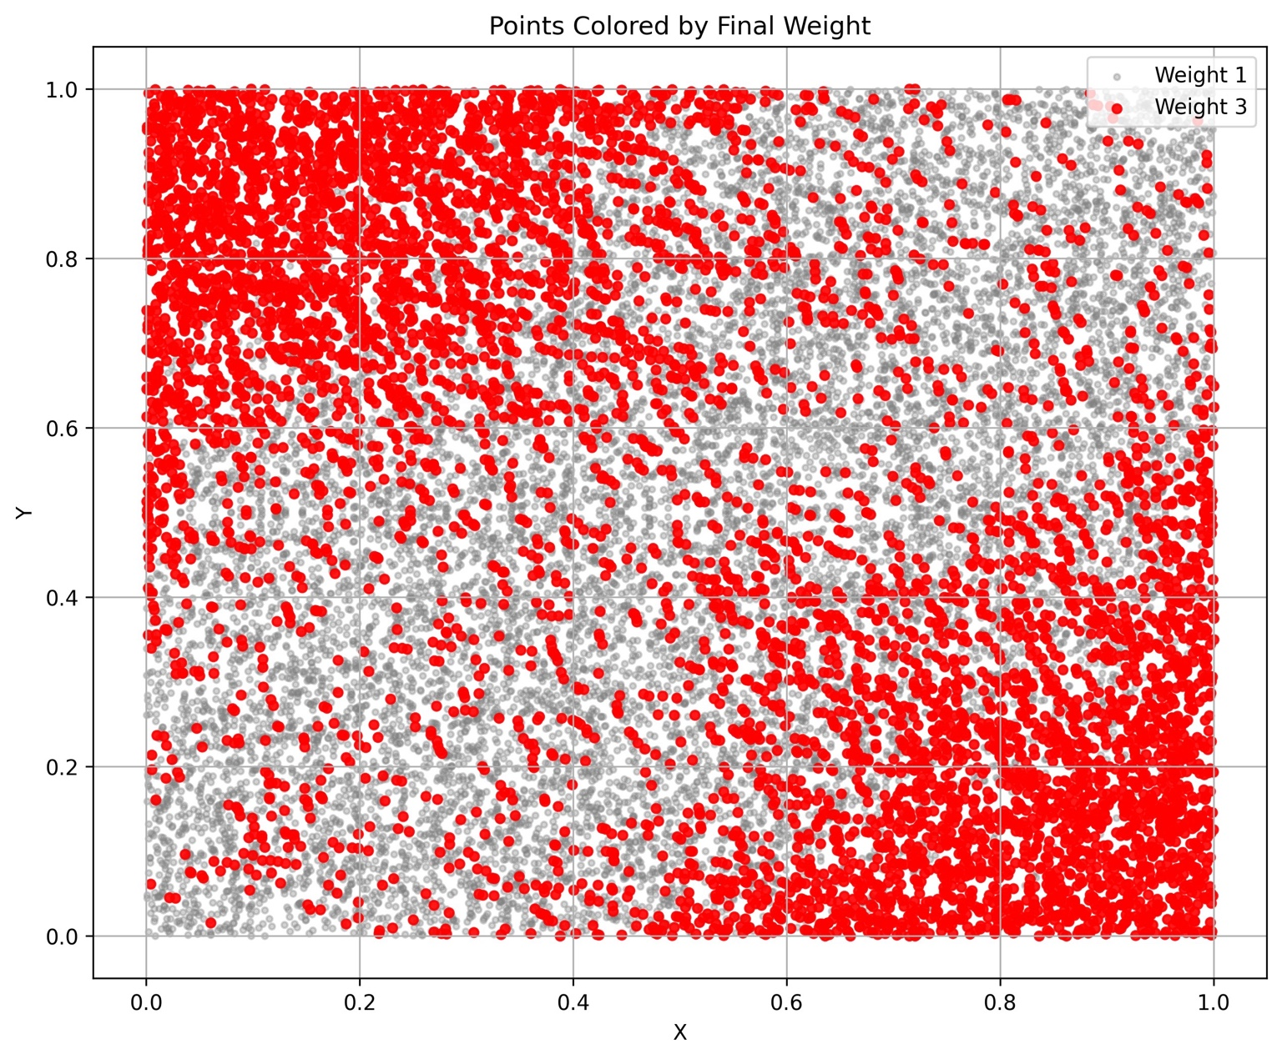

14. Summary
This project combines dynamic programming with a greedy-randomized search method.
The dynamic programming part is used to calculate the maximum weighted chains. This part is implemented in C++ to make the program faster.
The optimization part is implemented in Python using a GRASP heuristic. The algorithm tries to upgrade points from weight 1 to weight 3, while keeping the maximum weighted chain no bigger than the original value W.
The algorithm does not guarantee that it finds the global best solution, but it is designed to find a good feasible solution efficiently. The final validation step makes sure that the output is legal before it is written to the Excel file.

