CS 148

Connor Allan and Aaron Longchamp

Assignment: Final Project: Coupon Booking

Online Coupon Book

Version <1.0>

Table Of Contents

Time Log 3

Introduction 4

Purpose 4

Definitions, acronyms, and abbreviations 4

Overall Description 4

Story Board 5

Data Dictionary 6

ER- Diagram 7

Schema 8

Specific requirements 9

|  |  |  |  |
| --- | --- | --- | --- |
| Time Log | | | |
| Estimated time to complete assignment => | | | Hours |
| Date | Time Spent  (in hours) | Description | Author |
| 8/31/16 | .5 | First Version of Software Requirements | Connor |
| 11/1/16 | 1 | Story Board Layout | Connor |
| 11/2/16 | 2 | Login Page | Connor |
| 11/2/16 | 1 | ER Diagram & Data Dictionary | Connor  Aaron |
| 11/26/16 | .5 | Site Structure | Connor |
| 11/27/17 | 1 | Site Structure | Aaron |
| 12/1/16 | 2 | Login.php full functionality | Connor Allan |
| 12/1/16 | 3 | Login.php and CSS | Connor Allan |
| 12/2/16 | 2 | Finished Login.php | Connor Allan |
| 12/3/16 | 1 | SQL statements written and data entered into database | Aaron Longchamp |
| 12/4/16 | 2 | Created print, individual php pages | Aaron Longchamp |
| 12/5/16 | 6 | Created logo images | Aaron Longchamp |
| 12/5/16 | 7 | CSS and Site functionality | Connor Allan |
| 12/6/16 | 3 | Mail-Message and About us | Aaron Longchamp |
| 12/6/16 | 10 | CSS | Connor Allan |
| 12/8/16 | 2 | Mail-Message and About us page | Aaron Longchamp |
|  |  |  |  |
|  |  |  |  |
|  |  |  |  |
|  |  |  |  |
|  |  |  |  |
|  |  |  |  |
|  | 71 | <=Total Time Spent |  |

# Introduction

### Purpose

The purpose of this document is to describe the requirement specification for the web site Online Coupon Book.

The intended audience for this document is the local Burlington Community

*First it is the contract between you and the client. Second it is for the developer of the site. Two primary goals are:*

1. *Client gets a very good understanding of what you will be delivering.*
2. *Developer has a very good understanding of what they are going to create.*

### Definitions, acronyms, and abbreviations

*Sample for the client:*

ER Diagram – a diagram to represent the data you want to save with your system

W3 Validation – refers to both Html and CSS validation tool provided by the W3c.org. the html validator is located at:

<http://validator.w3.org/>

with the CSS validator located at:

<http://jigsaw.w3.org/css-validator/>

# Overall Description

A short paragraph describing the site

# Story Board

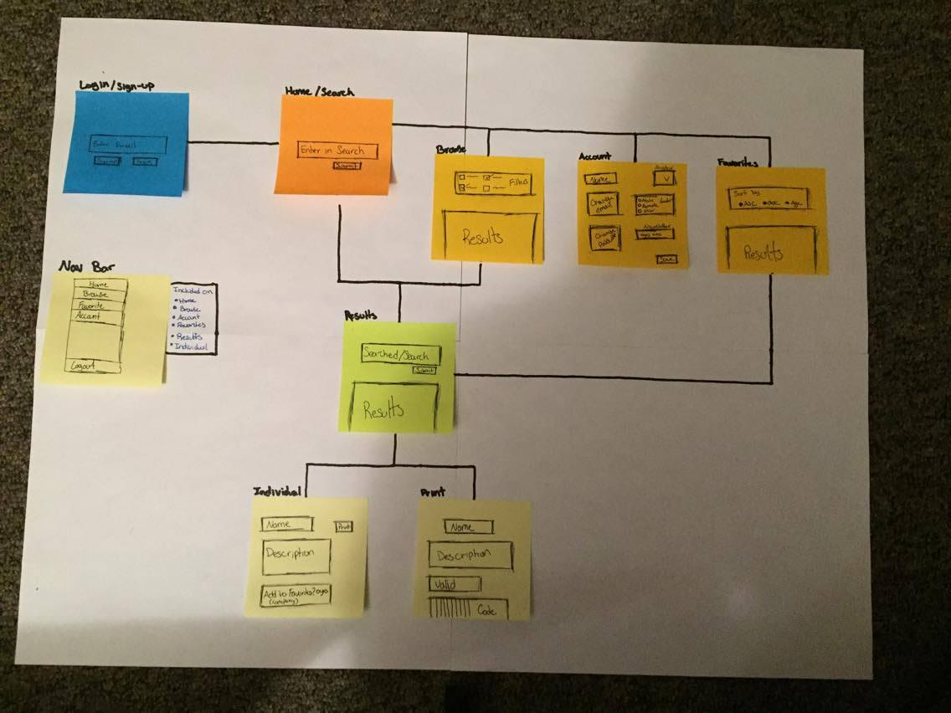

# Data Dictionary

Paste your Data Dictionary here. The final version is easy to get by exporting to the screen in phpMyadmin

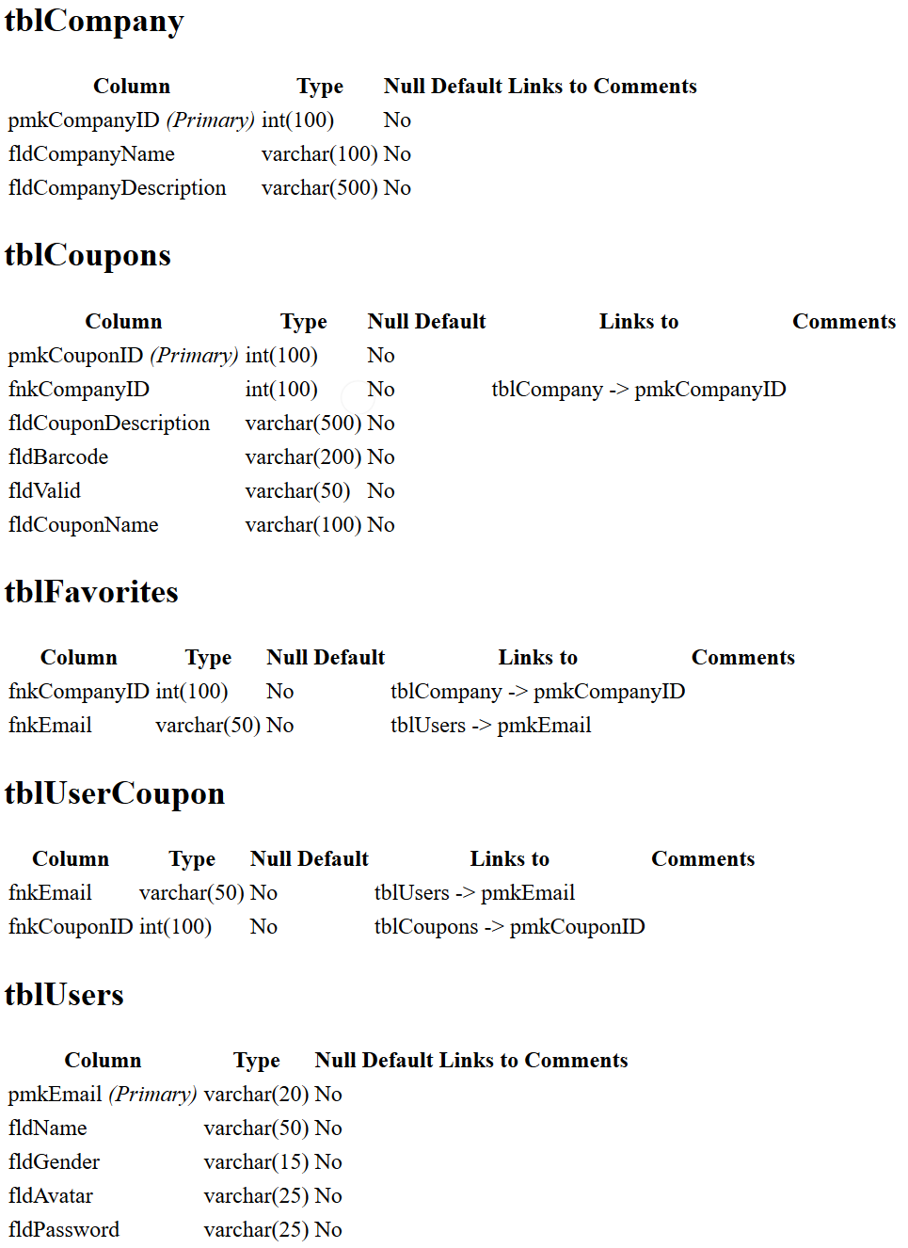

# ER- Diagram

You can use power point or any program really. Past the image here.

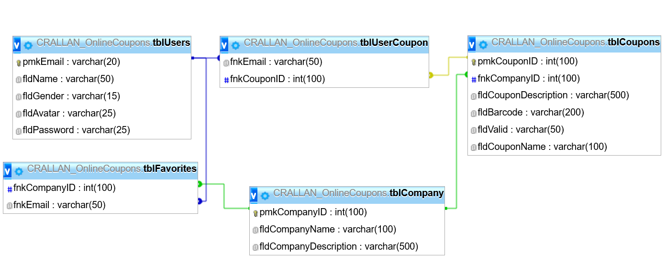

# Schema

CREATE TABLE IF NOT EXISTS `tblCompany` (

`pmkCompanyID` int(100) NOT NULL,

`fldCompanyName` varchar(100) NOT NULL,

`fldCompanyDescription` varchar(500) NOT NULL

) ENGINE=InnoDB DEFAULT CHARSET=utf8;

CREATE TABLE IF NOT EXISTS `tblCoupons` (

`pmkCouponID` int(100) NOT NULL,

`fnkCompanyID` int(100) NOT NULL,

`fldCouponDescription` varchar(500) NOT NULL,

`fldBarcode` varchar(200) NOT NULL,

`fldValid` varchar(50) NOT NULL,

`fldCouponName` varchar(100) NOT NULL,

`fldCategory` varchar(100) NOT NULL,

`fldExpired` varchar(5) NOT NULL

) ENGINE=InnoDB DEFAULT CHARSET=utf8;

CREATE TABLE IF NOT EXISTS `tblFavorites` (

`fnkCompanyID` int(100) NOT NULL,

`fnkEmail` varchar(50) NOT NULL

) ENGINE=InnoDB DEFAULT CHARSET=utf8;

CREATE TABLE IF NOT EXISTS `tblUserCoupon` (

`fnkEmail` varchar(50) NOT NULL,

`fnkCouponID` int(100) NOT NULL,

`pmkKey` int(11) NOT NULL

) ENGINE=InnoDB DEFAULT CHARSET=utf8;

CREATE TABLE IF NOT EXISTS `tblUsers` (

`pmkEmail` varchar(100) NOT NULL,

`fldName` varchar(50) NOT NULL,

`fldGender` varchar(15) NOT NULL,

`fldNewsletter` varchar(25) NOT NULL,

`fldPassword` varchar(100) NOT NULL

) ENGINE=InnoDB DEFAULT CHARSET=utf8;

ALTER TABLE `tblCompany`

ADD PRIMARY KEY (`pmkCompanyID`);

ALTER TABLE `tblCoupons`

ADD PRIMARY KEY (`pmkCouponID`),

ADD KEY `fnkCompanyID` (`fnkCompanyID`);

ALTER TABLE `tblFavorites`

ADD KEY `fnkCompanyID` (`fnkCompanyID`),

ADD KEY `fnkEmail` (`fnkEmail`);

ALTER TABLE `tblUserCoupon`

ADD PRIMARY KEY (`pmkKey`),

ADD KEY `fnkEmail` (`fnkEmail`),

ADD KEY `fnkCouponID` (`fnkCouponID`);

ALTER TABLE `tblUsers`

ADD PRIMARY KEY (`pmkEmail`);

ALTER TABLE `tblCompany`

MODIFY `pmkCompanyID` int(100) NOT NULL AUTO_INCREMENT;

ALTER TABLE `tblCoupons`

MODIFY `pmkCouponID` int(100) NOT NULL AUTO_INCREMENT;

ALTER TABLE `tblUserCoupon`

MODIFY `pmkKey` int(11) NOT NULL AUTO_INCREMENT;

ALTER TABLE `tblCoupons`

ADD CONSTRAINT `tblCoupons_ibfk_1` FOREIGN KEY (`fnkCompanyID`) REFERENCES `tblCompany` (`pmkCompanyID`);

ALTER TABLE `tblFavorites`

ADD CONSTRAINT `tblFavorites_ibfk_1` FOREIGN KEY (`fnkEmail`) REFERENCES `tblUsers` (`pmkEmail`),

ADD CONSTRAINT `tblFavorites_ibfk_2` FOREIGN KEY (`fnkCompanyID`) REFERENCES `tblCompany` (`pmkCompanyID`);

ALTER TABLE `tblUserCoupon`

ADD CONSTRAINT `tblUserCoupon_ibfk_1` FOREIGN KEY (`fnkEmail`) REFERENCES `tblUsers` (`pmkEmail`),

ADD CONSTRAINT `tblUserCoupon_ibfk_2` FOREIGN KEY (`fnkCouponID`) REFERENCES `tblCoupons` (`pmkCouponID`);

# Specific requirements

1. You will be developing a complete Graphical User Interface using PHP for customers, clients and management to access your database information. You must have at least three related tables.
2. Create a design specification (External documentation) for this project (pdf or web page). [Sample Project Specification Document](https://rerickso.w3.uvm.edu/web-documents/docx/cs148/sampleSpec.docx) (MS Word) and save as a pdf to be posted on your site with a link on your sitemap (you need to include everything i have listed in the sample).
3. Your interface should be easy to follow and understand.
4. Your interface needs to allow the administrator to do the following (for all tables):
   1. Add new records (populating relation tables automatically)
   2. Update Existing records
   3. Delete records (deleting relational records automatically)
   4. Be sure to validate all information
5. You need a minimum one form (mostly likely you will have several).
   1. Insert data into at least two tables.
   2. Include one text box for a users email address (the ones that make sense).
   3. Include two additional text boxes.
   4. Include one list box.
   5. Include three check boxes.
   6. Include three radio buttons.
   7. Include Submit button.
   8. Field sets and legends as needed.
   9. data should be validated for not missing, valid format etc as needed with php, appropriate error messages will be displayed.
   10. Form should email the person who filled it out.
   11. Form data should be saved to your database (one form needs to save to more than one table at once).
   12. Forms always need to provide feedback to the user so they know what happened after filling out the form.
6. Use git and gitlab to version your project. Create a screen shot of you commit page and post a link on your site map to this screen shot. Your repository should be private. We may request you show us.
7. Minimum of six web pages.
8. As always be sure to:
   1. validate your html and CSS (w3c.org).
   2. have the following Meta tags: author, content, description.
   3. have a link on your main index page to this assignment.
9. Login page that redirects when you try to access a page and haven’t logged in.