Same, More, or Different? Classifying Semantic Coverage with Generative and Discriminative Models
Dr. Aperstein Yehudit, Benita Gal, Gottlib Alon August 24, 2025
September 2, 2025

Abstract
Understanding how information is shared across documents, regardless of the format in which it is expressed, is critical for tasks such as information retrieval, summarization, and content alignment. In this work, we introduce a novel framework for modelling Semantic Coverage Relationships (SCR), which classifies document pairs based on how their informational content aligns. We define three core relationship types: equivalence, where both texts convey the same information using different textual forms or styles; inclusion, where one document fully contains the information of another and adds more; and semantic overlap, where each document presents partially overlapping content. To capture these relationships, we adopt a question answering (QA)-based approach, using the answerability of shared questions across documents as an indicator of semantic coverage. We construct a synthetic dataset derived from the SQuAD corpus by paraphrasing source passages and selectively omitting information, enabling precise control over content overlap. This dataset allows us to benchmark generative language models and train transformer-based classifiers for SCR prediction. Our findings demonstrate that discriminative models significantly outperform generative approaches, with RoBERTa-base achieving the highest accuracy of 61.4% and Random Forest showing the best balance with a macro-F1 score of 52.9%. The results show that QA provides an effective lens for assessing semantic relationships across stylistically diverse texts, offering insights into the capacity of current models to reason about information beyond surface similarity.

Introduction
Understanding semantic coverage relationships between documents is fundamental to a wide range of natural language processing (NLP) applications, where determining the overlap, inclusion, or divergence of information is critical. In information retrieval, determining whether a retrieved document fully addresses a user’s query or merely partially overlaps with the relevant content can significantly enhance ranking and relevance scoring. In multi-document summarization, systems must distinguish between redundant, complementary, and conflicting information across source texts to produce concise and accurate summaries. Fact-checking and misinformation detection benefit from SCR by enabling systems to compare claims against source documents and deter- mine whether the same facts are expressed, extended, or contradicted. In document clustering and deduplication, recognizing paraphrases or partial content overlap helps group related documents or eliminate near-duplicates in large corpora. Educational technology and reading comprehension tools can leverage SCR to track which concepts are introduced, reinforced, or omitted across learn- ing materials. Additionally, in legal and regulatory analysis, identifying when a new documentparaphrases, builds upon, or diverges from existing policy texts is essential for ensuring compliance and accurate interpretation. These scenarios underscore the practical significance of robust SCR modeling in enabling machines to comprehend informational content at a deeper semantic level.
Identifying Semantic Coverage Relationships (SCR) between documents is a non-trivial task due to the inherent flexibility, ambiguity, and variability of natural language. A key difficulty lies in distinguishing between two types of variation: when two texts convey the same information in different forms, and when one text introduces additional details not found in the other. These cases often appear deceptively similar. For example, the statements “Einstein developed the theory of relativity in the early 20th century” and “In the early 1900s, Albert Einstein formulated what became known as the theory of relativity” differ in structure and word choice but convey semantically equivalent content—an equivalence relationship. However, compare that to “Einstein developed the theory of relativity in the early 20th century, revolutionizing modern physics.” The addition of “revolutionizing modern physics” introduces new information, thereby shifting the relationship to one of inclusion. However, distinguishing this subtle extension from mere stylistic elaboration can be challenging even for humans.
The problem is further compounded when additional information is contextually related or implied. For instance, consider the following: “Photosynthesis converts sunlight into chemical energy in plants” versus “Photosynthesis enables plants to store solar energy by producing glucose.” The second version introduces biochemical specifics—glucose—that are not present in the first, even though the overall topic and function appear similar. Without domain knowledge or deeper semantic interpretation, it is difficult to determine whether this constitutes a reformulation or an informative extension.
Moreover, additional information can be interleaved, rephrased abstractly, or distributed across multiple sentences, making it more difficult to distinguish between shared and novel content. These nuances challenge surface-level methods that rely on token overlap or sentence matching. Accurate SCR detection thus requires models capable of understanding paraphrastic variation, reasoning over implicit and explicit knowledge, and recognizing when new, non-overlapping semantic content has been introduced—capabilities that go beyond what traditional similarity metrics can offer.
There is a closely related semantic relationship called textual entailment, which differs in es- sential ways from the Semantic Coverage Relationship (SCR) we introduce in this work. Textual entailment describes a logical, directional inference where one text (the hypothesis) must be valid if another text (the premise) is accurate, without introducing any new information beyond what the premise logically implies. For example, the statement “All mammals are warm-blooded” entails “Dolphins are warm-blooded,” since the latter follows logically from the former.
In contrast, the Semantic Coverage Relationship captures a broader range of informational connections between documents. While equivalence in SCR can be understood as a form of bidi- rectional entailment, where two texts mutually imply each other and convey the same information, inclusion represents a one-directional relationship where one document extends another by adding new information. Importantly, this additional content in inclusion is not necessarily derivable from the original document. For instance, one document might state “The new policy was approved last week,” while another extends this by adding “The policy aims to reduce carbon emissions by 20% over the next decade.” The latter introduces new facts that cannot be logically inferred from the former.
Thus, SCR encompasses richer and more nuanced semantic connections than textual entailment, explicitly modelling informational addition and asymmetry rather than purely logical inference.
To make Semantic Coverage Relationships (SCR) both operationally definable and empirically verifiable, we adopt a question-answering (QA)-based formulation grounded in the concept of an- swerability. We define the relationship between two documents based on whether a set of questions
derived from one document can also be answered using the other. This provides a constructive and testable definition: if both documents answer exactly the same set of questions, they exhibit an equivalence relationship; if one document can answer all questions answerable by another plus additional questions, we classify this as an inclusion relationship; if neither can answer all of the other’s questions but they share some common answerable questions, they exhibit semantic overlap.
While it is theoretically impossible to enumerate all possible questions that could be asked of a text, in practice, large-scale QA datasets such as SQuAD offer high-quality, human-curated question–answer pairs that serve as reliable proxies for core information contained in a passage. Moreover, generative models can produce diverse and contextually appropriate questions from a given text, enabling the construction of robust test sets that sample a broad range of semantic content. This QA-driven definition thus allows us to generate training and evaluation data with explicitly known coverage relationships, making the SCR framework both conceptually grounded and empirically tractable.
After constructing and verifying the dataset using the question answerability approach, we ex- plore two complementary strategies for modelling and classifying Semantic Coverage Relationships (SCR) between document pairs: (1) leveraging pretrained generative language models through prompting, and (2) training dedicated transformer-based and traditional machine learning classi- fiers.
In the first strategy, we utilize large generative language models (e.g., GPT-4.1-style models) un- der zero-shot and few-shot prompting scenarios. Given a pair of documents, the model is prompted with a natural language instruction to classify the relationship as equivalence, inclusion, or seman- tic overlap. In the few-shot setting, a small number of labeled examples are provided in the prompt to guide the model’s prediction. This approach evaluates the reasoning and generalization capacity of pretrained models without requiring additional training, offering a lightweight yet flexible way to assess model performance on semantic understanding tasks.
In the second strategy, we develop fine-tuned classifiers based on transformer architectures including BERT, RoBERTa, Longformer, and DistilBERT, as well as traditional machine learning approaches using Random Forest and Logistic Regression with engineered features. Each document pair is jointly encoded and the model is trained to predict the SCR category. This method enables task-specific learning, allowing the model to capture more precise patterns of lexical, syntactic, and semantic variation that signal equivalence, informational inclusion, or semantic overlap.
By comparing the performance of prompt-based and fine-tuned models, we assess both the zero-shot capabilities of large language models and the benefits of supervised training for nuanced semantic classification. This work makes the following contributions:
- A Public Dataset for Semantic Coverage Relationships (SCR): We introduce and release a synthetic dataset that captures fine-grained semantic coverage relationships between document pairs, specifically equivalence, inclusion, and semantic overlap. This dataset pro- vides a valuable resource for studying and modeling semantic content relationships.
- Evaluation Framework Based on Question Answerability: We leverage the concept of question answerability as a practical and interpretable method for validating and refining the dataset. By testing whether the same questions can be answered from both texts in a pair, we verify the intended semantic relationship and ensure consistency and accuracy in labeling assignments.
- Comparative Evaluation of Direct Classification Methods for Semantic Coverage Relationships (SCR): We evaluate and compare several approaches for directly classify- ing semantic coverage relationships from text, including large-scale generative models through
zero-shot and few-shot prompting, as well as supervised transformer-based and traditional ma- chine learning classifiers. These models function independently of the question-answerability framework and offer insights into the capabilities of different modeling paradigms for this task.

Prior Work

Textual Semantic Relationships
Semantic relationships between sentence pairs—such as entailment (one sentence implying another), paraphrase (meaning equivalence), contradiction, and graded similarity—are fundamental to lan- guage understanding. Early work framed Recognizing Textual Entailment (RTE) as a unified evaluation task: given two text fragments, determine if the meaning of one can be inferred from the other (Dagan et al., 2006). Modern practice often uses the terms Natural Language Inference (NLI) and RTE interchangeably, with tasks usually classifying a premise–hypothesis pair as entailment, contradiction, or neutral (Poliak, 2020). For instance, Bowman et al. (2015) note that “understand- ing entailment and contradiction is fundamental to understanding natural language”. Paraphrase detection treats the problem as a binary classification: deciding whether two sentences are seman- tically equivalent (Dolan and Brockett, 2005). Semantic Similarity tasks assign a graded score (often 0–5) reflecting the degree to which two sentences are alike; for example, the SemEval STS tasks measure meaning similarity on a continuous scale (Cer et al., 2017). Contradiction—when sentences express mutually incompatible facts—is typically modeled as the negation of entailment in NLI. In sum, the broad goal is to recognize whether one sentence entails or contradicts an- other, whether two are paraphrases, or how similar their meanings are. These tasks overlap; for example, paraphrases are bidirectional entailments and typically rank high in similarity, whereas contradictions receive low similarity scores.
Before the advent of deep learning, methods for these tasks were primarily symbolic or logic- based. Early RTE systems relied on lexical and syntactic features, including string overlap, WordNet relations, edit distance, and syntactic parse alignment (Glickman et al., 2005; Mehdad et al., 2009). Some approaches performed sentence alignment or graph matching (MacCartney and Manning, 2008; Mehdad et al., 2009) to compare premise and hypothesis tokens or dependency structures. Logical and rule-based inference was also explored; for example, Clark and Harrison (2009) developed a logic-theorem prover, NaturalLI, that mapped text to first-order logic forms, and MacCartney (2009) created natural logic rules to derive entailments without requiring com- plete logical forms. In Wang et al. (2017)’s survey, they note that solutions “range from shallow approaches based on lexical similarities... to advanced methods that consider syntax (Mehdad et al., 2009), perform explicit sentence alignment (MacCartney and Manning, 2008) or use for- mal logic (Clark and Harrison, 2009)”. Lexical databases, such as WordNet, enabled path-based similarity (Rada et al., 1989) and synonym-based entailment checks. Distributional semantics (LSA, word embeddings) also played a role; for instance, Baroni et al. (2012) demonstrated how vector similarity can capture paraphrases. However, these classical models often struggled with compositional meaning or required heavy feature engineering.
A variety of annotated corpora have driven research. The PASCAL RTE challenges (Dagan et al., 2006) provided small sets of sentence pairs labeled for entailment (yes/no). The SNLI cor- pus (Stanford NLI; Bowman et al. (2015)) revolutionized the field by providing ∼570,000 human- authored English sentence pairs labeled as entailment, neutral, or contradiction. This scale allowed data-hungry neural models to be trained. The MultiNLI corpus (Williams et al., 2018) extended SNLI to ∼433,000 pairs drawn from ten different written and spoken genres, enabling
evaluation of cross-genre generalization. The SICK dataset (Marelli et al., 2014) comprises ap- proximately 10,000 English sentence pairs, annotated for both semantic relatedness (on a 5-point similarity rating scale) and categorical entailment (entailment, contradiction, or neutral). For paraphrase identification, the Microsoft Research Paraphrase Corpus (Dolan and Brockett, 2005) has ∼5,800 news-sentence pairs labeled by humans as paraphrase or not. More recently, PAWS (Paraphrase Adversaries from Word Scrambling; Zhang et al. (2019b)) provides 108K high-lexical- overlap sentence pairs labeled paraphrase/non-paraphrase, specifically to challenge models that ignore word order and structure. Semantic similarity benchmarks include the SemEval STS shared tasks (2012–2017) and the STS Benchmark (Cer et al., 2017), which measure correlation between model scores and human ratings. The GLUE benchmark (Wang et al., 2018) combines multiple tasks, including MNLI, RTE, QQP, MRPC, STS-B, among others, into a single evaluation suite. Finally, for multilingual NLI, XNLI (Conneau et al., 2018) extends MultiNLI’s development and test sets into 15 languages (e.g., Arabic, Spanish, Urdu), enabling cross-lingual inference evalu- ation. These datasets have standardized evaluation: typically, accuracy for classification (NLI, paraphrase) and Pearson/Spearman correlation for regression similarity tasks.
With large datasets available, neural networks quickly came to dominate the field. Early neural NLI models encoded each sentence (typically using a BiLSTM or CNN) into a vector, and then combined or compared the vectors for classification. Bowman et al. (2015) reported a base- line where separate LSTM encoders for premise and hypothesis yielded ∼77.6% accuracy on SNLI. Soon after, more sophisticated architectures appeared. Wang et al. (2016) introduced match-LSTM, an LSTM that processes the hypothesis while attending to the premise at each word; this model achieved an accuracy of 86.1% on SNLI, substantially outperforming earlier baselines. Attention mechanisms became central: Parikh et al. (2016) proposed a Decomposable Attention model that explicitly aligns (“soft-attends”) words or phrases between the two sentences before comparing them. Their simpler, attention-based model achieved state-of-the-art performance on SNLI with significantly fewer parameters. Similarly, Chen et al. (2017) developed the ESIM (Enhanced Se- quential Inference Model), which utilizes BiLSTMs combined with a bidirectional attention step; ESIM achieved a score of 88.6% on SNLI, the highest to date. These models all follow a common pattern: attending to align substructures, comparing aligned pieces, and aggregating comparison features (the “Attend-Compare-Aggregate” framework). Parikh et al. (2016) note that for NLI it often suffices to “simply align bits of local text substructure and then aggregate” rather than building a single global embedding.
For paraphrasing and similarity, similar Siamese or attention-based networks have been em- ployed. Mueller and Thyagarajan (2016) trained Siamese LSTM networks to map sentences into a shared embedding space, utilizing cosine similarity for paraphrase detection. More recently, sentence-encoder approaches have thrived; for example, InferSent (Conneau et al., 2017) utilized supervised NLI data (SNLI) to train a universal encoder, demonstrating that it outperformed unsu- pervised embeddings on a range of tasks. Reimers and Gurevych (2019) proposed Sentence-BERT (SBERT), which involves feeding each sentence through a shared BERT encoder, a Siamese/triplet network, and computing cosine similarity between the fixed embeddings. SBERT dramatically speeds up similarity search (since each sentence is encoded once) while maintaining BERT-level accuracy on semantic textual similarity benchmarks. These methods contrast with cross-encoder models (like standard BERT fine-tuning on sentence pairs), which jointly encode both sentences and are slower at inference.
The most significant recent leap has come from large pre-trained Transformer models. De- vlin et al. (2018) introduced BERT (“Bidirectional Encoder Representations from Transformers”), which is pre-trained on vast text corpora with masked language modeling and next-sentence pre- diction objectives. Crucially, BERT can be fine-tuned on a downstream task by simply adding a
classifier. Devlin et al. (2018) demonstrated that fine-tuning BERT surpassed the state of the art on multiple tasks, with notable improvements. For instance, the MultiNLI accuracy increased to 86.7%, and the GLUE benchmark score rose from previous highs into the 80s. In effect, BERT learned rich contextual sentence representations that encode many facets of meaning and infer- ence. Follow-up work revealed that larger and better-tuned variants outperformed BERT. Liu et al. (2019) demonstrated that with more training data and hyperparameter tuning (RoBERTa), one can “match or exceed” all prior models and set new records on GLUE. Models such as XLNet (Yang et al., 2019) and ALBERT (Lan et al., 2019) employ alternative training objectives or pa- rameter sharing to enhance performance further. As a result, modern fine-tuned transformers, such as BERT, RoBERTa, and XLNet, achieve near-human or superhuman results on standard NLI and similarity benchmarks. For example, BERT alone drove the GLUE score to 80.5 (a +7.7 absolute jump) and substantially reduced errors on entailment and similarity tasks. These models are now the dominant approach: virtually all state-of-the-art NLI or semantic similarity systems start with a pretrained Transformer and fine-tune on the target dataset.

Answerability
The challenge of answerability arises when a QA system must determine whether a given ques- tion can be answered based on the provided context. Early QA benchmarks (like SQuAD v1.1) assumed all questions were answerable by extracting a span from the text. Modern QA datasets explicitly include unanswerable or “no-answer” questions to force models to learn when to abstain. For example, Rajpurkar et al. (2018) introduced SQuAD 2.0 by adding ∼50,000 crowd-sourced unanswerable questions to the original SQuAD data. These “impossible” questions are adversar- ially written to appear similar to answerable ones, so systems must not only find answers when they exist, but also predict correctly when the passage supports no answer. Similarly, other benchmarks incorporate answerability judgments: Natural Questions (NQ) asks real user queries against Wikipedia and marks many as unanswerable; NewsQA includes “nil” questions (no answer in the article) due to how questions were generated; QuAC contains dialog questions that are often open-ended or unanswerable; and BoolQ consists of naturally-occurring yes/no questions (always answered “Yes” or “No” based on a paragraph).
English QA dominates this space. In addition to SQuAD 2.0 and NQ, NewsQA (Trischler et al., 2017) is a CNN-based news dataset for span extraction, featuring a non-trivial fraction of unanswerable questions. QuAC (Choi et al., 2018) is a question-answer dialog dataset where many questions have no answer or depend on dialog context. BoolQ (Clark et al., 2019) contains naturally occurring yes/no questions that require entailment-style reasoning. While all are answerable by design (each answer is either “yes” or “no”), BoolQ highlights that binary QA tasks also implicitly require answer verification. More recently, multilingual tasks like TyDi QA (Clark et al., 2020) have been extended to 11 languages. In its primary tasks, the model must select either an answer span, a yes/no response, or report NULL if no answer is available. (In a simplified “gold passage” variant, TyDi discards unanswerable questions by construction.) Overall, these datasets spotlight answerability: a system must learn to output nothing (or a special token) when the evidence is insufficient.
QA models handle answerability mainly by integrating a no-answer prediction alongside answer extraction. Modern approaches can be grouped as follows:
Joint span-extraction with a “no-answer” score: Transformer-based extractive models (e.g., BERT) are typically extended to include an extra output for no-answer. For instance, BERT’s QA head can produce a probability for “empty” answer (often by using the [CLS] token) and a special SoftMax that includes the no-answer option. In one design, the model computes both

span-start and span-end scores, as well as a separate “no-answer” score, applying a SoftMax over all possibilities. Training then penalizes incorrect predictions of either spans or no-answer. In effect, the model jointly learns to extract an answer span when present and to flag unanswerable cases. Kundu and Ng (2018) describe such a “nil-aware” model, which returns a span if one exists or outputs “Nil” otherwise. In experiments on NewsQA, this approach is shown to outperform simpler pipelines or naive thresholding.
Pipeline vs. Threshold methods: An alternative is to decouple answer extraction and answerability detection. In a pipeline approach, one first applies an answer extractor (trained only on answerable data) and then uses a separate classifier to decide if the answer is valid. A threshold- based method, on the other hand, utilizes the model’s confidence. After the span is predicted, if its probability (or some model confidence score) falls below a chosen threshold, the system returns a ‘no-answer’. This threshold can be tuned on development data. Kundu and Ng (2018) report that simple thresholding (using high-entropy predictions as nil) is inferior to end-to-end models, but it remains a common baseline. Notably, Kamath et al. (2020) emphasize that raw SoftMax confidences are often poorly calibrated: a high SoftMax score may not reflect true certainty, especially under domain shift. They propose training a separate “calibrator” to predict when the model is likely to be wrong, thereby abstaining more reliably than naive thresholding.
Answer verification (“read-then-verify”): Some methods explicitly double-check answers. For example, Hu et al. (2019) develop a two-stage system: a reader extracts a candidate answer and outputs a probability of no answer, and a separate answer verifier verifies whether the context entails that answer. The verifier can be another neural model (often another transformer) that takes the question, context, and candidate answer and scores its plausibility. If the verifier finds the answer unsupported, the system abstains from processing. Such architectures have demonstrated strong performance: Hu et al. (2019) report a F1 score of ∼74.2 on SQuAD 2.0 (state-of-the-art at the time) using their read-and-verify model—other work similarly ensembles a QA model with an entailment checker or auxiliary “answerability” head.
Generative models and output tokens: More recently, seq2seq transformers (e.g., T5, BART) have been fine-tuned for extractive question-answering (QA). These can also be trained to emit a special output when no answer is available. For instance, a T5-based QA model can be given a special classification token (¡cls¿) at the start of the question; when fine-tuned on SQuAD2.0, it will output ¡cls¿ (effectively “no answer”) for unanswerable queries. In other words, the sequence model learns to generate either an answer span or a “no-answer” token. This approach turns answerability detection into a generation task. Likewise, more open-ended LLMs (e.g., GPT) can be prompted to respond with “I do not know” when unsure. However, ensuring reliability often requires careful fine-tuning or the development of effective prompting strategies, which are not yet fully resolved.
Transformer-era models have largely subsumed older QA architectures, but the need for answer- ability remains critical. Pretrained models, such as BERT (Devlin et al., 2018) or T5, are typically extended with an additional head or token for the “no-answer” option. For example, BERT-based QA (Devlin et al., 2018) yields a span and also assigns a probability to “no answer”, usually derived from the [CLS] token’s output. In practice, teams fine-tune these models end-to-end on datasets like SQuAD 2.0. A well-tuned BERT can achieve ≈ 80–85% F1 on SQuAD 2.0, which is far below its performance on the all-answerable SQuAD 1.1, reflecting the difficulty of answerability detection. Models like UnifiedQA or MultiQA train on many QA formats (span, Boolean, multiple-choice) and inherently handle yes/no and no-answer cases across tasks. In all cases, the key is that the model must learn a robust abstention behavior to avoid hallucinating answers for unanswerable queries.
Many key QA datasets incorporate answerability.

- SQuAD 2.0 (2018) dataset extends SQuAD 1.1 by adding 50K unanswerable questions. These negatives are adversarially created, so that an answerable-looking question may have no answer in the paragraph. Systems must predict “no answer” (often scored as the [CLS] token) when appropriate. SQuAD 2.0 remains a primary testbed for extractive QA with answerability.
- Natural Questions (2019): A large-scale Google dataset of real Google queries and Wikipedia pages. Annotators mark long and short answers, or label a question NULL if no answer is found. Kwiatkowski et al. (2019) report that about 50.5% of sampled queries had no relevant passage at all, and another ∼14.7% had only partial answers, which they label as unanswer- able. (On the official splits, roughly one-third of training examples are answerable.) NQ’s format includes yes/no classification for questions answerable only with a Boolean, adding another dimension to answerability.
- NewsQA (2017): QA over CNN news articles. Questions were written using only article summaries, so many questions end up unanswerable in the full article. Trischler et al. (2017) collected ∼100K QA pairs; later analyses (Kundu and Ng, 2018) note that a significant fraction (∼13–14% in train) are “nil” questions with no answer span. This makes NewsQA a valuable benchmark for nil-aware extraction models.
- BoolQ (2019): A crowdsourced yes/no reading-comprehension dataset. Each question has a paragraph and a binary (yes/no) answer. By design, every question is answerable, with the answer being either yes or no. However, BoolQ is often viewed as requiring answer- verification/inference (essentially an entailment problem) rather than span extraction. It demonstrates that answerability can be viewed as a classification problem (yes/no) given context, related to but distinct from “no-answer” detection.
- QuAC (2018) and CoQA (2019): Conversational QA datasets. In QuAC, a student asks free-form questions about a hidden Wikipedia paragraph, and the teacher answers with spans or “n/a” (no answer). Many QuAC questions are unanswerable or require dialog context. CoQA similarly includes some unanswerable turns (annotated as “” or “unknown”). These tasks stress models’ ability to track context and declare “no answer” when the conversation’s current question cannot be answered from the text.
- TyDi QA (2020). A multilingual info-seeking QA dataset across 11 languages. In its primary tasks, systems must select the passage containing the answer (or NULL if none exists) and then produce an answer span or a yes/no response. Thus, TyDi explicitly trains models to output NULL or no answer when needed. Its “gold passage” variant, however, follows SQuAD’s convention by discarding questions that are unanswerable from the given passage.
Transformer-based models, including BERT and T5, currently dominate QA systems. These models generally incorporate answerability in one of three ways: (i) multi-class output: extending the output space to include a “no answer” label (for example, adding a special token or classification head); (ii) confidence estimation: using calibrated probabilities or external classifiers to decide when to abstain; or (iii) answer verification: using a second-pass model to check an answer’s validity. For instance, Hu et al. (2019) demonstrate that a two-stage reader and verifier can significantly enhance the handling of SQuAD 2.0. A key insight from recent analysis is that many unanswerable questions have distinctive cues. Yatskar (2019) finds that SQuAD 2.0’s unanswerable questions often involve “entity salad,” false premises, or missing information, making them relatively easy

to identify. QA datasets are known to contain annotation artifacts; Gururangan et al. (2018) and others have shown that even without a passage, simple heuristics applied to the question alone can predict answerability or answers in some crowdsourced data. These artifacts can inadvertently help answerability models cheat, but also risk poor generalization. Kamath et al. (2020) warn that models tuned to SoftMax confidence may overfit such artifacts and perform poorly under distribution shift.
They advocate calibration or using external signals to make the abstention decision more robust. In multilingual settings, answerability becomes more complex. Aside from TyDi QA, cross-lingual datasets (e.g., XOR QA) sometimes phrase answerability as retrieving the correct snippet in any language or answering “no” if no snippet is sufficient. Generally, the core issue is similar: models must learn to predict NULL/absence. Notably, many translation-based QA benchmarks (MLQA, XQuAD) drop unanswerable items by construction, so answerability is less emphasized there. Fi- nally, a recent trend is the use of large generative models, such as GPT-style models. These models often produce answers even when the users are not confident, which raises safety concerns. Some work explores techniques for “self-verification” or uncertainty-aware generation. For example, one can prompt an LLM to say “I cannot answer” when uncertain explicitly. Preliminary studies of abstention in LLMs indicate that explicit training or thresholding can enable models to withhold answers in cases of low confidence. This is an active area of research, especially for open-domain QA.

Generation of Synthetic data for QA and text relationships modeling
Deep generative models are increasingly used to produce synthetic text data for NLP tasks. These methods can greatly expand limited training corpora by “generate-annotate-learn” approaches (He et al., 2022). For instance, synthetic question-answer (QA) pairs and paraphrase sentences can be created by fine-tuned or prompted language models, and then labeled or filtered to train classifiers. Synthetic datasets serve both as additional training data and as challenging evaluation sets that probe model behavior, such as adversarial or domain-generalization benchmarks. For example, Takahashi et al. (2023) utilize an instruction-tuned model to generate Japanese QA pairs, achieving performance comparable to that of human-curated data. Likewise, Hosseini et al. (2024) create a high-quality synthetic NLI (entailment/contradiction) dataset spanning multiple domains, which significantly improves cross-domain accuracy. Overall, synthetic data aims to augment scarce labels, enable domain transfer, and improve robustness in low-resource settings (Takahashi et al., 2023; Namboori, 2024).

Methodologies for Synthetic Generation
      - Back-Translation: Translating a source text into another language and then translating it back can produce paraphrases. This technique has boosted semi-supervised training (Xie et al., 2020) and is used for paraphrase augmentation. For example, Moon and Fan (2021) cite back-translation (Xie et al., 2020) as a baseline for generating question paraphrases.
      - Masked Language Modeling: Randomly masking spans in a sentence and using a pre- trained masked language model (MLM) to fill them can generate novel variants. Akil et al. (2022) demonstrate this by tagging parts of speech in Bangla sentences, masking them, and filling them with XLM-RoBERTa or BanglaBERT, thereby creating large synthetic para- phrase corpora.
      - Prompt-based LLM Generation: Large language models (e.g., GPT) can be directly

prompted with instructions or examples to produce synthetic data. Takahashi et al. (2023) show that an instruct-tuned model (gpt-3.5-turbo) can generate QA pairs in a zero/few- shot manner, eliminating manual annotation. Similarly, Namboori (2024) uses AlexaTM 20B to generate multilingual QA data via a one-shot prompt, iteratively filtering high-quality examples.
      - Fine-Tuned Generative Models: Encoder–decoder models (e.g., BART or T5) can be fine-tuned on existing data to output target structures. Shakeri et al. (2020) train a single transformer to generate both answer and question token-by-token from a passage, using the generation likelihood as an intrinsic filtering score. They fine-tune BART (Lewis et al., 2019) end-to-end for QA pair generation and report substantial gains in domain adaptation.
      - Multistep/Chain-of-Thought Generation: Complex synthetic examples can be created by chaining multiple prompts or models. For example, Hosseini et al. (2024) first prompt an LLM to propose target domains, then use a prompt-tuned LLM to generate diverse premise- hypothesis-label triples, yielding a synthetic NLI dataset (GNLI). Such pipelines allow control over domains, lengths, and labels in generation.

Synthetic QA Datasets
Synthetic data has been used extensively to augment QA systems. Early work (Alberti et al., 2019) introduced “round-trip consistency” QA generation, showing improvements on SQuAD and Natural Questions. More recent systems train on millions of automatically generated QA pairs (Subramanian et al., 2020). Shakeri et al. (2020) propose an end-to-end BART model that, given a passage, generates (answer, question) pairs; they train on SQuAD and then fine-tune on target domains, significantly improving cross-domain QA. Hematian Hemati and Beigy (2024) address conversational QA by incorporating synthetic follow-up questions into the dialogue history, thereby making models more robust to augmented conversation turns.
In multilingual and low-resource settings, synthetic QA is especially valuable. Takahashi et al. (2023) synthesize Japanese QA pairs using an English-trained instructive large language model (LLM) and find that the model fine-tuned on this synthetic data matches human-curated per- formance. Namboori (2024) develops GeMQuAD, utilizing an AlexaTM 20B LLM with one-shot prompts to generate QA pairs for Hindi and Spanish, and then applies a semi-supervised Weak- DAP filtering approach to select high-quality examples. These examples show that prompt-based generation can overcome the scarcity of labeled data.
Selecting and filtering synthetic QA is crucial. Jin and Wang (2024) note that naively adding all generated QA can harm performance if the quality is poor. They propose using a large LLM as a “reward model” in reinforcement learning to pick the best synthetic QA pairs. Other fil- tering methods include using the generation probability (Shakeri et al., 2020) or an external QA model to evaluate the quality of generated questions. In all cases, synthetic QA for training is typically combined with real data to avoid model drift. For evaluation, synthetic QA has also been used to stress-test systems (e.g., adversarial questions), though most studies focus on training augmentation.

Synthetic Paraphrase Datasets
Paraphrase detection and generation also benefit from synthetic examples. One approach is neural question paraphrasing, where Moon and Fan (2021) generate paraphrase pairs of questions by combining answer-aware question generation (QG) with filtering. They demonstrate that their QG- based paraphrases outperform simple methods, such as back-translation or synonym replacement. In low-resource languages, synthetic paraphrases can be created via “pivot” or MLM techniques.

Akil et al. (2022) construct BanglaParaphrase by first generating a raw synthetic set (via bilingual pivoting and MLM) and then filtering with lexical and semantic metrics. They mask selected Bangla tokens and fill them in using BanglaBERT to create variants, then retain only pairs that exceed the PINC and BERTScore thresholds to ensure diversity and meaning. The result is a high-quality paraphrase corpus that improves model training.
Other augmentation methods include simple data-augmentation heuristics. For instance, Wei and Zou (2019) proposed EDA (Easy Data Augmentation), which utilizes synonym replacement and random swaps to enhance classification. Such strategies can generate paraphrase-like text cheaply, though they lack the linguistic fidelity of neural methods. More recently, large pretrained models have been prompted to rephrase sentences directly. Across all approaches, the goal is to enrich models’ exposure to alternate phrasings without additional human labeling. Metrics such as BERTScore (Zhang et al., 2019a) and PINC (Chen and Dolan, 2011) are often used to filter out trivial or low-quality paraphrases in synthetic datasets.

Synthetic NLI and Entailment Datasets
Synthetic generation for Natural Language Inference (NLI) and textual entailment is a newer area. Hosseini et al. (2024) find that creating a diverse NLI dataset (GNLI) through large language model (LLM) generation can significantly improve domain generalization. They prompt models to generate premises and hypotheses across various domains, ensuring that the synthetic examples have accurate entailment labels. This yields NLI pairs formed in creative ways, rather than through trivial edits, with high label precision.
Other work uses synthetic data to probe or evaluate NLI. For example, the HANS dataset (McCoy et al., 2019) is a synthetic evaluation set designed to test models on lexical heuristics. Although not generated by neural models, it illustrates the value of synthetic test cases. Genera- tive approaches to NLI are emerging: chain-of-thought prompts or multi-step pipelines can yield premise–hypothesis–label triples (Hosseini et al., 2024). In related tasks, Tang et al. (2024) gen- erate synthetic claim-passage pairs for fact-checking using multi-stage LLM prompts, an approach analogous to natural language inference (NLI) generation. Overall, synthetic NLI aims to cover unseen domains and linguistic phenomena (e.g., negation, quantifiers) that extend beyond existing datasets, such as SNLI or MultiNLI.

Quality Control Strategies
Ensuring the quality of synthetic text is critical. Common strategies include:
      - Filtering by Model Confidence: Use generation probabilities as scores. For example, Shakeri et al. (2020) use the likelihood of the generated QA (from BART) to filter out low- confidence pairs. Alberti et al. (2019) similarly require that a synthetic QA be answerable by a pretrained model in a round-trip check.
      - Metric-based Filtering: Compute lexical/semantic metrics between the original and gen- erated text. In paraphrase datasets, thresholds on PINC (Chen and Dolan, 2011) and BERTScore (Zhang et al., 2019a) ensure paraphrases are both diverse and meaning-preserving. For QA generation, answer overlap and language quality measures (such as BLEU and ROUGE) may be used.
      - Classifier or LLM Evaluation: He et al. (2022) advocate using a strong classifier to label synthetic examples: the synthetic text is first generated (or labeled) and then passed

through the “best available” task model to obtain pseudo-labels. Jin and Wang (2024) train an RL-based selector with an LLM reward to pick high-quality QA pairs, outperforming naive selection. In other words, models themselves act as gatekeepers on generated data.
      - Human Verification: When feasible, humans can vet a sample of synthetic data to calibrate filters. Akil et al. (2022) use human evaluation to set BERTScore thresholds for Bangla paraphrases. This ensures the chosen thresholds align with actual semantic correctness.
      - Mix with Real Data: Crucially, studies note synthetic examples should supplement rather than replace human data. He et al. (2022) and others caution that iterative augmentation should retain original data to avoid feedback loops. As long as the gold data remains in training, synthetic augmentation can steadily improve models without divergence.
By combining these quality control tactics, researchers mitigate noise in synthetic datasets. In practice, a multi-stage pipeline is often employed, involving the generation of candidate examples, the application of automated filters (such as likelihood, metrics, and model checks), and the optional use of a small set of human ratings to adjust thresholds. These steps help ensure that synthetic QA, paraphrase, and NLI examples are coherent, relevant, and beneficial for learning.

Methodology

Dataset generation
To construct a high-quality synthetic dataset for evaluating semantic coverage relationships (SCR), we leverage the Stanford Question Answering Dataset (SQuAD 1.1), a widely used bench- mark for reading comprehension and answerability tasks. The dataset comprises over 100,000 crowd-sourced questions posed against Wikipedia passages, where answers are typically extractive spans within the passages. Each data instance contains a context paragraph, a question, and one or more annotated answers. Table 1 illustrates a representative context along with several associated questions and answers.
Our methodology follows a systematic approach to create semantic coverage relationships, draw- ing from the requirements specified for generating exactly 36 labeled pairs per paraphrase source. The process comprises several key steps:
Step 1: Text Filtering with Perfect QA Accuracy We begin by filtering texts where the language model can answer ALL questions correctly with 100% accuracy. Starting with 1,000 SQuAD contexts that meet our minimum requirement of 5 answerable questions per context, we apply our filtering criteria. Through this process, we retain only texts where Azure GPT-4.1 can answer every question with perfect accuracy, as validated by our JUDGE system.
Quantitative Results of Step 1 Filtering: From the initial 1,000 SQuAD contexts, 918 con- texts (91.8%) were removed during the first filtering step where Azure GPT-4.1 failed to achieve 100% accuracy on all questions. Only 82 contexts (8.2%) passed this stringent requirement, demon- strating the demanding nature of our accuracy threshold. This high filtering rate ensures that only the highest-quality, information-dense texts proceed to paraphrase generation.
The QA system uses the following prompt for answer generation:
“You are a precise question-answering assistant. Answer questions based solely on the provided context. Provide direct, specific answers.”
This prompt is designed to elicit focused, factual responses without elaboration or hedging. The system is instructed to rely solely on the provided context, preventing hallucination or incorporation

 | Table 1: SQuAD 2 sample
 | Text | Answer
Context | The Apollo program was the third
 | United States human spaceflight pro-
 | gram carried out by NASA, which ac-
 | complished landing the first humans on
 | the Moon from 1969 to 1972. First con-
 | ceived during Dwight D. Eisenhower’s
 | administration as a follow-up to Project
 | Mercury, which put the first Americans
 | in space, Apollo was later dedicated to
 | President John F. Kennedy’s national
 | goal of “landing a man on the Moon and
 | returning him safely to the Earth” by
 | the end of the 1960s.
QA1 | Which space agency was responsible for | NASA
 | the Apollo program?
QA2 | What was the goal of the Apollo pro- | Landing a man on the Moon and
 | gram? | returning him safely to the Earth
QA3 | When did the Apollo Moon landings | from 1969 to 1972
 | take place?
QA4 | Who initiated the Apollo program? | Dwight D. Eisenhower
QA5 | Which program came before Apollo? | Project Mercury

of external knowledge that might compromise the controlled nature of our question-answerability framework.
Each generated answer is then evaluated using our JUDGE system, which compares the LLM- generated answer against reference answers using semantic equivalence rather than exact string matching.
Step 2: Paraphrase Generation and Filtering To simulate varied semantic coverage rela- tionships, we generate paraphrased versions of the filtered contexts using Azure GPT-4.1. The rewrites are created using controlled prompting strategies that encourage substantial lexical and syntactic divergence while preserving semantic content. We apply METEOR-based filtering with a threshold of 0.6 to ensure sufficient stylistic variation while maintaining meaning preservation. Only paraphrases that maintain 100% QA accuracy on all questions are retained.
Step 3: Systematic Variant Creation For each successful paraphrase pair, we create exactly 6 synchronized variants of both the original and paraphrased texts. These variants systematically remove 0, 1, 2, 3, 4, or 5 questions worth of information, using the same removal patterns for both texts to ensure proper relationship alignment. This systematic approach enables precise control over the semantic coverage relationships.
Step 4: Labeled Pair Generation From the synchronized variants, we systematically gen- erate exactly 36 labeled pairs per paraphrase source following a strict distribution:
- 6 equivalence pairs: Texts with identical question coverage (synchronized variants)
- 10 inclusion pairs: Texts where one covers all questions of another plus additional questions

- 20 semantic overlap pairs: Texts with partial question overlap but neither fully including the other
This approach ensures a balanced dataset with controlled semantic relationships based on ques- tion answerability rather than surface-level text similarity.

Dataset validation
To ensure the quality and accuracy of the synthetic dataset for Semantic Coverage Relationship (SCR), we implement a multi-step validation process that combines automated question-answering (QA) systems with semantic similarity metrics and LLM-based evaluation.
We evaluate each text variant using Azure GPT-4.1 as the primary QA system, with each doc- ument paired with a set of questions derived from the corresponding source text. For equivalence examples, all questions must remain answerable from both texts. For inclusion examples, a designated subset of questions is expected to become unanswerable due to the systematic removal of key information, while all other questions should remain answerable. For semantic overlap examples, each text should answer some but not all of the other’s questions.
In this setting, an answer is considered correct if it conveys the same semantic information as the reference answer, as determined by our JUDGE system. The JUDGE system uses Azure GPT-4.1 to compare answer pairs and determine semantic equivalence without relying on exact string matching or reference to the original SQuAD ground truth. This approach allows for natural language variation while maintaining semantic accuracy.
To complement the QA-based validation, we compute sentence-level cosine similarity us- ing Sentence-BERT (SBERT) embeddings (Reimers and Gurevych, 2019), which provide a global measure of semantic overlap between text pairs. Additionally, we use METEOR scores to evaluate lexical variation, ensuring that paraphrases show sufficient surface-level differences while maintaining semantic content.
The JUDGE System Our validation process centers on a JUDGE system implemented using Azure GPT-4.1 to evaluate semantic equivalence between answers. The JUDGE system operates independently of SQuAD ground truth and focuses on semantic content rather than exact string matching. The system uses the following prompt:
“Compare two answers to the same question and determine if they contain the same information.
Question: {question}
Answer 1: {answer1}
Answer 2: {answer2}
Do these answers contain the same information? Answer only ‘YES’ or ‘NO’.”
The JUDGE system requires binary responses (YES/NO) and is used both during initial text filtering and final validation. For each set of questions, the maximum possible score equals the number of questions, enabling precise measurement of semantic coverage relationships. This system is distinct from the QA answerability test in that it focuses on comparing semantic equivalence between two generated answers rather than determining whether a question can be answered from a given context.
The validation pipeline ensures high-quality supervision for training and evaluating models on the SCR task by operationalizing nuanced semantic distinctions through measurable QA perfor- mance metrics.

Generative models for SCR
Generative language models can be effectively employed for multi-class classification tasks through prompt-based zero-shot and few-shot learning. In the context of Semantic Coverage Relationship (SCR) classification, we aim to categorize pairs of texts into one of three semantic relationship types: equivalence (both texts convey the same information), inclusion (one text contains all the information in the other, plus additional content), and semantic overlap (the texts present partially overlapping but neither fully contains the other’s information).
This classification task can be approached by casting it as a generative task, where the model is instructed, through a natural language prompt, to generate the appropriate label given two input texts. In the zero-shot setting, the prompt defines the task and lists the possible labels, followed by the input texts. The model is expected to infer and output the label directly.
In the few-shot setting, the prompt is extended by including several examples of labeled text pairs that illustrate each of the three classes. These examples serve as in-context supervision, helping the model generalize better to unseen instances by anchoring the decision boundary through analogical reasoning. The model is then presented with a new pair of texts and asked to generate the relationship label based on the structure established by the prior examples.
We evaluate two versions of GPT models: GPT-4.1 and GPT-4o, each tested in zero-shot and few-shot configurations, with and without justification prompting to potentially improve per- formance on this challenging semantic classification task.
To evaluate the performance of models on the Semantic Coverage Relationship (SCR) classifica- tion task, we treat the problem as a standard multi-class classification problem with three mutually exclusive categories: Equivalence, Inclusion, and Semantic Overlap. Given the structured nature of the task, we rely on established multi-class evaluation metrics to assess both the accuracy and reliability of model predictions.
The primary metric is accuracy, defined as the proportion of instances for which the predicted label matches the ground truth label exactly. To address potential class imbalance, we report the macro-averaged F1 score, which computes the F1 score independently for each class and then takes the unweighted average across all classes. This ensures that all classes contribute equally to the final evaluation, regardless of their frequency of occurrence.
We also analyze the confusion matrix, which provides detailed insight into systematic predic- tion errors by showing how frequently each class is misclassified as another. For example, confusion between inclusion and equivalence indicates challenges in distinguishing between complete semantic overlap and partial coverage.

BERT-based and traditional classification
To complement the zero-shot and few-shot classification with generative models, we train dedicated discriminative models for direct multi-class classification of Semantic Coverage Relationships (SCR) using pre-trained transformer encoders and traditional machine learning approaches.
For transformer-based models, we fine-tune BERT-base, Longformer-base, RoBERTa- base, and DistilBERT, each selected for their strong performance across various sentence-pair classification tasks. For traditional approaches, we employ Random Forest and Logistic Re- gression with carefully engineered features.
Transformer Model Training: All transformer models follow a standard sentence-pair clas- sification setup where two input texts are concatenated using model-specific separator tokens (e.g., [CLS] text1 [SEP] text2 [SEP] for BERT). The contextual representation from the [CLS] token is passed through a classification head to predict one of the three SCR categories. Models are

fine-tuned using cross-entropy loss with the following hyperparameters:
- Training epochs: 3
- Learning rate: 2e-5
- Batch size: 16 (8 for Longformer due to memory constraints)
- Warm-up steps: 500
- Weight decay: 0.01
- Max sequence length: 512 (4096 for Longformer)
- Early stopping: Based on validation performance
The input format for each model consists of the concatenated text pair with appropriate spe- cial tokens, allowing the transformer to learn cross-document attention patterns for relationship classification.
For traditional machine learning approaches, we extract comprehensive feature sets including:

Lexical Features:
- METEOR scores: Computed between text pairs using precision, recall, and penalty for word-order differences
- Jaccard similarity: Word-level set intersection over union after tokenization and stopword removal
- Word overlap ratio: Proportion of shared words relative to the larger vocabulary
- Length features: Character and word length ratios, absolute length differences
- Edit distance: Normalized sequence similarity using difflib SequenceMatcher

Semantic Features:
- Sentence-BERT embeddings: 384-dimensional vectors from all-MiniLM-L6-v2 model
- Cosine similarity: Between SBERT embeddings to capture semantic closeness
- Embedding dimensions: First 10 dimensions of each text’s SBERT representation as in- dividual features
- Semantic textual similarity: Derived from SBERT model confidence scores

Syntactic Features:
- Sentence structure: Ratios of sentence counts and average sentence lengths
- Complexity measures: Average words per sentence, clause depth indicators
- Part-of-speech patterns: Distribution comparisons of POS tag frequencies
- Syntactic similarity: Based on dependency parse tree structural overlaps

QA-based Features:

- Question answerability: Number of questions answerable from each text
- Shared questions: Proportion of questions answerable by both texts
- Answer confidence: Average confidence scores from the QA system
- Semantic answer similarity: Cosine similarity between generated answers for common questions
These features directly encode the question-answerability framework underlying our SCR defi- nitions, providing traditional ML models with explicit access to the semantic coverage information captured through QA performance.
All transformer models are fine-tuned using a cross-entropy loss over the three SCR classes. Training hyperparameters include: 3 epochs, learning rate of 2e-5, batch size of 16 (8 for Long- former), warm-up steps of 500, weight decay of 0.01, and early stopping based on validation per- formance. Traditional models are trained on the engineered feature representations using stratified 80/20 train-test splits with 5-fold cross-validation for hyperparameter tuning.

Results

Dataset Creation and Validation
Our dataset creation pipeline successfully generated a comprehensive synthetic dataset following the systematic methodology outlined in our approach. Starting with 1,000 SQuAD contexts that contained at least 5 answerable questions each, we applied our rigorous filtering process.
Step 1 Filtering Results: From the initial 500 contexts, 418 were excluded during the first filtering step where Azure GPT-4.1 failed to achieve 100% accuracy on all questions. Only 82 contexts (16.4%) passed this stringent requirement, where the model could answer every single question correctly as validated by our JUDGE system. This high filtering rate reflects our de- manding accuracy threshold, ensuring only the highest-quality, information-dense texts proceeded to paraphrase generation.
Step 2 Paraphrase Creation: From the 82 filtered contexts, we successfully generated 82 paraphrase pairs that met our METEOR similarity threshold (< 0.6) while maintaining 100% QA accuracy. This resulted in a 100% success rate for paraphrase generation among the high-quality filtered texts, indicating that contexts passing Step 1 contained sufficiently rich and well-structured information to support effective paraphrasing.
Step 3 Variant Generation: Each of the 82 paraphrase pairs was used to create exactly 6 synchronized variants (removing 0, 1, 2, 3, 4, or 5 questions worth of information), resulting in 984 total text variants.
Step 4 Labeled Pair Generation: Following our systematic methodology, each paraphrase pair generated exactly 36 labeled pairs, yielding 2,952 total labeled pairs distributed as: 492 equiv- alence pairs (16.7%), 820 inclusion pairs (27.8%), and 1,640 semantic overlap pairs (55.5%). This distribution precisely matches our target specifications.
Data Splitting: The final dataset was split using stratified sampling to maintain class bal- ance: 2,361 pairs for training (80%) and 591 pairs for testing (20%), with random seed 42 for reproducibility. The test set contained 99 equivalence pairs, 164 inclusion pairs, and 328 semantic overlap pairs, maintaining the target distribution.
Histogram of Pairs by Type: Our systematic generation process created pairs with exactly the intended distribution. Each of the 82 paraphrase pairs contributed precisely 6 equivalence

pairs (through synchronized removal patterns), 10 inclusion pairs (through subset-superset question relationships), and 20 semantic overlap pairs (through partial overlaps), confirming the controlled nature of our dataset construction.
Through our systematic filtering and generation process, we created a substantial dataset of text pairs with controlled semantic relationships. The final dataset contains labeled pairs distributed across three semantic coverage relationship types: equivalence (texts answering identical question sets), inclusion (texts with subset-superset question relationships), and semantic overlap (texts with partial question overlap).
Our validation process confirmed the quality of the generated relationships. The JUDGE system successfully validated answer correctness without relying on exact string matching, and METEOR scores confirmed sufficient lexical variation in paraphrases while maintaining semantic content. The systematic approach of creating exactly 36 labeled pairs per successful paraphrase source (6 equivalence + 10 inclusion + 20 semantic overlap) achieved the target distribution specified in our methodology.

Classification Results
We evaluated seven different approaches for classifying Semantic Coverage Relationships (SCR) between document pairs, including both generative and discriminative models. Table 2 presents the comprehensive results of our classification experiments.

Table 2: Classification Results for Semantic Coverage Relationship Detection

Model | Accuracy | Macro-F1
RoBERTa-base | 0.614 | 0.446
DistilBERT | 0.606 | 0.441
Logistic Regression | 0.604 | 0.478
Random Forest | 0.591 | 0.529
Longformer-base | 0.555 | 0.238
GPT-4.1 Zero-Shot | 0.339 | 0.341
GPT-4.1 Few-Shot | 0.313 | 0.307
GPT-4.1 Zero-Shot Justification | 0.408 | 0.409
GPT-4.1 Few-Shot Justification | 0.406 | 0.398
GPT-4o Zero-Shot | 0.354 | 0.355
GPT-4o Few-Shot | 0.311 | 0.265
GPT-4o Zero-Shot Justification | 0.399 | 0.406
GPT-4o Few-Shot Justification | 0.279 | 0.220

Performance Analysis
The results reveal several important findings about the relative effectiveness of different modeling approaches for semantic coverage relationship detection:
Discriminative models significantly outperformed generative approaches. RoBERTa- base achieved the highest overall accuracy at 61.4%, followed closely by DistilBERT at 60.6%. This demonstrates the effectiveness of task-specific fine-tuning for nuanced semantic classification tasks. Traditional machine learning models showed competitive performance with better class balance. Notably, Random Forest achieved the highest macro-F1 score of 52.9%, indicating

superior performance across all three relationship classes. Logistic Regression also performed well with a macro-F1 of 47.8%, demonstrating that carefully engineered features can effectively capture semantic coverage patterns.
Generative models struggled with the task. All GPT variants performed poorly, with accuracies ranging from 27.9% to 40.8%. The baseline GPT-4.1 zero-shot achieved 33.9% accuracy while GPT-4.1 few-shot achieved 31.3% accuracy. These results suggest that this fine-grained semantic classification task requires specialized training rather than general language understanding capabilities.
Justification prompting showed mixed results. While justification prompting improved some GPT-4.1 variants (zero-shot improved from 33.9% to 40.8%), it had inconsistent effects across different models and settings, and GPT-4o few-shot with justification performed worst at 27.9% accuracy.
Dataset balance analysis. The test dataset is imbalanced with semantic overlap comprising 55.5% of examples (328 out of 591), inclusion 27.8% (164 examples), and equivalence 16.7% (99 examples). This imbalance partially explains why some models may default to predicting the majority class, contributing to the poor performance of generative models.
Transformer model performance varied significantly. While RoBERTa and DistilBERT achieved strong results, Longformer-base substantially underperformed (55.5% accuracy), despite its ability to process longer sequences. This suggests that document length was not a limiting factor in our dataset, and the sparse attention mechanism may not provide advantages for this particular task.

Confusion Matrix Analysis
Based on the provided confusion matrices (Figures 1 through 8), we observe distinct patterns in how different models handle the three relationship types:
Equivalence relationships proved most challenging for all models, with most models misclas- sifying equivalence pairs as semantic overlap. This is evident from the confusion matrices showing most equivalence examples being predicted as semantic overlap, likely due to the subtle semantic preservation required when texts show substantial lexical variation.
Inclusion relationships were handled most effectively by Random Forest and other discrim- inative models, contributing to their superior macro-F1 scores. The hierarchical nature of decision trees appears well-suited to capturing the asymmetric nature of inclusion relationships.
Semantic overlap relationships showed the most consistent performance across model types, with most models correctly identifying the majority of semantic overlap cases. This suggests that partial overlap patterns are relatively easier to detect, possibly due to this class being the majority in the dataset.
GPT models show systematic biases. The confusion matrices reveal that GPT models often exhibit systematic prediction patterns, frequently defaulting to semantic overlap predictions regardless of the true relationship type. This suggests the models may be exploiting dataset statis- tics rather than learning the underlying semantic relationships.

Model-Specific Insights
RoBERTa-base demonstrated the most robust overall performance, benefiting from its optimized pre-training regime and larger training corpus compared to standard BERT. Its success validates the importance of high-quality pre-trained representations for semantic understanding tasks.

Random Forest achieved the best balance across relationship types, with its ensemble ap- proach effectively handling the multi-class nature of the task. The model’s interpretability also provides insights into which feature types are most predictive of different relationship categories.
GPT models showed particular difficulty with the systematic nature of our three-class system. The poor performance (around 30% accuracy) suggests potential issues with the prompting strat- egy, task complexity, or fundamental limitations in applying generative models to this specialized semantic classification task without fine-tuning.
The results demonstrate that semantic coverage relationship detection benefits from specialized model training and that traditional machine learning approaches with engineered features remain competitive with modern transformer architectures, particularly when class balance is prioritized.

Conclusion and Future Work
In this work, we introduced the concept of Semantic Coverage Relationship (SCR) as a fine-grained framework for analysing semantic relationships between pairs of texts. We proposed a three-class typology consisting of Equivalence, Inclusion, and Semantic Overlap, which captures asymmetric and non-equivalent information overlap through a question-answering based approach. To support the development and evaluation of models for SCR classification, we constructed a systematic synthetic dataset derived from the SQuAD corpus using Azure GPT-4.1 for controlled paraphrasing and information omission, generating exactly 36 labeled pairs per paraphrase source.
Our evaluation framework leveraged a novel question-answering paradigm to define and validate semantic relationships, enabling the practical verification of inclusion and equivalence through QA consistency without relying on ground truth comparisons. We benchmarked both generative models (in zero- and few-shot settings) and discriminative approaches including fine-tuned transformer models and traditional machine learning classifiers with engineered features.
The results demonstrate significant performance differences across modeling approaches. Dis- criminative models substantially outperformed generative approaches, with RoBERTa-base achiev- ing the highest accuracy of 61.4%. Notably, traditional machine learning methods showed compet- itive performance with superior class balance - Random Forest achieved the best macro-F1 score of 52.9%, while Logistic Regression obtained 47.8%. These findings suggest that carefully engi- neered features remain competitive with end-to-end neural approaches for this specialized semantic classification task.
The poor performance of generative models (GPT-4.1 variants: 27.9%-40.8%, GPT-4o variants: 26.5%-39.9%) indicates that fine-grained semantic coverage relationships require specialized training beyond general language understanding capabilities. This highlights an important limitation of current large language models in nuanced classification tasks that require systematic relationship detection.
For future work, we plan to expand the dataset to include more diverse textual sources be- yond Wikipedia, covering various genres, domains, and languages. We also aim to explore more sophisticated prompting techniques and instruction tuning for improving generative model perfor- mance on this task. Furthermore, we envision extending the SCR framework to multi-document scenarios and integrating it into downstream tasks such as document alignment, summarization, and fact-checking. Finally, we will investigate the interpretability of our best-performing models to better understand how they internally reason about semantic coverage, thereby supporting more transparent and explainable AI systems for semantic relationship detection.

References
Akil, M. A., Sultana, A., and Islam, M. S. (2022). Banglaparaphrase: A high-quality bangla para- phrase dataset. In Proceedings of the 60th Annual Meeting of the Association for Computational Linguistics, pages 5783–5797.
Alberti, C., Andor, D., Pitler, E., Devlin, J., and Collins, M. (2019). Synthetic qa corpora genera- tion with round-trip consistency. In Proceedings of the 57th Annual Meeting of the ACL, pages 6168–6173. Association for Computational Linguistics.
Baroni, M., Bernardi, R., Do, N.-Q., and Shan, C.-c. (2012). Entailment above the word level in distributional semantics. In Proceedings of the 13th Conference of the European Chapter of the Association for Computational Linguistics, pages 23–32.
Beltagy, I., Peters, M. E., and Cohan, A. (2020). Longformer: The long-document transformer.
arXiv:2004.05150.
Bowman, S. R., Angeli, G., Potts, C., and Manning, C. D. (2015). A large annotated corpus for learning natural language inference. In Proceedings of EMNLP, pages 632–642.
Cer, D., Diab, M., Agirre, E., Lopez-Gazpio, I., and Specia, L. (2017). Semeval-2017 task 1: Semantic textual similarity multilingual and crosslingual focused evaluation. In Proceedings of SemEval-2017, pages 1–14.
Chen, D. L. and Dolan, W. B. (2011). Collecting highly parallel data for paraphrase evaluation. In Proceedings of the 49th Annual Meeting of the ACL, pages 190–200. Association for Compu- tational Linguistics.
Chen, Q., Zhu, X., Ling, Z., Wei, S., Jiang, H., and Inkpen, D. (2017). Enhanced lstm for natural language inference. In Proceedings of ACL, pages 1657–1668.
Choi, E., He, H., Iyyer, M., Yatskar, M., Yih, W.-t., Choi, Y., Liang, P., and Zettlemoyer, L. (2018). Quac: Question answering in context. In Proceedings of the 2018 Conference on Empirical Methods in Natural Language Processing, pages 2174–2184.
Clark, C., Lee, K., Chang, M.-W., Kwiatkowski, T., Collins, M., and Toutanova, K. (2019). Boolq: Exploring the surprising difficulty of natural yes/no questions. In Proceedings of NAACL, pages 2924–2936.
Clark, P. and Harrison, P. (2009). An inference-based approach to recognizing entailment. In Text Analysis Conference.
Clark, J. H., Choi, E., Collins, M., Garrette, D., Kwiatkowski, T., Nikolaev, V., and Palomaki,
J. (2020). Tydi qa: A benchmark for information-seeking question answering in typologically diverse languages. Transactions of the Association for Computational Linguistics, 8:454–470.
Conneau, A., Kiela, D., Schwenk, H., Barrault, L., and Bordes, A. (2017). Supervised learning of universal sentence representations from natural language inference data. In Proceedings of EMNLP, pages 670–680.
Conneau, A., Rinott, R., Lample, G., Williams, A., Bowman, S. R., Schwenk, H., and Stoyanov,
V. (2018). Xnli: Evaluating cross-lingual sentence representations. In Proceedings of EMNLP, pages 2475–2485.

Dagan, I., Glickman, O., and Magnini, B. (2006). The pascal recognising textual entailment chal- lenge. In Machine Learning Challenges: Evaluating Predictive Uncertainty, Visual Object Clas- sification, and Recognising Textual Entailment, pages 177–190. Springer.
Devlin, J., Chang, M.-W., Lee, K., and Toutanova, K. (2018). Bert: Pre-training of deep bidirec- tional transformers for language understanding. arXiv preprint arXiv:1810.04805.
Dolan, W. B. and Brockett, C. (2005). Automatically constructing a corpus of sentential para- phrases. In Proceedings of IWP (NAACL), pages 9–16.
Glickman, O., Dagan, I., and Koppel, M. (2005). A probabilistic classification approach for lexical textual entailment. In Proceedings of the twentieth national conference on artificial intelligence, pages 1050–1055.
Gururangan, S., Swayamdipta, S., Levy, O., Schwartz, R., Bowman, S., and Smith, N. A. (2018). Annotation artifacts in natural language inference data. In Proceedings of the 2018 Conference of the North American Chapter of the Association for Computational Linguistics, pages 107–112.
He, X., Nassar, I., Kiros, J., Haffari, G., and Norouzi, M. (2022). Generate, annotate, and learn: Nlp with synthetic text. Transactions of the Association for Computational Linguistics, 10:826–842.
Hematian Hemati, H. and Beigy, H. (2024). Consistency training by synthetic question generation for conversational question answering. In Proceedings of the 62nd ACL (Short Papers), pages 631–638. Association for Computational Linguistics.
Hosseini, M. J., Petrov, A., Fabrikant, A., and Louis, A. (2024). A synthetic data approach for domain generalization of nli models. arXiv:2402.12368.
Hu, M., Peng, Y., Huang, Z., Qiu, X., Wei, F., and Zhou, M. (2019). Read+ verify: Machine reading comprehension with unanswerable questions. In Proceedings of the AAAI conference on artificial intelligence, pages 6529–6537.
Jin, J. and Wang, H. (2024). Select high-quality synthetic qa pairs to augment training data in mrc under the reward guidance of generative language models. In LREC-COLING 2024, pages 14543–14554. European Language Resources Association.
Kamath, A., Das, R., Jia, R., and Liang, P. (2020). Selective question answering under domain shift. In Proceedings of the 58th Annual Meeting of the Association for Computational Linguistics, pages 5684–5696.
Kundu, S. and Ng, H. T. (2018). A nil-aware answer extraction framework for question answering. In Proceedings of the 2018 Conference on Empirical Methods in Natural Language Processing, pages 4243–4252.
Kwiatkowski, T., Palomaki, J., Redfield, O., Collins, M., Parikh, A., Alberti, C., Epstein, D., Polosukhin, I., Devlin, J., Lee, K., et al. (2019). Natural questions: a benchmark for question answering research. Transactions of the Association for Computational Linguistics, 7:453–466.
Lan, Z., Chen, M., Goodman, S., Gimpel, K., Sharma, P., and Soricut, R. (2019). Albert: A lite bert for self-supervised learning of language representations. arXiv preprint arXiv:1909.11942.
Lewis, M., Liu, Y., Goyal, N., Ghazvininejad, M., Mohamed, A., Levy, O., Stoyanov, V., and Zettlemoyer, L. (2019). Bart: Denoising sequence-to-sequence pre-training for natural language generation, translation, and comprehension. arXiv preprint arXiv:1910.13461.

Liu, Y., Ott, M., Goyal, N., Du, J., Joshi, M., Chen, D., Levy, O., Lewis, M., Zettlemoyer, L., and Stoyanov, V. (2019). Roberta: A robustly optimized bert pretraining approach. arXiv preprint arXiv:1907.11692.
MacCartney, B. and Manning, C. D. (2008). Modeling semantic containment and exclusion in nat- ural language inference. In Proceedings of the 22nd International Conference on Computational Linguistics, pages 521–528.
MacCartney, B. (2009). Natural language inference. PhD thesis, Stanford University.
Marelli, M., Menini, S., Baroni, M., Bentivogli, L., Bernardi, R., and Zamparelli, R. (2014). A sick cure for the evaluation of compositional distributional semantic models. In Proceedings of LREC, pages 216–223.
McCoy, R. T., Pavlick, E., and Linzen, T. (2019). Right for the wrong reasons: Diagnosing syntactic heuristics in natural language inference. In Proceedings of the 57th Annual Meeting of the Association for Computational Linguistics, pages 3428–3448.
Mehdad, Y., Negri, M., and Cabrio, E. (2009). Using lexical alignment and semantic resources for recognizing textual entailment. In Proceedings of the AAAI Conference on Artificial Intelligence, pages 1633–1639.
Moon, S. R. and Fan, J. (2021). Conquest: Contextual question paraphrasing through answer- aware synthetic question generation. In Proceedings of the 8th WNUT Workshop, pages 168–178. Association for Computational Linguistics.
Mueller, J. and Thyagarajan, A. (2016). Siamese recurrent architectures for learning sentence similarity. In Proceedings of the thirtieth AAAI conference on artificial intelligence, pages 2786– 2792.
Namboori, A. (2024). Gemquad: Generating multilingual question answering datasets from large language models using few-shot learning. arXiv:2404.09163.
Parikh, A. P., T¨ackstr¨om, O., Das, D., and Uszkoreit, J. (2016). A decomposable attention model for natural language inference. In Proceedings of EMNLP, pages 2249–2255.
Poliak, A. (2020). A survey on recognizing textual entailment as an nlp evaluation. In Proceedings of Eval4NLP Workshop, pages 92–109.
Rada, R., Mili, H., Bicknell, E., and Blettner, M. (1989). Development and application of a metric on semantic nets. IEEE transactions on systems, man, and cybernetics, 19(1):17–30.
Rajpurkar, P., Jia, R., and Liang, P. (2018). Know what you don’t know: Unanswerable questions for squad. In Proceedings of ACL, pages 784–789.
Reimers, N. and Gurevych, I. (2019). Sentence-bert: Sentence embeddings using siamese bert networks. In Proceedings of EMNLP-IJCNLP, pages 3982–3992.
Shakeri, S., dos Santos, C. N., Zhu, H., Ng, P., Feng, Z., Nallapati, R., and Xiang, B. (2020). End-to-end synthetic data generation for domain adaptation of question answering systems. In EMNLP 2020, pages 5445–5460. Association for Computational Linguistics.
Subramanian, A., Dai, A. M., and Le, Q. V. (2020). Training question answering models from synthetic data. In EMNLP 2020, pages 5814–5824. Association for Computational Linguistics.

Takahashi, K., Omi, T., Arima, K., and Ishigaki, T. (2023). Training generative question-answering on synthetic data obtained from an instruct-tuned model. In PACLIC 2023, pages 281–290. Asia Pacific Language and Information Association.
Tang, R., Zhang, X., Lin, X., Liu, J., Hu, Y., and Cambria, E. (2024). Generate then refine: Data augmentation for zero-shot intent detection. arXiv preprint arXiv:2106.15647.
Trischler, A., Wang, T., Yuan, X., Harris, J., Sordoni, A., Bachman, P., and Suleman, K. (2017).
Newsqa: A machine comprehension dataset. In Proceedings of RepL4NLP, pages 191–200.
Wang, S. and Jiang, J. (2016). Learning natural language inference with lstm. In Proceedings of NAACL, pages 1442–1451.
Wang, S. and Jiang, J. (2017). A compare-aggregate model for matching text sequences. arXiv preprint arXiv:1611.01747.
Wang, A., Singh, A., Michael, J., Hill, F., Levy, O., and Bowman, S. (2018). Glue: A multi-task benchmark and analysis platform for natural language understanding. In Proceedings of the BlackboxNLP Workshop (EMNLP), pages 353–355.
Wei, J. and Zou, K. (2019). Eda: Easy data augmentation techniques for boosting performance on text classification tasks. In EMNLP 2019, pages 6383–6387. Association for Computational Linguistics.
Williams, A., Nangia, N., and Bowman, S. R. (2018). A broad-coverage challenge corpus for sentence understanding through inference. In Proceedings of NAACL, pages 1112–1122.
Xie, Q., Dai, Z., Hovy, E., Luong, M.-T., and Le, Q. V. (2020). Unsupervised data augmentation for consistency training. In Advances in Neural Information Processing Systems, volume 33, pages 6257–6268. Curran Associates.
Yang, Z., Dai, Z., Yang, Y., Carbonell, J., Salakhutdinov, R. R., and Le, Q. V. (2019). Xlnet: Generalized autoregressive pretraining for language understanding. In Advances in Neural Infor- mation Processing Systems, pages 5753–5763.
Yatskar, M. (2019). A qualitative comparison of coqa, squad 2.0 and quac. In Proceedings of the 2019 Conference of the North American Chapter of the Association for Computational Linguistics, pages 2318–2323.
Zhang, T., Kishore, V., Wu, F., Weinberger, K. Q., and Artzi, Y. (2019a). Bertscore: Evaluating text generation with bert. In International Conference on Learning Representations.
Zhang, Y., Baldridge, J., and He, L. (2019b). Paws: Paraphrase adversaries from word scrambling.
In Proceedings of NAACL, pages 1298–1308.

Appendix

Examples of Generated Pairs
This appendix provides concrete examples of the systematic pair generation process, illustrating how the original texts, paraphrases, and variants with removed information create the three types of semantic coverage relationships.

Source Text and Paraphrasing Example
- Source Text: The New York City Fire Department (FDNY) provides fire protection, technical rescue, response to various hazards, and emergency medical services throughout the five boroughs of New York City. It is the largest municipal fire department in the United States and the second largest in the world, after the Tokyo Fire Department. The FDNY employs approximately 11,080 uniformed firefighters and over 3,300 uniformed EMTs and paramedics. The department is often referred to as New York’s Bravest.

Generated Questions (Intermediate Step):
  - What are the primary responsibilities and operational areas of the FDNY?
  - How does the FDNY’s size compare to other fire departments in the U.S. and globally?
  - What is the approximate number of uniformed personnel in the FDNY?
  - What is the well-known motto or nickname associated with the department?

Generated Answers (Intermediate Step):
  - The Fire Department of New York (FDNY) is responsible for fire suppression, technical rescue operations, initial response to biological, chemical, and radiological incidents, as well as emergency medical care throughout all five boroughs of New York City.
  - As the largest municipal fire department in the United States, FDNY ranks second globally, with only the Tokyo Fire Department being larger.
  - The department has a workforce of around 11,080 uniformed firefighters and more than 3,300 uniformed emergency medical technicians and paramedics.
  - The department is often recognized by a phrase that honors the bravery of its members.
- Final Generated Paraphrase (Answers combined and edited): The Fire Department of New York (FDNY) is responsible for fire suppression, technical rescue operations, initial response to biological, chemical, and radiological incidents, as well as emergency medical care throughout all five boroughs of New York City. As the largest municipal fire department in the United States, FDNY ranks second globally, with only the Tokyo Fire Department being larger. The department has a workforce of around 11,080 uniformed firefighters and more than 3,300 uniformed emergency medical technicians and paramedics. The department is often recognized by a phrase that honors the bravery of its members.

Variants with Removed Information
Variant with 1 Question Removed (Question 4): The Fire Department of New York (FDNY) is responsible for fire suppression, technical rescue operations, initial response to biological, chem- ical, and radiological incidents, as well as emergency medical care throughout all five boroughs of New York City. As the largest municipal fire department in the United States, FDNY ranks sec- ond globally, with only the Tokyo Fire Department being larger. The department has a workforce of around 11,080 uniformed firefighters and more than 3,300 uniformed emergency medical technicians and paramedics.
Variant with 2 Questions Removed (Questions 3 and 4): The Fire Department of New York (FDNY) is responsible for fire suppression, technical rescue operations, initial response to

biological, chemical, and radiological incidents, as well as emergency medical care throughout all five boroughs of New York City. As the largest municipal fire department in the United States, FDNY ranks second globally, with only the Tokyo Fire Department being larger.
Variant with 3 Questions Removed (Questions 2, 3, and 4): The Fire Department of New York (FDNY) is responsible for fire suppression, technical rescue operations, initial response to biological, chemical, and radiological incidents, as well as emergency medical care throughout all five boroughs of New York City.

Example Relationship Classifications

Equivalence Example:
    - Text A: Original text (all 4 questions answerable)
    - Text B: Paraphrased text (all 4 questions answerable)
    - Relationship: Equivalence - both texts can answer exactly the same set of questions despite lexical and syntactic differences

Inclusion Example:
    - Text A: Variant with 2 questions removed (Questions 1, 2 answerable)
    - Text B: Original text (Questions 1, 2, 3, 4 answerable)
    - Relationship: Inclusion - Text B can answer all questions that Text A can answer, plus additional questions (3 and 4)

Semantic Overlap Example:
    - Text A: Variant with questions 1, 3 removed (Questions 2, 4 answerable)
    - Text B: Variant with questions 2, 4 removed (Questions 1, 3 answerable)
    - Relationship: Semantic Overlap - neither text can answer all questions of the other, but they share some common information domain (FDNY topic)
This systematic approach ensures that each relationship type is grounded in concrete, measur- able differences in question answerability rather than subjective semantic judgments.

Prompts for Generative Models

Zero-shot Prompt
You are a language expert tasked with identifying the semantic relationship between two texts. The possible relationships are:
- EQUIVALENCE – both texts express the same information.
- INCLUSION – one text contains all the information in the other, plus additional content.
- SEMANTIC OVERLAP – the texts have partial semantic overlap but neither fully includes the other.

Text A:
“{TEXT A}”
Text B:
“{TEXT B}”
What is the semantic relationship between Text A and Text B?
Answer with one of: “EQUIVALENCE”, “INCLUSION”, or “SEMANTIC OVERLAP”.

Few-shot Prompt
You are a language expert tasked with identifying the semantic relationship between two texts. The possible relationships are:
1. EQUIVALENCE – both texts express the same information. 2. INCLUSION – one text contains all the information in the other, plus additional content. 3. SEMAN- TIC OVERLAP – the texts have partial semantic overlap but neither fully includes the other.
Example 1:
Text A: “The Eiffel Tower is located in Paris and attracts millions of tourists every year.”
Text B: “Many tourists visit the Eiffel Tower in Paris annually.” Answer: INCLUSION
Example 2:
Text A: “Photosynthesis occurs in plant leaves using sunlight, water, and carbon diox- ide.”
Text B: “The process of photosynthesis in plants uses water, CO, and sunlight in leaves.” Answer: EQUIVALENCE
Example 3:
Text A: “The collapse of mortgage-backed securities triggered the 2008 financial crisis.” Text B: “The Great Depression was caused by a stock market crash in 1929.”
Answer: SEMANTIC OVERLAP
Now, determine the relationship in the following example: Text A:
“{TEXT A}”
Text B: “{TEXT B}”
Answer

Classification Results Comparison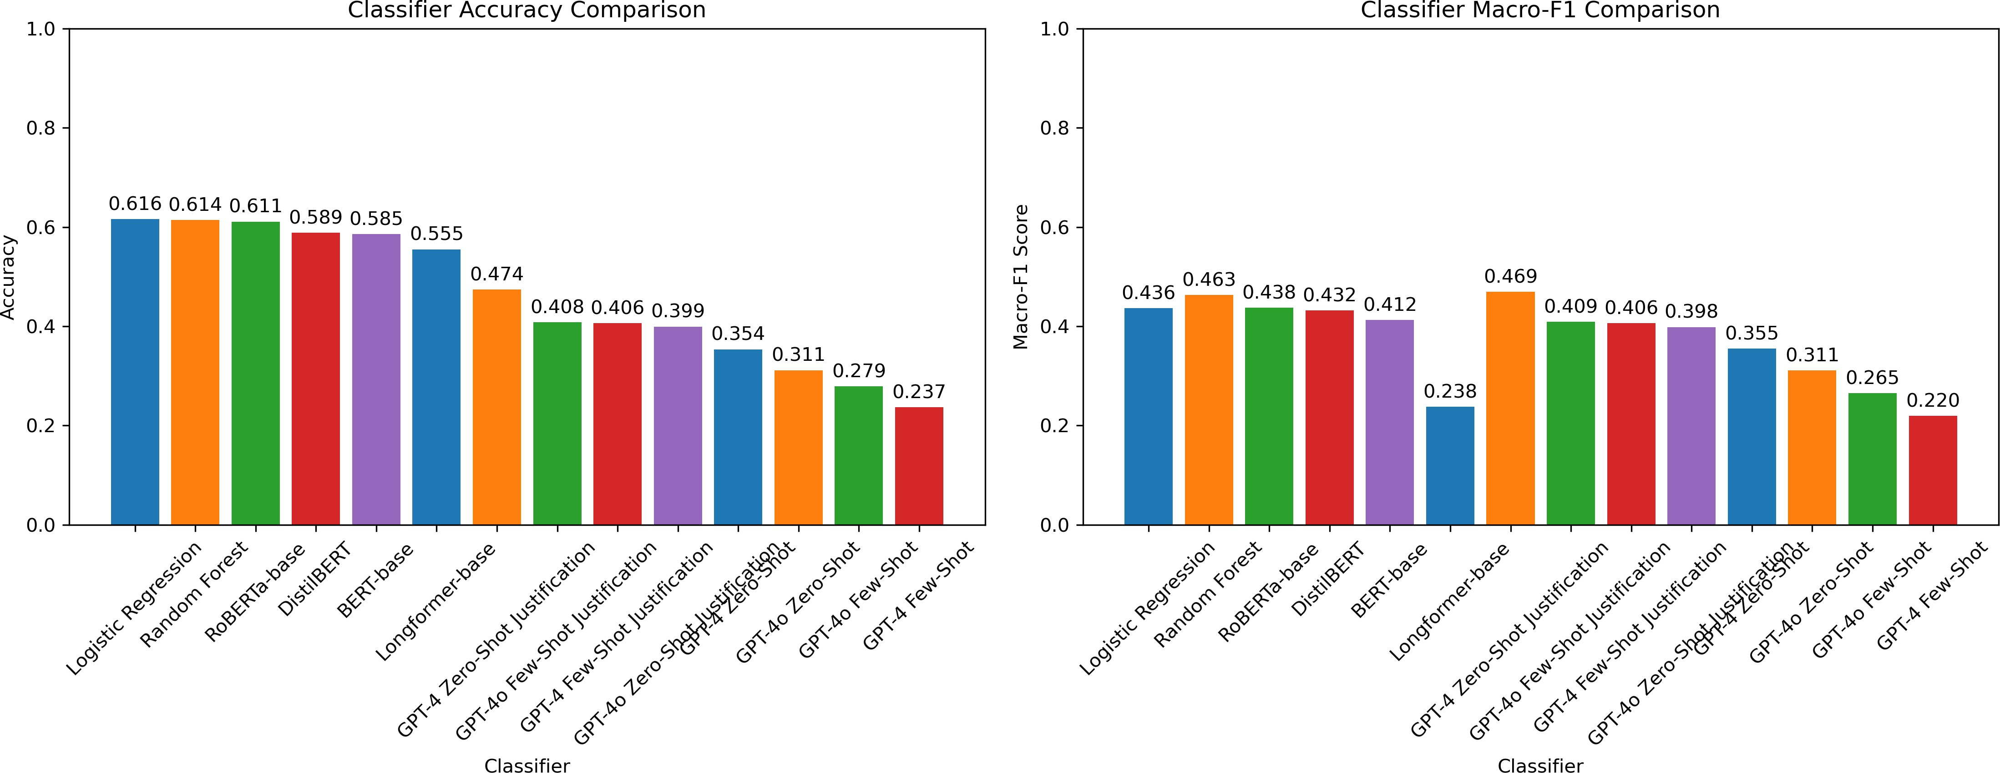
Figure 1: Classifier Accuracy and Macro-F1 Comparison Across All Models
- Confusion Matrices for GPT Models
This section presents the confusion matrices for all GPT model variants tested in our experiments. The matrices reveal systematic prediction patterns and biases in how generative models handle the three-class semantic coverage relationship classification task.

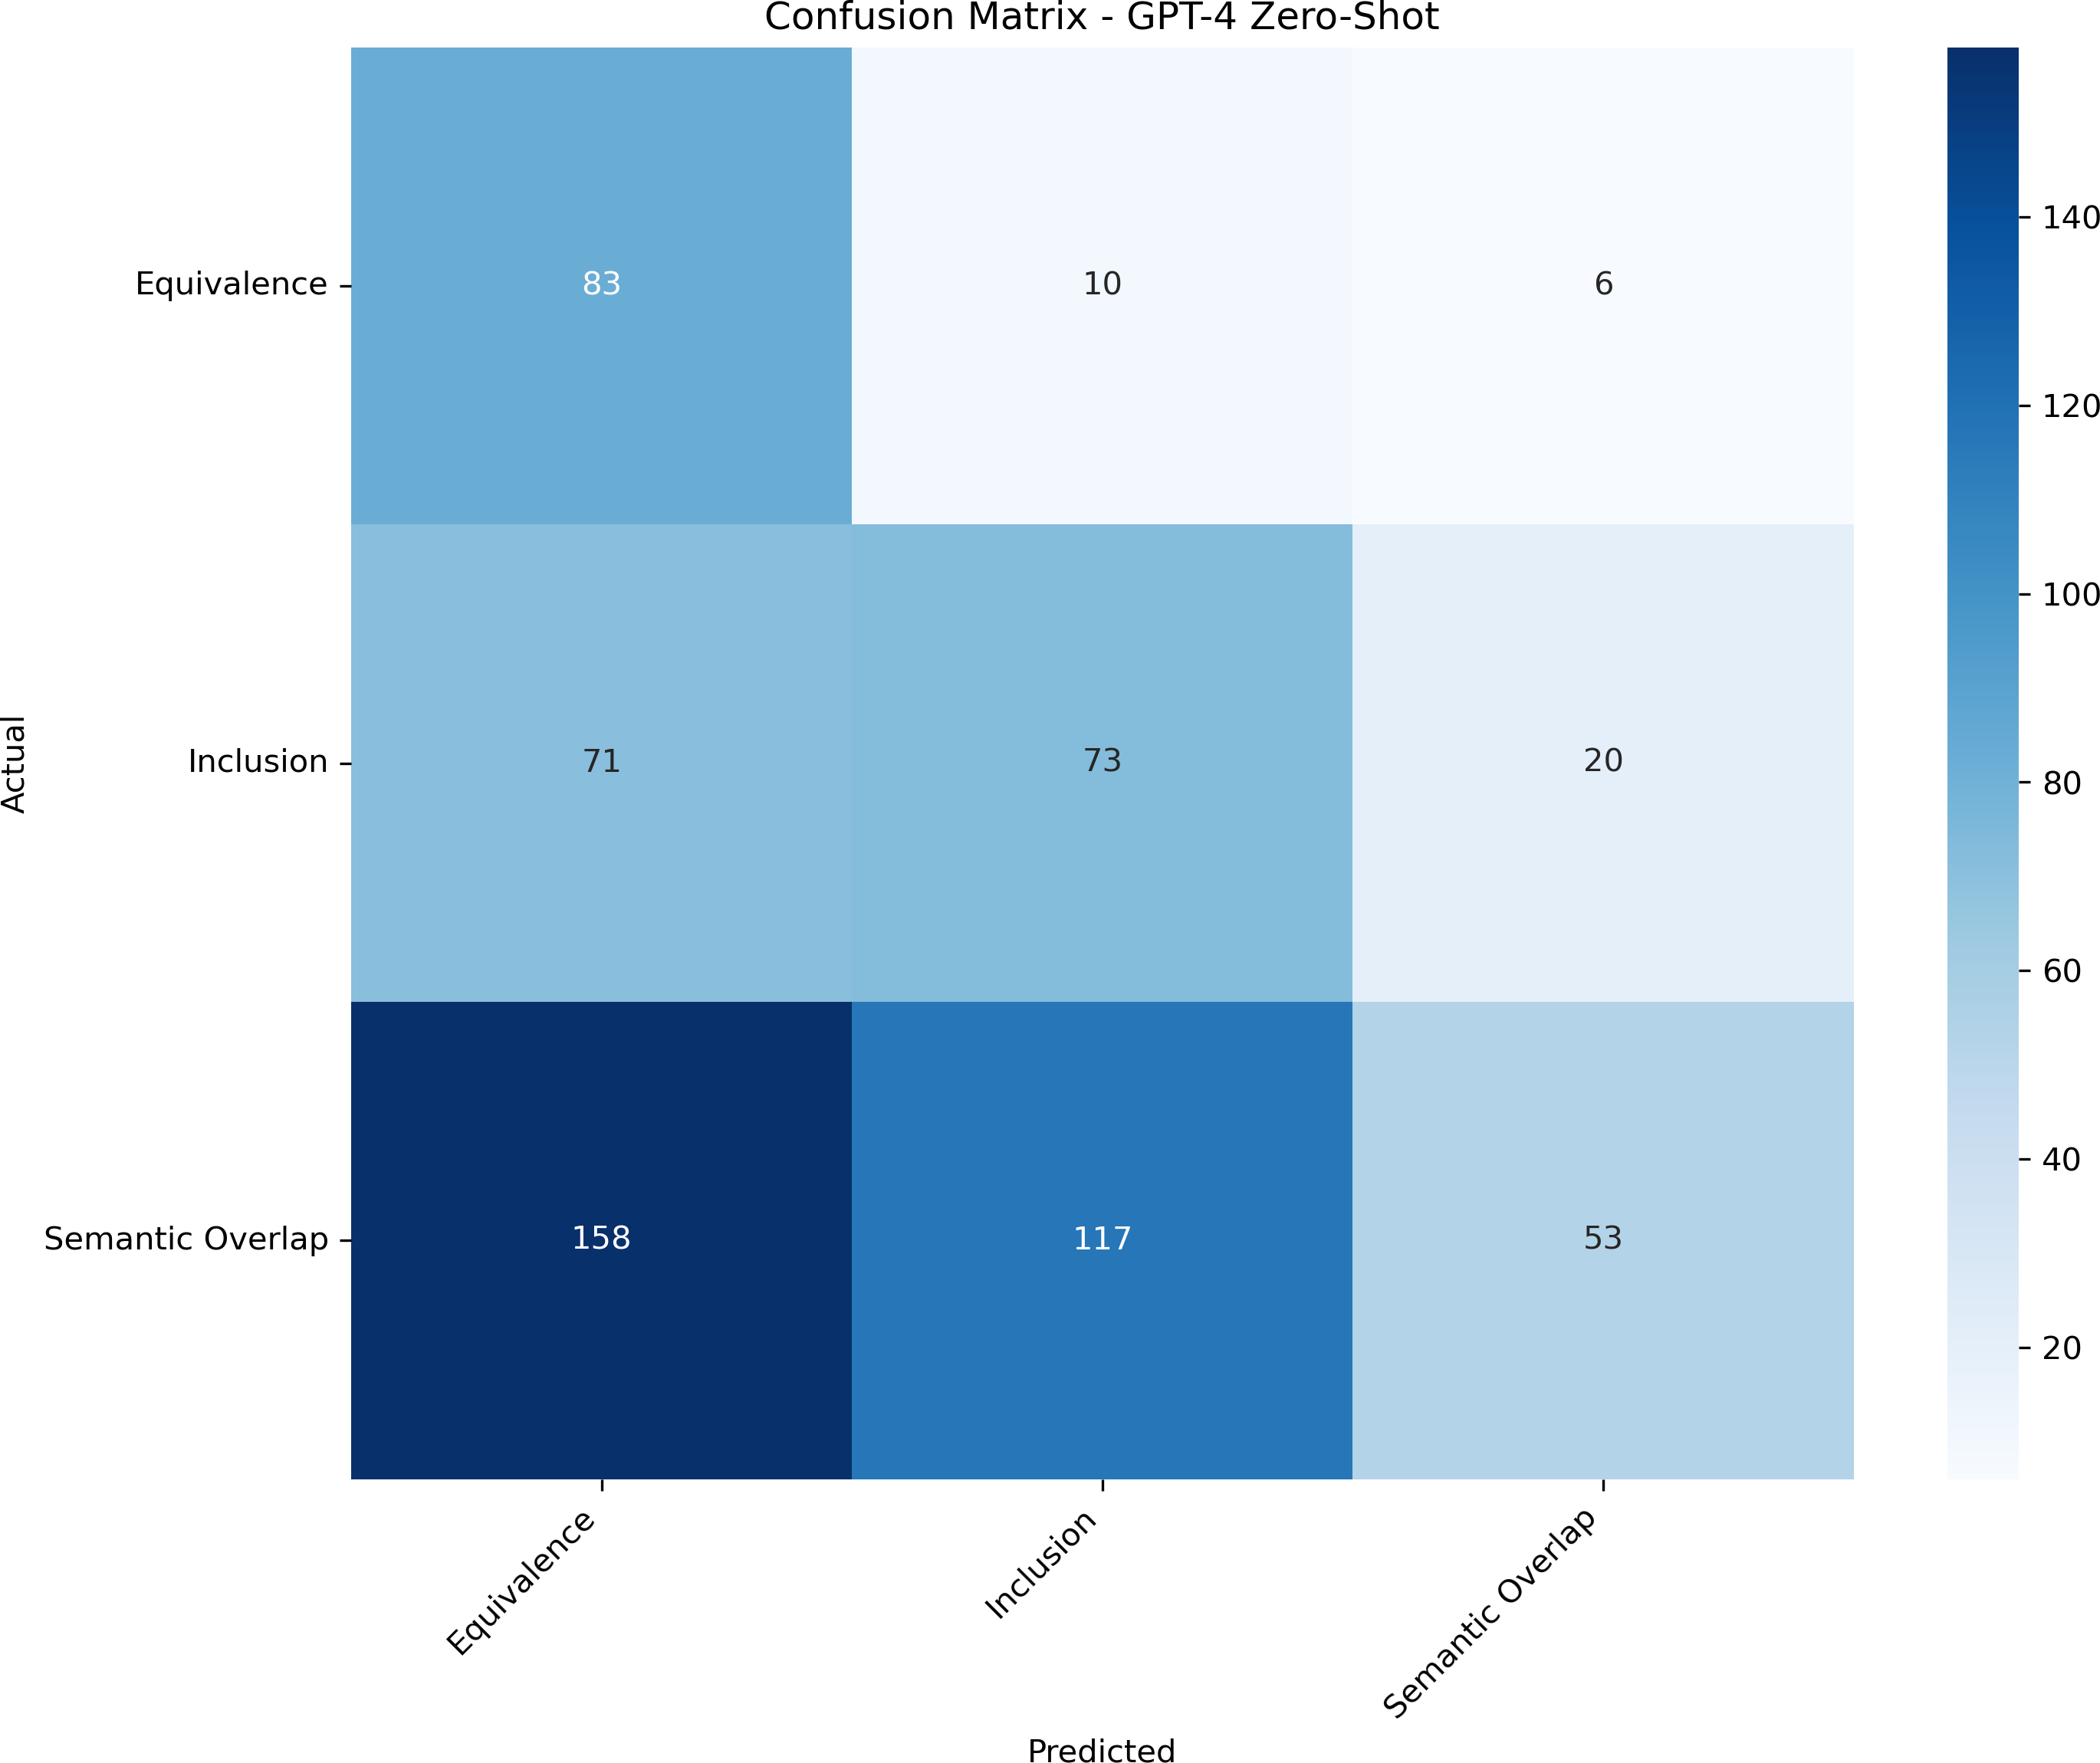

Figure 1: Confusion Matrix - GPT-4.1 Zero-Shot
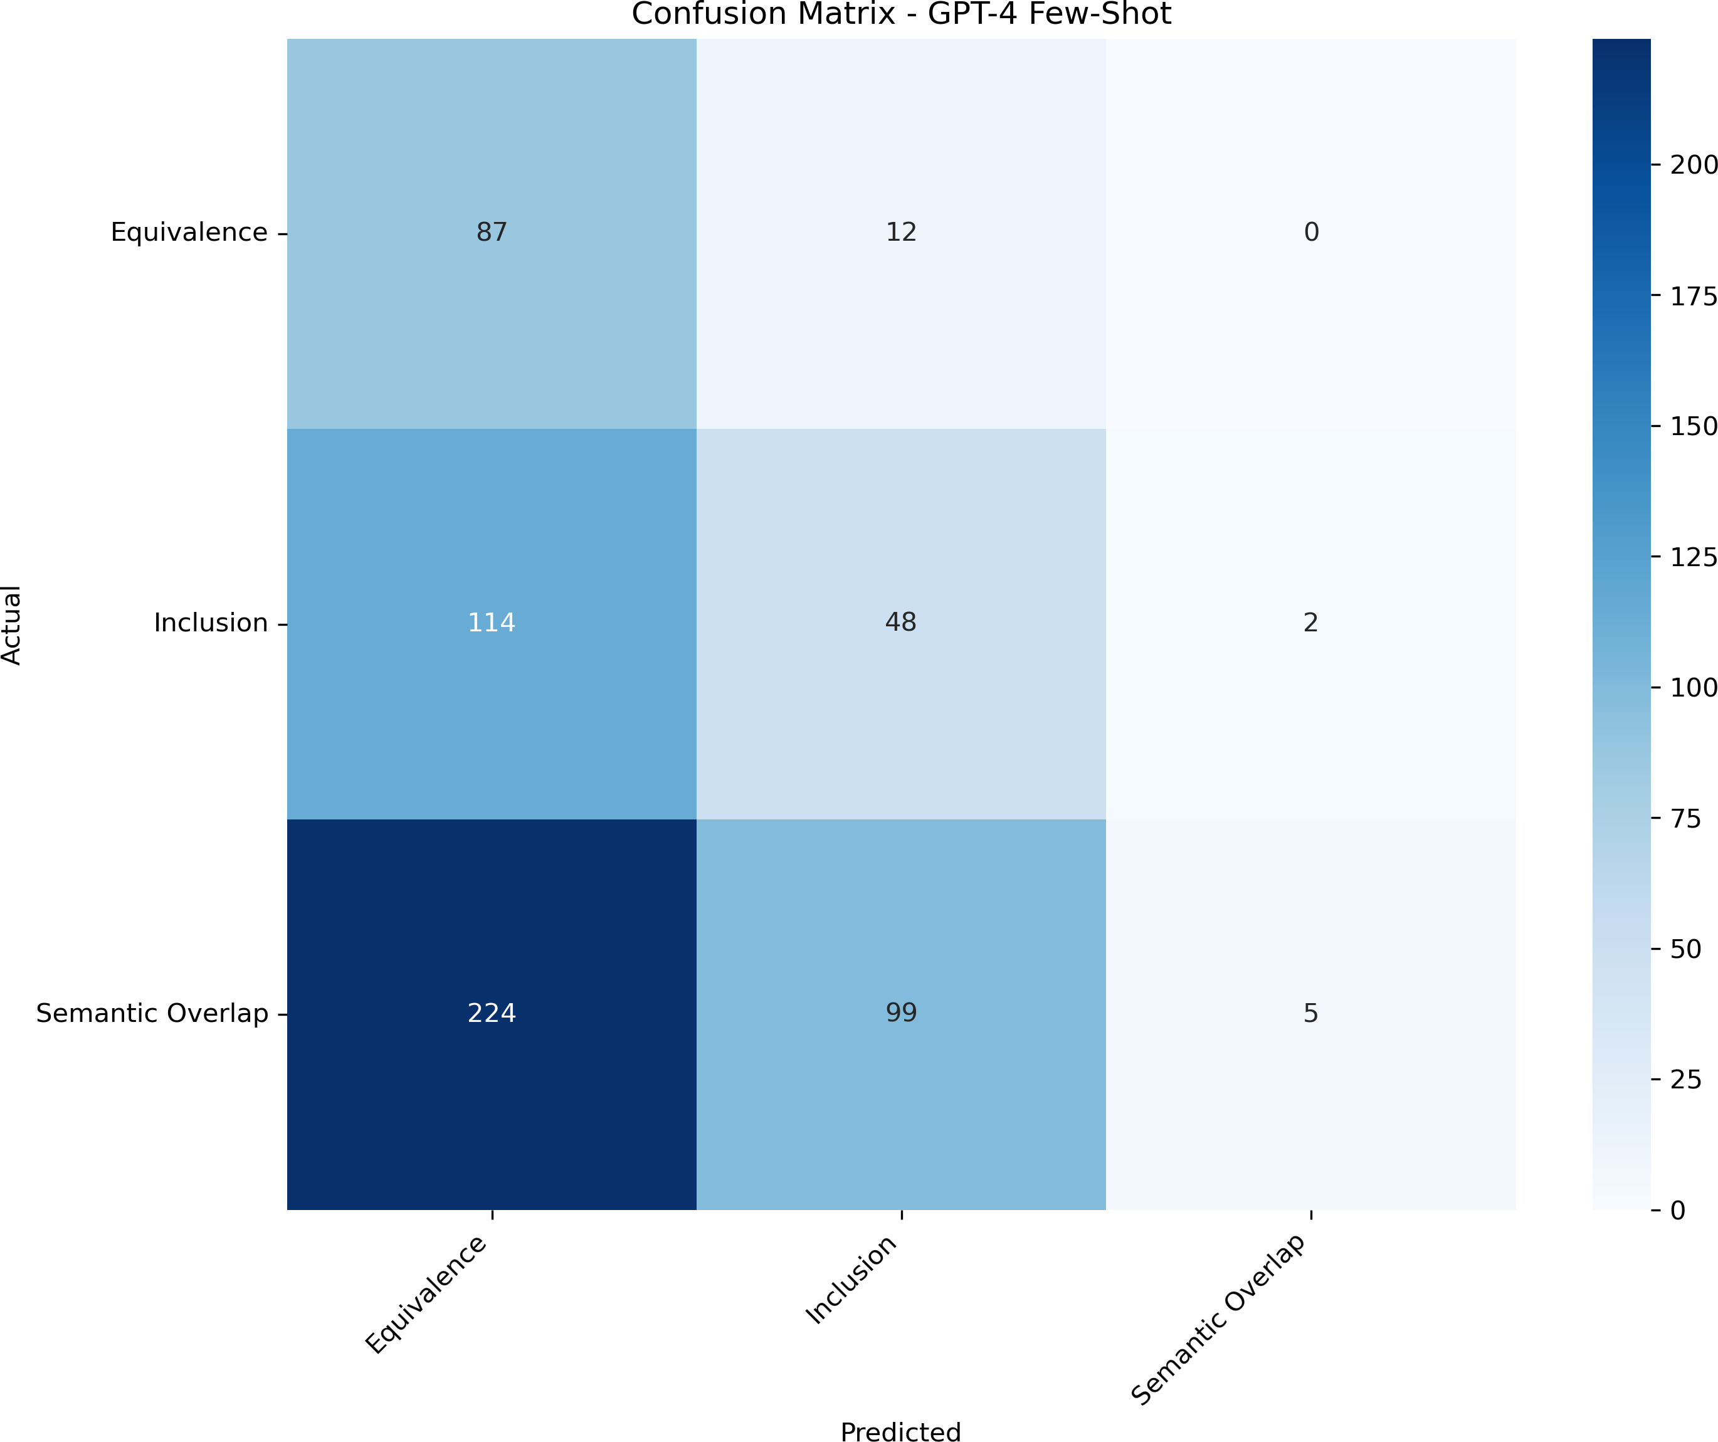

Figure 2: Confusion Matrix - GPT-4.1 Few-Shot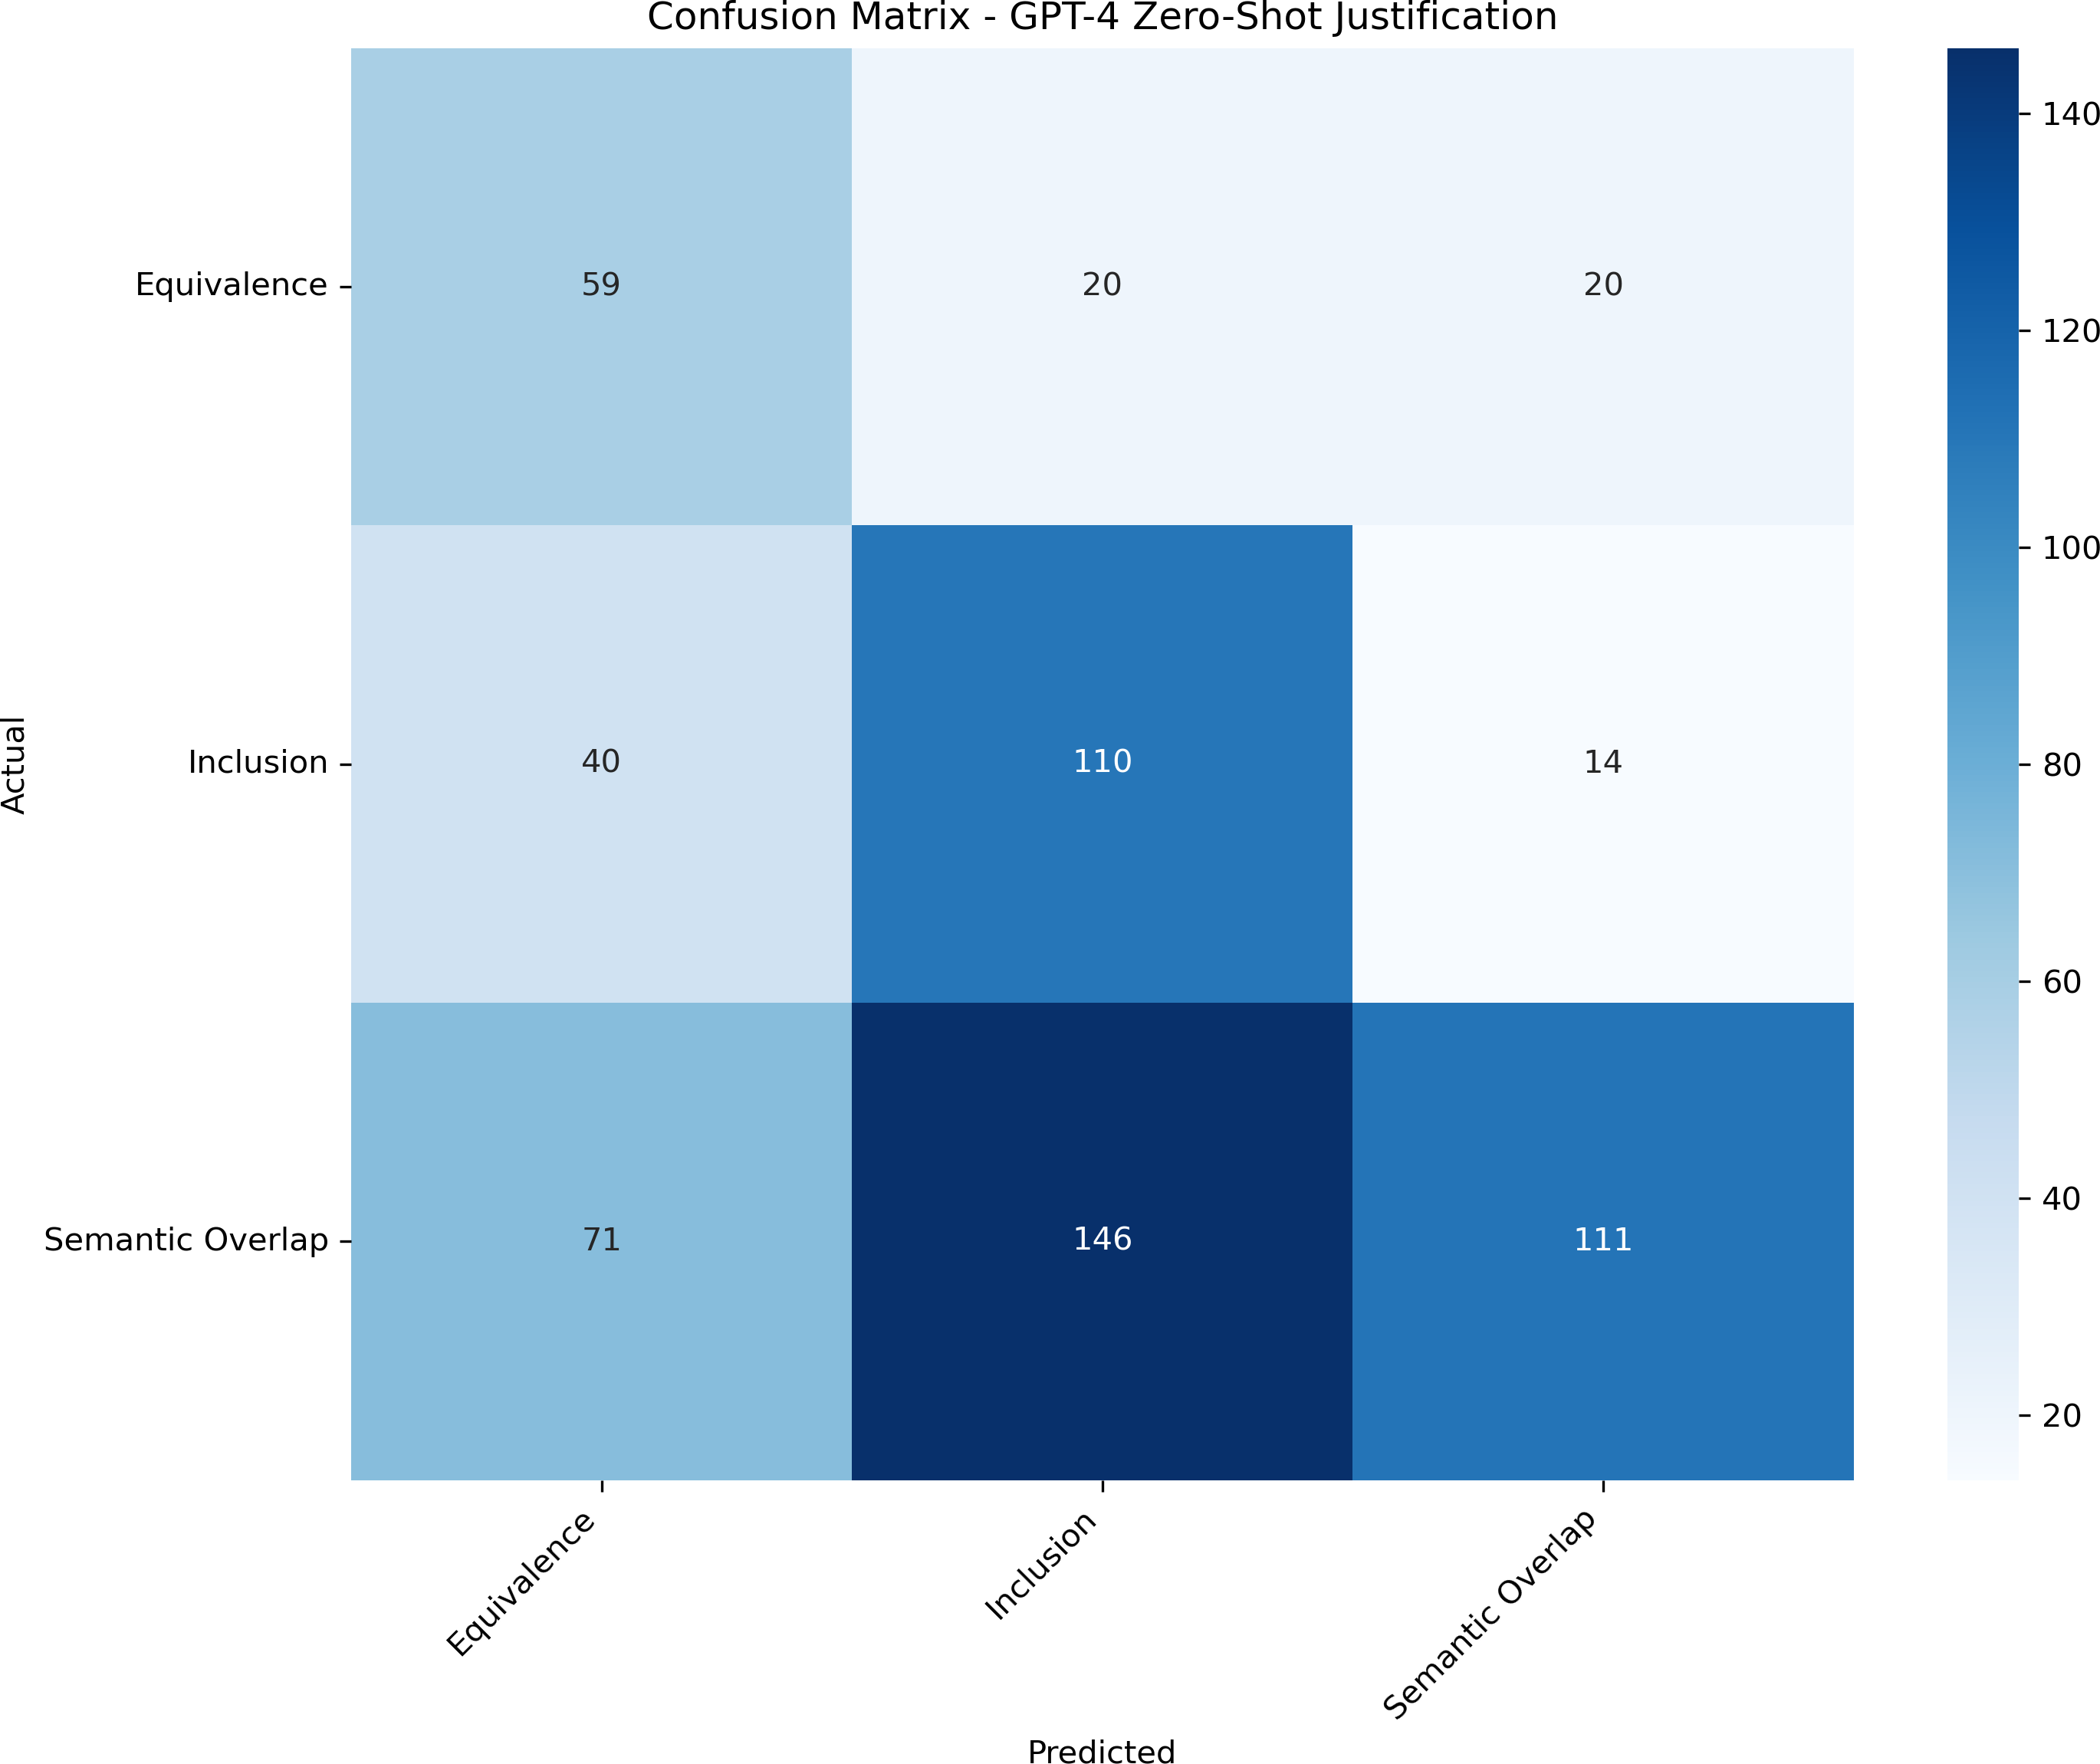

Figure 3: Confusion Matrix - GPT-4.1 Zero-Shot Justification

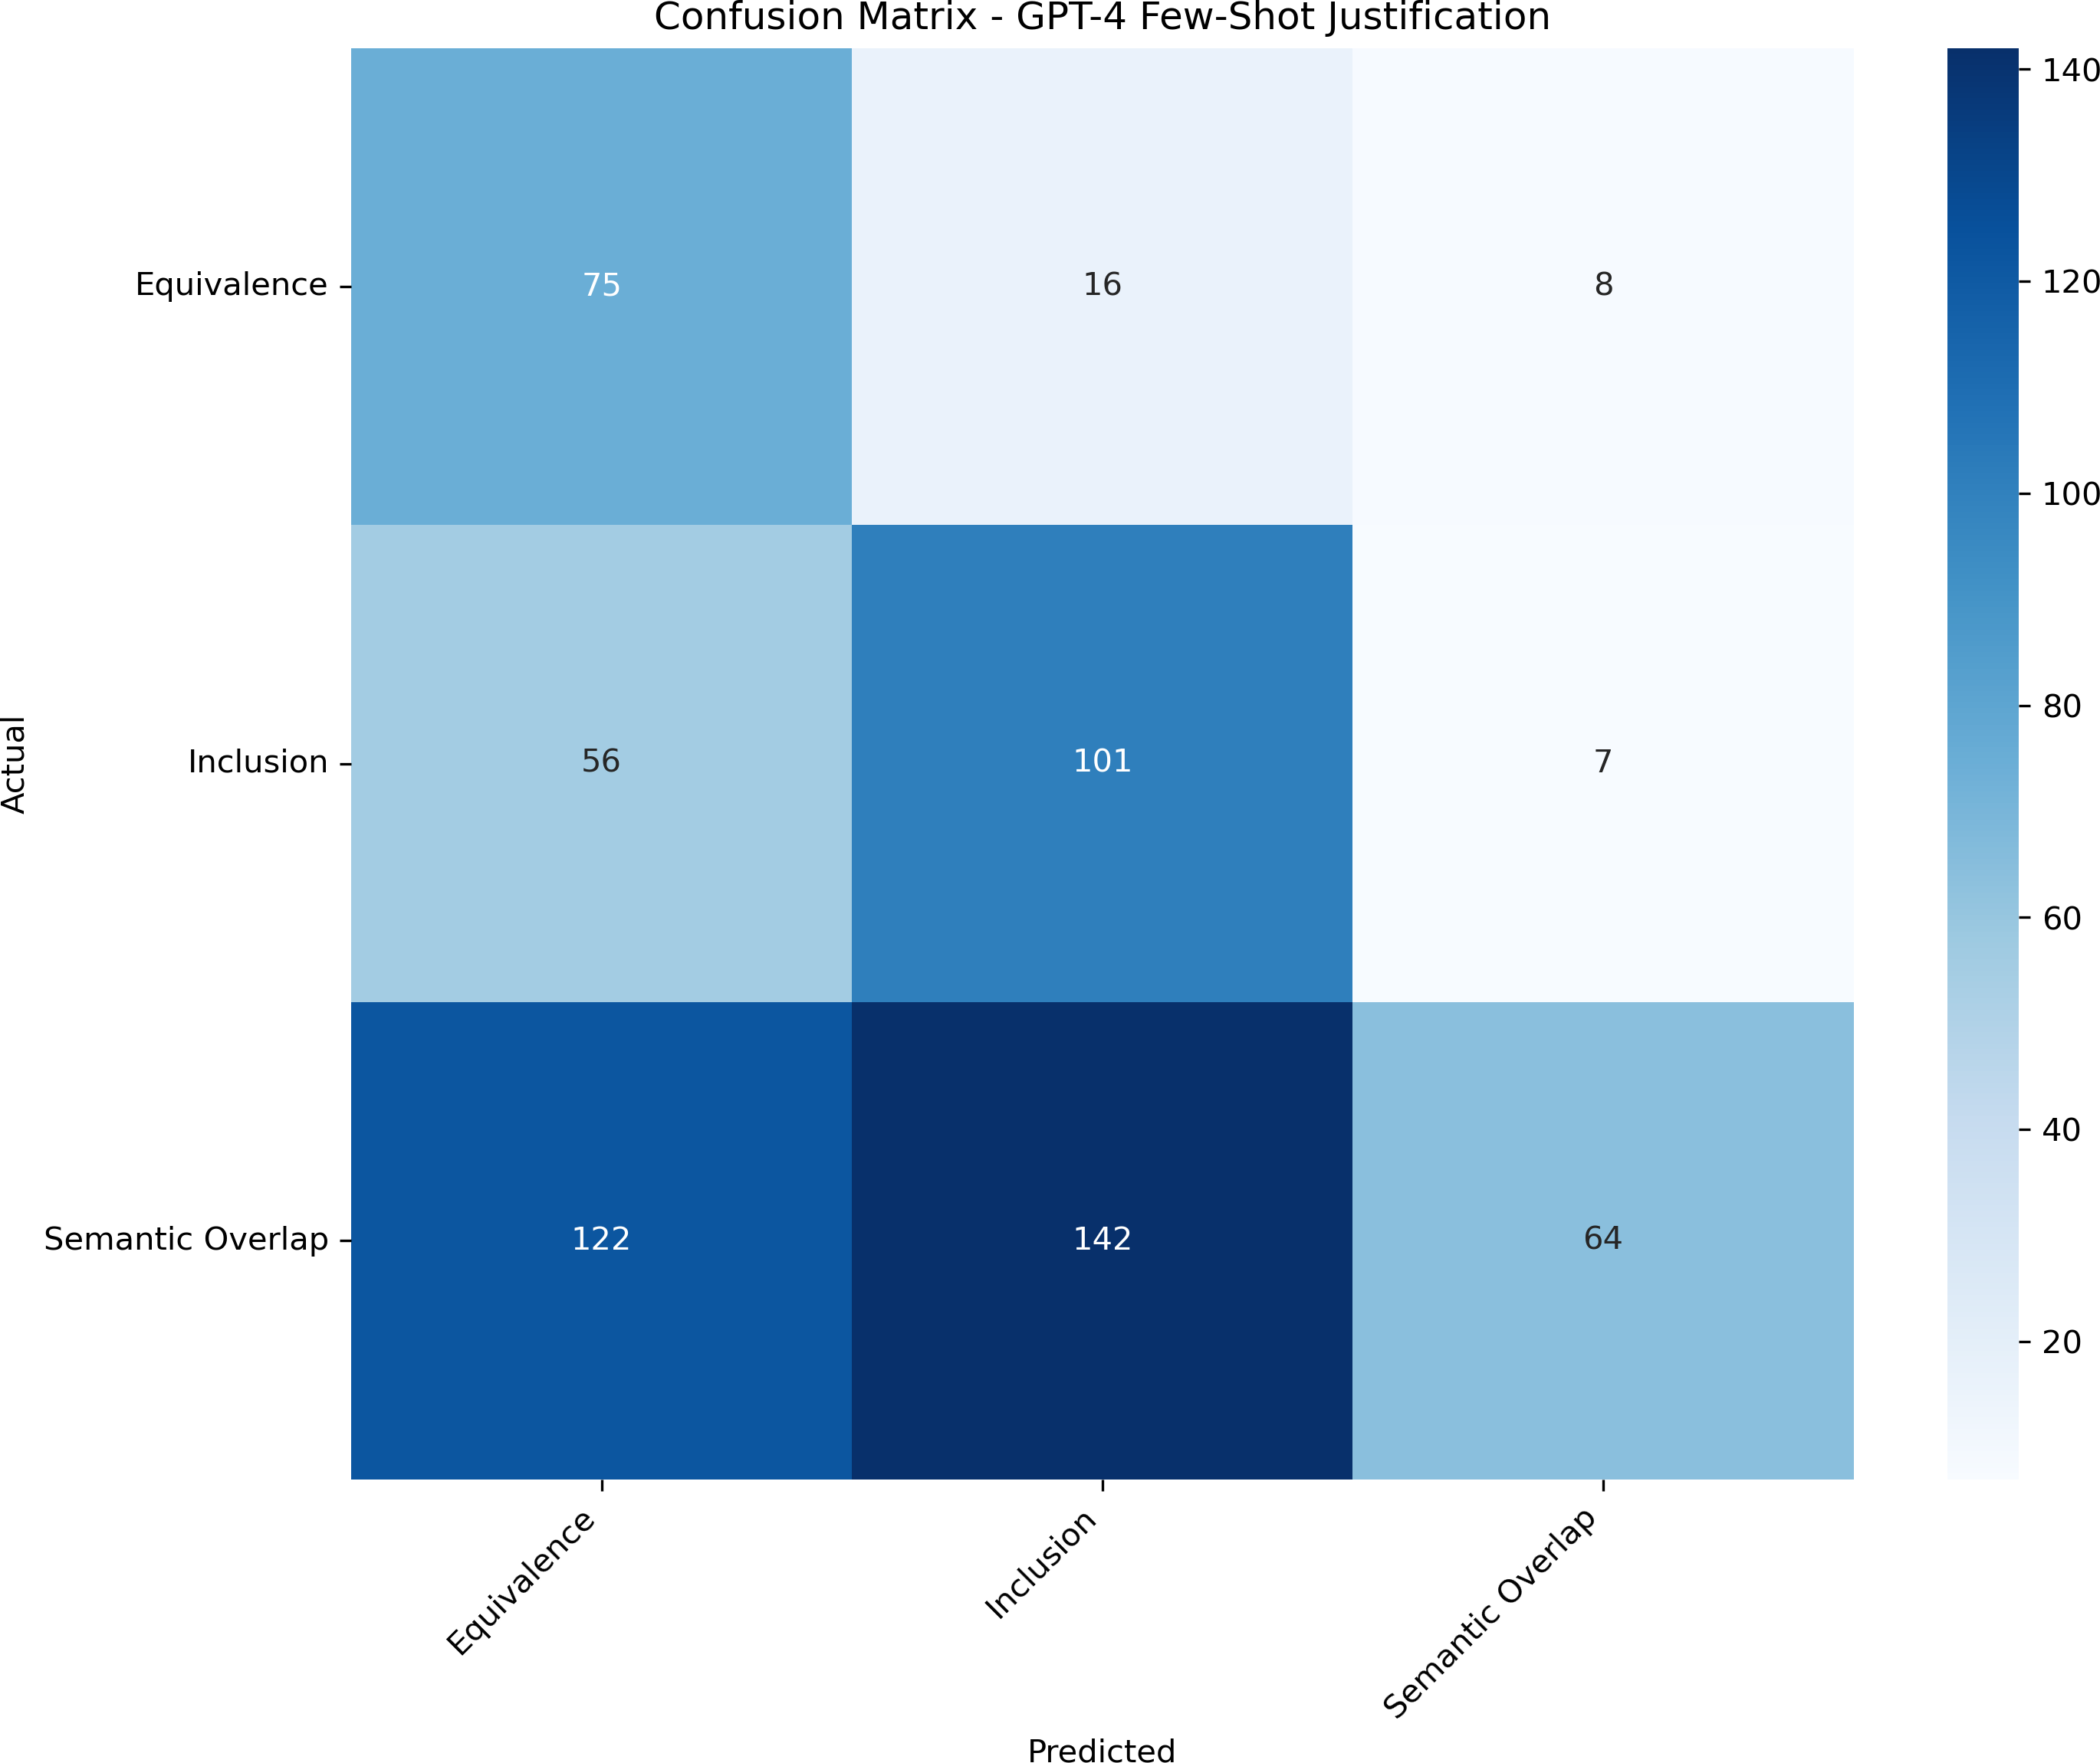

Figure 4: Confusion Matrix - GPT-4.1 Few-Shot Justification

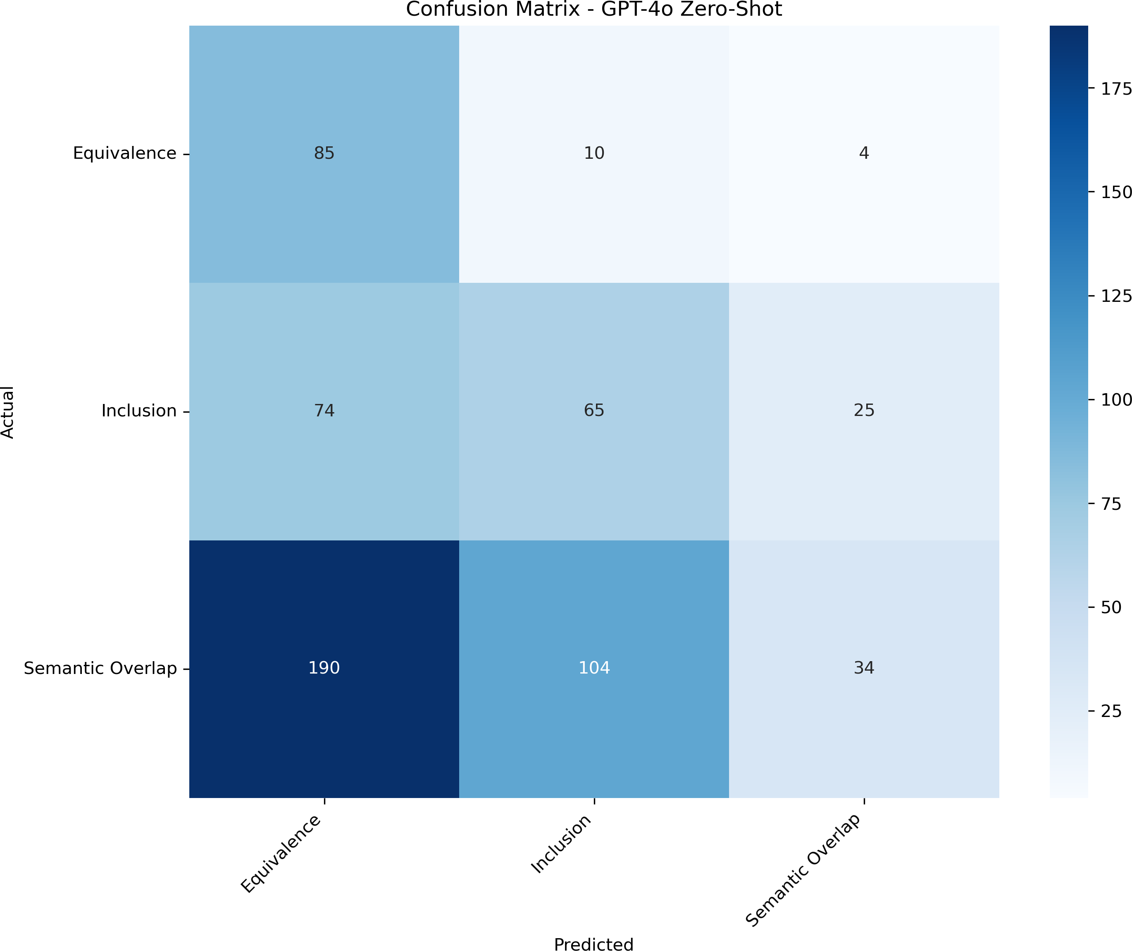

Figure 5: Confusion Matrix - GPT-4o Zero-Shot

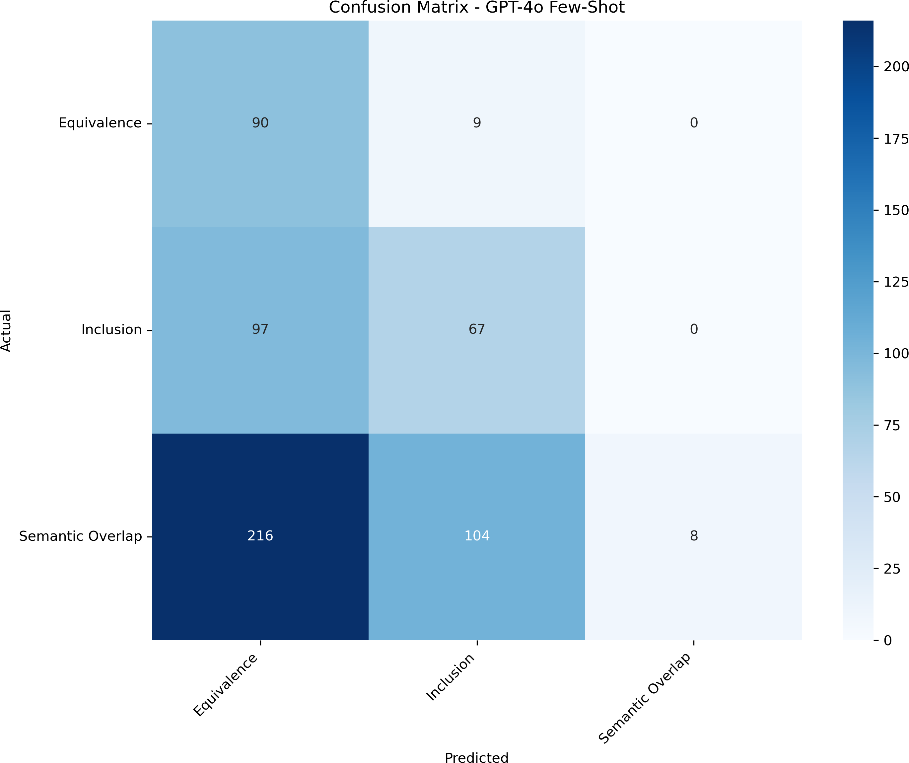

Figure 6: Confusion Matrix - GPT-4o Few-Shot

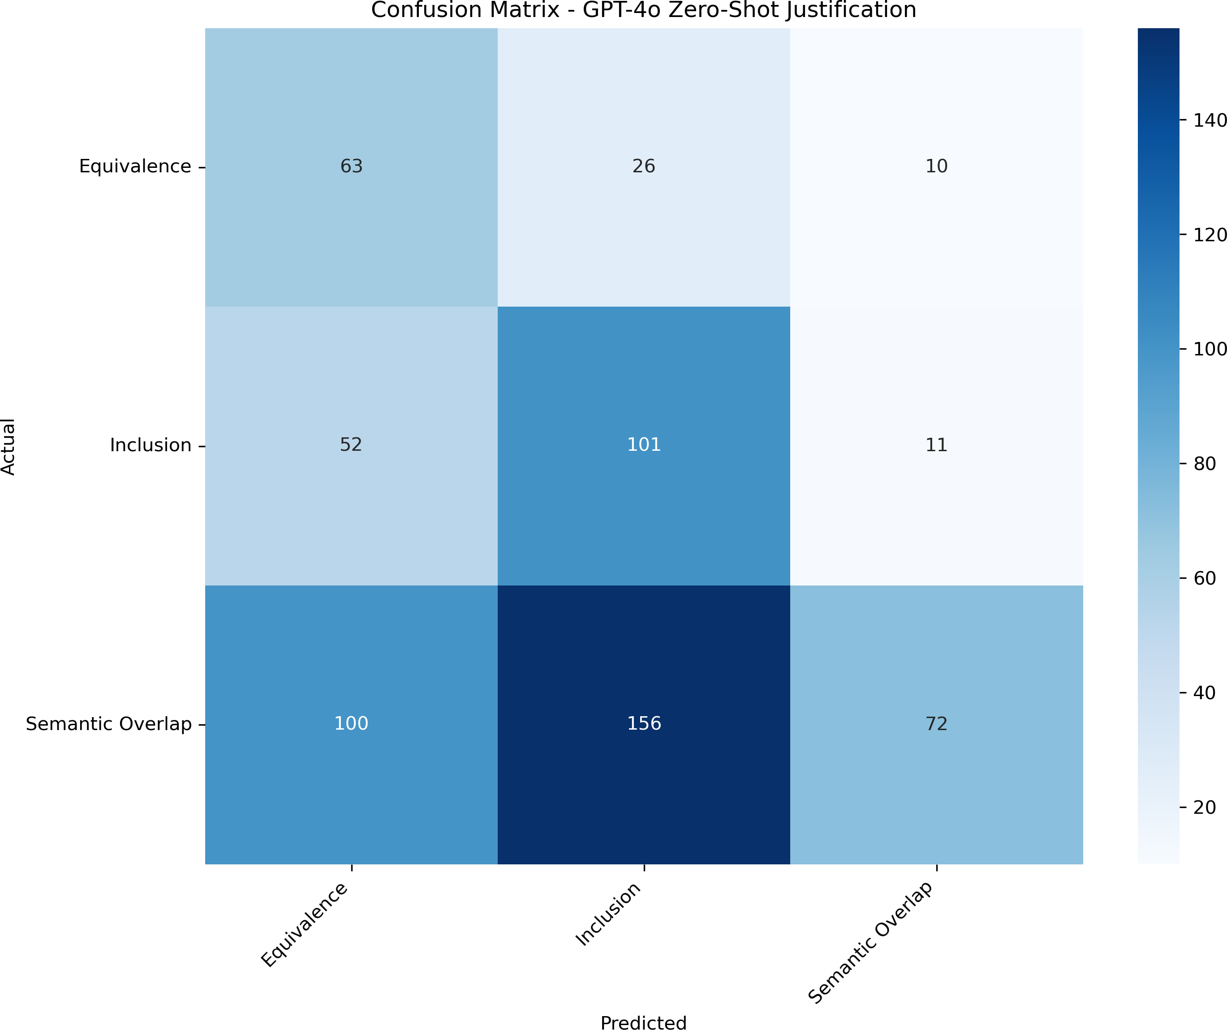

Figure 7: Confusion Matrix - GPT-4o Zero-Shot Justification

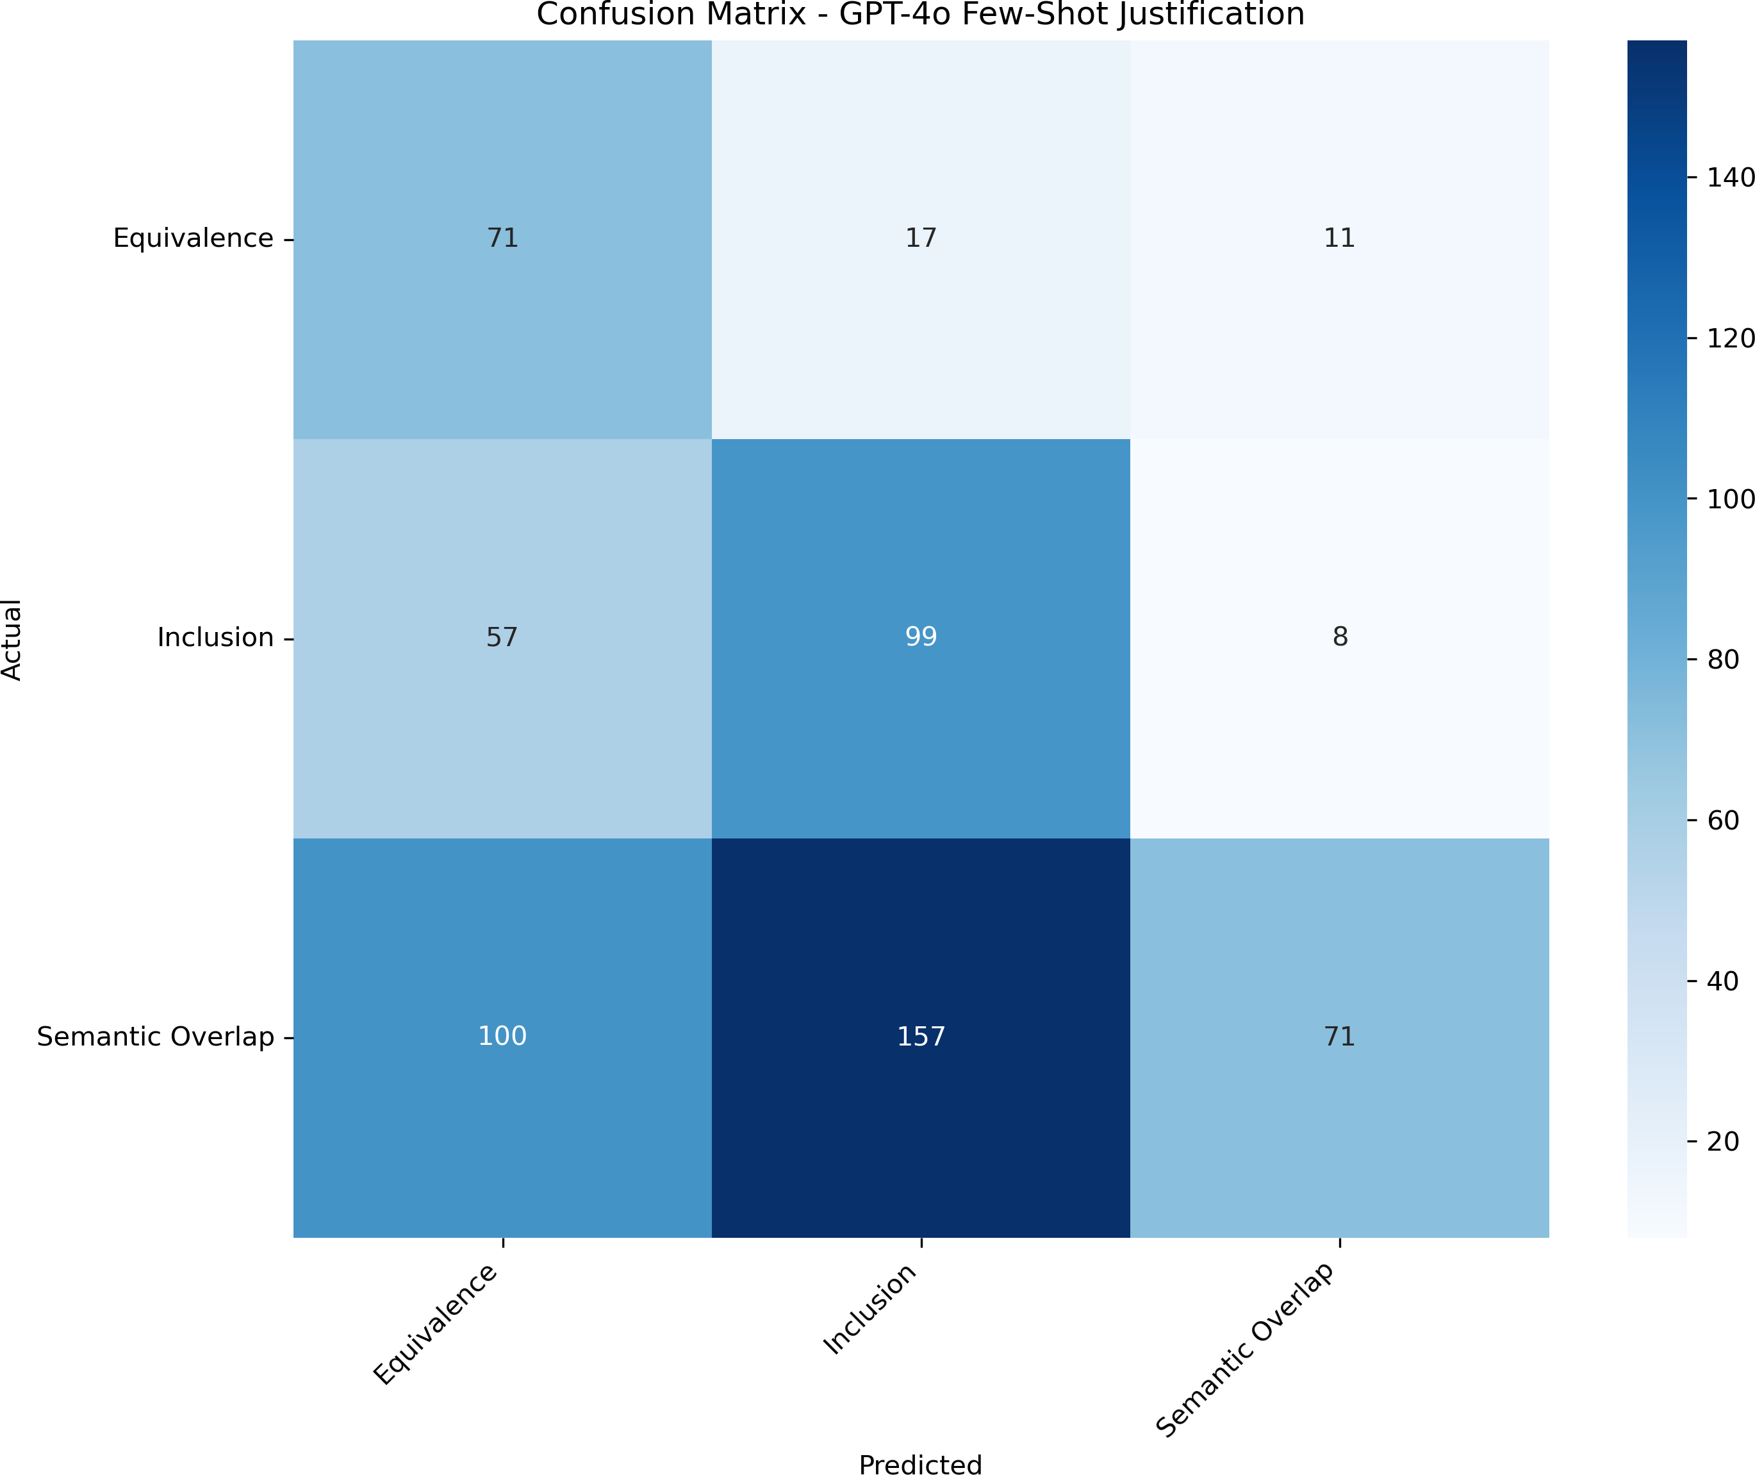

Figure 8: Confusion Matrix - GPT-4o Few-Shot Justification

