Solutions for CS 224N Assignment#2 word2vec written:

(a). Since y is one hot vector, so = (when w = o ,it`s , else 0)

(b)

(c)

(d)

(e)

for k = 1, 2, ,3 …. K

Q:Why this neg-sample is much more efficient?
A:From native softmax , we could see for eachit needs compute with the all ‘outside’ vectors U contains a vector for every word in vocabulary. however neg-sample loss function only needs calculate fixed size matrices rather than calculate all words vectors like U and V, so neg-sample is much more efficient and scale-able.

(f)
(i)

(ii)

(iii)
2. (c)
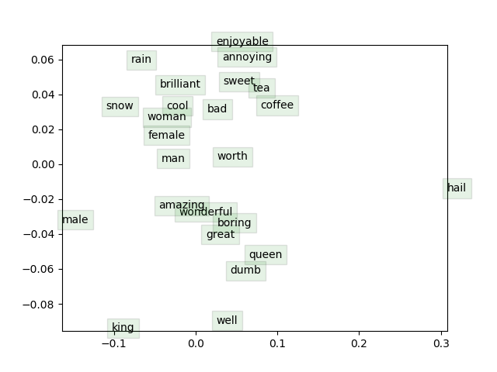
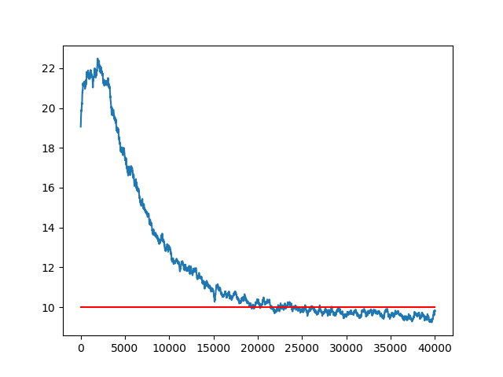
Loss :

