Minesweeper Project
Introduction
This project began as a personal hobby over the past two years, evolving through several iterative stages of development. What started as a simple recreation grew into a comprehensive platform as I integrated new features and deeper logic with each milestone.

Originally introduced by Microsoft in 1990, Minesweeper is a classic that has remained fundamentally unchanged for decades. However, beneath its deceptive simplicity lies significant mathematical and logical complexity. I chose this project because Minesweeper offers a unique intersection of game design and algorithmic challenges.

This project serves a dual purpose: it is a polished "sandbox" for casual players and a robust environment for testing algorithms and conducting statistical or computational analysis. The documentation is organized logically, allowing you to navigate specific modules—from core gameplay to advanced analytics—using the legend below.

You can find the project in my GitHub: https://github.com/aloni34

Legend
1. Gameplay & User Experience
  - Core Mechanics
  - User Interface
  - Operational Modes
- Technical Architecture
  - MVC++ Framework
  - Data Structures & Memory Management
  - Logical Implementation
  - Environment Setup & Execution
- The Sandbox & Analytics
3.1 Algorithm Testing Suite
3.2 Different Algorithms
  - Statistical Analysis
- Development Journey
  - Version History
  - Refactoring Lessons
- References

- Gameplay & User Experience
  - Core Mechanics
Minesweeper is fundamentally a game of logical elimination. The objective is to identify and flag every mine within a grid without triggering an accidental detonation. While every randomly generated board presents unique patterns, the underlying principles of the game remain constant.
The First Move
At the start of every game, the user is guaranteed 100% certainty that the initial click will not land on a mine. This "safe-start" logic ensures the player has a foundation to begin their analysis. From this starting point, the player must navigate the board using the numerical data revealed by each cleared space to deduce the location of hidden mines.
For instance:
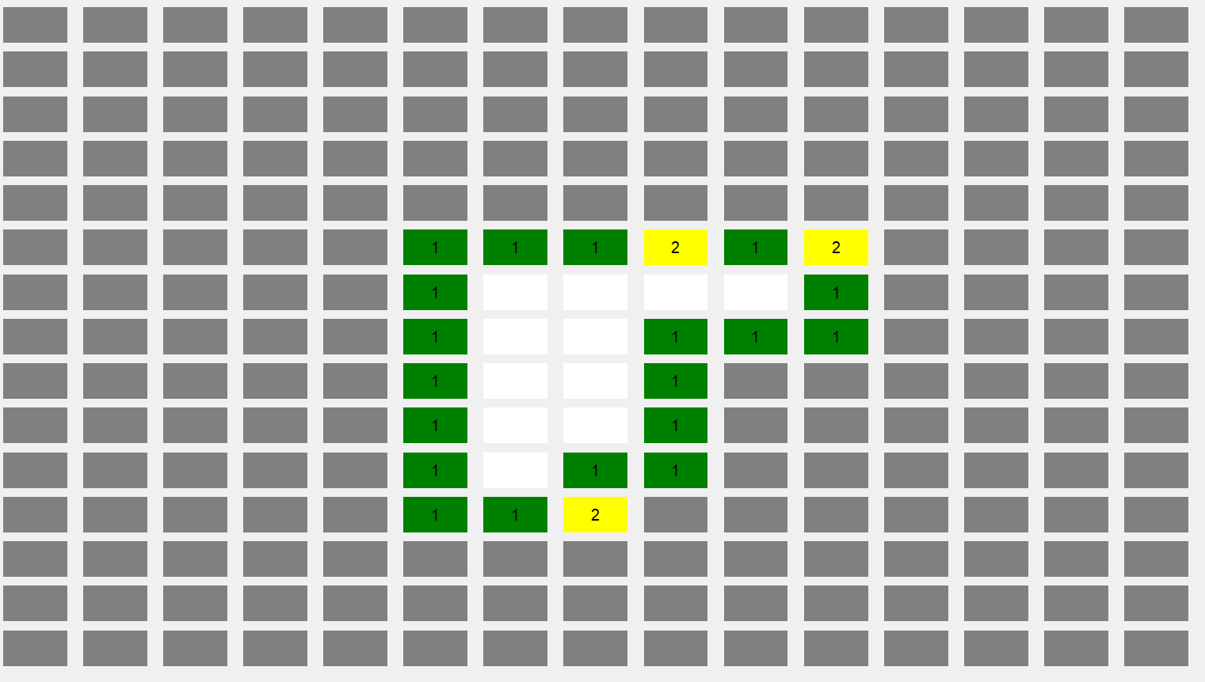
if a player initiates a game by selecting a tile at the center of the grid, the engine processes the "First-Click Safety" logic and reveals a cluster of safe tiles. This transition from a hidden board to a numerical interface provides the player with their first set of data points.
Game State & Numerical Mapping
Following the initial move, the player must navigate the board based on the Local State revealed. The engine calculates the proximity of mines for every non-mine tile, assigning a value from 1 to 8.
The Proximity Scale
Each number represents the count of mines in the 8 adjacent tiles. To assist the player in rapid pattern recognition, each numerical value is mapped to a specific color:
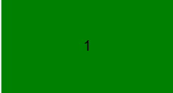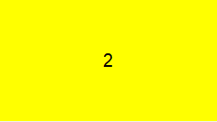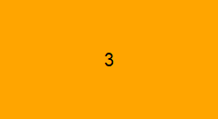
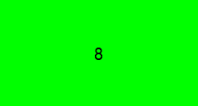
For example, if we look at a tile which has the number 5, then there are 5 bombs near that tile.
Deduction vs. Probability
Progress is achieved through Logical Elimination. By comparing overlapping numerical hints, players can find "Certainty" (tiles that are 100% safe or 100% mines). However, a key mathematical challenge in Minesweeper is the Force-Guess Scenario, where the board state provides no logical solution, requiring a statistical risk to proceed.
Termination Logic (Game Over)
If a mine is triggered, the game state changes to LOST. At this point:
- Input Handling is disabled to prevent further moves.
- Full Reveal: The engine iterates through the entire grid array and renders all mine positions in Black, providing the player with a post-game analysis of the board's hidden layout.
Example of a failed game:
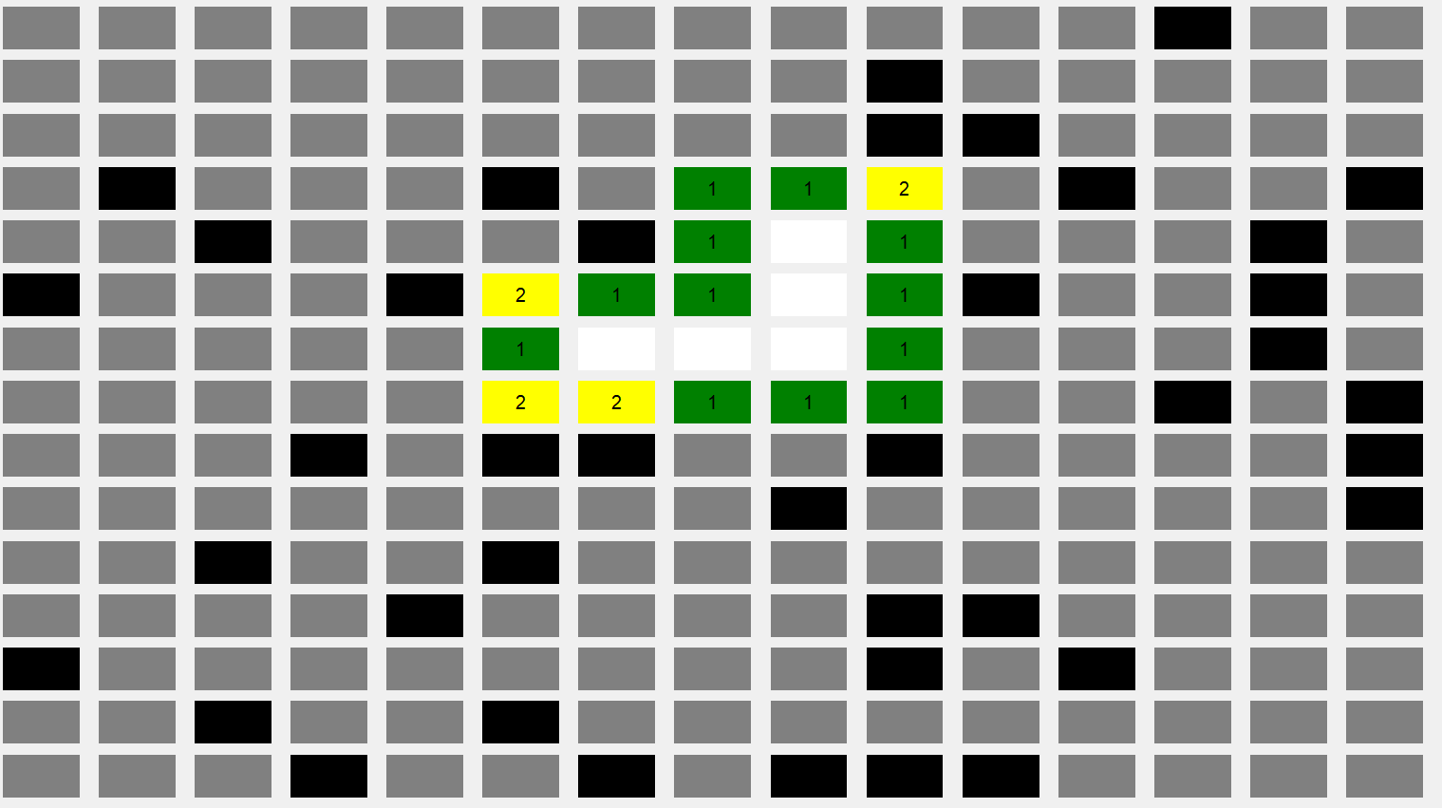
Example of a successful game:
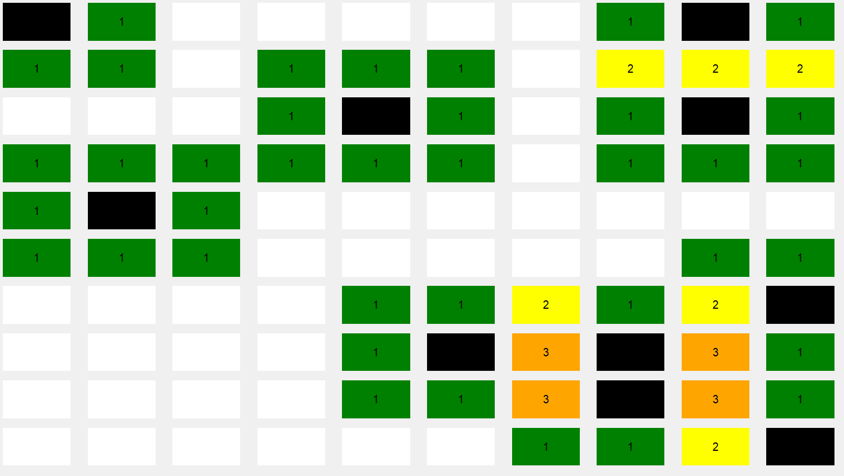
Where in this case, after we have solved the entire board successfully, the positions of the bombs have been revealed.

  - User Interface
Upon launching the application, the user is presented with the primary Game Canvas and Control Panel. The interface is designed for both high-speed play and analytical testing.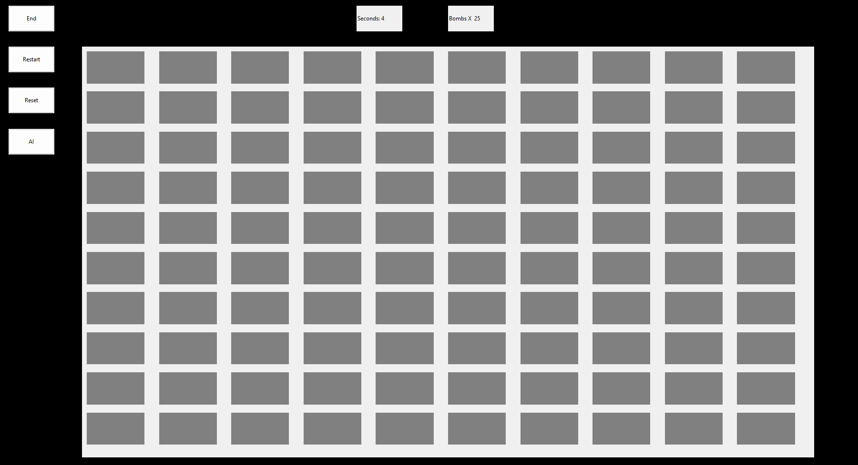
Input Mapping
The interaction layer is divided into mouse-based gameplay and keyboard-driven shortcuts for efficiency:
Primary Action (Left Click): Uncovers a tile. If the tile is a mine, the game terminates; otherwise, it reveals the proximity value or triggers a recursive expansion.
Tactical Action (Right Click): Flags a tile as a confirmed mine. This prevents accidental clicks and updates the mine counter.
System Shortcuts:
Restart (CTRL + R): Re-initializes the current board parameters for a fresh game.
Exit (CTRL + E): Gracefully terminates the application process.
Command Module
Beyond standard gameplay, the interface includes dedicated buttons for advanced features:
Reset: Clears the current progress while maintaining the board configuration.
AI Integration: Activates the automated solving algorithms to analyze or complete the current board state.
Configuration (values.py)
For granular control over the environment (such as grid dimensions, mine density, or custom color HEX codes), the project utilizes a centralized configuration file: values.py.
Note: A detailed breakdown of how these constants interact with the game engine can be found in the next Section under Data Structures.

  - Operational Modes
The project is engineered to support two distinct modes of operation, catering to both interactive gameplay and high-speed algorithmic testing.
Interactive Mode (User Play)
By default, the application launches in Interactive Mode. This provides the standard user experience where all inputs are manual. The graphical interface remains active, and the game engine waits for hardware interrupts (mouse clicks/keyboard shortcuts) to progress the board state.
Autonomous Mode (Ai & Simulation)
The AI mode can be engaged in two ways, depending on the desired level of visual feedback:
Real-Time AI: Triggered via the AI Button or a specific toggle. The AI analyzes the current grid state and executes moves visibly on the board. This is ideal for studying the AI’s decision-making process.
Headless Simulation: By disabling the View/GUI component of the project, the engine enters a "Headless" state. Without the overhead of rendering graphics, the AI can process games at maximum CPU velocity.
Use Case: This is used for large-scale simulations to gather statistical data on win rates, average game duration, and algorithm efficiency across thousands of iterations.

- Technical Architecture
The system is built on Object-Oriented Programming (OOP) principles, prioritizing modularity, encapsulation, and code reusability. To manage the complexity of the game logic versus the user interface, the project utilizes the Model-View-Controller (MVC) architectural pattern with additional tuning.
  - MVC++ Framework
To ensure the project is maintainable and scalable, I adopted a modified Model-View-Controller (MVC) architecture. This decoupling allows the logical engine to function independently of the graphical interface.

Model (mine_sweeper.py): The core logical structure. It manages the 2D grid array, tracks mine coordinates, and executes the recursive reveal algorithms. It is strictly "UI-agnostic," meaning it performs calculations without any knowledge of the visual display.
View (view.py): The "Presentation Layer". It handles the rendering of the grid, color mapping, and UI components. It serves as a visual output for the data processed by the Model and the specialized classes in brain.py.
Connector (connector.py): The "Central Hub". This acts as the bridge (Controller) that routes tasks between different classes. It manages the communication flow, ensuring that user inputs or AI decisions are correctly translated into logical updates and visual changes.
AI Engine (brain.py): The "Autonomous Intelligence". This module contains a library of various algorithms designed to play the game independently. Each algorithm follows a unique heuristic, allowing for comparative analysis of different solving strategies.
Test (test.py): The "Research Layer". This module executes automated simulations and captures raw performance data. This data is exported to Excel (.xlsx) formats, enabling deep statistical analysis of AI efficiency and board solvability.
Board Generator (generate_boards.py): A specialized utility for procedural generation. It creates standardized or custom board configurations, ensuring a consistent testing environment for the AI classes.
Here is a flow-diagram which breakdown the structure of the project:
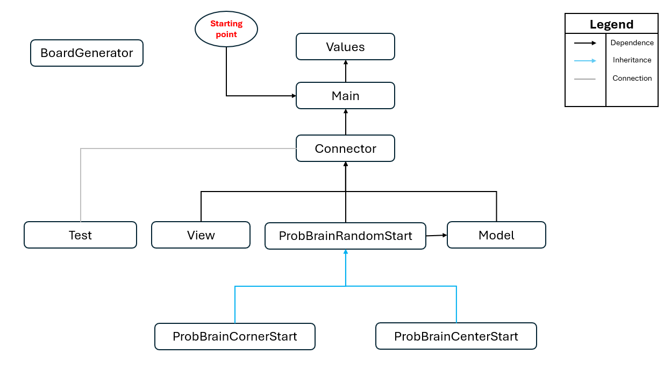

  - Data Structures & Memory Management
The project leverages a variety of fundamental data structures, optimized for both real-time gameplay and high-velocity simulations. Each module utilizes a specific combination of these structures to balance access speed with memory efficiency.
We utilize the inbuilt python library tkinter for the UI section in the project.
    - GUI Framework: Tkinter
For the graphical implementation, the project utilizes the Tkinter library.
Event-Driven Execution: Tkinter was selected for its native integration with Python's standard library and its efficient mainloop() execution. This allows the game to remain in a "low-power" state while waiting for user or AI interrupts.
Component Mapping: Each tile on the board is represented as a Tkinter Label or Button object, which is stored in a 2D list for O(1) coordinate-based access.
    - The Grid Engine (2D Arrays & Lists)
The project maintains the game state through two parallel 2D Lists, both named board. This allows for a strict separation between the data processed by the engine and the information displayed to the user.
The Model Board (Logic Layer)
Located in the Model class, this grid is the "Source of Truth" for all calculations. Each cell in this 2D list stores an integer value representing its logical state:
Value | Meaning | Description
0 - 8 | Proximity Count | The exact number of mines in the 8 adjacent tiles.
-1 | Flagged State | Indicates a tile that the user (or AI) has marked as a suspected mine.
9 | Mine Presence | A reserved value identifying the precise location of a bomb.

The View Board (Presentation Layer)
Located in the View class, this grid is responsible for the Synchronized Update of the UI. It acts as a visual buffer, translating the numerical values from the Model into assets the user can see (such as specific colors, button states, or mine icons).

By using two separate grids, the engine can perform high-speed "What-If" simulations in the Model without triggering unnecessary graphical refreshes, significantly optimizing performance during AI play.
2.2.2 Tile Management & The Active Frontier
To optimize the engine's performance—especially for the AI Engine and the Recursive Reveal logic—the Model class maintains specialized 1D Lists to track the state of the board dynamically.
The available_place List
The most critical of these is the available_place list. This list acts as the "Active Frontier" of the game. Instead of the engine scanning the entire 2D grid every time a move is made (which would be inefficient), it only tracks the tiles that are currently relevant to the player or the AI.
Logic: Every time a tile is revealed, its coordinates [row, col] are added to this list.
Purpose: This list defines the boundary between the "Known" and "Unknown" parts of the board. For the AI, this list represents the only tiles it can use to make logical deductions.
Format: The list stores entities as coordinate pairs: [[r1, c1], [r2, c2], ... [rn, cn]].
For example:
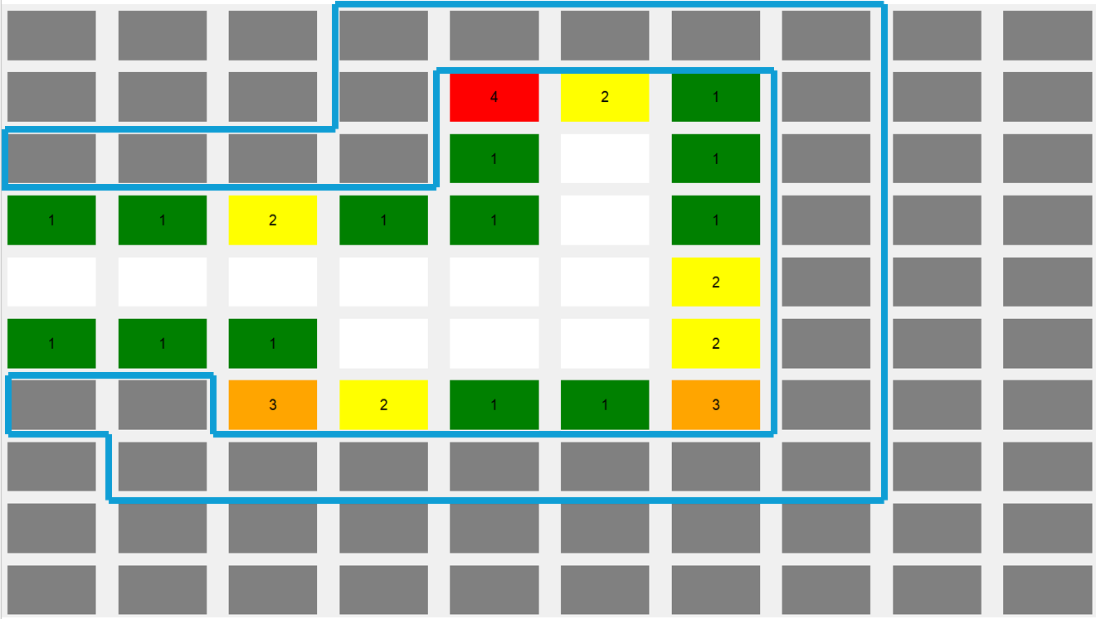
As shown in Figure above, the "blue layer" represents the tiles currently stored in available_place. By isolating these specific coordinates, the Model can rapidly iterate through available data points without processing "dead" tiles (tiles that are completely surrounded) or "hidden" tiles that haven't been reached yet.
The update_places List
The update_places list serves as a Transaction Buffer. Its primary purpose is to decouple the "Calculation Phase" from the "Rendering Phase". Instead of updating the UI every time a single tile is calculated, the Model aggregates all planned changes into this list and pushes them to the View in a single batch.
The Logic: After a user interaction (such as a click), the engine performs all necessary logical checks. Any tile that needs to change state—whether it is revealed, changed to a number, or flagged—is appended to this list.
The Format: Each entry is stored as a triplet: [row, col, value].
Including the value directly in the list allows the Connector to update the View and the Model board simultaneously without performing redundant lookups.
Purpose: This prevents "flicker" in the UI and ensures that the View is always perfectly synchronized with the Model's latest calculations.
By way of illustration:
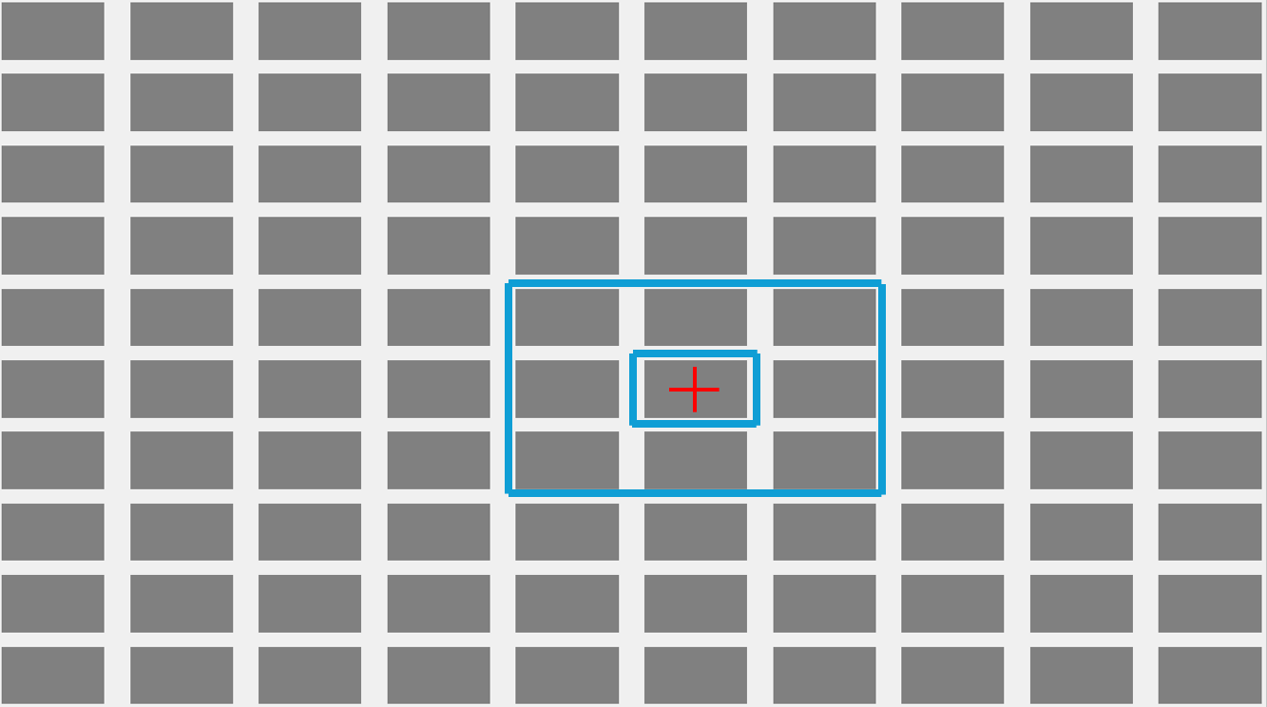
As shown in the figure above, if a player clicks the tile marked with the Red Cross, the engine calculates the impact on all neighbouring tiles. Those specific tiles (highlighted in the Blue Layer) are then added to update_places. Only after this list is populated does the Connector trigger the visual update, ensuring a smooth transition from a hidden state to a revealed numerical state.
The bomb_places List
The bomb_places list serves as the static "Source of Truth" for the board's hidden state. While the 2D grid manages the current interactive state, this 1D list provides an indexed map of every hazard on the board.
The Logic: During the initial board generation phase, the coordinates of every mine are appended to this list.
The Format: Each entry is stored as a coordinate pair: [row, col].
Purpose: Collision Detection: When a user clicks a tile, the engine performs a high-speed check against this list to determine if a "Game Over" state should be triggered.
Termination Reveal: Upon losing the game, the engine iterates through this specific list to instantly render all mine positions in Black, bypassing the need to scan every empty tile on the 2D grid.
Efficiency: By isolating mine coordinates, the Model can calculate proximity numbers for the entire board in a single pass (O(N) where N is the number of mines), rather than checking every single cell.
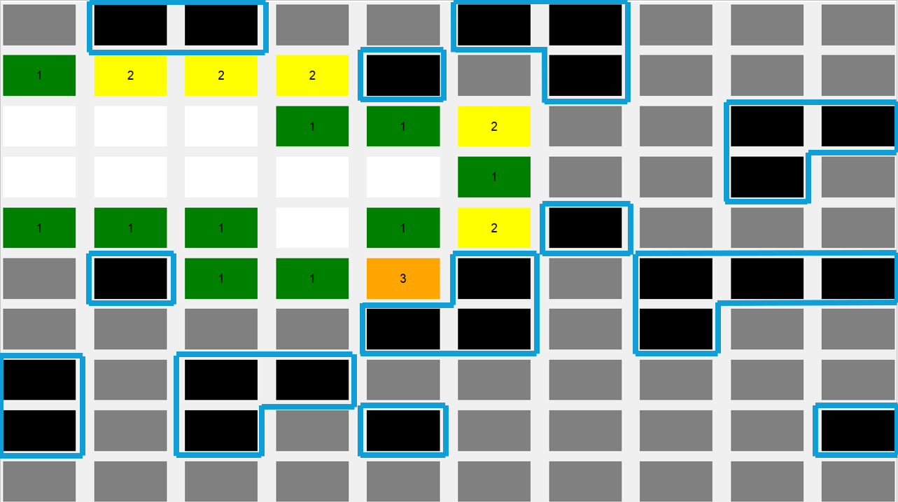
In this figure, we can see this list tracks the location of the bombs which are enveloped by the “Blue Layer”.
    - AI Inference Structures: Probability & Traversal
To facilitate autonomous gameplay, the AI classes, which are present in the Brain.py file, maintains two specialized data structures that allow the AI to move beyond simple pattern matching into Statistical Inference and State Tracking.
The probability_places Map (Risk Assessment)
While a human player might "feel" which tile is safer, the AI requires a quantified approach. The probability_places 1D list serves as the AI's primary decision-making matrix.
Logic: For every coordinate in the available_place frontier, the AI calculates the mathematical likelihood of a mine being present ($0≤p≤1$).
Elimination Process: The AI iterates through this list to identify "Zero-Risk" tiles ($p=0$) to reveal or "Certain-Mines" ($p=1$) to flag.
Fallback Strategy: In scenarios where no logical certainty exists (a "Force-Guess"), the AI queries this list to select the tile with the lowest statistical probability of failure, ensuring the highest possible survival rate during simulations.
For example:
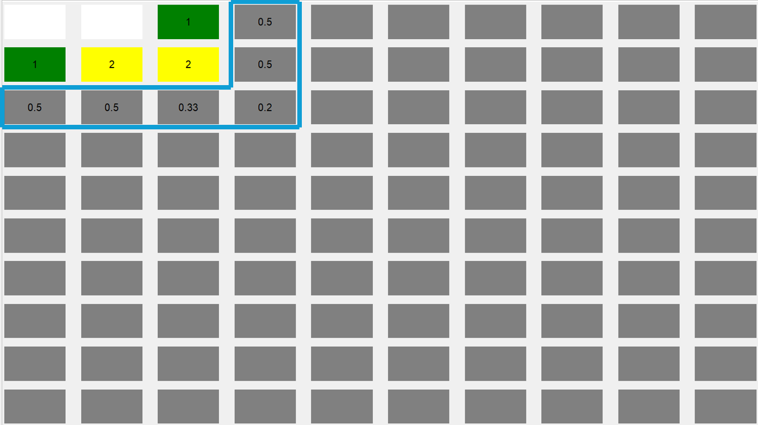
Functional Analysis: As demonstrated in the figure above, the "blue layer" identifies the specific tiles currently stored within the probability_places 1D list.
Dynamic Mapping: Each tile enveloped by this layer has a corresponding numerical weight (probability) assigned to it based on the surrounding revealed numbers.
The Decision Boundary: The AI does not scan the entire board; it focuses its computational resources exclusively on this "envelope".
Prioritization: By isolating these tiles, the engine can quickly sort them by risk. Tiles with a probability of 0 are immediately moved to the update_places list for revealing, while tiles with a probability of 1 are moved to the bomb_places reference for flagging.
The traveled_places Registry (Optimization & Cycle Prevention)
To maintain high-velocity processing in Headless Mode, the AI must avoid redundant calculations. The traveled_places list acts as a Visited Registry.
Infinite Loop Prevention: During complex recursive checks or multi-tile logic chains, this list ensures the AI does not re-enter a logical loop it has already solved.
Double-Process Mitigation: By "marking" coordinates that have already been evaluated in a single decision cycle, the engine saves CPU cycles, allowing for significantly faster simulation speeds in the test.py module.
As an example:
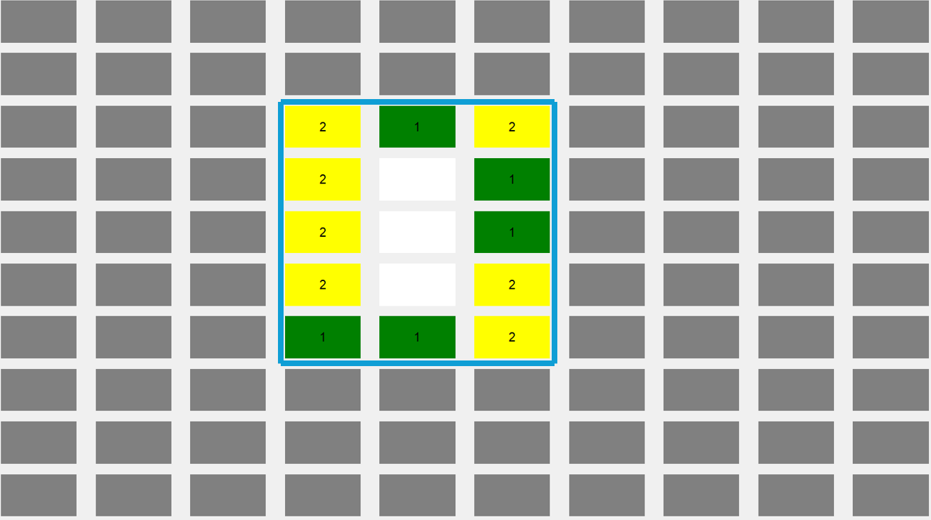
In the figure above, the tiles inside the “blue layer” are being saved in the traveled_places list.
    - The Configuration Layer (values.py)
To ensure the project remains modular and easy to reconfigure, all "Hard-Coded" data is abstracted into a centralized configuration file. This file acts as the single source of truth for the game’s environment and visual identity, divided into two specialized classes.
Class: SettingValues (Environment Control)
This class manages the Simulation Parameters and Game Rules. By modifying these variables, a user can instantly change the difficulty or execution mode of the project:
Grid Dimensions: Defines the N x M scale of the board.
Mine Density: Sets the total number of bombs generated by generate_boards.py.
Execution Mode: Contains a boolean toggle (e.g., HEADLESS_MODE) that determines if the Tkinter GUI should be rendered or if the engine should run high-speed simulations for the AI.
Class: ConstantValues (Visual Assets)
This class is primarily utilized by the View Class to maintain a consistent UI theme. It serves as a Style Sheet for the application:
Numerical Color Mapping: Stores the Hexadecimal or RGB codes for numbers 1–8 (as detailed in the Proximity Scale table).
UI Assets: Defines the colors for the "Flagged," "Exploded," and "Hidden" tile states.

  - Logical Implementation
This section details the dynamic execution flow of the project. The system is entirely Event-Driven; every player interaction triggers a chain of functions that synchronize the internal logic with the user interface.
2.3.1 Interaction Flow: The "Play" Chain
When a player performs a Left-Click, the following sequence is initiated:
View Layer: action_left_click is triggered, which calls retrieve_label_location to identify the specific (row, col) coordinates.
Connector Layer: The coordinates are passed through the Connector.play() method, acting as the bridge to the logic engine.
Model Layer: The Model.play() function determines the game state and routes the request to either the initialization logic or standard gameplay logic.
The First Move Logic
To ensure the "100% Safety" rule, the board is not fully generated until the first click occurs.
State Transition: The is_first flag is toggled to False.
Safe Zone Definition: The clicked tile and its immediate neighbors (Moore Neighborhood) are reserved as "Safe Zones."
Deferred Mine Placement: Only after the safe zone is defined does the engine randomly distribute mines across the remaining valid coordinates in the 2D grid.
Initial Expansion: The recursive_placement (DFS) function is called to clear the starting area, providing the player with their initial data set.
Subsequent Moves & Terminal Logic
If Value = 0: Triggers the recursive_placement algorithm to expand the revealed area.
If Value = 9: Triggers the Terminal State (Loss), stopping the game and initiating the full mine reveal.
The Aftermath: Synchronized Rendering
Throughout the execution of the Model's logic, every changed tile is cached in the update_places transaction buffer. Once the logical calculations are complete, this list is returned to the View. The update_labels function then iterates through this buffer to update the GUI, ensuring the user sees a perfectly synchronized board.
Here is a flowchart which illustrate this process:
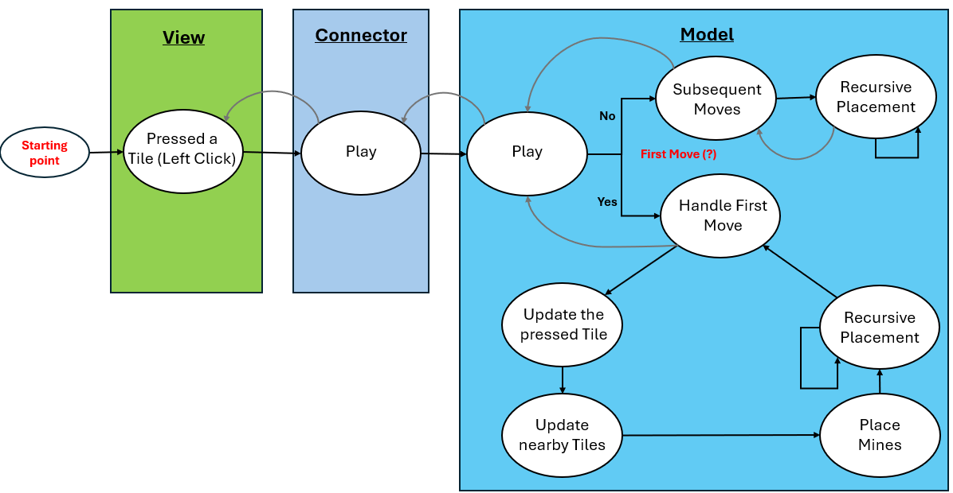

2.3.2 Flagging Logic: “Mark a Bomb”
The flagging system is an essential tactical tool for the player, managed through a Right-Click event. To ensure the integrity of the game state, the engine performs a validation check before any visual change occurs.
Validation & Filtering
Similar to the primary interaction flow, the View retrieves the (row, col) coordinates and passes them to the Connector. The system evaluates the current state of the target tile using the value from the board at that specific coordinate:
The Logic Check: The engine verifies if the tile's current value is 0 (Hidden/Initial State) or 9 (Hidden Mine).
State Filter: If the tile has already been revealed (displaying a proximity number 1–8), the function returns False and ignores the input. This prevents the user from flagging a tile that is already confirmed to be safe.
The Toggle Mechanism
If the validation returns True, the Model executes a Toggle operation:
Marking: If the tile is currently unflagged, it is assigned a value of -1 (Flagged) and added to bomb_places.
Unmarking: If the tile is already flagged, the engine reverts it to its original hidden state (0 or 9) and removes it from the bomb_places list.
Visual Synchronization: The change is appended to the update_places buffer, and the View updates the tile with the "Flag" icon or restores the original tile texture.
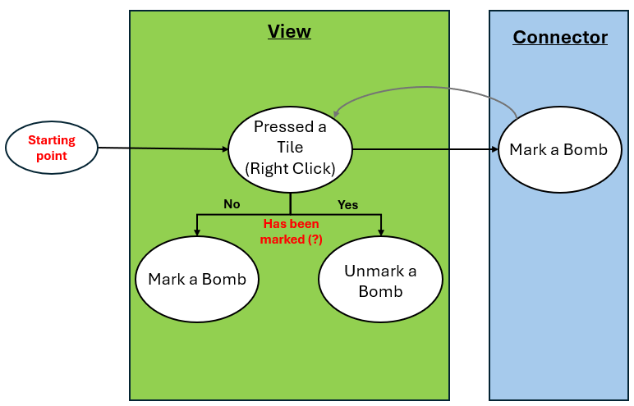
2.3.3 Control Logic: System Commands
To manage the lifecycle of a game session, the interface provides four primary control modules. These functions allow the user to manipulate the Main Loop and the Game State.

Command | Trigger | Logical Impact
End | Button/ CTRL + E | Process Termination: Sends a SIGTERM-style signal to the root.mainloop(), gracefully closing all GUI windows and freeing memory
Restart | Button/ CTRL + R | Hard Reset: Fully terminates the current loop and re-initializes the Model and View classes. This generates a completely new board seed.
Reset | Button | Soft Reset: Clears the current progress and update_places buffer while maintaining the existing root window. It allows for a fast "retry" on a fresh grid.
AI Engagement | Button | Autonomous Play: Switches the Connector focus from user mouse events to the brain.py execution loop.

  - Environment Setup & Execution
To ensure the project runs correctly across different systems, the following environment configuration is required. The project relies on a mix of Python’s Standard Libraries and specialized Data Science packages for the AI simulation.
    - Project Dependencies
Before launching the application, ensure the following libraries are installed in your Python environment:
Library | Type | Primary Purpose
Tkinter | Standard | Graphical User Interface (GUI) and event management.
Pandas | External | High-performance data manipulation for simulation logs.
NumPy | External | Mathematical operations and multi-dimensional array handling.
Openpyxl | External | Engine used by Pandas to export simulation data to Excel (.xlsx).
OS | Standard | File system navigation and directory management for logs.
Math / Random | Standard | Geometric calculations and stochastic mine placement.

    - Execution Guide
There are two primary methods for interacting with the project depending on your objective:
Standard Gameplay (End-User)
Download the project repository to your local directory.
Locate the main.py file.

Execute the file via terminal or command prompt (python main.py). This will automatically initialize the Tkinter window and start the game in Interactive Mode.
Development & Simulation (Advanced User)
For users intending to modify the AI Heuristics in brain.py or run large-scale tests in test.py, it is highly recommended to open the project in a professional IDE (Integrated Development Environment) such as PyCharm or VS Code.
Customization: This allows for real-time debugging and easy modification of the values.py configuration file.
Analysis: Opening the project in an IDE simplifies the process of viewing the generated Excel files immediately after a simulation run.

- The Sandbox & Analytics
Beyond its function as a game, this project serves as a robust Benchmarking Platform designed to evaluate the efficiency of various solving algorithms. By utilizing the "Headless" execution mode, the system transforms into a high-speed data generation engine.
3.1 Algorithm Testing Suite
The testing suite is engineered for large-scale simulations, allowing developers to stress-test AI logic across millions of unique board configurations without manual intervention.
3.1.1 The Test Class & Data Persistence
Managed within test.py, the Test class captures the performance metrics of every simulation batch.
Console Reporting: Real-time results are streamed to the console for immediate monitoring.
Automated Data Export: When IS_TO_SAVE is toggled to True in the SettingValues class, the engine triggers the save_as_a_new_file function.
Dynamic Pathing: To ensure data organization, the system uses Formatted String Literals to automatically generate directory structures based on board dimensions:
Path: Data/Samples/{HEIGHT}X{WIDTH}/
File: {HEIGHT}X{WIDTH}-{BOMBS}.xlsx
3.1.2 Batch Configuration & Stress Testing
The simulation environment is controlled by three primary variables in SettingValues, allowing for complex, multi-stage testing cycles:
NUMBER_OF_TESTS: Defines the sample size per batch (e.g., 10,000 games).
TEST_CYCLE: Determines how many times the entire batch should repeat, allowing for the calculation of mean performance across tens of thousands of games.
STEP: A dynamic incrementor for difficulty. If the STEP is set to 5, each subsequent batch will automatically increase the mine density by 5, allowing for a "stress test" that identifies the exact point where an algorithm's win rate begins to decay.
3.1.3 Performance Optimization (Headless Mode)
To achieve maximum throughput, the project utilizes a Headless Execution strategy.
Bypassing the GUI: By setting is_to_view to False, the engine disables all Tkinter rendering and object instantiation.
CPU Efficiency: This removes the graphical overhead, redirecting 100% of the CPU's computational power to the logical and statistical processing in brain.py. This optimization is what enables the system to process millions of games in a fraction of the time required for standard gameplay.
This is important because as we increase the size of the board by a factor of N, the time complexity will increase as $O(N^{2})$ which reduces performance.
3.2 Different Algorithms
3.3 Statistical Analysis
This section evaluates the performance of the Deterministic Statistical Marker (DSM) algorithm across varying board complexities. The goal of this analysis is to identify the "Breaking Point" of the heuristic—the density at which logical certainty is no longer sufficient to guarantee a win.
3.3.1 The DSM Variable: PB (Percentage of Bombs)
To standardize the difficulty across different board sizes, we utilize the PB Constant:
$$PB= \frac{Total Mines}{Total Grid Area}X 100$$
By using PB instead of raw mine counts, we can compare 10x10 board with 10 mines (PB = 10) directly against a 20x20 board with 40 mines (PB = 10).
3.3.2 Variant: DSM – Start Center (DSM-SC)
As being explained in previous sections in this file, the DSM AI aims to solve the board based on probability elimination and certainty for the placement of bombs or not.
Under this AI there are several different algorithms which vary only by a small part.
Before we continue, we will introduce a new variable under the name PB. This variable represents the percentage of bombs covering the board. For example, if the board is 10x10 and the number of bombs is 10, then PB will be set to 10.
The DSM-SC is a specialized iteration of the core algorithm designed to test the impact of "Initial Information Density".
The Logic: Unlike the standard DSM, which may start at a random coordinate, the SC variant forces the first move to the exact center of the grid.
The Hypothesis: Starting in the center maximizes the "Active Frontier" (available_place) in all four directions, potentially increasing the probability of finding a high-value numerical cluster early in the game.
Comparative Data Analysis
The following diagrams represent the synthesized data from over 10 of millions of iterations. To ensure statistical significance, each data point on the charts is an aggregate of thousands of individual game cycles. According to the Law of Large Numbers, these results provide a highly reliable representation of the algorithm's expected performance in a real-world environment.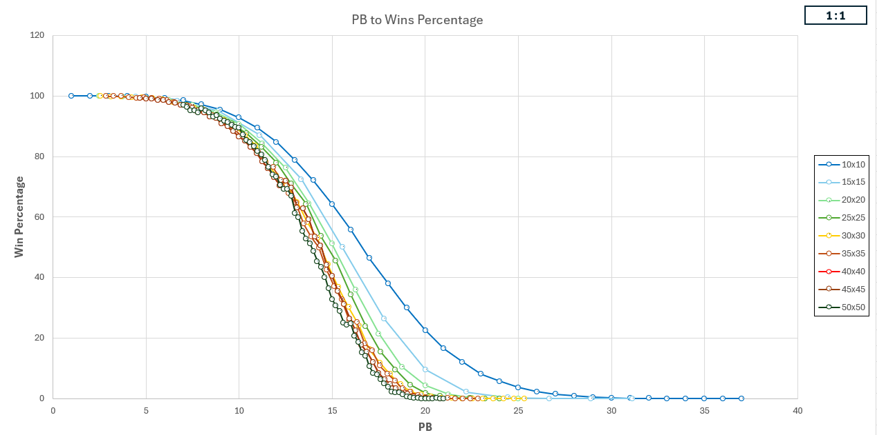

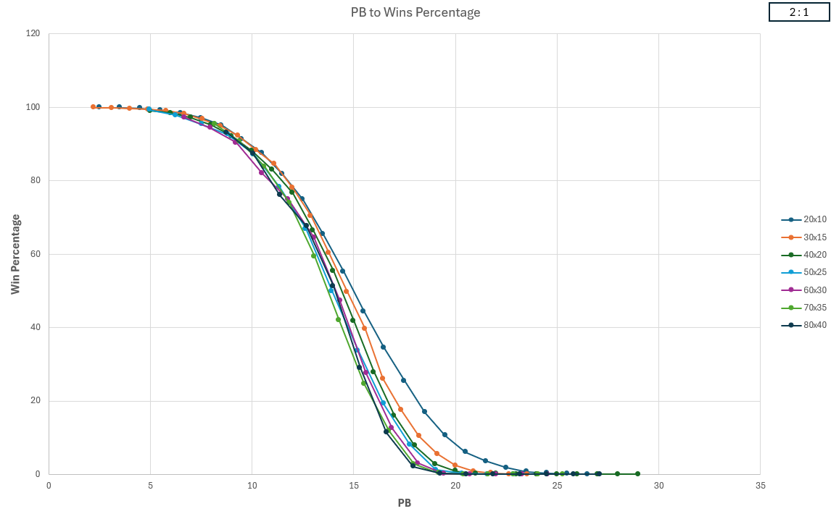
Correlation Analysis: Density, Scale, and Geometry
The data from our multi-million iteration simulations reveals three distinct correlations that define the limits of the DSM-SC algorithm.
- The Density Threshold (PB Sensitivity)
The most aggressive variable in determining success is the Percentage of Bombs (PB).
- High-Reliability Zone ($PB≤7$): The algorithm maintains a success rate above 90%. At this density, the logical "frontier" is expansive enough that the AI rarely encounters a situation requiring a non-deterministic move.
- The Failure Cascade ($PB≥25$): Once density reaches 25–30%, the win rate collapses to below 10%. This suggests a mathematical "Phase Transition" where the board state becomes dominated by localized clusters that provide zero logical certainty.
- The Scale Factor (Board Dimensions)
Interestingly, the data shows that Size and Density are not independent variables.
- Cumulative Risk: Under a constant PB, increasing the total number of tiles significantly decreases the win rate.
- The Reasoning: Larger boards naturally contain a higher volume of "isolated logic pockets." Since the AI only needs to fail a single guess to lose the entire game, the probability of a perfect run decreases exponentially as the total number of required decisions increases.
III. Geometric Constraints (Aspect Ratio)
One of the most nuanced insights discovered during testing is the impact of board shape on the AI's efficiency.
The 1:1 Parity Advantage: Boards with a 1:1 Height-to-Width ratio consistently outperform rectangular boards (such as 2:1 ratio).
Edge Effects: On a square board, the AI can expand the "Active Frontier" more uniformly. On elongated boards, the AI is more likely to be "cornered" against a boundary early in the game, which limits the number of neighbours available for statistical elimination.

3.3.3 Variant: DSM – Start Edge (DSM-SE)
The DSM-SE variant serves as the structural "control group" for our starting position experiments. By forcing the algorithm to begin in the Top-Left Corner (0, 0), we limit the initial "Active Frontier" to a maximum of 3 neighbors, rather than the 8 available in the center.
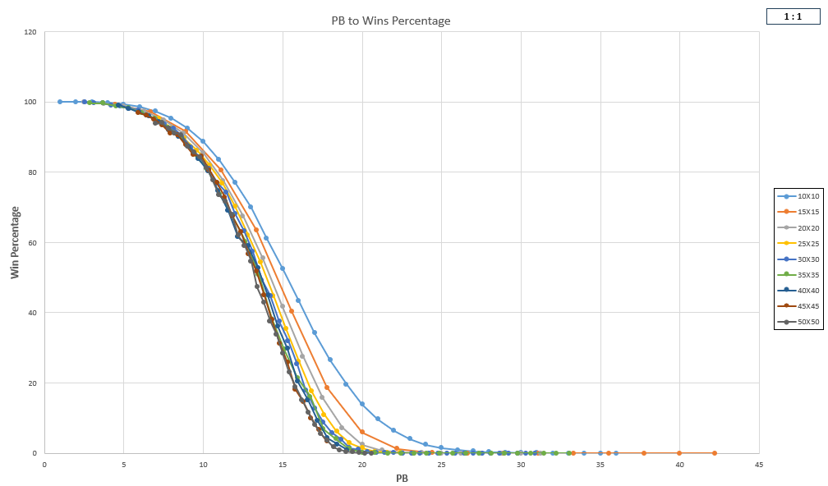

Comparative Data Insights
The data retrieved from the DSM-SE simulations reveals a distinct performance gap when compared to the DSM-SC:
- Information Scarcity: The Start-Edge approach consistently results in a smaller initial "Zero-Tile" expansion. This forces the AI to transition into the Probability Elimination phase earlier in the game, increasing the risk of an early-game failure.
- The "Cornering" Effect: Statistically, starting at the edge leads to a higher frequency of Dead-End Logic, where the AI's frontier is bounded by the board's limits on two sides. This reduces the number of overlapping constraints the AI can use to calculate certainty.
- Win Rate Variance: While the win rate remains stable at very low PB, the DSM-SE variant shows a lower success rate than the DSM-SC as density increases or board size.

