**CHAPTER 1 – INTRODUCTION**

* 1. **Problem Definition**

When customers visit shopping malls they are usually confused about the shops present in the mall, where they can find a particular product and what not. In this project, we will be designing a simple mall management system. The mall will provide a soothing shopping experience for customers, provide mall management functions to mall administrators and the customers.

The proposed system allows a customer to select an item from the clothes and electronics sections based on the search he provides. The customer can also view he cart, delete items from the cart and proceed for payment which makes the customer convenient to buy items as in when they require.

* 1. **Scope**

Mall Management System make the life of customers very easy as they don’t need to wait search for the required item in each shop in the mall and wait for long queues during the billing session .On the other hand the Management Department of the mall finds it easier to keep track of each item and customer details. It also can enhance its mall system by using a feedback .With the help of this System the customer can view all the item details and check for its availability. The admin can add items when the stock is over. An email is ‘sent to the user as after shopping in the mall

**CHAPTER 2 –Software Requirement Specification**

1. **Functional Requirements**

**Administrator Module**: In this module we can do the following:

* + - Admin should be able to insert an item based on the department.
    - Admin can delete any item he doesn’t want to keep it in the mall.
    - Admin can view all the items based on the departments.
    - Admin can view the customer details and their feedback

**Customer Module:** In this module we can do the following:

* + - The customer can select which department he wants the item from.
    - The customer can search for a specific item.
    - The customer can customize the settings of the application based on his/her requirements.
    - The customer can add an item to the cart.
    - In the cart he can delete the item and increment its quantity.
    - He can then preview his purchases and pay the amount.
    - Customer gets an email regarding his purchase.

1. **Software Requirements**

**Operating Systems:** Windows 7 or higher **Languages**: JAVA,PL/SQL

**Database:** Oracle Database 11g Express Edition

**IDE:** NetBeans IDE 8.2

1. **Hardware Requirements**

Installed Memory (RAM):2GB or higher

Processor:1Ghz or higher

Hard Disk space: 20GB or higher

Display: Standard output Display

**CHAPTER 3 – SYSTEM DESIGN**

1. **ER Model**

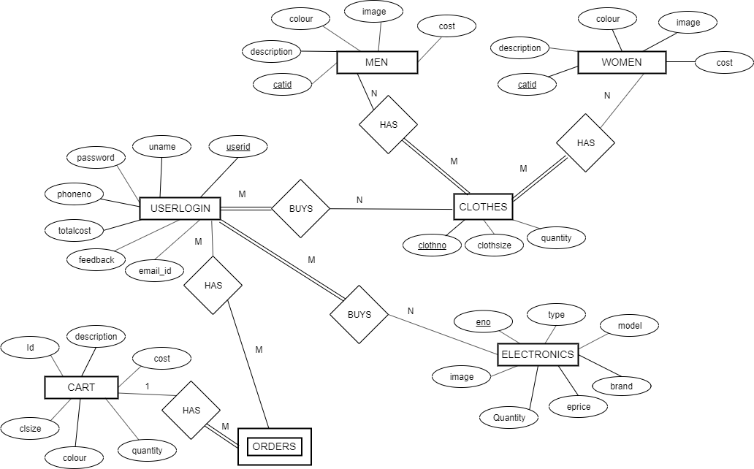

**Fig. 3.1: ER Diagram**

1. **Schema Diagram**

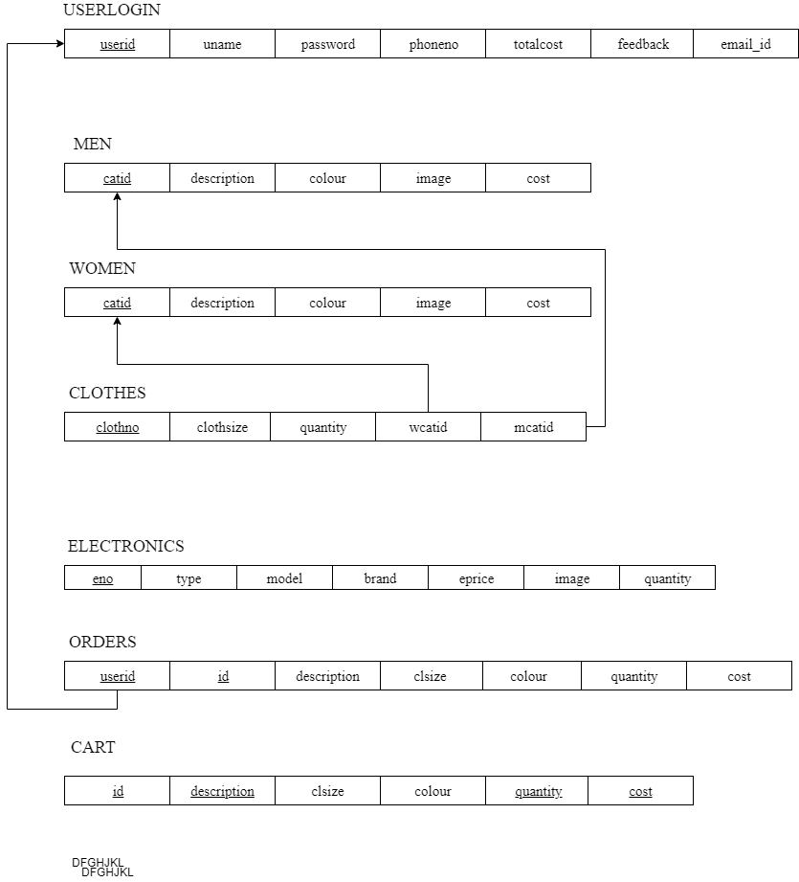

**Fig. 3.2: Schema Diagram**

1. **Tables Description**

Table 3.1: USER LOGIN

|  |  |  |  |
| --- | --- | --- | --- |
| **Attributes** | **Data type** | **Constraints** | **Description** |
| USERID | NUMBER(4,0) | Primary Key | Unique user ID |
| UNAME | VARCHAR2(20) | NOT NULL | Name of the user |
| PASSWORD | VARCHAR2(20) | NOT NULL | Password for login |
| PHONENO | VARCHAR2(20) | NOT NULL | Phone number of the user |
| FEEDBACK | NUMBER(1,0) |  | Feedback given by the user |
| TOTALCOST | NUMBER(10,2) |  | Total cost of the user during a purchase |
| EMAIL_ID | VARCHAR2(30) |  | Email address of the user |

Table 3.2: MEN

|  |  |  |  |
| --- | --- | --- | --- |
| Attributes | Data type | Constraints | Description |
| CATID | VARCHAR2(10) | Primary Key | Category ID for the Category |
| DESCRIPTION | VARCHAR2(20) | NOT NULL | Description of the item |
| COLOUR | VARCHAR2(20) |  | Color of the item |
| IMAGE | VARCHAR2(100) |  | Image path of the item |
| COST | NUMBER(7,2) | NOT NULL | Cost of the item |

Table 3.3: WOMEN

|  |  |  |  |
| --- | --- | --- | --- |
| Attributes | Data type | Constraints | Description |
| CATID | VARCHAR2(10) | Primary Key | Category ID for the Category |
| DESCRIPTION | VARCHAR2(20) | NOT NULL | Description of the item |
| COLOUR | VARCHAR2(20) |  | Color of the item |
| IMAGE | VARCHAR2(100) |  | Image path of the item |
| COST | NUMBER(7,2) | NOT NULL | Cost of the item |

Table 3.4.CLOTHES

|  |  |  |  |
| --- | --- | --- | --- |
| Attributes | Data type | Constraints | Description |
| CLOTHNO | VARCHAR2(10) | Primary Key | Unique Cloth Number |
| CLOTHSIZE | CHAR(1) | NOT NULL | Size of the Cloth |
| QUANTITY | NUMBER(3,0) | NOT NULL | Quantity of the Clothes |
| WCATID | VARCHAR2(10) | References WOMEN(CATID)  On delete cascade | Category ID of the Cloth |
| WCATID | VARCHAR2(10) | References MEN(CATID)  On delete cascade | Category ID of the Cloth |

Table 3.5: ELECTRONICS

|  |  |  |  |
| --- | --- | --- | --- |
| Attributes | Data type | Constraints | Description |
| ENO | VARCHAR2(10) | Primary Key | Electronic No for the Item |
| TYPE | VARCHAR2(20) | NOT NULL | Type of the item |
| MODEL | VARCHAR2(30) | NOT NULL | Model of the item |
| BRAND | VARCHAR2(30) | UNIQUE | Brand of the item |
| EPRICE | NUMBER(7,2) | NOT NULL | Cost of the item |
| QUANTITY | NUMBER(3,0) | NOT NULL | Quantity of the item |
| IMAGE | VARCHAR2(100) | NOT NULL | Image of the item |

Table 3.6: CART

|  |  |  |  |
| --- | --- | --- | --- |
| Attributes | Data type | Constraints | Description |
| ID | VARCHAR2(10) | NOT NULL | ID for the Item |
| IMAGE | VARCHAR2(100) | NOT NULL | Image of the item |
| DESCRIPTION | VARCHAR2(100) | NOT NULL | Description of the item |
| CLSIZE | CHAR(1) |  | Size of the Cloth |
| COLOUR | VARCHAR2(20) |  | Color of the cloth |
| QUANTITY | VARCHAR2(100) | NOT NULL | Quantity of the item |
| COST | NUMBER(3,0) | NOT NULL | Cost of the item |

Table 3.7: ORDERS

|  |  |  |  |
| --- | --- | --- | --- |
| Attributes | Data type | Constraints | Description |
| USERID | NUMBER(4,0) | References USERLOGIN(USERID)  On delete cascade | Unique Id for the user |
| ID | VARCHAR2(10) | NOT NULL | ID for the Item |
| IMAGE | VARCHAR2(100) | NOT NULL | Image of the item |
| DESCRIPTION | VARCHAR2(100) | NOT NULL | Description of the item |
| CLSIZE | CHAR(1) |  | Size of the Cloth |
| COLOUR | VARCHAR2(20) |  | Color of the cloth |
| QUANTITY | VARCHAR2(100) | NOT NULL | Quantity of the item |
| COST | NUMBER(3,0) | NOT NULL | Cost of the item |

**CHAPTER 4 – IMPLEMENTATION**

**4.1 Implementation Of Trigger**

**Description:** Deletes the Cart table when totalcost is updated in the USERLOGIN table

**Trigger Event:** DELETE

**Trigger action:** Deletes the cart table

create or replace trigger "TRIGG" after

update of "TOTALCOST" on "USERLOGIN" for each row

DECLARE

begin

EXECUTE IMMEDIATE 'delete from cart'; end;

1. **Implementation Of Trigger**

**Stored Procedure Name:** CALCULATETOTAL

**Description:** This procedure calculates the total by multiplying quantity with cost from CART table and UPDATES the TOTALCOST in the USERLOGIN table .

CREATE OR REPLACE PROCEDURE "CALCULATETOTAL"(UID IN NUMBER)

IS

CST CART.COST%TYPE;

QUAN CART.QUANTITY%TYPE;

TCST NUMBER(10,2);

CURSOR CT IS

SELECT COST,QUANTITY FROM CART;

BEGIN OPEN CT;

TCST:=0;

LOOP

FETCH CT INTO CST,QUAN;

EXIT WHEN CT%NOTFOUND;

TCST:=TCST+CST*QUAN;

END LOOP;

UPDATE USERLOGIN

SET TOTALCOST=TCST WHERE USERID=UID;

CLOSE CT;

END

**CHAPTER 5 – SCREENSHOTS**

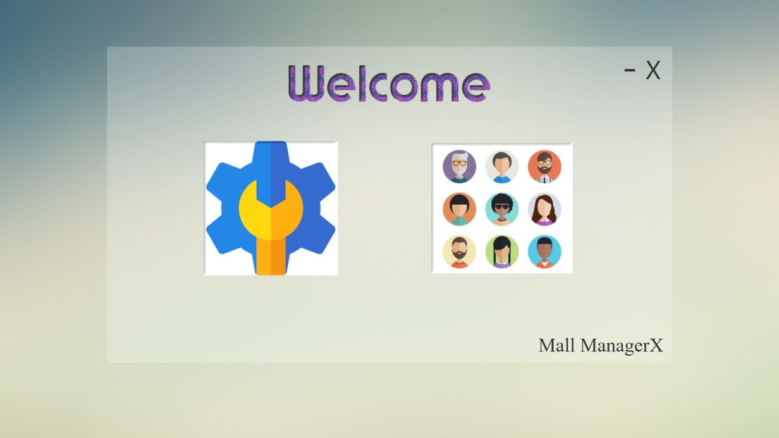

**Fig. 5.1: Home Page**

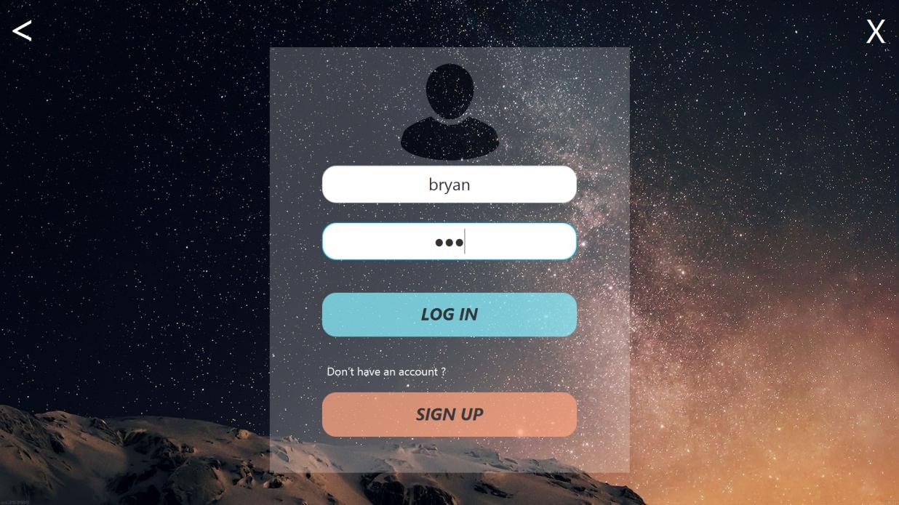

**Fig. 5.2: User Login Window**

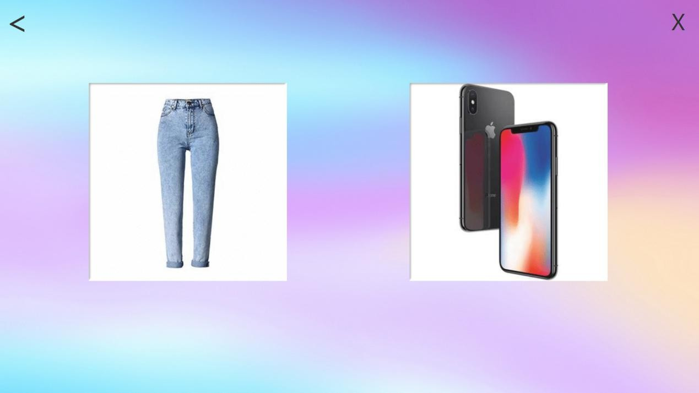

**Fig. 5.3: User Selection Window**

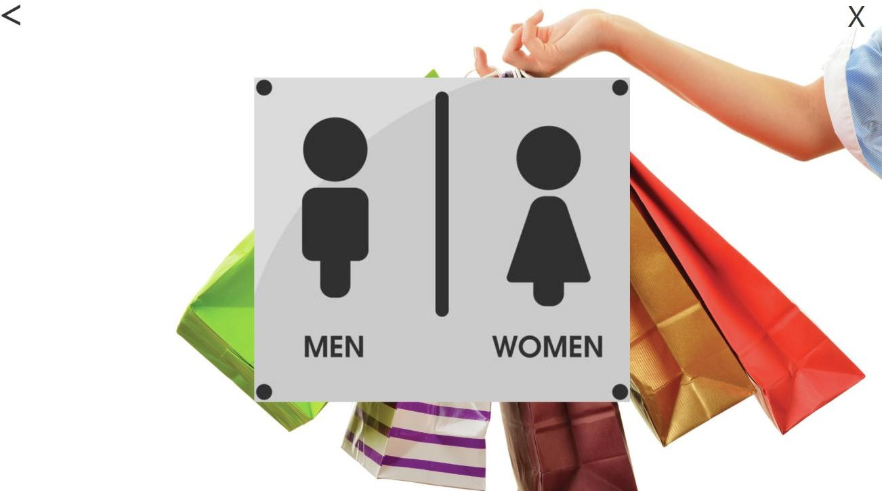

**Fig. 5.4: Clothes Men-Women Selection Window**

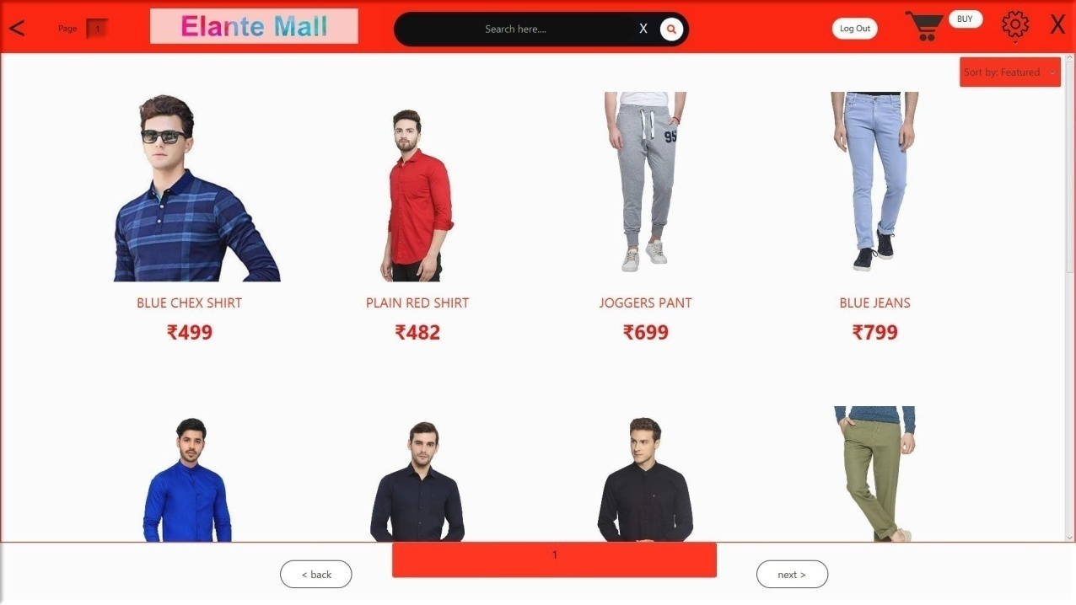

**Fig. 5.5:Men’s Clothes Window**

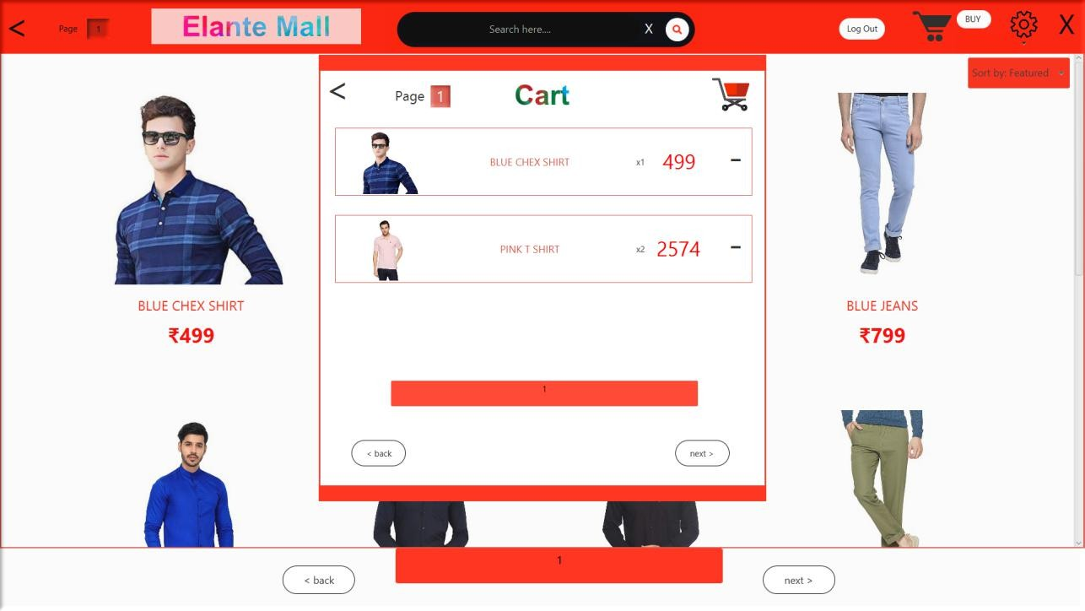

**Fig. 5.6: User Cart**

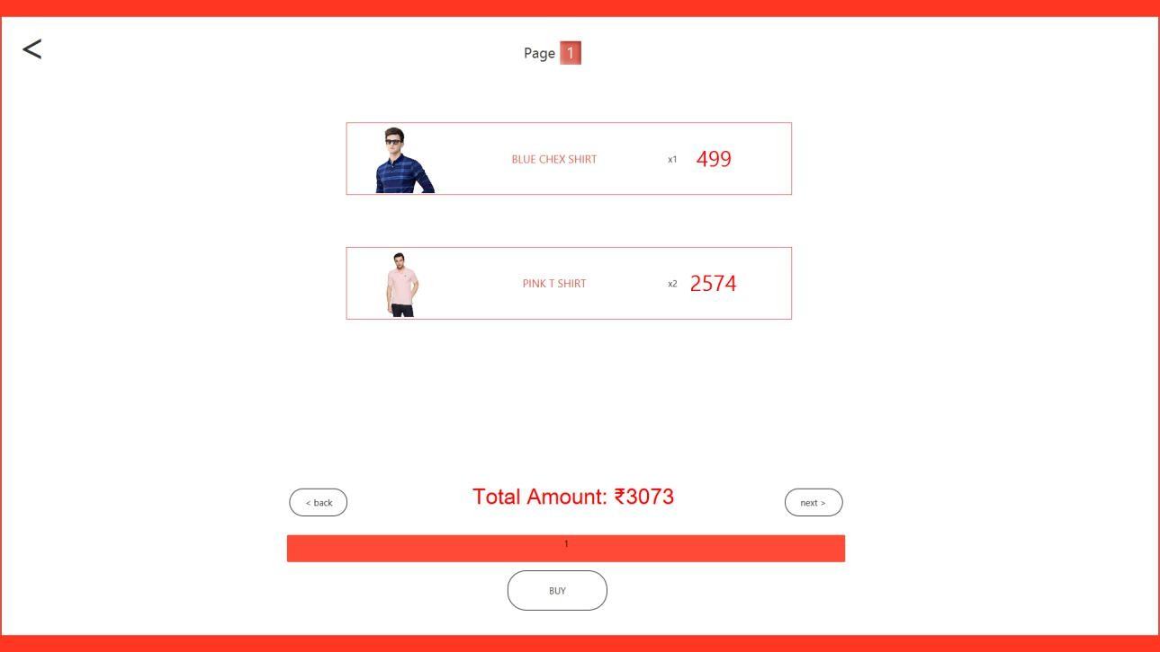

**Fig. 5.7: Buy Item Window**

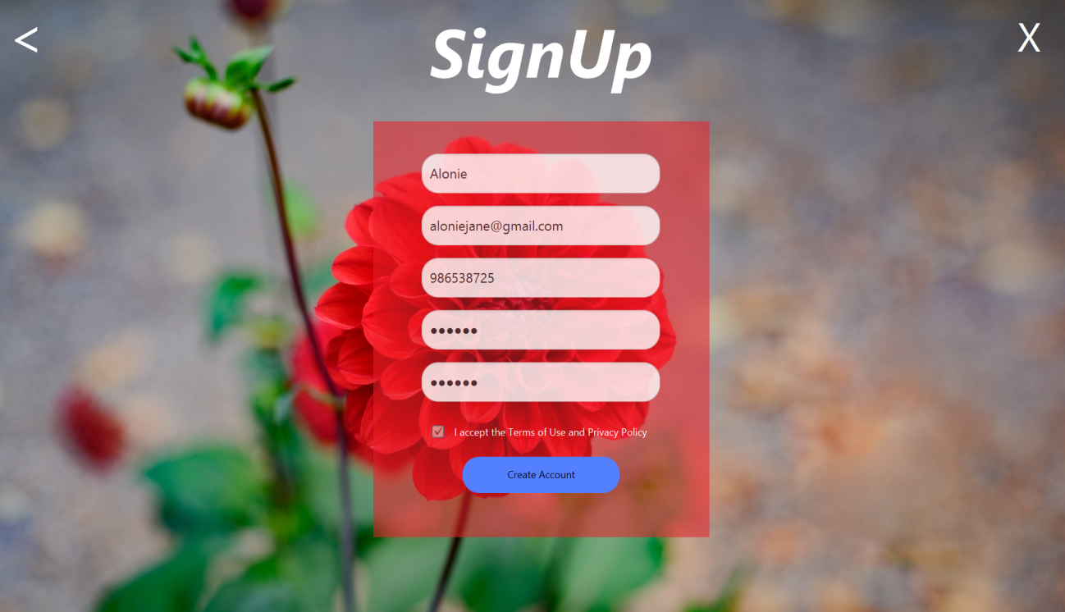**Fig. 5.8: SignUp Window**

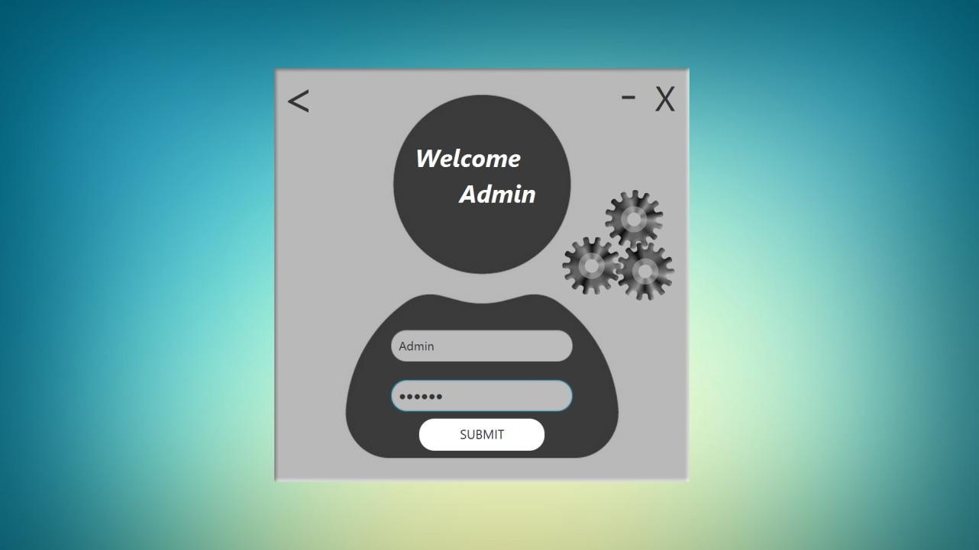

**Fig. 5.9: Admin Login Window**

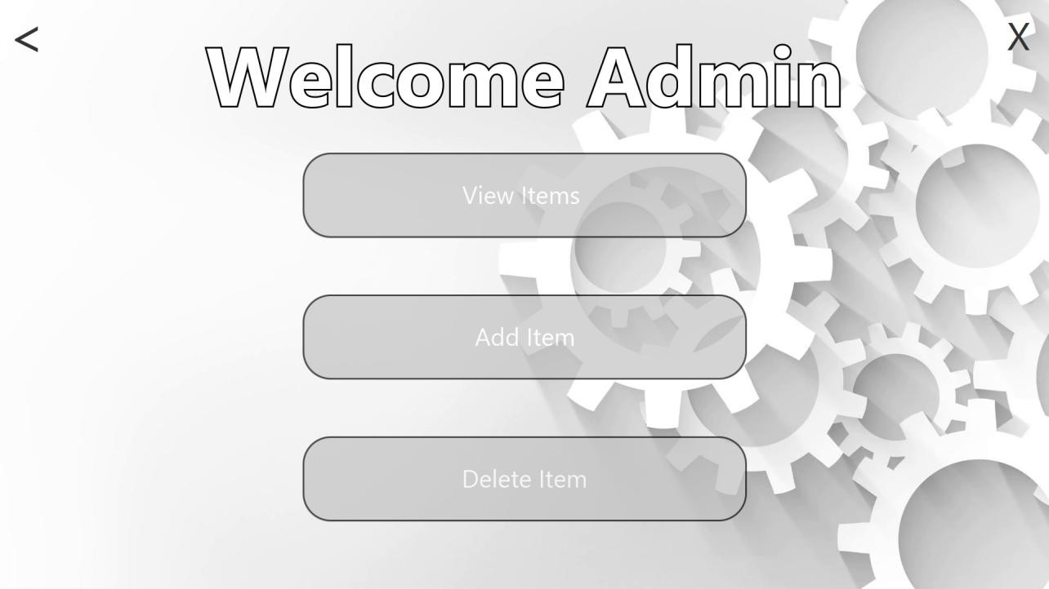

**Fig. 5.10: Admin Selection Windo**

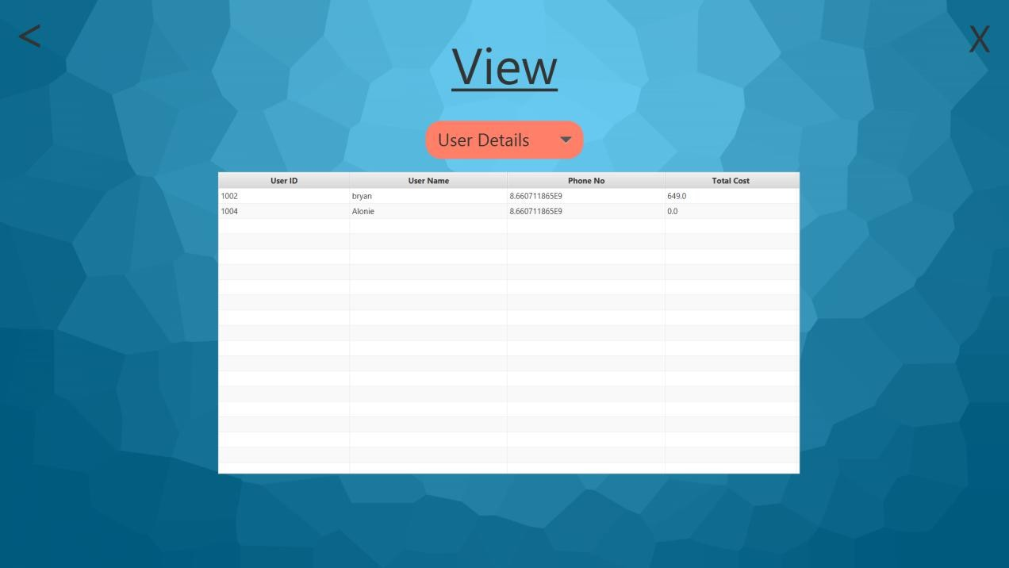

**Fig. 5.11: View Database**

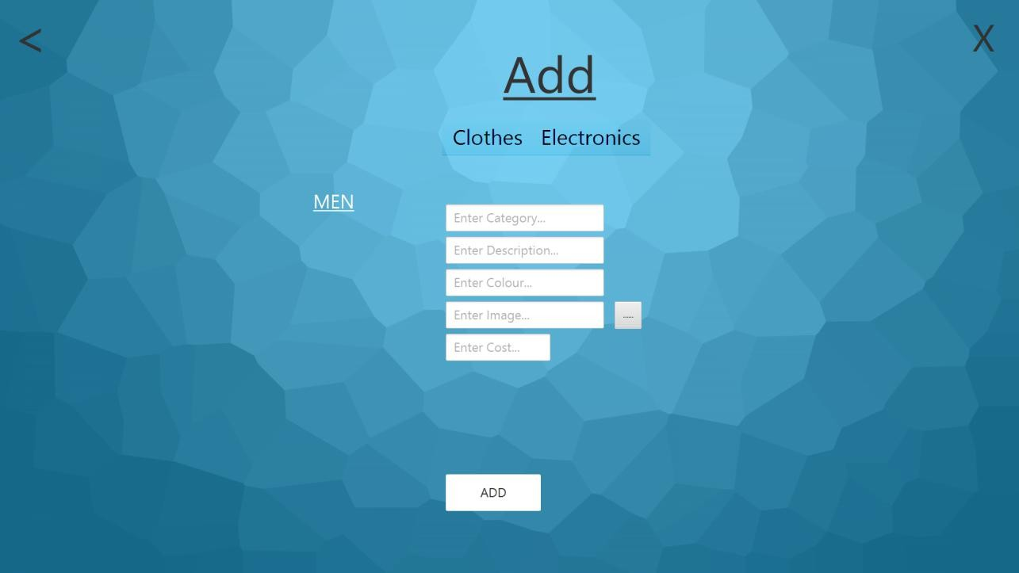

**Fig. 5.12: Add Into Men**

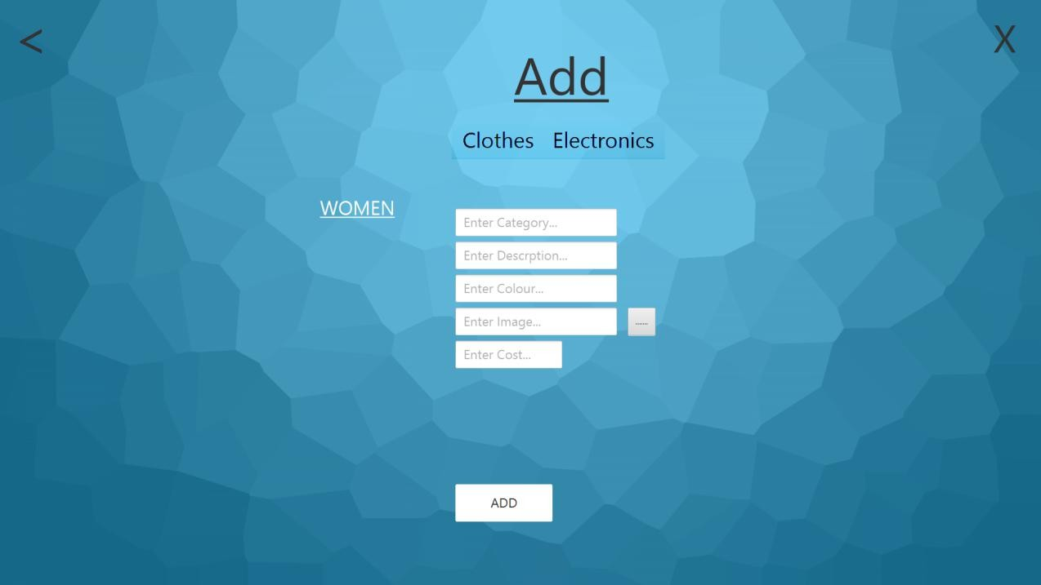

**Fig. 5.13: Add Into Women**

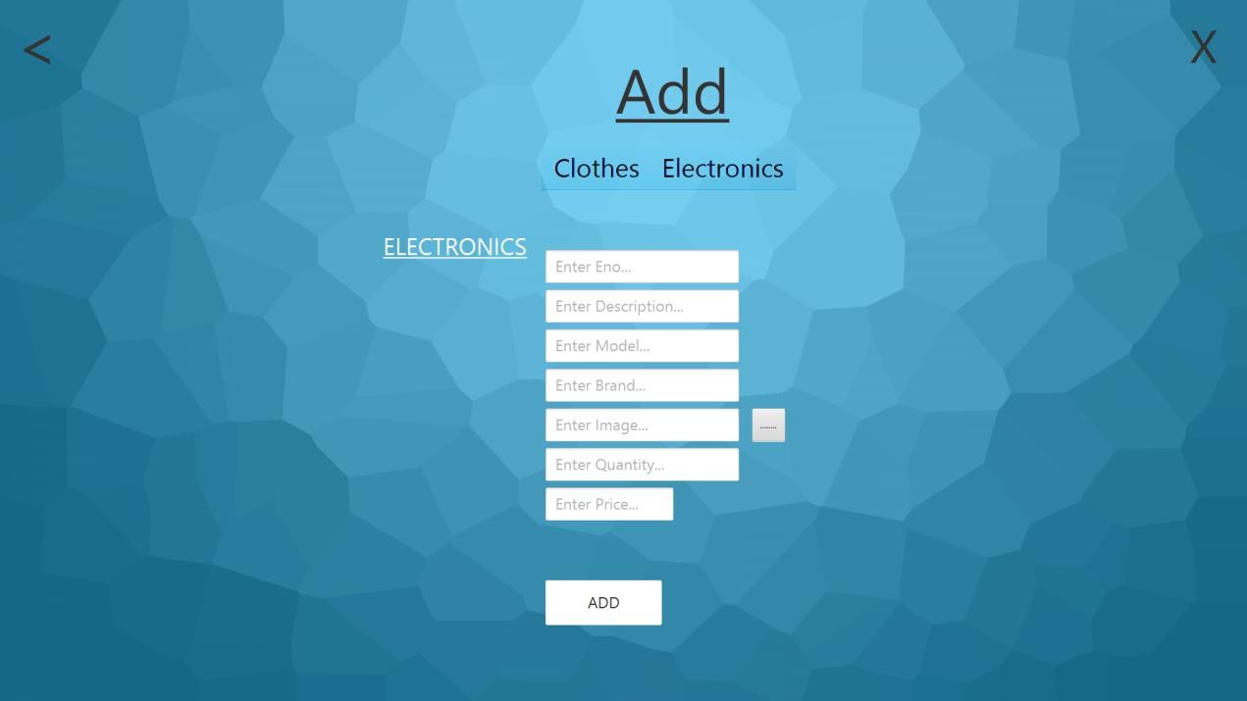

**Fig. 5.14: Add Into Electronics**

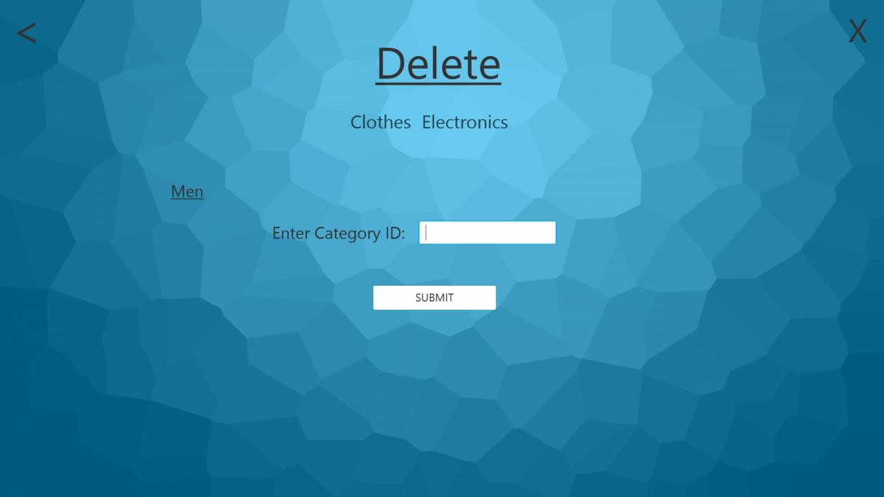

**Fig. 5.15: Delete From Men**

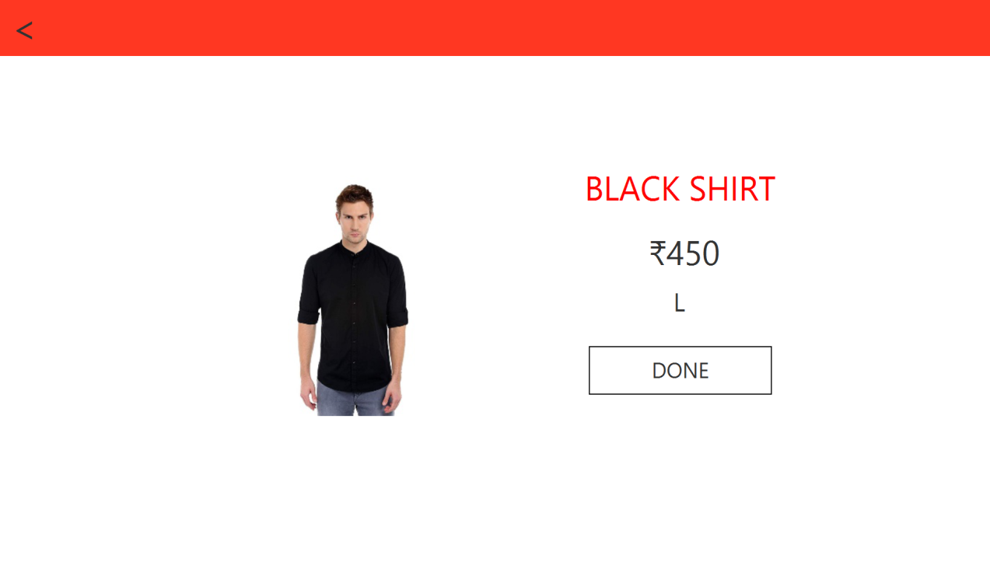

**Fig. 5.16: Buy Now Window**

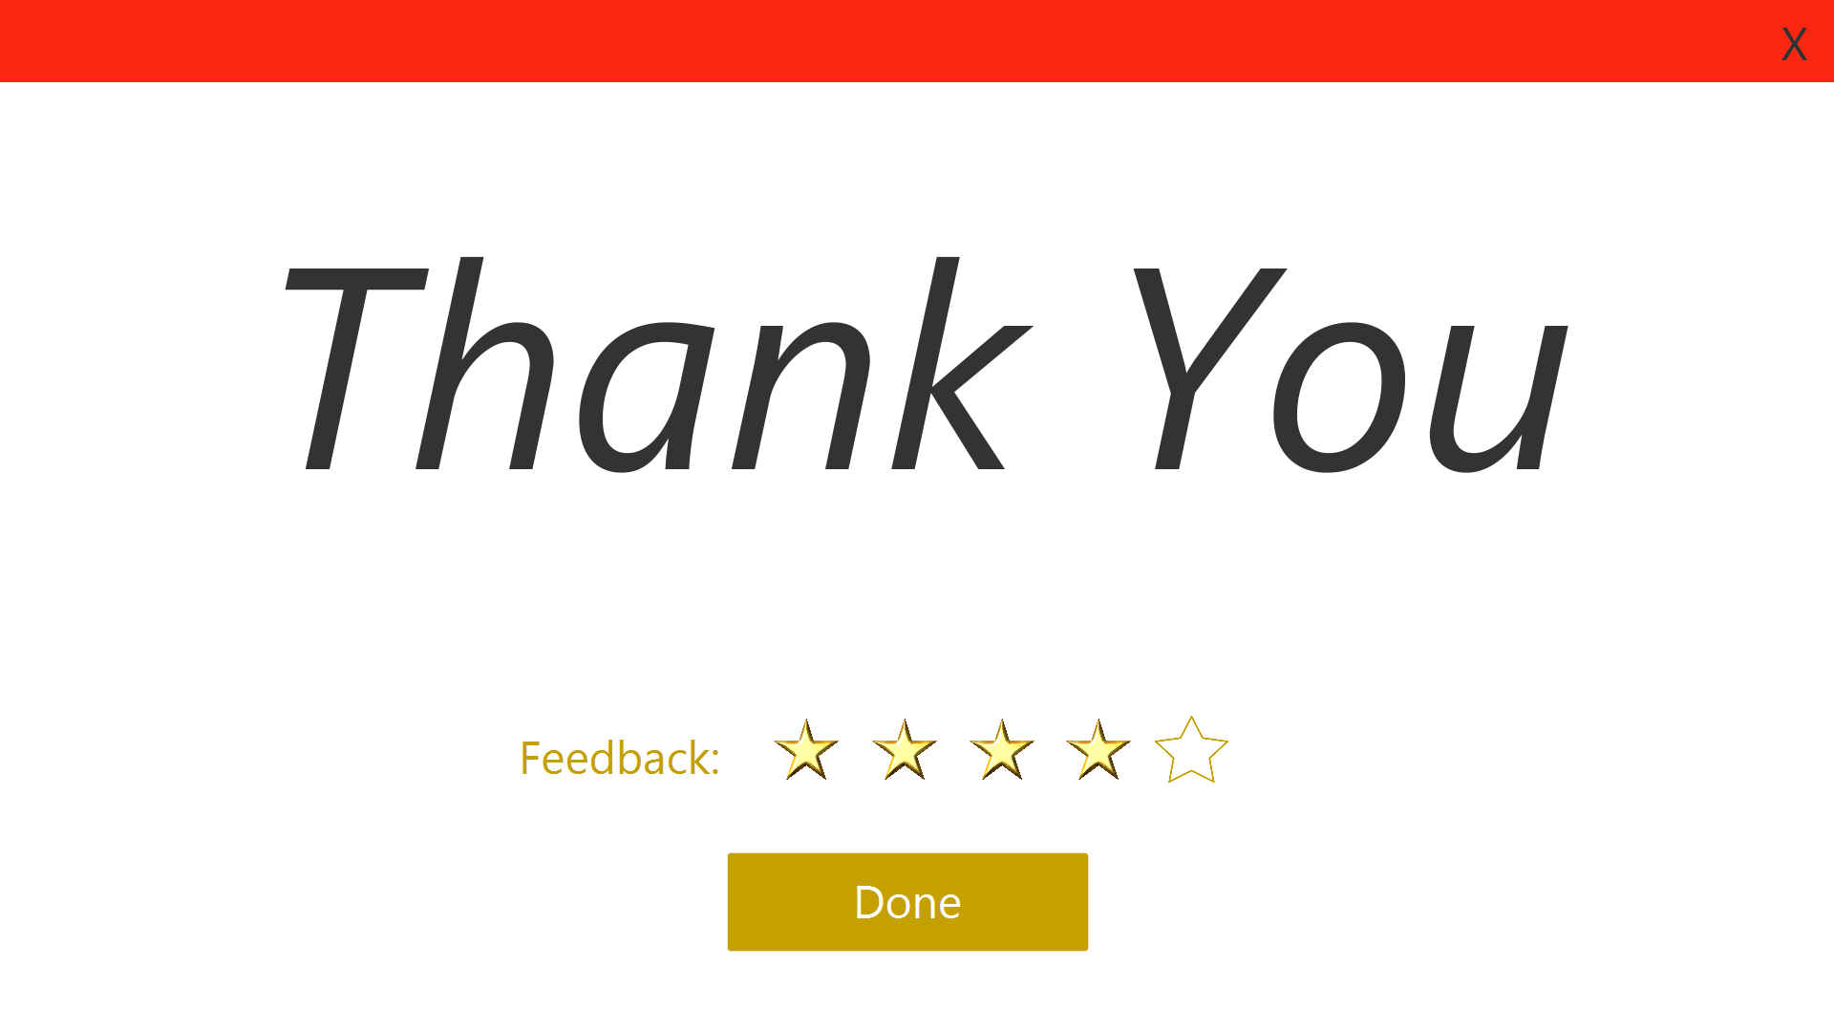

**Fig. 5.17: Thank You Window**

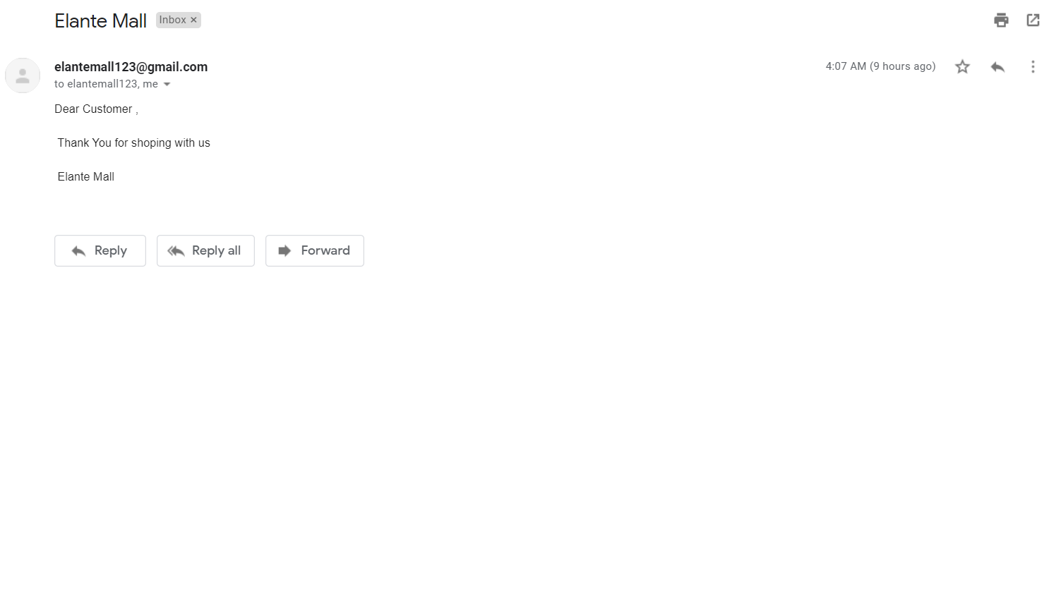

**Fig. 5.18: Email Received**

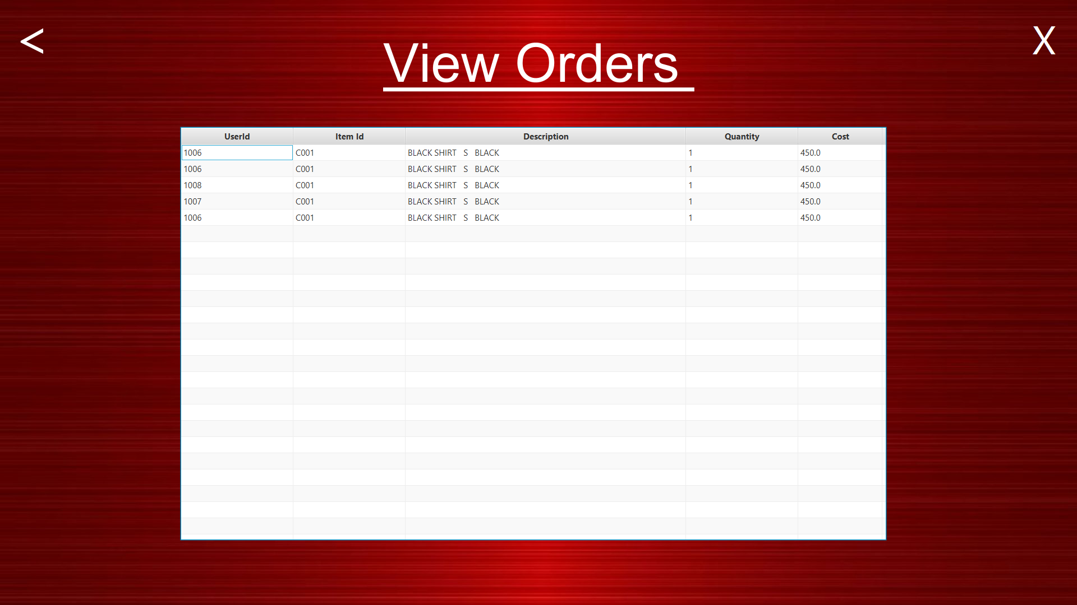

**Fig. 5.19: View Orders Window**

**CHAPTER 6 – CONCLUSION and FUTURE WORK**

Mall Management System aims to provide its customers with an efficient, convient and hassle free shopping experience. Elamate Mall allows its customers to view information of different items and add it to their cart.

We plan to accommodate Entrainment features like Cinema and food picking systems so that the customer can have a wonderful shopping experience. We also plan to convert our desktop application to mobile/web application.

**REFERENCES**

1. Ramez Elmasari Shamkant and B.Navathe, “Database System Models,Languages design and Application Programming”,Pearson,7th Edition.
2. Ramakrishna and Gehrke,Database Management Systems,McGraw Hill 3rd edition 2014
3. Herbert Schidt,JAVA the complete Reference,Tata McGraw Hill 7th Edition,2007
4. Youtube(<https://www.youtube.com/>)
5. Google(<https://www.google.com/>)