**

**Get Ready for your arrival**

### **Check-In**

**Check-in Time:** 3:00 PM  
Check-in must be done at the confirmed time. If you arrive earlier without confirmation, you won't be able to access since the automatic lock code won't work until the scheduled time.

**Early Check-in:**

If you need access before the defined time on Airbnb, please write to us at least 48 hours in advance. We allow one hour of early check-in for free. After that, a charge of $130 MXN per additional hour will apply to compensate the staff's effort in preparing the space. Please do not plan an early arrival without prior confirmation.

**Access Code and Instructions:**

We will provide you with your access code on the day of your arrival. If you don't have it before arriving at the building, contact us immediately to provide it and avoid inconvenience at the time of your arrival.

### **Check-Out**

We allow up to one and a half hours after the check-out time. Notify us if you plan to leave late as the cleaning staff arrives at check-out time.

**Check-Out Instructions:**

* Close windows and blinds.
* Do not leave dirty dishes.
* Do not leave food in the refrigerator.
* Do not make the beds; we will take care of the linen change.
* Place towels in the blue basket.
* Take out the trash and place it in the containers in the parking lot, ensuring you use the one for tower F. It is located down the stairs to the left upon exiting the building.
* Do not leave personal items. If you forget something, we will keep it for two days before discarding it.

### 

### 

### 

### **Offered Amenities**

**Bathroom:**

* Towels (Body, Face, Hair, Makeup - black towels)
* Shampoo, body lotion, and soap kit
* Two rolls of toilet paper
* Cotton swabs
* Cotton pads
* Earplugs
* Hairdryer

**Kitchen:**

* Paper towels
* Dish soap
* Oil
* Multi-capsule coffee maker and ground coffee
* Nespresso capsules
  + Dolce Gusto capsules
  + Salt and pepper
  + Paper napkins
* Blender, basic kitchen utensils

**Bedrooms:**

**Master Bedroom:**

* Sheets
* Duvet
* Pillows
* Desk
* Monitor
* Lamp

**Secondary Bedroom:**

* Sheets
* Duvet
* Ironing board
* Iron

**Laundry Area:**

* Washer-dryer
* Soap capsules or powder detergent
* Fabric softener
* Cleaning supplies (broom, dustpan, floor cleaner, mop, and wringer bucket)

**Living and Dining Room:**

* Alexa
* TV
* Fan
* Sofa bed
* Duvet and cushions

**Kitchen:**

* **Coffee Maker:** It is multi-capsule, so you can use it for Nespresso, Dolce Gusto, or ground coffee. We will provide the capsules.
* **Stove:** **Avoid setting the flame to the minimum as it turns off due to gas pressure.** Up to medium flame does not affect its operation. We are working on its repair.
* **Purifying Jug:** You can use it as needed. The filter life indicator is active.
* **Ice Machine:** Add water to the maximum level, and it will make ice every 9 minutes.

**Laundry Area:**

* **Washer-Dryer:** It has pre-programmed cycles. Select the one that suits your needs. It has a 9 kg capacity.

### **House Rules**

* Pets are allowed but must be registered. Maintain your responsibility as an owner.
* Parties are not allowed. The condominium has rules about quiet hours.
* Smoking is not allowed in the accommodation, not even on the balcony.
* Quiet hours: 8 PM to 8 AM.
* Maximum of 4 registered guests for safety reasons.
* If something breaks or gets damaged, let us know. Usually, there are no charges for small items, but it is important that you inform us.

### **Coffee Selection**

**National:**

* **Punta del Cielo Coffee:** Choosing Punta del Cielo coffee means selecting high-quality coffee grown in the best regions of Mexico with a distinctive flavor and sustainable practices that support local communities. The brand combines tradition and innovation to offer an authentic and modern experience, celebrating Mexico's coffee heritage and guaranteeing a premium product.

**Nespresso Capsules:**

* Oaxaca Coffee
* 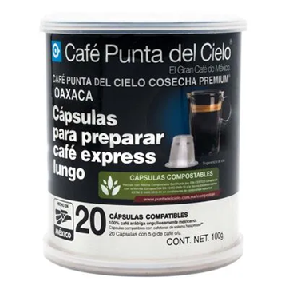

**Dolce Gusto Capsules:**

* Cappuccino (uses two capsules: one for milk and one for coffee)
* Americano
* 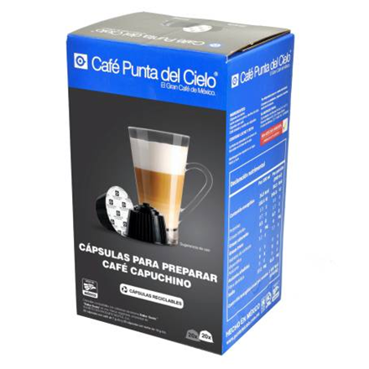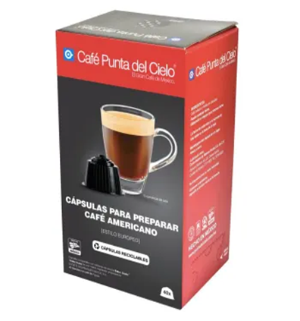

**Ground Coffee:**

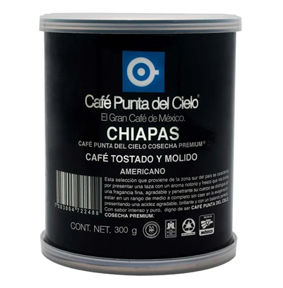

**American Brands:**

* **Starbucks Pike Place Coffee:** Starbucks Pike Place coffee is balanced and accessible with a smooth flavor profile that includes cocoa and roasted notes, moderate acidity, and medium body. Its medium roast highlights the natural flavors of the bean. It is known for its consistency and pleasant aroma.

