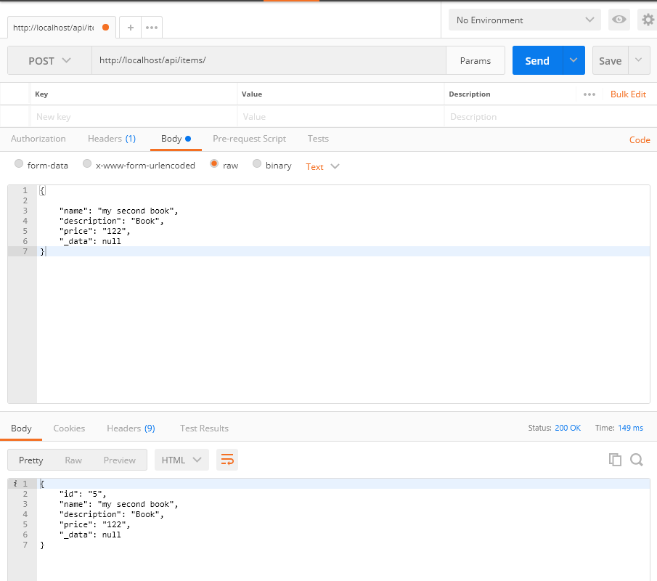

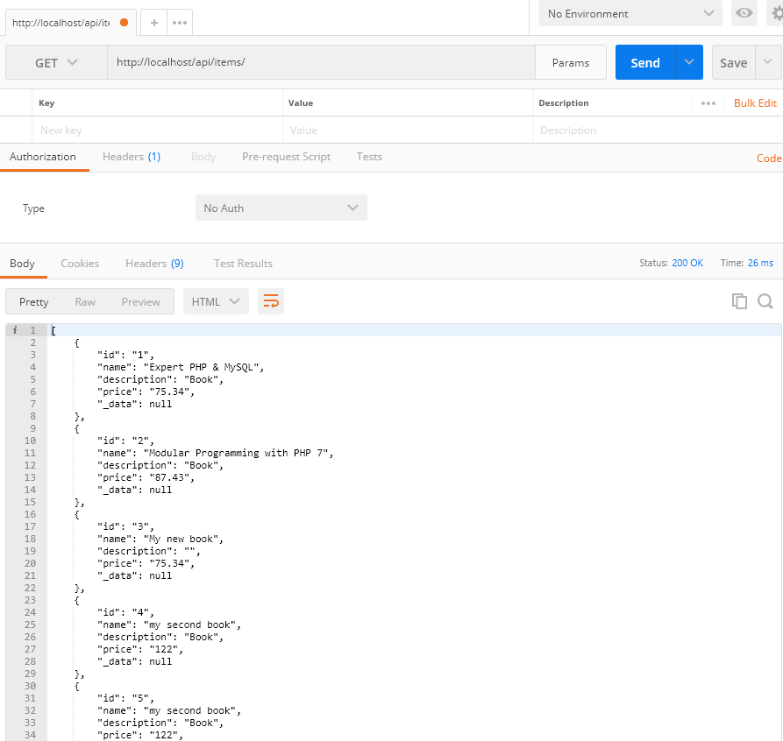

WORKBENCH

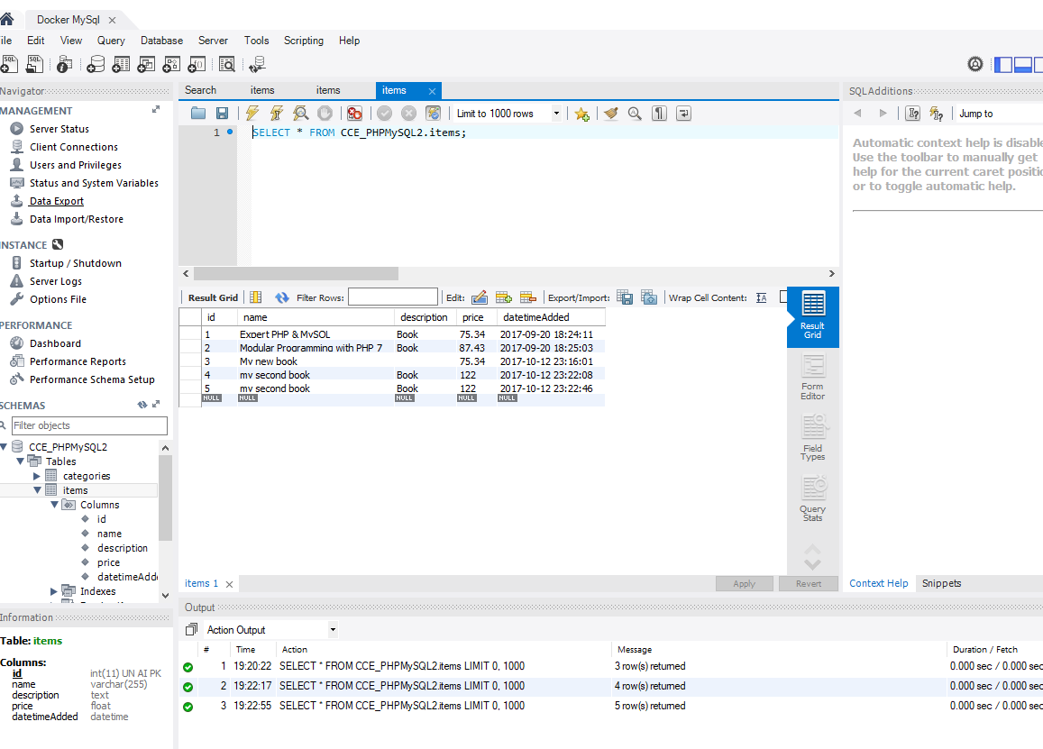

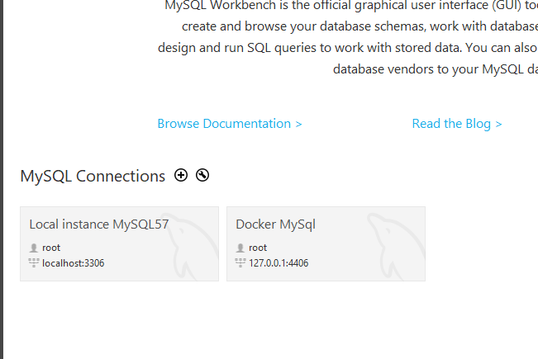

Password “root”

IN THE ITEM_MODEL:

<?php

class ItemModel

{

public $id;

public $name;

public $description;

public $price;

public $_data;

private $db_connection; <<<<<In the MODEL this variable is PRIVATE no one can access this conection