owo test

Tuesday, January 4, 2022

11:05 PM

**Bold,** *italic* and underscored text.

Formatted text.

_LISTS_

**Unordered:**

* Bulleted list item  
  Paragraph below list item  
  Second paragraph below list item

* Second bullet
  + Child bullet  
    Paragraph at deeper indent level
  + Child bullet separated by line break
    - Third
    - Fourth
  + Deindented bullet

**Ordered:**

1. Numbered list item
2. Second numbered item  
   Indented paragraph under numbered list item
   1. Child numbered item
   2. Second child numbered item
      1. …
         1. …
            1. …

Empty list items are deleted, such as the ones (not) seen below.







_TABLES_

|  |  |  |
| --- | --- | --- |
| a | b | c |
| 1 | 4 | 7 |
| 2 | 5 | 8 |
| 3 | 6 | 9 |

_FIGURES_

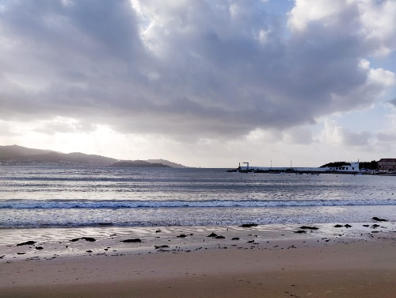

_UNSUPPORTED_

**Indented paragraph separated by line break**

Issues:

**+** Blank lines afterwards not conserved

* _  
    
  **<HERE>**

< --- >

**Deindented bullet after blank line**

Issues:

**+** Indentation not conserved

* _
  + _
    - _

* **<HERE>**

< --- >

**Deindented bullet after indented paragraph**

Issues:

**+** Paragraph content wrapped in #+QUOTE

**+** Indentation not conserved

* _
  + _
    - _

_

* **<HERE>**