Installation

Requirements
The plugin will require:
- PHP 7.4 or higher
- WordPress 5.9 or higher

Manual installation
Currently, the plugin is not in the WordPress Plugin's repo, which means that it should be installed manually. The archive file (zip) will need to be added as a new plugin from the admin panel of the WordPress site (usually this will be /wp-admin/plugin-install.php). From the top select "Upload Plugin" and browse the zip file. After the upload you will need to activate the plugin.

WPML Support
The plugin can work with WPML for multiple languages, but you need to make the post-type sheltered-animal and the taxonomy kind-of-animal translatable from within the WPML settings.

Set up
The most of the setup will be already completed when the plugins is activated. Still there are few things that will need your attention.
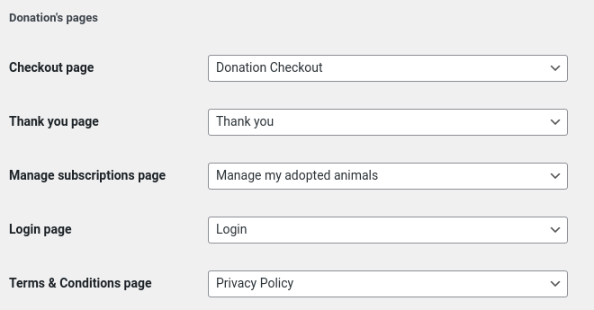
You might need to add the Terms & Conditions page, as the plugin won’t create it.

Adding PayPal client ID and secret key
For activating the payment system you will need an additional developer's account connected to your business PayPal account. To create one you will need to be logged in your business account and then go to this page, in most cases you won't need to log in again, and it should activate it.

For creating the PayPal client ID and the PayPal secret key you need to follow the official tutorial.

The client ID and the secret key need to be copied and pasted in the Virtual Adoptions' settings page. The page can be found in the admin dashboard > Settings > Virtual adoptions.

Once you have added the credentials click the "Test PayPal connection" button, which will verify the credentials. If your developer's account in PayPal is in test mode, check the "Activate test environment" checkbox, to make the plugin work in test mode as well.
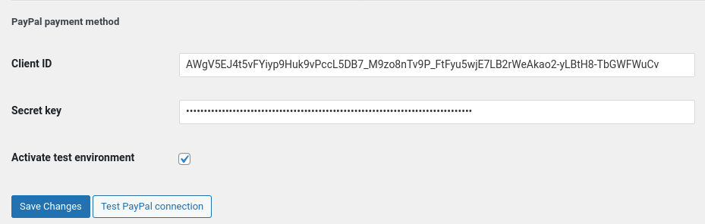

Setting up the payment plans
The second thing that needs to be done is to create subscription plan. In the Admin dashboard you will find in the menu "Subscription plans". From there you will need to add a new one. Choose whatever title you would like, this will appear in your business PayPal account, as well in the subscriber's PayPal account, so the title need to be self-explanatory. You will need to set also the plan's cost (the payment per month) and the currency.

Once you save the plan you will see a PayPal product ID and PayPal subscription plan ID. These are just a references, and they come from PayPal.

Note: If you create a subscription plan in test mode, it will be stored in the test mode for the default test business account and not in your live account. You will need to disable test mode in both PayPal and the current site.

Second Note: Once the plan is created you can't edit it from WordPress. Deleting it from there won't delete it from PayPal. If you want to manage the plan you will need to do this from the PayPal account.

Adding Animals
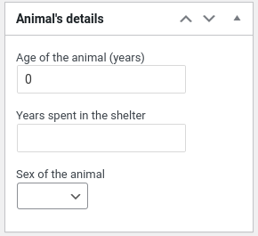
To add animals you need to go to the admin dashboard and then from the menu to select "Sheltered animals" > "Add new". You will be required to add the name of the animal as a title. In the main content textarea you can add whatever kind of description or media files you like. There are 3 meta boxes (in the right panel) for adding the sex of the animal, the time since being sheltered, and its age. You will be able to add a featured image of the animal as well. The recommended proportions of the image should be 1:1 or 1:1.5. It is possible the image to be cropped from the active theme settings.
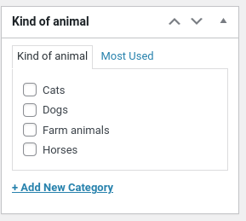
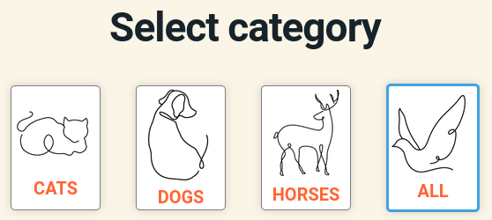
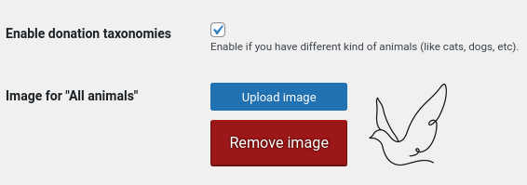
There is a taxonomy called "Kind of animal" that can be used for classification of the animal according their species, but if you would like to keep only one type of animals you can skip this part. In the other case you will need to add the "Kind of animals" (you will see the option to do this from the left menu below "Sheltered animals"). There you will add the title, the description (short presentation of the problems you have with those animals, and why they need the support), and finally - the logo. The logo is a small image of the animal that you can make visible for the users on the front. Adding the categories won't make them automatically visible on the front end. You will need to check this option from "Settings" -> "Virtual adoptions" -> "Enable donation taxonomies".

To the top of the archive page of all the animals you can insert an additional text from a custom page. This text can be a short introduction of your initiative or other sort of promoting text. Once you create that page you will need to go to the Settings -> Virtual adoptions and select that page from "Organization's short description page". Save the settings and the content (with its original formatting) will appear on the top of the archive pages of all the animals.

Subscriptions

Creating new subscription
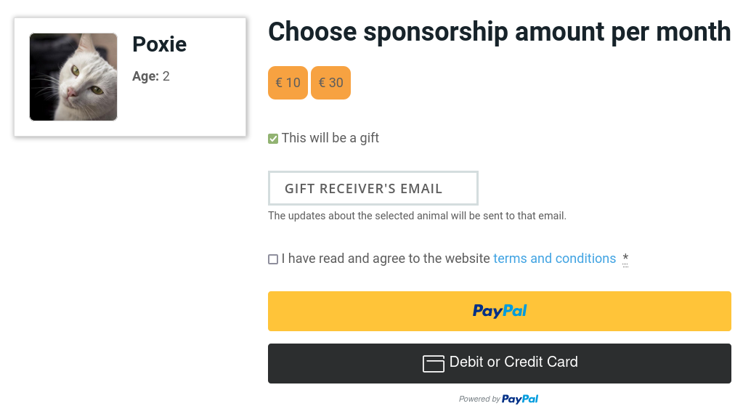
The creation of a new subscription is a process that would require a user's account to be created. The user will pick up an animal which s/he would like to support. On the checkout page a registration form will be presented (or a login option). Once the user is logged in the options with the payment amounts will be displayed. There is also an option for adding a gift email to which the animal's updates will be sent to, so the user can gift the virtual adoption to someone else.

The payment method is done only by PayPal, but it supports both a standard PayPal payment and card payment. The subscription will be for the selected amount as monthly payment limited to 24 months.

On successful payment the user will be redirected to "Thank you" page. You can edit its content.

Canceling the subscription plan
If only one monthly payment fails then the whole subscription will be canceled.
The users can manage their subscription from withing the account of your site, where they can review the list of their sponsored animals. From there they can initiate a subscription's cancellation or cancel the subscription from within their PayPal's account.

Reporting
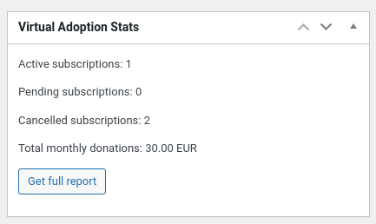
As administrators of the website you can view the monthly stats of the donations and download detail report for all the subscriptions and payments. The report is in CSV format and can be opened with LibreOffice, OpenOffice or something else like the MS Excel. From there you can add filtered for the columns and filter only by the active subscription. This way you can view only the subscriptions that are currently supporting your animals and get info about the emails with the updates you need to send (there will be also a column about the gift emails which will be different from the original account if a gift email was added).

