Cluster -> has the files to run magicplate.pl on a cluster that uses Sun grid engine. You will have to change some of the dir links in the bash script processPlates.sh

Non-cluster -> the code to run magicplate.pl on a server

Here are the perl modules you will need:

use GD;

use GD::Simple;

use POSIX qw(ceil floor);

use Data::Dumper;

use warnings;

use Getopt::Long qw(:config no_ignore_case no_auto_abbrev pass_through);

no warnings "recursion";

use strict;

use Math::Round qw/round/;

magicPlate.pl is the program that is used to generate the intensity values for each of the images. I have provided work.pl that will allow you to send many programs to the system. Work.pl should have the default setting that I generally use. Below is a bunch of screen shots that show how this works and what you should get out of it.

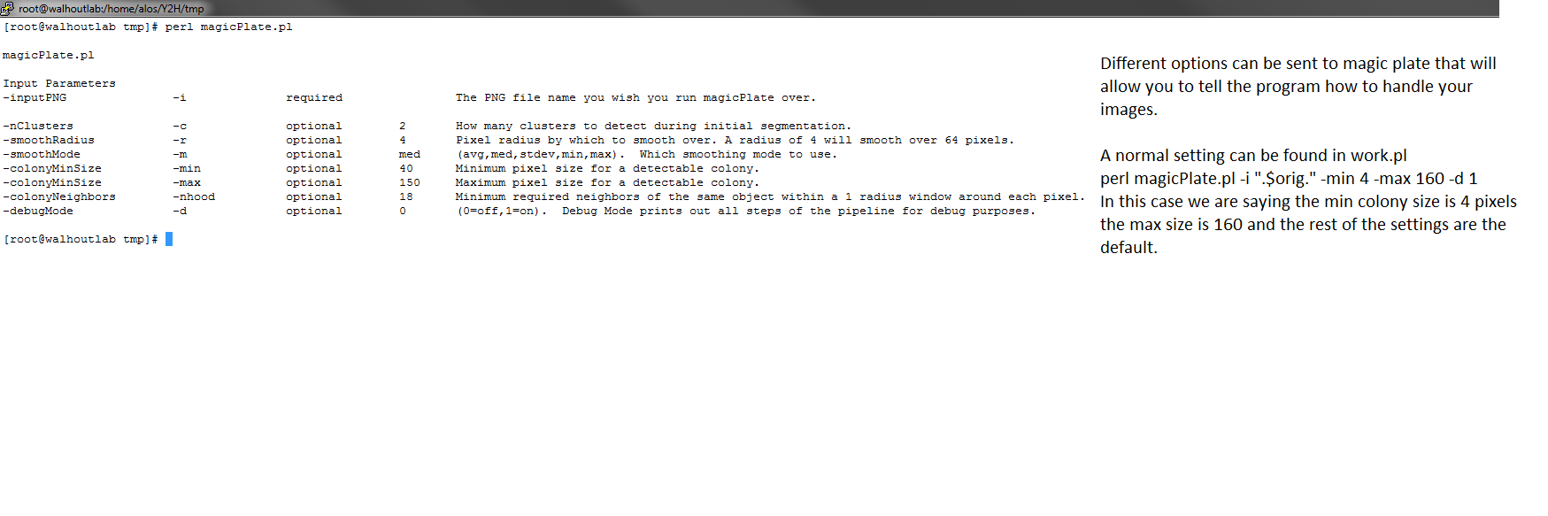

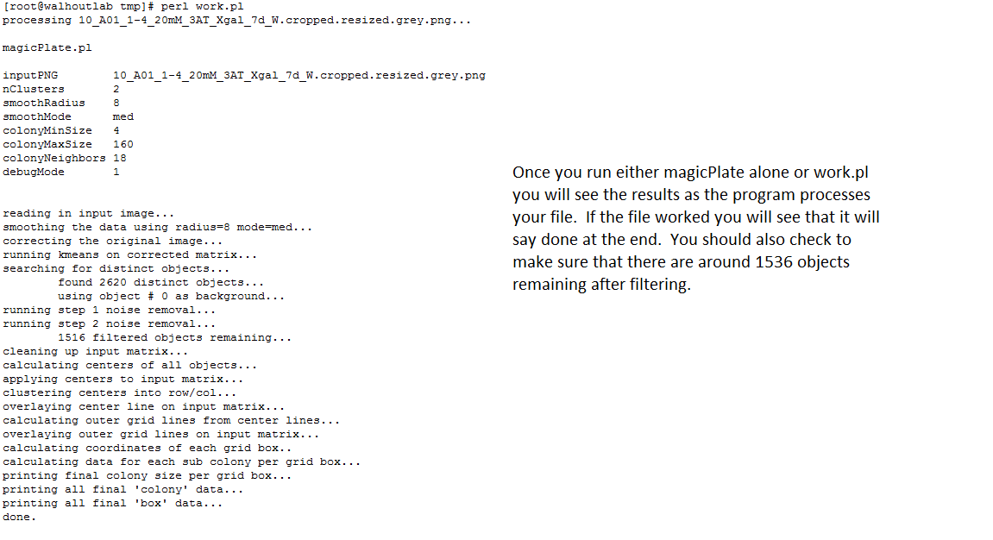

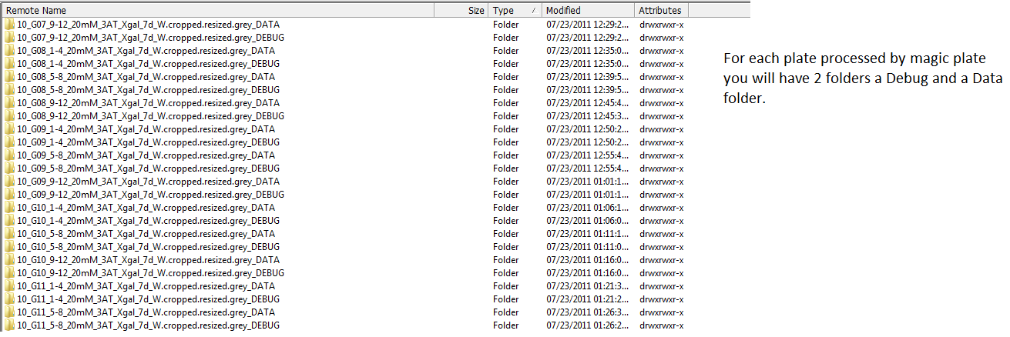

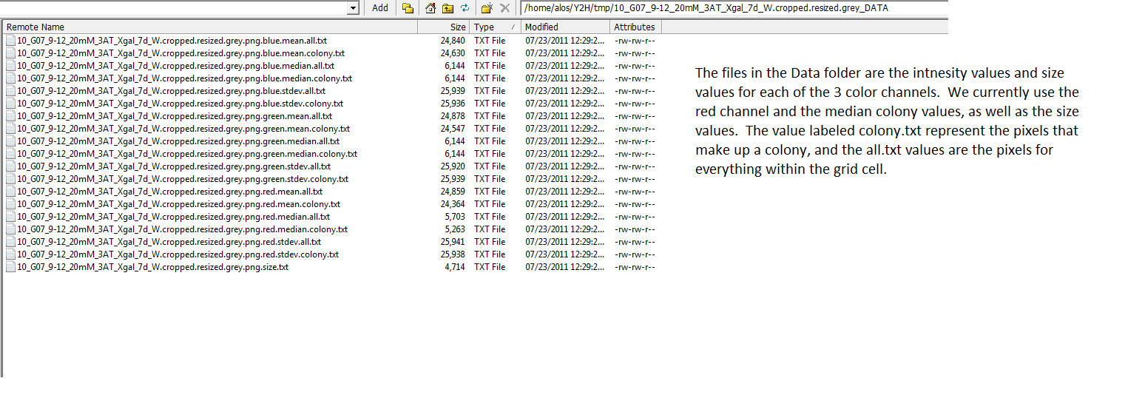

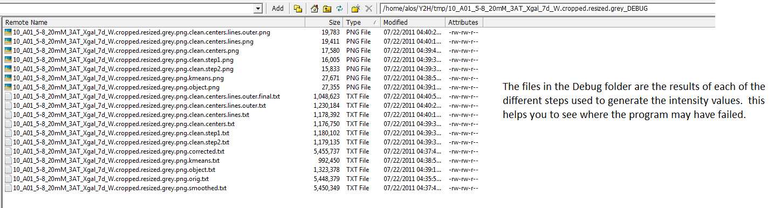

One of the Debug files will be named

*.cropped.resized.grey.png.clean.centers.lines.outer.png, this will tell you if the gridding worked. You will be able to see how the computer did with each colony.

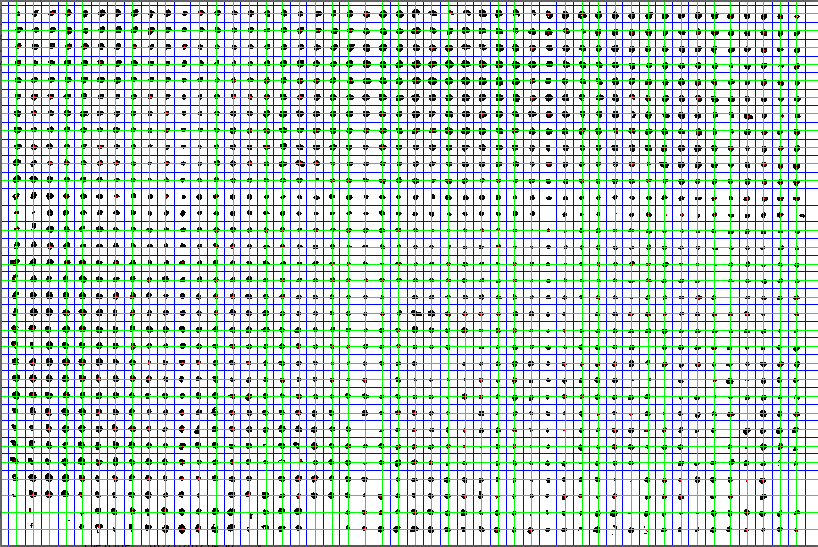

Once you’re done, the rest of the code only uses:

The *.colony.txt , *.size.txt, and or the *.all.txt files