Interaction-list code

You should have the results from magicplate.pl now. You should break those up by plate. Right now I have it set up to accept 3 plate types but that could change. You will need at the moment 1 dir per plate type.

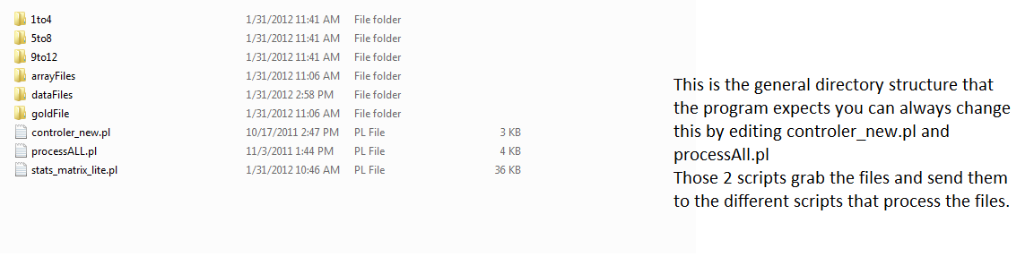

In each dir are the files that are used to process the plates. You will also need a copy of all of the plates in dataFiles goldFile contains the different files that are the bait names, tf names, list of human calls et cetera. ArrayFiles is the dir that has the array coord info for each array. I have included code that I used to make the array files in case you need it. I stored it in code_to_make_arrays.

You want to put the result text files from magic plate in the plate directories and dataFiles. Once that is done you run the program by running controller_new.pl. You will need to alter it depending on what files you use i.e. red channel all colonies or whatever.

Okay now let’s look at the code. You will most likely have to alter it:  
If you want to benchmark the code alter the following sub routine in stats_matrix_lite.pl:  
controller

Change

my $test_mode = "no";

my $type_of_list = "short";

my $type_of_list_end = "long";

***to*** my $test_mode = "yes";

Once that is done then you will have a result file run crawler.pl followed by the result file in Data_files.

If you want the results without changing the z-score cutoff you will want to just change:

my $test_mode = "no";

my $type_of_list = "short";

my $type_of_list_end = "long";

***to***

my $test_mode = "no";

my $type_of_list = "short";

my $type_of_list_end = "short";

also uncomment out the print statements in

shortlist()

If you want output for each colony change it to:

my $type_of_list_end = "long";

It might take a little time to tweak it so that your plates work, as a lot of the code is there to help with our plates, but I can work with you to get things going if you need.