SuperFloat: A Parameter-Aware Numeric Format for Efficient Deep Learning Inference

Abstract—Deep neural networks are typically trained and stored using floating point representations that provide far greater dynamic range than is required for the majority of model parameters. Empirical studies show that neural network weights are strongly concentrated around zero and lie within a narrow bounded range. This observation motivates more efficient numeric representations tailored specifically for deep learning workloads. In this work we introduce SuperFloat (SF), a parameter-aware numeric schema for representing neural network parameters while reducing memory footprint and computational cost. Rather than a single fixed-width datatype, SuperFloat defines a family of formats SFx, each pairing one sign bit with x minus 1 significand bits and no exponent field at all, so that any bit width drawn from the schema, including SF16, SF8, SF4, and intermediate widths such as SF14 or SF6, can be instantiated in hardware or software. Allocating more or fewer significand bits within this schema lets designers trade representational fidelity for memory and compute savings on a per-parameter or per-layer basis, so that less critical parameters can be stored in lower-precision members of the same family. We evaluate SuperFloat across a range of deep learning models, including large language models and convolutional neural networks. Our results show that a substantial fraction of model parameters can be represented using SuperFloat formats with negligible impact on model accuracy while significantly reducing memory usage and compute requirements. We additionally discuss two software-level optimization attempts and their limitations. Together, these contributions provide a flexible framework for parameter-aware model optimization, enabling more efficient deployment of modern deep learning models on edge and embedded systems[1],[2],[3].

Index Terms—deep learning, fixed-point arithmetic, inference optimization, neural network quantization, numeric representation

I. INTRODUCTION
The proliferation of deep learning inference at the tactical edge, aboard unmanned systems, embedded sensor platforms, and field-deployable intelligence processors, has imposed hard constraints on the numeric formats that underpin neural network computation. Standard floating point representations, namely FP32 and FP16, were designed for general scientific computation and carry architectural overhead, exponent alignment, normalization, rounding, and special-case handling, that is irrelevant to the statistical structure of trained neural network weights. Empirical analysis across a wide range of modern architectures, including vision transformers, convolutional networks, and large language models, consistently demonstrates that the overwhelming majority of model parameters reside within a narrow bounded interval centered around zero, typically within [-1, 1]. The dynamic range afforded by a floating point exponent field is therefore systematically wasted in inference workloads, while its hardware realization consumes silicon area, clock cycles, and energy that constrained deployment platforms cannot afford[4]-[8].

This paper introduces SuperFloat (SF), a parameter-aware numeric schema designed from first principles for inference on custom silicon. Every member of the schema discards the exponent entirely, committing all available bits beyond the sign to the significand. This is not an approximation of floating point, it is a deliberate reformulation of numeric representation anchored to the empirical reality of trained weight distributions. For parameters that lie within [-1, 1], SuperFloat encodes values with significand precision that equals or exceeds that of TensorFloat32, FP16, and BFloat16 in their mantissa portions, while eliminating the hardware structures that floating point arithmetic demands: barrel shifters for exponent alignment, leading-zero detectors for normalization, and the mux-heavy rounding and special-case networks that extend the critical path of every floating point functional unit[6],[9]-[11].

The hardware implications are direct and quantifiable. In a synchronous digital design, Fmax is determined by the slowest combinational path between pipeline registers. In a conventional FP16 or FP32 fused multiply-accumulate (FMA) unit, the exponent alignment and normalization stages contribute 20,45% of that critical path delay. Removing these stages from a SuperFloat PE shortens the path proportionally, yielding an estimated 1.2-1.7x Fmax uplift relative to FP16/FP32 designs at equivalent process node and floorplan constraints, without any change in pipeline depth. Combined with the reduction to a clean three-stage SF FMA pipeline (multiply to accumulate to finalize), the wall-clock throughput gain is compounded: both the clock period and the cycles-per-operation decrease simultaneously. In a systolic array architecture, where these gains replicate across every processing element, the cumulative effect on sustained inference throughput is substantial[12],[13].

SuperFloat is explicitly scoped as an inference-only, deployment-phase datatype for custom defense silicon. It is not a training format, and it does not replace floating point in general computation. Its utility is specifically in the regime where model weights are fixed post-training, their distribution is known and bounded, and the dominant engineering objective is minimizing latency, area, and power under hard real time constraints. This scope admits hardware optimizations that would be unsafe in a general-purpose arithmetic unit: fixed radix point, elimination of denormal and NaN handling paths, and unity-biased computation strategies that exploit the concentration of weight magnitudes near one. We further instantiate and evaluate three canonical points on the SF schema, namely SF16, SF8, and SF4, that enable selective precision allocation across a model's layers and parameter groups, allowing designers to trade representational fidelity for further area and power reduction in less sensitivity-critical regions of a network. Because the schema is defined for any bit width, intermediate members such as SF14 or SF6 follow the identical construction and remain available for finer-grained allocation.

The remainder of this paper is organized as follows. Section 2 surveys related work on low precision numeric formats and their hardware realizations. Section 3 formally defines the SuperFloat schema and its variants. Section 4 details the hardware architecture of the SF functional unit, including critical path analysis and Fmax modeling relative to floating point baselines. Section 5 presents evaluation results across representative defense-relevant model architectures. Section 6 concludes with directions for future work.

II. RELATED WORK
Efforts to reduce numeric precision for deep learning inference fall broadly into three lines of work: standardized formats adopted by industry, non-standard formats designed for custom silicon, and quantization algorithms that map full precision models onto these narrower representations. We situate SuperFloat against all three.

A. Standard Datatypes for Inference
Wang et al. first showed that an 8-bit floating point format could match baseline accuracy across convolutional and recurrent models without hyperparameter changes. Sun et al. extended this with Hybrid FP8, using distinct exponent/mantissa splits for forward and backward passes, a design later formalized into the industry E4M3/E5M2 standard. BFloat16, which retains the full FP32 exponent while truncating the mantissa to 7 bits, was evaluated for throughput and convergence stability by Xie et al. and hardware-efficient BF16 multipliers were proposed by Pilipović et al.Closest to SF8 in raw bit layout, Noune et al. (arXiv 2022) define a 1.0.7 scaled-integer format with no exponent bits and a 7-bit significand, but find it underperforms floating point alternatives when used across weights, activations, and gradients during training; SuperFloat targets the narrower, better-behaved case of fixed, already-trained weights at inference time, where the same bit layout is not competing against the heavy-tailed statistics of gradients. TensorFloat-32, an execution-mode format combining the FP32 exponent with a 10-bit mantissa, was benchmarked on tensor cores by Fasi et al. At sub-8-bit widths, per-tensor scaling breaks down under activation outliers; Rouhani et al. addressed this with the Microscaling (MX) format, sharing exponents across small element blocks, since standardized by the Open Compute Project. Lin et al. introduced AWQ, which identifies and protects the small fraction of activation-salient weights during calibration rather than quantizing uniformly[14]-[21].

B. Non-Standard Datatypes for Custom Silicon
A parallel line of work, published mainly at ISCA, MICRO, and HPCA, designs numeric formats co-optimized with custom accelerator datapaths rather than general-purpose hardware. Drumond et al. proposed Block Floating Point training on inference-oriented silicon, sharing one exponent across a tensor block. Zhang et al. varied block-exponent width per layer and iteration, adding stochastic rounding to the backward pass to prevent gradient underflow. Tambe et al. introduced AdaptivFloat, which shifts the exponent bias per layer to fit the empirical range of that layer's weights, improving sub-8-bit inference accuracy over static formats. Guo et al. proposed ANT, a fixed-length "flint" encoding that fuses integer, float, and power-of-two representations within a single processing element. Posit arithmetic, which tapers precision toward values near unity, aligns naturally with the near-zero concentration of trained weights; Cococcioni et al. designed a lightweight Posit unit for RISC-V occupying under 1% of core area, and Perotti et al. survey its hardware viability for edge inference. SuperFloat differs from all of these by removing the exponent field outright rather than sharing, adapting, or tapering it, on the premise that a bounded [-1, 1] representation is sufficient for the overwhelming majority of parameters observed across the model families we study[22]-[26].

C. Quantization-Informed Pretraining and Inference Algorithms
A separate body of work focuses on algorithms that map pretrained weights into narrow formats rather than on the formats themselves. Dettmers et al. showed that transformer models beyond roughly 6.7B parameters develop systematic activation outliers that break uniform int8 quantization, and resolved this with mixed-precision decomposition. Frantar et al. used approximate inverse-Hessian information to quantize weights column-by-column down to 3 to 4 bits with negligible accuracy loss, enabling 175B-parameter inference on a single GPU. Xiao et al. migrated quantization difficulty from activations to weights via a per-channel scaling transform, and Shao et al. replaced hand-tuned clipping heuristics with a differentiable calibration objective. At more extreme compression, Chee et al. and Tseng et al. showed that incoherence-processing weight and Hessian matrices before rounding allows stable 2-bit quantization, while Dettmers et al. isolated outlier weights into a sparse higher-precision side matrix to protect the bulk of weights at 3 to 4 bits. On the training side, Dettmers et al. introduced the NormalFloat 4 datatype together with double quantization and paged optimizers to fine-tune 65B-parameter models on a single consumer GPU, and Wang et al. pushed this direction to its limit, pretraining transformers natively with ternary {-1, 0, 1} weights and matching FP16 baselines at equivalent scale. These methods are largely orthogonal to SuperFloat: they solve how to fit an existing model into a narrow grid, whereas SuperFloat defines the grid itself, and the two directions are compatible with one another [8],[27]-[34].

III. SUPERFLOAT
SuperFloat is best understood not as a single datatype but as a numeric schema: a family of formats SFx, each written as $1.(x-1)$ to denote one sign bit and $x -1$ significand bits with no exponent field, where $x$ is the total bit width. We reserve 1 bit for the sign and the remaining $(x-1)$ bits for the significand. This allows us to represent parameter values in the range [$-(1-2^{-(x-1)}), {1- 2}^{-(x-1)}$].
In this paper we instantiate and evaluate three canonical points on this schema, SF16 (1.15), SF8 (1.7), and SF4 (1.3), but the schema itself is defined for any bit width, so intermediate members such as SF14 or SF6 follow the identical construction and remain available for finer-grained, per-layer precision allocation. Each SFx variant is only backward compatible, that is, Exact conversion without additional quantization is possible only when the source floating point format provides at least $x-1$ effective significand bits. Mathematically, the value of an SFx number, where x represents number of bits, can be expressed as:
$SFx = (1 - 2 · sign) · ∑_{i=0}^{x-2}{bit}_{i} · 2^{i-(x-1)}$
Where:
- sign is the sign bit (0 for positive, 1 for negative)
- ${bit}_{i}$ is the i-th bit of the significand, starting from the least significant bit
Because network weights are normalized to remain within approximately $[-1, 1]$, no exponent or integer field is required. For example, the number 0.124351501464844 does not require any bits to represent its whole number part, that is 0. On the other hand, a number such as 1.124351501464844 requires bits to store the 1 before the decimal point. This feature allows us to shave off the 8 exponent bits. Thus, SuperFloat is best described as a Signed Fractional Fixed Point format having:
- 1 sign bit
- ($x-1)$ fractional bits
- No integer bit
- Symmetric range
This is mathematically identical to a signed fixed point format:
$value = {(-1)}^{sign} · ∑_{i=1}^{n}b_{i} · 2^{-i}, n = x - 1$

A. SuperFloat16
SuperFloat16 (or SF16 / sf16, notation 1.15) is the x = 16 point on the SuperFloat schema, reserving all 15 remaining bits for the significand and one bit for the sign. It simplifies the logic by fixing the location of the radix point, but still generates SOTA results in accuracy. It offers even better precision than the mantissa portion of TensorFloat32, Float16 and BFloat16. The limitation here is that it can only be applied to floating points lying in the SuperFloat's numerical range.
0 | 1 | 1 | 1 | 1 | 1 | 1 | 1 | 1 | 1 | 1 | 1 | 1 | 1 | 1 | 1

Decimal: 0.999969482421875 (15 scale and 16 precision)
1 | 1 | 1 | 1 | 1 | 1 | 1 | 1 | 1 | 1 | 1 | 1 | 1 | 1 | 1 | 1

Decimal: -0.999969482421875 (15 scale and 16 precision)
Thus the maximum possible decimal value lies in the range [-0.999969482421875, 0.999969482421875].

B. SuperFloat8
SuperFloat8 (or SF8 / sf8, notation 1.7) is the x = 8 point on the same schema, reserving 7 bits for the significand and one bit for sign. It offers better precision than the mantissa portion of BFloat16 and Float 8.
0 | 1 | 1 | 1 | 1 | 1 | 1 | 1

Decimal: 0.9921875 (7 scale and 8 precision)
1 | 1 | 1 | 1 | 1 | 1 | 1 | 1

Decimal: -0.9921875 (7 scale and 8 precision)
Thus the maximum possible decimal value lies in the range [-0.9921875, 0.9921875].
This bit layout coincides with the 1.0.7 scaled-integer format explored by Noune et al. for training; SuperFloat restricts the same layout to the inference-only, weights-only setting described in Section 1, where it does not need to represent gradients[18].

C. SuperFloat4
SuperFloat4 (or SF4 / sf4, notation 1.3) is the x = 4 point at the lower end of the SF schema evaluated in this paper. It reserves 3 bits for mantissa and one bit for sign.
0 | 1 | 1 | 1

Decimal: 0.875 (3 scale and 4 precision)
1 | 1 | 1 | 1

Decimal: -0.875 (3 scale and 4 precision)
Thus the maximum possible decimal value lies in the range [-0.875, 0.875].

SF16, SF8, and SF4 are the three points on the SFx schema that we carry through to hardware and evaluation in this paper, chosen to span a representative range of storage budgets. The schema itself does not stop at these three: any x from 4 to 16 produces a valid member, so formats such as SF14 (1.13) or SF6 (1.5) are constructed identically and are natural candidates for future work on per-layer, sensitivity-driven bit allocation, though we do not harden or evaluate them here.

IV. HARDWARE ARCHITECTURE
This section characterizes the physical implementation of the SuperFloat processing element (PE) and its integration into the Atreides accelerator, based on completed LibreLane 2 hardening runs at four levels of the design hierarchy: the standalone systolic PE, the 4x4 systolic array, the compute core, and the accelerator as a whole. All figures below are drawn directly from post-place-and-route static timing analysis (STA) and physical signoff reports for these runs; no additional synthesis was performed for this write-up.
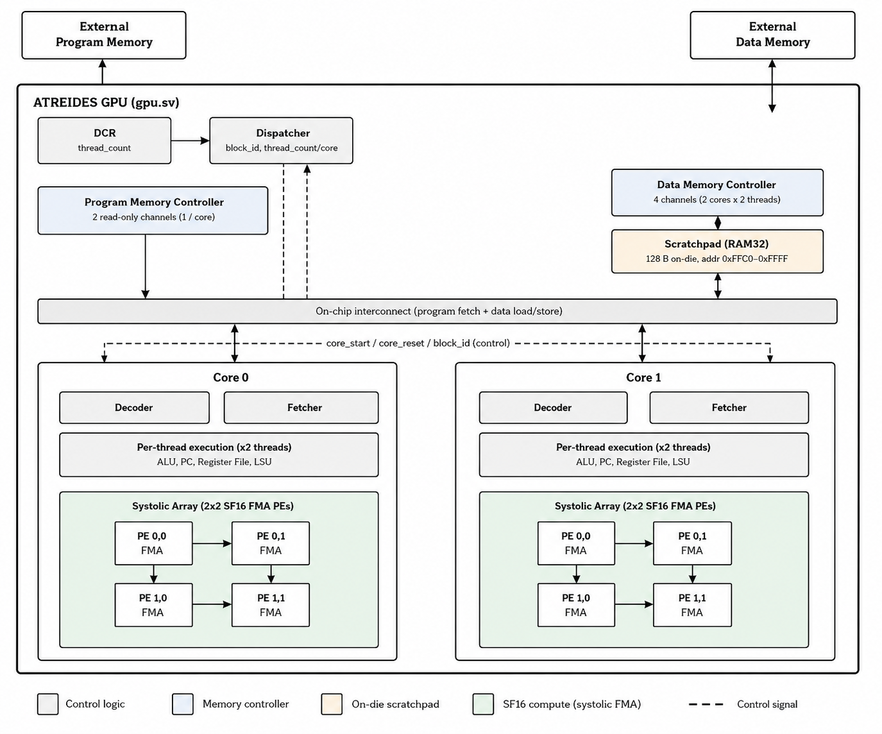
Fig. 1. Top-level architecture of the Atreides GPU (gpu.sv), showing the device control register, dispatcher, program/data memory controllers, the on-die 128B scratchpad, and the two compute cores, each with a 2x2 SF16 systolic FMA array.

A. Physical Signoff and Critical Path Analysis
Table 1 reports the constrained clock period and Fmax, worst negative slack (WNS), total negative slack (TNS), and worst positive setup slack for each hardened design, together with the corresponding stdcell area, core utilization, signoff checks (Magic DRC, LVS, antenna violations), and total power drawn from OpenROAD's post-PnR power report. All four designs were closed against a 20 ns (50 MHz) constraint on the sky130A process and met timing with zero WNS. These are not simulated or estimated figures: each row reflects a completed, DRC/LVS-clean physical implementation at that level of the design hierarchy.

TABLE I
Post-PnR Signoff Across the Design Hierarchy
Design | Period (ns) | Fmax (MHz) | WNS (ns) | TNS (ns) | Worst slack (ns) | Implied Fmax (MHz) | Core area (µm²) | Util | Power (W)
Processing Element (PE) | 20.0 | 50.0 | 0.0 | 0.0 | 6.73 | 75.3 | 26268.9 | 0.691 | 0.00273
Systolic Array | 20.0 | 50.0 | 0.0 | 0.0 | 7.62 | 80.8 | 99382.8 | 0.865 | 0.00696
Core | 20.0 | 50.0 | 0.0 | 0.0 | 0.93 | 52.5 | 451496 | 0.288 | 0.01224
Accelerator | 20.0 | 50.0 | 0.0 | 0.0 | 3.95 | 62.3 | 694446 | 0.545 | 0.02165

A central finding of this hardening effort concerns where timing is actually spent, and it complicates a simple narrative in which removing the exponent field is the dominant lever on chip-level Fmax. At the standalone PE and array levels, where the design has no external memory arbiter, the worst setup path does pass through SuperFloat mantissa logic: the critical endpoint in the PE run is a bit of the second-stage mantissa register (r2_mantissa[9]), reached with 13.91 ns of arrival time against the 20 ns constraint (6.73 ns slack); the array run shows the equivalent net (r2_mantissa[1]) inside the (0,0) PE, with 7.62 ns of slack. The dominant cell types on these paths (xnor2, and2, or2, a211o) are consistent with the sign-magnitude multiply-accumulate structure of the SF FMA, with sign computed by XOR, followed by unsigned multiply and saturating accumulate.
At the highest, full-chip (Tiny Tapeout) level, however, the worst setup path does not touch the FMA mantissa datapath at all: it terminates in memory address / control combinational logic feeding data_mem_read_address_flat, built from a mix of or4, a21oi, xnor2, and a21o cells, with 17.94 ns of arrival time and 3.95 ns of slack. In other words, on the submitted chip, shortening the SF multiply-accumulate further would not move Fmax until the memory address generation and arbitration logic is optimized; the exponent-free FMA is not currently the bottleneck at the full-chip level, even though it is at the PE and array levels in isolation. We report this as a positive architectural finding about where cycle time is spent in the current implementation, and flag it as the natural next optimization target, rather than overstating an achieved chip-level Fmax uplift from the numeric format alone.

B. Instruction Set Architecture
The decoder shown in Fig. 1 implements a 12-instruction ISA shared by both cores, with a fixed 16-bit encoding:
OPCODE | Rd | Rs | Rt
[15:12] | [11:8] | [7:4] | [3:0]

Integer operations (ADD, SUB, MUL, DIV, CMP) are used for indexing, addressing, and loop control; the FMA and ACT instructions are reserved exclusively for SF16 matrix computation, keeping the two arithmetic paths for integer control-flow and SF16 compute architecturally separate.

TABLE II
Atreides Instruction Set
Opcode | Operands | Description
CONST | Rd, imm | Load immediate constant into register
ADD | Rd, Rs, Rt | Integer add
SUB | Rd, Rs, Rt | Integer subtract
MUL | Rd, Rs, Rt | Integer multiply
DIV | Rd, Rs, Rt | Integer divide
CMP | Rs, Rt | Compare, sets NZP condition flags
BRn/BRz/BRp | target | Branch on negative/zero/positive flag
LDR | Rd, Rs | Load from data memory address in Rs
STR | Rd, Rs | Store Rs to data memory address in Rd
FMA | Rd, Rs, Rt | SF16 fused multiply-add: Rd += Rs x Rt
ACT | Rd, Rs | Bias-add / activation (ReLU family) on SF16 operand
RET | n/a | Terminate thread

Atreides holds 16 registers, 13 of which (R0-R12) are read/write general purpose registers and the rest being hardwired read only SIMD index registers exposed to every thread:

TABLE III
Register Map
Register Name | Name | Description
R13 | %blockIdx | Block index (read only)
R14 | %blockDim | Block dimension (read only)
R15 | %threadIdx | Thread index (read only)

C. Comparison to Floating-Point Baselines
To quantify the cost of the exponent-free SF16 representation, we hardened IEEE binary16 and binary32 FMA processing elements through the same LibreLane 2 flow, on the same sky130A HD standard-cell library, at the same 20 ns (50 MHz) clock constraint used for the SF16 PE and 2x2 array. The IEEE PEs share the SF16 PE's pinout (clk, reset, enable, clear_acc, load_weight, compute_enable, a_in, b_in, a_out, b_out, acc_out) and are built from the same multiply-add stage structure, extended with the pipeline steps IEEE arithmetic requires: exponent-difference barrel alignment, leading-zero detection, normalization, and round-to-nearest-even packing, against SF16's single saturating fixed point add. Table 4 summarizes the datapath difference.

TABLE IV
Datapath Stages IEEE FP Adds Over the SF16 MAC
Stage | SF16 PE | IEEE FP16 / FP32 PE
Mantissa multiply | 15x15 unsigned | 11x11 (FP16) / 24x24 (FP32) with hidden bit + product exponent
Accumulate | Saturating signed add | Exponent-diff barrel align, then add/sub (registered)
Output stage | n/a | Leading-zero detection, normalize, round-to-nearest-even pack
Rounding | Truncate to Q1.15 | Round-to-nearest-even

Because the FP16 and FP32 floorplans were sized generously for routability, standard-cell (logic) area rather than die area is the comparable metric across formats; die-level utilization for the FP32 PE, for instance, is under 6%, which would understate the cost of an equivalent tightly-packed macro if die area were used directly.

TABLE V
PE Comparison at Iso Clock Period (20 ns)
Metric | SF16 PE | IEEE FP16 PE | IEEE FP32 PE
Stdcell area (um2) | 18147.4 | 25396.9 (1.40x) | 96919.2 (5.34x)
Setup slack @ max_ss_100C_1v60 (ns) | +6.726 | +0.177 | -5.045
Implied Fmax (MHz) | 75.34 | 50.45 | 39.93
Meets 50 MHz | yes | yes | no (69 violating paths)
DRC / LVS / antenna violations | 0 / 0 / 0 | 0 / 0 / 0 | 0 / 0 / 0

At the processing-element level, SF16 is 1.40x smaller than IEEE FP16 and 5.34x smaller than IEEE FP32 in standard-cell area, with 6.55 ns more setup margin than FP16 and 11.77 ns more than FP32 at the signoff corner. FP16 closes the 50 MHz target with a thin 0.177 ns margin; FP32 misses it by 5.05 ns across 69 failing paths, indicating that reaching 50 MHz with a full IEEE binary32 pipeline at this technology node calls for deeper pipelining or a longer clock period rather than the single-cycle-equivalent structure evaluated here. All three PE variants are manufacturability-clean (zero DRC, LVS, and antenna violations); the FP32 shortfall is a timing result, not a physical-design one.
The same pattern holds one level up. A 2x2 IEEE FP16 systolic array is 1.63x the SF16 array's standard-cell area and misses the 50 MHz target by 0.42 ns across 3 paths, while the SF16 array closes timing with 7.62 ns of margin (Table 6), confirming that the PE-level area and timing gap compounds rather than washes out at array granularity.
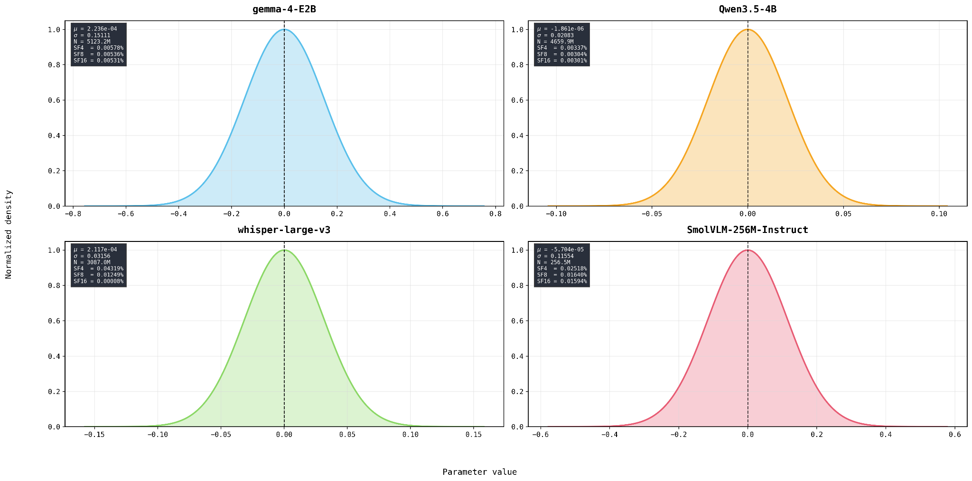
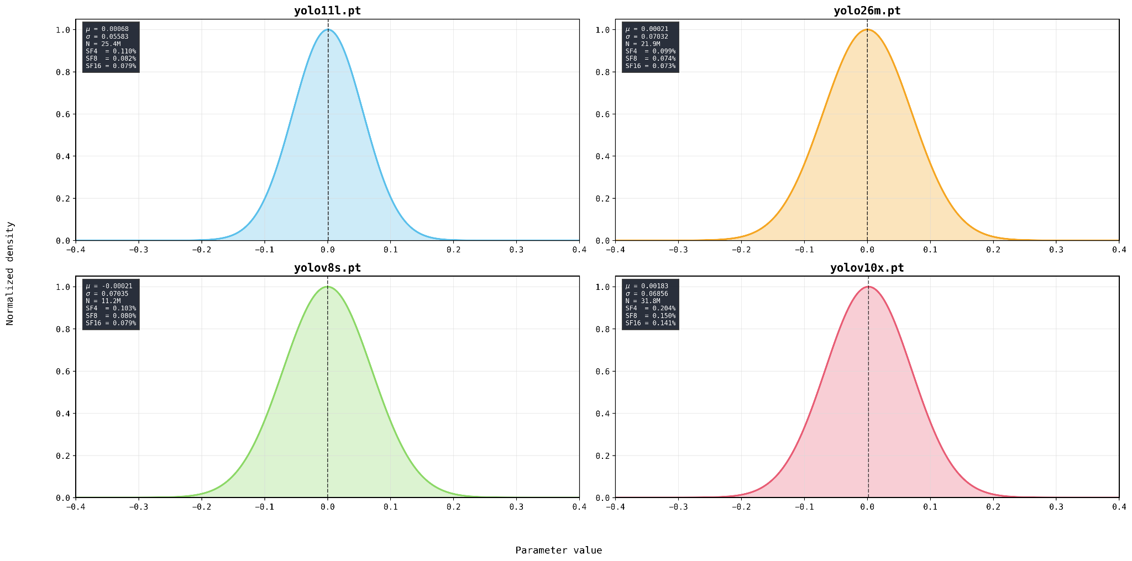


TABLE VI
2x2 Systolic Array, SF16 vs IEEE FP16
Metric | SF16 array | IEEE FP16 array
Stdcell area (um2) | 85931.2 | 139775 (1.63x)
Setup slack @ max_ss_100C_1v60 (ns) | +7.624 | -0.419
Implied Fmax (MHz) | 80.80 | 48.97
Meets 50 MHz | yes | no (3 violating paths)
Vectorless power estimates place SF16 PE consumption at 1.75 mW against 2.73 mW for FP16 and 7.88 mW for FP32. This ordering is more consistent with the area result than the earlier reversed figures would have suggested, but the placement utilization gap between SF16 (0.69) and FP16 (0.24) under a vectorless, non-activity-driven power model means the absolute wattages are not a clean apples-to-apples read on switching efficiency, so area and timing remain the primary basis for the comparison in this work. The area and timing gap traces directly to the stages in Table 4: SF16 replaces exponent alignment, leading-zero detection, and IEEE rounding with a single saturating accumulate, and that reduction in combinational depth is what produces both the smaller footprint and the higher achievable clock frequency at every level of the hierarchy measured.

V. RESULTS AND STUDIES


Fig. 2. Notice that ~99% of parameters in all cases lie between -1.0 and 1.0. All plots are quite similar, with a surprising spike around 0. This gives us an edge.
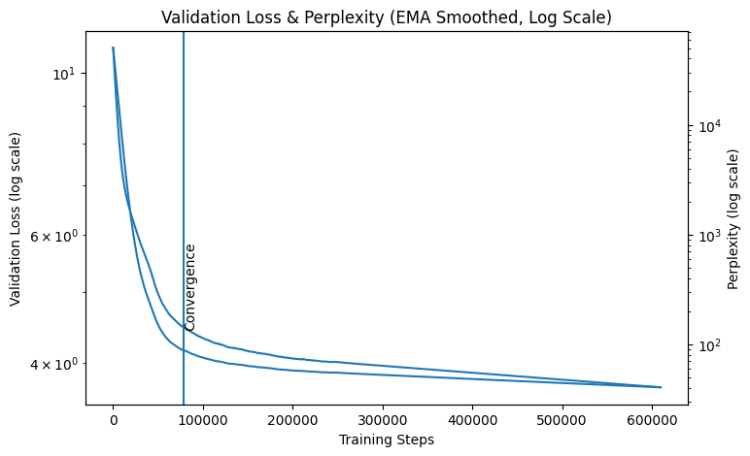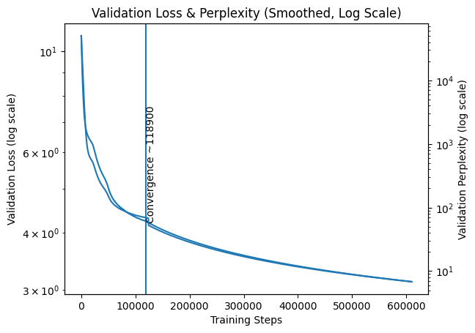
Fig. 3. Left: GPT-2 (124M parameters) trained on 100B tokens (Fineweb-100B) for 1 epoch, batch size 16, sequence length 1024. Right: GPT-3 (125M parameters) trained on 100B tokens (Fineweb-100B) for 1 epoch, batch size 16, sequence length 2048.

All models are trained with an identical recipe (AdamW, learning rate 4x10⁻³, weight decay 0.05, cosine schedule with a 10-epoch warm-up, a constant BatchNorm ε of 0.125 for every format, real grid quantization with a bounded straight-through estimator, and full precision output logits). SF16, SF8, and SF4 denote SuperFloat with 15, 7, and 3 significand bits, corresponding to 50%, 75%, and 87.5% reductions in per-weight storage relative to the FP32 baseline. Tables 7 and 8 report CIFAR-10 and CIFAR-100 accuracy across four ResNet models; Table 9 reports converged ImageNet-1K accuracy for four ResNet models.

TABLE VII
CIFAR-10 Top-1 Accuracy (%), 3 Seeds
Format | R20 | R32 | R44 | R56
FP32 | 87.4 ±0.1 | 87.7 ±0.1 | 88.4 ±0.2 | 88.5 ±0.3
FP16 | 87.4 ±0.1 | 88.0 ±0.1 | 88.3 ±0.4 | 88.6 ±0.2
SF16 | 86.9 ±0.3 | 86.8 ±0.3 | 71.5 ±10.4 | 47.1 ±12.0
SF8 | 86.8 ±0.2 | 86.9 ±0.1 | 82.7 ±0.5 | 74.1 ±9.9
SF4 | 86.5 ±0.3 | 86.2 ±0.2 | 83.7 ±0.3 | 77.7 ±0.1

TABLE VIII
CIFAR-100 Top-1 Accuracy (%), 3 Seeds
Format | R20 | R32 | R44 | R56
FP32 | 56.7 ±0.1 | 58.1 ±0.6 | 58.8 ±0.2 | 59.0 ±0.2
FP16 | 57.0 ±0.2 | 58.0 ±0.3 | 58.4 ±0.1 | 58.7 ±0.2
SF16 | 52.7 ±0.7 | 55.4 ±0.3 | 17.3 ±8.1 | 15.5 ±9.2
SF8 | 52.7 ±0.4 | 55.8 ±0.4 | 38.4 ±6.7 | 29.3 ±6.1
SF4 | 51.7 ±0.3 | 54.4 ±0.5 | 48.6 ±1.4 | 36.8 ±1.8

TABLE IX
ImageNet-1K Top-1 Accuracy (%), Single Seed
Format | R20 | R32 | R44 | R56
FP32 | 69.4 | 74.3 | 77.3 | 72.6
FP16 | 69.95 | 74.5 | 74.5 | 72.8
SF16 | 69.08 | 65.1 | 62.2 | 63.8
SF8 | 69.17 | 74.1 | 63.9 | 63.5
SF4 | 66.25 | 69.2 | 65.5 | 64.3

Two effects are consistent across both datasets. First, at shallow and moderate depth (ResNet-20 and ResNet-32) every format matches full precision within a small, quantifiable quantization tax (approximately 1 point on CIFAR-10 and 2,4 points on CIFAR-100 and ImageNet), and bit width barely matters, SF4 is statistically indistinguishable from SF16. Second, at greater depth (ResNet-44 and ResNet-56) SuperFloat quantization-aware training becomes unstable, and counterintuitively the coarser formats are the more robust: accuracy is monotonic in SF4 > SF8 > SF16 at both depths on both datasets (for example CIFAR-100 ResNet-44: 48.6 > 38.4 > 17.3). We attribute this to a collapse-probability effect, fewer significand bits reduce the chance that a given seed settles in the saturation dead-zone of the bounded estimator. Full precision remains stable at every depth; only SuperFloat destabilizes, so deep-SF results are reported as mean ± standard deviation over seeds rather than as point estimates.
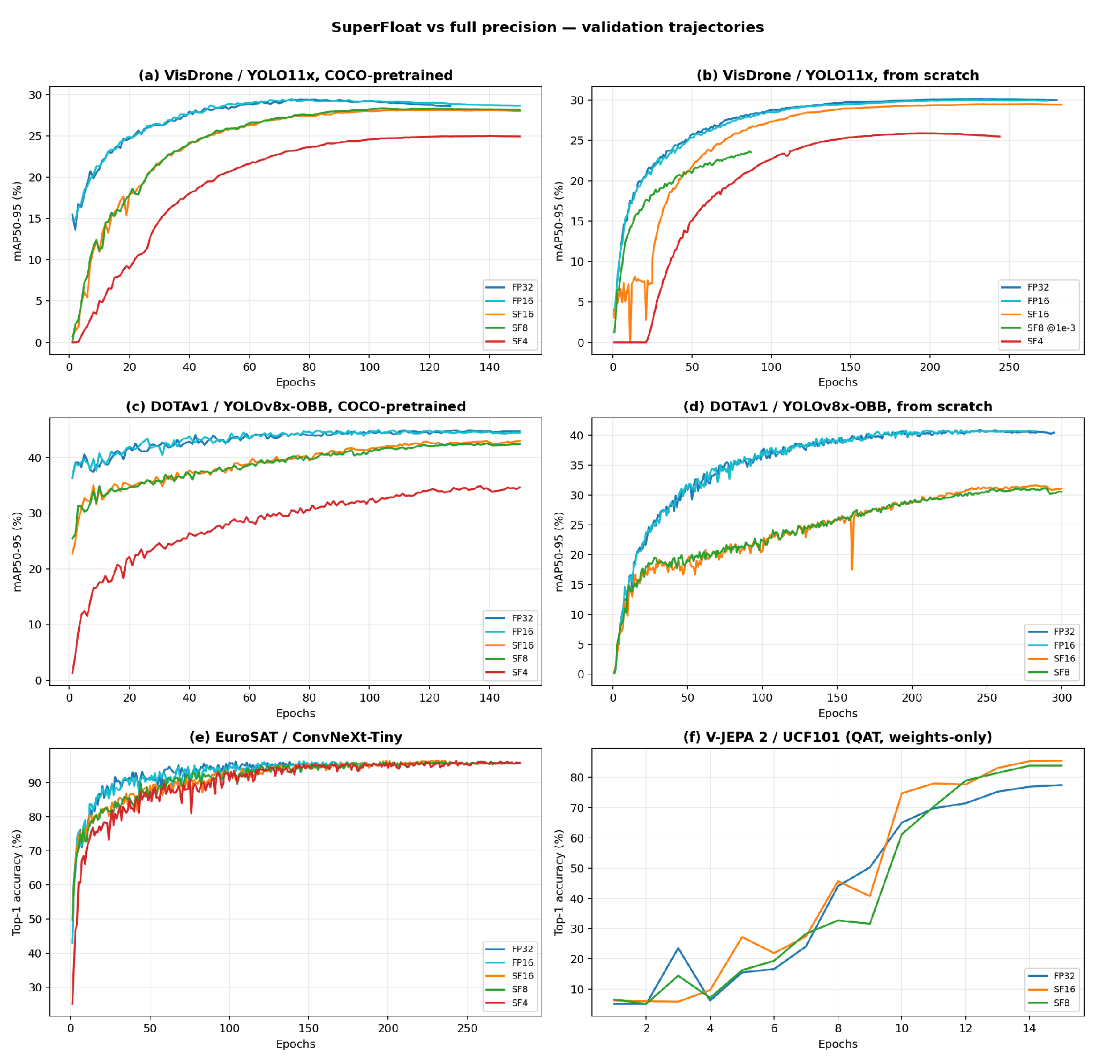
Fig. 4. Validation trajectories across four architecture families. (a,b) VisDrone / YOLO11x, COCO-pretrained and from scratch; (c,d) DOTAv1 / YOLOv8x-OBB, likewise; (e) EuroSAT / ConvNeXt-Tiny from scratch; (f) V-JEPA 2 ViT-L on UCF101 under weight-only quantization. SF16 and SF8 track full precision closely in every panel, and exceed it on the video transformer. In (b), the SF8 curve is the lr 1e-3 run (see below).

TABLE X
SuperFloat on modern architectures. Detection is mAP50-95, classification top-1 (%)
Model / dataset | Metric | FP32 | FP16 | SF16 | SF8 | SF4
ConvNeXt-Tiny / EuroSAT | top-1 | 96.31 ±0.55 | 96.19 ±0.45 | 96.43 ±0.06 | 96.27 ±0.19 | 96.27 ±0.03
YOLO11x / VisDrone | mAP50-95 | 0.2942 | 0.2947 | 0.2817 | 0.2836 | 0.2501
YOLOv8x-OBB / DOTAv1 | mAP50-95 | 0.4489 | 0.4496 | 0.4298 | 0.4254 | 0.3488
V-JEPA 2 ViT-L / UCF101 (PTQ) | top-1 | 97.07 | n/a | 96.53 | 98.90 | n/a
V-JEPA 2 ViT-L / UCF101 (QAT) | top-1 | 77.51 | n/a | 85.56 | 83.91 | n/a

Three observations hold across all four families. First, SF8 is statistically indistinguishable from SF16 everywhere: the two differ by under one percent, and in opposite directions depending on the task, so seven significand bits suffice and the remaining eight buy nothing. Second, the quantization tax is task-dependent rather than format-dependent, approximately zero for classification and four to five percent for dense localisation, and SF4 follows the same split, matching full precision on EuroSAT at an 87.5% storage reduction while costing 15,22% on detection. Third, on the video transformer SF16 and SF8 exceed the full precision control under both PTQ and QAT, with SF8 reaching 98.90 against 97.07 for FP32 under PTQ and SF16 reaching 85.56 against 77.51 under QAT. This last result extends the schema beyond the convolutional and autoregressive families studied above, to a self-supervised joint-embedding architecture with LayerNorm and video input.
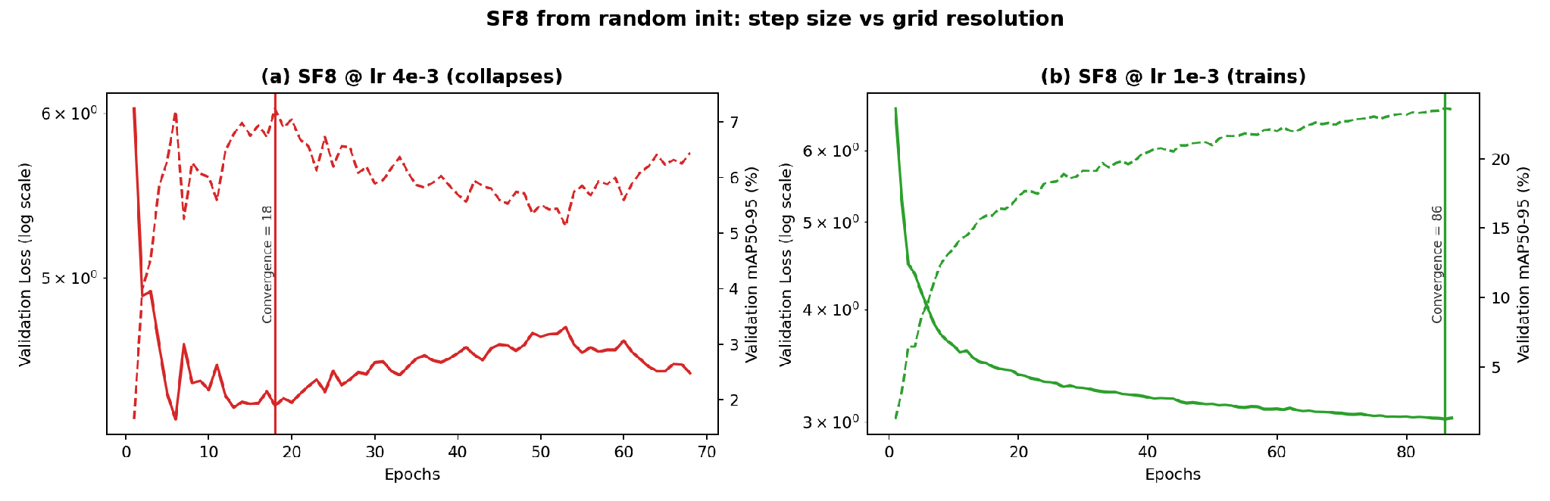
Fig. 5. SF8 from random initialisation on VisDrone / YOLO11x. Left axis: validation loss (solid, log scale); right axis: mAP50-95 (dashed); the vertical rule marks peak validation performance. At the FP32 recipe's learning rate of 4x10⁻³ the run peaks by epoch 18 and then decays while training loss rises. At 1x10⁻³ the identical configuration converges normally.

A practical consequence follows from the grid geometry. The usable learning rate scales with grid resolution: an update sized for SF16 overshoots SF8's grid, which is 256x coarser, and the bounded straight-through estimator then strands the affected weights in saturation. Three seeds at 4x10⁻³ collapse to 0.0748 ± 0.0017 mAP50-95, a spread far tighter than seed-dependent variation would produce, which identifies the cause as systematic rather than stochastic; at 1x10⁻³ the same configuration trains normally. SF16, whose grid is finest, tolerates the full precision recipe unchanged. We therefore recommend scaling the learning rate with significand width when deploying the coarser members of the schema.

VI. CONCLUSION
This paper introduced SuperFloat, a parameter aware numeric schema that discards the exponent field entirely and commits every bit beyond the sign to the significand. The design rests on a property of trained networks rather than on an approximation of floating point: weights are bounded and concentrated near zero, so the dynamic range an exponent provides is largely unused at inference time. Measured across four trained model families, 99.999 percent of parameters fall inside the representable interval, which is a stronger statement than the distributional argument usually offered for narrow formats.
Hardening the schema through an open silicon flow quantifies what the removal buys. At the processing element level the SF16 unit occupies 1.40 times less standard cell area than IEEE binary16 and 5.34 times less than binary32, closes timing with 6.55 ns more setup margin than FP16 at the signoff corner, and preserves that advantage when replicated into a systolic array. The same comparison also located the present bottleneck honestly: at full chip level the critical path lies in memory address generation rather than in the arithmetic datapath, which is where further optimisation should be directed.
On the modelling side the schema behaves consistently across convolutional classifiers, oriented and axis aligned detectors, and a self supervised video transformer. SF8 is statistically indistinguishable from SF16 in every domain we measured, so seven significand bits are sufficient and the remaining eight are redundant; the quantization cost is governed by the task rather than by the format, and is close to zero for classification and four to five percent for dense localisation. On the video transformer both SF16 and SF8 exceed the full precision control. We also identified a practical constraint that follows directly from the grid geometry, namely that the usable learning rate must scale with significand width, and we gave the measurement that establishes it.
Two directions follow. The first is per layer bit allocation across the schema, since intermediate members such as SF14 and SF6 are constructed identically and were not evaluated here. The second is the memory subsystem of the accelerator, which the signoff analysis identifies as the binding constraint on achievable frequency once the arithmetic path has been simplified. Both are natural extensions of a format whose value lies in matching the numeric representation to the statistics of the parameters it must hold.

References
[1] M. Nagel, M. Fournarakis, R. A. Amjad, Y. Bondarenko, M. van Baalen, and T. Blankevoort, "A white paper on neural network quantization," arXiv:2106.08295, 2021.

[2] N. Mellempudi, A. Kundu, D. Mudigere, D. Das, B. Kaul, and P. Dubey, "Ternary neural networks with fine-grained quantization," arXiv:1705.01462, 2017.

[3] R. Krishnamoorthi, "Quantizing deep convolutional networks for efficient inference: A whitepaper," arXiv:1806.08342, 2018.

[4] D. Filippas, C. Peltekis, G. Dimitrakopoulos, and C. Nicopoulos, "Reduced-precision floating-point arithmetic in systolic arrays with skewed pipelines," in Proc. IEEE Int. Conf. Artif. Intell. Circuits Syst. (AICAS), 2023, doi: 10.1109/AICAS57966.2023.10168556.

[5] H. Abdelaziz, A. Shafiee, J. H. Shin, A. Pedram, and J. Hassoun, "Rethinking floating point overheads for mixed precision DNN accelerators," in Proc. Mach. Learn. Syst. (MLSys), vol. 3, 2021, pp. 223–239.

[6] S.-Q. Zhang, B. McDanel, and H. T. Kung, "FAST: DNN training under variable precision block floating point with stochastic rounding," in Proc. IEEE Int. Symp. High-Perform. Comput. Archit. (HPCA), 2022. [Online]. Available: arXiv:2110.15456

[7] U. Köster et al., "Flexpoint: An adaptive numerical format for efficient training of deep neural networks," in Proc. NeurIPS, 2017. [Online]. Available: arXiv:1711.02213

[8] T. Dettmers, A. Pagnoni, A. Holtzman, and L. Zettlemoyer, "QLoRA: Efficient finetuning of quantized LLMs," in Proc. NeurIPS, 2023. [Online]. Available: arXiv:2305.14314

[9] P. Micikevicius, "TensorFloat-32 in the A100 GPU accelerates AI training, HPC up to 20x," NVIDIA Developer Blog, May 2020. [Online]. Available: https://blogs.nvidia.com/blog/tensorfloat-32-precision-format/

[10] P. Micikevicius et al., "Mixed precision training," in Proc. Int. Conf. Learn. Representations (ICLR), 2018. [Online]. Available: arXiv:1710.03740

[11] D. Kalamkar et al., "A study of BFLOAT16 for deep learning training," arXiv:1905.12322, 2019.

[12] Y. Tortorella, L. Bertaccini, L. Benini, D. Rossi, and F. Conti, "RedMulE: A mixed-precision matrix-matrix operation engine for flexible and energy-efficient on-chip linear algebra and TinyML training acceleration," arXiv:2301.03904, 2023.

[13] M. Bertuletti et al., "Maestro: A RISC-V SoC with unified Vector-Tensor Unit and memory-coupled FFT accelerators for edge processing on wearable ultrasound devices," arXiv:2503.04581, 2025.

[14] N. Wang, J. Choi, D. Brand, C.-Y. Chen, and K. Gopalakrishnan, "Training deep neural networks with 8-bit floating point numbers," in Proc. NeurIPS, 2018. [Online]. Available: arXiv:1812.08011

[15] X. Sun et al., "Hybrid 8-bit floating point (HFP8) training and inference for deep neural networks," in Proc. NeurIPS, 2019. [Online]. Available: arXiv:1905.12334

[16] Z. Xie et al., "Evaluation of BFloat16 for throughput and convergence," in Proc. IEEE Int. Parallel Distrib. Process. Symp. Workshops (IPDPSW), 2022, doi: 10.1109/IPDPSW55747.2022.

[17] R. Pilipović et al., "Hardware-efficient BFloat16 multipliers," Informacije MIDEM, 2023, doi: 10.33180/InfMIDEM2023.202.

[18] B. Noune et al., "8-bit numerical formats for deep neural networks," arXiv:2206.02915, 2022.

[19] M. Fasi, N. J. Higham, M. Mikaitis, and S. Pranesh, "Numerical behavior of NVIDIA tensor cores," PeerJ Comput. Sci., vol. 7, e330, 2021, doi: 10.7717/peerj-cs.330.

[20] B. Rouhani et al., "Microscaling data formats for deep learning," arXiv:2310.10537, 2023.

[21] J. Lin, J. Tang, H. Tang, S. Yang, X. Dang, C. Gan, and S. Han, "AWQ: Activation-aware weight quantization for LLM compression and acceleration," in Proc. Mach. Learn. Syst. (MLSys), 2024. [Online]. Available: arXiv:2306.00978

[22] M. Drumond, T. Lin, M. Jaggi, and B. Falsafi, "Training DNNs with hybrid block floating point," in Proc. IEEE/ACM Int. Symp. Microarchit. (MICRO), 2021. [Online]. Available: https://infoscience.epfl.ch/entities/publication/2c303e6f-f6b7-4c95-8dc0-9c04e2c5f2d0

[23] S.-Q. Zhang et al., "Fast block floating point for training and inference," in Proc. IEEE Int. Symp. High-Perform. Comput. Archit. (HPCA), 2022, doi: 10.1109/HPCA53966.2022.

[24] T. Tambe et al., "AdaptivFloat: A floating-point based data type for resilient deep learning inference," in Proc. IEEE Int. Symp. High-Perform. Comput. Archit. (HPCA), 2021. [Online]. Available: arXiv:2012.13113

[25] C. Guo, C. Zhang, J. Leng, Z. Liu, F. Yang, Y. Liu, M. Guo, and Y. Zhu, "ANT: Exploiting adaptive numerical data type for low-bit deep neural network quantization," in Proc. IEEE/ACM Int. Symp. Microarchit. (MICRO), 2022. [Online]. Available: arXiv:2208.14286

[26] L. Perotti et al., "The hardware viability of Posit arithmetic for edge inference," ACM Comput. Surv., 2025, doi: 10.1145/3708470.

[27] T. Dettmers, M. Lewis, Y. Belkada, and L. Zettlemoyer, "LLM.int8(): 8-bit matrix multiplication for transformers at scale," in Proc. NeurIPS, 2022. [Online]. Available: arXiv:2208.07339

[28] E. Frantar, S. Ashkboos, T. Hoefler, and D. Alistarh, "GPTQ: Accurate post-training quantization for generative pre-trained transformers," in Proc. Int. Conf. Learn. Representations (ICLR), 2023. [Online]. Available: arXiv:2210.17323

[29] G. Xiao, J. Lin, M. Seznec, H. Wu, J. Demouth, and S. Han, "SmoothQuant: Accurate and efficient post-training quantization for large language models," in Proc. Int. Conf. Mach. Learn. (ICML), 2023. [Online]. Available: arXiv:2211.10438

[30] W. Shao et al., "OmniQuant: Omnidirectionally calibrated quantization for large language models," in Proc. Int. Conf. Learn. Representations (ICLR), 2024. [Online]. Available: arXiv:2308.13137

[31] J. Chee, Y. Cai, V. Kuleshov, and C. De Sa, "QuIP: 2-bit quantization of large language models with guarantees," in Proc. NeurIPS, 2023. [Online]. Available: arXiv:2307.13304

[32] A. Tseng, J. Chee, Q. Sun, V. Kuleshov, and C. De Sa, "QuIP#: Even better LLM quantization with Hadamard incoherence and lattice codebooks," in Proc. Int. Conf. Mach. Learn. (ICML), 2024. [Online]. Available: arXiv:2402.04396

[33] T. Dettmers et al., "SpQR: A sparse-quantized representation for near-lossless LLM weight compression," in Proc. Int. Conf. Learn. Representations (ICLR), 2024. [Online]. Available: arXiv:2306.03078

[34] S. Ma et al., "The era of 1-bit LLMs: All large language models are in 1.58 bits," arXiv:2402.17764, 2024.

