**Instructions**

**Introduction before session**

**General rules at the experimental session**

If you have a question, raise your hand, and one of the experimenters will come to your desk to answer it.

You are not allowed to communicate with other participants during the experiment. If you violate this rule, you will be asked to leave and will not be paid.

You can write on the instructions and the blank piece of paper provided.

**Introduction I.**

You are about to participate in an economics experiment. The instructions are simple. If you follow them carefully, you can earn a substantial amount of money. Your earnings will be paid to you in cash in Czech Crowns (CZK) at the end of the experiment.

Your expected earnings are about CZK 500 (including a show-up fee of CZK 200 which you will receive regardless of your results) for a session of approximately 75 minutes. Your specific earnings will depend mostly on your choices and the choices of the participants in your group.

We first explain the basic rules of the experiment. Then we explain how the experiment will progress and how to use the auction screen. The auction screen contains clear graphics and helps you to make good (profitable) choices.

**Introduction II.**

In this experiment, you have the role of a builder of an wind power plant, and you participate in a procurement auction for a contract to build the power plant and to receive a subsidy. Each round, you will make a bid based on the amount of subsidy you want to receive. The higher the subsidy, the higher your profit and the higher your earning from the experiment.

Other players participate in the contest as wind power plant owners. Each round there will be total of 4 players. There will be two scenarios of demand for projects (number of plants that will receive a subsidy); scenario with low demand where only one project will be chosen and a scenario with high demand where three projects will be chosen.

You are thus competing with the other plant owners. The lowest bids are successful. If you are successful in the auctions, you will receive a subsidy based on your own bid in the auction.

**Rounds**

Please note that sometimes you will enter the auction with a good project (with low cost) and it will be significantly easier to make higher profit. Other times you will be entering with bad project (high cost) and to make profit might be difficult or not possible at all. However, make sure that you are always trying to maximize your profit.

**Your project**

Each round your power plant will have different cost parameters. You will be informed about the wind potential of your site (these can be between 5 and 9 m/s of average wind, the more wind the better your project) and other costs of your project (relative coefficient between 0,8 and 1,2; imagine for example cost for building the project).

The most important information is the cost of your project in EUR/MWh. You need to receive at least this amount in the auction, this would lead to profit of 0. Should you receive less, you would realize a loss on the project. The more subsidy you are able to receive in the auction, the higher will be your profit.

The distribution of minimum bids is shown in Figure 1.

Figure 1: Distribution of minimum bids

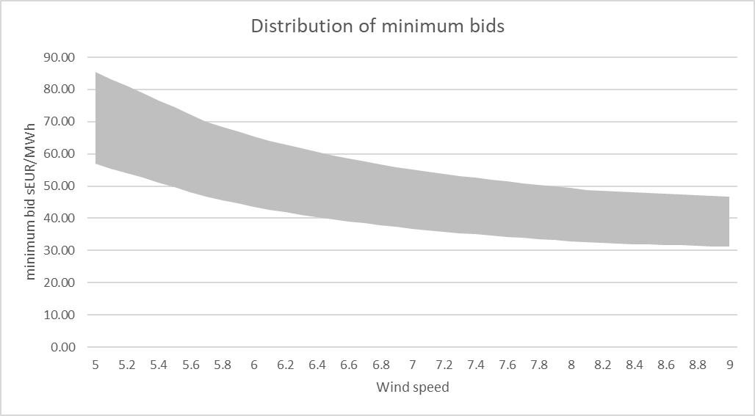

The lowest possible bid could be placed by the best project with wind speed of 9 and other costs 0,8. This would translate to cost of 31,14 EUR/MWh. Conversely, the worst possible project would have a wind speed of 5 m/s and other cost of 1,2; with a total cost of 85,4 EUR/MWh.

The maximum bid allowed in the auctions is 90,3 EUR/MWh.

**Preferential treatment <only of RYM applicable>**

The auctioneer has decided that competition between projects with various wind speeds is not fair and the resulting geographical distribution of projects might not be optimal. There will be a specific correction factor deriving from your wind speed. This correction factor applies to wind speeds between roughly 5,3m/s and 8,7m/s and can reach values between 0,79 (for project with highest wind speed) and 1,29 (for project with lowest wind speeds). If your project is better or worse than the limit amounts, these differences will not be corrected.

The relation of wind speed and respective correction factor is shown in Figure 2.

Figure 2: Wind speed and correction factor

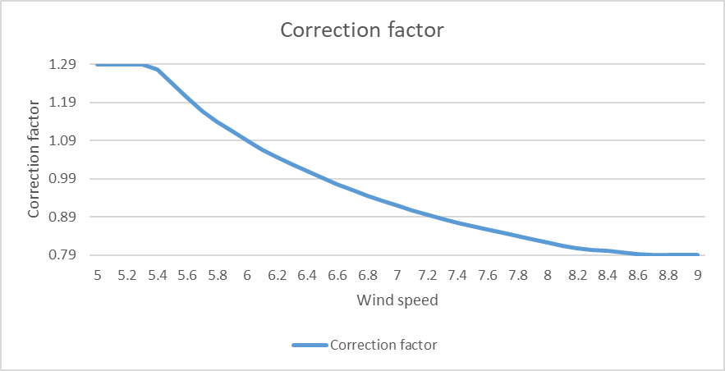

The auction will be evaluated based on placed bids, however, your subsidy received will be adjusted by your respective correction factor. You will be informed about the total cost of your project, your correction factor and resulting minimum bid in the auctions. You will be also shown what subsidy you would receive if you would place specific bid in the auction.

This mechanism changes the resulting minimum bids distribution. The resulting distribution is shown in Figure 3.

Figure 3: Distribution of minimum bids including the correction factor

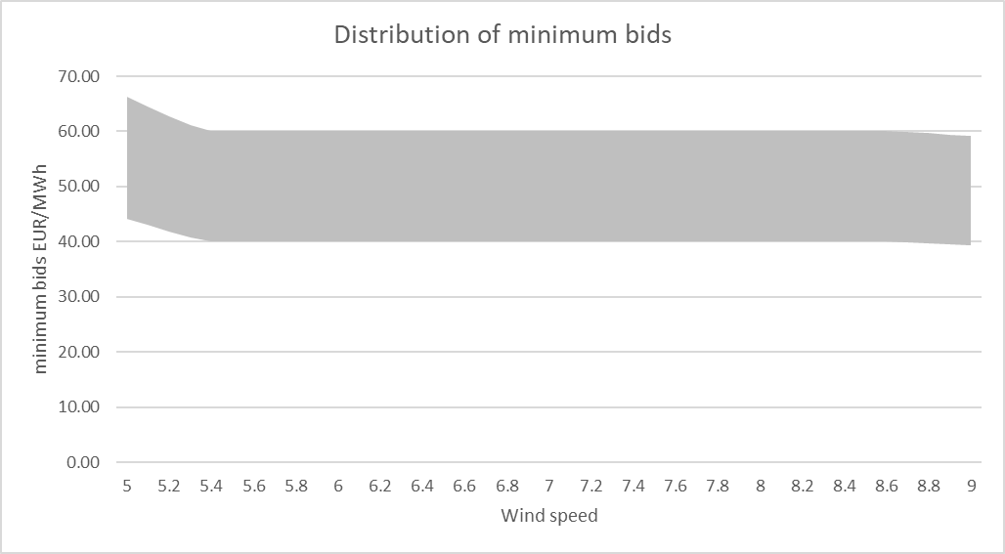

The lowest possible bid could be placed by the best project with wind speed of 9 and other costs 0,8. This would translate to a minimum bid of 39,42 EUR/MWh. Conversely, the worst possible project would have a wind speed of 5 m/s and other cost of 1,2; with a minimum bid of 66,2 EUR/MWh.

Please note that the respective bids will be adjusted by specific correction factor, therefore the project will actually receive higher/lower subsidy than placed bid.

Considering the correction factor the maximum possible bid is set to 70 EUR/MWh.

**Treatments**

The number of players entering the auctions will be constant; 4 players. However, each round you will be competing against different players.

You will play a four sets of 25 rounds with different demand for projects. Two sets the demand will be high (3 projects will be chosen and potential for profit creatin will be higher), two sets the demand will be low (1 project will be chosen and potential for profit creation will be lower).

You will be informed about the level of competition upfront an auction set of 25 rounds.

**Auction evaluation**

After each round of auction there will be an evaluation. You will receive information whether you were successful in the auction and what is your profit. Further you will receive general information about the auction round:

* Lowest successful bid
* Highest successful bid

Please not that in case of low demand auctions (1 project), these numbers will have similar value.

**Auction screen**

Here you will be provided with example of the auction screen. Read all the information in detail. There are five sections in the Auctions screen:

* *A. Parameters*; here you are informed about your specific project parameters as well as auction parameters.
* *B. Distributions*; here your project is compared to the distribution of other possible projects and their minimum bid. This picture provides you with information about the potential profitability of your project. The better the project (lower on y axis) the better your chance to make higher profit.
* *C. Bidding*; Place your bid in the highlighted box before the auction time run out. You are also informed about the subsidy you are going to receive should you win as well as the profit.
* *D. Auction outcome*; After each auction round, you will be informed whether you were successful in the auction or not; what was the subsidy awarded and about your profit. You will be also informed about highest successful and lowest successful bid.
* *E. History*; In this section you will find information about previous rounds of auctions.

Figure 4; Example of auction screen

<No RYM>

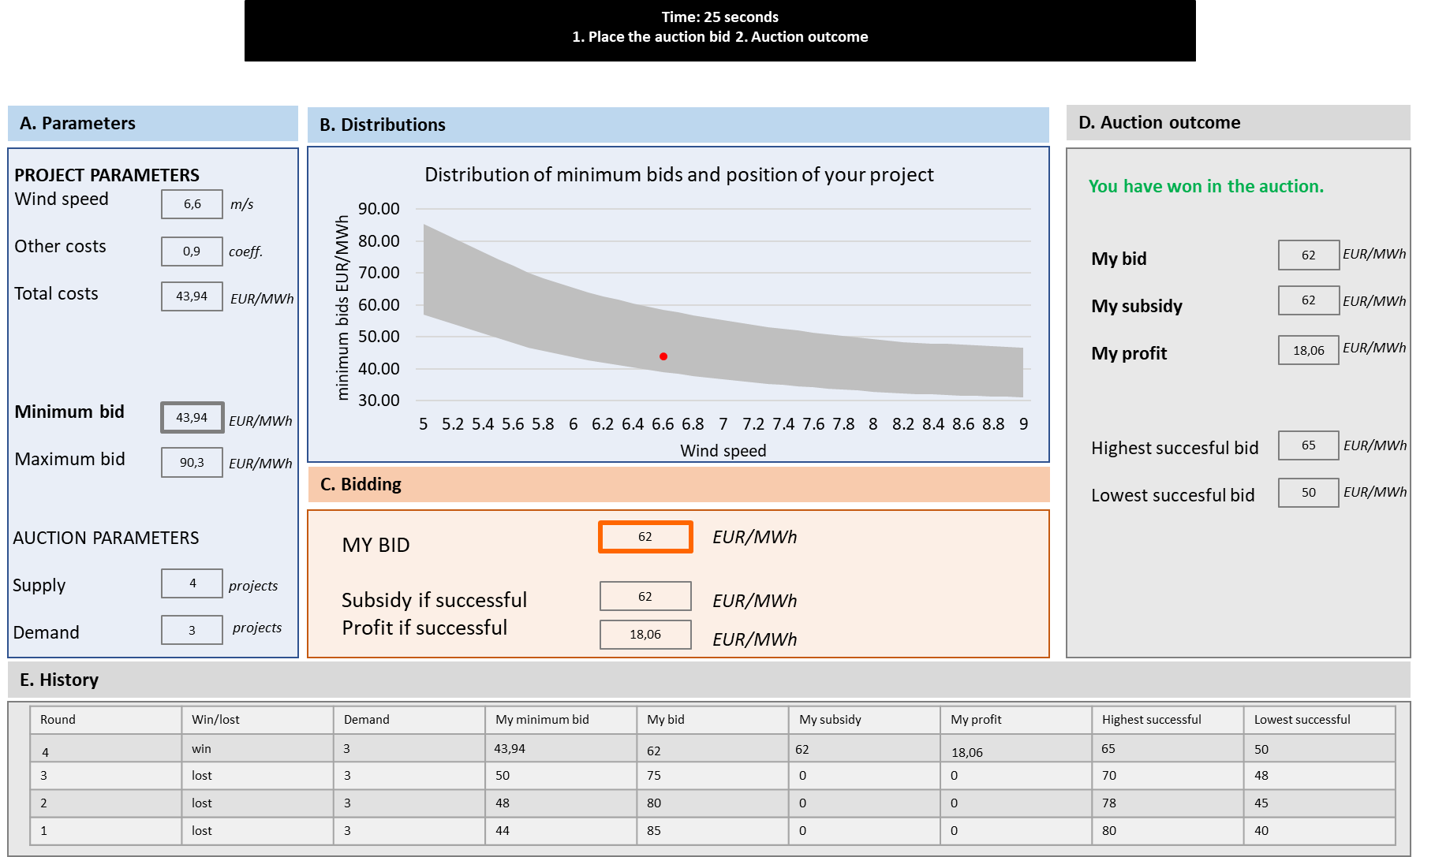

<RYM>

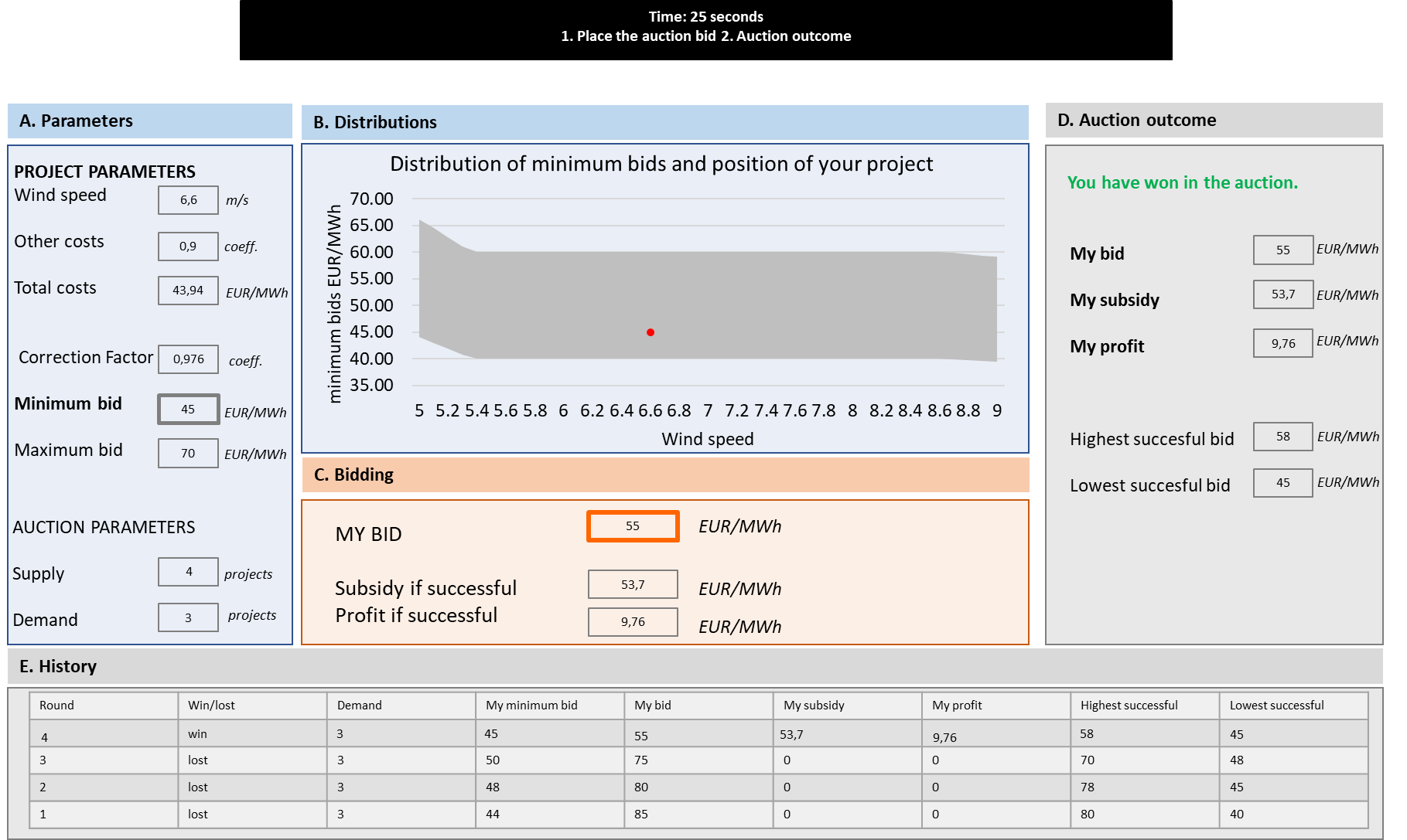

**Full experiment**

In total you will play 100 auction rounds. The game will be divided into 4 sections, each containing 25 rounds, with different demand structure.

**Remuneration**

There is a total estimated budget per player of CZK 500 including a minimum payment of CZK 200 for each player. You will receive a cash payment based on sum of your profits from all auction rounds and your relative performance as compared to other players.

The better you will perform the more money you will receive.

**Between treatments**

**Demand 1**

You are entering an auction with low demand. Only 1 project (out of 4) will be chosen each round. You should place your bid accordingly.

Please note that as each round is very competitive, it may be difficult or not possible at all to succeed in the auctions if your projects is not very good.

You will be playing 25 rounds.

**Demand 3**

You are entering an auction with high demand. 3 projects (out of 4) will be chosen each round. You should place your bid accordingly.

Please note that as each round 3 out of 4 projects are chosen, you should be able to succeed in the auctions and make profit most of the times.

You will be playing 25 rounds.