* Create a database called "contact"
* Create a collection called "contactlist"

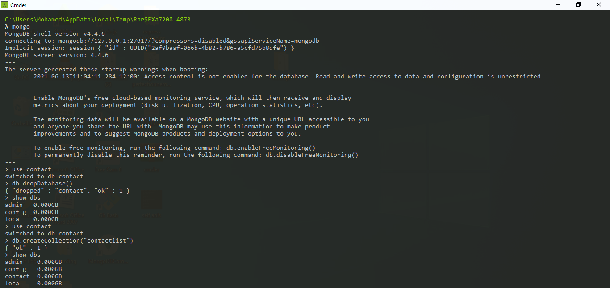

* Insert these documents  in "contactlist"

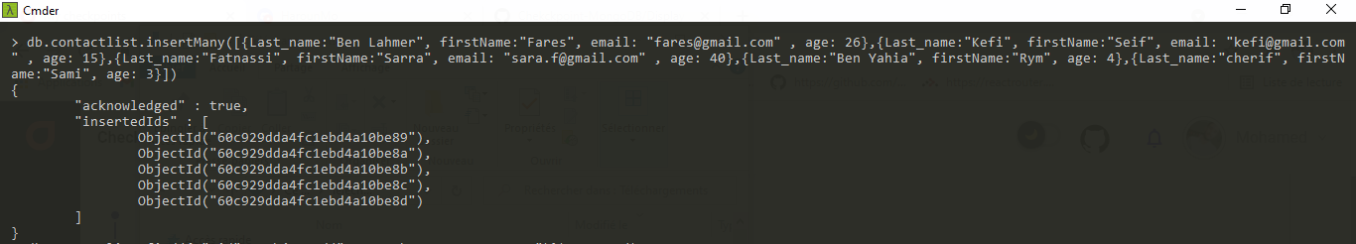

* Display all the information about only one person using his ID.

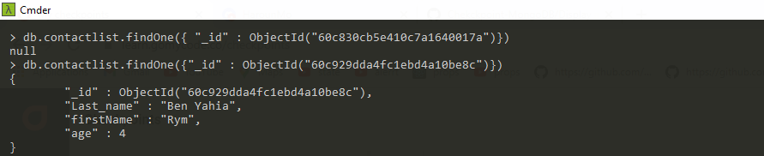

* Display all the contacts with an age >18.

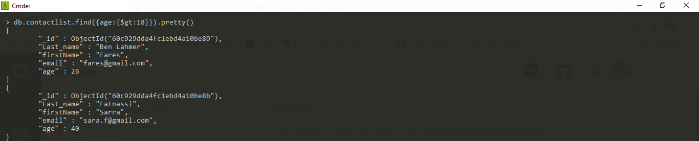

* Display all the contacts with an age>18 and name containing "ah".

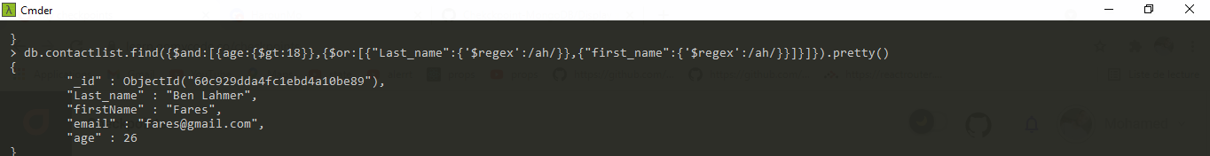

* Change the contact's first name from"Kefi Seif" to "Kefi Anis".

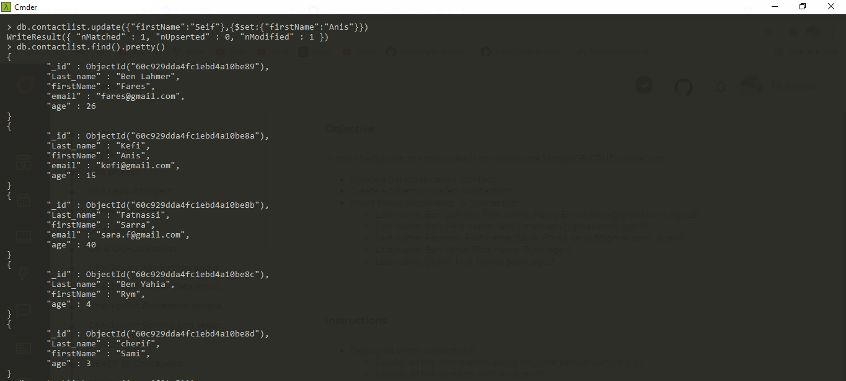

* Delete the contacts that are aged under <5.

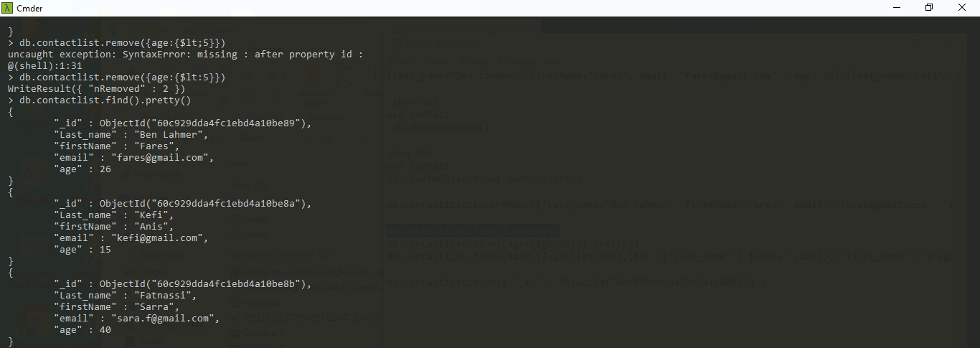

* Display all of the contacts list.

