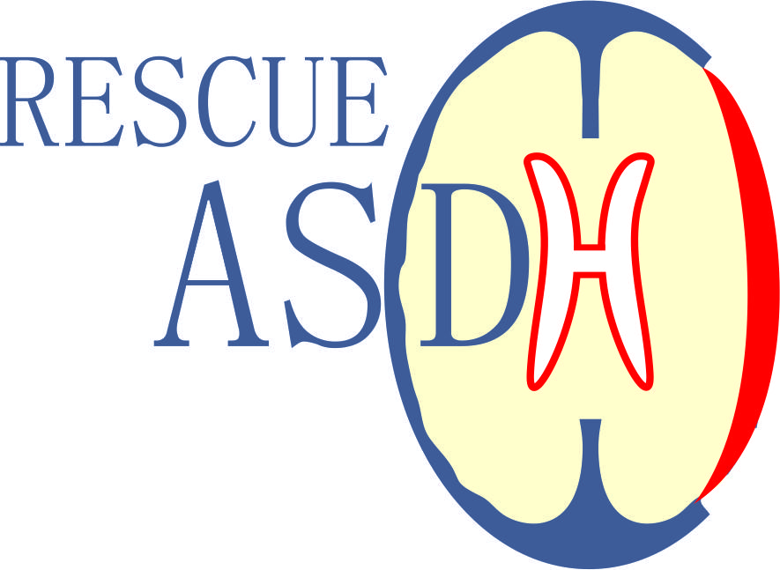**R**andomised **E**valuation of **S**urgery with **C**raniectomy for patients

**U**ndergoing **E**vacuation of **A**cute **S**ubdural **H**aematoma

**(RESCUE-ASDH)**

|  |
| --- |
| **Outcomes Questionnaire**  **(Glasgow Outcomes Scale – Extended)**  Dear **<patient name>**,  We would be very grateful if you or a relative/friend would agree to complete the following questionnaire. Your participation and co-operation are important so that the results of the study are reliable and useful to improve the care of patients with acute subdural haematomas.  In this questionnaire, we use the words **“you”, “your” and “head-injured person”** referring to **<patient name>**. Some people in this study may have a medical condition or disability that would prevent them to fill in these questionnaires themselves. In that case, a relative/friend can fill out the questionnaires, however the words “you” and “your” still refer to **<patient name>** and not to the person helping/assisting in filling out the questionnaires.  A FREEPOST envelope is provided for return of the questionnaire. Please answer multiple choice questions by putting a in ONE BOX for each question.  ✓  **Please complete today’s date below:**    ______ / ______ / ______  Day Month Year  **Please also let us know who will complete this questionnaire:**  🞎 **<patient name>** Alone  🞎 **<patient name>** With help from relative/friend/carer.  🞎 Or it was completed by someone who cares for **<patient name>**  **NOW PLEASE TURN THE PAGE TO START THE QUESTIONNAIRE** ▶  If you do not wish to complete this questionnaire, please return the unanswered questionnaire in the FREEPOST envelope provided.  Your current and future care will not be affected whether you decide to, or not to, fill out this questionnaire. |

**For each question please select the response that best describes your answer by marking (✓) the appropriate box.**

Part 1. Consciousness

1. **Is the head-injured person able to obey simple commands or say any words?**

Note: obeying commands is considered anyone who shows the ability to obey even simple commands or utter any word or communicate specifically in any other way. Eye movements alone are not reliable evidence of meaningful responsiveness.

🞎 NO

🞎 YES

Part 2. Independence at home

1. **Is the assistance of another person at home essential every day for some activities of daily living?**

Note: for a NO answer you should be able to look after yourself at home for 24 hours if necessary. Not requiring assistance means that you have the ability to plan for and carry out the following activities: getting washed, putting on clean clothes without prompting, preparing food for themselves, dealing with callers and handling minor domestic crises. You should be able to carry out activities without needing prompting or reminding and should be capable of being left alone overnight.

🞎 NO – GO TO PART 3

🞎 YES – Please give details about the number of visit(s) below

1. **Do you need frequent help or someone to be around at home most of the time?**

Note: for a NO answer you should be able to look after yourself at home up to 8 hours during the day if necessary.

🞎 NO

🞎 YES

1. **Was assistance at home essential before the injury?**

🞎 NO

🞎 YES

**PLEASE TURN THE PAGE TO CONTINUE** ▶

Part 3. Independence outside home

1. **Are you able to shop without assistance?**

Note: this includes being able to plan what to buy, take care of money yourself and behave appropriately in public.

🞎 NO

🞎 YES

1. **Were you able to shop without assistance before?**

🞎 NO

🞎 YES

Part 4. Independence outside home - 2

1. **Are you able to travel locally without assistance?**

Note: you may drive or use public transport to get around. Ability to use a taxi is sufficient, provided that you person can phone for it yourself and instruct the driver.

🞎 NO

🞎 YES

1. **Were you able to travel locally without assistance before the injury?**

🞎 NO

🞎 YES

Part 5. Work

1. **Are you currently able to work (or look after others at home) to your previous capacity?**

🞎 NO

🞎 YES – GO TO PART 6

**PLEASE TURN THE PAGE TO CONTINUE** ▶

1. **How restricted are you?**

🞎 a. Reduced work capacity

🞎 b. Able to work only in a sheltered workshop **or** non-competitive job **or** currently unable to work

1. **Were you either working or seeking employment before the injury (answer is ‘Yes’) or were you doing neither (answer is ‘No’)?**

🞎 NO

🞎 YES

Part 6. Social and Leisure activities

1. **Are you able to resume regular social and leisure activities outside home?**

Note: you need not have resumed all your previous leisure activities, but should not be prevented by physical or mental impairment. If you have stopped the majority of activities because of loss of interest or motivation, then this is also considered a ‘No’ answer.

🞎 NO

🞎 YES – GO TO PART 7

1. **What is the extent of restriction on your social and leisure activities?**

🞎 a. Participate a bit less: at least half as often as before injury

🞎 b. Participate much less: less than half as often

🞎 c. Unable to participate: rarely, if ever, take part

1. **Did you engage in regular social and leisure activities outside home before injury?**

🞎 NO

🞎 YES

**PLEASE TURN THE PAGE TO CONTINUE** ▶

Part 7. Family and friendships

1. **Have there been psychological problems which have resulted in ongoing family disruption or disruption to friendships?**

Note: typical post-traumatic personality changes are: quick temper, irritability, anxiety, insensitivity to others, mood swings, depression and unreasonable or childish behaviour.

🞎 NO – GO TO PART 8

🞎 YES

1. **What has been the extent of disruption or strain?**

🞎 a. Occasional - less than weekly

🞎 b. Frequent - once a week or more, but not tolerable

🞎 c. Constant - daily and intolerable

1. **Were there problems with family or friends before injury?**

Note: if there were some problems before injury, but these have become markedly worse since the injury then answer ‘No’ to question

🞎 NO

🞎 YES

**EPILEPSY**

1. **Since the injury have you had any epileptic fits?**

🞎 NO

🞎 YES

1. **Have you been told that you are currently at risk of developing epilepsy?**

🞎 NO

🞎 YES

**PLEASE TURN THE PAGE TO CONTINUE** ▶

Part 8. Return to normal life

1. **Are there any other current problems relating to the injury which affect daily life?**

Note: other typical problems reported after head injury: headaches, dizziness, sensitivity to noise or light, slowness, memory failures and concentration problems.

🞎 NO

🞎 YES

1. **Were similar problems present before surgery?**

Note: if there were some problems before injury, but these have become markedly worse since injury then please answer ‘No’

🞎 NO

🞎 YES

Part 9. Return to normal life - 2

1. **What is the most important factor affecting your outcome?**

🞎 The effects of head injury?

🞎 Effects of illness or injury to another part of the body?

🞎 A mixture of these?

**PLEASE TURN THE PAGE TO CONTINUE** ▶

Part 10. Comments

Your comments are important to us. Please feel free to provide any other comments you have in the box below.

Thank you for your help!

If you would like to ask us any questions about completing this questionnaire please email or call:

Name of contact person

🖂 email@website.org

🕿 00000-000000