CIS-476 Term Project
Ali Ramadan

Singleton pattern:
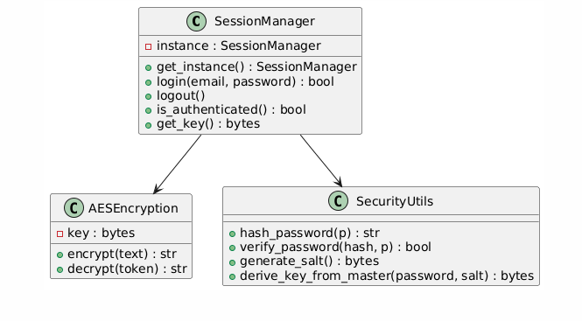
The Singleton pattern ensures that only one instance of the SessionManager class exists throughout the entire application. This is important, as session handling must stay consistent and globally accessible while preventing multiple conflicting states of the session. In MyPass, the Singleton handles authentication status, the storage of an AES key, and user activity timestamps. By housing this logic centrally in one shared instance, the system has secure, synchronized session control across all routes and interactions with the UI.

Observer pattern:
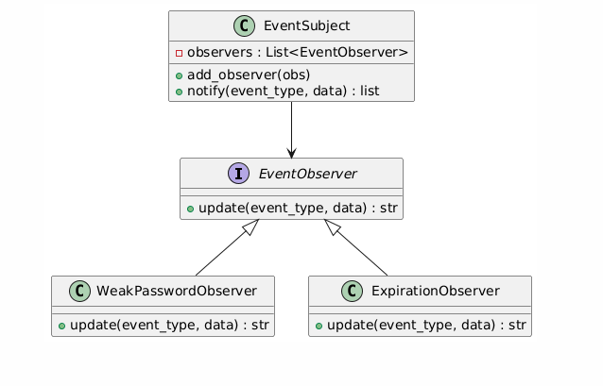
MyPass employs the Observer pattern to automatically detect and act upon important security-related events whenever the user saves sensitive items. An EventSubject plays the role of the notifier, while the WeakPasswordObserver and ExpirationObserver are observers that observe events such as saving a weak password or adding a credit card whose expiration date has passed. The observers check the event and return warnings if necessary. This design allows the main security checks to be modular; adding new observers does not require changes to the core application logic. Indeed, this provides flexibility and extensibility for the monitoring system.

Mediator pattern:
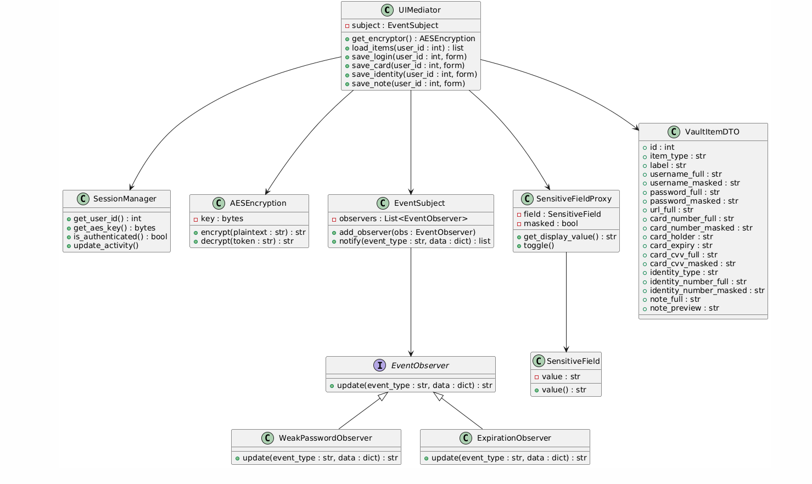
In the MyPass implementation, the UIMediator class acts as the Mediator pattern, ensuring that all communication between the user interface, session management, encryption logic, observers, and sensitive field masking is performed through it. Rather than allowing Flask routes to directly interact with encryption, database objects, or security observers, the mediator places these interactions within one central location, keeping components loosely coupled and easier to maintain. Upon loading or saving of items, it fetches the current user session, derives the appropriate AES encryption instance, formats decrypted data to display-ready objects, and initiates observer notifications for things like weak password or expiration warnings. It also works with the SensitiveFieldProxy to create masked and unmasked versions of sensitive values destined for the UI. This has the added benefit of keeping the UI layer straightforward, while the complex coordination logic is encapsulated within the mediator, enhancing the system organization and extensibility.

Builder pattern:
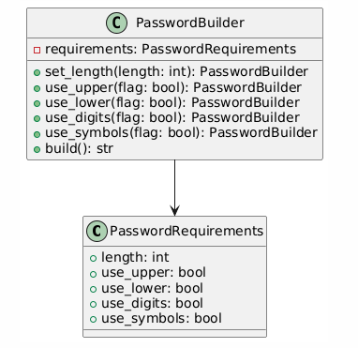
In MyPass, the Builder pattern is implemented via the PasswordBuilder class, which is responsible for generating strong yet customizable passwords based on a set of configurable requirements. Instead of creating a rigid function to build a password, the builder maintains a PasswordRequirements object that defines the length of the generated password and whether to include uppercase letters, lowercase letters, digits, and symbols. The application can then fluently configure these options using methods such as set_length, use_upper, use_lower, use_digits, and use_symbols. Finally, calling build() produces a random password that fits the specified criteria. This pattern separates the logic of construction from the final representation of the password and allows easy adaptation of strength policies or future extension of the generator. In the UI, this builder is used by the password generation feature to provide users with strong, automatically generated passwords for their vault items.

Proxy pattern:
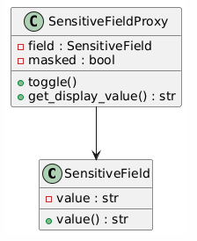
The Proxy pattern in MyPass is implemented by the SensitiveField and SensitiveFieldProxy classes to secure sensitive information such as passwords, credit card numbers, CVV, and identity numbers from exposure when shown in a user interface. SensitiveField holds the real decrypted value, while SensitiveFieldProxy controls whether to show the user the masked or unmasked version. The full value is hidden by default; the proxy returns a masked form exhibiting asterisks for most of the characters and showing only the last few digits. If the user clicks the Show/Hide button, the proxy switches between these two states without ever directly exposing the underlying field. This pattern gives the application fine-grained control over how sensitive information is revealed, enhances security by preventing its accidental exposure, and cleanly separates data representation from data protection logic.

Chain of Responsibility pattern:
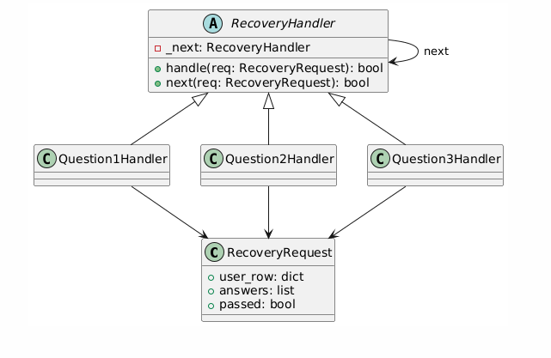
MyPass makes use of the Chain of Responsibility pattern to implement secure and structured password recovery using the three security questions provided during account registration. A chain of handler classes is defined in the system: Question1Handler, Question2Handler, and Question3Handler. All these handlers extend the abstract base class RecoveryHandler. Each handler is in charge of one answer validation in the sequence, and in case of a correct answer, it forwards the request to the next handler in the chain. If any answer is wrong, the chain stops immediately, avoiding further processing and denies recovery. The RecoveryRequest object carries the user’s stored hashed answers, the submitted answers, and a final passed flag that becomes True only if all three handlers approve the request. This design cleanly separates the validation steps, enhances modularity, and ensures that the recovery flow is both secure and easily extensible.

Database schemas
Users Table Schema:
users (
id INTEGER PRIMARY KEY AUTOINCREMENT,
email TEXT UNIQUE NOT NULL,
password_hash TEXT NOT NULL,
salt BLOB NOT NULL,
q1 TEXT NOT NULL,
a1_hash TEXT NOT NULL,
q2 TEXT NOT NULL,
a2_hash TEXT NOT NULL,
q3 TEXT NOT NULL,
a3_hash TEXT NOT NULL
)
The users table contains all the information on authentication and recovery. For each user, it stores a unique email and a hashed password, along with a cryptographic salt to derive their AES-256 encryption key. It also keeps the three customizable security questions and their securely hashed answers. This design supports highly secure login, AES key derivation, and multi-step password recovery, without storing the plaintext answers or passwords at any moment.

Vault Items Table Schema:
vault_items (
id INTEGER PRIMARY KEY AUTOINCREMENT,
user_id INTEGER NOT NULL,
item_type TEXT NOT NULL,
label TEXT NOT NULL,

username_enc TEXT,
password_enc TEXT,
url_enc TEXT,

card_number_enc TEXT,
card_holder_enc TEXT,
card_expiry TEXT,
card_cvv_enc TEXT,

identity_number_enc TEXT,
identity_type TEXT,

note_enc TEXT,

FOREIGN KEY (user_id) REFERENCES users(id) ON DELETE CASCADE
)
The encrypted user data is stored in the vault_items table. Each row in the table represents a user and one of the four built-in types: LOGIN, CREDIT_CARD, IDENTITY, or SECURE_NOTE. There are different encrypted columns depending on which item type is used. For example, encrypted username and password for login entries, encrypted card number and CVV for credit cards, encrypted passport/ID/SSN values for identity entries, and fully encrypted text for secure notes. All sensitive fields are encrypted using AES-256-GCM with a per-user key derived from the password. This structure supports secure storage, editing, masking/unmasking, and item-type-specific UI interactions.

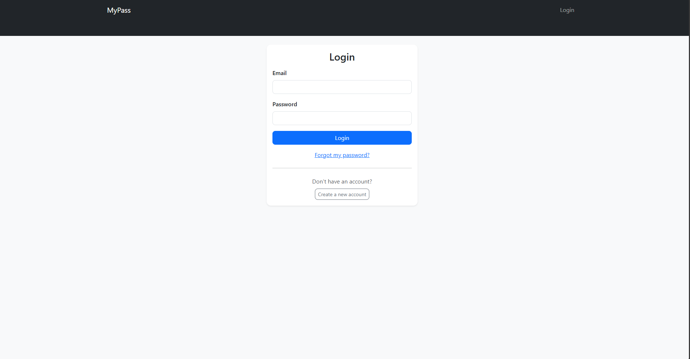
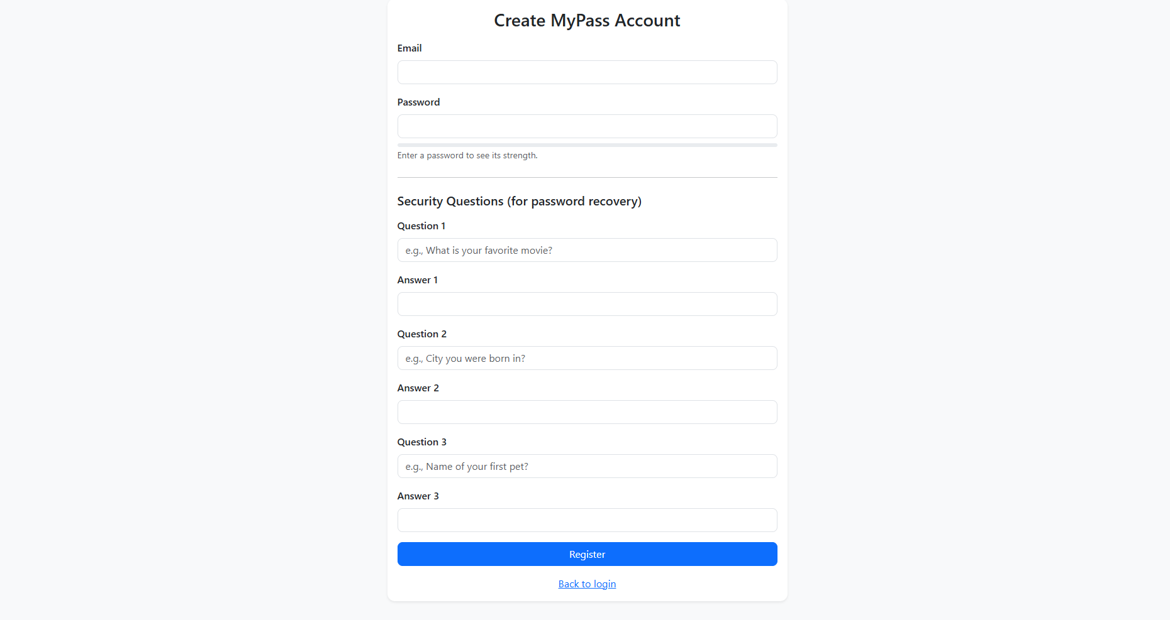
The login screen allows users to authenticate with their email and password. It also provides access to the password recovery workflow.
The registration screen collects user credentials and three security questions used for recovery. The password strength meter guides users toward stronger passwords.

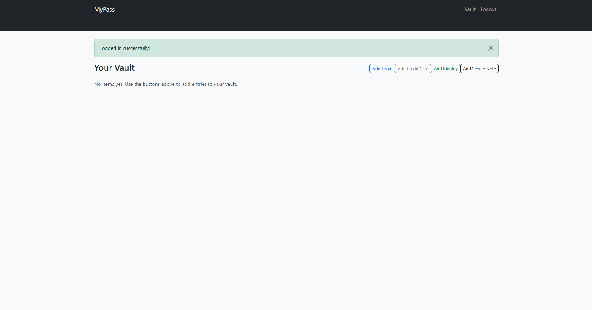
The vault screen is the main interface where users can view and manage all of their sensitive items. Masked fields prevent accidental exposure.
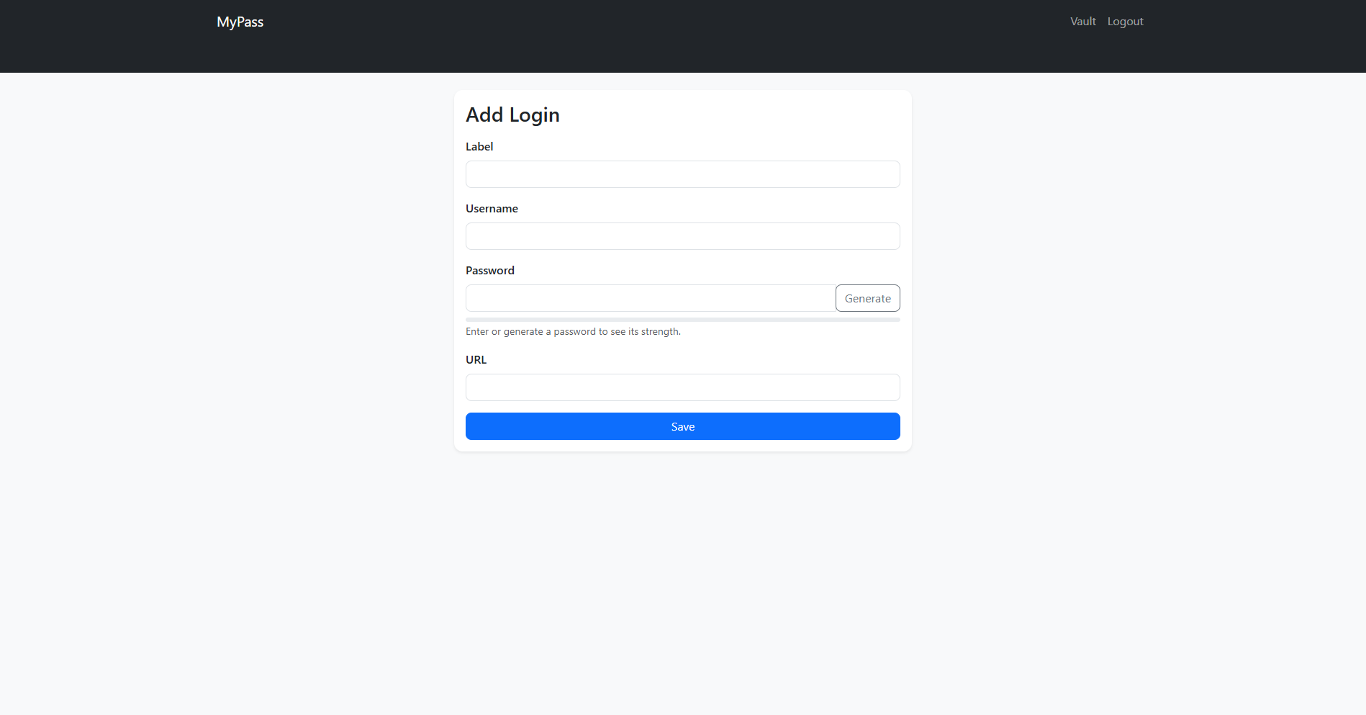
This form allows users to create a Login item, including username, password, and URL. A built-in password generator and strength meter improve security.

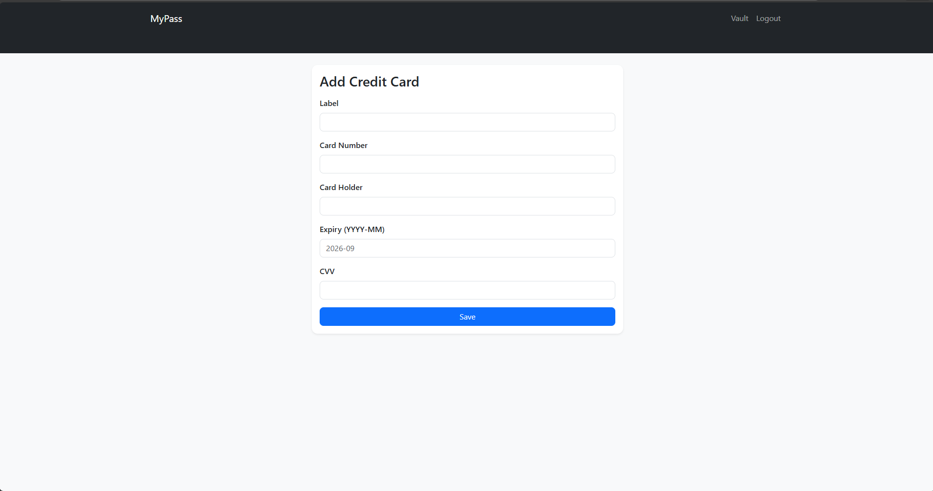
The credit card form securely stores payment card details using AES encryption and masking.
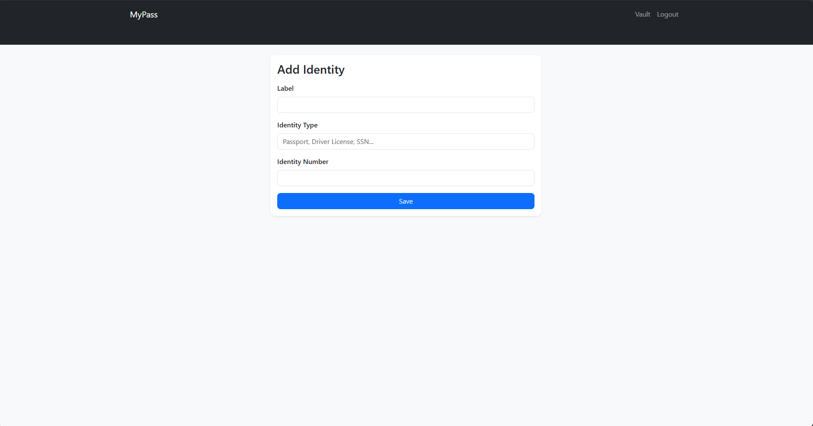
The identity form is used to store official identification numbers securely.

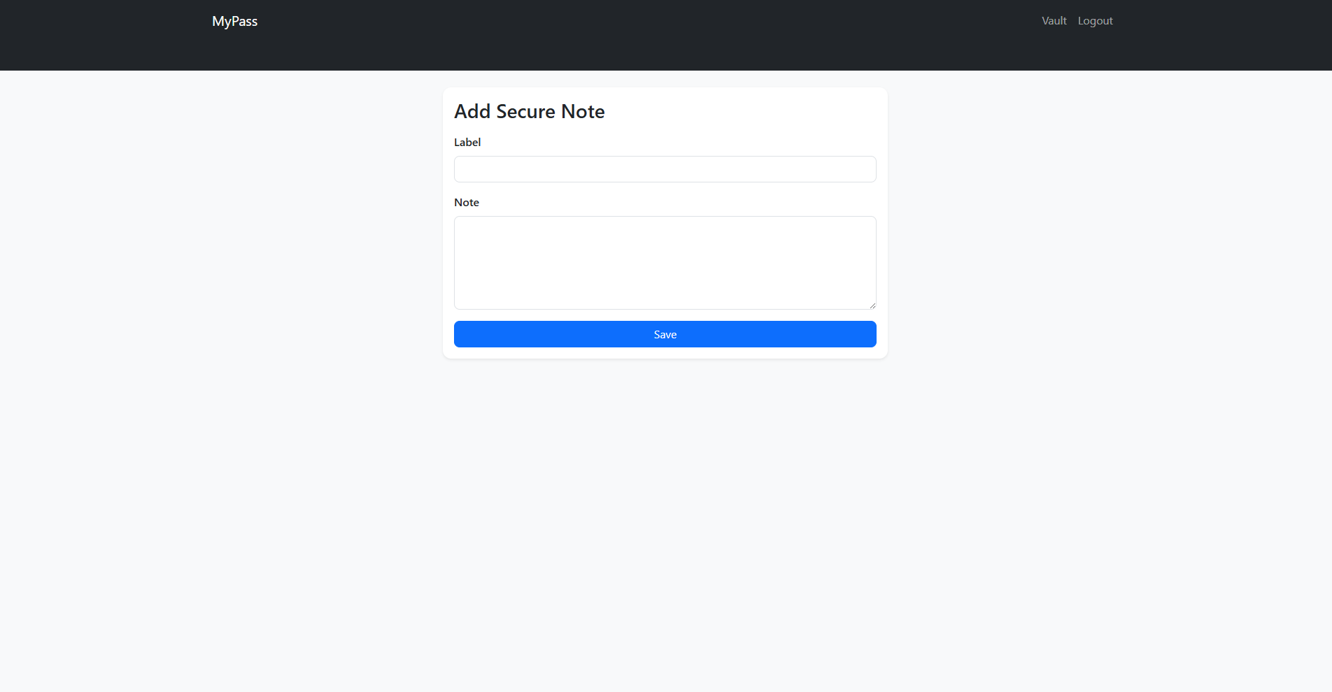
The secure note form stores private text that is encrypted and masked by default.
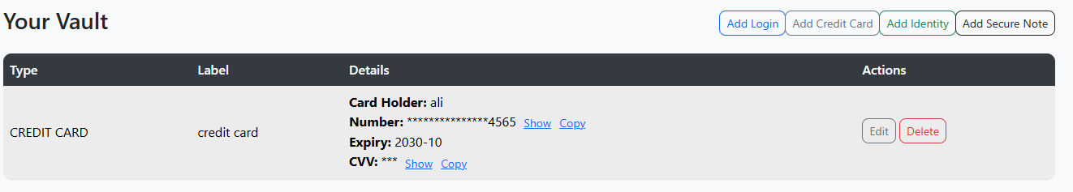
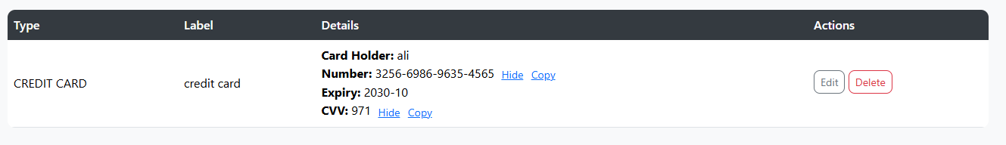
Masking prevents accidental exposure of sensitive data. Users can selectively unmask individual fields when needed.
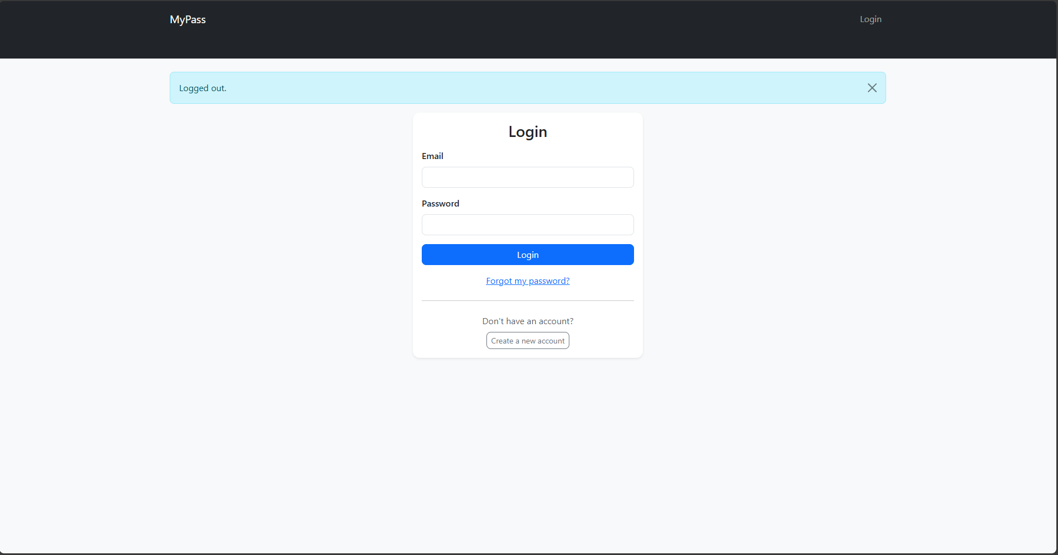
To prevent unauthorized access, MyPass automatically logs out users after inactivity.
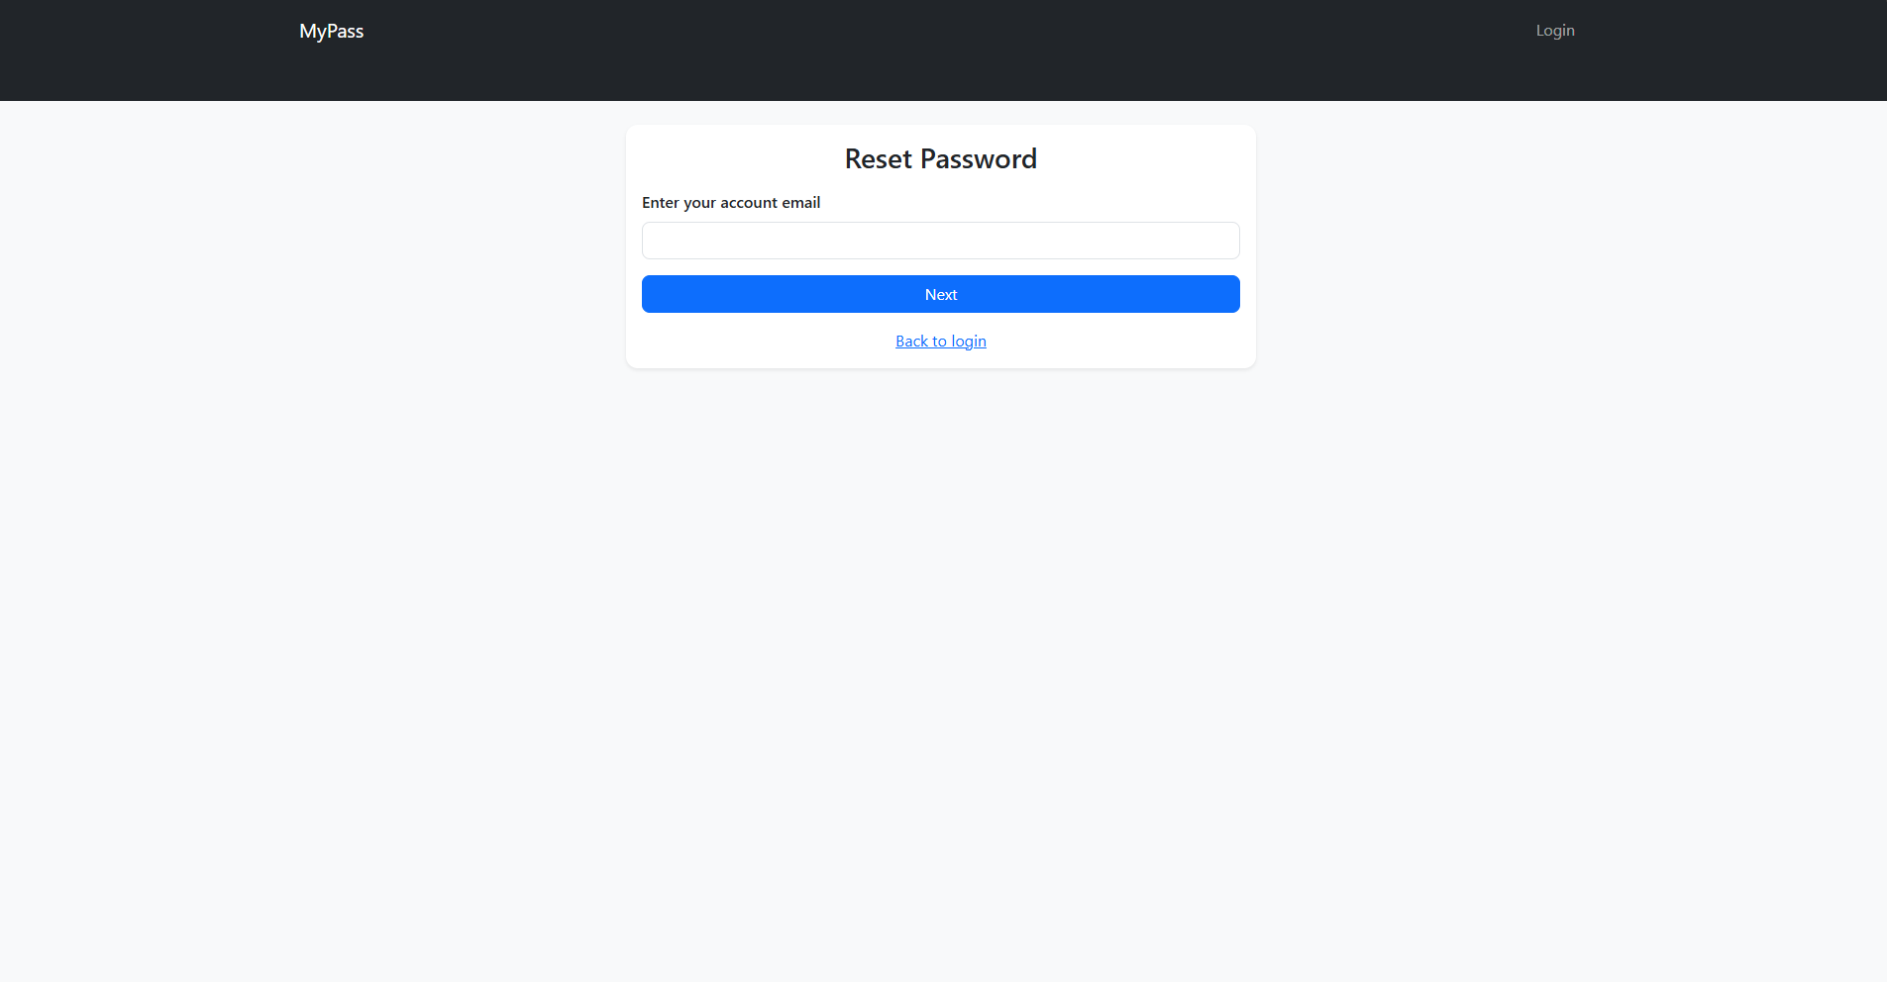
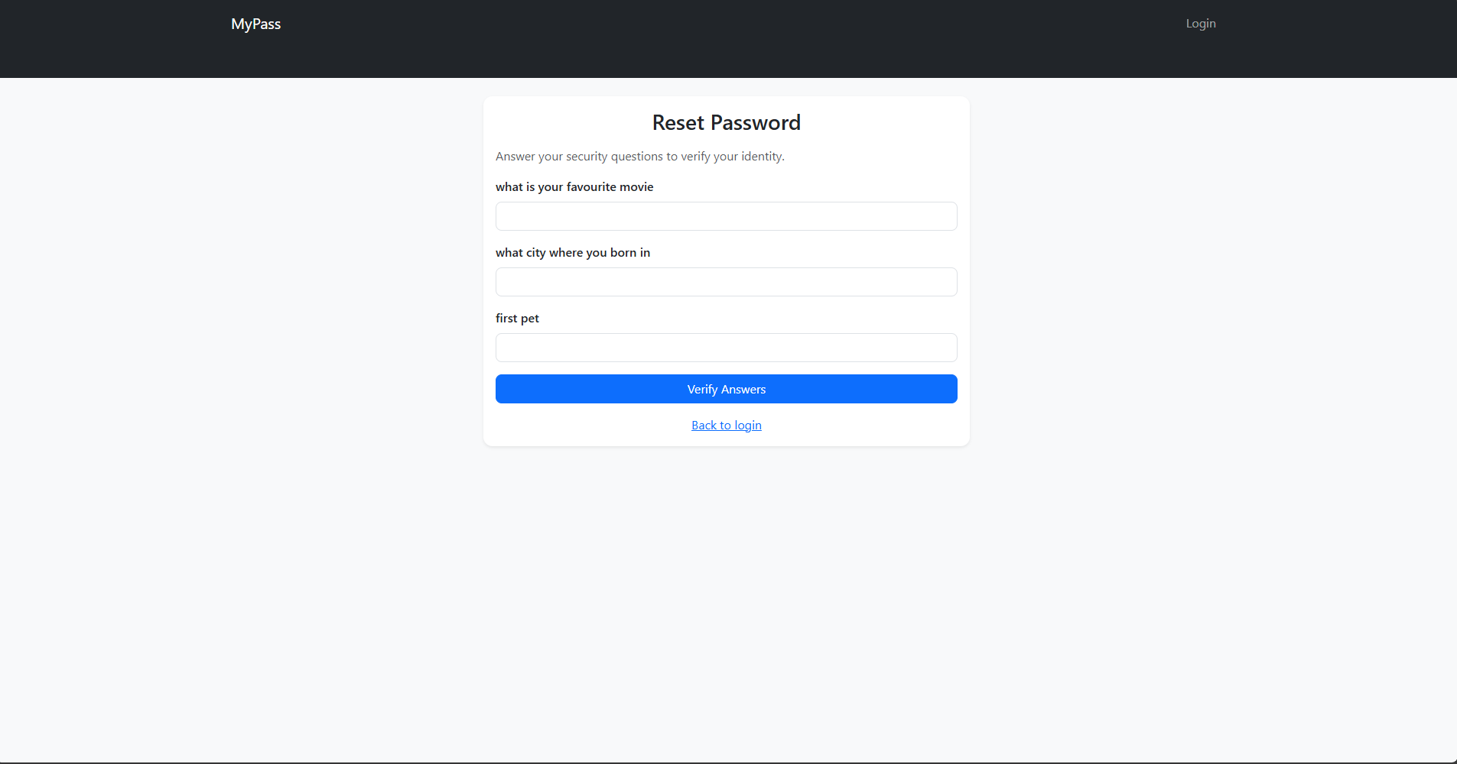
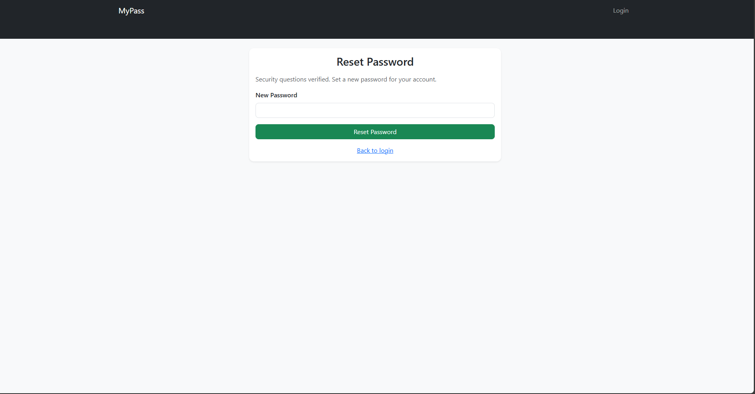
The password recovery workflow uses the Chain of Responsibility pattern, validating each answer step-by-step before permitting a password reset.

