Lineups: Building Intuition for Two-Sample Inference

Adam Loy

**Background**

Evidence suggests that reward systems may operate in the opposite way from what is intended (e.g., ranking systems may decrease productivity; grading systems not stimulate learning). To investigate this phenomenon, Amabile, T. M. (1985) designed a study to explore whether motivation type (intrinsic or extrinsic) impacted creativity scores. In this study, 47 creative writers were randomly assigned to one of two questionnaires where they ranked reasons they write. One questionnaire listed intrinsic motivations and the other listed extrinsic motivations. After completing the questionnaire, all subjects wrote a Haiku about laughter, which was graded for creativity by a panel of poets. The average rating (out of 40 points) for each subject was recorded. In this activity, you will explore whether there are discernible differences in creativity between the two groups.

1. Is this an experimental or observational study? How do you know?
2. What research question is being investigated? That is, what is the objective of this study?
3. Write down the competing claims (i.e., hypotheses) being investigated.
4. Identify the response variable and the treatment.
5. What type of plot could you use to compare the two treatment groups? Why did you choose this plot type? How does this plot help you investigate the competing claims?
6. Below is a lineup where one panel is a plot of the observed data and the other 19 plots are generated under the situation where there is no difference between the treatment groups. Which panel is the most different from the others? What feature of the plot led you to this choice? 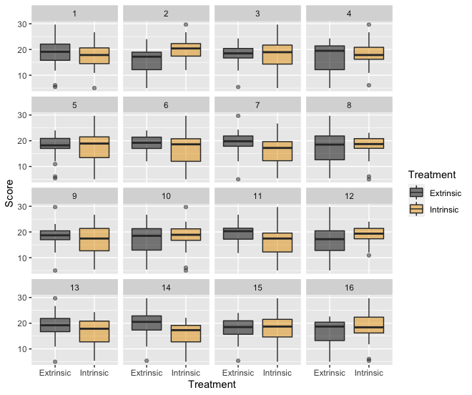
7. GROUP DISCUSSION…
8. REVEAL PANEL, GROUP DISCUSSION OF IMPLICATIONS…
9. What assumptions need to be checked before we can conclude the analysis in Question 6) is appropriate? For example, did keeping or removing the outliers influence the results? If some of the students used hints and others did not, are the results biased?
10. State your conclusions in context. For example, explain whether we can use this data to conclude that our results hold for all students at our school. In addition, if the model assumptions were not perfectly met, explain how your results might be influenced.