Learning to Read Residual Plots via Lineups

Adam Loy

Loading necessary packages:

library(broom)  
library(nullabor)  
library(ggformula)

## Loading required package: ggplot2

## Loading required package: ggstance

##   
## Attaching package: 'ggstance'

## The following objects are masked from 'package:ggplot2':  
##   
## geom_errorbarh, GeomErrorbarh

##   
## New to ggformula? Try the tutorials:   
## learnr::run_tutorial("introduction", package = "ggformula")  
## learnr::run_tutorial("refining", package = "ggformula")

library(dplyr)

##   
## Attaching package: 'dplyr'

## The following objects are masked from 'package:stats':  
##   
## filter, lag

## The following objects are masked from 'package:base':  
##   
## intersect, setdiff, setequal, union

Loading the data set from Stat2Data:

data("RailsTrails", package = "Stat2Data")

Fitting the SLR model:

rt_lm <- lm(Price2014 ~ Distance, data = RailsTrails)  
summary(rt_lm)

##   
## Call:  
## lm(formula = Price2014 ~ Distance, data = RailsTrails)  
##   
## Residuals:  
## Min 1Q Median 3Q Max   
## -202.74 -56.27 -15.91 31.53 551.45   
##   
## Coefficients:  
## Estimate Std. Error t value Pr(>|t|)   
## (Intercept) 352.16 15.18 23.192 < 2e-16 ***  
## Distance -53.01 10.44 -5.079 1.72e-06 ***  
## ---  
## Signif. codes: 0 '***' 0.001 '**' 0.01 '*' 0.05 '.' 0.1 ' ' 1  
##   
## Residual standard error: 99.55 on 102 degrees of freedom  
## Multiple R-squared: 0.2018, Adjusted R-squared: 0.194   
## F-statistic: 25.79 on 1 and 102 DF, p-value: 1.72e-06

Creating a lineup of residual plots:

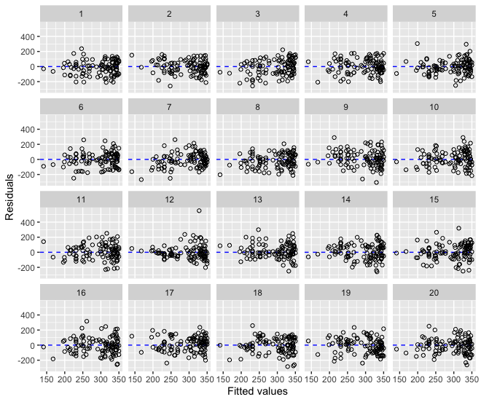

Creating a lineup of residual histograms:

