Polynomial Regression

## Example 1

For each regression model, sketch the fitted model. To do this, first write the expression for the fitted model for smokers and the fitted model for non-smokers (e.g., plug in 0 and 1 for the indicator variable). Once you have these two equations, use them to sketch the lines on the provided graph.

**Model 1: $μ\left(y|x\right)=10+1age−2smoker$**

Fitted equation for non-smokers:

Fitted equation for smokers:

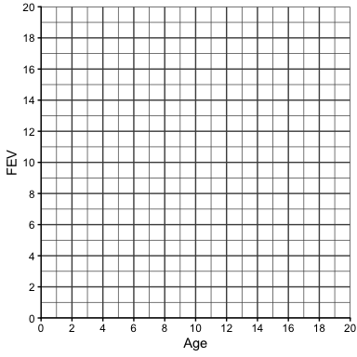

**Model 2: $μ\left(y|x\right)=5+1age−0.5age×smoker$**

Fitted equation for non-smokers:

Fitted equation for smokers:

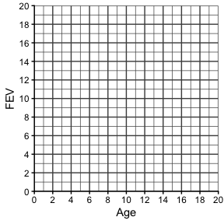

**Model 3: $μ\left(y|x\right)=4+0.5age+3smoker−0.5age×smoker$**

Fitted equation for non-smokers:

Fitted equation for smokers:

