Revision History
Date | Version | Description | Author
21/11/2018 | 1.0 | Added component diagram for section 2. Added class diagrams for component 1,2 and 3 | Ataberk Ozek
21/11/2018 | 1.1 | Added component interfaces for all components | Alp Demirezen
22/11/2018 | 1.2 | Added activity diagrams for all components | Alp Demirezen
23/11/2018 | 1.3 | COTS identification added | Elif Gocumoglu, Ege Bilir
23/11/2018 | 1.4 | Added mapping of software requirements | Ahmet Gokce
30/11/2018 | 1.5 | Software Architecture Overview, Subsection names and COTS identification updated. | Ege Bilir
30/11/2018 | 1.6 | Added components interfaces and activity diagram for component 4 | Mert Anıl Büyükiz
30/11/2018 | 1.7 | Edited House , Land , Workplace class diagrams and edited section 2 | Ataberk Ozek
30/11/2018 | 1.8 | Edited mapping of software requirements | Ahmet Gokce
30/11/2018 | 1.9 | All document revised. | Alp Demirezen

TABLE OF CONTENTS
Revision History 1
1 Introduction 3
1.1 References 3
1.1.1 Project References 3
2 Software Architecture overview 3
3 Software design description 4
3.1 House 4
3.1.1 Component interfaces 4
3.1.2 Component design description 4
3.1.3 Workflows and algorithms 5
3.1.4 Software requirements mapping 5
3.2 Workplace 5
3.2.1 Component interfaces 5
3.2.2 Component design description 6
3.2.3 Workflows and algorithms 6
3.2.4 Software requirements mapping 7
3.3 Land 7
3.3.1 Component interfaces 7
3.3.2 Component design description 7
3.3.3 Workflows and algorithms 8
3.3.4 Software requirements mapping 8
3.4 System 8
3.4.1 Component Interfaces 8
3.4.2 Component Design Description 8
3.4.3 Workflows and Algorithm 9
3.4.4 Software requirements mapping 9
4 COTS Identification 9

Introduction

This document describes the design of the REP software system.

References

Project References

# | Document Identifier | Document Title
[SRS] | REP-SRS-1 | Software Architecture Overview
SRS | REP-SRS-1 | Requirements

Software Architecture overview
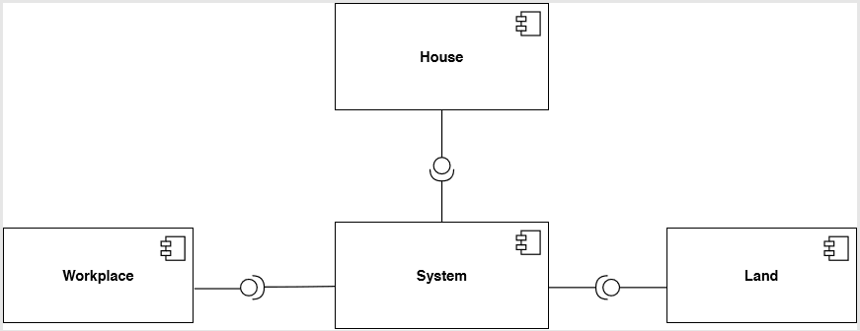

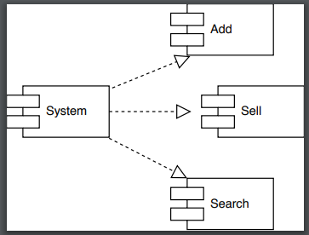

Software design description

House

Component interfaces
House will be an interface which will have “For sale” as an input of Boolean. House will be an interface which will have “For sale” as an input of Boolean.

Component design description

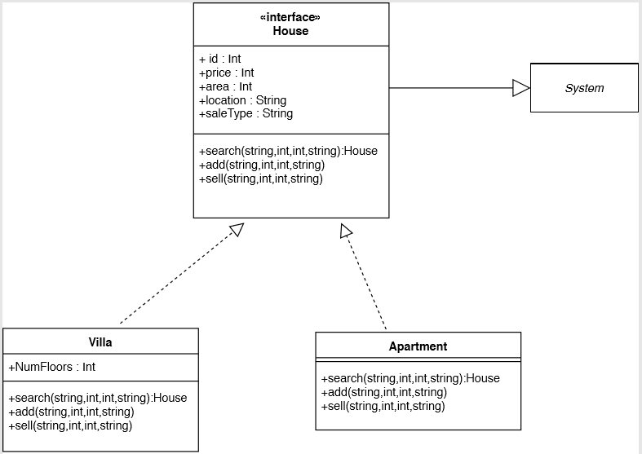

Workflows and algorithms
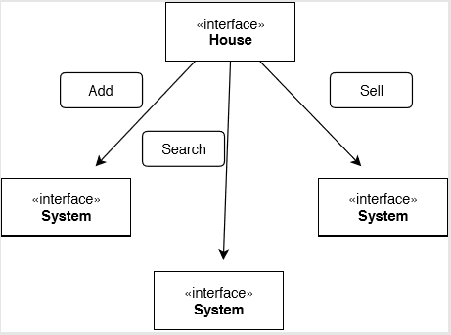

Software requirements mapping

House component is used for these requirements;
SRS-REP-004
SRS-REP-005
SRS-REP-006
SRS-REP-007

Firstly, user shall choses type of house which are apartment or villa. After that, user reaches add, sell and search methods. The attributes of villa are id, area, location, price, numbers of floors and sales type. Apartment attributes are id, price, location, floor, area and sales type. Search needs all of attributes expect id and add method uses all attributes as input. Sell needs id as input.

Workplace

Component interfaces
Workplace will be an interface which will have “For sale” as an input of Boolean. House will be an interface which will have “For sale” as an input of Boolean.

Component design description
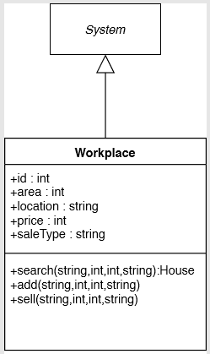

Workflows and algorithms

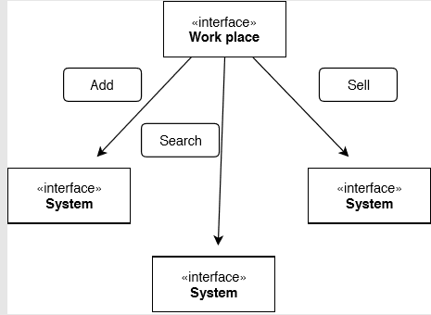

Software requirements mapping

Workplace component is used for these requirements;
SRS-REP-004
SRS-REP-005
SRS-REP-006
SRS-REP-007

Workplace provide search, add and sell methods to user. Attributes of workplace area, location, price, sales type and id. Search method needs the attributes as inputs expect id. Add method use all attributes as input. Sell needs only id as input.

Land

Component interfaces
Land will be an interface which will have “For sale” as an input of Boolean. House will be an interface which will have “For sale” as an input of Boolean.

Component design description

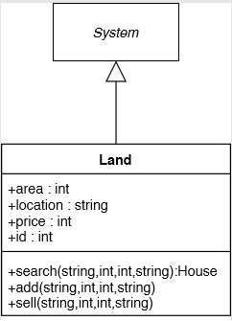

Workflows and algorithms
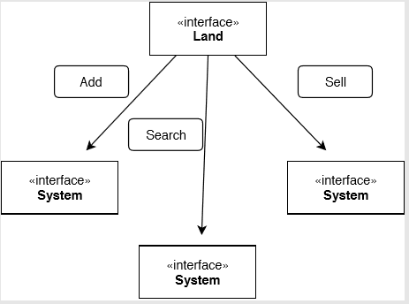

Software requirements mapping
Land component is used for these requirements;
SRS-REP-004
SRS-REP-005
SRS-REP-006
SRS-REP-007

Land service add, search and sell methods to users. Attributes of land are area, location, price and id. Search needs all attributes as input expect id. Add uses all attributes as input and Shell only needs id.

System

Component Interfaces

System will be a interface which will contain three methods named add search and buy. System will take inputs from other classes.

Component Design Description

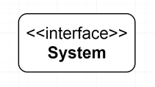

Workflows and Algorithm
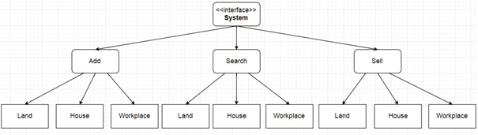

Software requirements mapping

System component is used for these requirements;
SRS-REP-003

Add sell and search methods will take inputs from class land house and workplace. Through methods system contains , it returns what is needed for classes.

COTS Identification

// Not: feedbackte externally used libraries and frameworks denmiş, aklınıza json dısında bir sey gelirse eklersiniz (Ege Bilir)

COTS (commercial of the shelf) libraries used in REP are the following:
- Org.json.simple.JSONArray, org.json.simple.JSONObject,
org.json.simple.JSONValue, etc. for JSON.

