Revision History
Date | Version | Description | Author
21/11/2018 | 1.0 | Added component diagram for section 2. Added class diagrams for component 1,2 and 3 | Ataberk Ozek

TABLE OF CONTENTS
Revision History 1
1 Introduction 3
1.1 References 3
1.1.1 Project References 3
2 Software Architecture overview 3
3 Software design description 3
3.1 Component 1 3
3.1.1 Component interfaces 3
3.1.2 Component design description 4
3.1.3 Workflows and algorithms 4
3.1.4 Software requirements mapping 4
3.2 Component 2 4
3.2.1 Component interfaces 4
3.2.2 Component design description 5
3.2.3 Workflows and algorithms 5
3.2.4 Software requirements mapping 5
3.3 Component 3 5
3.3.1 Component interfaces 5
3.3.2 Component design description 6
3.3.3 Workflows and algorithms 6
3.3.4 Software requirements mapping 6
4 COTS Identification 6

Introduction

This document describes the design of the REP software system.

References

Project References

# | Document Identifier | Document Title
[SRS] | REP-SRS-1 | REP Software Requirements Specifications

Software Architecture overview

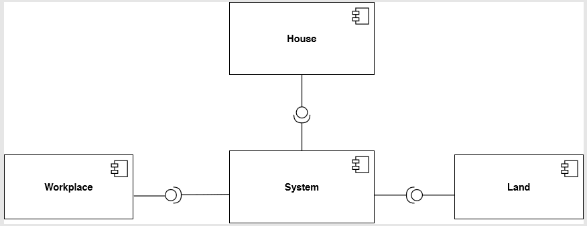

Software design description
Describe each top level package/component of your software in the following subsections. The number of sub-sections (3.1, 3.2, … etc.) depends on the number of packages/components in your architecture diagram.

Component 1

Component interfaces
Describe the interfacees of the component and input output data

Component design description

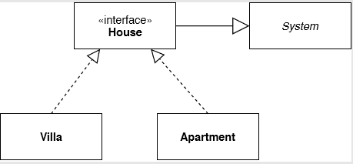

Workflows and algorithms

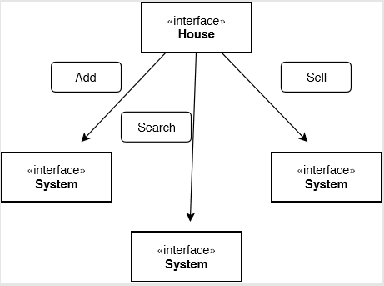

Software requirements mapping
List the SRS requirements handled by this component

Component 2
Repeat the pattern for each component.

Component interfaces
Describe the interfaces of the component and input output data

Component design description

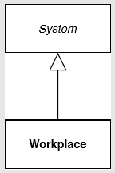

Workflows and algorithms

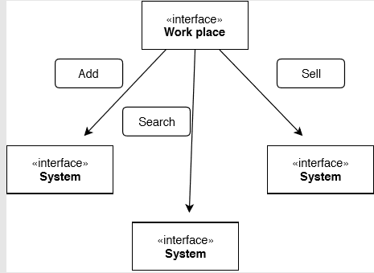

Software requirements mapping
List the SRS requirements handled by this component

Component 3
Repeat the pattern for each component.

Component interfaces
Describe the interfaces of the component and input output data

Component design description

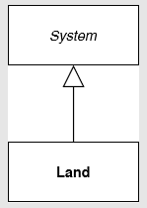

Workflows and algorithms

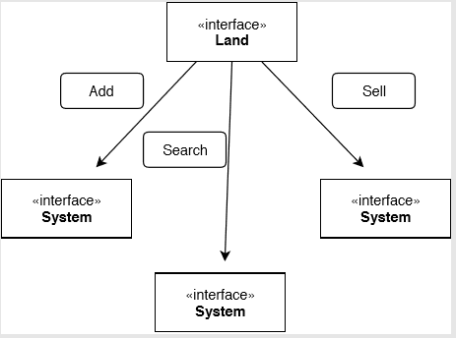

Software requirements mapping
List the SRS requirements handled by this component

COTS Identification
List external software components/libraries that your system relies on, if there are any.
Example:
COTS (commercial of the shelf) libraries used in XXX are the following:
- foo.jar, version id, download URL, License type,
- bar.jar, version id, download URL, License type,

