How to copy date from Azure Blob Storage to Azure Data Lake gen 2?

**Requirements:**

Copy **a moviesDB.csv file** from “**input**” container of Azure Blob Storage to “**tblmoviesDB**” table of Azure SQL Database

**Solutions:** There is a single file and needs a Data Movement operation using copy activity.

**Source** is Azure Blob Storage and **Sink/destination** is Azure SQL Database

**Pipeline Design:**

**Here we need two linked Services as our source and sink are two different data sources.**

If you do not have a linked services/Datasets in your Azure Data Factory which is pointing to Azure Blob Storage or Azure Data Lake gen 2 then please create them else skip this step.

1. Create linked Services
2. Create a linked service to point to Azure Blob Storage as **“LS_ABLB”**
3. Create a linked service to point to Azure Data Lake Gen 2 as **“LS_ASQL”**
4. Create datasets
5. Create a dataset to point to Azure Blob Storage
   1. **“DS_ABLB_IN”**
6. Create a dataset to point to Azure Data Lake gen2
   1. **“DS_ ASQL_OUT”**
7. Create a pipeline **“PL_LAB1_2”**
8. Add copy activity into your pipeline
9. Source properties as below. It should be point to dataset having above particular file(**moviesDB.csv**)

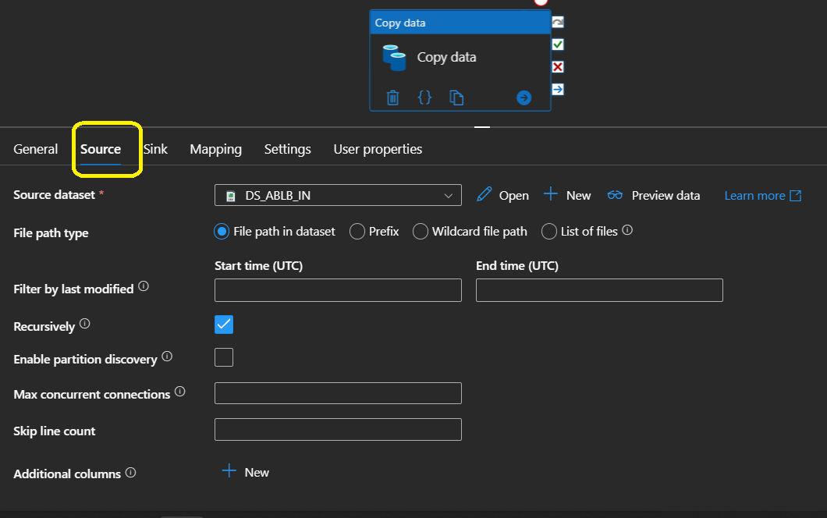

Source Dataset settings:

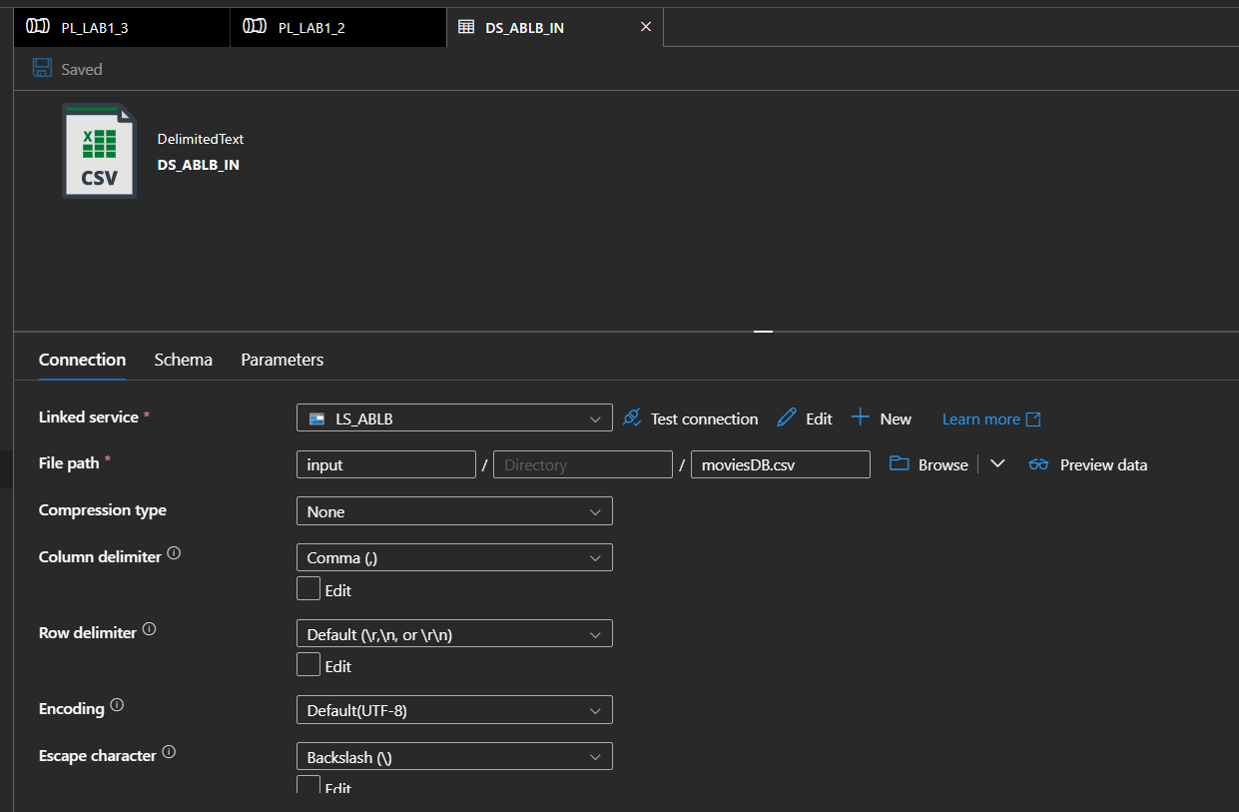

**Sink Properties as below:**

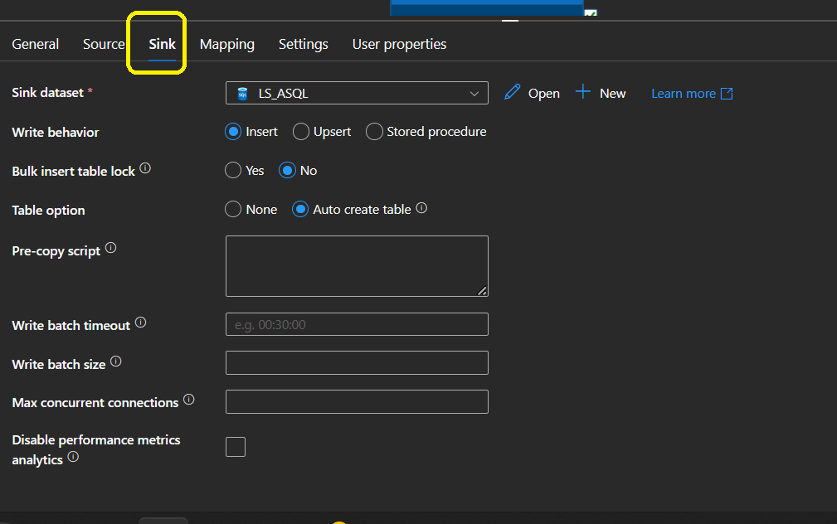

**Sink Dataset Settings:**

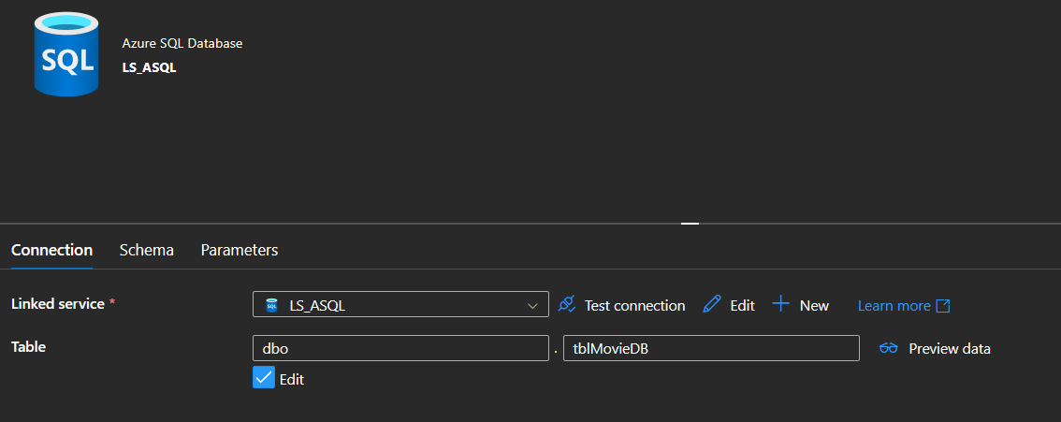

1. Check Azure SQL Database “tbl**moviesDB**” table. For 1st time, there will not be any table.
2. Debug your pipeline