How to copy date from Https server to Azure Blob Storage?

**Requirements:**

Copy **date** from “**https**” server to “**input**” container of Azure Data Lake Gen

**Solutions:** There is date and need a Data Movement operation using copy activity.

**Source** is Https server and **Sink/destination** is Azure Data Lake Gen

**Pipeline Design:**

**Here we need two linked Services as our source and sink are two different data sources.**

If you do not have a linked services/Datasets in your Azure Data Factory which is pointing to Azure Blob Storage or Azure Data Lake gen 2 then please create them else skip this step.

1. Create linked Services
2. Create a linked service to point to Azure Blob Storage as **“LS_ADLG”**
3. Create a linked service to point to Http Server as **“LS_HTTP”**
4. Create datasets
5. Create a dataset to point to Azure Blob Storage
   1. **“DS_ADLG_OUT”**
6. Create a dataset to point to HTTP Server
   1. **“DS_ HTTP_IN”**
7. Create a pipeline “PL_LAB1_3”
8. Add copy activity into your pipeline
9. Source properties as below:

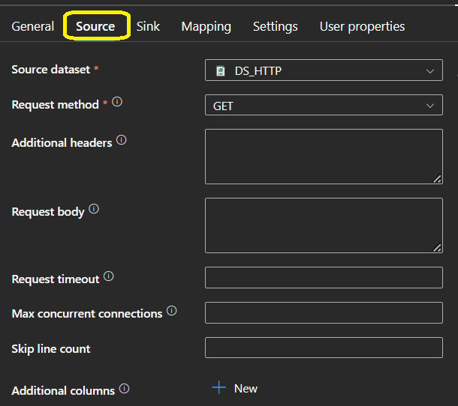

It should be point to dataset of HTTP

**Source Dataset:**

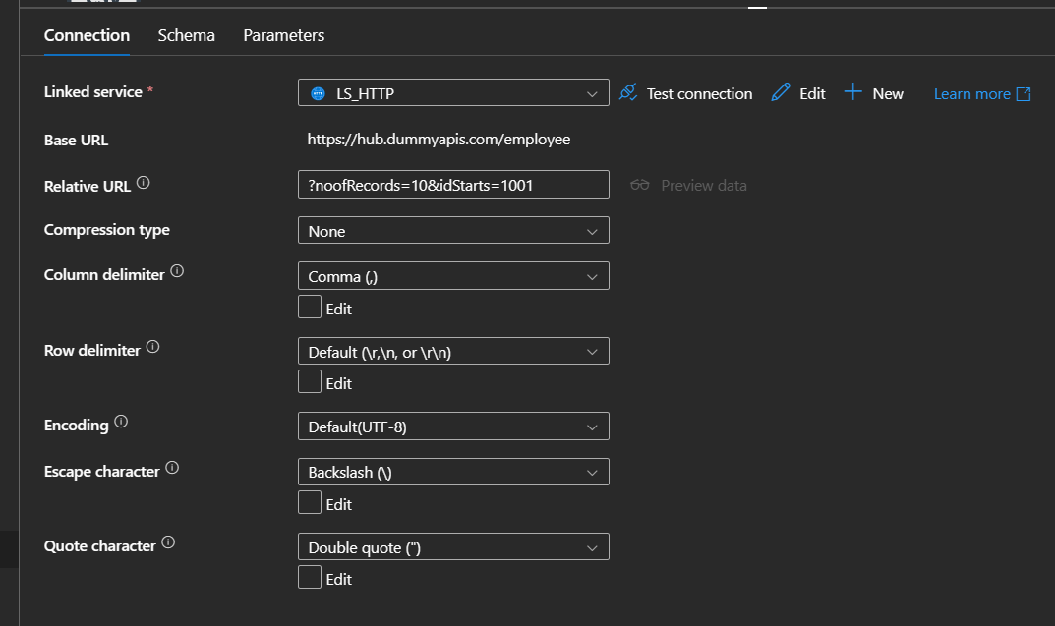

**Source Linked Services:**

[**https://hub.dummyapis.com/employee**](https://hub.dummyapis.com/employee)

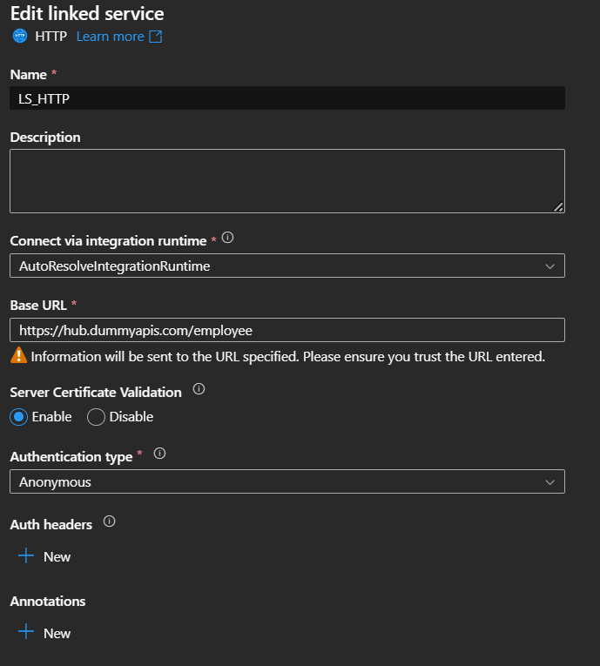

1. Sink Properties as below:

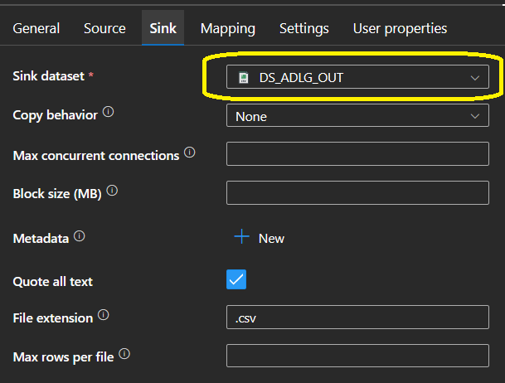

**Sink Dataset:**

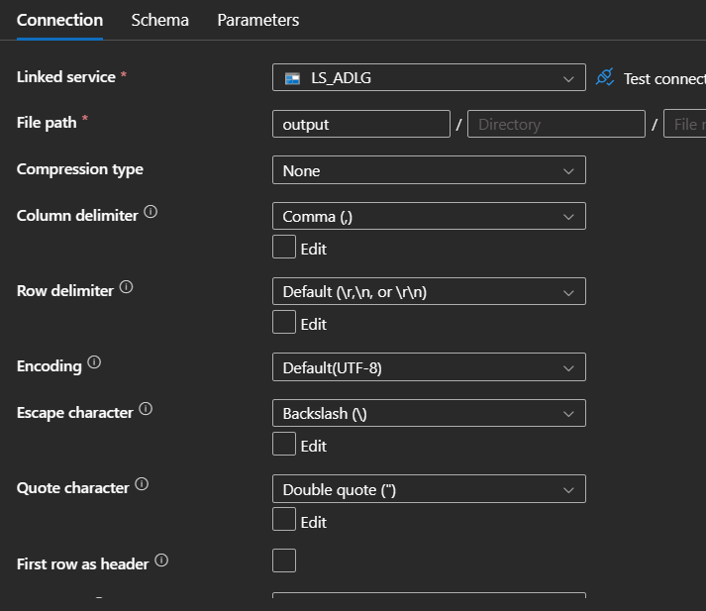

1. Check Azure Data Lake Gen 2 “output” Container.
2. Debug your pipeline
3. Now again check Azure Data Lake Gen 2 “output” Container.