**Parameter:**

It is very similar to parameters in any programing languages or database languages.

It is use for reusability purpose.You create a parameter to pass it’s value to activity, Datasets, Linked Services, Dataflow.

You will pass external value into parameter. This flow always in one direction as below.

You can pass by creating paramete at Pipeline level and they it goes from activity and dataset.

You can also pass values of parameters which are at dataset level from activity.

**Pipelines**

**Activity**

**Datasets**

**Linked Services**

**Mapping Data Flows**

Here when pipeline run using trigger or by user, they will pass parameter values as external value and then it pass to activity,dataset and linked services.

Sometime, activity like foreach loop, get metadata, look up, etc also prepare value for dataset. In this senarions you do not need to create parameter at pipeline level



**Create Parameter at pipeline level:**

**Pipeline : PL_DELETE_FILE_IN_1_DAY**

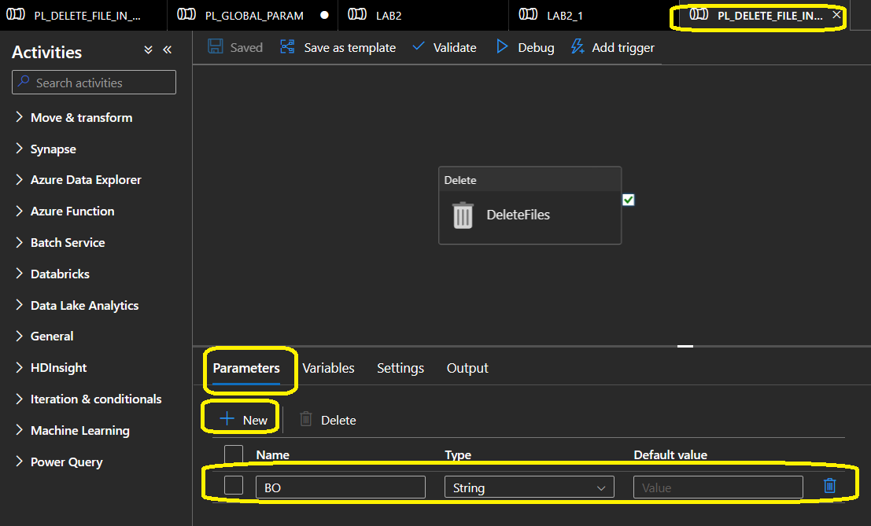

**Consum Parameter (which created at pipeline level)**

**Pipeline Parameter:** @pipeline().parameters.ParameterName

**In Above example, @pipeline().parameters.BO**

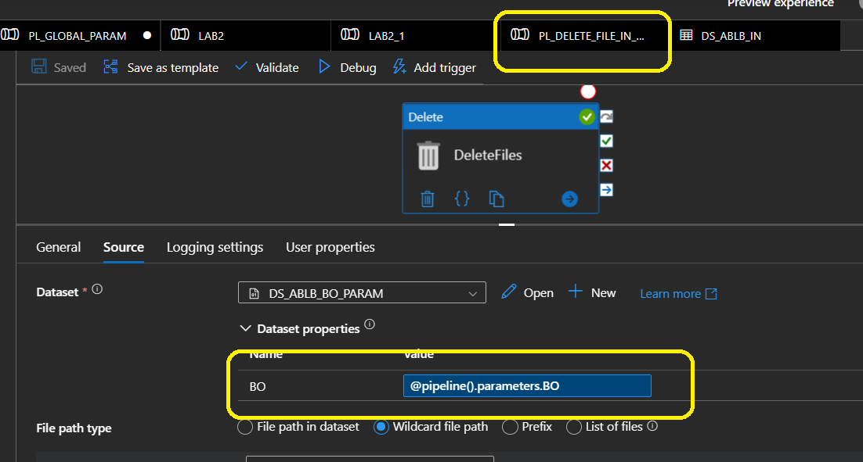

Once you create a pipeline at parameter level, you need to pass it to dataset. This you can do by creating parameter at dataset which hold value

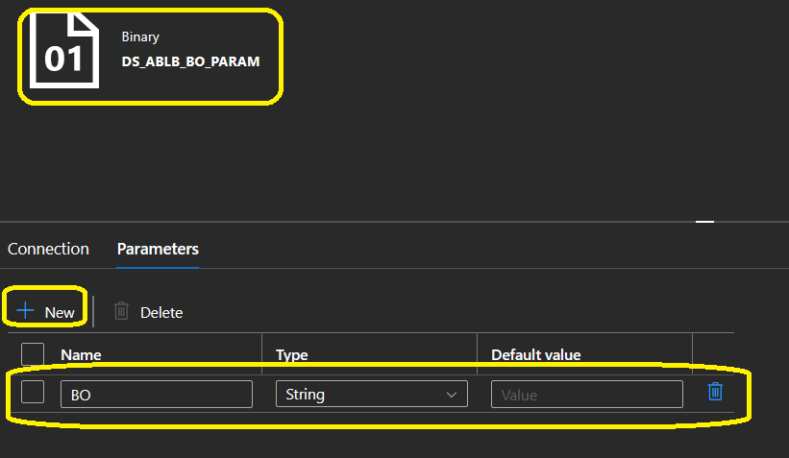

**You can use it as:**

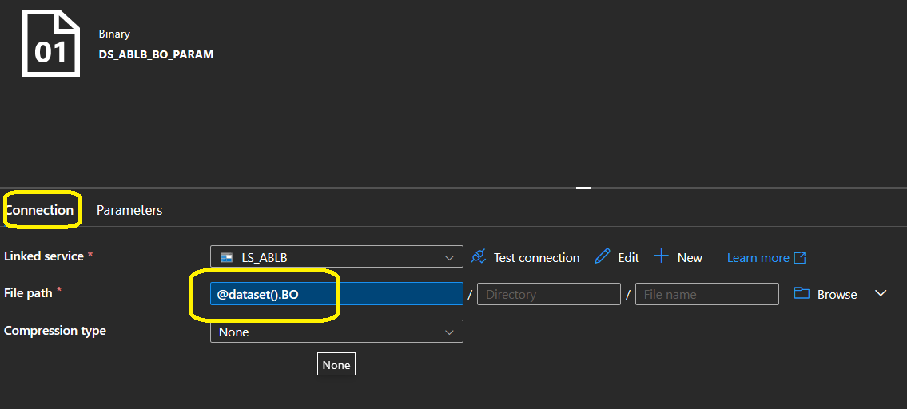

As soon as you have parameter at dataset level, it appeas in activity below. So here you are passing value from your pipeline (@pipeline.parameters.BO)

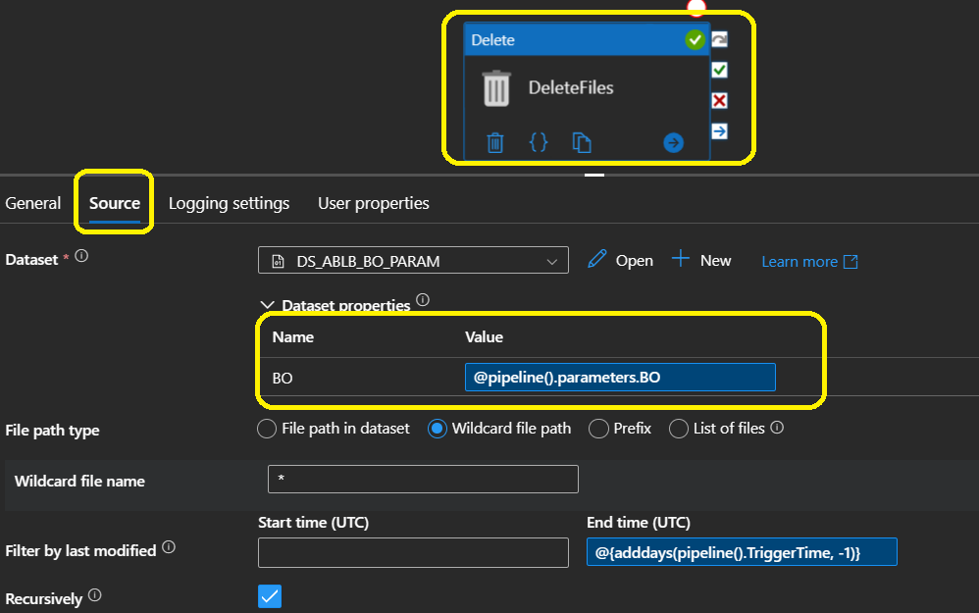

**Dataset Parameter:**

**@dataset(). ParameterName**

You can parameterized your linked services when you are going to connect more than one database from same server or more than one instance of storage account or REST API instance.

**Linked Service :**

**@linkedService().ParameterName**

**There are system parameters which are inbuild.**

System Parameters e.g :

@pipeline().DataFactory

@pipeline().TriggerTime

If want to consum pipeline parameter than you must need to create same parameter at dataset level (name can be different ). Dataset can not have visibility to see pipeline parameters. Hence you need to create parameter at dataset level and at source or sink property of activity you access it.

Activities’ Properties

**Dataset**

**BO**

**Pipeline BO**

**BO**

@Dataset.BO

@Pipeline.parameters.BO