**Variables:**

It uses for reusability purpose. This value only lives inside pipeline. You can set value of variables N number of times and for that you need to use “set variable” activity. If you have default value set then if you do not set up value then it will use default values.

You cannot externally value into variable directly e.g. when you execute pipeline, you can not pass value for variable while you do same for Parameter

You can compare variable in any programing languages or database languages. You declare or create variable and then set value to variable.

You can add variable three type of variable Boolean, String or Array.

Pipeline - PL_VAR

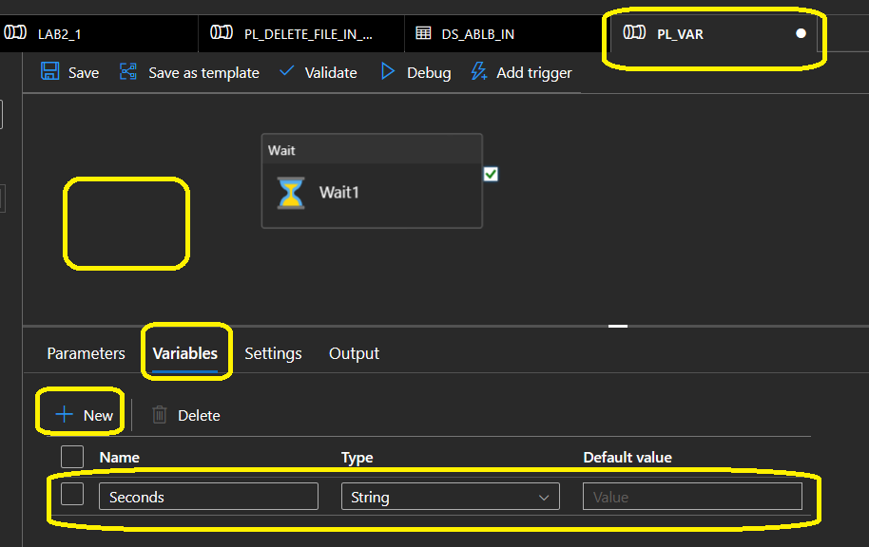

You can consume as below:

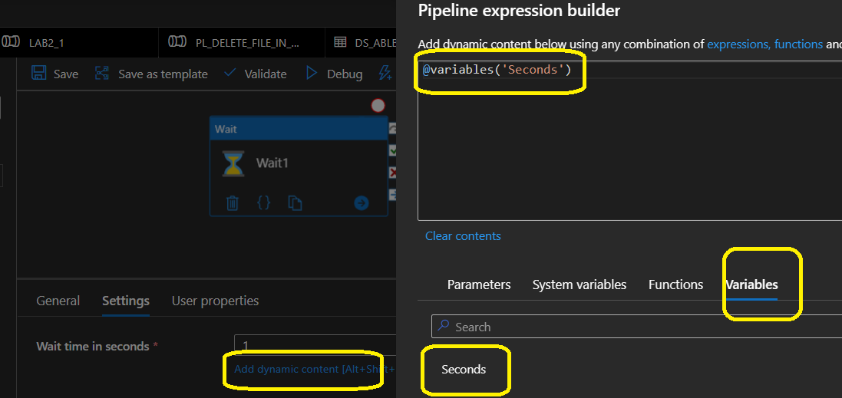

However above pipeline will failed as we do not have default value while creating variable as well as we have not set variable.

To set Variable you need to use “set Variable” activity. Before using variable unless it has default value.

So, solution with default value:

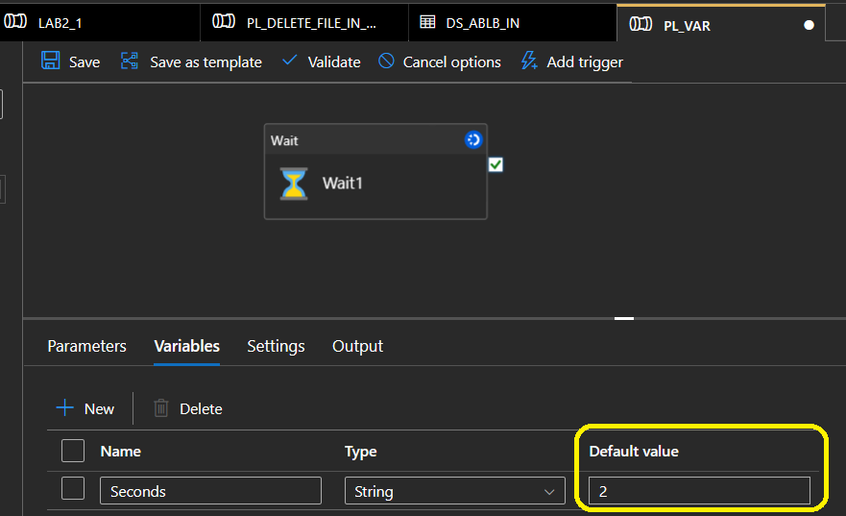

**Solution with “set variable” as:**

