Contents
Step 1: Install Visual Studio Code 1
Step 2: Create Project Folder 1
Step 3: Open Terminal Inside VS Code 1
Step 4: Install Microsoft Foundry Local CLI 2
Step 5: Verify Installation 2
Step 6: List Available Models 2
Step 7: Run First Local Model 3
Summary 3

Lab 0 – Microsoft Foundry Local Setup (Step-by-Step from VS Code)
We are going to create Lab 0 – Local Machine Setup Guide (step-by-step from VS Code)
It includes:
• Open VS Code
• Create project folder
• Open terminal inside VS Code
• Install Foundry Local (Windows + macOS commands)
• Verify installation
• List models
• Run first model locally
• Test prompt successfully

Step 1: Install Visual Studio Code
- Open your browser and go to https://code.visualstudio.com
- Download Visual Studio Code for your operating system (Windows or macOS).
- Install Visual Studio Code using default settings.
- Launch Visual Studio Code after installation completes.

Step 2: Create Project Folder
- Open Visual Studio Code.
- Click File → Open Folder.
- Create a new folder named: foundry-local-lab0
- Select the folder and click Open.

Step 3: Open Terminal Inside VS Code
- Inside Visual Studio Code, click Terminal → New Terminal.
- A terminal window will open at the bottom of VS Code.
- Ensure the terminal path matches your project folder location.

Step 4: Install Microsoft Foundry Local CLI
- Run this command in the terminal (Windows):
winget install Microsoft.FoundryLocal

- If using macOS, run:
brew tap microsoft/foundrylocal
Then run:brew install foundrylocal
Wait for installation to complete.

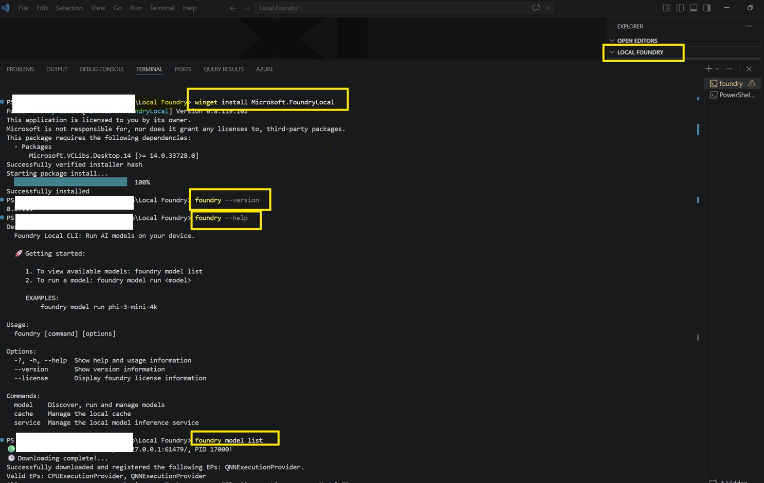

Step 5: Verify Installation
- Run command: foundry --version
- If installed correctly, version information will appear.
- Run command: foundry --help
- This confirms Foundry Local CLI is working successfully.

Step 6: List Available Models
- Run command: foundry model list
- This shows supported local models available for your machine.

Step 7: Run First Local Model
- Run command: foundry model run phi-3.5-mini
- Wait while the model downloads (first time only).
- Type a sample prompt such as: Why is the sky blue?
- You are now running your first local AI model successfully.
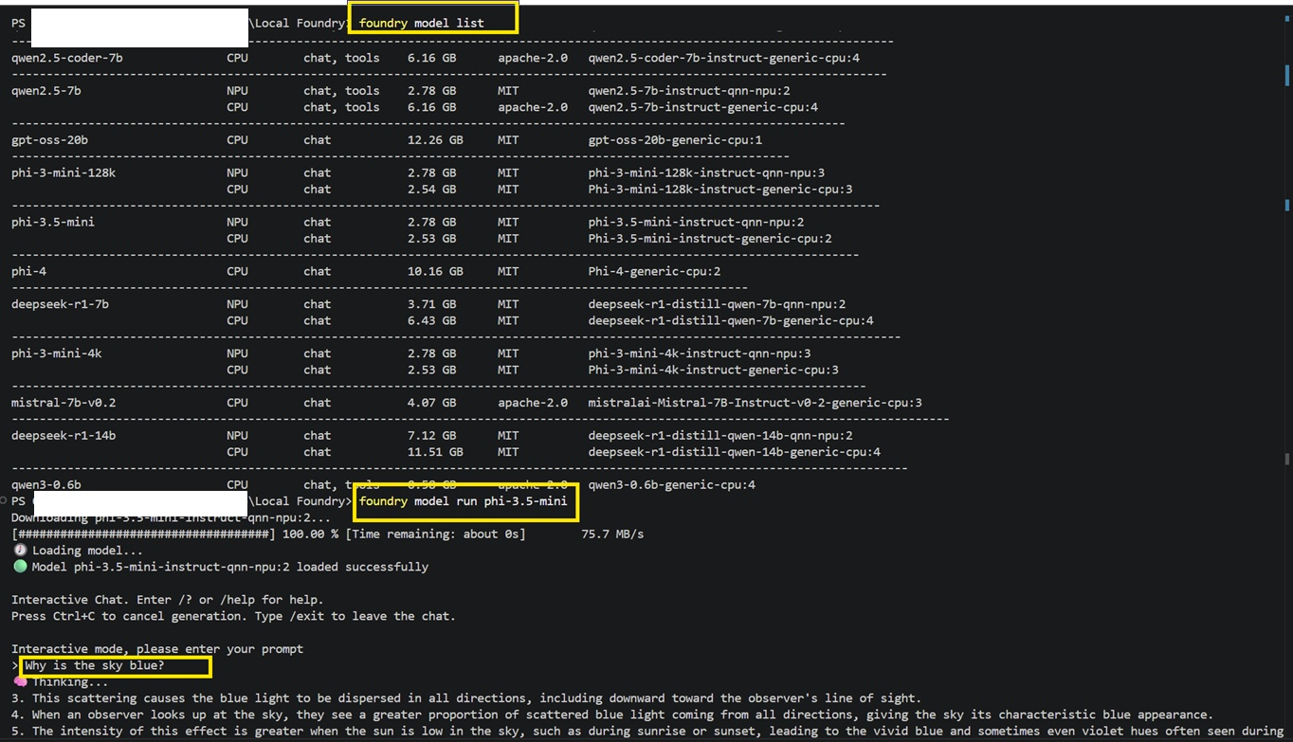

Summary
- Foundry Local appears installed and operational.
- Model catalog is available and includes both CPU and NPU optimized variants for multiple model families.

Following command has been run in VS code
1. winget install Microsoft.FoundryLocal
2. foundry --version
3. foundry --help
4. foundry model list
5. foundry model run phi-3.5-mini

