Do you like to refresh your PowerBI Imported Dataset whenever you would like to refresh and how many times per day?

Or just after refresh data to your Azure Data Lake or Data Warehouse or just after populating to Azure SQL table?

There are few possible easier solutions:

1. Azure Data Factory & Logic Apps
2. Azure Logic Apps Only
3. Azure Data Factory Only
4. Microsoft Workflow
5. Power Automation
6. Azure Function

In this blog, I am going to explain, 1st three solutions.

Let’s start exploring 1st options,

## Azure Data Factory & Logic Apps

Here, there are two ADF Pipelines. Pipeline 1 will load data to Azure SQL Table. Once it successfully loaded Pipeline 2 will call Azure Logic Apps to refresh Power BI Imported Dataset.

Logic Apps has actions which can either just refresh your PowerBI Dataset or it can add new row to your dataset.

This pipeline and workflow you can build it very quickly and very easily with no code or Low code.

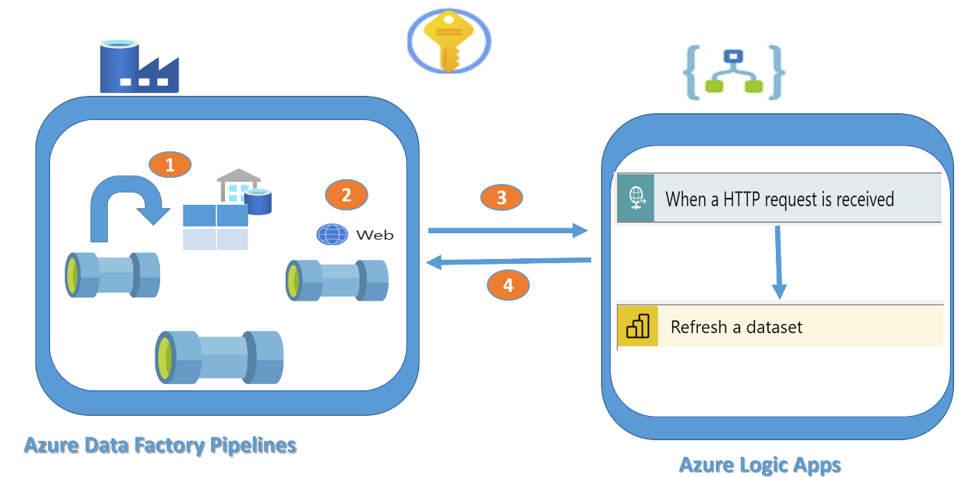

## Azure Logic Apps Only

Pipeline has Lookup activity and If activity which has web activity to refresh power BI dataset

Here, Power BI Imported Dataset will refresh once new entry comes to Azure SQL Table. Look up activity is checking based on flag, new data loaded to table or not. If flag is true then and then if activity execute Web activity which refresh power BI using rest API.

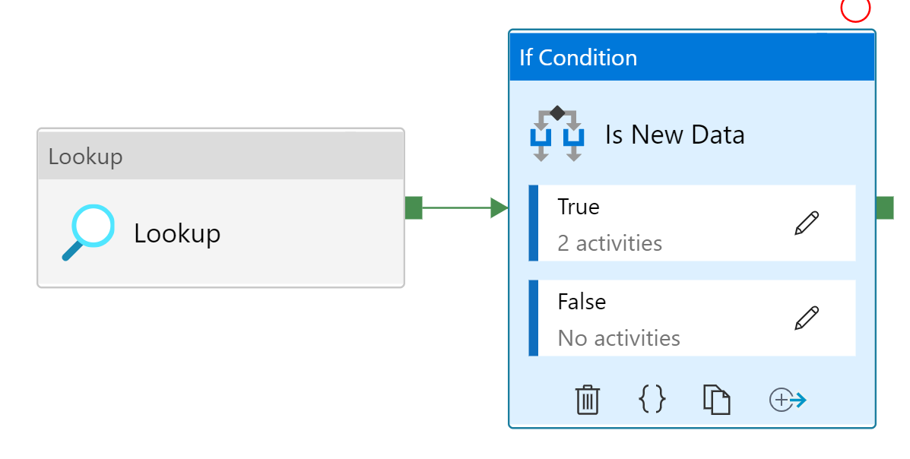

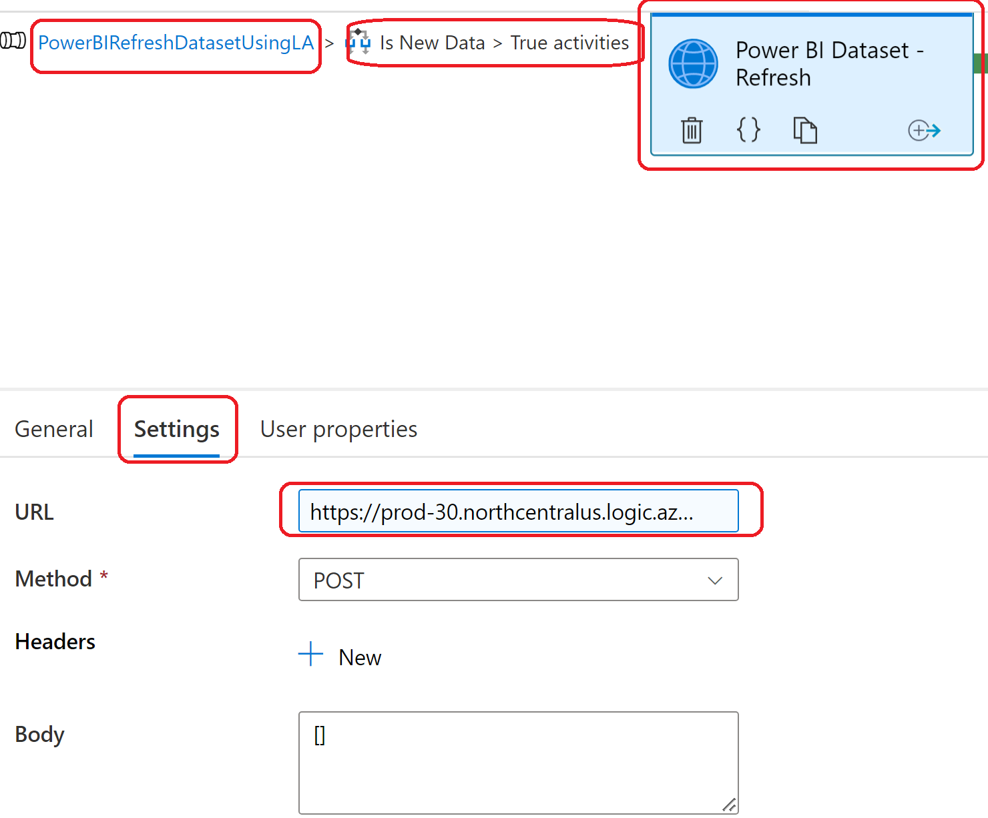

## Azure Logic Apps Only

Now let’s explore second options, here you are just triggering Logic Apps. It can trigger based on time e.g. every minutes or every second. If condition match then workflow perform actions else it does not do anything.

Here, Logic Apps has a trigger which is trigger and execute workflow or series of steps when http request is received.

1. When a http request is received
2. Action/Actions will execute and it refresh a dataset or add new row in Power BI Dataset.

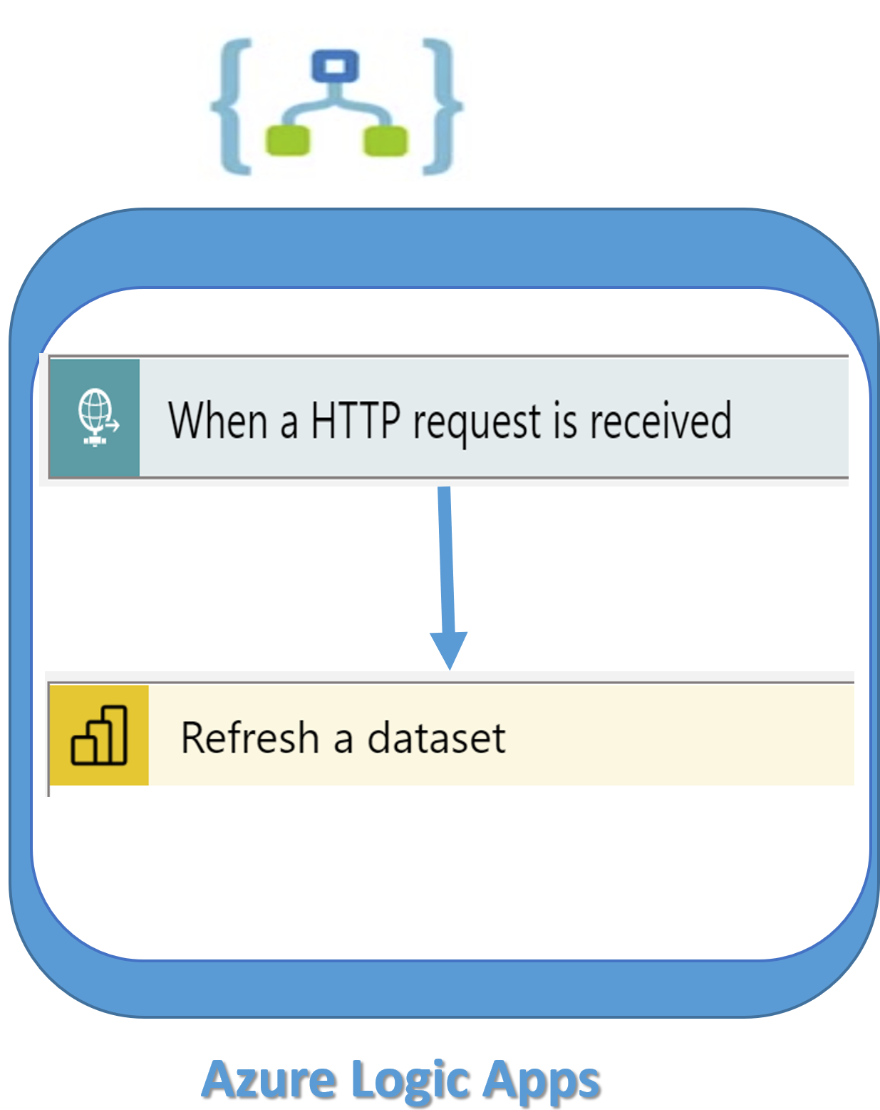

Here logic Apps, get http request and based on that workflow /action will execute. Here only an action which is Refresh a dataset. This action has two parameters Workspace and Dataset. Once successful execution of this Power BI imported Dataset will be refreshed. You can verify it by using Dev.powerbi.com .Here you need to check dataset and its run history.

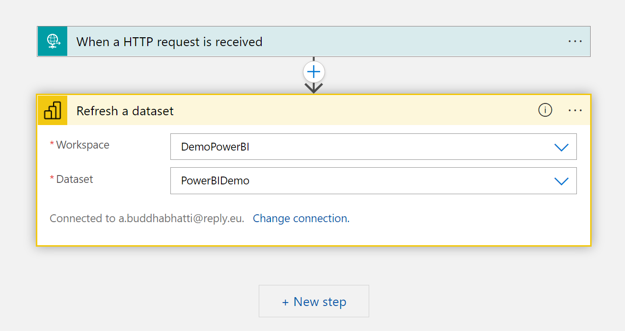

## Azure Data Factory Only

Let’s explore now 3rd options, Here you have ADF pipelines and you do not like to implement Azure Logic Apps, Azure Function or Microsoft Work flow etc.

1. Create App registration Azure Active Directory and add secret
2. Create a user group with adding above member
3. Create Azure Key Vault
4. Create three secrets to store Tenant Id and Client Id to Client Secret
5. Create Power BI Dataset
6. Add Service Principle user group at **power BI App => setting =>admin portal=>tenant setting => developer tab**

**Note** – this will not available for all user so either you need to ask network admin to do those setting for yourService Principle user group

1. Create ADF pipeline
2. Add three web activity to read secret from KV
3. Add Web activity to generate token using step 8
4. Add web activity to call Power Bi rest URL to refresh Dataset

