# Floating Narrative Nodes Template

**Approx. 200 words**

## Step 1: Choose a location in the town of Crowhurst from (OR MAKE YOUR OWN):

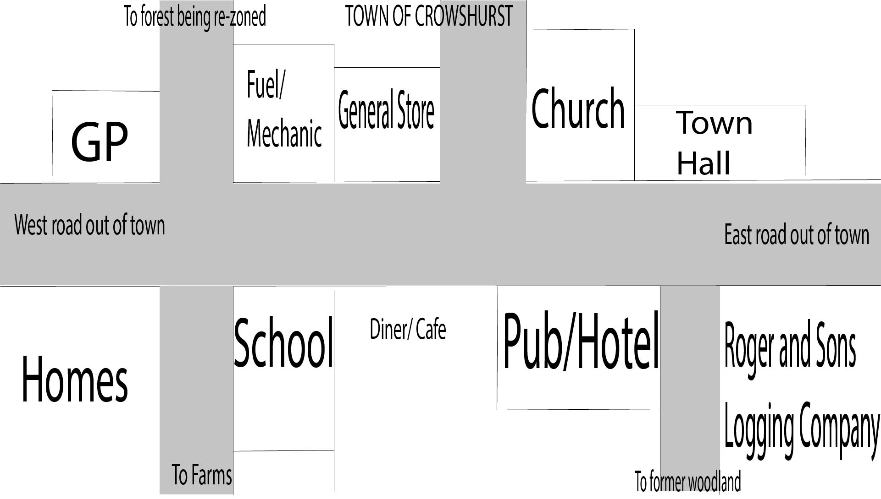

**WRITE HERE THE NAME OF THE LOCATION:**

## Step 2: Choose a secondary (non-player) character (**NPC**) from this list OR make your own:

Olga: an old lady who uses a walker and is loud vocal and unapologetic, the kind of person everyone knows the rants they offer several times a week at local gatherings.

Carol: A quiet and reserved late 50s lady who used to be a teacher or librarian, is unhappy with having been forced out of her job and is trying to make the best of things. Has a past with Roger.

Harold: owner of the pub, vegetarian due to health concerns, friendly and bubbly as a person. Has a wife with two children and what's to be around to see them grow up. Is open to ideas and change, but recoils at an overbearing approach.

Roger: The owner of roger and sons logging company, and pseudo-politician, is hoping to get access to new logging rights and is trying to win town favour. Willing to cheat lie and bribe. Has two sons that can be influenced and swayed.

Tim: Bookish man who keeps to himself, somewhat snobbish, friends with roger, willing to help him bribe and cheat for his own gain.

DR.ANDREW SCHOLSON - as yet unwritten, requested a member of an environmental activist group to come and help him convince the town to not go through with giving more logging rights to Roger.

Jim/Jimmy - Bartender at the pub, unwritten.

## Step 2b: If you made your own, give name and brief description

**WRITE HERE THE NAME OF THE NPC:**

## Step 3: Choose a Player Group Identification of one OR a MIX of the following:

**Activist**: this group are active in the fight for the planet. They take actions and want to spread awareness. This is the branch that we have focused on till now and the goal of this branch is to teach activists in essence what this game hopes to achieve, that you can't approach everyone in the same way and that to best move people to awareness and action you need to speak to their identified groups values and concerns, rather than what matters to you.

**Concerned**: This group construes people who are already knowledgeable about the climate change debate, but don't know how to take action. The narrative of this branch needs to focus on demonstrating how they can take action and the value of self-efficacy.

**Curious**: This group is curious and care about the climate debate and want more information, this narrative needs to focus on the provision of information and a push toward awareness.

**Disengaged**: for various reasons the people in this group have turned off from the debate and either don't care or are uninterested in what is happening. The narrative here needs to focus on the values of this group and get them to care about the debate again and push them toward curiosity.

**Denier**: This group are the detractors and conspiracy group. They will argue strongly against any hint of climate debate. So, this narrative needs to focus on other things: pollution, destruction of wildlife by companies, outdated and overpriced fuel and energy sources, economic, cultural and social benefits of solar and wind energy and so forth.

**WRITE HERE WHICH GROUP(S) THE PLAYER BELONGS TO:**

Remember: The Point of View is from the Player’s perspective

## Step 4: Write the Hook

Introduction of situation, of character interacting with, some contextualisation.

## Step 5: Add a complication

Complication:

What is the sense of tension created in this node?

## **Step 6**: Give 3-4 Options for Player responses

1. **Option 1. e.g Say something specific**
2. **Option 2 e.g. Say something else**
3. **Option 3 e.g. Do an action, e.g. Leave**
4. **Option 4. e.g. have a thought (which could change something)**

## **Step 7**: Briefly: state consequences of each option.

For example:

1. **The Player** becomes more aligned with a Player Group ID (e.g. they become more activist or become more disillusioned)
2. **Relationship** change with NPC + or –: The NPC likes you a bit less (-1 or -2) or more (+1 or +2). The scale is -10 to +10
3. **The NPC** becomes more aligned with a Group ID (e.g. more curious about Climate Change)
4. Change one of the currencies:
   1. The Empathy the Town feels towards you
   2. Your self confidence

## **Step 8**: Conclusion:

Describe in text the consequence, but leave the narrative world largely intact, that is any node should be able to connect to any other, with a few exceptions, feel free to make exceptions.

## **Step 8b:** instructions

(Include instructions for coders for how this should affect game state and relations).

E.g. “increase self-confidence”

OPTIONAL Step 9: Rinse and Repeat

Another small node that is linked to this one (e.g. next step in the conversation

OR

State you exit the conversation