Consider a monolithic java application stack.

Apache Web Server, Apache Tomcat application server with Active MQ and Oracle and MongoDB backend.

Propose a solution to migrate this application stack to AWS. Mention all the AWS services you would use and how you would maintain HA and Load Balancing (consider app to be stateless). Mention rationale for each design decision.

Explicitly state the assumptions you are making, if any.

The following is my proposed solution:

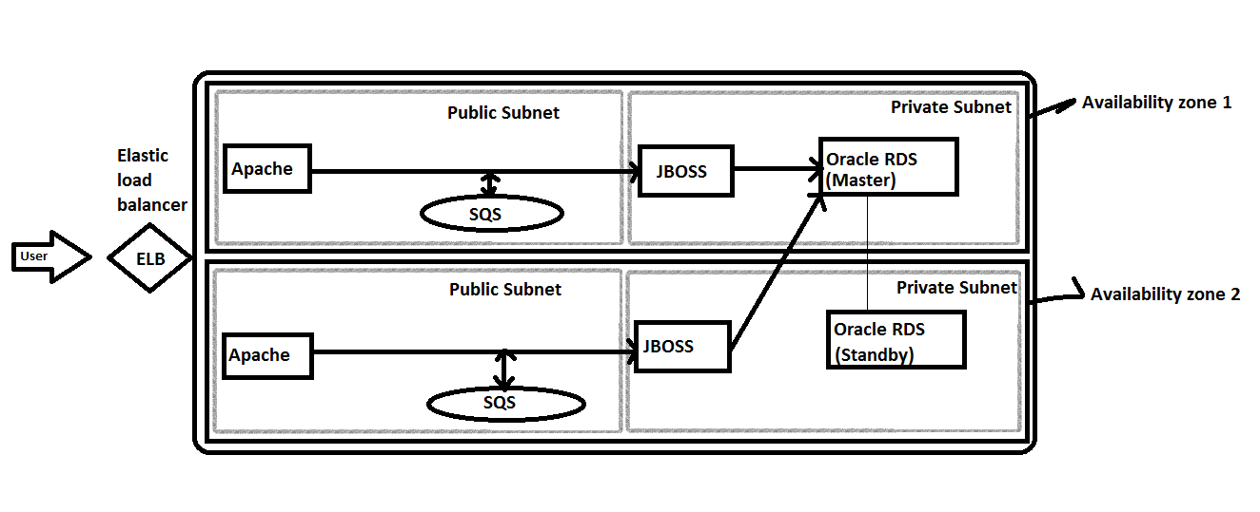

SQS is an HA service

RDS DBS is set for HA by using multi-AZ

Two zones for HA of web application server

Assumption:

They may be using mongodb to store data in ActiveMQ persistently.