STM32 PCB DESIGN Wıth ALTIUM

Contents

STM32 PCB DESIGN Wıth ALTIUM 1

1. Introduction 2

2. Components 2

2.1 LQFP48 STM32 48-Pin 2

2.1.1 PCB Library (.PcbLib) 2

2.1.2 Schematic Library (.SchLib) 4

2.2 5V Regulator D7805 DPAK package 7

2.2.1 PCB Library (.PcbLib) 7

2.2.2 Schematic Library (.SchLib) 10

2.3 MPU-6050 QFN Package 11

2.3.1 PCB Library (.PcbLib) 11

2.3.2 Schematic Library (.SchLib) 12

2.4 BMP280 Digital Pressure Sensor 13

2.4.1 PCB Library (.PcbLib) 13

2.4.2 Schematic Library (.SchLib) 14

2.5 KLS1-TF-003 Micro SD Card Holder 15

2.5.1 PCB Library (.PcbLib) 15

2.5.2 Schematic Library (.SchLib) 16

2.6 Terminal Library 17

2.6.1 PCB Library (.PcbLib) 17

2.6.2 Schematic Library (.SchLib) 18

2.7 Buzzer 19

2.7.1 PCB Library (.PcbLib) 19

2.7.2 Schematic Library (.SchLib) 20

2.8 Female Header 1x3, 1x4, 1x5 21

2.8.1 PCB Library (.PcbLib) 21

2.8.2 Schematic Library (.SchLib) 22

2.9 SMD Capacitors 24

2.9.1 PCB Library (.PcbLib) 24

2.9.2 Schematic Library (.SchLib) 25

2.10 Tantal Capacitors 25

2.10.1 PCB Library (.PcbLib) 25

2.10.2 Schematic Library (.SchLib) 26

2.11 SMD Resistor Library 27

2.11.1 PCB Library (.PcbLib) 27

2.11.2 Schematic Library (.SchLib) 28

3. System Schematic Design 28

4. PCB Design of the System 30

4.1 Transferring schematic design into PCB 30

4.2 PCB Sizing 30

4.3 Placing Components into PCB 31

4.4 GERBER Output of PCB 35

# Introduction

In this report, STM32 microprocessor will be designed schematically in Altium. All components schematic & PCB libraries are created in Altium by me, but 3D designs will be added from third part sites. I will use STM32 LQFP48 package with 48-pin.

# Components

## LQFP48 STM32 48-Pin

### PCB Library (.PcbLib)

I have created STM32 with LQFP package by the help of Altium, which supplies IPC Compliant Footprint Wizard. The important parameter is the size of the microcontroller that I can find on the net easily.

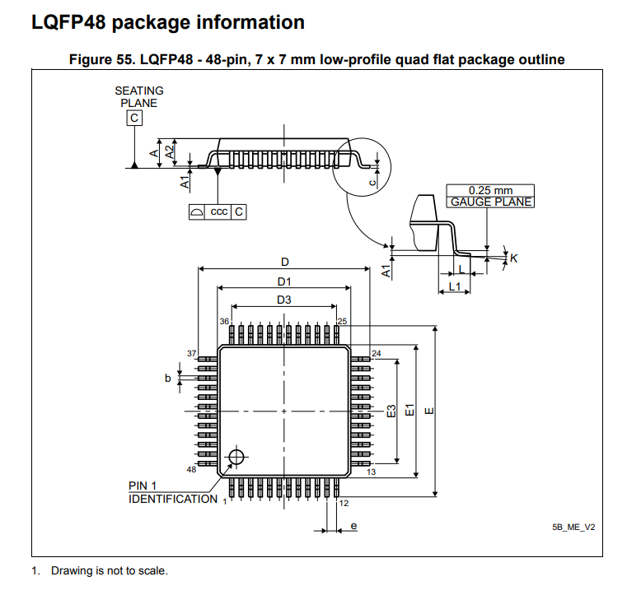

Figure 1. STM32 LQFP48 package information

We need sizes of the package which is also provided by the manufacturer:

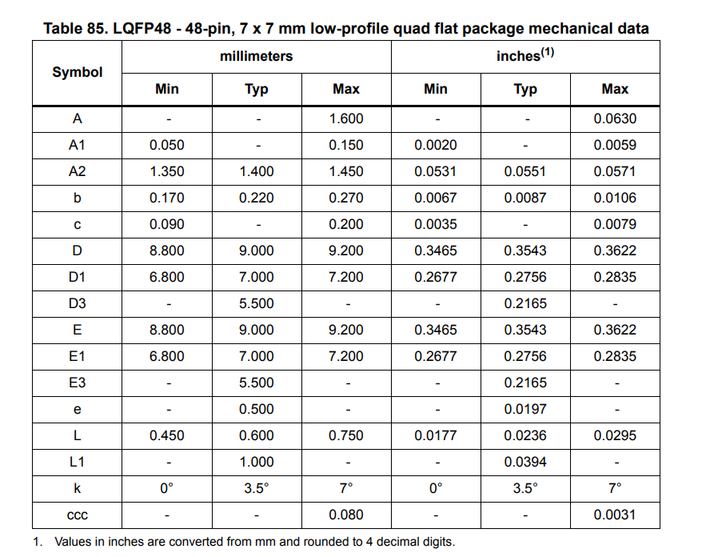

Figure 2. Sizes of LQFP48 package

Now, we can design STM32 in Altium without drawing one by one and we do not need to 3D body with the help of IPC Compliant Footprint Wizard (follow the path in PCB library documents → Tools → IPC Compliant Footprint Wizard)

After entering the given values to the program generates 2D and 3D body:

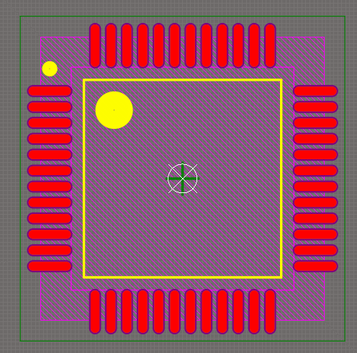

Figure 3. LQFP48 2d footprint

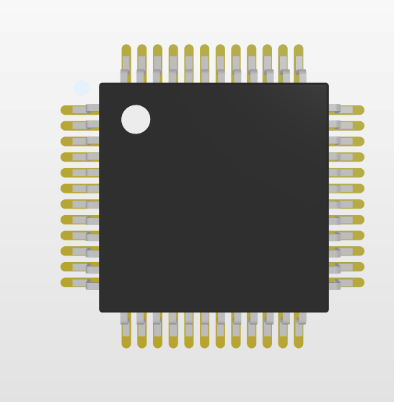

Figure 4. 3D body of LQFP48 package

### Schematic Library (.SchLib)

To create schematic: Go to SCH Library → AddI draw a rectangular and added 48 pins to around of the rectangular. It should be mentioned that I did not design schematic in sequence. In other words, it is not going like 1-2-3-4-…-48. Instead, I have divided pins into the groups like power pins, serial communication pins, ground pins etc. Be careful when adding pins that white rectangular of pin should be outside as below.

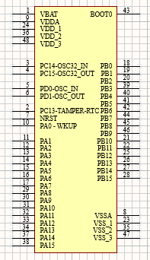

The last step is adding PCB footprint to the schematic:

From Editor tab → Add Foodprint: → Browse → Choose 3D model print and Click OK → OK

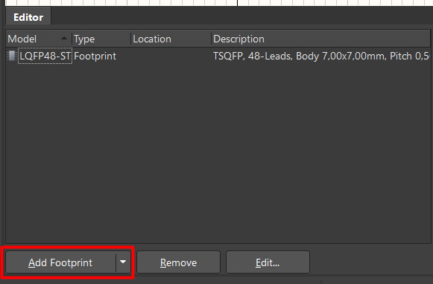

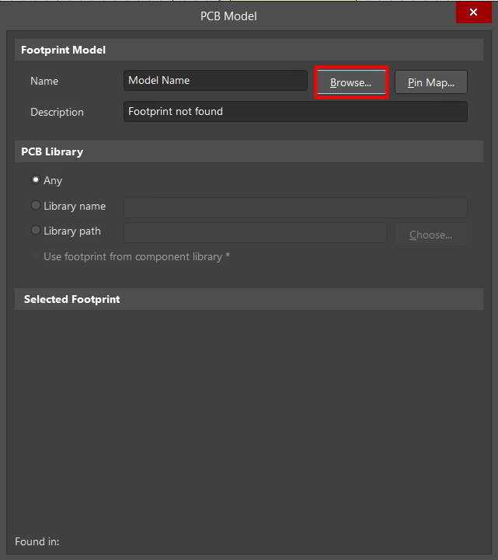

It is now added. Don’t forget writing **Designator** value of the component which is U? for the integrated components.

I? → integrated components

U? → Microprocessors

R? → Resistors

C? → Capacitors

J? → Jumpers

B? → Buzzers, buttons

Y? → Crystal Oscillators

L?→ Inductors

## 5V Regulator D7805 DPAK package

I will use 5V regulator but DPAK package

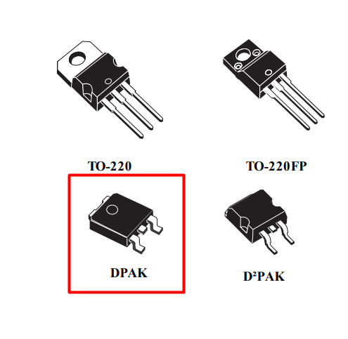

Figure 5. Package types of regulator

### PCB Library (.PcbLib)

Again, Altium provides us to use IPC Compliant Footprint Wizard to generate the regulator in DPAK package

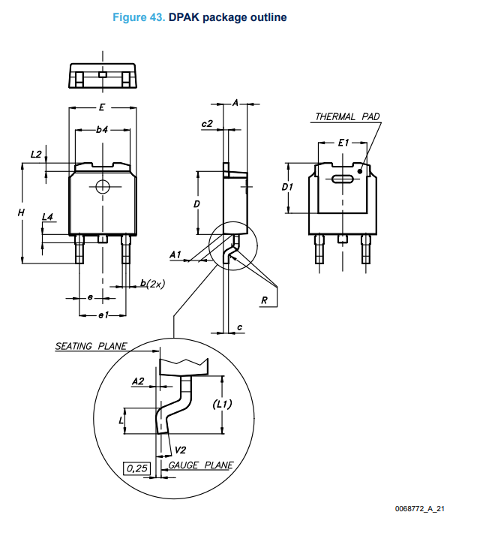

Figure 6. DPAK package information

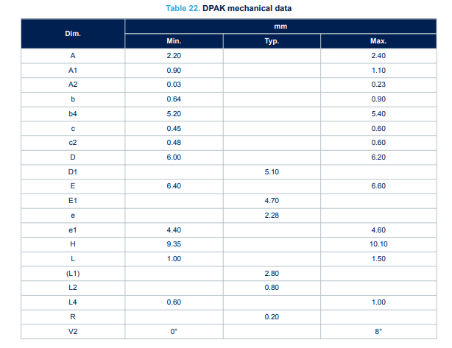

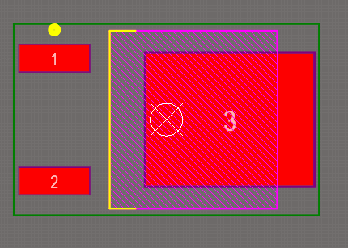

Figure 7. PCB schematic of DPAK regulator

### Schematic Library (.SchLib)

Now, we need to pin configuration schematic to create schematic of the regulator

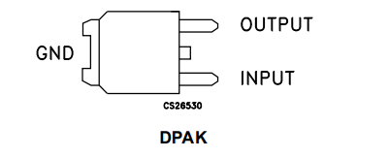

Figure 8. Pin configuration of the regulator

To create schematic go to Schematics Library Documents → SCH Library → Add → Draw the schematic

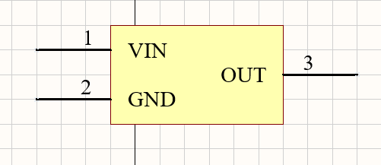

Figure 9. Schematic of the regulator

Add schematic PCB footprint as shown in part **2.1.2**

## MPU-6050 QFN Package

### PCB Library (.PcbLib)

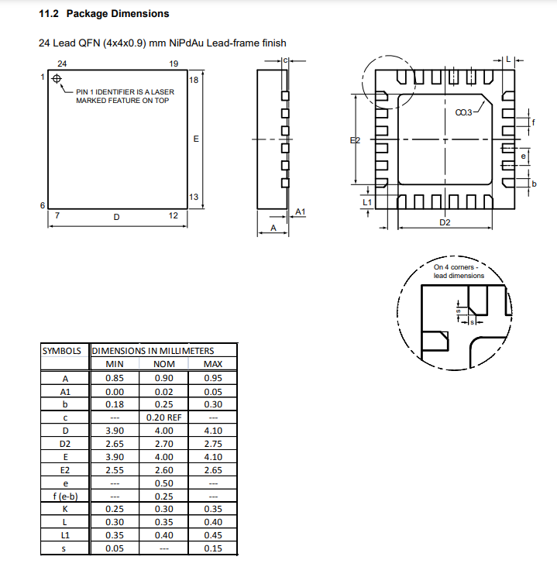

Figure 100. MPU-6050 package dimensions

Again, use Footprint wizard, QFN package is used to create PCB model of the component:

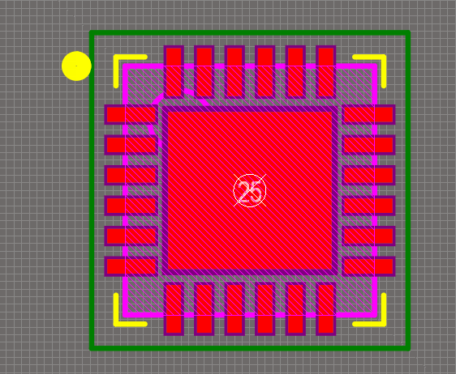

Figure 11. PCB schematic of MPU-6050

### Schematic Library (.SchLib)

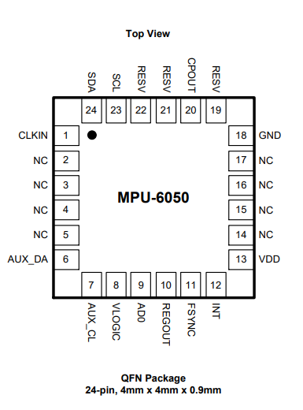

Figure 12. MPU-6050 PINs

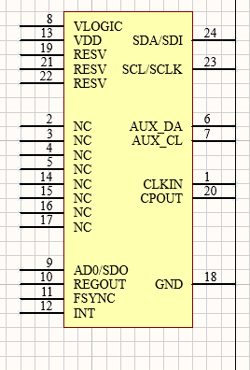

Figure 13. Schematic of MPU-6050

Add PCB footprint and MPU-6050 is completed.

## BMP280 Digital Pressure Sensor

For this BMP280 sensor, Altium IPC Footprint Wizard does not have package model of the sensor. Therefore, it should be drawed by third person (me 😊 )

### PCB Library (.PcbLib)

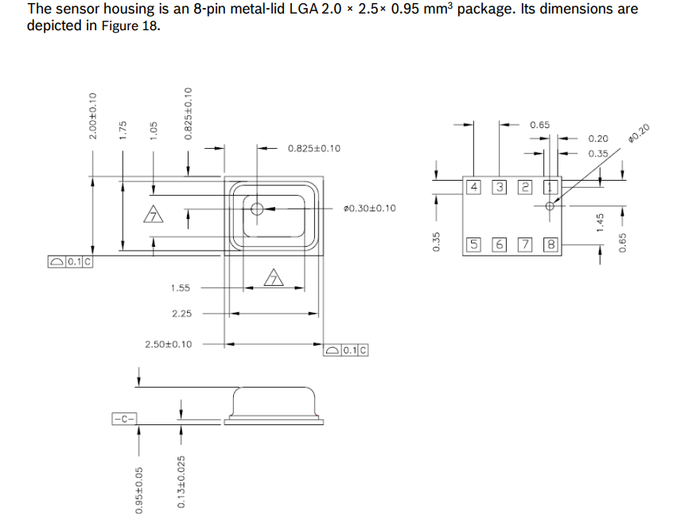

Figure 14. Dimensions of the sensor

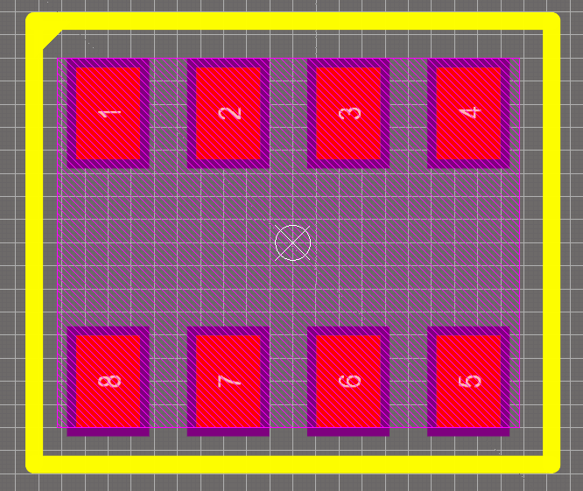

Figure 15. PCB schematic of BMP280

Now we need to insert 3D body to the footprint, I am using [Digi-Key](https://www.digikey.com/) or [ComponentSearchEngine](https://componentsearchengine.com/). I prefer to use Digikey library

We need to go to the Documents & Media → [EDA Models](https://www.digikey.com/en/models/6136307) → Select Download Format → Choose .step format

After downloading .step file, click **P → 3D Body → Select .step file you downloaded**

Put 3D body according to the pins and check if it is proper or not.

### Schematic Library (.SchLib)

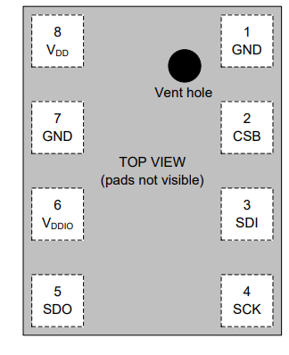

Figure 16. PIN description of BMP280

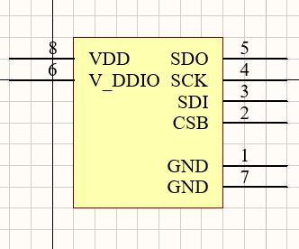

Figure 17. Schematic design of BMP280

Add footprint: Editor → Add Foodpring → Browse → Select PCB footprint → OK → Ok

## KLS1-TF-003 Micro SD Card Holder

### PCB Library (.PcbLib)

For micro SD card holder, Altium does not provide any footprint wizard. Therefore, it should be made by drawing by hand. However, to draw pcb footprint, we need footprint schematic which is provided by the manufacturer or third part sites. [Here](https://cdn.ozdisan.com/ETicaret_Dosya/466548_2616024.PDF)

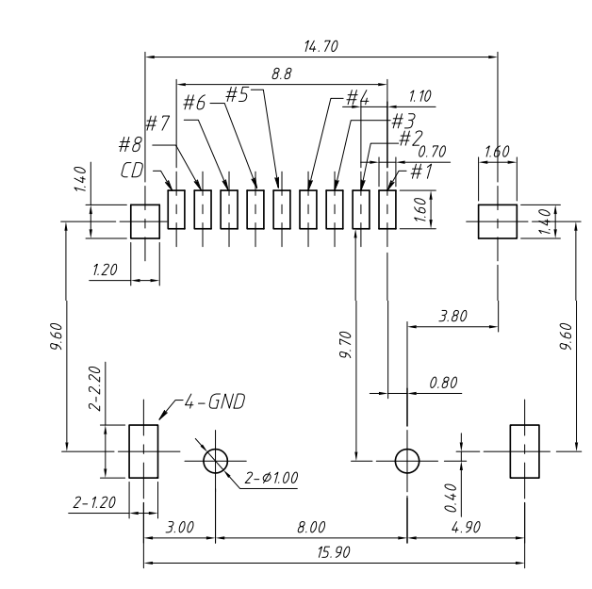

Figure 18. KLS1-TF-003 footprint

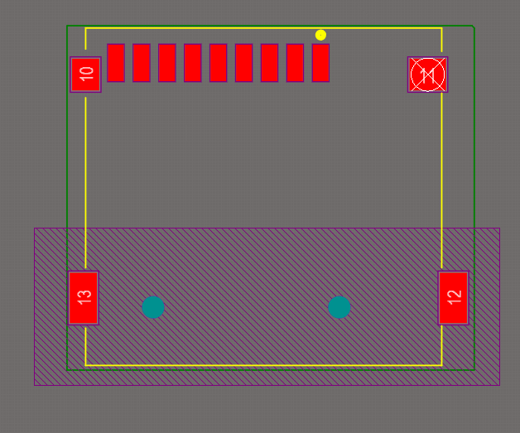

Figure 19. PCB schematic of KLS1-TF-003

Now, we need to add 3D body of the micro SD card holder. [ComponentSearchEngine KLS1-TF-003](https://componentsearchengine.com/search?term=L-KLS1-TF-003-H1.85-R)

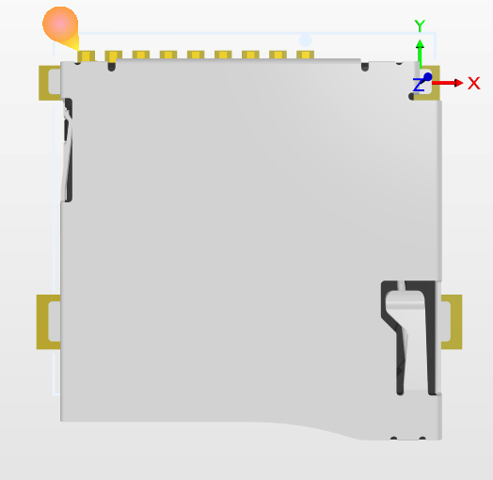

Figure 20. 3D Body of KLS1-TF-003

### Schematic Library (.SchLib)

We have PIN assignment manufacturer provides to us.

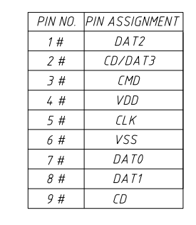

Figure 21. PIN assignment of KLS1-TF-003

Now, we need to create schematic of the micro sd card:

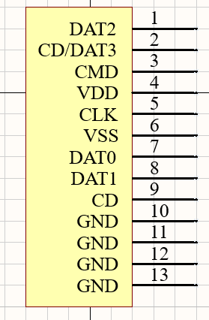

Figure 22. Schematic of micro sd card holder

After adding footprint of micro sd card, it is completed.

## Terminal Library

### PCB Library (.PcbLib)

We need terminal library which we will use in our PCB design.

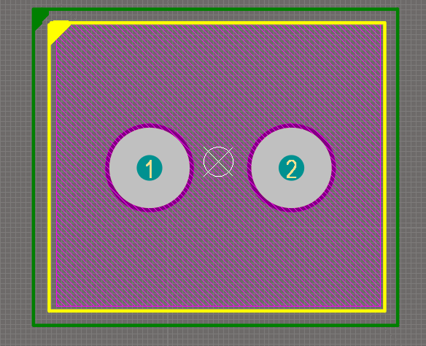

Figure 23. Terminal PCB footprint

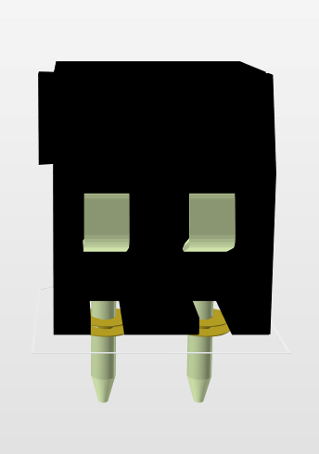

Figure 24. 3D body of terminal

### Schematic Library (.SchLib)

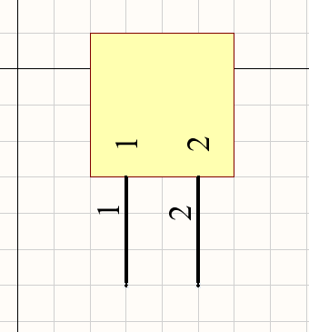

Figure 25. Schematic of terminal

## Buzzer

### PCB Library (.PcbLib)

The mechanical drawing which is provided by [octapart](https://octopart.com/datasheet/cem-1205c-cui+devices-106234830)

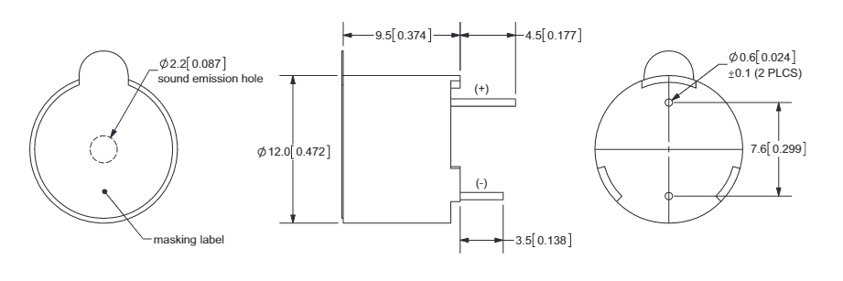

Figure 26. Mechanical drawing of buzzer

Let’s draw it in Altium:

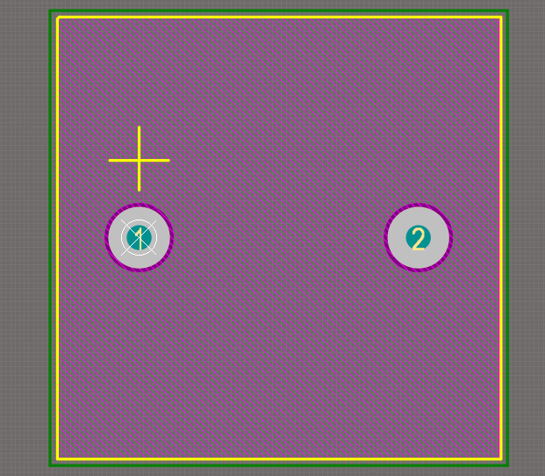

Figure 27. PCB footprint of buzzer

We need 3D body which can be found here [3dcontentcentral.com Buzzer CEM-1205C](https://www.3dcontentcentral.com/download-model.aspx?catalogid=171&id=557827)

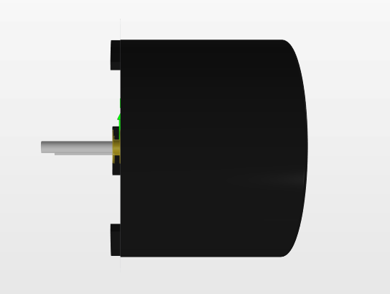

Figure 28. 3D body of buzzer

### Schematic Library (.SchLib)

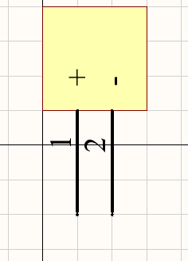

Figure 29. Schematic of buzzer

## Female Header 1x3, 1x4, 1x5

### PCB Library (.PcbLib)

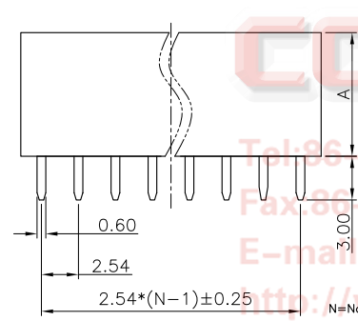

Figure 30. Mechanical drawing

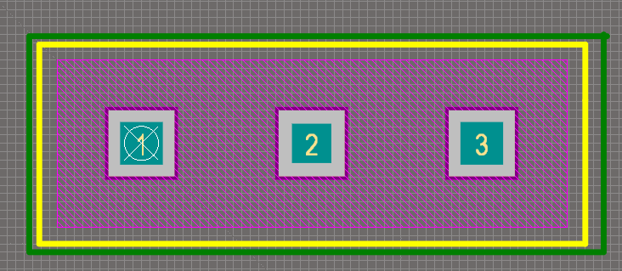

Figure 31. PCB footprint

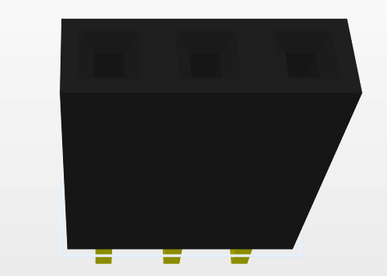

Figure 32. 3D body of 1x3 header

We can also design 1x4 and 1x5 header the same way.

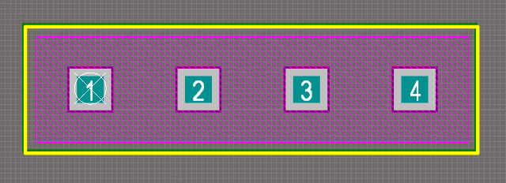

Figure 33. 1x4 header

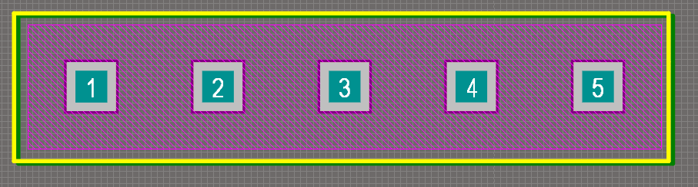

Figure 34. 1x5 header

### Schematic Library (.SchLib)

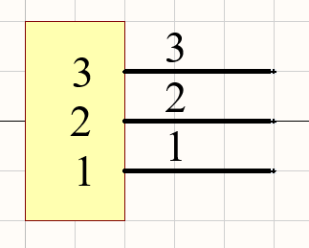

Figure 35. Schematic of 1x3 header

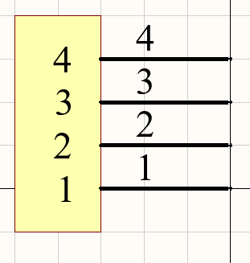

Figure 36. Schematic of 1x4 header

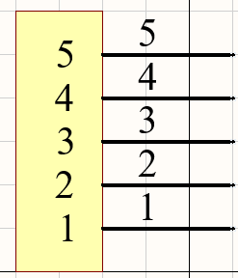

Figure 37. Schematic of 1x5 header

## SMD Capacitors

### PCB Library (.PcbLib)

I will use SMD type of capacitors in the PCB design, which is easy to use and suitable.

I will design 10µF, 0.1µF, 2.2nF, 330nF, 16pF. They are all SMD package capacitors, so I will show one design for all of them, applies to others.

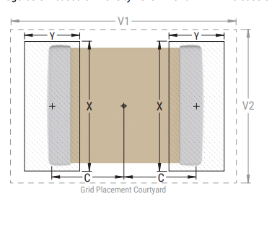

Figure 38. Mechanical drawing of SMD capacitor

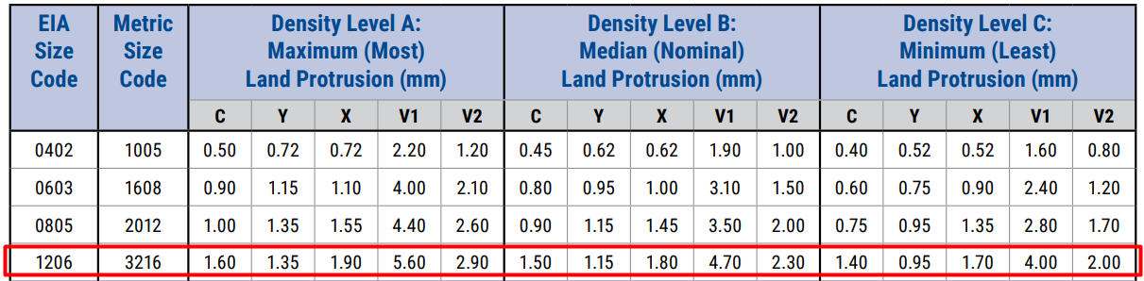

Figure 39. Dimensions of SMD package 1206 type

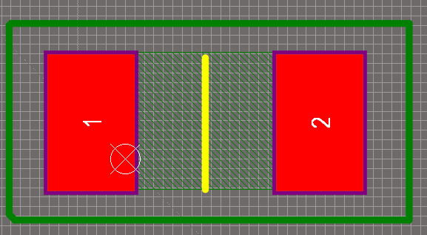

Figure 40. PCB footprint of SMD capacitors



Figure 41. 3D body of SMD capacitor

### Schematic Library (.SchLib)

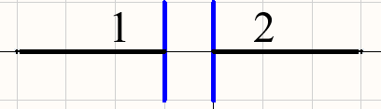

Figure 42. Schematic of SMD capacitors

## Tantal Capacitors

Tantal capacitors are separated by their polarity, they have positive (+) and negative (-) polarity. To show polarity, Yellow triangle is put in order to show positive polarity. I will use 10µF tantal capacitor for diversity.

### PCB Library (.PcbLib)

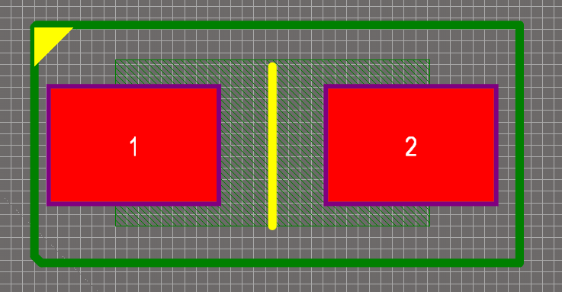

Figure 43. Tantal capacitor PCB footprint

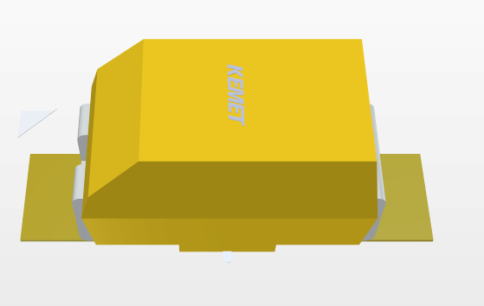

Figure 44. 3D body of tantal capacitor

### Schematic Library (.SchLib)

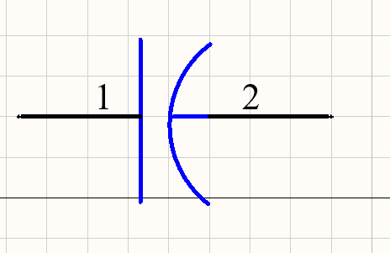

Figure 45. Tantal capacitor schematic

Polarity in schematic is like straight line is positive, arc line is negative polarity.

## SMD Resistor Library

We will be using 1206 resistor library which is same with the capacitor package we used. We are using 1K, 2.2K, 4.7K, 10K resistors.

### PCB Library (.PcbLib)

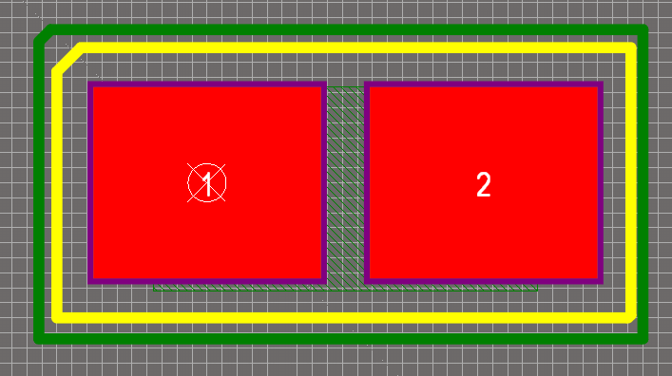

Figure 46. PCB footprint of R1206 resistors

I have put some curve at the corner of footprint to show it is positive polarity of the resistor as we have polarity in SMD type of resistors.

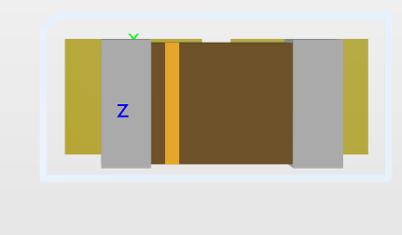

Figure 47. SMD type resistors with polarity

### Schematic Library (.SchLib)

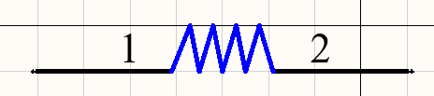

Figure 48. Resistor schematic

# System Schematic Design

We completed PCB and schematic designs of the components in the previos section. Now, we are ready to do schematic design of the system.

We need to add our schematic lib (.SchLib) to main schematic panel:

Panels → Components →

We can see now our components in the component section.

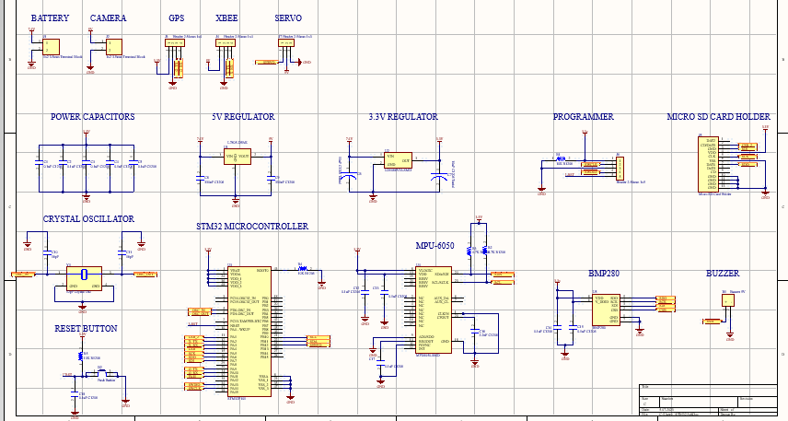

Figure 49. Schematics of components

We need to design all schematic drawings according to component specs. The capacitor/resistor values are generally specified and suggested to be use given range.

# PCB Design of the System

## Transferring schematic design into PCB

First, on Schematic page (.SchDoc) → Tools → Annotation → Annotate Schematics Quietly → Yes

It enumerates the components like C? → C1, C2, C3 etc.

Then go Design → Update PCB document …. → Execute Changes → Close

## PCB Sizing

I will use a 4.5cm x 4.5cm board. It might be said that we have many components that is not fitting in; however, we can use double layers to overcome the problem.

Draw 4.5cm x 4.5cm square with P→Line. Then press one edge of the square and press TAB to select all square → Design → Board Shape → Define from selected objects

## Placing Components into PCB

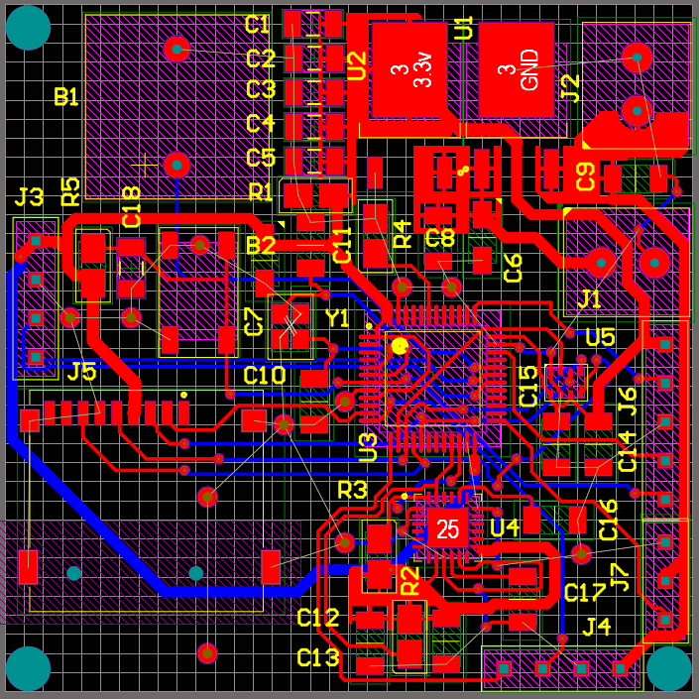

Figure 50. 2D Top-layer view of PCB

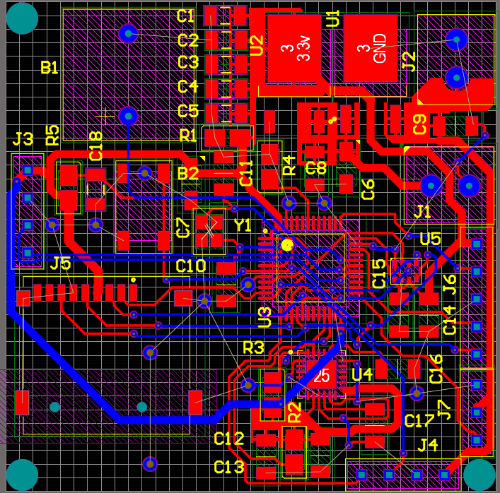

Figure 51. 2D Bottom-layer of PCB

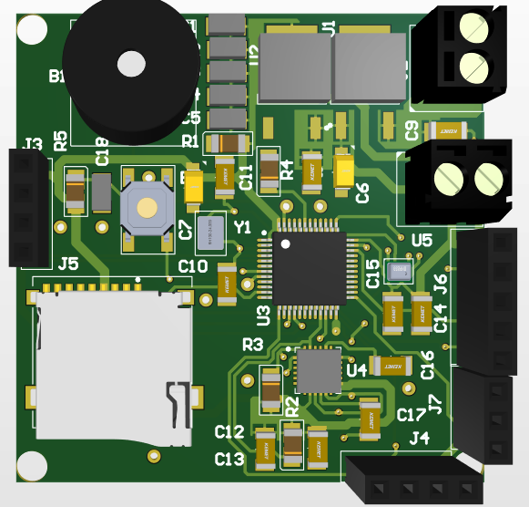

Figure 52. 3D Top-view of PCB

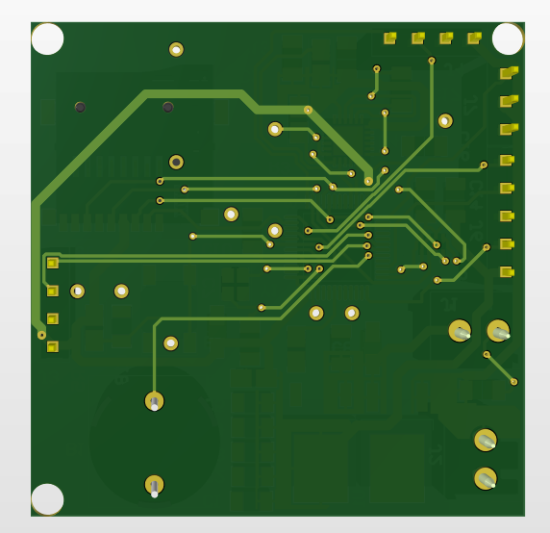

Figure 53. 3D Bottom view of PCB

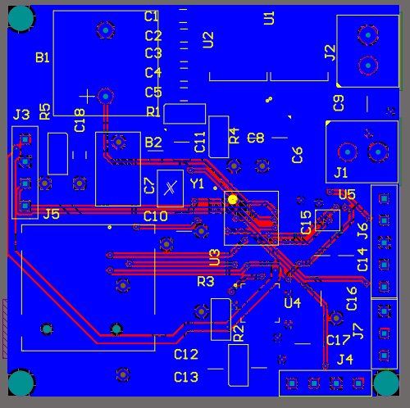

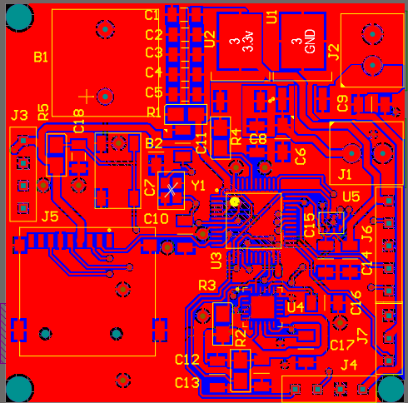

Figure 54. After pouring both sides of PCB with GND

## GERBER Output of PCB

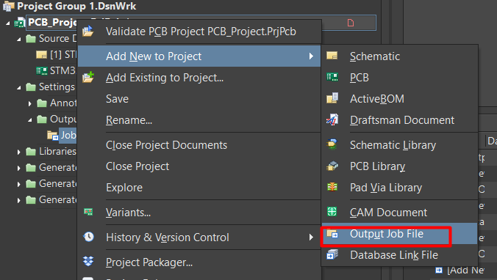

Figure 55. Step 1 to get GEBER output

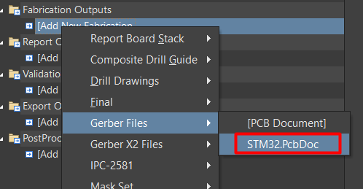

Figure 56. Step 2 to get GEBER output

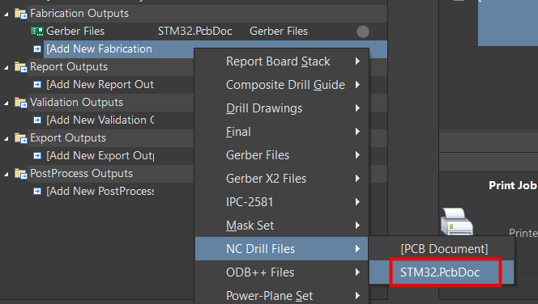

Figure 57. Step 3 to get GEBER output

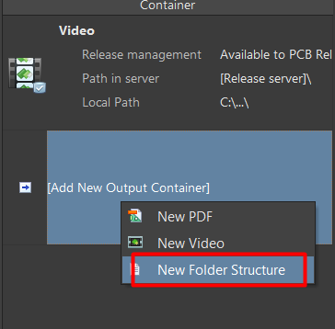

Figure 58. Step 4 to get GEBER output

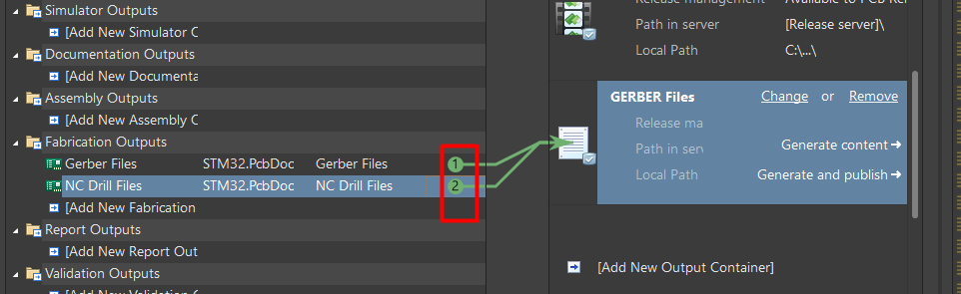

Figure 59. Step 5 to get GEBER output

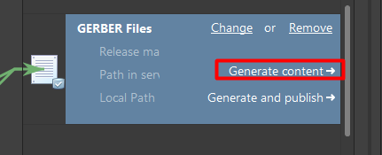

Figure 60. Final step to get GERBER output

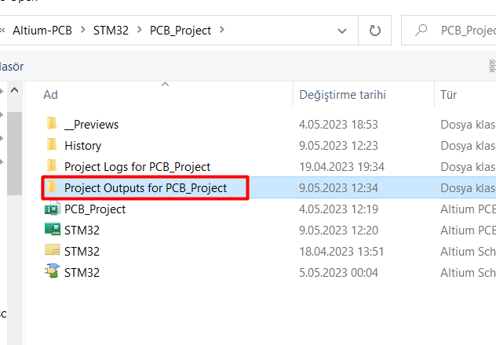

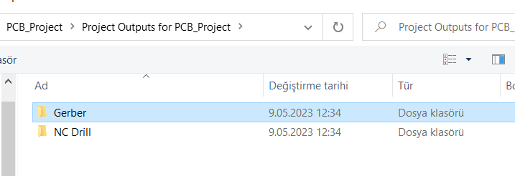

Figure 61. GERBER and Drill outputs