**MIDDLE EAST TECHNICAL UNIVERSITY**

**ELECTRICAL & ELECTRONICS ENGINEERING**

***EE464 – STATIC POWER CONVERSION-II***

**ISOLATED DC-DC CONVERTER DESIGN AND IMPLEMENTATION**

**EREN ALPASLAN-2152262**

***Table of Contents***

1. Introduction 4

2. Project Specs 4

3. Topologies 5

3.1 Flyback Converter 5

3.1.1 Advantages 5

3.1.2 Disadvantages 5

3.2 Forward Converter 6

3.2.1 Advantages 6

3.2.2 Disadvantages 6

3.3 Push-Pull Converter 7

3.3.1 Advantages 7

3.3.2 Disadvantages 8

3.4 Topology Selection 8

4. Analytical Calculations 8

4.1 Waveforms and Gain Function of Flyback Converter 9

4.2 Magnetic Design 11

4.2.1 Number of turns calculation 14

4.2.2 Duty Cycle (D) 15

4.2.3 Magnetizing Inductance Calculation 15

4.2.4 Core Loss 16

4.2.5 Copper Loss 17

5. Simulations 19

6. PCB Design 19

7. Bill of Materials (BOM) 19

8. References 19

**Table of Figures**

Figure 3‑1. Flyback converter circuit 7

Figure 3‑2. Forward converter circuit 8

Figure 3‑3. Push-Pull converter circuit 9

Figure 4‑1. Flyback converter schematic 10

Figure 4‑2. Flyback converter cct schematic in Simulink 15

Figure 4‑3. Transformer parameters in ideal case 16

Figure 4‑4. Minimum input voltage settings 16

Figure 4‑5. Output voltage ripple measurement 17

Figure 4‑6. Output current 17

Figure 4‑7. Diode current and voltage 18

Figure 4‑8. Adjusting system to maximum voltage level 18

Figure 4‑9. Output voltage level 19

Figure 4‑10. Output current 19

Figure 4‑11. FET current and voltage 20

Figure 4‑12. Diode current and voltage 20

Figure 4‑13. Area product distribution (WaAc) chart from Magnetics Inc. 24

Figure 4‑14. 43515 core power handle chart (for 100kHz frequency, 135W can be handled) from Magnetics Inc. 24

Figure 4‑15. Dimensions of the 0F43515EC core 28

Figure 4‑16. An optocoupler 31

Figure 4‑17 Compensation network with TL431 32

Figure 4‑18. Pin configuration of UCx88x series 35

Figure 5‑1. Complete design with close feedback loop 37

Figure 5‑2. Output voltage waveform when Vin = 48V 38

Figure 5‑3. Output current waveform when Vin = 48V 39

Figure 5‑4. Output current waveform when Vin = 24V 40

Figure 5‑5. Output voltage waveform when Vin = 24V 41

Figure 5‑6. Secondary side diode voltage waveform when Vin=48V 42

Figure 5‑7. Primary side FET voltage waveform when Vin=48V 43

Figure 6‑1. Schematic design of the circuit 44

Figure 6‑2. PCB design of the circuit 45

# Introduction

In this project documentation, one of 3 isolated DC-DC converter topologies will be chosen with respect to its advantages and usage. Beside topology selection, magnetic design and controller selection will be examined in detail. Simulations will be added to support calculations. Components will be selected according to the results and Bill of material (BOM) will be shared in the last section. PCB will be designed in Altium. Simulations will be handle in LTSpice and matlab/Simulink.

# Project Specs

|  |  |
| --- | --- |
| **Minimum Input Voltage** | 24 V |
| **Maximum Input Voltage** | 48 V |
| **Output Voltage** | 15 V |
| **Output Power** | 45 W |
| **Output Voltage Peak-to-Peak Ripple** | 3% |
| **Line Regulation** | 3% |
| **Load Regulation** | 3% |

According to given specs, there are multiple types of topologies to choose in view of advantages and disadvantages.

A closed-loop control is must.

# Topologies

## Flyback Converter

Flyback converter is one of the most commonly used isolated DC-DC power converters. It is derived from buck-boost converter. Dots are opposite direction.

Figure 3‑1. Flyback converter circuit

### Advantages

* Simple design and implementation as compared to other isolated DC-DC topologies
* Less switching elements
* Operate in a wide range of input voltages
* Less cost compared to other isolated DC-DC topologies.

### Disadvantages

* Ripple at the output is significant means we might have EMI problems
* Flyback is kind of storage&release converter, therefore to storage more energy, gapped core is used. A gapped core means more EMI problems and more losses.
* Air gap decreases inductance and increases saturation current that means we can push more current means we can storage more energy. (To see calculations: Magnetic Design Guidance P. 6)
* Flyback requires additional snubber circuit in order to discharge leakage inductance in transformer.

## Forward Converter

Figure 3‑2. Forward converter circuit

Forward converter is derived directly from buck converter in contrary flyback is derived from buck-boost converter. Here, dots are same direction. It is usually used in off-line supplies in range of 100-200W.

### Advantages

* Power is directly transferred from input to output. Therefore, no need to use air gap to storage extra energy which means the core size becomes smaller.
* Better utilization of transformer. (direct power transfer)
* A gapless core can be used because we directly transfer energy, no need to storage.
* Output inductor & diode ensures continuous output current.

### Disadvantages

* Increased cost (extra diode and inductor)
* Gain changes a lot in DCM (Discontinuous Conduction Mode)
* Higher voltage requirements for MOSFET means higher component, increase PCB size.

## Push-Pull Converter

Figure 3‑3. Push-Pull converter circuit

In push-pull converters we have 3 operations sections:

We do not turn on both switches at the same time.

### Advantages

* The biggest advantage of push-pull converter is they utilizes the magnetic core better due to drawing current from both halves of the switching period (high efficiency) that leads to smaller core size.
* It is like a buck converter but it makes 2 cycles in one period. That is, for example, switches are operating x Khz, but inductor current at the output is going up & down at 2x kHz. That helps to reduce current ripple compared to normal buck converter or forward converter.

### Disadvantages

* More switches means more losses and more cost
* Hard to implement compared to flyback

## Topology Selection

Flyback converter is more easier to design and implement. It might be unuseful because of losses and EMI problems, it requires more attention to select components. However, with the selection of right components and precise calculations, the problems will be solved.

# Analytical Calculations

First, we need to understand the waveforms of Flyback converter in detail.

Figure 4‑1. Flyback converter schematic

## Waveforms and Gain Function of Flyback Converter

Voltage conversion ratio can be calculated in 3 different ways:

1. Magnetic circuit: Transformer flux
2. Graphically: Voltage-second balance of the inductor
3. Steady-state current

From voltage-second balance:

During ON period:

During OFF period:

For our system,

In Flyback converter, it is often used to work converter in DCM mode different than push-pull and forward converter. DCM seems like a disadvantage to run a converter in. However, it is used to limit the flux density, so we can actually use a smaller core. Furthermore, the switch or the diode is reaching zero voltage in DCM. Therefore, in the next turn on, we are not doing hard switching. It means, we are not turning on and off while it is carrying current. DCM mode was selected.

As we decided to run our Flyback converter in DCM. Output current , should be smaller than the smallest value of in order to ensure a DCM. Smallest occurs at the highest value of duty ratio which in this problem corresponds to lower value

can be calculated from the output power .

Average inductor current can be calculated as following:

Now, we need to calculate ripple current for worst case scenario. In the worst case scenario, it is important that calculations should be done according to highest input voltage level which is 48 V.

The results we get shows magnetizing inductance should be more than . The value should be larger than .

Before move further, peak value of the inductor current needs to be calculated:

It is specified that output peak-to-peak voltage ripple is 3%. Therefore, we can calculate approximate capacitor value:

From , capacitor current

*→*

Table 1. Output capacitor values for different cases

|  |  |
| --- | --- |
| **Case** | **(μF)** |
| V, | 25.33 |
| V, | 2.533 |
| V, | 15.86 |
| V, | 1.586 |

We have different cases like input voltage change and load current change. They all affect the capacitor value. Therefore, we will calculate all cases and choose worst case to specify the output capacitor value.

Also note that, the calculated capacitor values are the minimum values for the required capacitance. It is strongly recommended to use it higher than the founded values for safety margin. Moreover, as the voltage across the capacitor increases, capacitance value is decreases.

## Ideal Case Simulations (Simulink)

It is important to see ideal case scenario in the simulation. Here, we are using matlab/Simulink to represent computer simulations.

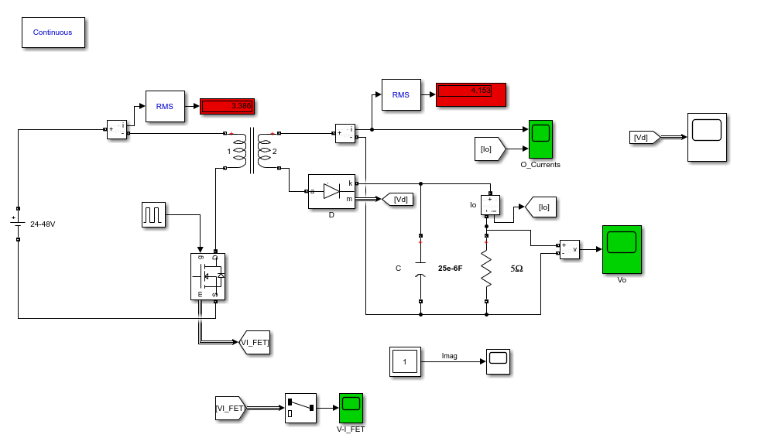

Figure 4‑2. Flyback converter cct schematic in Simulink

Simulations are tested in two conditions, which are &

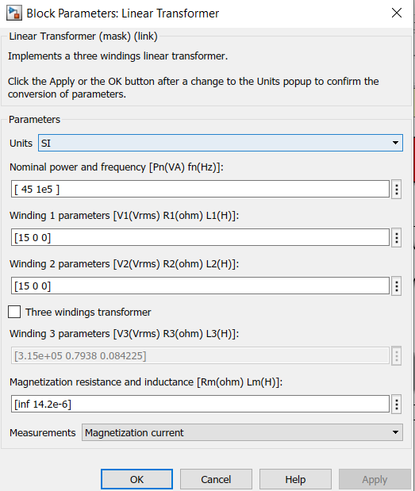

Figure 4‑3. Transformer parameters in ideal case

As we have calculated in previous, Duty cyle for  **is 0.38.**

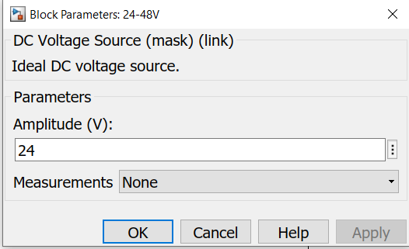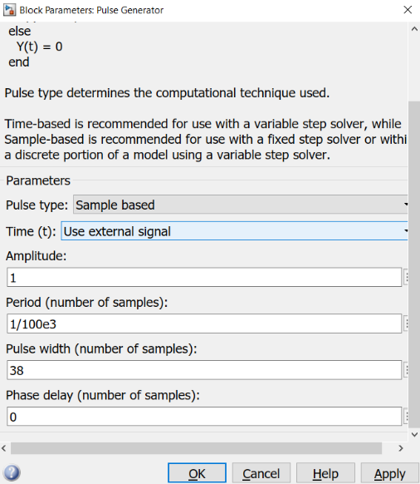

Figure 4‑4. Minimum input voltage settings

1. Input Voltage
2. Duty cycle settings of FET

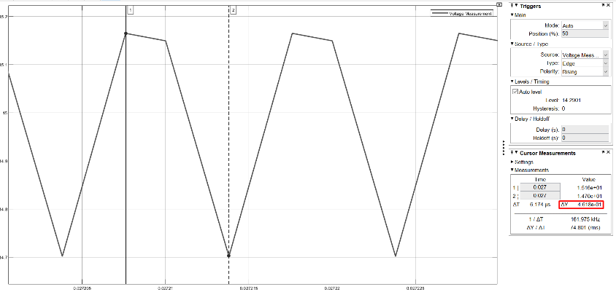

Figure 4‑5. Output voltage ripple measurement

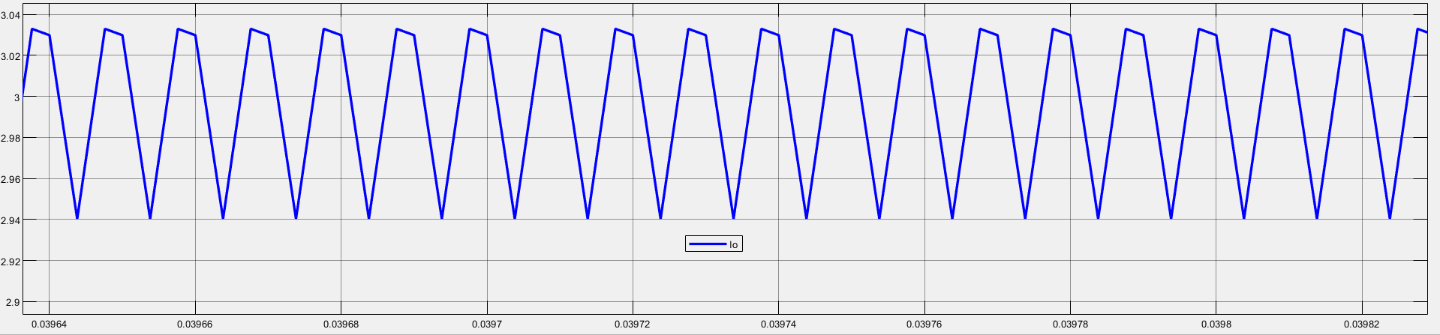

Figure 4‑6. Output current

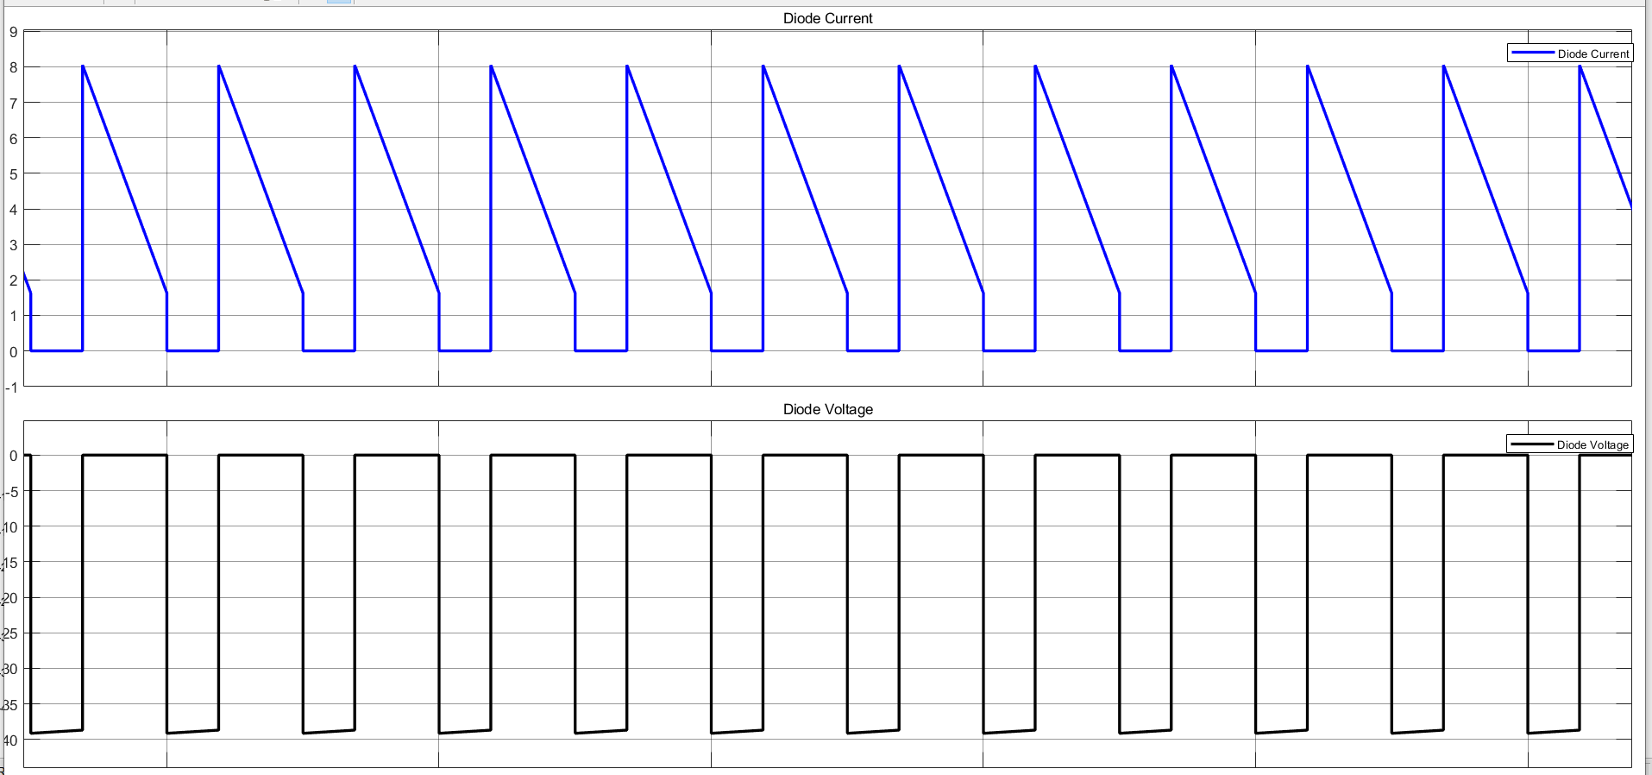

Figure 4‑7. Diode current and voltage

**When :**

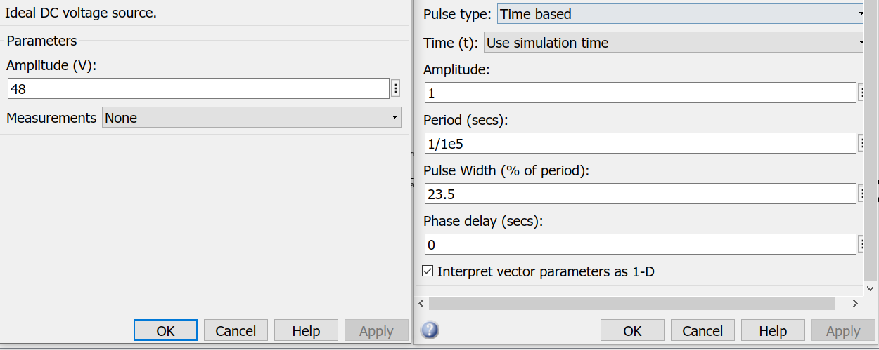

Figure 4‑8. Adjusting system to maximum voltage level

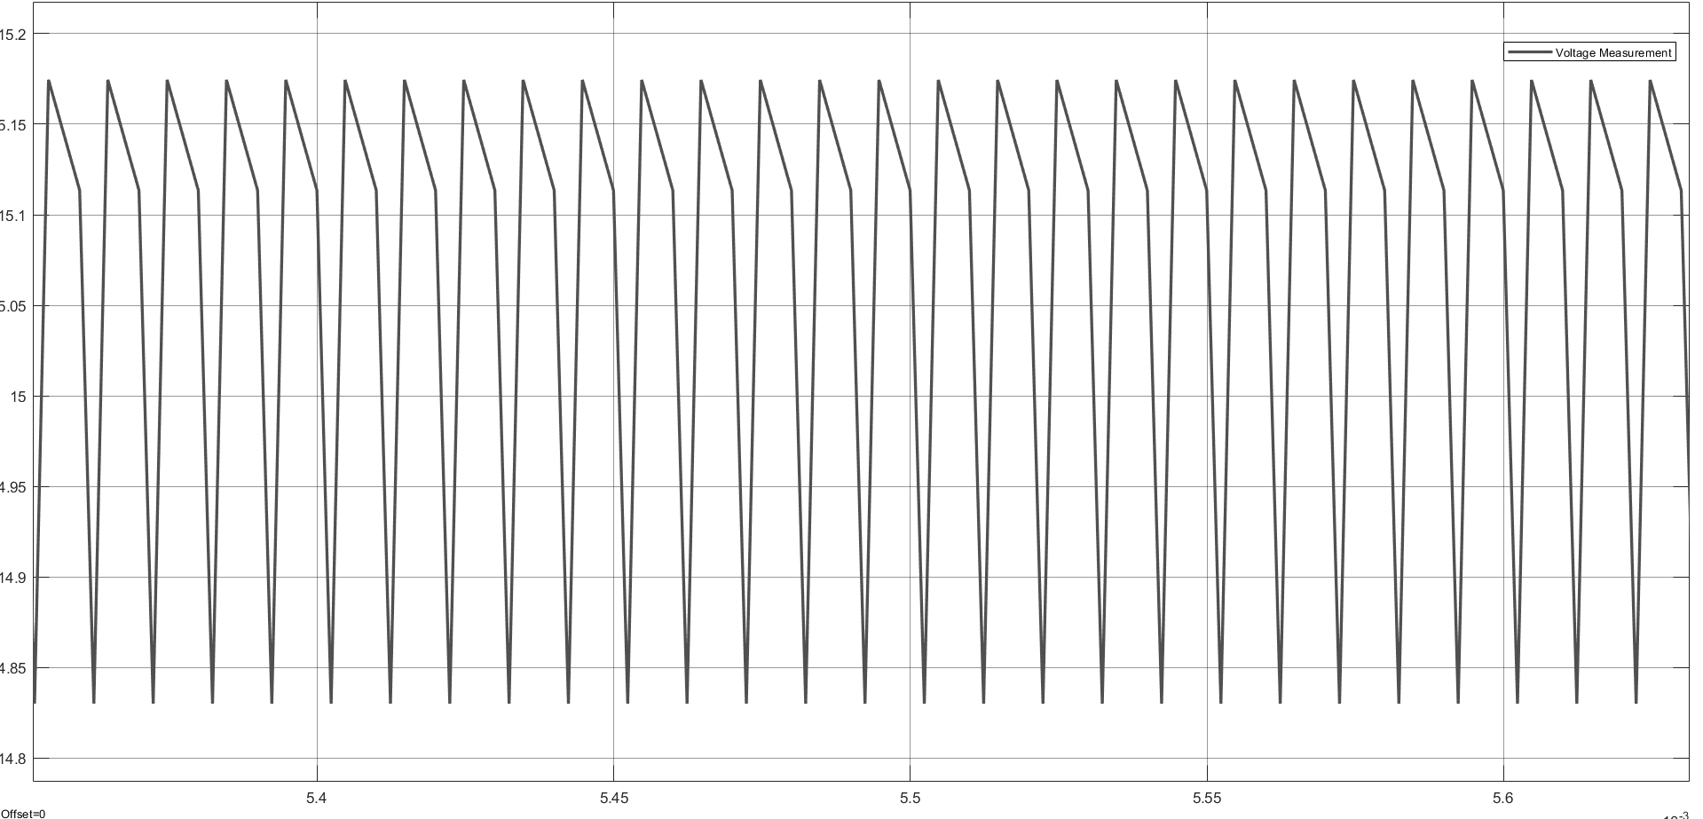

Figure 4‑9. Output voltage level

We can observe that our output voltage ripple is around 3% same as the minimum voltage level.

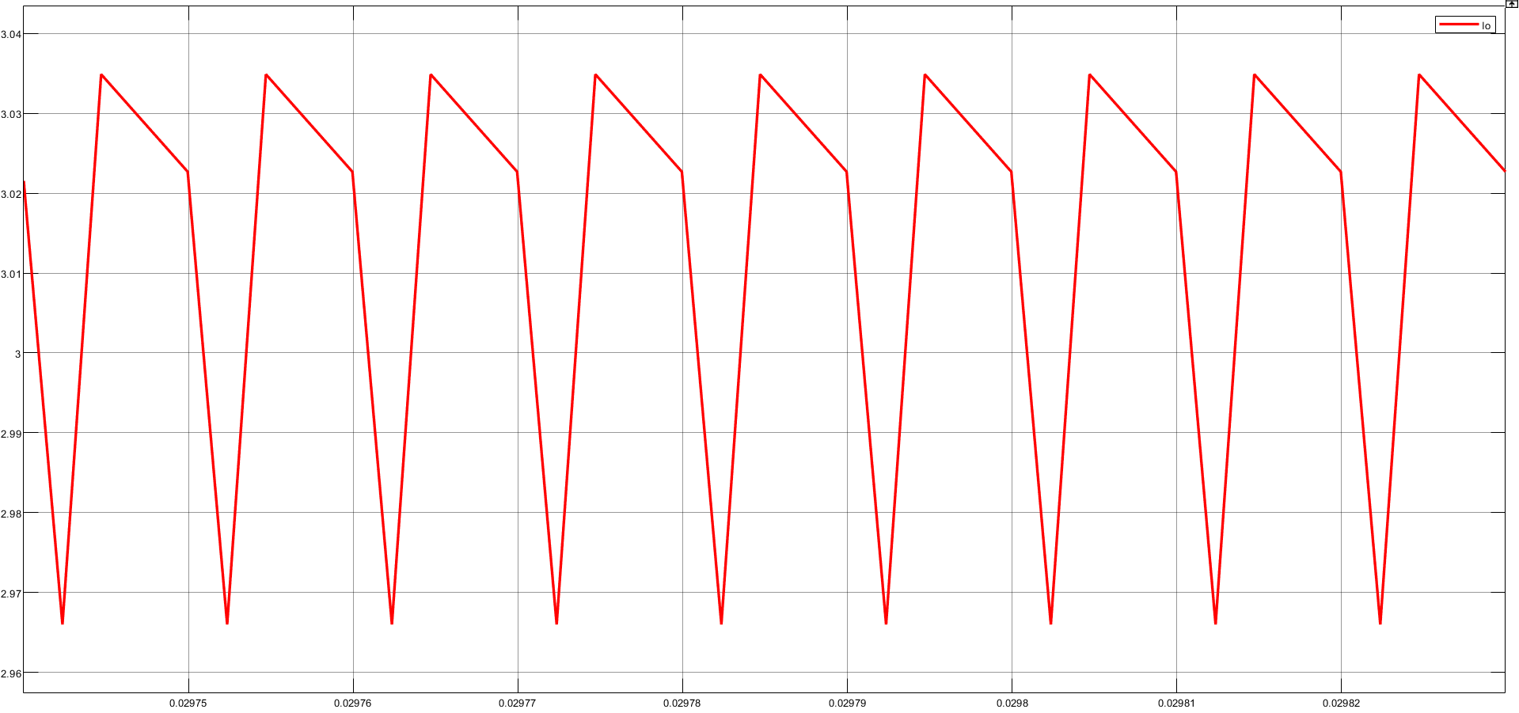

Figure 4‑10. Output current

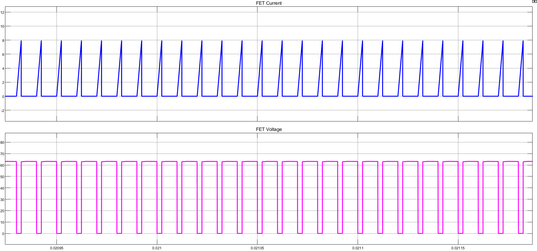

Figure 4‑11. FET current and voltage

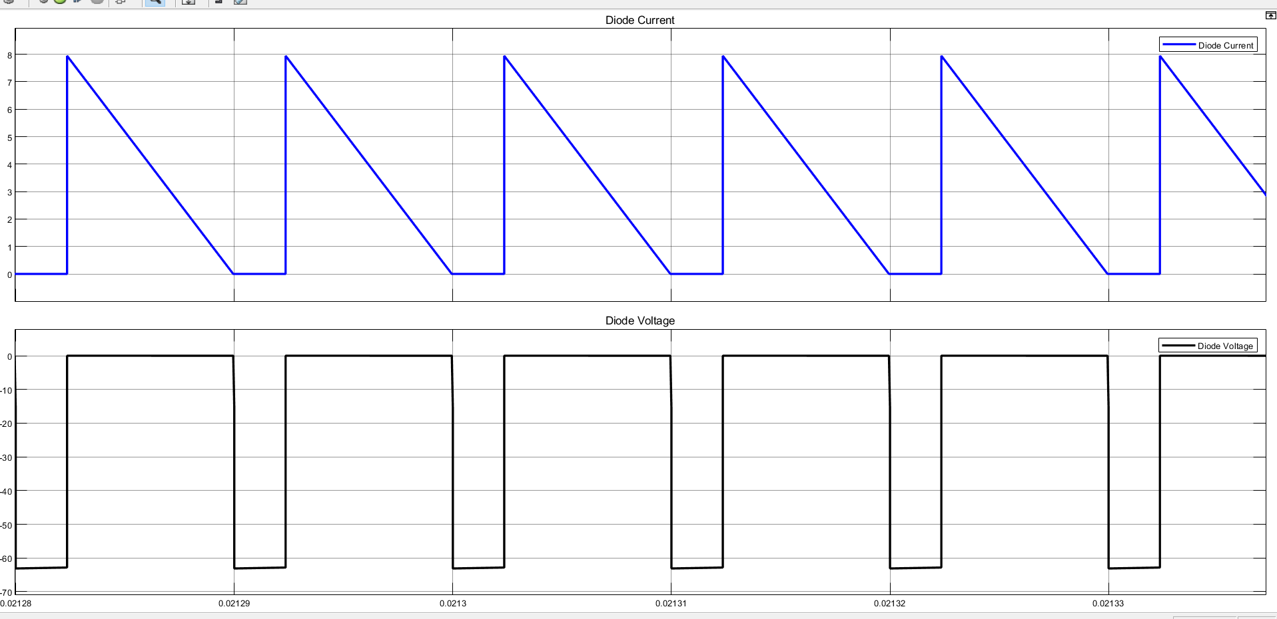

Figure 4‑12. Diode current and voltage

*Note that when we design clamp circuit that we will again calculate maximum voltage on the FET and diode. Here, maximum voltage is around 63.5V. It will be used for switch selection. Also, will be discussed at Clamp Circuit Design

## Magnetic Design

Faraday’s law for each turn of wire:

Total winding voltage is:

Express flux (𝛷) in terms of flux density 𝛷 =

is not one of the specificationsof transformer, therefore we can write instead:

I=J where is area of copper wire

However, is still not related to transformer specifications; therefore, we write instead:

Fill factor

Copper area

Window area

We are using constant 2 because having 2 winding in the transformer

Insert into

= Flux density (gauss) selected based upon

Switching frequency. As it is decided

: Topology constant, for Flyback it is 0.00033 (single winding), 0.00025 (multiple winding)

J (current density can be selected depends upon the amount of heat rise allowed. 750 cir.mils/amp is conservative, 500 cir.mils/amp is aggressive.

Above 20kHz, core losses increases significantly.

To operate ferrite cores at higher frequencies,

it is necessary to operate the core flux levels lower

than ±2kg. The flux density vs frequency chart

shows the reduction in flux levels required to maintain 100 mW/cm³ core losses at various frequencies, with a maximum temperature rise of 25°C. for a typical power material, Magnetics’ P material. From transformer design with magnetics ferrite cores (Mag. Inc)

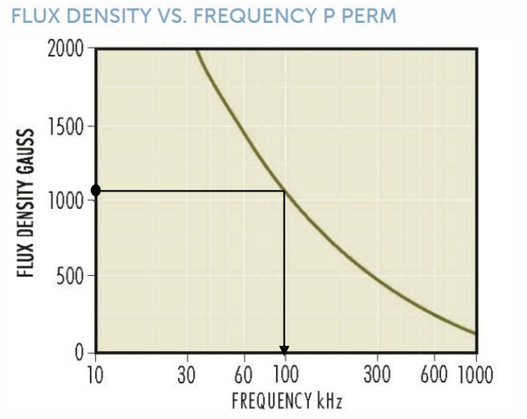

Figure. Flux density (gauss) vs Frequency (kHz)

For 100kHz, flux density is around

For clearity, 1 Tesla (T) = 10,000 gauss

Therefore 1000 gauss is 0.1T

Now, next step is choosing suitable core for the transformer.

Magnetics Inc. has a guidance for area product distribution ()

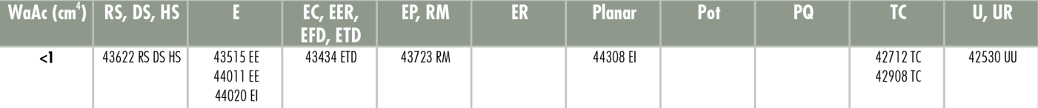

Figure 4‑13. Area product distribution (WaAc) chart from Magnetics Inc.

Suitable cores are 43622 RS,DS,HS cores, 43515 EE, 44011 EE, 44020 EI core.



Figure 4‑14. 43515 core power handle chart (for 100kHz frequency, 135W can be handled) from Magnetics Inc.

43515 EE core is suitable and can handle 45 W easily.

Our E type core is R material with a code number 0R43515EC

Effective area of the E core which we chosen is and nominal inductance , relative permeability ( = 3000.

### Number of turns calculation

Faraday’s law of induction should be applied:

Turn ratio (n) is chosen to be 1

turns

Let’s ensure that the values we found are correct:

According to Faraday’s Law of induction that induced emf across a coil:

We prefer selecting the value from Magnetics Inc., so turns ratios are

### Air Gap Calculation

Magnetizing inductance ripple is not given/specified. However, we need to specify a limit to design transformer. Therefore, magnetizing inductance ripple is determined and should not exceed 20% of magnetizing current.

Inductance L also can be expressed:

Now, matlab script which we wrote will help to find air gap in terms of meter.

% Given values

mu_0 = 4*pi*1e-7; % Permeability of air

l_e = 69.3 / 1000; % Air gap length in meters

N_pri = 14; % Number of primary windings

B_core = 0.1; % Core magnetic field

mu_r = 3000; % Relative permeability

I_m = 6.808; %Maximum current of primary

% Calculation to find the air gap length (l_g)

l_g = (mu_0 * (N_pri * I_m)) / (2 * B_core) - l_e / (2 * mu_r);

% Displaying the result

disp("Air gap length (l_g) = " + num2str(l_g) + " meters");

Air gap length (l_g) = 0.00058731 meters

We found air gap lenght as . It is equal to 6 A4 paper width (1mm).

### Cable Selection

When safety is considered first, it is better to use J = 4 A/ to stay in the safety zone.

First, we need to know primary and secondary RMS currents to have knowledge about cable thickness.

17AWG is appropriate for primary side and 16AWG for the secondary in terms of cross-sectional area. However, skin depth will be problem this time. Therefore;

26 AWG is suitable for 100kHz operation with cross-sectional area of 26 AWG of .

Therefore, # of parallel cables for primary is 9, # of parallel cables for secondary is 11.

The last step after determining cable type, we can calculate resistance of the cables.

### Core Loss

In 0F43515EC core datasheet, and are specified as below:

at 25kHz. We expect an increase at core loss at 100kHz which our system will be working at.

### Copper Loss

In order to calculate copper loss, some specifications should be known. One of them is MLT (Mean-lenght-per-turn). In datasheet of the core, it is not specified directly. However, it can be calculated readily. MLT is as known as the lenght of any turn along the surface of the core.

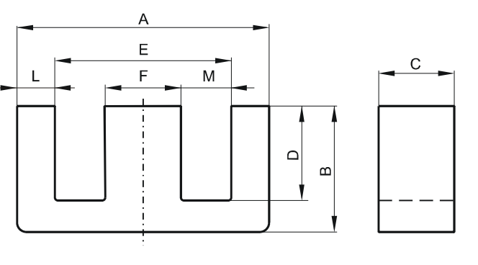

Figure 4‑15. Dimensions of the 0F43515EC core

## Clamp Circuit Design

Flyback converter is such a converter that requires snubber/clamp circuit to suppress ringing and spikes. Without any type of protection, these spikes is because of leakage inductance may put too much stress on switching devices and can damage on the device. Thefore, some protections should be implemented.

First, we need to calculate voltage at turn off on FET:

We assume the maximum voltage might go up to 100V due to spikes.

The voltage is on FET ( should be 66% FET’s maximum allowable voltage.

Therefore **FET’s voltage should be selected around 150V**

Unlike RC snubber, the value of RCD capacitor does not impact losses. Its value, therefore; is not critical, it just needs to be large enough such that voltage remains constant during snubber operation. It is essentially a RC circuit so a good compromise would be allow 2.5 to 5 time constant

To minimize ESR of capacitor, multiple capacitors can be put into parallel combination to reduce ESR. For example

## Closed-Loop Feedback System

As it is mandatory to design closed-loop feedback system for our converter. We need to understand the basics. In general, gate driver circuits are used to control the converter. They take feedback from output and adjust gate signal of the switch/es. However, there are voltage difference between input and output. Direct feedback from the output might damage the device. Therefore, feedback with isolation is used. One example is a opto-coupler.

### Optocoupler

Opto-coupler is like a standard BJT but:

* Instead of Base terminal, we have a LED inside the package
* It is same logic as in BJT, increasing/decreasing the current through the LED is just like increasing/decreasing the base current
* We have **C**urrent **T**ransfer **R**atio (**CTR**) instead of β

Figure 4‑16. An optocoupler

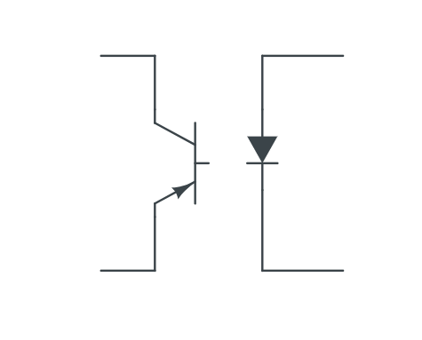

**C**

**E**

Where

LED also has a forward drop across itself like any other diode ()

### Compensation Network Transfer Function

Flyback is a isolation converter type that prevent high voltage transferring from input to output and keep the devices in safe region. Therefore, feedback circuit also must be isolated. Optocoupler is used for this purpose. TL431 is an adjustable shunt regulator that is similar (not identical) to the amplifier. Check the fig.

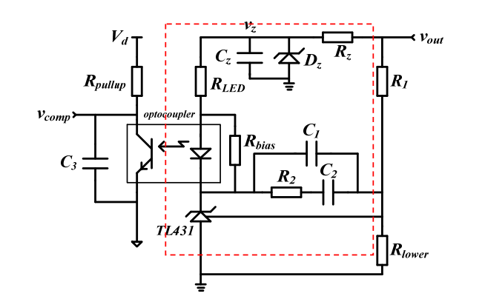

Figure 4‑17 Compensation network with TL431

In general application, the REF pin connects output of the divider network, and sense the variation in the output. The error signal is converted to sink current of the cathode pin, thus it can be regarded as a transconductance amplifier.

TL431 is considered a transconductance amplifier, therefore, a substantial transconductance amplification is essential for compensation usage. One notable characteristic of TL431 is that, when the sink current (Ik) on the cathode pin remains at a low level, the transconductance gain is also low. However, as Ik increases, the transconductance gain experiences rapid growth, which necessitates the establishment of a minimum Ik limitation. The datasheet for TL431 suggests a bias current of 1 mA. In Figure 4.5-2, the bias current is supplied by .

Optocoupler is specifically engineered to enable signal transmission between two electrically isolated circuits while ensuring a significant level of electrical isolation. The current transmission rate (CTR), denoted as /, is a crucial parameter that depends on the phototransistor's forward current () and temperature. Typically, an analysis would consider the adoption of a typical CTR value. represents the equivalent capacitor, which is connected in parallel with the silicon NPN phototransistor. In Figure 4.5-2, is also connected in parallel with . Since is considerably smaller than , it can be eliminated during calculations.

In order to ensure an adequate gain margin and phase margin by compensating for the original zero pole and polar pole, the widely employed approach is the utilization of a second-order (order II) network. This order II network, depicted in Figure 4.5-2, consists of , , , and . It encompasses one zero pole and two polar poles, enabling it to provide satisfactory DC gain, appropriate cross-over frequency, and exceptional attenuation at high frequencies.

As shown in Figure 4.5-2, the transfer function of the part surrounded by red dashed line:

( 1 )

The transfer function of order II network is:

( 2 )

Commonly , so equation evolves the following:

( 3 )

According to Equations (1) and (3), the compensation network transfer function can be deduced as follow:

( 4 )

### Controller Selection

I am planning to design feedback controller with opto-coupler. There are many available controllers in the market; however, choosing right controller is important. Also, the controller can be implemented and tested in spice.

After some research over the manufacturers and controllers, UC2842, UC3842, LT1242 might be good solution for driving FET. UC2842 can operate at 100% duty cycle. On the other hand, UC3842 can operate at 50% duty cycle. These controller required third winding to feed controller beside they have complex feedback design. However, robust system is one of the main target. Availability of component is also important for us. When we research over the internet, UC2842 is good controller for our system.

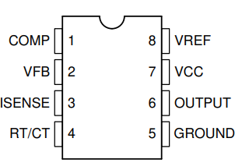

Figure 4‑18. Pin configuration of UCx88x series

#### Oscillator Frequency (RT/CT)

We designed our magnetic design according to the frequency which is 100kHz. Therefore, we need to set up oscillator frequency is 100kHz. When we look at the details in the datasheet, it is stated that it is suggested to use of range , the recommended range of timing capacitor values is between 1 nF and 100 nF.

When we use minimum resistor value , is equal to 3.01nF, we have commercially 3.3nF available in the market.

Therefore

#### Current Sense Network

sets the maximum peak current in the transformer primary based on the maximum amplitude of the pin, which is specified to be 1 V. To achieve 1.36-A primary side peak current, a 0.75-Ω resistor is chosen for .

# LTSpice Simulations

## Overall Design

Figure 5‑1. Complete design with close feedback loop

In the controller, it is decided to use Ucx84x series. When we looked at the datasheet in details, UC2842 is one of the optimal solution. However, third winding is required to feed controller. The circuit schematic of the controller is shown above in Fig. 5-1.

## Simulation waveforms

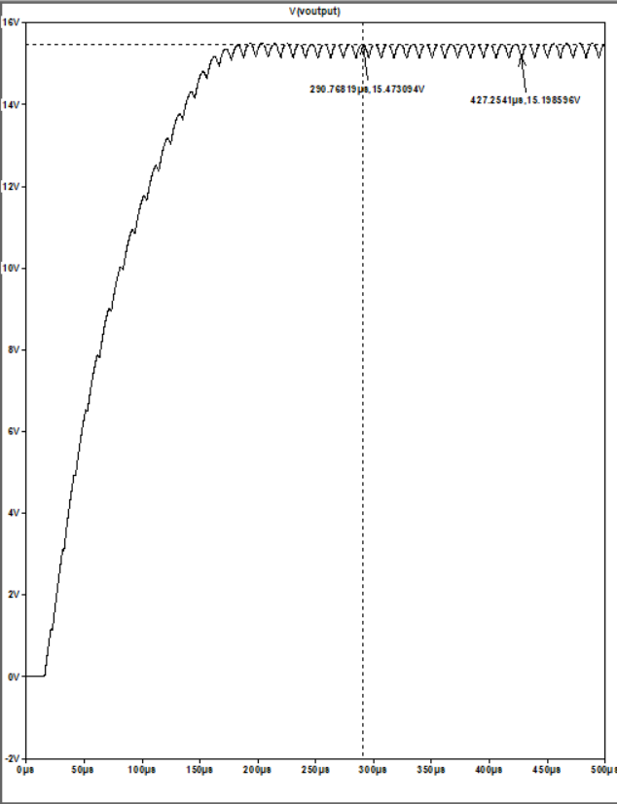

Figure 5‑2. Output voltage waveform when Vin = 48V

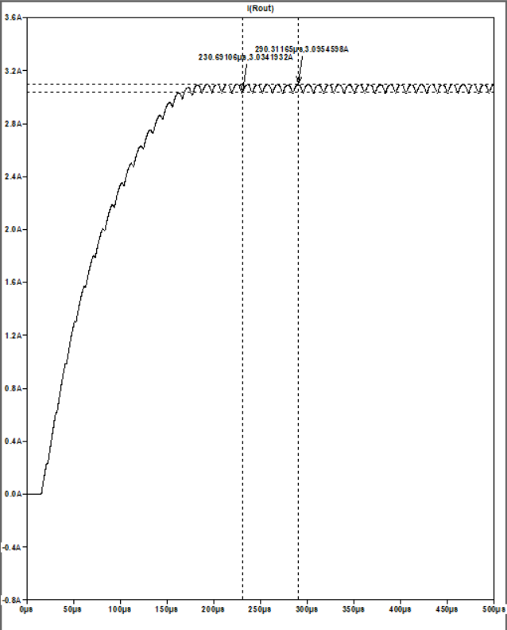

Figure 5‑3. Output current waveform when Vin = 48V

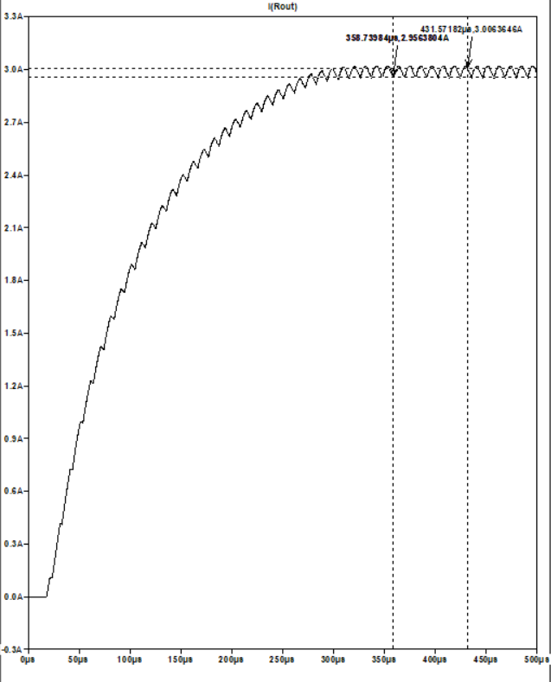

Figure 5‑4. Output current waveform when Vin = 24V

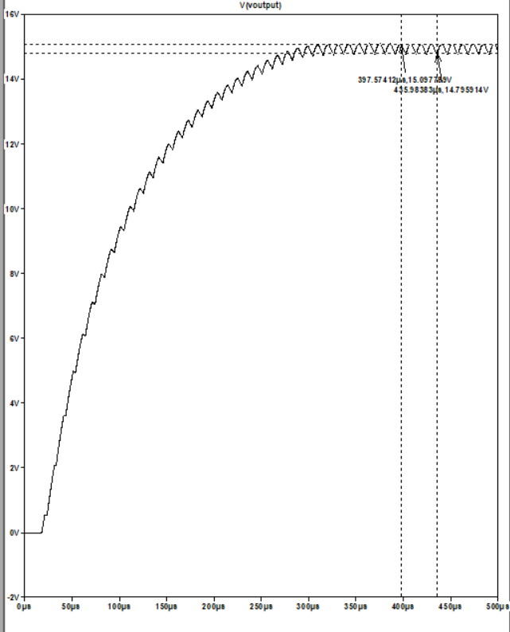

Figure 5‑5. Output voltage waveform when Vin = 24V

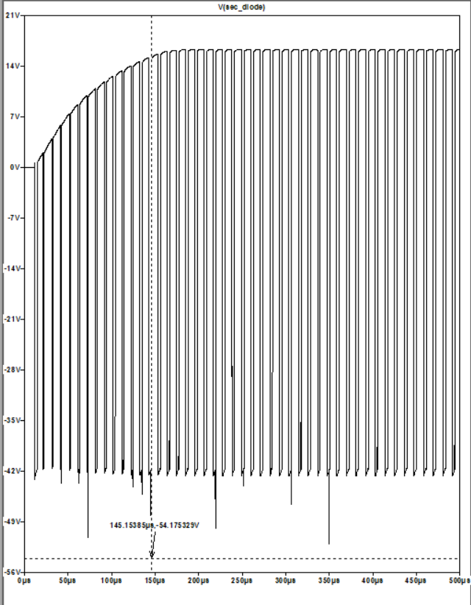

Figure 5‑6. Secondary side diode voltage waveform when Vin=48V

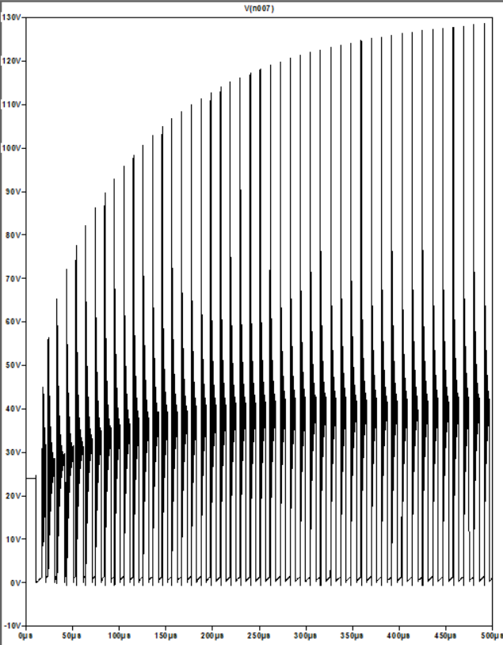

Figure 5‑7. Primary side FET voltage waveform when Vin=48V

# Altium PCB Design

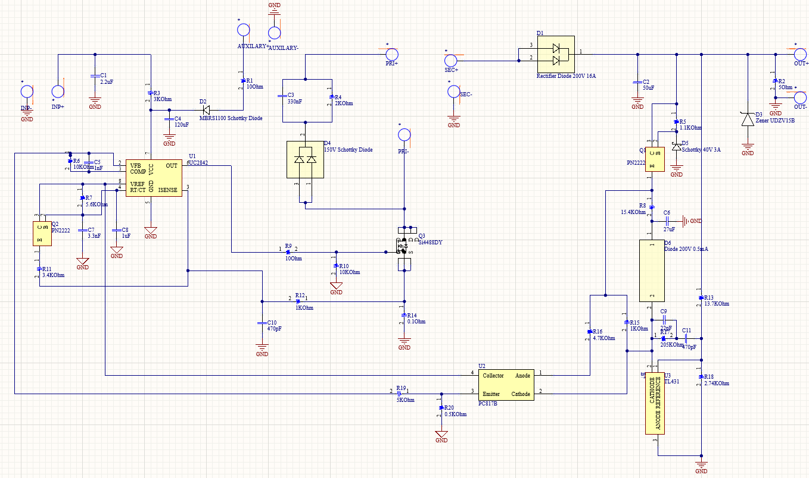

Figure 6‑1. Schematic design of the circuit

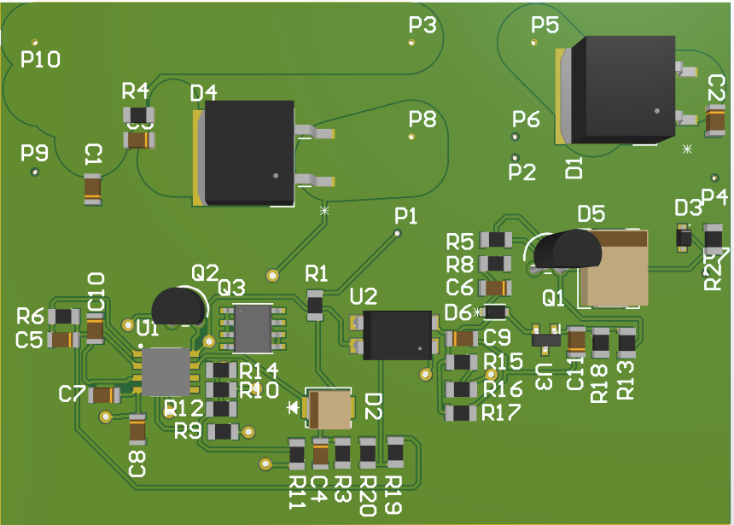

Figure 6‑2. PCB design of the circuit

# References

1. Alpaslan, E. (n.d.). Magnetic Design Guidance for Power Electronics. <https://smallpdf.com/file#s=2d68bdca-20fe-4e29-afa1-f774f24afc3c>
2. Williams, J. (2012) Study of Current Optocoupler Techniques and Applications for Isolation of Sensing and Control Signals in DC-DC Converters. <https://scholarworks.uark.edu/cgi/viewcontent.cgi?article=1647&context=etd>
3. Han, M., Ye, Z. (2013) *Compensation Design with TL431 for UCC28600* <https://www.ti.com/lit/an/slua671/slua671.pdf?ts=1687466655883>