Bode Plot & Coding in MATLAB

In this tutorial, the aim is to explain Gain Margin, Phase Margin & Crossover Frequency that defines the system’s stability. First of all, the terms will be explained. Then, it is going to be coded and plotted in MATLAB.

1. Crossover Frequency (wC)

It is the frequency where the magnitude (dB) of the system is equal to 0.

$$\left|G(jw_{c})\right|=0 dB$$

For example, $G\left(s\right)= \frac{100}{s^{3}+10.1s^{2}+s}$

The bode plot of $G\left(s\right)$ is

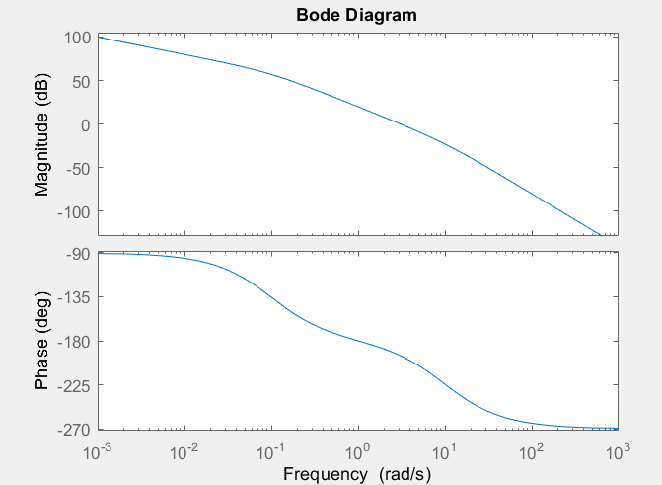

Figure 1. Bode Plot of G(s)

It can be seen on the graph that red circle with cross is the crossover frequency.

1. Phase Margin

It is the difference between the phase lag φ (< 0) and -180°

∠ $G(jw_{C}) + 180°$

1. Gain Margin

It is the gain needed to increase magnitude to 0 dB when phase is -180°.

1. Stabilization with Bode Plot

Bode plot is the frequency response of $G\left(s\right)$

Reference Output

GP(s)

GC(s)

Controller Plant

We may or may not add some sort of controller, so we look at the bode plot & all the stability analysis we are doing where we seeing phase margin & gain margin and how far it is from $-180°$& 1 (0 dB) (magn.) We are looking at those things that’s all because we want to see what happens when we connect it in this type of feedback above. If we find that the system GP(s) is not stable if it has a negative phase margin. That means its phase goes past $-180°$ at crossover frequency, so we need to add controller to try stabilize the system.

Let’s get into the MATLAB code

To find exact value of the crossover frequency from MATLAB

First of all we need to define the function $G\left(s\right)= \frac{100}{s^{3}+10.1s^{2}+s}$

Gs = tf($\left[100\right],\left[1 10.1 1 0\right]$)

The output will be:

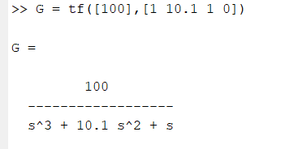

To plot bode diagram we use the command

bode(Gs)

MATLAB will plot the bode diagram with ‘bode()’ command

For our transfer function, the bode diagram will be plotted as

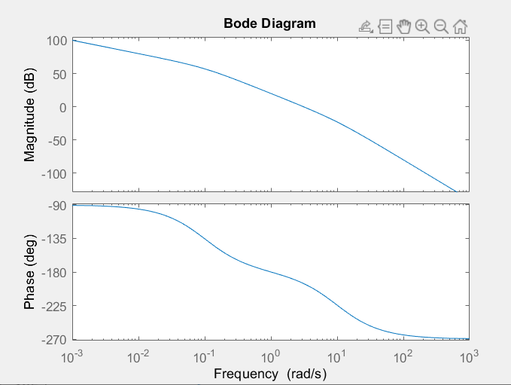

Figure 2. Bode Plot of Gs

To grid enable to get results more clear

Enter the following command:

grid on

The graph will have grid:

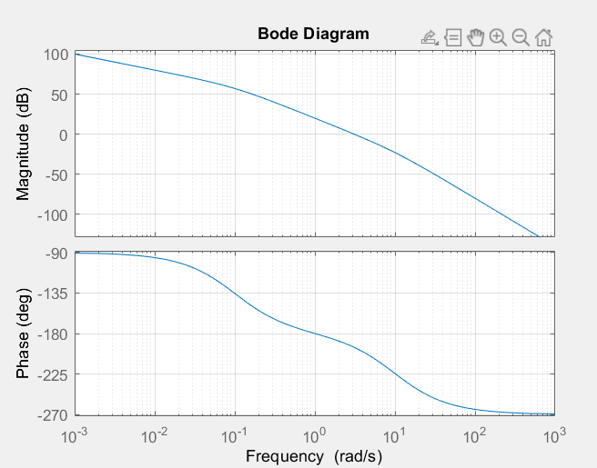

Figure 3. Bode plot of Gs with Grid Enable

To get Gain Margin, Phase Margin, Angle of Gain & Phase Margin, we use the code following:

[Gm, Pm, PhiGM, PhiPM] = margin(G)

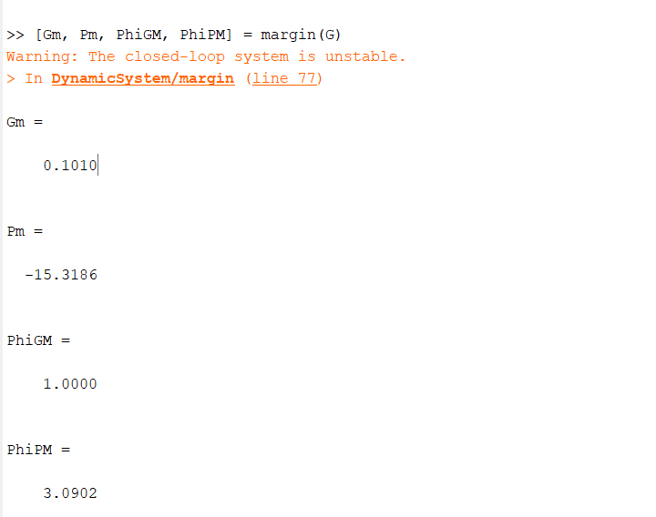

From the results, it can be said that to reach stability we need to multiply our system by the value which is lesser than Gm value which is equal to 0.1010.

For example G1 = 0.05

Let’s multiply G by G1 and get the bode plot. Following code shows how to do that.

Bode(G)

hold on

G1 = 0.5

bode(G\*G1)

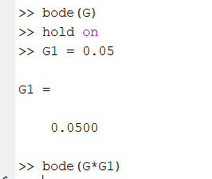

The bode plot will be like

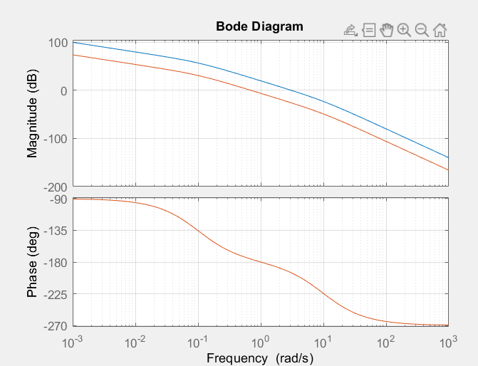

Figure 4. Bode plot of Gs and G1\*Gs

\*Blue one is the new one.

Let’s check our new Gm, Pm, PhiGM, PhiPM values

[Gm, Pm, PhiGM, PhiPM] = margin(G\*G1)

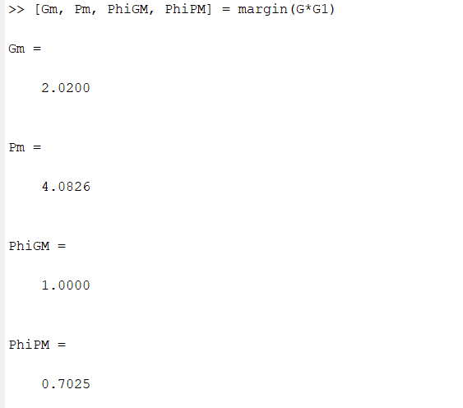

As we can see our new Pm = 4.08 (it is positive value) so our system became stable now.

1. Lag Compensation

Another way to stabilize our system is lag controller.

Lag controller is the way to stabilize our system without shift all the curve. Instead, we just shift specific area to reach stability.

For example, let’s add new controller:

G2 = tf($\left[0.02 0.0005\right],\left[1 0.0005\right]$)

bode(G2)

The bode plot of G2 is

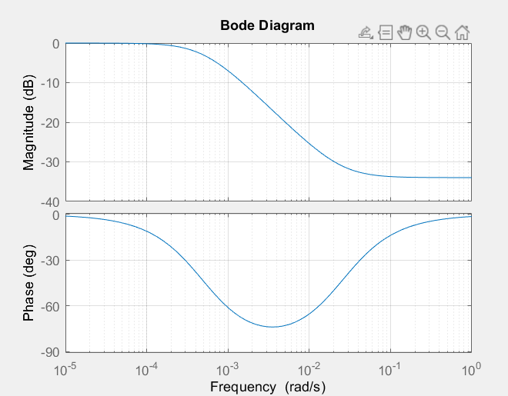

Figure 5. Bode Plot of G2

It can be said that we decreased the gain at higher frequencies without changing phase not much.

Adding following commands

bode(G)

hold on

bode(G\*G2)

grid on

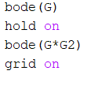

The bode plot will be

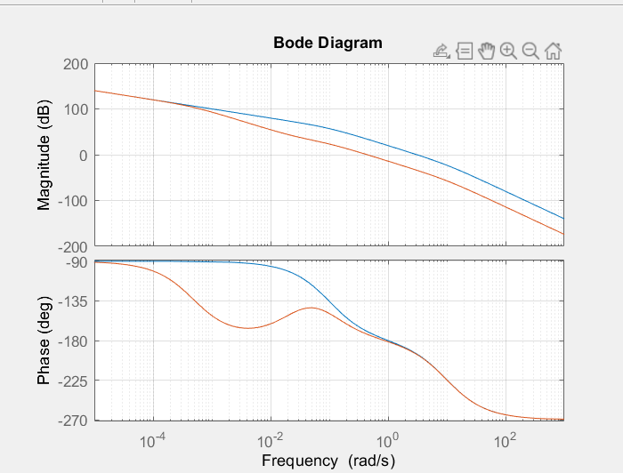

Figure 6. Bode Plot with New Controller

Let’s check our values again with following code

[Gm, Pm, PhiGM, PhiPM] = margin(G\*G2)

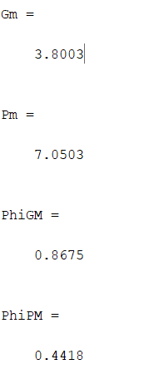

We have positive phase margin that system is stable.

1. Lead Compensation

Let’s add new controller

G3 = tf($\left[1 2\right],\left[1 4\right]$)

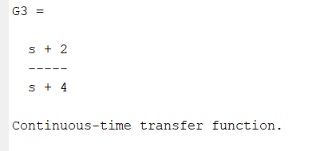

With new controller, our bode plot will be

bode(G)

hold on

bode(G\*G3)

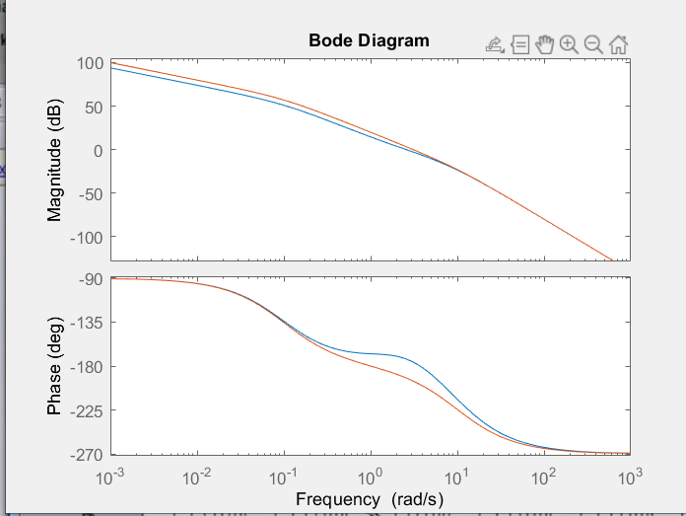

\*blue is the new one (G\*G3)

As we can see on the graph, magnitude is around same but phase is shifted towards up (blue one).

Let’s check our values.

[Gm, Pm, PhiGM, PhiPM] = margin(G\*G3)

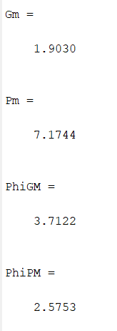

As we can see above, Phase Margin is positive, our system became stable.

1. Things we can do to stabilize a closed-loop system based on the open-loop bode plot:
2. Change the gain (apply proportional control to shift the crossover frequency)
3. Lag compensation control to decrease gain above a certain frequency.
4. Lead compensation control to boost gain at crossover frequency.