DC/DC Converters

**Contents**

1. Buck Converter 2

2. Boost Converter 16

## Buck Converter

A step-down DC/DC converter will be used in regulated power supply. The specifications are; the input voltage range is 12-24 V and the output voltage is fixed at 5 V. The output voltage control is maintained by means of feedback control. The switching frequency is selected as 500 kHz. The L and C filter components are given as 5 µH and 10 µF. Assume ideal components, ignore all parasitic effects and assume ideal switches.

**a)** Find the load current that guarantees CCM operation under all operation conditions. Don't just use the formula; derive your steps.

**b)** Assume that rated output power is 15 W. Calculate the maximum inductor current ripple and output voltage ripple for the given input voltage range.

**c)** Simulate the steady-state behaviour of the converter and show the important waveforms for boundary conduction mode with 24 V of input voltage. Plot following waveforms and comment on the results.

* Inductor voltage and current
* Output voltage
* Diode voltage and current
* Switch voltage and current

**d)** Repeat part-c with 12 V input and 1 W output power. Comment on the results.

**e)** What is inrush current, define it. Considering the case in part-d, what is your inrush current at input current for this case. Propose a method to avoid inrush current and implement your solution to your simulation model. Compare the results by plotting the cases in this part and part-d.

**f)** Now, consider that the output capacitor has 50 mΩ ESR. Simulate the converter for boundary conduction mode with 24 V of input voltage. Compare the results with ideal case of part-c. Comment on the effect of adding capacitor ESR to the converter parameters such as output voltage ripple. Also, offer a solution to decrease the equivalent ESR of the output capacitor and to reduce the output voltage ripple.

1. Find the load current that guarantees CCM operation under all operation conditions. Don't just use the formula; derive your steps.

The question is asking us to ensure the system is continuing in CCM for any condition.

That means, the current value should be always higher than ILB(MAX) (Boundary current that seperates CCM and DCM)

toff

ton

IL,peak

Vd-Vo

ILB

(Boundary Current)

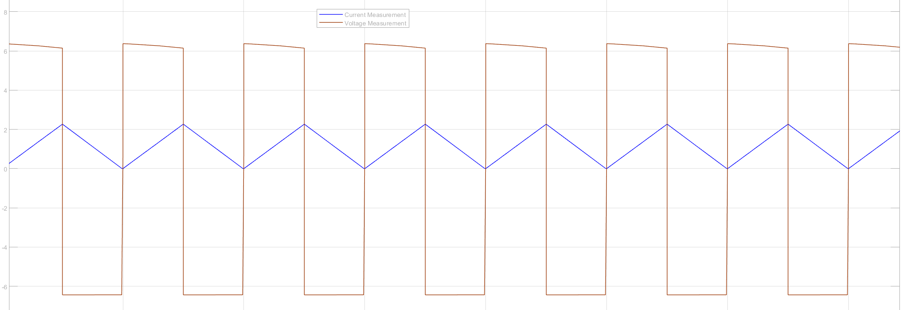

-Vo

IL

IL

Ts

Figure 1. Buck Converter Inductor Current & Voltage Waveform

In buck converter,

Boundary current between

Continuous Conduction Mode & Discontinuous Conduction Mode

When

D

ILB=IOB

CCM

DCM

**If it is needed to stay in CCM longer, either L should be increased or higher switching frequency or Vd should be reduced.**

For 12V Vd,

For 24V Vd,

To guarantee CCM operation under both conditions, should be 1.2A. That means, the inductor current should always be higher than 1.2A

1. Assume that rated output power is 15 W. Calculate the maximum inductor current ripple and output voltage ripple for the given input voltage range.

Assure R = 1.66Ω. (To reach 15W rated output power)

First, we need to obtain transfer function of the plant system which is

Put our passive parameters value into the equation above

Calculate for (It’s OK for )

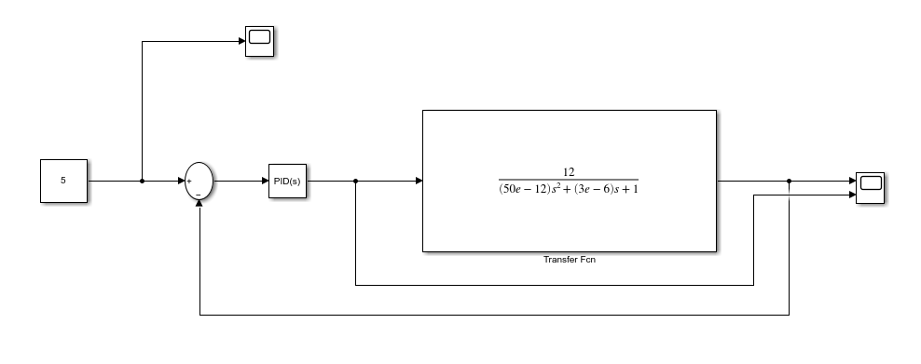

Figure 2. Design of PID Controller for Feedback Control

We design our transfer function in the MATLAB/Simulink. To adjust PID Controller, there is an option for autotune in property in the PID controller:



When it is pressed to Tune button, the screen will be opened:

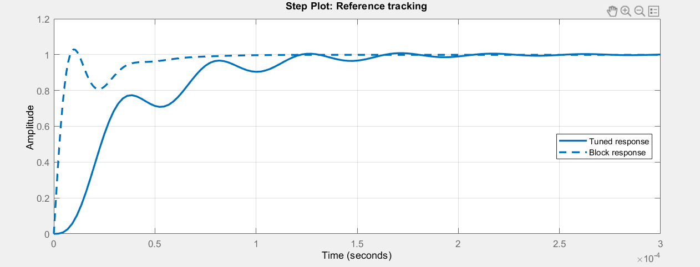

Figure 3. PID Tuner

In the PID Tuner, the dashed waveform is already belongs to the designed system, when it is designed and updated block, the PID tuner will give the parameters of P,I,D, and N. The key factor here is the adjusting overshoot and finding desired waveform. The values will be given by PID Tuner:

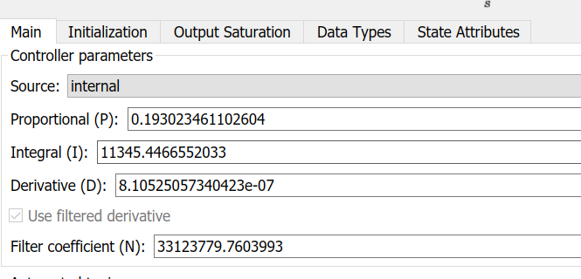

Figure 4. PID Parameters

When the parameters is applied to the feedback control, the output voltage and the output current values are measured:

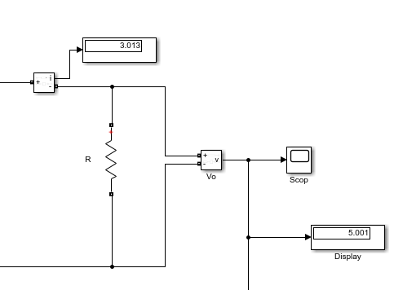

→Output voltage

→Output current

* The second part of the question is calculate the maximum inductor current ripple and output voltage ripple for the given input voltage range.

**Inductor Current Ripple**

Our Vo =5V, Vi = 12/24V

Vo = D. Vi

For Vi=12V → D =

For Vi=24V → D =

*iL*

*if*

Δ*iL*

t

*Io*

**Output Voltage Ripple**

*iL*

QC is charging

QC is discharging

IL*,peak*

t

Io

Vo

ΔVo

Vo

t

Using off time (1─D) → ΔıL =

1. Simulate the steady-state behaviour of the converter and show the important waveforms for boundary conduction mode with 24 V of input voltage. Plot following waveforms and comment on the results.

* 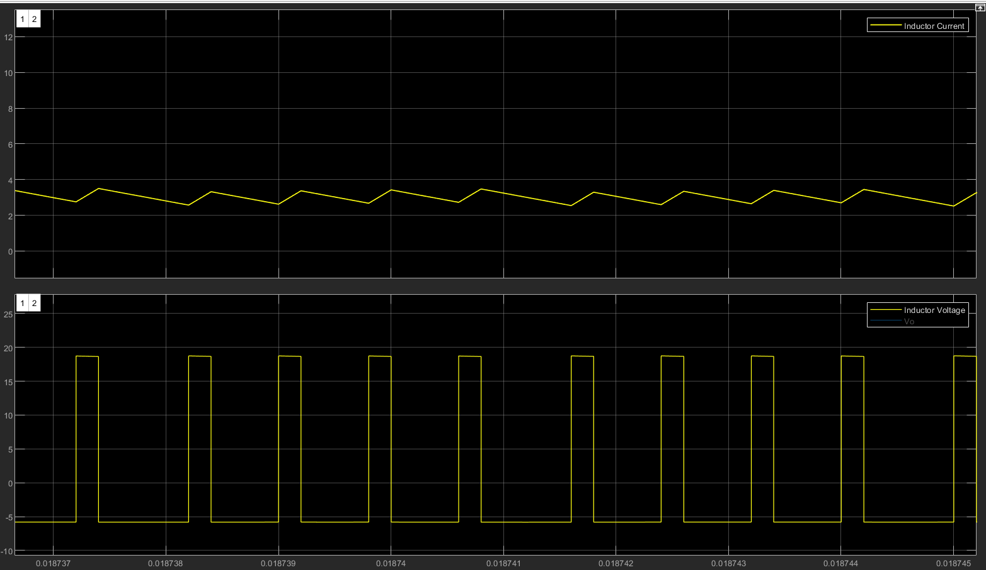Inductor voltage and current

Figure 5. Inductor current & voltage

Comments: As it is showed in the graph above, Inductor current increases during ON operation, and that means during ON op.



From the measurement, we can see . It is a bit different from ideal case because of parameters which we did not include in ideal case.

And during OFF op., . It is expected that is -5V during OFF op.



The measurement says the inductor voltage during OFF op., is -5.8V

* Output voltage

Output voltage is 5V always because feedback control provides fixed output voltage from the various input voltage (12/24V).

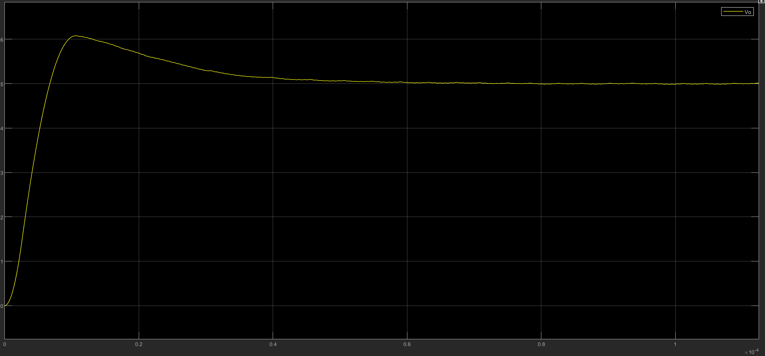

Figure 6. Output Voltage Waveform

As the system is designed like critically damped (desired one). The output voltage waveform is smooth and less ripple as compared to other types.

* Diode voltage and current

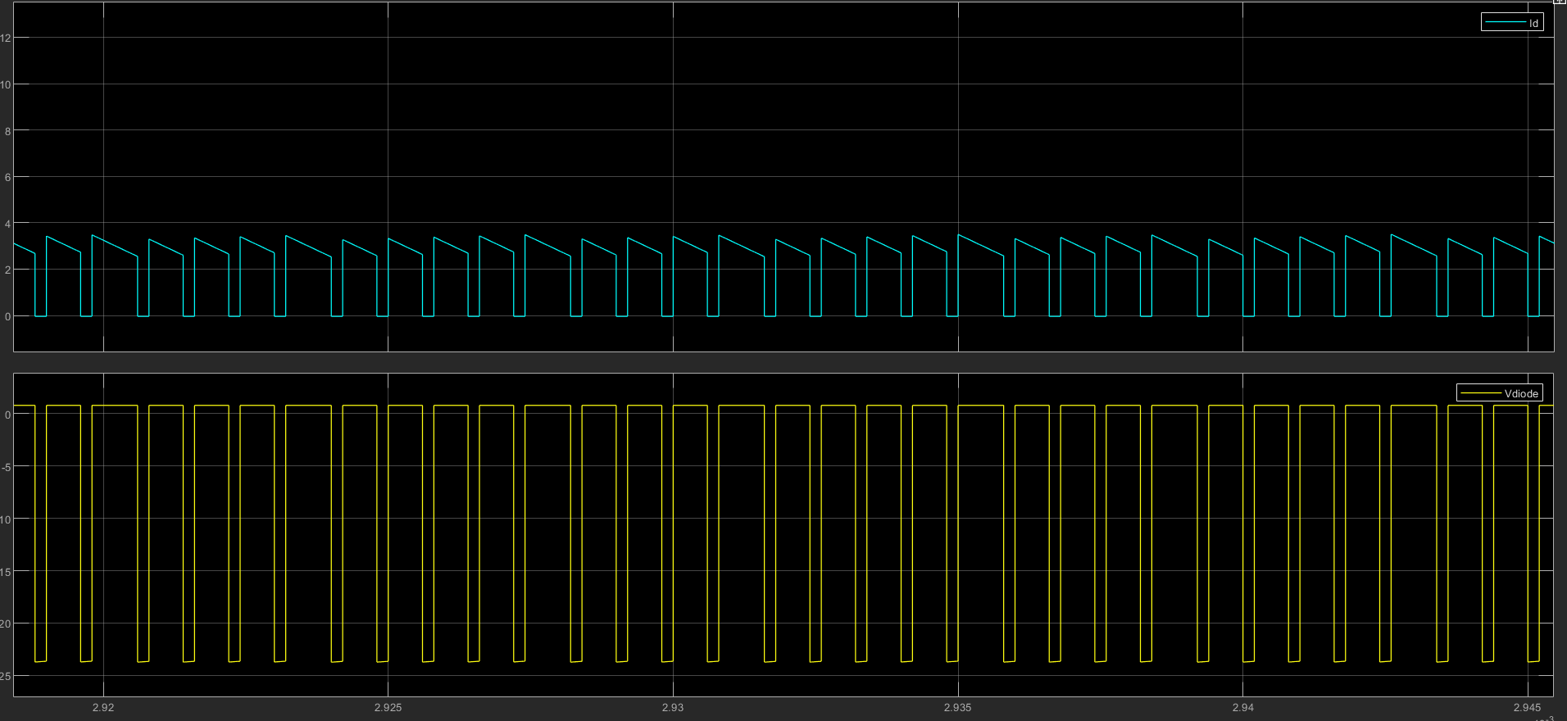

Figure 7. Diode Current & Voltage Waveforms

It can be stated that during ON time, there is no current flow through the diode because it is reverse biased. In OFF condition, voltage across the diode is *.* The diode current is like discharging because of the inductor.

* Switch voltage and current,

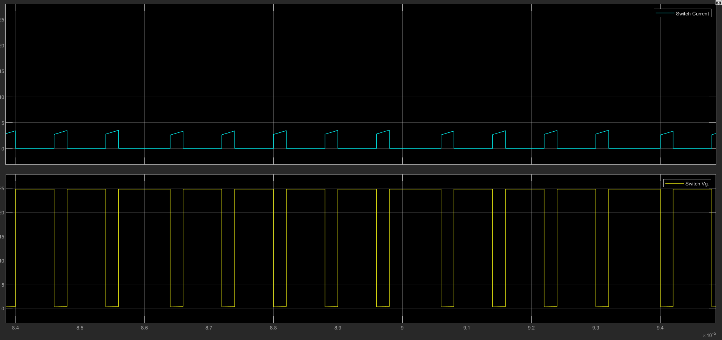

Figure 8. Switch Voltage & Current Waveforms

The switch current is varying between 2.577A and 3.325A. The variation happens due to inductor. During ON time, the switch voltage is 0.3V (ideal case is 0V). During OFF time, the switch voltage is 24.8V (ideal case is 24V = )

1. Repeat part-c with 12 V input and 1 W output power. Comment on the results.

* Inductor voltage & current

The load resistance is adjusted to 25Ω to get 1W output power. The waveforms of the inductor voltage and current:

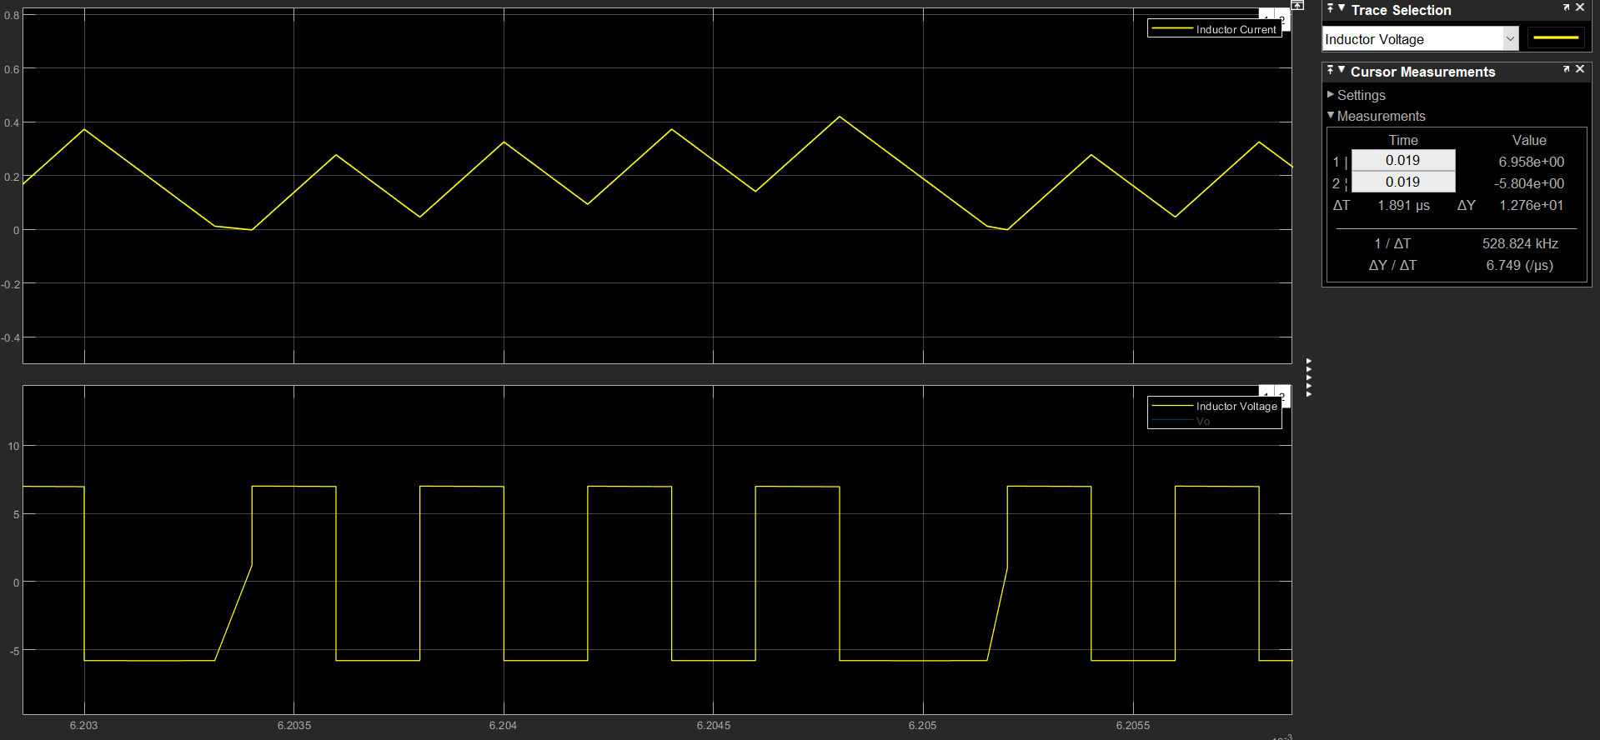

Figure 9. Inductor voltage and current

It is very obvious that because the output resistance is increased, so the current value is decreased sharply. That means it is in DCM (Discontinuous Conduction Mode) now.

As it is found previous section

Above formula is being adapted in the current situation will be

If the current value gets lower than means the system goes into DCM.

* Output voltage

Because feedback control is still used, the output voltage value is to be not expected change.

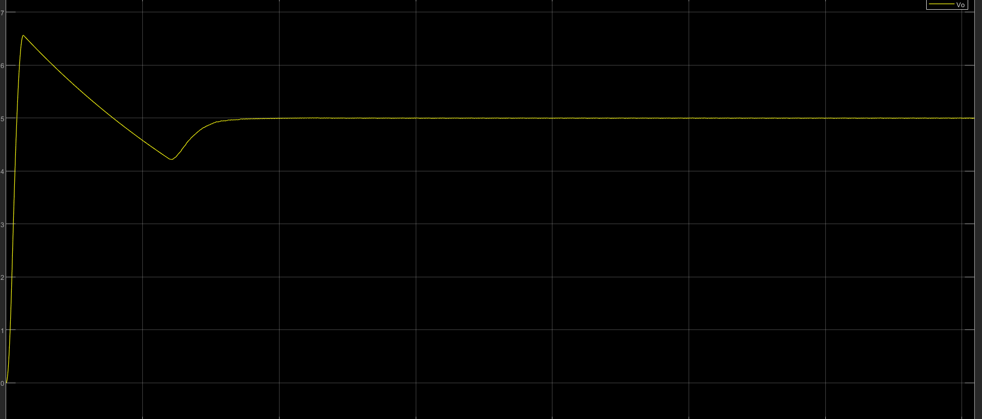

Figure 10. Output voltage waveform

* Diode voltage & current

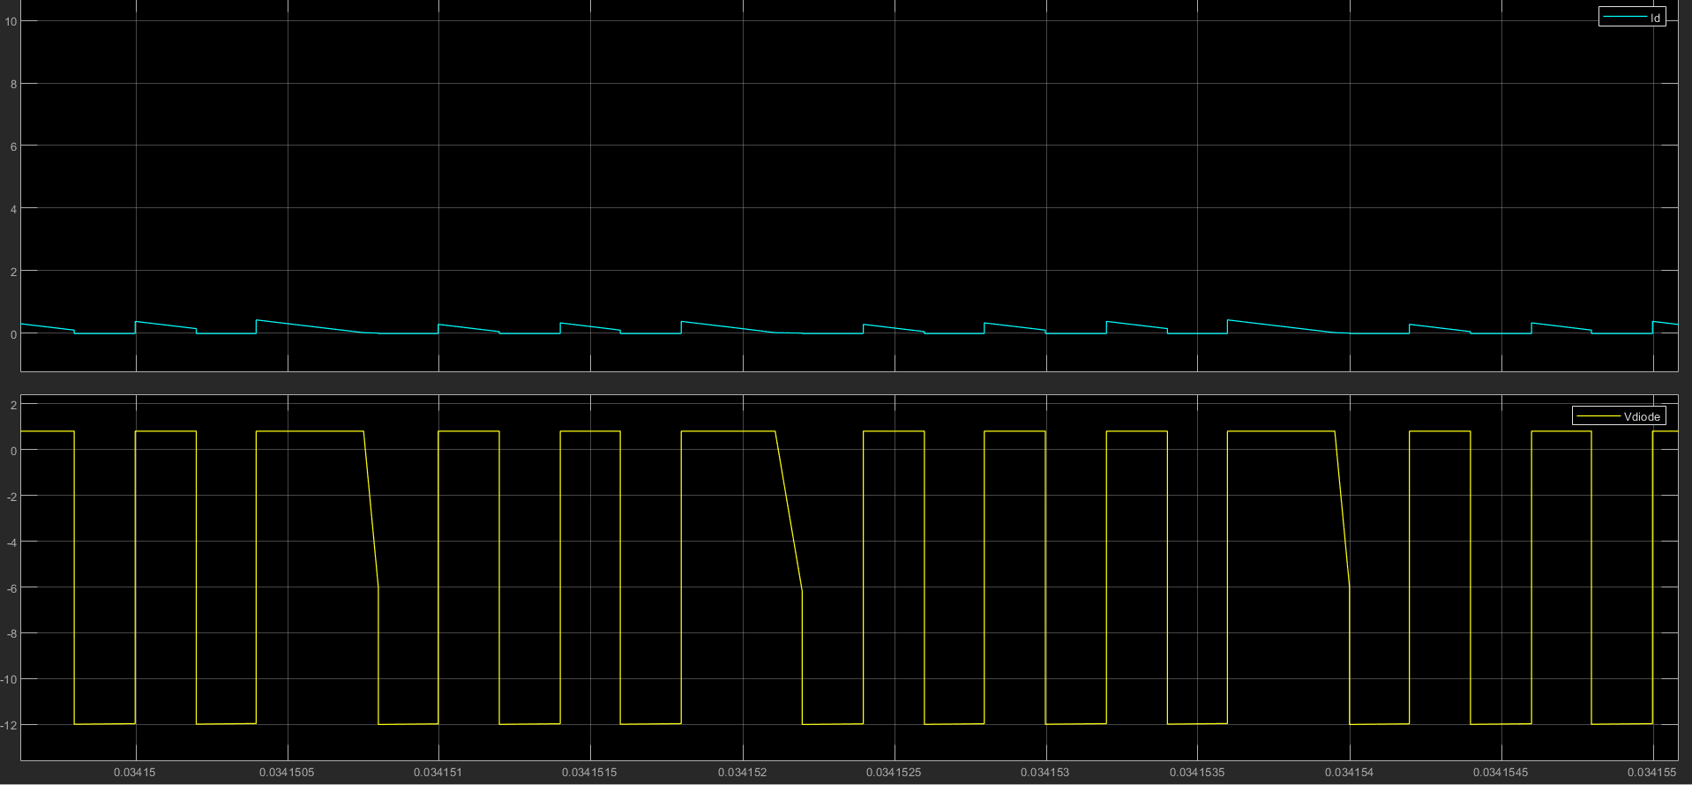

Figure 11. Diode voltage & current

* Switch voltage & current

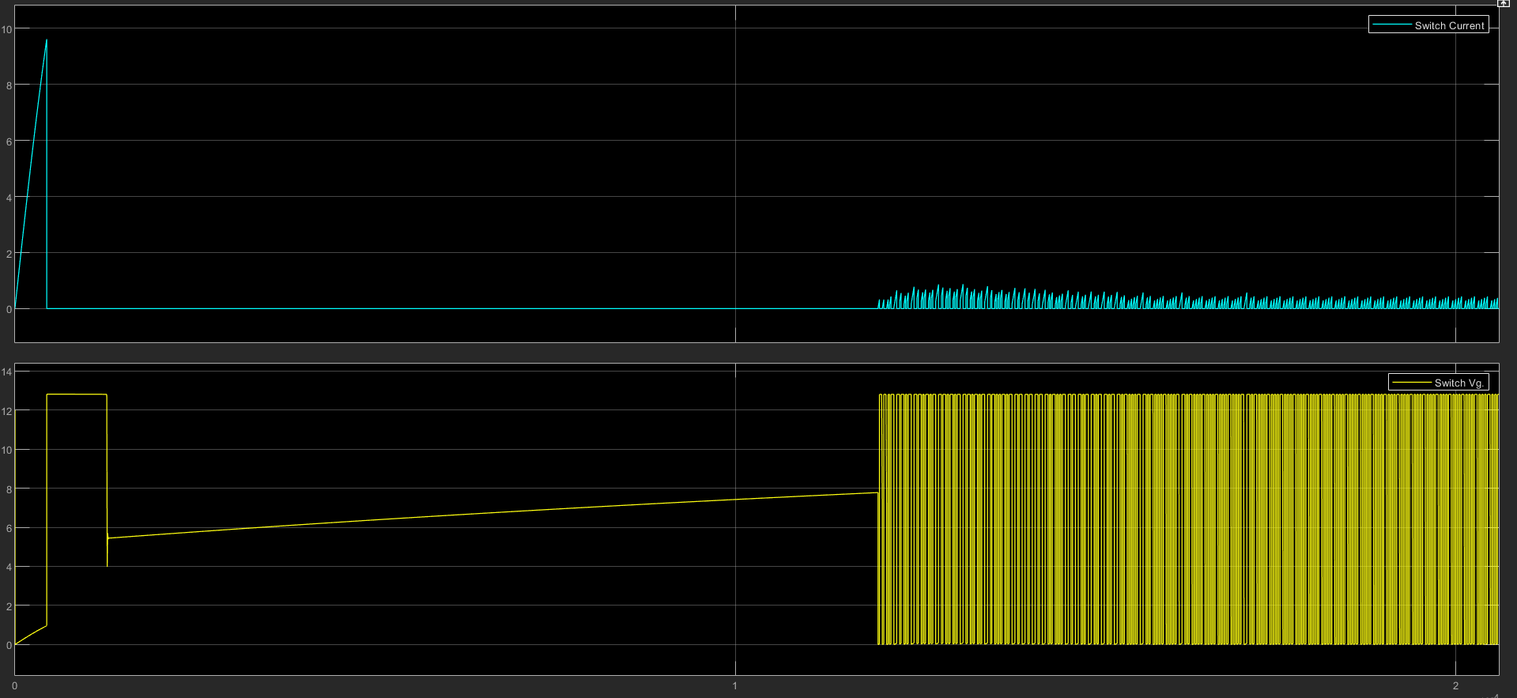

Figure 12. Switch voltage & current

As it can be observed from the graph, there is huge current draw at the start of the system. The huge current draw is called *‘’inrush current’’.* It is peak value and dependent on characteristics of the input source and input impedance.

1. What is inrush current, define it. Considering the case in part-d, what is your inrush current at input current for this case. Propose a method to avoid inrush current and implement your solution to your simulation model. Compare the results by plotting the cases in this part and part-d.

Inrush current in a DC-DC converter is the initial, high level of current that flows into the converter when it is first turned on. This high level of current is caused by the charging of the input capacitance and the output inductance of the converter. It is typically much higher than the steady-state operating current of the converter and can cause damage to the converter if not properly managed. Inrush current limiting is a common technique used to prevent this high level of current from causing damage.

Inrush current limiting is a technique used to prevent high levels of inrush current from damaging a DC-DC converter. There are several methods that can be used to limit inrush current, including using NTC thermistors, using series resistors, and using active circuits. Using a series resistor is a simple method to limit inrush current. A resistor is placed in series with the input of the converter to limit the current that can flow into it. The value of the resistor is chosen so that the inrush current is within safe limits. However, this method causes a voltage drop across the resistor and results in a loss of efficiency.

When a series resistor is added to the input of the converter, (R = 10Ω). The switch voltage and current waveform will be

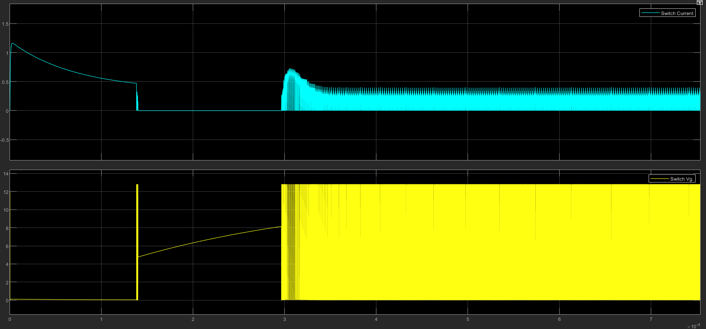

Figure 13. Switch voltage and current with a series resistor (R = 10Ohm)

1. Now, consider that the output capacitor has 50 mΩ ESR. Simulate the converter for boundary conduction mode with 24 V of input voltage. Compare the results with ideal case of part-c. Comment on the effect of adding capacitor ESR to the converter parameters such as output voltage ripple. Also, offer a solution to decrease the equivalent ESR of the output capacitor and to reduce the output voltage ripple.

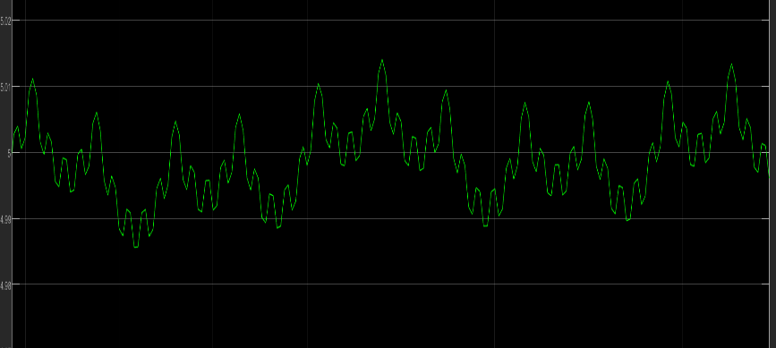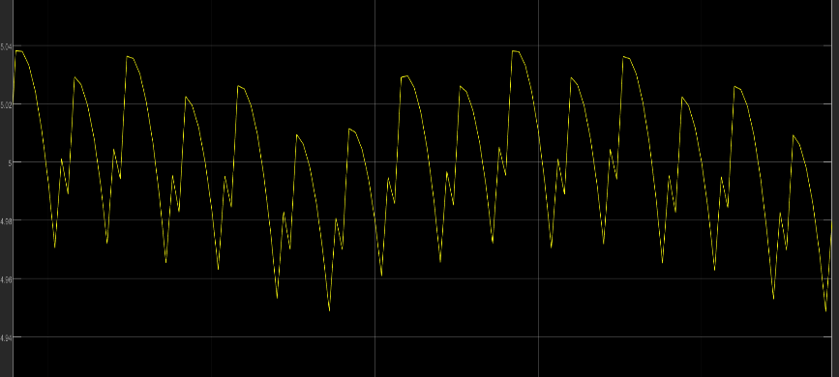

Figure 14.Output voltage waveform without capacitor with ESR

Figure 15. Output voltage waveform with capacitor with ESR

It is seen on the graph that capacitor with ESR increases the ripple at the output voltage. To reduce ESR, there is a method that is commonly used widely. That is connecting capacitor(s) in series with the capacitor.

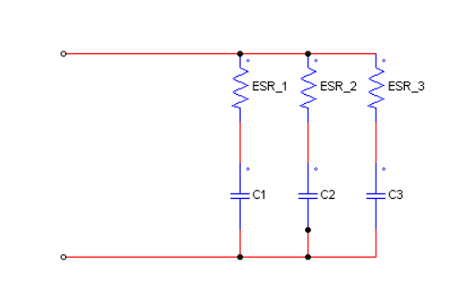

The effect of ESR is reducing by connecting capacitors in parallel. For example, we have 10µF capacitor. It can be connected as two 5µF capacitors in parallel.

## Boost Converter

In step-up DC/DC converter, let input voltage range be 5-12 V and output voltage be 16 V with switching frequency of 300 kHz. Assume that rated output power is 16 W.

a) Consider all components as ideal. Calculate minimum inductance that will keep the converter operating in the CCM operation for rated output power.

b) Calculate the output capacitance for peak-to-peak voltage ripple less than 2% under rated output power.

c) Simulate the steady-state behaviour of the converter and show the important waveforms for boundary conduction mode of part-a. Plot following waveforms and comment on the results.

* Inductor voltage and current
* Output voltage
* Diode voltage and current
* Switch voltage and current

d) Assuming the switches and capacitors are ideal, but the inductor has 30 mΩ ESR, and considering the load resistance is equal to the rated load resistance, derive the voltage gain as a function of the duty cycle. Show your steps clearly. On the MATLAB, plot the voltage gain with and without ESR on the same graph as a function of duty cycle. Comment on the results.

e) Repeat the same steps in part-d for the converter efficiency.

f) Choose commercial semiconductor products using Digikey that is appropriate for your design. Calculate the losses on these devices for rated power operation with 12 V input voltage. How would losses on the diode and switch change if the duty cycle is increased? Explain in detail.

g) Using the calculated loss values, construct a thermal lumped element model and estimate the junction temperature without a heatsink. If necessary, choose a thermal interface material and heatsink and find out the junction temperature with these materials. Clearly state any assumption that you made.

**a)**

*Input characteristics are generally not given, so we need to manipulate the formula a bit*

Boundary Conduction Mode

If *L >*  means system in CCM

If *L <*  means system in DCM

*For* →→ → D = 0.6875

*For* →→ → D = 0.25

In the question, it is asked to calculate minimum inductance that will keep the converter operating in the CCM operation for rated output power.

→

To ensure CCM operation in both cases, it is necessary to choose higher value which is

**b) Calculate the output capacitance for peak-to-peak voltage ripple less than 2% under rated output power.**

Put the values into the equation for both cases. Again our rated output power is 1W.

To ensure output voltage ripple is 2% for both cases, it is needed to use the bigger value.

So, 10µF is chosen.

L is found 5.73µH for ideal case; however it does not provide CCM in the design, so 50µH is was tried and it ensured CCM.

**c) Simulate the steady-state behaviour of the converter and show the important waveforms for boundary conduction mode of part-a. Plot following waveforms and comment on the results.**

* **Inductor voltage and current**
* **Output voltage and current**
* **Diode voltage and current**
* **Switch voltage and current**

Inductor voltage and current waveforms:

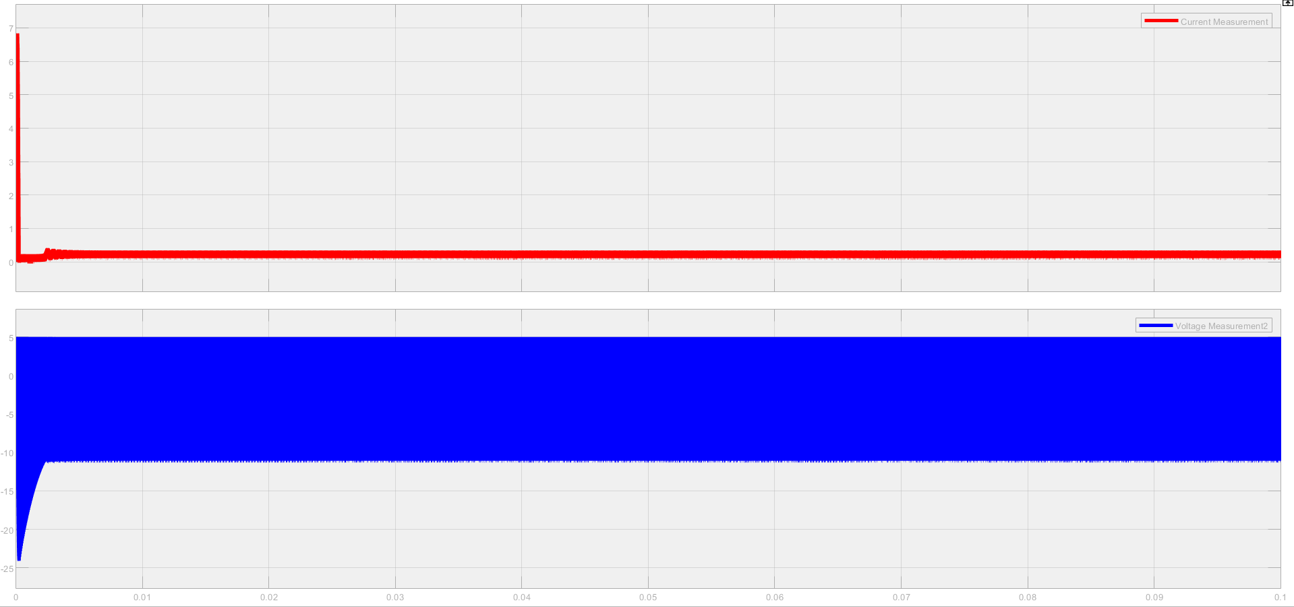

Figure 16. Inductor voltage and current waveform

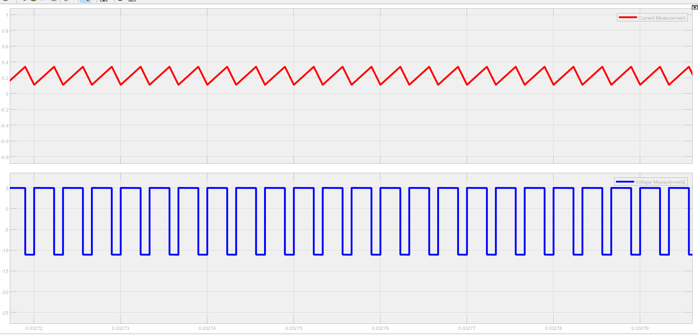

Figure 17. Close-up view to waveforms

It can be observed from Fig.17, our system is in CCM, inductor voltage VL = 5V for switch ON, VL = -11V for switch OFF. It confirms the desired specifications.

Output voltage and current:

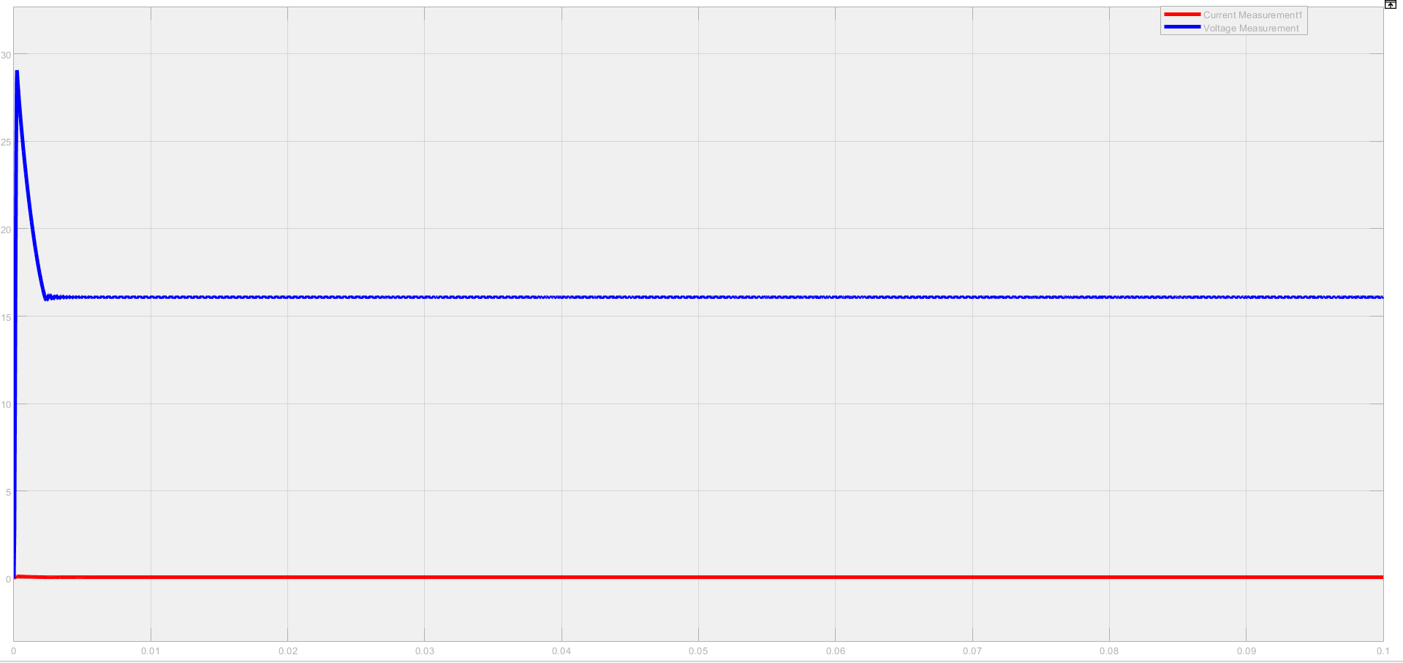

*Output voltage*

*Output current*

Figure 18. Voltage and current waveforms

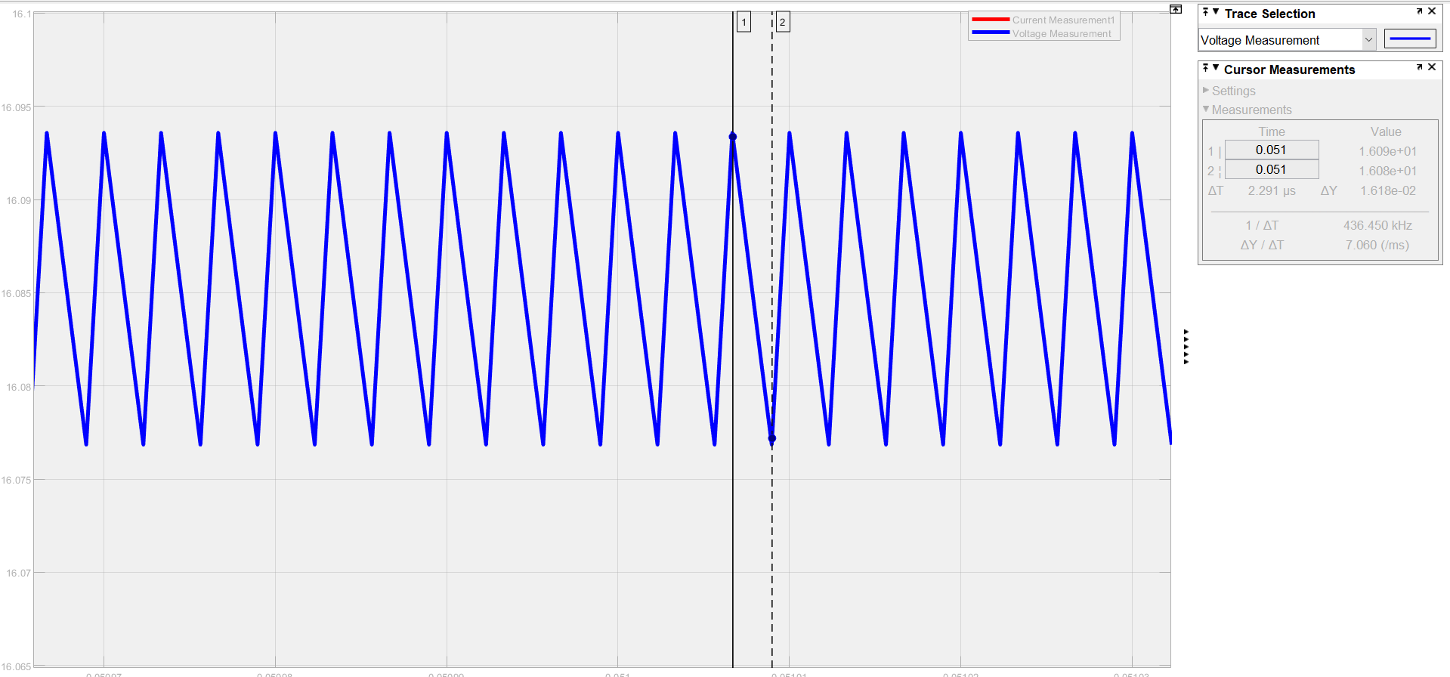

Figure 19. Voltage ripple at the output

As it can be seen on the Fig.19, voltage ripple at the output is less than 2%. (ΔY = 1.618e-02)

In steady-state, average output voltage is 15.94V, average output current is 6.226e-02A.

Poutput = 15.94 x 6.226e-02 = 0.9924W ≅ 1W

Desired values are met.

Diode voltage and current:

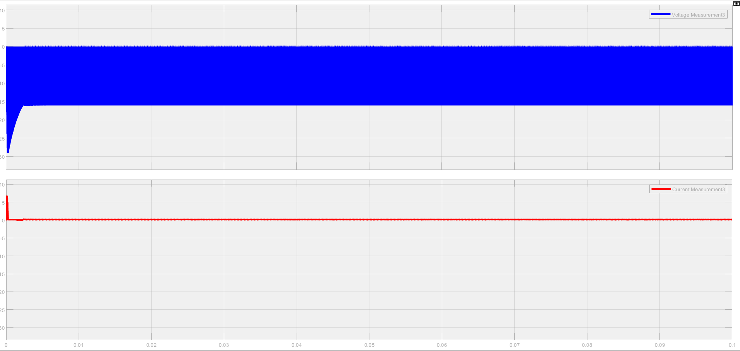

Figure 20. Diode voltage and current

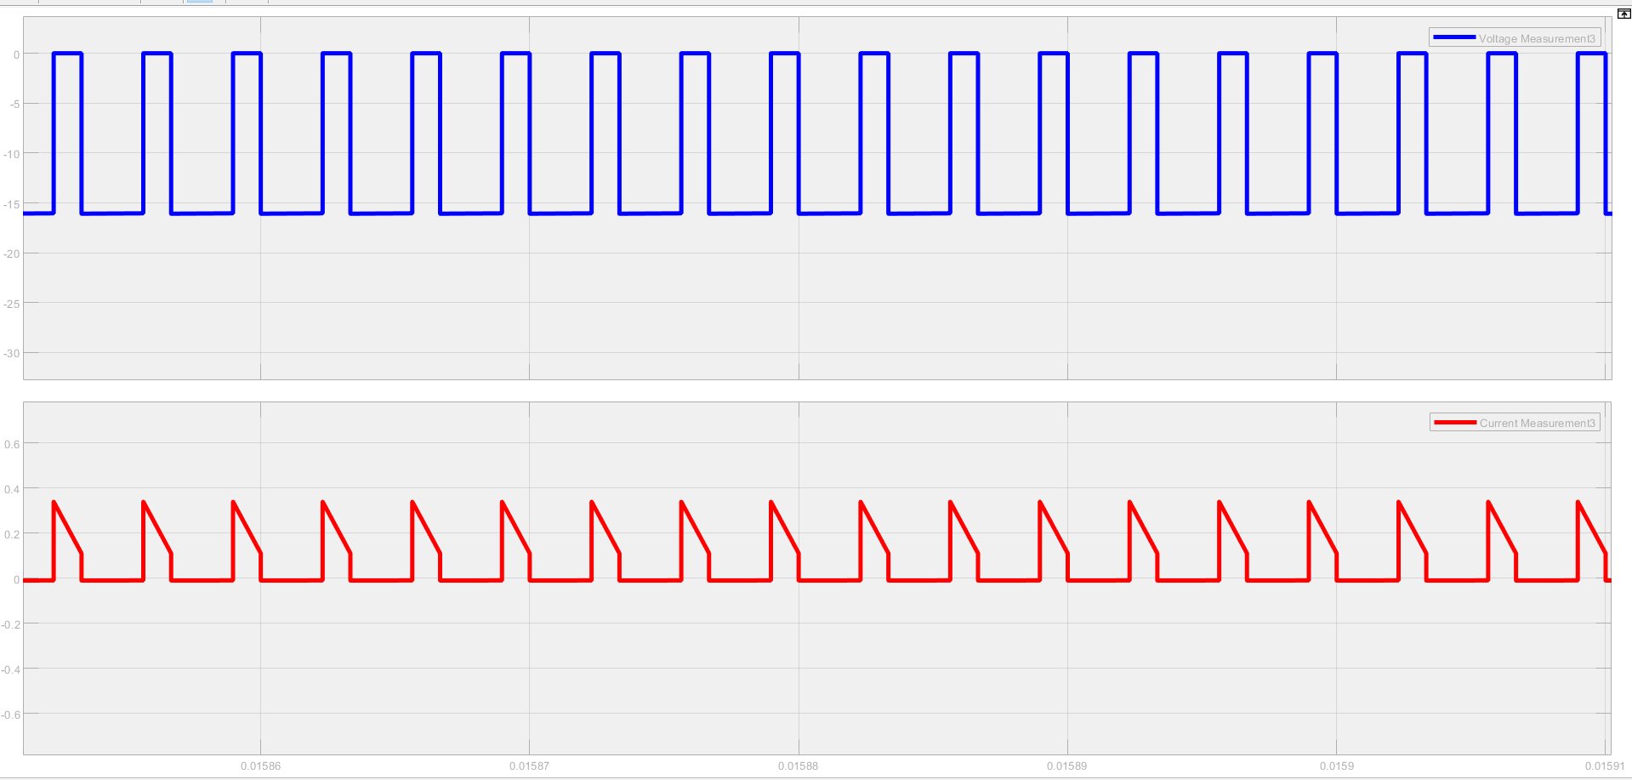

Figure 21. Close-up view to diode waveforms

Switch voltage and current:

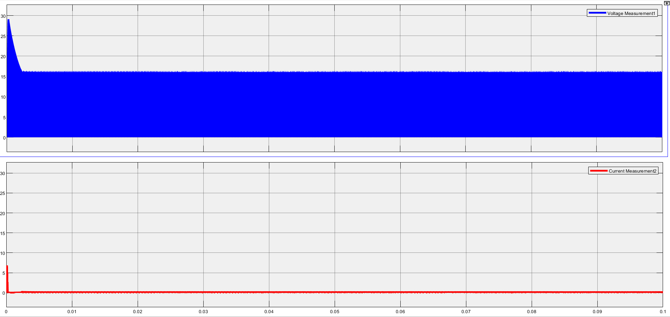

Figure 22. Switch voltage and current waveforms

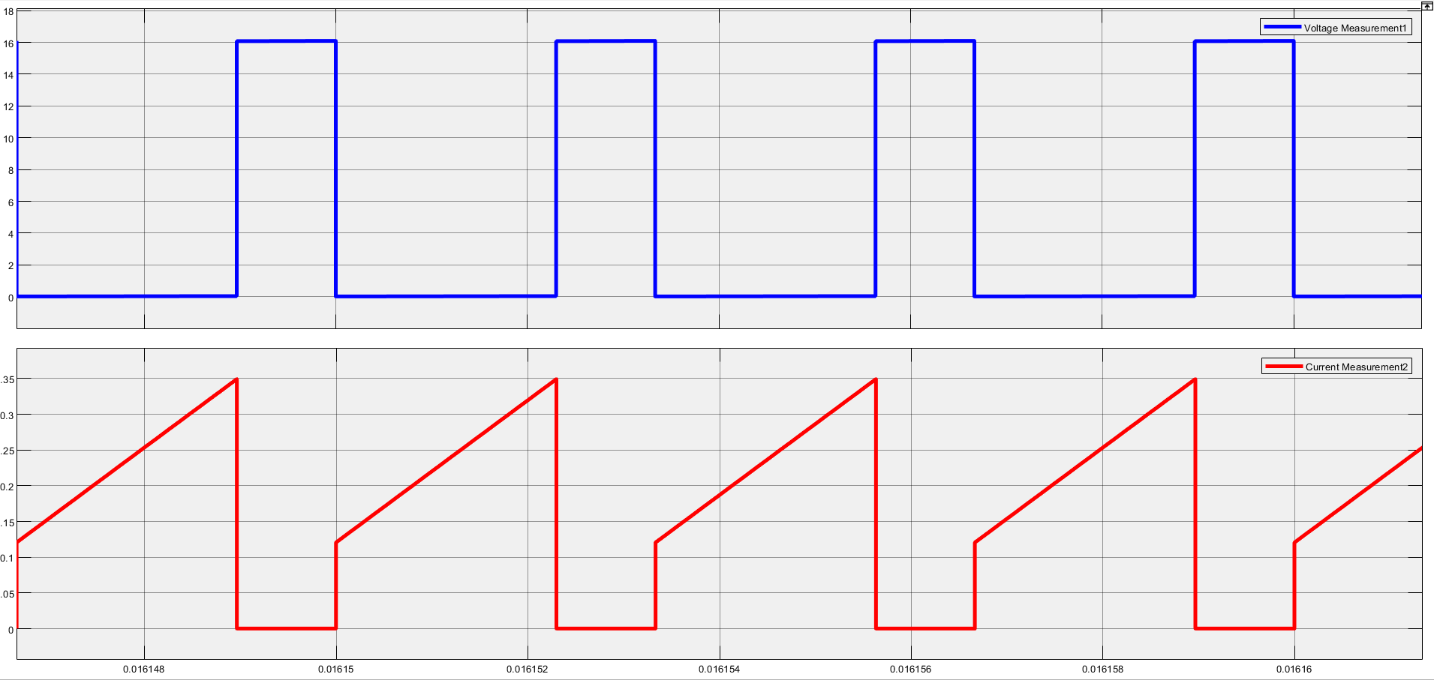

Figure 23. Close-up view to switch waveforms

When switch is ON, the switch voltage is 0V and switch current is increased, when switch is OFF, the switch voltage is Vs = Vo = 16V and no current through switch.

**d) Assuming the switches and capacitors are ideal, but the inductor has 30 mΩ ESR, and considering the load resistance is equal to the rated load resistance, derive the voltage gain as a function of the duty cycle. Show your steps clearly. On the MATLAB, plot the voltage gain with and without ESR on the same graph as a function of duty cycle. Comment on the results.**

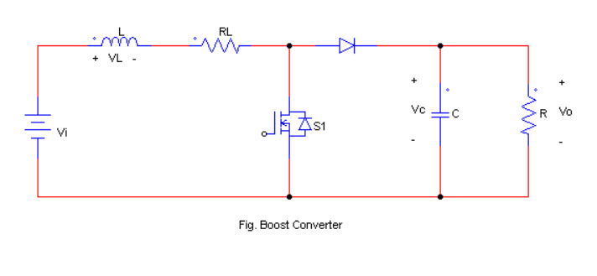

From volt-second balance, the inductor voltage is as follows:

At on-state:

At off-state:

Therefore;

Where = resistance of the inductor, = load resistance

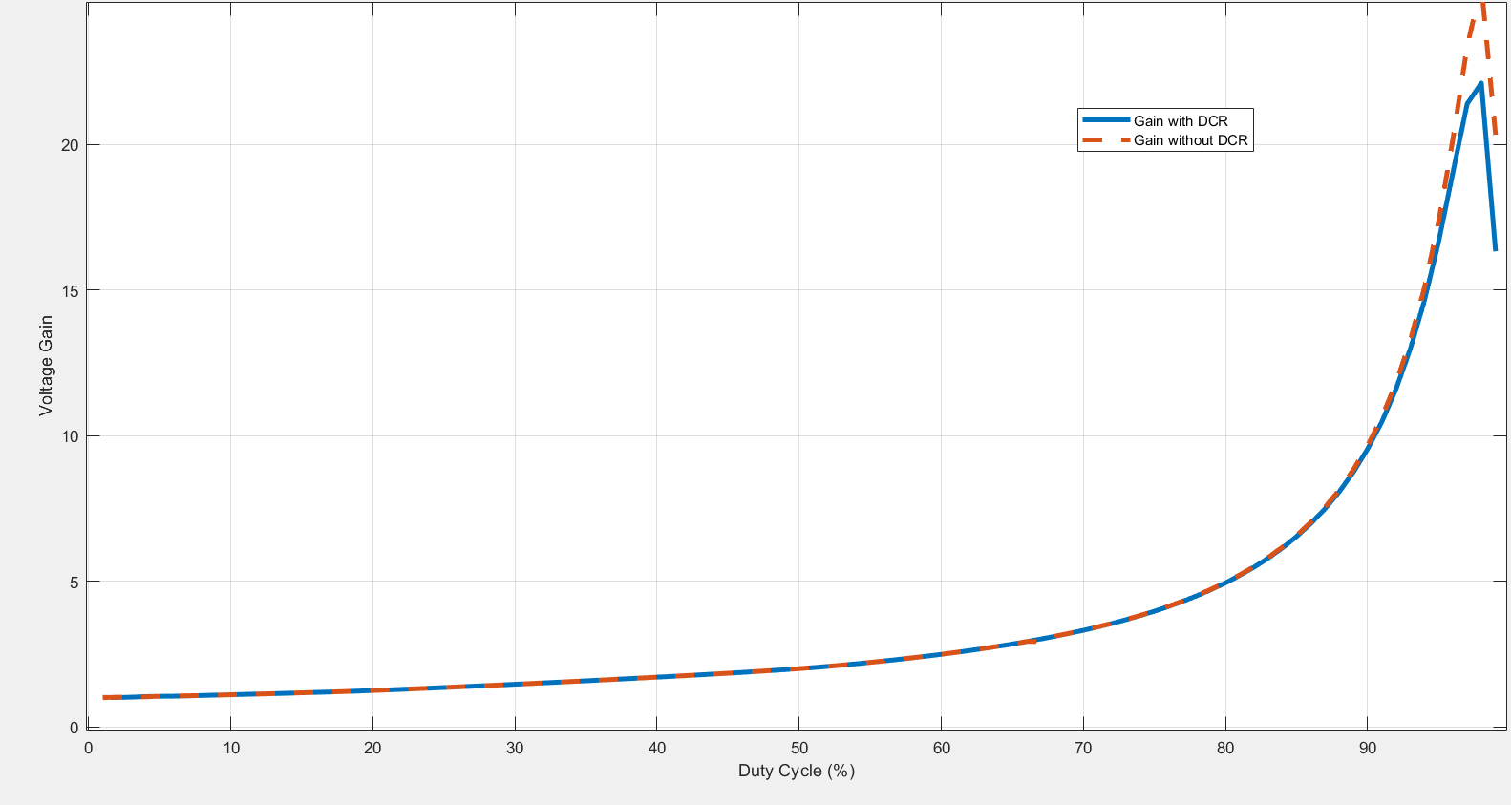

Figure 24. Gain with respect to duty cycle w/(out) DCR

It can be observed that DCR (ESR) will reduce the gain at the higher duty cycle ratio.

**e) Repeat the same steps in part-d for the converter efficiency.**

The converter efficiency is measured by the efficiency ratio (η) which is

In the system, the diode and the switch are supposed to be ideal, so

*.*

In MATLAB, following codes are implemented to graph efficiency with respect to (w.r.t.) duty cycle:

D = (0:0.01:0.99); %Variable Duty Cycle

V_i = 5; %Input Voltage

V_o = 16; %Output Voltage

P_o = 1; %Output Power

I_o = (P_o / V_o) * ones(1,100); %Output Current

I_i = I_o ./ (1-D); %input current w.r.t duty cycle

R_inductor = 0.03; % 30mΩ inductor resistor

P_cu = (I_i.^2) * R_inductor; %Copper loss w.r.t input Current

eff = P_o ./ (P_o + P_cu); %efficiency calculation

plot(D, eff) %plotting the efficiency w.r.t duty cycle

hold on %holds the graph

grid on %enables grid

R_inductor = 0; %to calculate without inductor resistance

P_cu = (I_i.^2) * R_inductor %P_cu = 0 (R_inductor = 0)

eff = P_o ./ (P_o + P_cu); %P_o / P_o = 1

plot (D, eff)

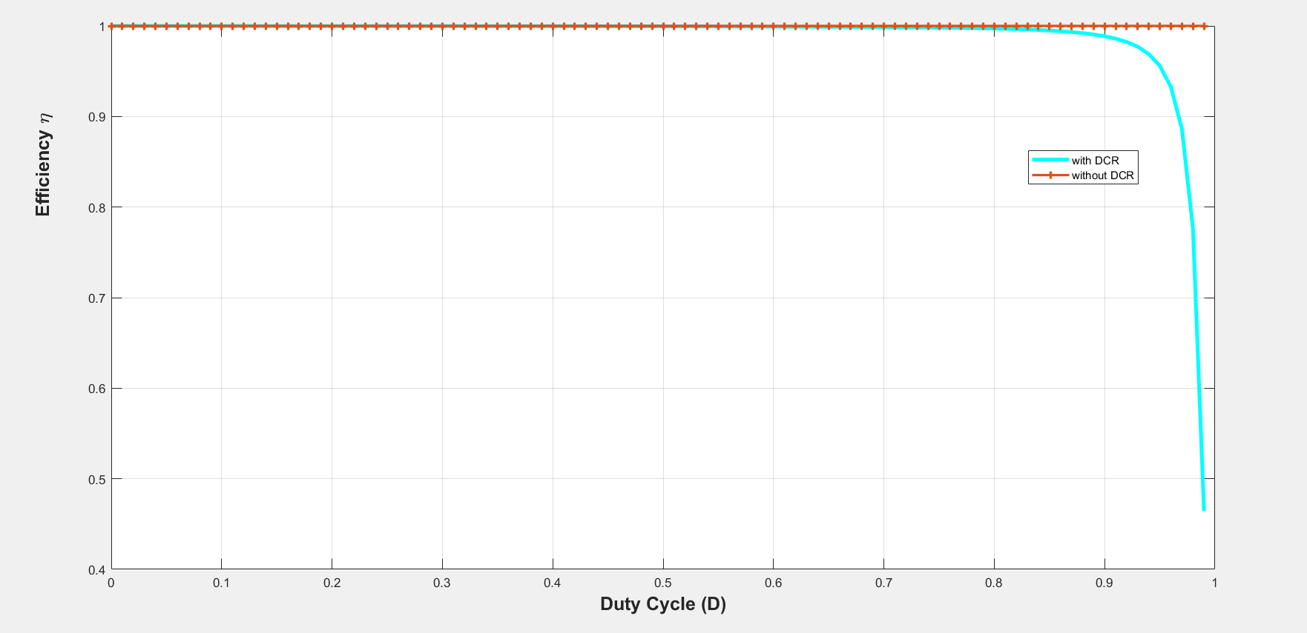

Figure 25. Efficiency w.r.t. duty cycle

**f) Choose commercial semiconductor products using Digikey that is appropriate for your design. Calculate the losses on these devices for rated power operation with 12 V input voltage. How would losses on the diode and switch change if the duty cycle is increased? Explain in detail.**

**MOSFET**

First, the parameters of the MOSFET should be defined:

As it can be seen on the fig. below, the maximum switch voltage is close to 31V

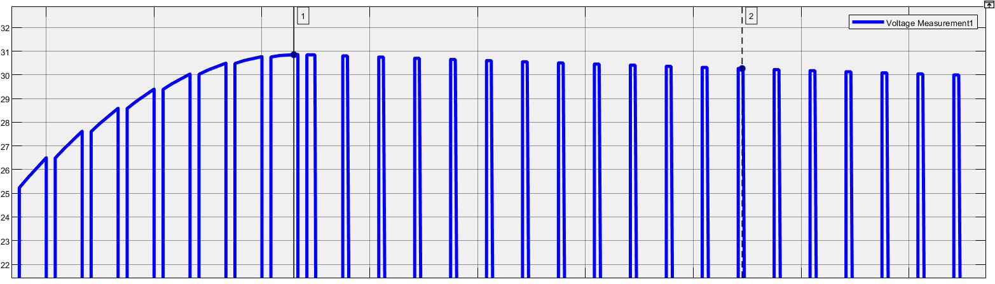

Figure 26. Switch voltage

Maximum spike current is shown below: 7.131A and steady-state max. current value is 0.2228A.



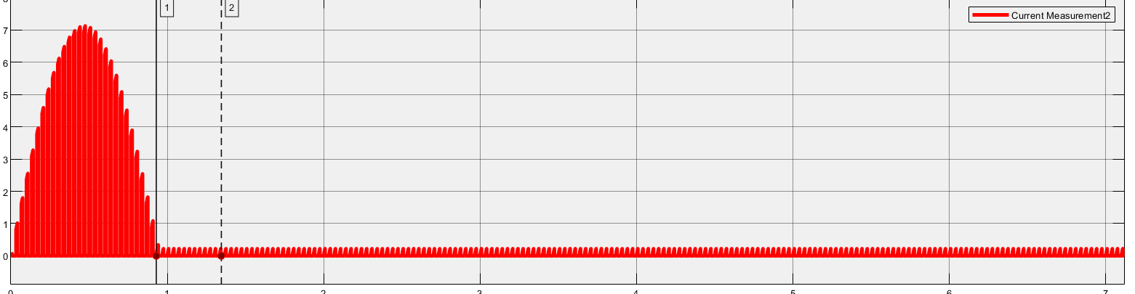

Figure 27. Switch Current

From [digikey.com](https://www.digikey.com/en/products/detail/infineon-technologies/IRLML0040TRPBF/2354137), IRLML0040TRPBF n-channel MOSFET is available for the system.

Let’s check the parameters of the MOSFET:

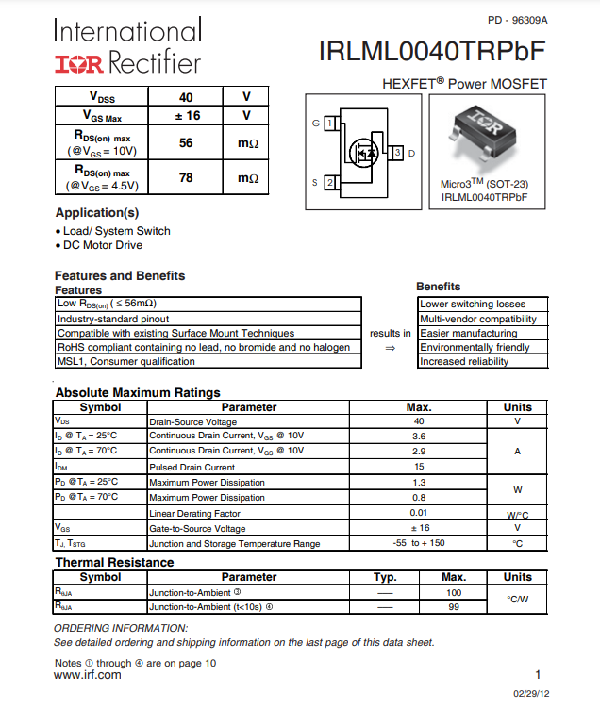

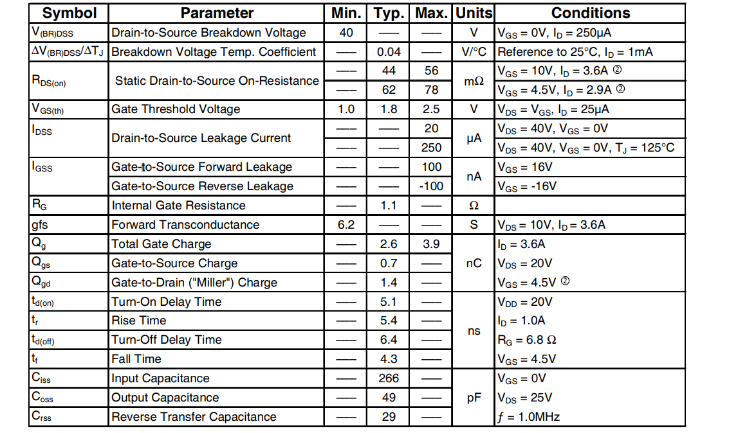

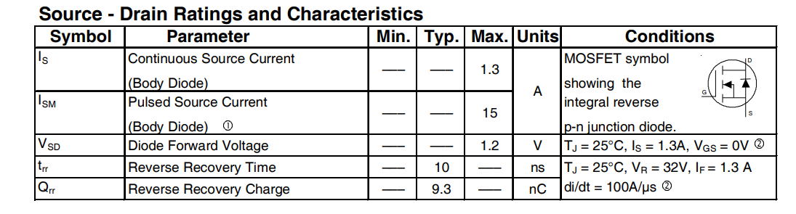

Important parameters are marked with red rectangle.

From the datasheet, all the parameters are in large margin that means the MOSFET can be used safely for this boost converter design.

**DIODE**

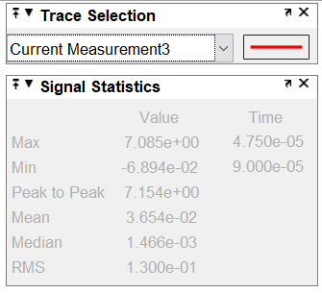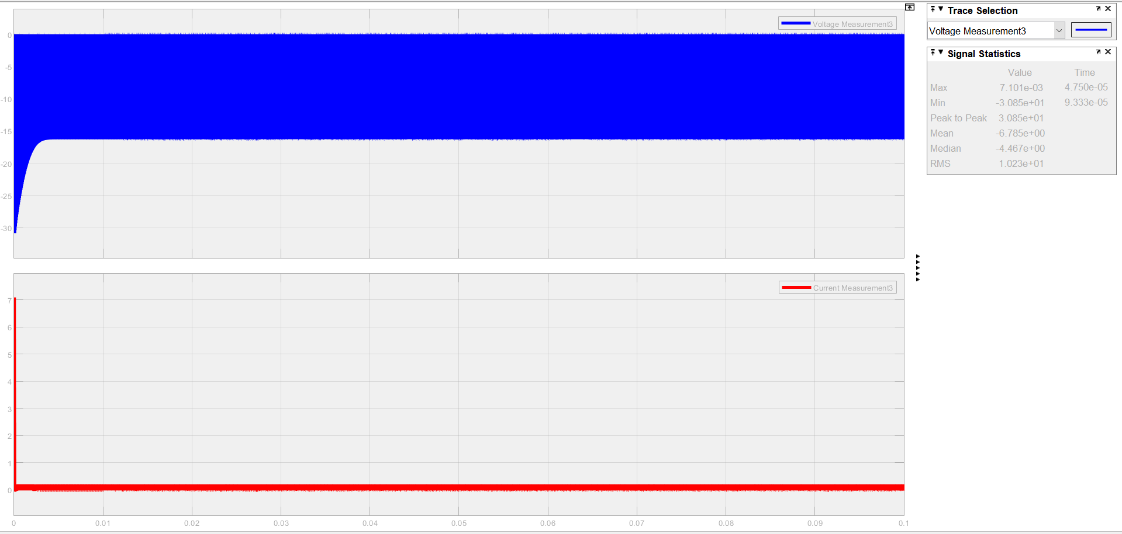

Figure 28. Diode voltage and current waveforms

The diode is used for blocking reverse voltage when .

Therefore, reverse blocking voltage is important parameter here. Zener type is not useful because it should not allow reverse current.

From [toshiba.semicon-storage.com](https://toshiba.semicon-storage.com/info/CUHS20F40_datasheet_en_20190831.pdf?did=63600&prodName=CUHS20F40&returnFlg=false), CUHS20F40 is available for our system design.

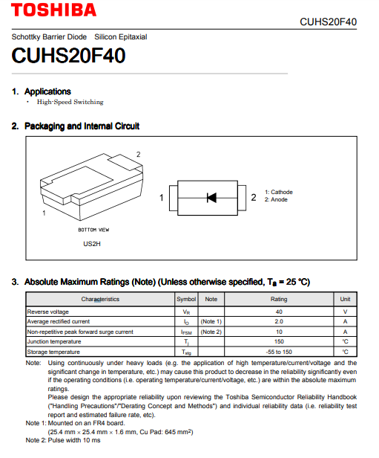

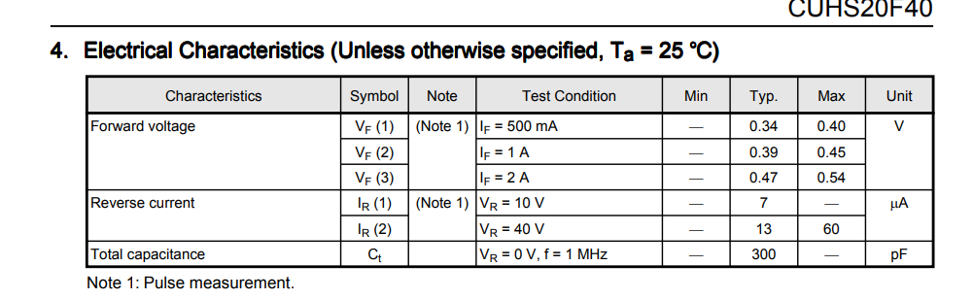

**→ Calculate the losses on these devices for rated power operation with 12 V input voltage. How would losses on the diode and switch change if the duty cycle is increased? Explain in detail.**

MOSFET:

DIODE:

If the duty cycle is increased, will increase. Because of all losses parameters depend on , the losses will increase.

**g) Using the calculated loss values, construct a thermal lumped element model and estimate the junction temperature without a heatsink. If necessary, choose a thermal interface material and heatsink and find out the junction temperature with these materials. Clearly state any assumption that you made.**

Steps of thermal design in power electronics:

* Determining the components
* Calculating the losses
* Getting thermal resistances from datasheet
* Determining maximum heatsink thermal resistance
* Finding a proper heatsink, deciding on cooling type (natural, forced, etc…)
* Iterating until getting a reasonable operating temperature

MOSFET: IRLML0040TRPBF n-channel thermal resistance parameters:

*(Junction to ambient thermal resistance is used in cases which does not have heatsink connected to the case of the MOSFET)*

Losses of the MOSFET:

where

Conclusion: No need for heatsink on the MOSFET. It is in the safe range.

**END**