Isolated Full Brıdge DC/DC Converter

# Abstract

The aim of the work is desinging 96W full-bridge isolating converter with and with 1% output voltage ripple. Switching frequency of the converter is 100kHz.

Contents

Isolated Full Brıdge DC/DC Converter 1

1 Abstract 1

2 Circuit Parameters 3

3 Magnetic Design 10

3.1 Design your transformer with cores which can be found on Magnetics. Clearly indicate the reasoning behind choosing the core. Find the primary and secondary number of turns. Calculate the magnetizing inductance of the transformer. (Hint: Magnetics has some great design guides for inductor and transformer designs. Please have a look at those guidelines.) 11

3.1.1 Number of turns calculations: 15

3.1.2 Magnetizing Inductance Calculations: 16

3.1.3 With current density being 4 A/mm2, find an AWG cable according to the switching frequency and current value. Firstly, calculate the fill factor of the transformer with the chosen cable. Is it a reasonable value? Then, calculate the cable DC and AC resistances and copper loss of the transformer (Proximity can be ignored). 16

3.1.4 Fill factor calculation: 18

3.1.5 Copper loss calculation: 19

3.1.6 Calculate the core loss of the transformer using core loss formulas given by the manufacturer and compare it with previously found copper loss value. Does your design require new iterations? 20

3.2 Design the output inductor with cores on Magnetics. Find the required number of turns and make sure that core is not saturated by checking the DC bias curves of the material. 20

3.2.1 Compute the product of LI² where 21

3.2.2 Number of turns calculation: 22

3.2.3 Choose appropriate AWG cable for the design with 4 A/mm2 current density and calculate the fill factor. Is it a reasonable value? Then, calculate the cable DC and AC resistances and copper loss of the inductor. 23

3.2.4 Copper loss calculation of inductor: 23

3.2.5 Calculate the core loss of the inductor and compare it with previously found copper loss value. Does your design require new iterations? 25

4 SIMULATION 26

5 References 29

# Circuit Parameters

1. Assuming operating duty cycle is 0.4, find the turns ratio of the transformer.
2. Find the required inductance value so that the filter inductor current ripple is 10% of the average inductor current.
3. Find the output capacitor value to meet the output voltage ripple requirements. Do not just use the formula, show derivaton.

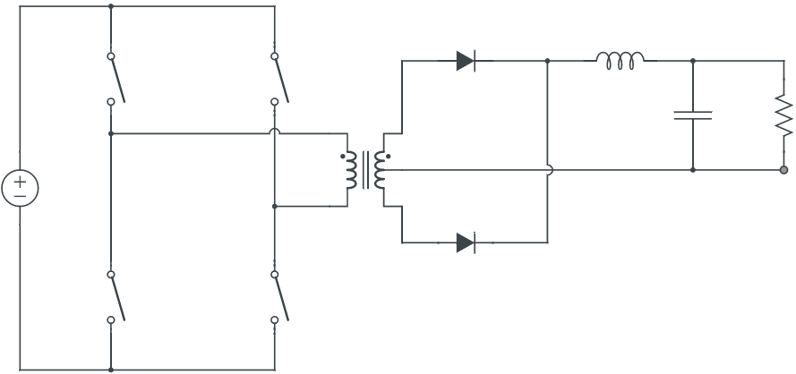

−

+

−

+

−

+

Figure 1. Isolated Full-Bridge Converter

& are operating in simultaneously. Besides, & are operating in simultaneously.

When & are ON and & are OFF:



+

−

+

−

+

−

+

−

+

−

+

−

Figure 2. Isolated Full-Bridge SW1 & SW2 ON, SW3 & SW4 OFF

When & are OFF and & are ON:



Figure 3. Figure 2. Isolated Full-Bridge SW1 & SW2 OFF, SW3 & SW4 ON

As it can be observed from the figures above, inductor voltage is positive in the both cases, therefore; the third case should be added and it should let discharge the inductor.

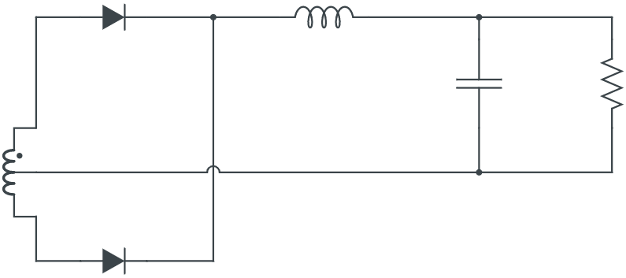

−

+

−

−

+

+

Figure 4. Isolated Full-Bridge SW1, SW2, SW3 & SW4 OFF

Here, voltage induced on secondary side cancels each other and is being discharged.

0

Ripple frequency of inductor current is twice of the main frequency.

As the ripple frequency is twice of main signal.

The inductor must discharge its energy to not charging up continuously and damage to circuit eventually. There are 2 charge period in the inductor like it can be seen on the graph above. Therefore, duty cycle can’t be larger than D=0.5. However, there is no discharging period/time; so, D must be smaller than half of the period (D<0.5) to discharge properly.

As it is given:

1. Assuming operating duty cycle is 0.4, find the turns ratio of the transformer.
2. Find the required inductance value so that the filter inductor current ripple is 10% of the average inductor current.

To get required inductance value, we need to have voltage waveform of the inductor:

From the negative portion of the inductor voltage:

and

Average inductor current is

1. Find the output capacitor value to meet the output voltage ripple requirements. Do not just use the formula, show derivaton.

To get required capacitance value, we need to have current waveform of the capacitor:

It is not easy to calculate capacitance value from this graph. Therefore, it is possible to derive capacitance value from the technique is used in buck converter.

Electrical capacitance says

∆

Using off-time equation:

It is given that we have 1% ripple at the output voltage.

# Magnetic Design

The total loss of magnetic components -transformer and inductor- should not exceed 15 W and fill factor of the cores should not be less than 30%.

It is strongly advised to use programs such as Matlab or Excel, since magnetic design can be a tedious job which may require a few iterations to find the optimum parameters. A simple script would save you from losing your precious hours.

a) Design your transformer with cores which can be found on Magnetics. Clearly indicate the reasoning behind choosing the core. Find the primary and secondary number of turns. Calculate the magnetizing inductance of the transformer. (Hint: Magnetics has some great design guides for inductor and transformer designs. Please have a look at those guidelines.)

b) With current density being 4 A/mm2, find an AWG cable according to the switching frequency and current value. Firstly, calculate the fill factor of the transformer with the chosen cable. Is it a reasonable value? Then, calculate the cable DC and AC resistances and copper loss of the transformer (Proximity can be ignored).

c) Calculate the core loss of the transformer using core loss formulas given by the manufacturer and compare it with previously found copper loss value. Does your design require new iterations?

d) Design the output inductor with cores on Magnetics. Find the required number of turns and make sure that core is not saturated by checking the DC bias curves of the material.

e) Choose appropriate AWG cable for the design with 4 A/mm2 current density and calculate the fill factor. Is it a reasonable value? Then, calculate the cable DC and AC resistances and copper loss of the inductor.

f) Calculate the core loss of the inductor and compare it with previously found copper loss value. Does your design require new iterations?

## Design your transformer with cores which can be found on Magnetics. Clearly indicate the reasoning behind choosing the core. Find the primary and secondary number of turns. Calculate the magnetizing inductance of the transformer. (Hint: Magnetics has some great design guides for inductor and transformer designs. Please have a look at those guidelines.)

First, let’s try to understand basics:

Faraday’s law:

For each turn of wire:

Total winding voltage is

Core area



Express flux in terms of flux density

is not one of the specificationsof transformer, therefore we can write instead:

*where is the area of copper (wire)*

However, is still not related to the transformer specifications, therefore, we can write instead:

Fill factor

Copper area

Window area

We are using constant 2 because having 2 winding in the transformer

Insert into the equation:

To simplify the equation, following equation can be used which is taken from Magnetics.Inc:

*Where = Topology constant*

*Forward converter = 0.0005*

*Push-Pull = 0.001*

*Half-bridge = 0.0014*

*Full-bridge = 0.0014*

*Flyback = 0.00033 (single winding)*

*Flyback = 0.00025 (multiple winding)*

Current density can be selected depending upon the amount of heat rise allowed. 750 cir. mils/amp is conservative; 500 cir. mils is aggressive.

Our specifications:

Suggested interval for is between 500 to 750 cir. mils/amp

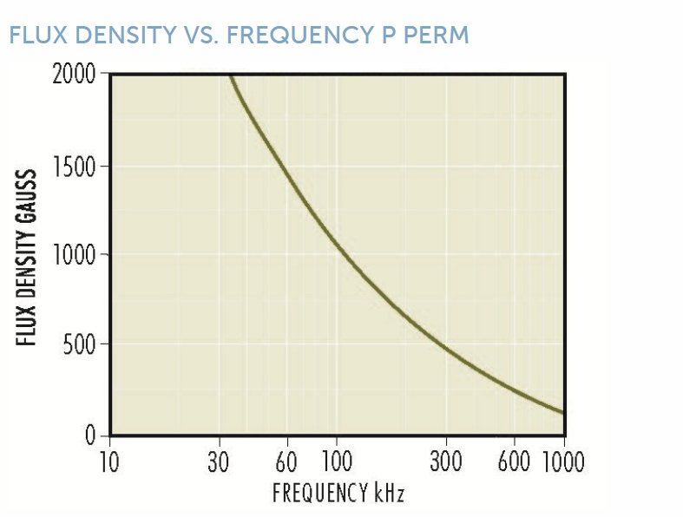

Figure 5. Flux density (gauss) vs frequency (kHz)

Flux Density (gauss) selected based upon frequency of operation. Above 20kHz, core losses increase. To operate ferrite cores at higher frequencies, it is necessary to operate the core flux levels lower than ± 2 kg. The Flux Density vs. Frequency chart shows the reduction in flux levels required to maintain 100 mW/cm³ core losses at various frequencies, with a maximum temperature rise of 25°C. for a typical power material, Magnetics’ P material. From [transformer design with magnetics ferrite cores](https://www.mag-inc.com/Design/Design-Guides/Transformer-Design-with-Magnetics-Ferrite-Cores) (Mag. Inc)



Figure 6. Flux density (gauss) vs frequency (kHz)

From the graph above, it is suitable for using the value

Now, it is time to choose suitable core for the design of transformer,

It is important that our core is able to handle power of 96W and meet .

When we check [Area Product Distribution (](https://www.mag-inc.com/Media/Magnetics/File-Library/Product%20Literature/Ferrite%20Literature/WaAc-Chart-2021.pdf)) Chart (Mag. Inc) and [Typical Power Handle Chart (Mag. Inc)](https://www.mag-inc.com/Media/Magnetics/File-Library/Product%20Literature/Ferrite%20Literature/Typical-Power-Handling-Chart-2021.pdf)



Figure 7. WaAc chart

Suitable cores are 43019 DS HS, 42515 EE, 43009 EE.



|  |  |  |  |
| --- | --- | --- | --- |
| 20 kHz | 50 kHz | 100 kHz | 250 kHz |

Figure 8. Typical power handle chart

We are working on 100kHz. We need at least 96W power ratings for our system. Hence, it is better to choose the bottom row.

Suitable cores are 42823 PC,43019 RS DS PC, 43009 EE.

43009 EE meets the requirements for and handles the requirement power rating.

Now let’s check 43009 EE core in detail. It is a E core with part number 3009.



Figure 9. Magnetics Inc. material list

As it is decided that system will be working on 100mT (1,000 Gauss) and 100kHz.

According to [Magnetics Inc. Ferrite Core Material Summary](https://www.mag-inc.com/getattachment/Products/Ferrite-Cores/Ferrite-Shapes/FerriteCoresMaterialsSummary-(2).pdf?lang=en-US)

The cores have types like L, R, P, F, T

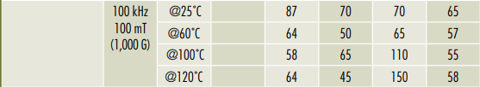

Figure 10. Ferrite core material types

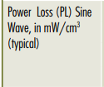

Power loss of material types can be observed on figure above. To make losses minimize, P or T types are better to use.

The choose is: [P type 3009 E core](https://www.mag-inc.com/Media/Magnetics/Datasheets/0P43009EC.pdf).

### Number of turns calculations:

Again from Faraday’s law of induction:

To simplify the equation, following equation can be used which is taken from Magnetics.Inc:

Effective cross-sectional area

### Magnetizing Inductance Calculations:

= inductance factor

value of [0P43009EC](https://www.mag-inc.com/Media/Magnetics/Datasheets/0P43009EC.pdf) is 3147

### With current density being 4 A/mm2, find an AWG cable according to the switching frequency and current value. Firstly, calculate the fill factor of the transformer with the chosen cable. Is it a reasonable value? Then, calculate the cable DC and AC resistances and copper loss of the transformer (Proximity can be ignored).

**Cable Selection:**

Current density is specified as

Therefore;

Let’s check American Wire Gauge(AWG) table:

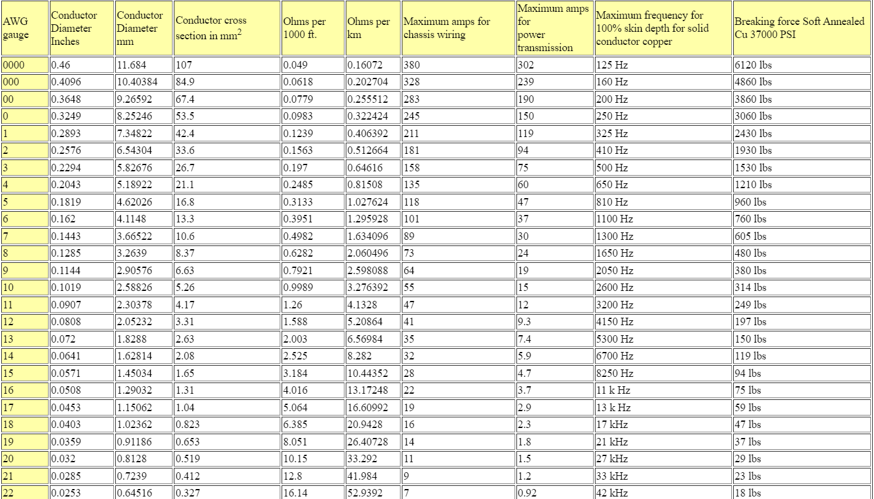

Figure 11. American Wire Gauge (AWG) table

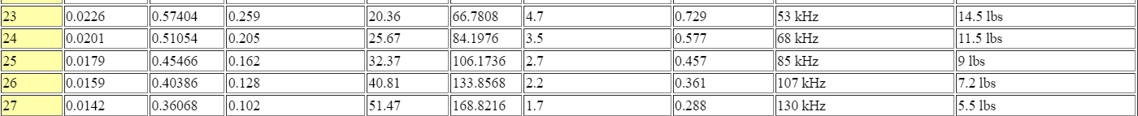

In normal conditions, 12AWG for primary, 21AWG for secondary is suitable. But, we have a constraint of skin depth δ. The system switching frequency is 100kHz. As it can be seen on the above list, for both 12AWG and 21AWG, skin depth δ reach maximum value below 100kHz. Therefore, we need to use strands of small gauge which has skin depth δ is above 100kHz. For this purpose, 26AWG cable with having cross-sectional area 0.128 is good solution. To get same cross-sectional area, for example, 24×26AWG in parallel for primary winding, 4×26AWG in parallel for secondary windings is necessary.

### Fill factor calculation:

### Copper loss calculation:

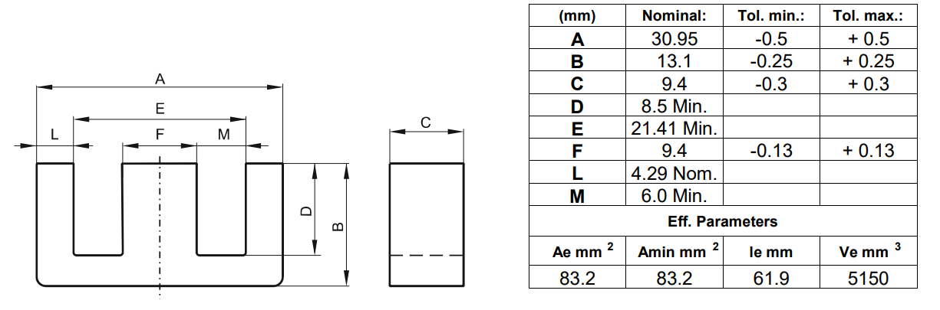

Figure 11. 0P43009EC core dimensions

Number of parallel cables for pri = 24

Number of parallel cables for sec = 4

### Calculate the core loss of the transformer using core loss formulas given by the manufacturer and compare it with previously found copper loss value. Does your design require new iterations?

To calculate core loss, we are using Steinmetz’ equation:

The parameters depend on the material which is supplied by the manufacturer.

Typically,

Our system design is not required further iterations. Losses are kind of valid.

## Design the output inductor with cores on Magnetics. Find the required number of turns and make sure that core is not saturated by checking the DC bias curves of the material.

To design an inductor, two parameters must be known:

1. Inductance required with DC bias
2. DC current

Inductance was found as 240μH and DC average current of the inductor is equal to the output current

The procedure is:

### Compute the product of LI² where

* L = inductance required with DC bias (millihenries)
* I = maximum DC output current + 1/2 AC Ripple

The ripple is specified as 10%. Therefore, we take I as

Figure 12. Magnetics Inc. Ferrite core selection chart

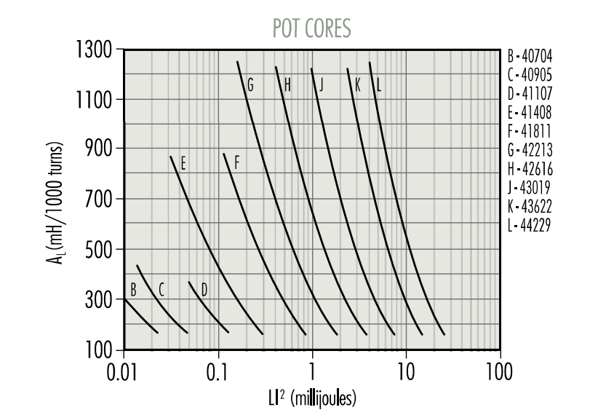

From above picture which shows ferrite core selection chart according to value.

We found . Put the value into the chart and follow the coordinate up to intersection point. and core type is G (42213) which can be found on [Magnetics Inc. Ferrite Pot Cores with part number 2213](https://www.mag-inc.com/Products/Ferrite-Cores/Ferrite-Pot-Cores)

Required inductance L, core type and core nominal inductance are known.

### Number of turns calculation:

Where L is in millihenries.

Let’s recheck

1. Design the output inductor with cores on Magnetics. Find the required number of turns and make sure that core is not saturated by checking the DC bias curves of the material.

One of suitable core is Ferrite Pot Core part number 2213 with material type of P, having

To check saturation:

The maximum allowable H = 25 Oersted

So, it is in safe region.

### Choose appropriate AWG cable for the design with 4 A/mm2 current density and calculate the fill factor. Is it a reasonable value? Then, calculate the cable DC and AC resistances and copper loss of the inductor.

We have 2.2A passing through the inductor.

From AWG list in page 16, 19AWG with 0.653 is suitable; however, skin depth factor is occurs because our system is working on 100kHz.

Therefore, we can use parallel strands 26AWG with 0.128 by the number of 5. Therefore, core losses can be minimized.

### Copper loss calculation of inductor:

Ω for 26AWG

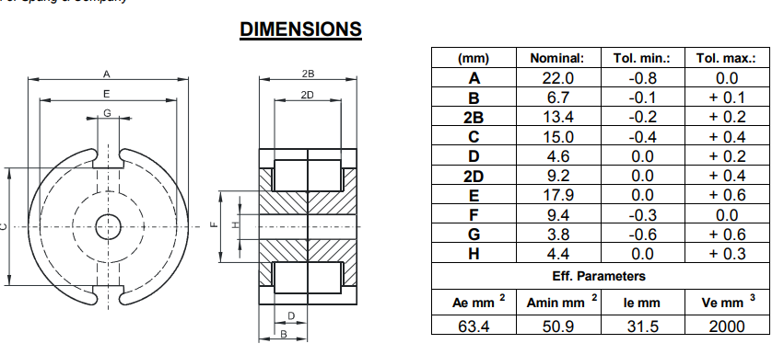

Figure 13. POT core dimensions

Copper loss of inductor

### Calculate the core loss of the inductor and compare it with previously found copper loss value. Does your design require new iterations?

**Core loss calculation of inductor:**

000

Typically,

All values seems to be valid.

# SIMULATION

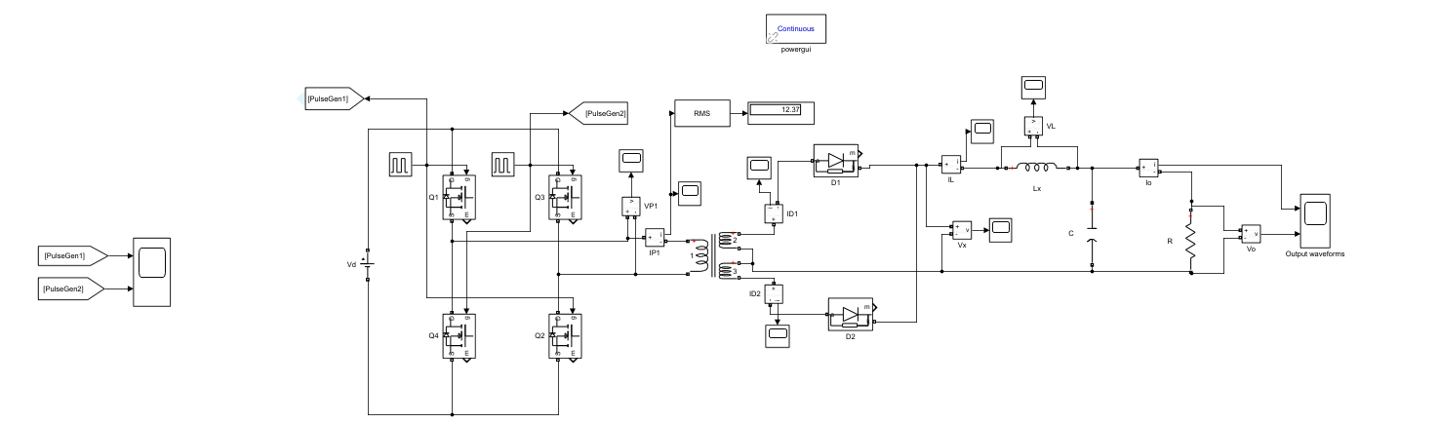

Figure 14. Simulink schematic design of Full-Bridge DC-DC Converter

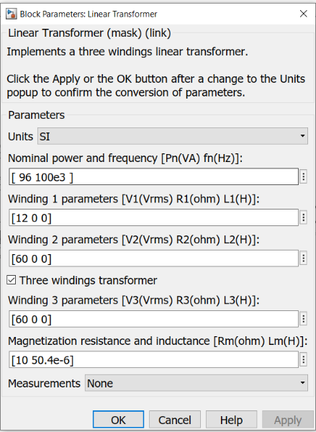

Figure 15. Transformer parameters

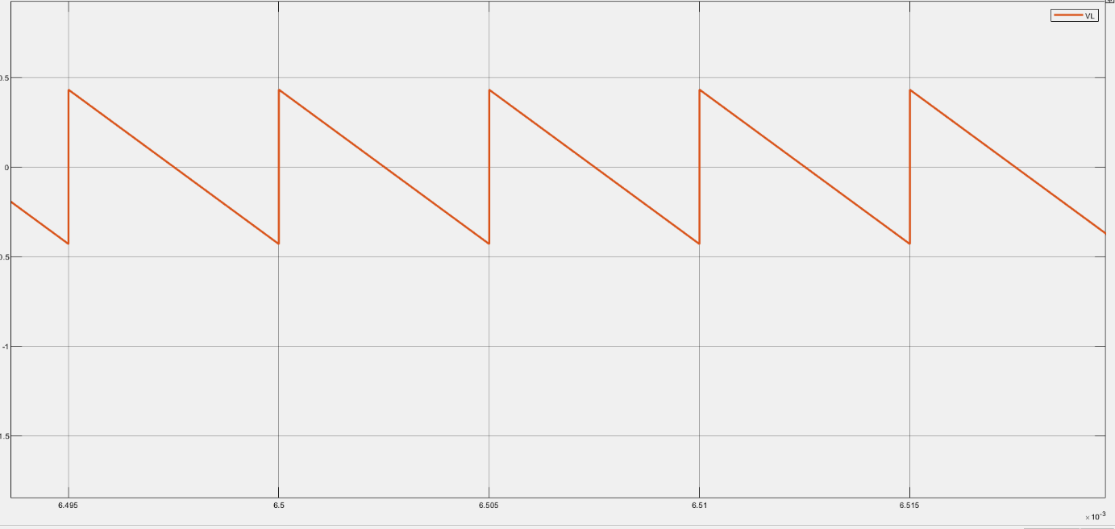

Figure 16. Inductor voltage waveform

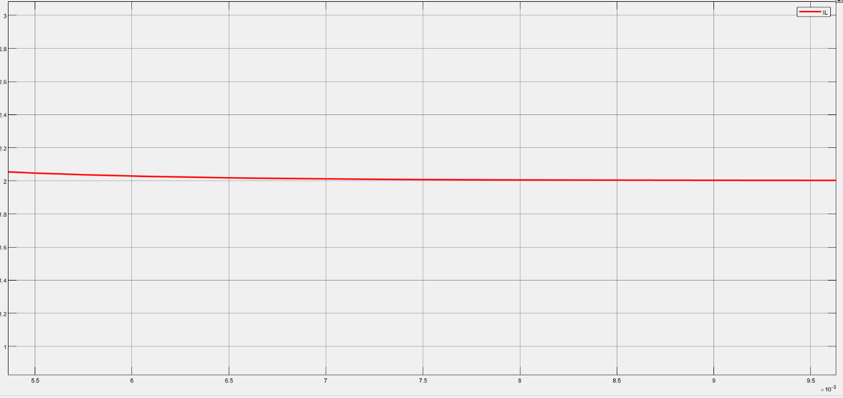

Figure 17. Inductor current waveform

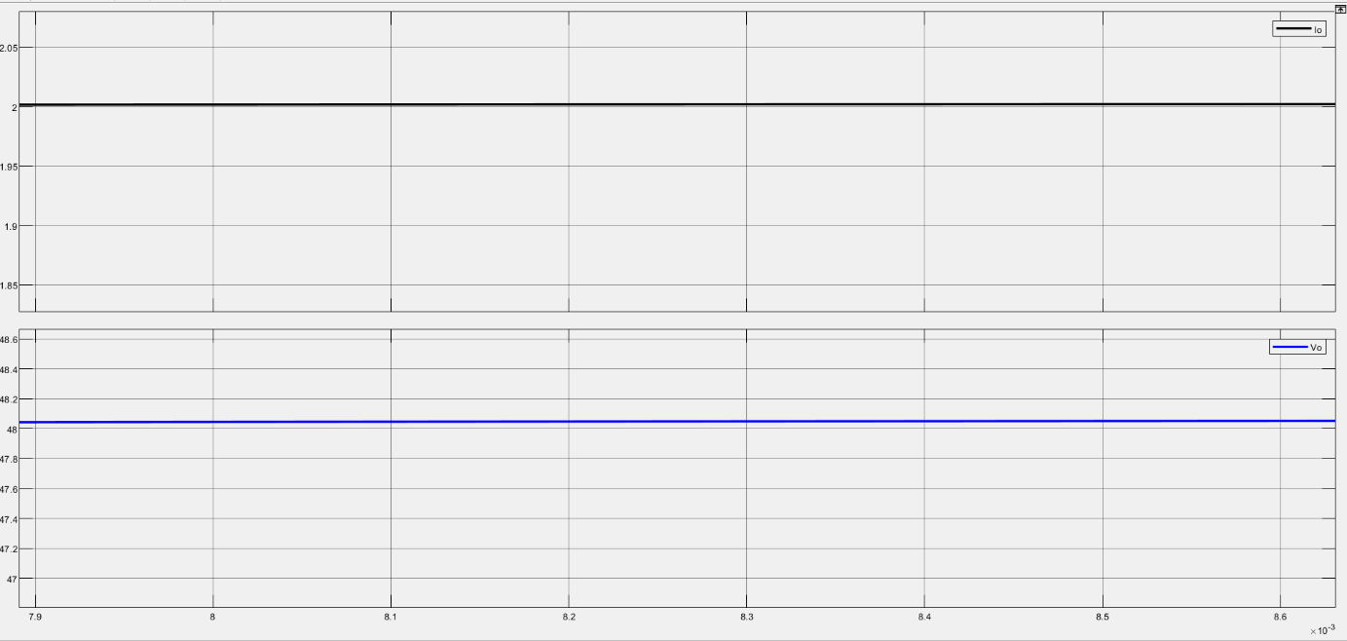

Figure 18. Output parameters

# References

(n.d.). Magnetic Design Guides. Magnetics. https://www.mag-inc.com/Design/Design-Guides