**Single Phase Half-Wave (Half Bridge), Single Phase Full-Wave (Full Bridge) & Three Phase Full Bridge Rectifiers Design & Simulation Work**

Table of Contents

1) Single Phase Half-Wave Diode Rectifier 2

b. Plot the output voltage waveform for step times of 1 ns, 0.1 ms and 1 ms. 3

c. Comment on the significance of step time in computer simulations. Which one would you prefer for this question? Comment on the advantages and disadvantages of the selection of step time too small or too large. It is again accurate and fast results as compared to 1ns step time. 4

d. Analytically, calculate the output average voltage and input current THD. 4

2) Single Phase Full-Wave Diode Rectifier 7

e. What do Ls and Rs represents in practical applications? 8

f. Using simulation tools, find the minimum output filter capacitance to have 4% output voltage peak-to-peak ripple to mean ratio. Use the values of same AC voltage source in part 1, LS = 1 mH, RS = 1 mΩ and RLOAD = 100 Ω. Assume diodes are ideal. 8

g. Plot the output voltage, input voltage and current at the same graph. 11

h. Measure average of output voltage, input current THD and power factor. 11

i. Simulate the same circuit without RS and LS and observe and state the differences. What is the effect of these two? 13

3) Three Phase Full Bridge Diode Rectifier 14

j. Simulate the circuit for Ls=0, Van, Vbn and Vcn are balanced three phase voltages connected to the same grid as before, ideal diodes and Id=50 A. Plot the output voltage and phase A input current on the same graph. 14

k. Analytically, calculate the output voltage average and compare with simulation results. Comment on any differences. 15

l. Perform the harmonics analysis, i.e. find the harmonic content of output voltage and input current up to 30th harmonic of line frequency. 17

m. Simulate the same rectifier for Ls=1 mH and plot the output voltage and input current. Observe the effect of line inductance and comment on your observations. 19

n. Compare the harmonic content of the input current for different Ls values of 0, 1 mH, 10 mH by checking IEEE 519-2014 standard. Comment on the differences. What kind of problems can having high input current THD cause to the grid? 20

1. Single Phase Half-Wave Diode Rectifier

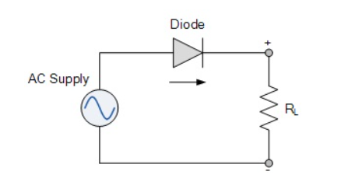

Figure Single Phase Half-Wave Rectifier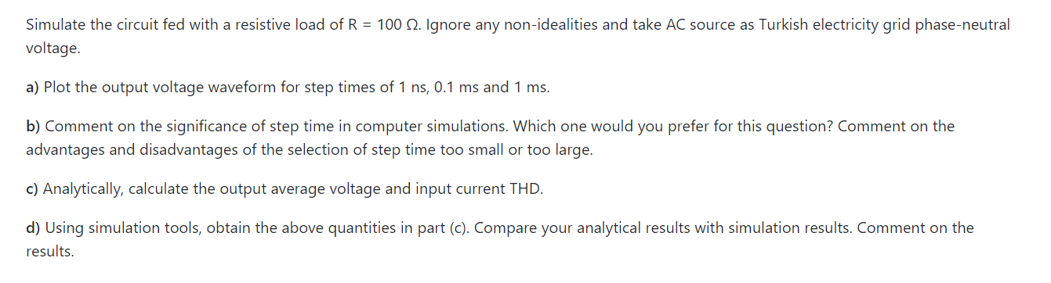

MATLAB/Simulink modelling of single-phase half-wave rectifier is:

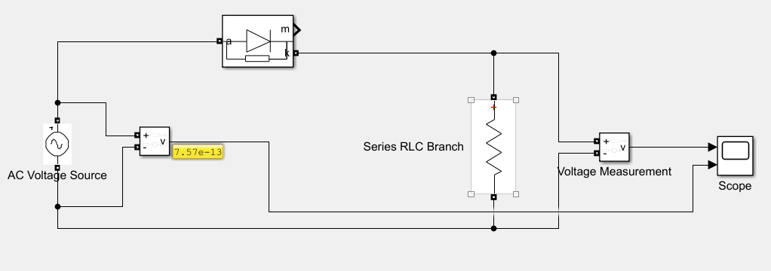

Figure Matlab/Simulink Design of Half-Wave Rectifier

# Plot the output voltage waveform for step times of 1 ns, 0.1 ms and 1 ms.

* **When sample time is 1ns:**

Output voltage waveform is:

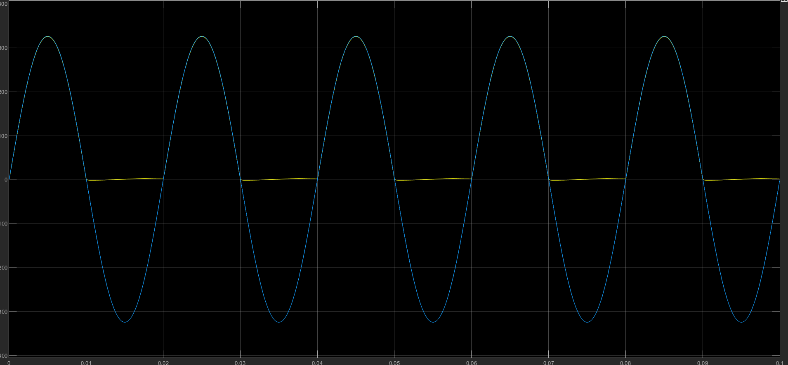

Figure Output Voltage Graphs Vs&Vo vs t

As we can see since our sample time is very small, we are getting very accurate results according to graph in above. It is expected. However, simulation time takes too much time to show the results.

* **When sample time is 0.1ms:**

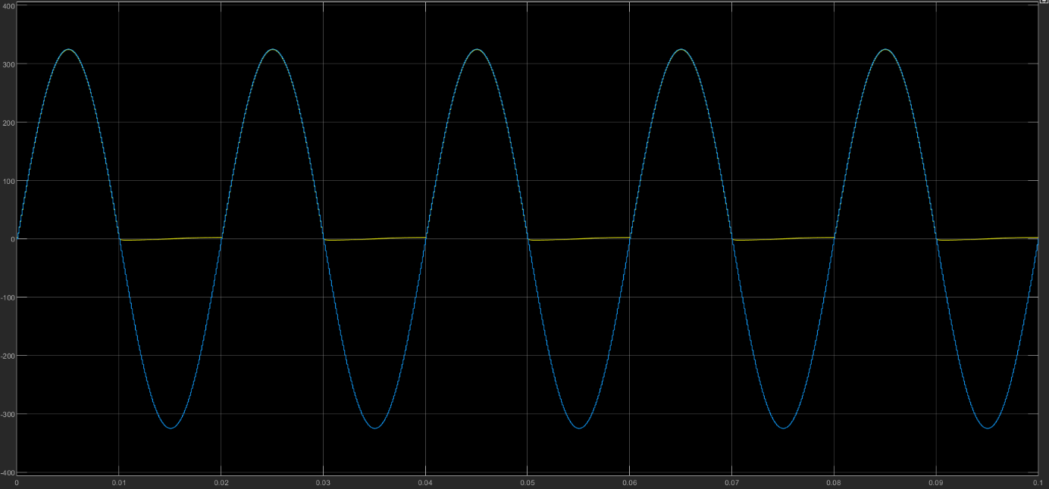

Figure . Output Voltage Graphs Vs&Vo vs t

Figure Output Voltage Graphs Vs&Vo vs t

# Comment on the significance of step time in computer simulations. Which one would you prefer for this question? Comment on the advantages and disadvantages of the selection of step time too small or too large. It is again accurate and fast results as compared to 1ns step time.

* **When sample time is 1ms:**

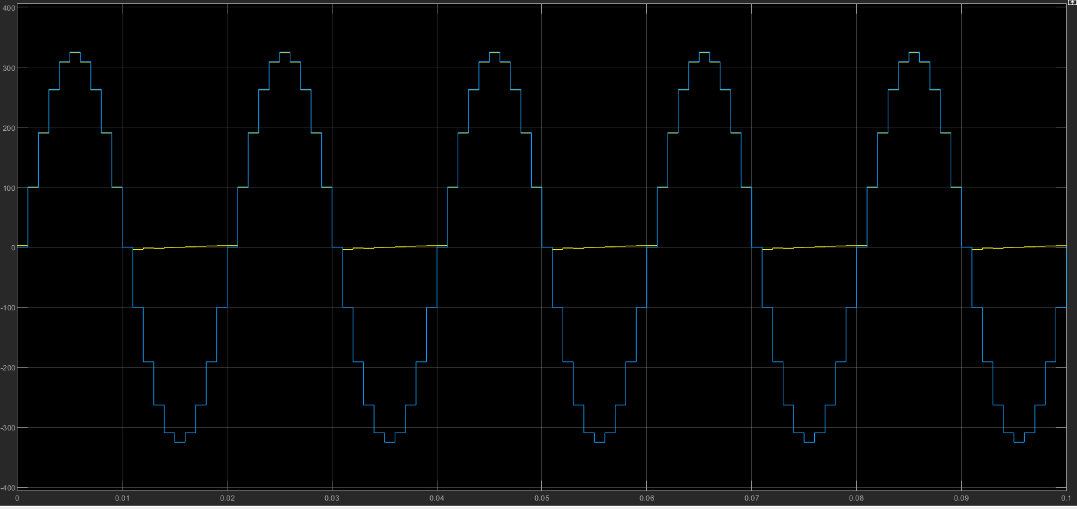

Figure 6. Output Voltage Graphs Vs&Vo vs t

Here we see that our step time is nearly our period that ms. Therefore, our graph like a step function that gave inaccurate results compared to 1ns and 0.1ms step times. However, it is the fastest computation time.

# Analytically, calculate the output average voltage and input current THD.

When T sample is 0.001 (1ms), there will be distortion in input current that looks like as figure below:

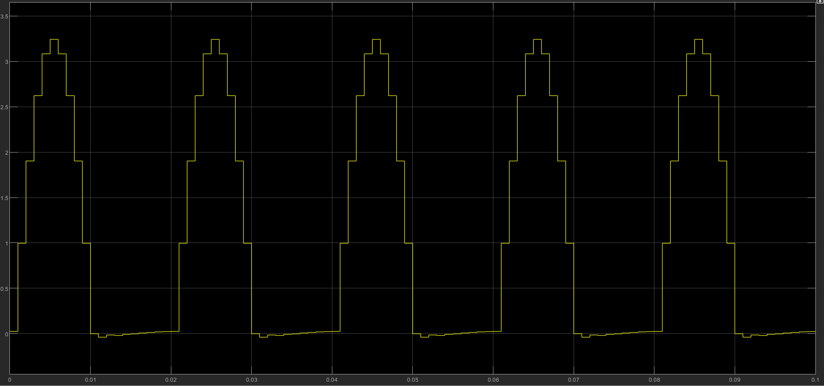

Figure 7. Input Current Waveform

As it can be observed that the distortion in the sinusoidal waveform of the input current is occurred because of sampling time. Because it is not trigonometric function anymore, there will be harmonics that are part of the non-trigonometric function and harmonics are sum of many trigonometric function that can be calculated via Fourier Series. Why it is calculated via Fourier Series instead of Fourier Transform? It is because they are non-trigonometric periodic functions, and non-trigonometric periodic functions are calculated by Fourier Series. On the other hand, Fourier Transform is applied on non-trigonometric non-periodic functions.

Fourier Series is represented as

THD =

Use powergui tool FFT Analysis that shows the fundamental and other harmonics shown below:

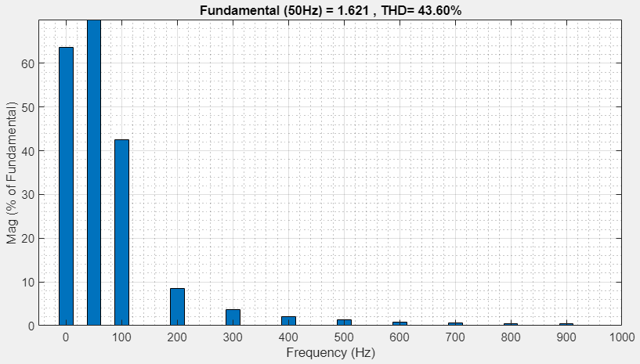

Figure 8. FFT Analysis of Input Current

THD is found as 43.6 %.

1. Single Phase Full-Wave Diode Rectifier

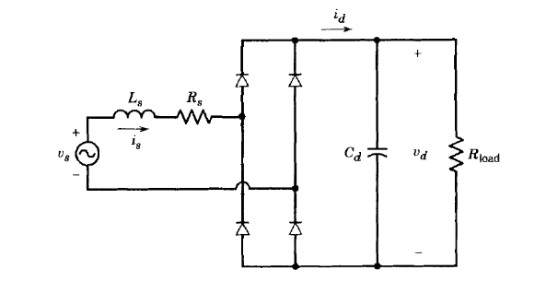

**Figure 9. Single Phase Full Wave Rectifier Circuit**

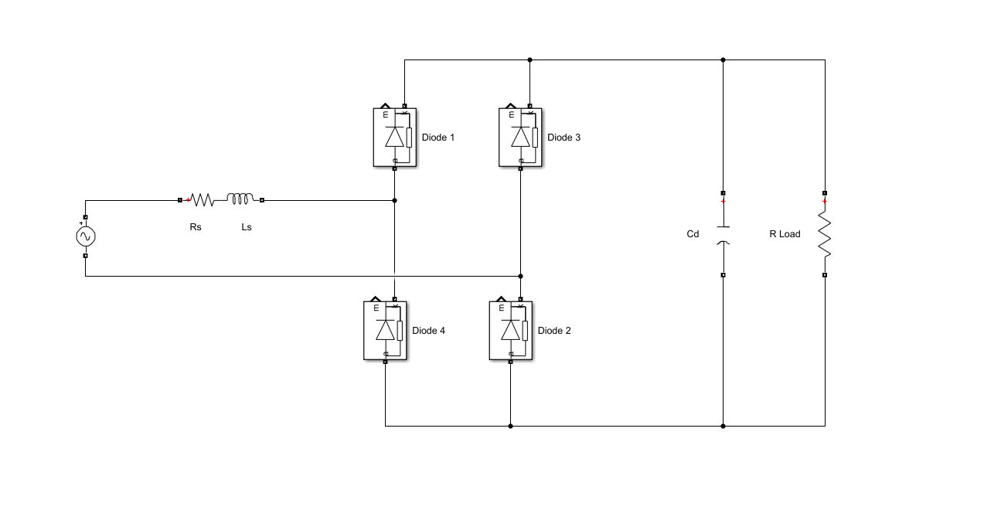

**Figure 9. Single Phase Full-Wave Rec. Circuit Schematic**

# What do Ls and Rs represents in practical applications?

LS and RS are representing line impedance and resistance in power systems. As we know that no ideal source is existed itself. There always be some passive components in the systems that we represent as a source resistance and impedance.

# Using simulation tools, find the minimum output filter capacitance to have 4% output voltage peak-to-peak ripple to mean ratio. Use the values of same AC voltage source in part 1, LS = 1 mH, RS = 1 mΩ and RLOAD = 100 Ω. Assume diodes are ideal.

For this question, first we need to know how to calculate the capacitor value of full-wave rectifier (full bridge rectifier).

For example, let’s adding 1mF capacitor to the circuit and observe the voltage waveform of the capacitor.

**tc**

**td**

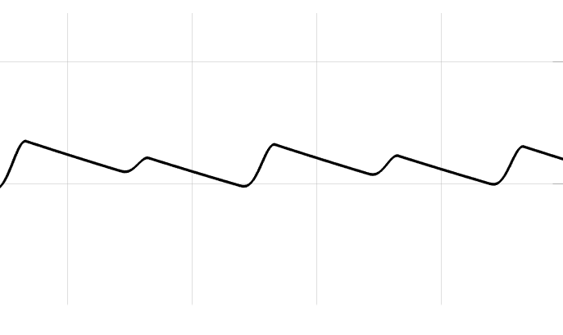

**VO**

**Vmin**

**Vmax**

**θ**

**π-θ**

**t**

Figure 10. Voltage Waveform of the Capacitor

The energy sum of capacitor is equal to output voltage PO .

That means

* As it is known that frequency is doubled in Full-Wave Rectifier.

ΔVr

Vo

🡪

We leave C alone in the equation.

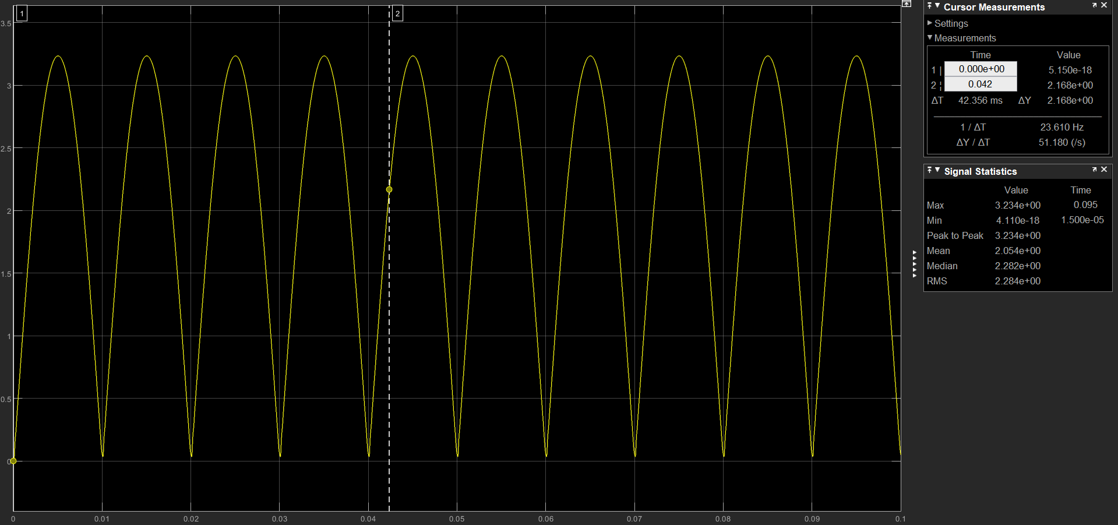In design specifications it is asked that output filter capacitance to have 4% output voltage peak-to-peak ripple to mean ratio. To find the capacitor value, the current value and angle values are needed. The output current (IO) can be get from simulation results:

Figure 11. The Output Current Graph when C is not added

IO is measured 2A.

And when we add IO into the equation that derived above section:

When the capacitor is added to the circuit and the results will:

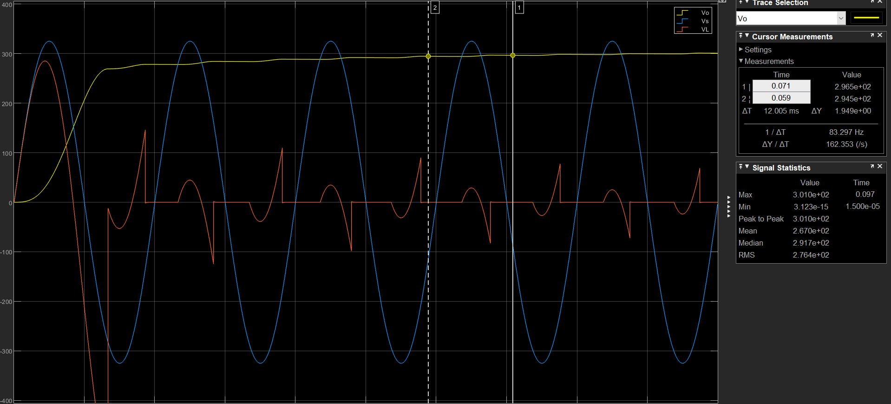

Figure 12. Output Voltage Waveform of Vs, Vo & Vl

It can be seen that output voltage waveform became straight line as compared to Full-Wave Rectifier without capacitor. Also, ripple voltage is less than 0.4%.

# Plot the output voltage, input voltage and current at the same graph.

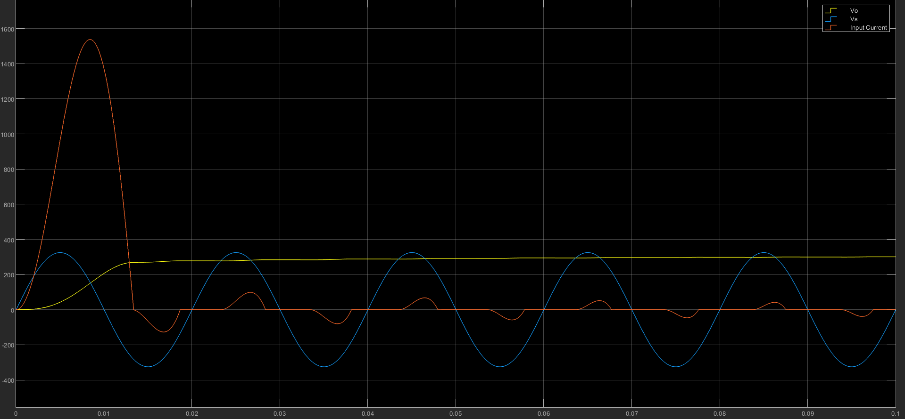

Figure 13. Input Current, Voltage & Output Voltage

# Measure average of output voltage, input current THD and power factor.

Output voltage:

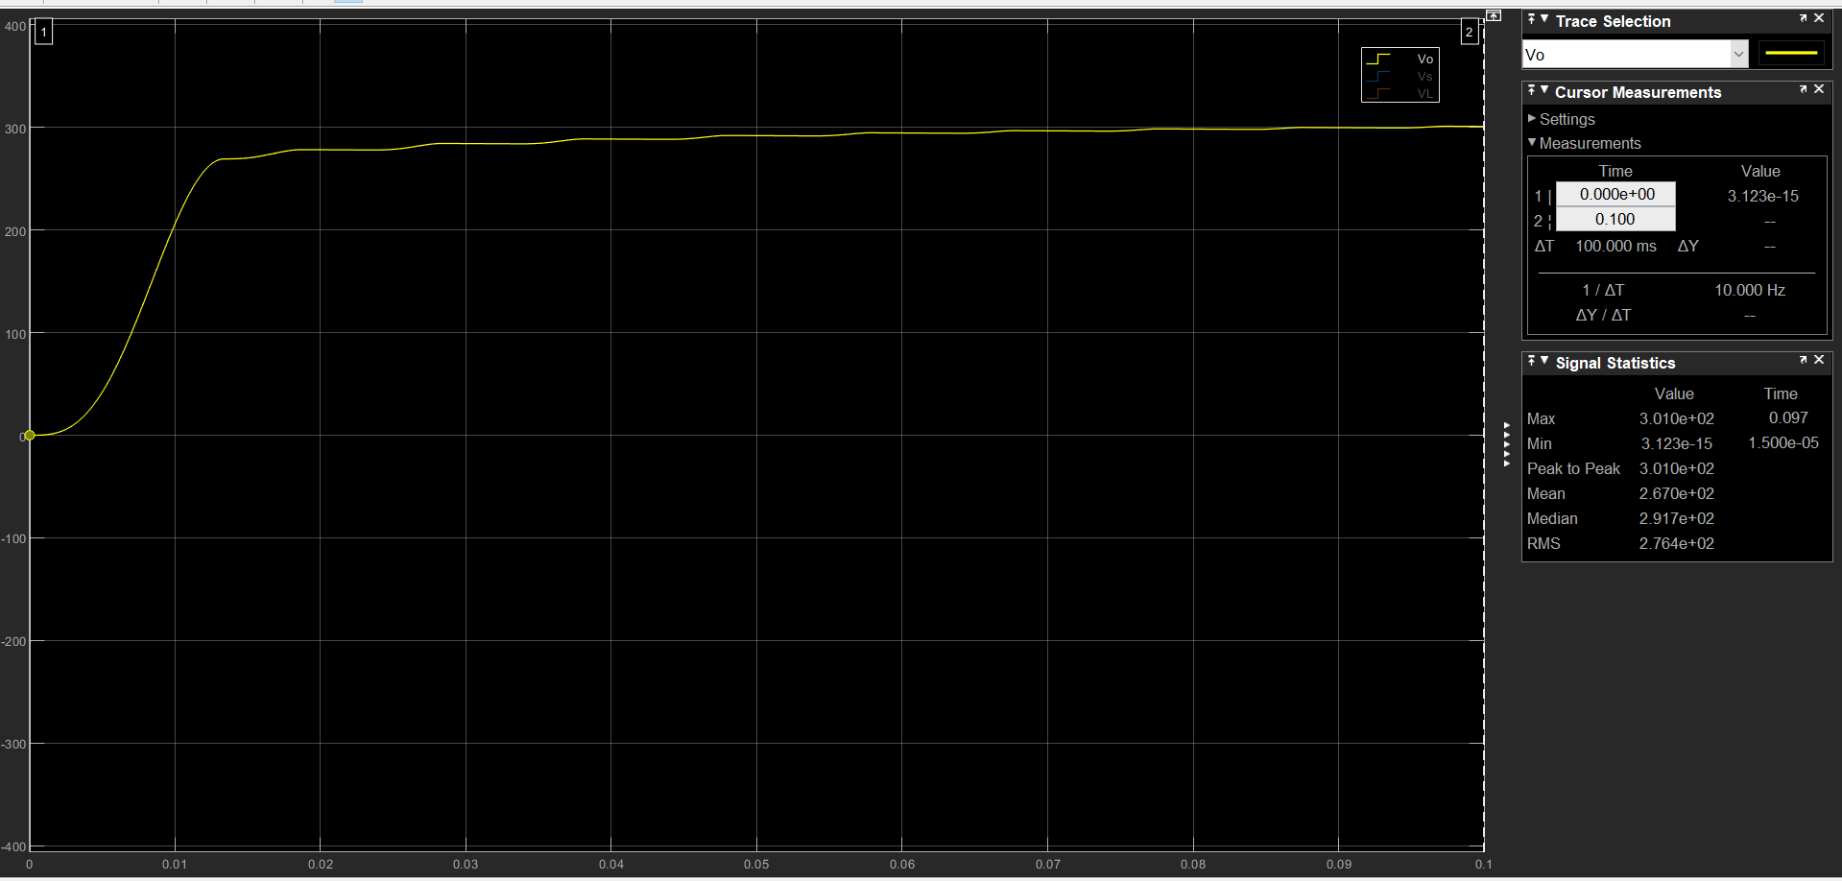

Figure 14. Output Voltage Waveform

Given specific time, our average output voltage is calculated by MATLAB is:

VO(avg) = 267V.

Input Current THD:

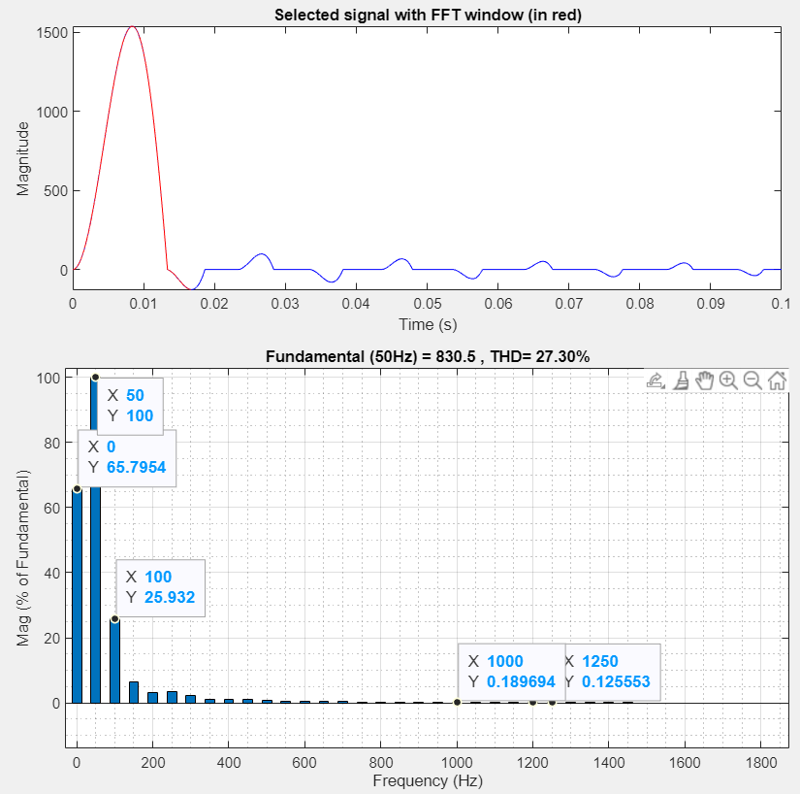

Figure 15. Fundamental Frequency and THD of Input Current Waveform

Power Factor:

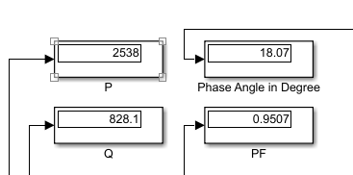

Figure 16 P,Q, Phase Angle (Theta) and PF

# Simulate the same circuit without RS and LS and observe and state the differences. What is the effect of these two?

When LS and RS effects are removed, the output graph will be more straight line and no distortion as it is shown in the below graph:

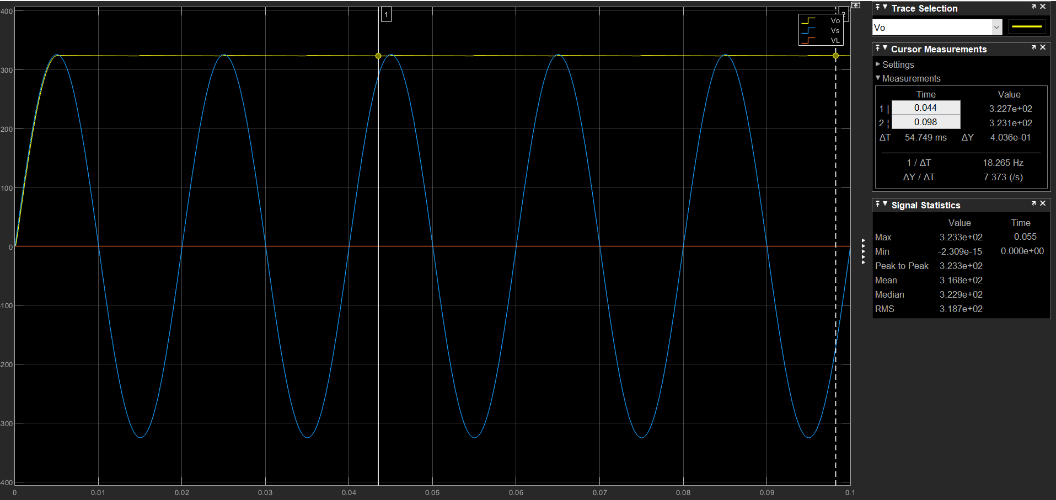

Figure 17. Output Voltage Graph w/out Rs and Ls

1. Three Phase Full Bridge Diode Rectifier

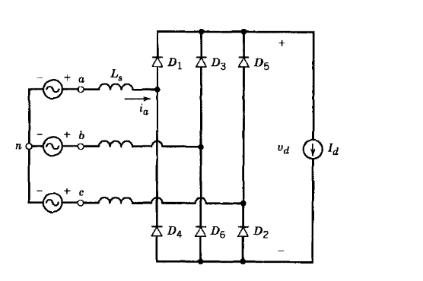

Figure 18. 3-Phase Full Bridge Rectifier Circuit

# Simulate the circuit for Ls=0, Van, Vbn and Vcn are balanced three phase voltages connected to the same grid as before, ideal diodes and Id=50 A. Plot the output voltage and phase A input current on the same graph.

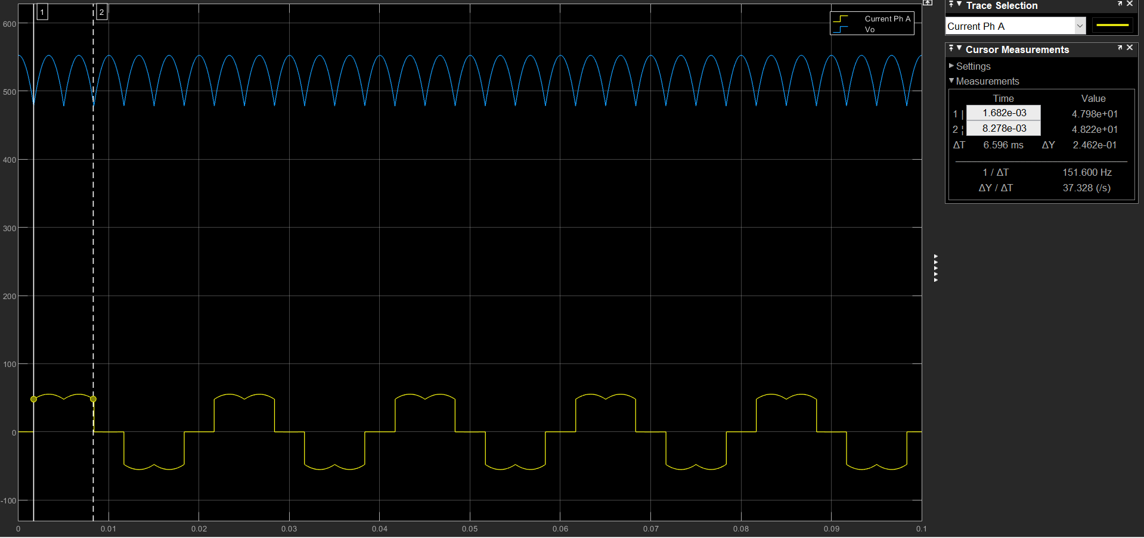

Figure 19. Phase A Input Current and Output Voltage Waveform

# Analytically, calculate the output voltage average and compare with simulation results. Comment on any differences.

½

0

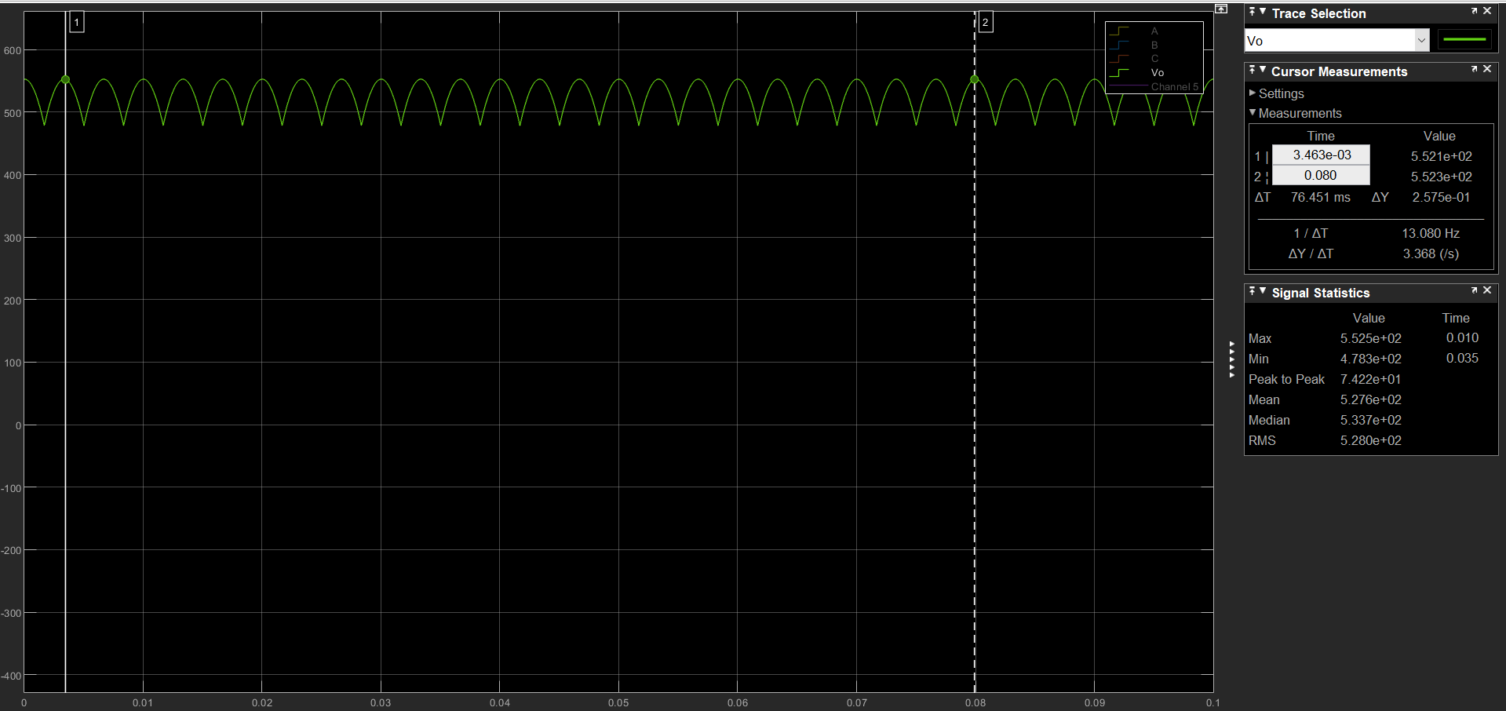

Figure . Output Voltage Waveform of 3-Phase Diode Rectifier

As it is shown in the figure above, the mean (average) value of the output voltage waveform is 533.7V

Analytical calculation of the output voltage in 3-Phase Diode Rectifier is:

The difference is between analytical and simulational result is as voltage drop losses due to the diode.

# Perform the harmonics analysis, i.e. find the harmonic content of output voltage and input current up to 30th harmonic of line frequency.

Input Current:

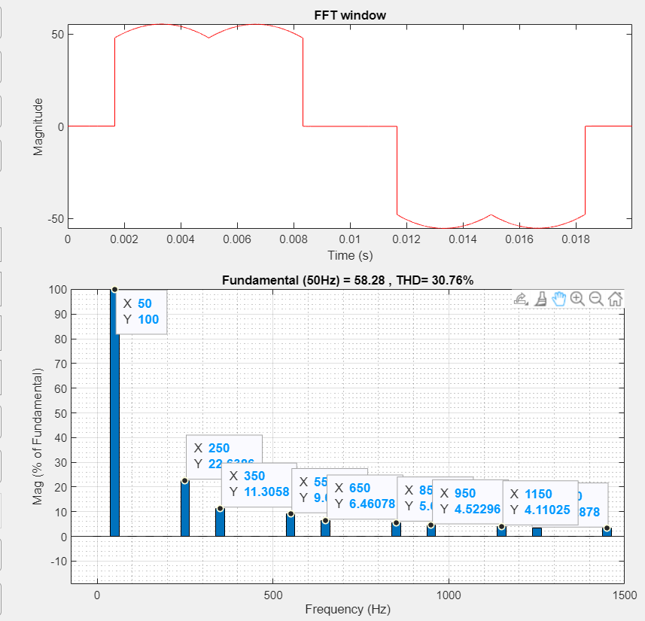

Figure 21. Input Current Harmonics and THD

It can be observed that in current harmonics we have fundamental, 5th, 7th, 11th harmonics.

Output Voltage:

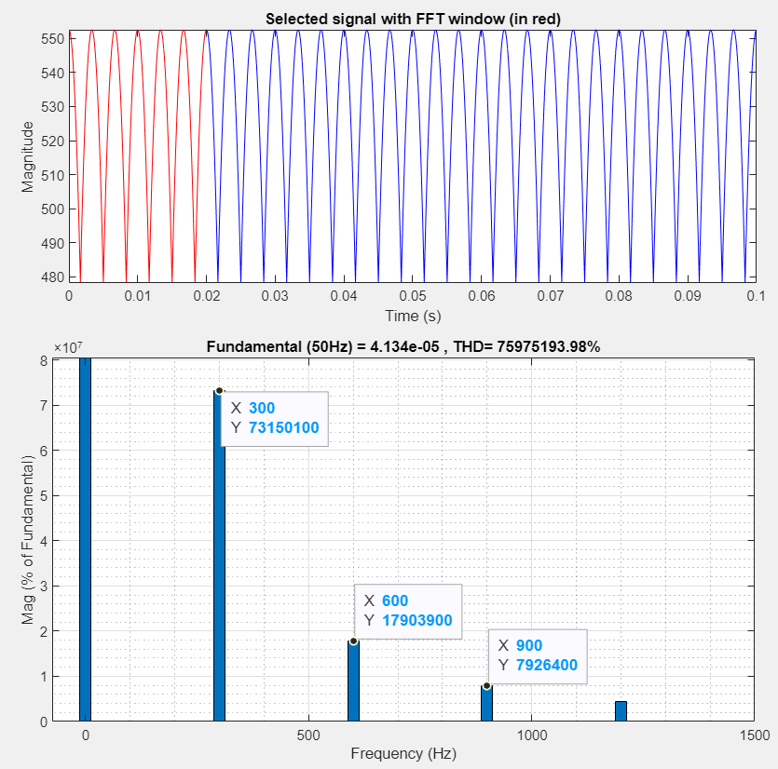

Figure 22. Output Voltage Harmonics & THD

# Simulate the same rectifier for Ls=1 mH and plot the output voltage and input current. Observe the effect of line inductance and comment on your observations.

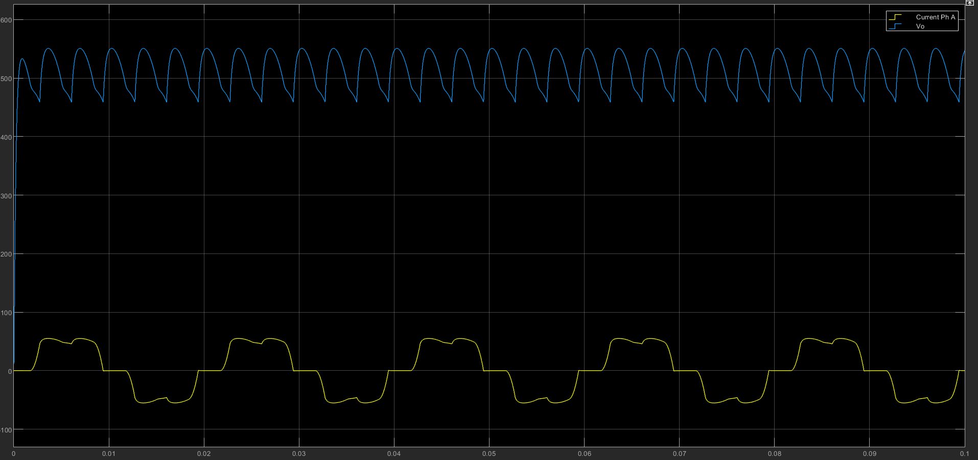

Figure 23. Output Voltage & Input Current Waveforms with Line Inductance

It can be easily observed that line inductance affects the waveforms in manner of distortion. There occurs commutation due to the line inductance because it delays the current and cause current positive and negative cycle happens at the same time during commutation.

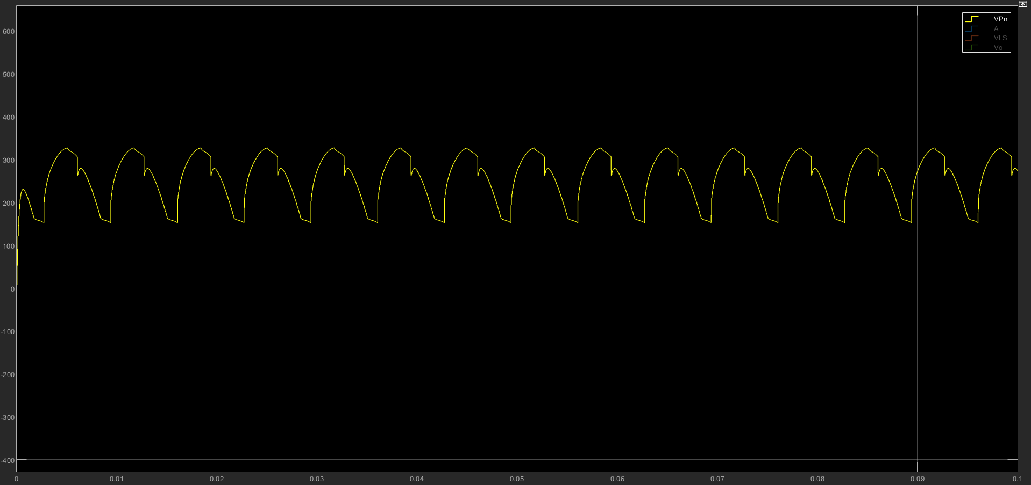

Figure 24. Commutation Effects

1. Repeat part (b) with Ls=1mH.

Average voltage lost due comm.

Output voltage with comm.

Output avg voltage was calculated in previous section that is 537.7V

With commutation the output voltage is reduced to 519V

So our commutation loss is 533.7 – 519 = 14.7V

Let’s calculate in analytically:

?

# Compare the harmonic content of the input current for different Ls values of 0, 1 mH, 10 mH by checking IEEE 519-2014 standard. Comment on the differences. What kind of problems can having high input current THD cause to the grid?

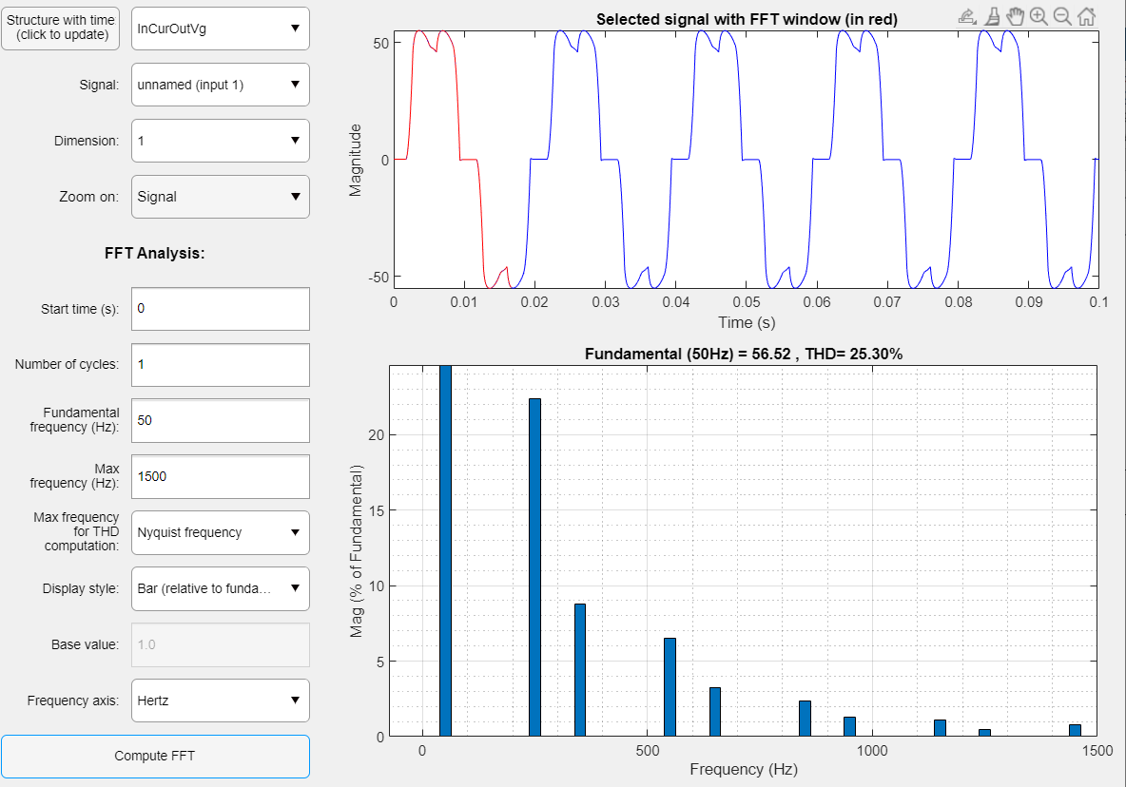

Figure 25. THD when Ls = 1mH

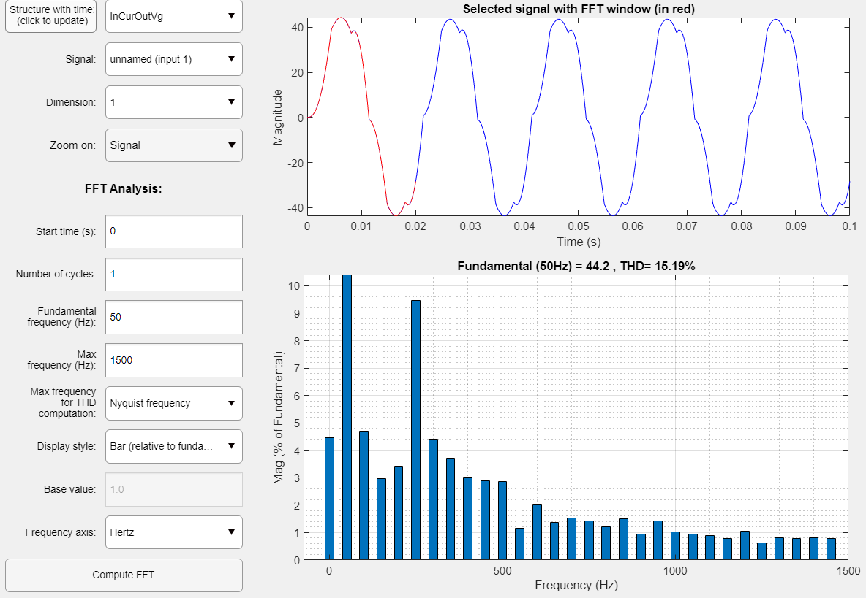

Figure 26. THD when Ls = 10mH

Result: When LS value gets higher, the input current will reduce and THD becomes smaller.