Understanding Power and Controlled Rectifiers

Contents

1. Fully Controlled: 3

2. Half-Controlled: 6

1. ****Active Power Creation****
2. Let’s say we have a voltage source supplying a current such as

* Calculate the supplied active power of this voltage source. Indicate the components creating active power.

The active power P

1. What is the rule of thumb to create non-zero active power?

To create non-zero active power, we need to have voltage and current. And, the phase angle θ(theta) between voltage and current should have value other than 90°.

1. Single Phase Controlled Rectifier

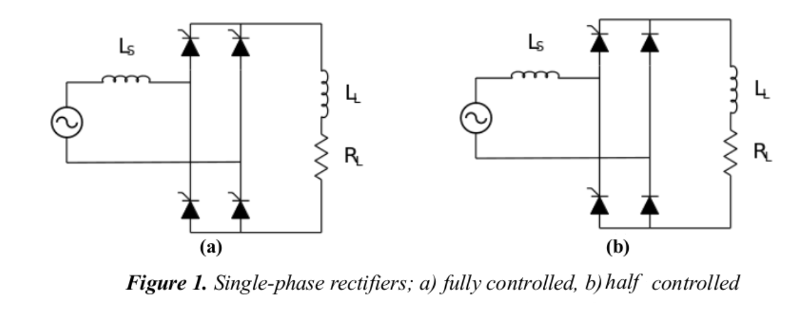

Where VSOURCE = 230V/50Hz, R = 4 Ω, LL = 150 mH, Ls = 2 mH.

1. Calculate analytically the required firing angle α which results in an average output current value of 40 A for both topologies given above, and verify your calculations with simulations (Plot Vo and its average).

# Fully Controlled:

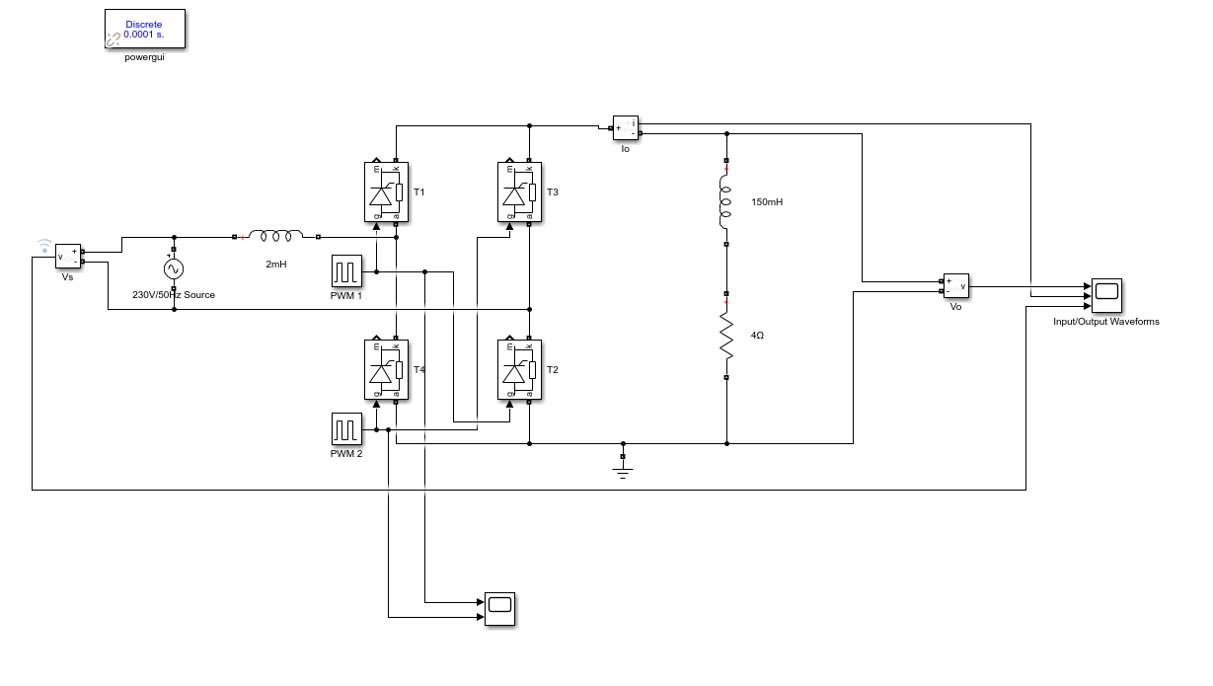

Figure 2. Fully Controlled Full Bridge Thyristor Rectifier

Here is the design of the fully controlled full-bridge rectifier with thyristor. When the firing angle (α) is 30°, the output voltage and current waveforms will be

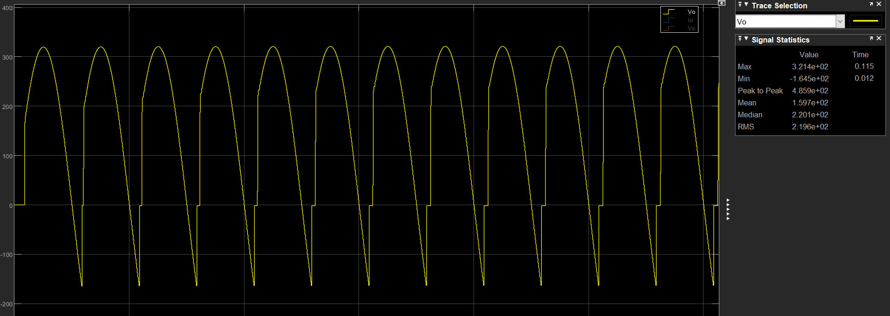

Figure 3. Output Waveform

The average value of the output waveform in the graph is 160V.

The current waveform is:

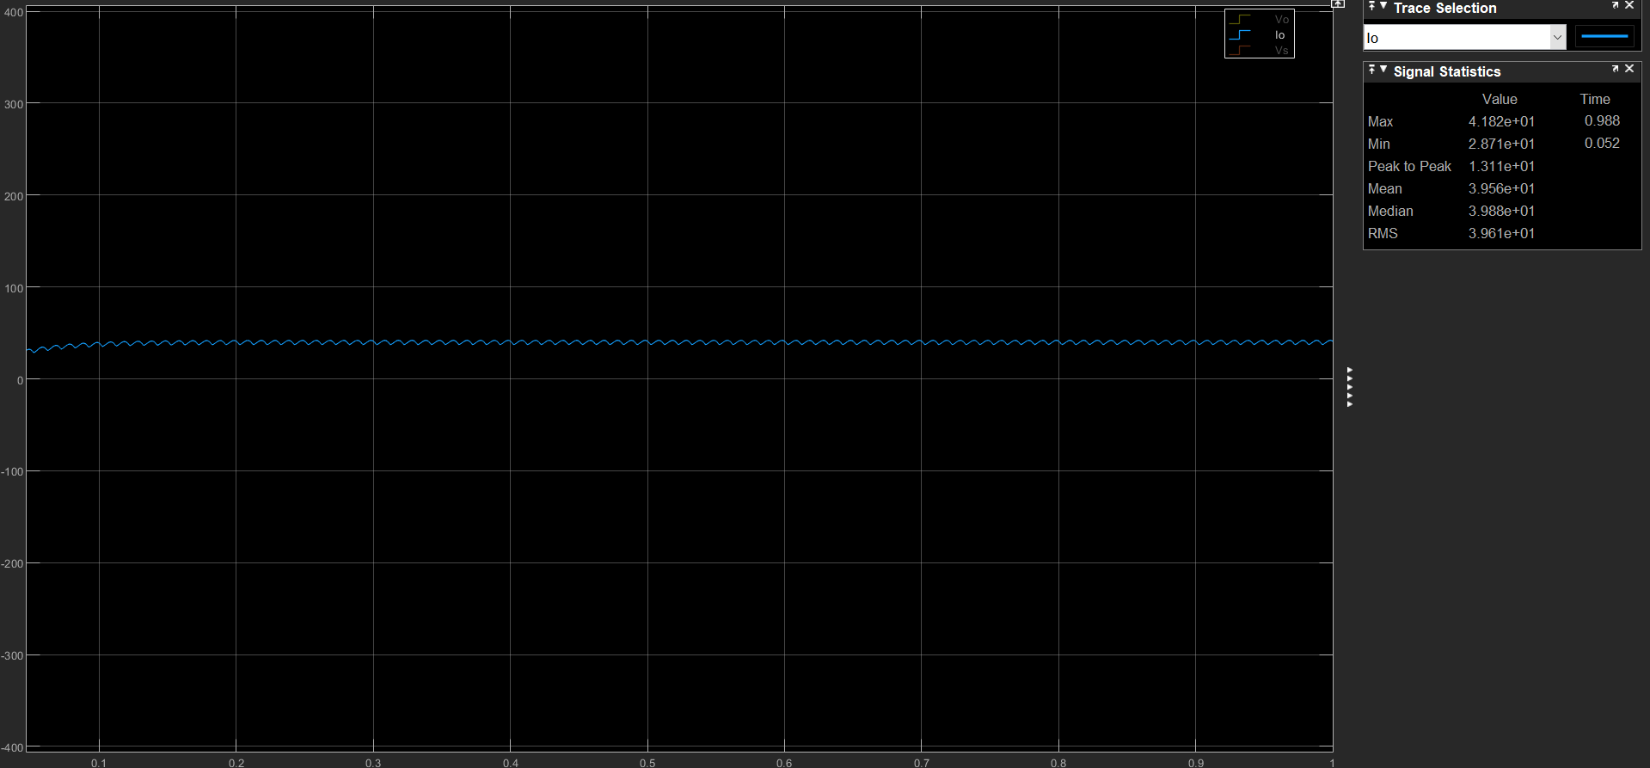

Figure 4. Current Waveform

The average current value of the waveform is 40A.

The requirements are met in the design.

The proof of the period and the firing angle (α)

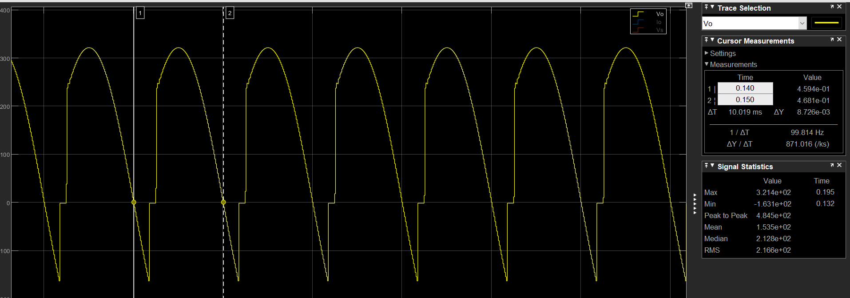

Figure 5. Period of one wave

As we see ΔT = 10ms that half of the our period 20mS (f = 50Hz, so period is 1 / f = 1 / 50 = 20ms)

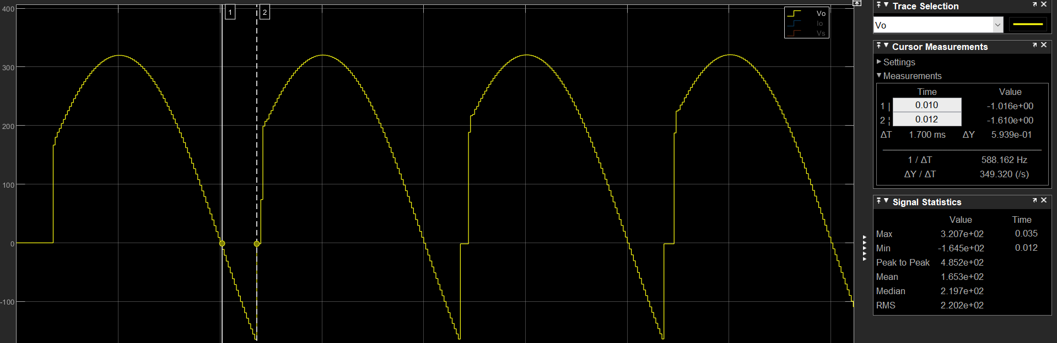

Figure 6. Firing Angle (α)

ΔT = 1.7ms

So, our waveforms prove the firing angle (= 30°

1. Let’s do analytical calculate

In the simulation,

# Half-Controlled:

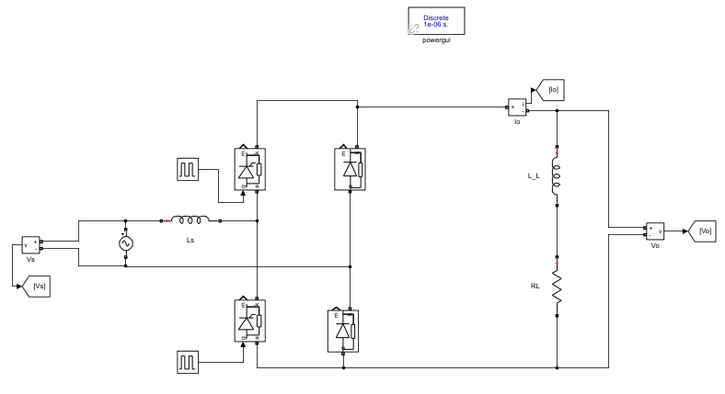

Figure 7. Half-Controlled Bridge Rectifier

1. Here is the design of half-controlled thyristor rectifier. The diodes are working like freewheeling principle in half-controlled thyristor design. Therefore, freewheeling provides no negative voltage at the output. Output will have less ripple; so overall efficiency increased. On the other hand, output voltage has to be larger than zero, so it does not have inverter mode in this design of topology.

From the previous topology which is full-controlled full bridge rectifier, firing angle (α) is found 30°. However, now the topology does not have negative voltage; therefore, efficiency is increased. That means, if 30° firing angle is fired, the output voltage & current will be larger than desired value. As follows:

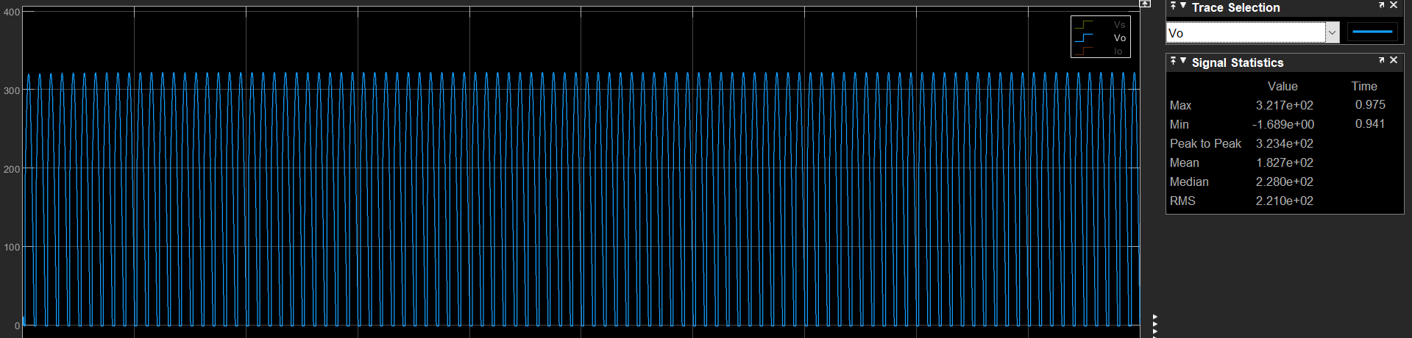

Figure 8. Output Voltage in Half-Controlled Rectifier

Our average(mean) value is around 183V.

The current value: 44A

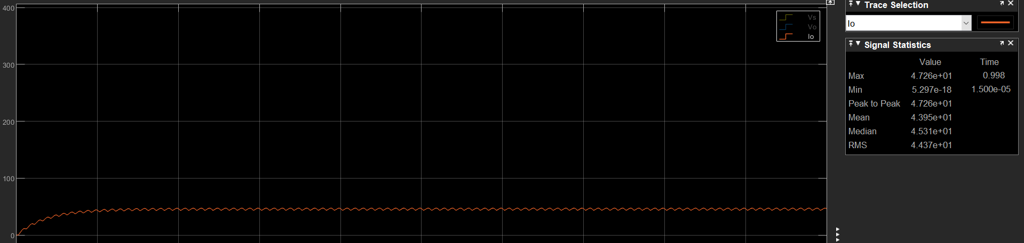

Figure 9. Current Waveform in Half-Controlled Rectifier

That means the firing angle (α) should be less than 30°.

1. Let’s do the analytical calculation

If the firing angle is 30°:

The output voltage waveform:

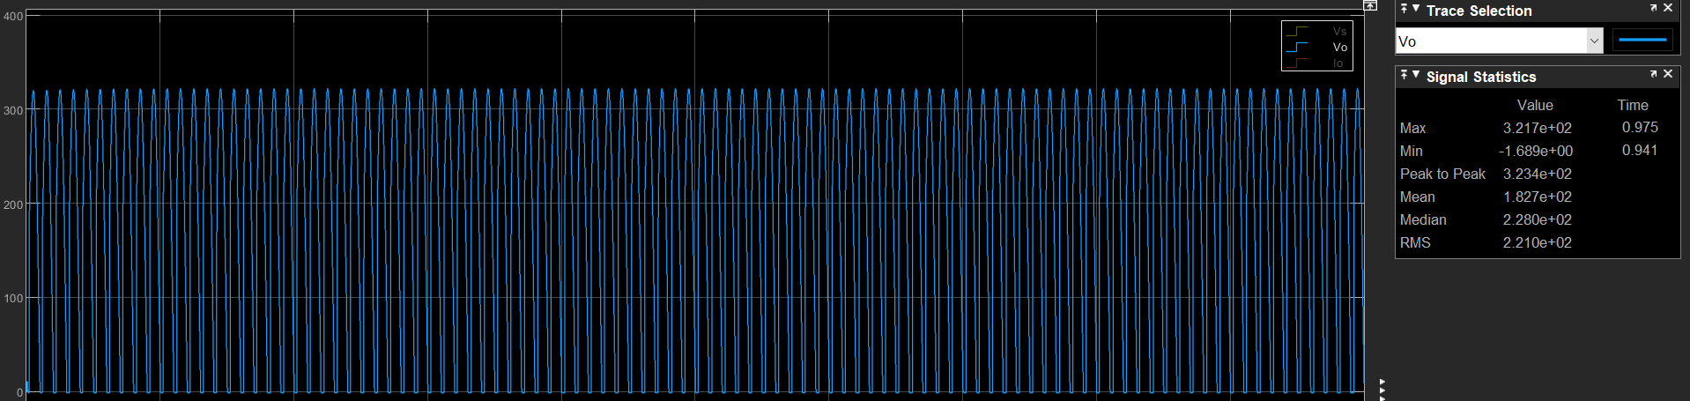

Figure 10. The Output Voltage Waveform in Half-Controlled Rectifier

Average output voltage = 182.7V.

The output current waveform:

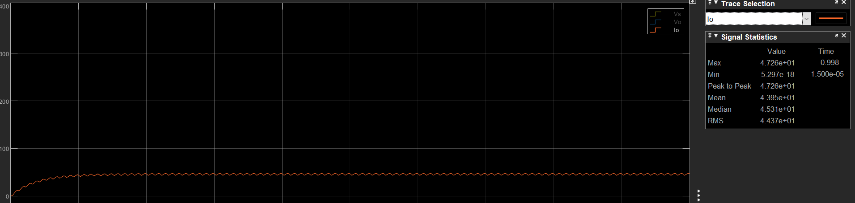

Figure 11. The Output Current Waveform in Half-Controlled Rectifier

Average output current = 43.95A.

So our reactance is around 4.15Ω

To make output current(avg) 40, the average output voltage should be around

4.15 x 40A = 166V

In analytical calculations, to make the output voltage 166, the firing angle should be 78°

Let’s apply firing angle which is found in analytical calculations to the simulation.

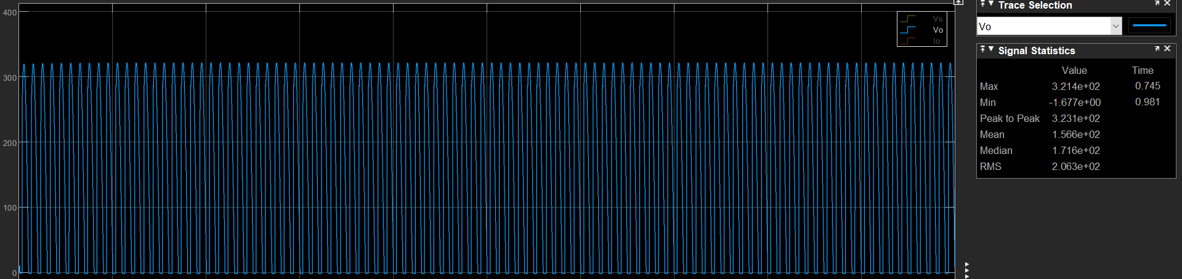

Figure 12. Output voltage vaveform when firing angle is 53°

As it can be seen on the graph, the average value of the output voltage is 156.6V. What it has been found in analytical calculation was 166V

Let’s observe the avg. output current waveform

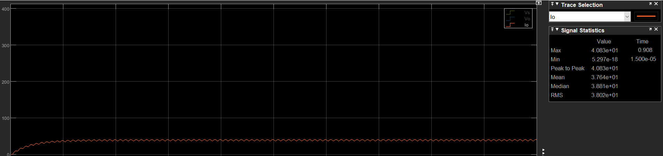

Figure 13. Output current waveform when the firing angle is 53°

Average output current is 37.64A that can be observed in the graph. However, it is not the desired value which is 40A. Therefore, we need to decrease firing angle to increase the current value to the desired value.

When the firing angle is decreased to 45°, the output current waveform will be such as

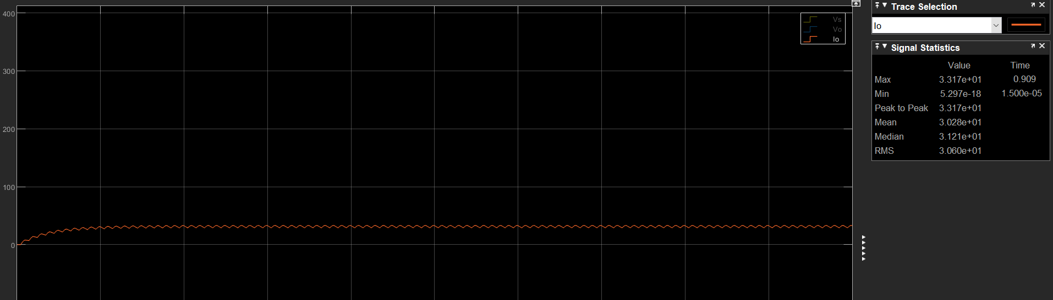

Figure 14. Output Current Waveform when the Firing Angle is 45°

Here, the desired value of the current is accomplished by setting firing angle to 45°.

1. Plot Vsource and Isource on the same graph and find the THD value of Isource for both topologies.

* Half Controlled Thyristor THD:

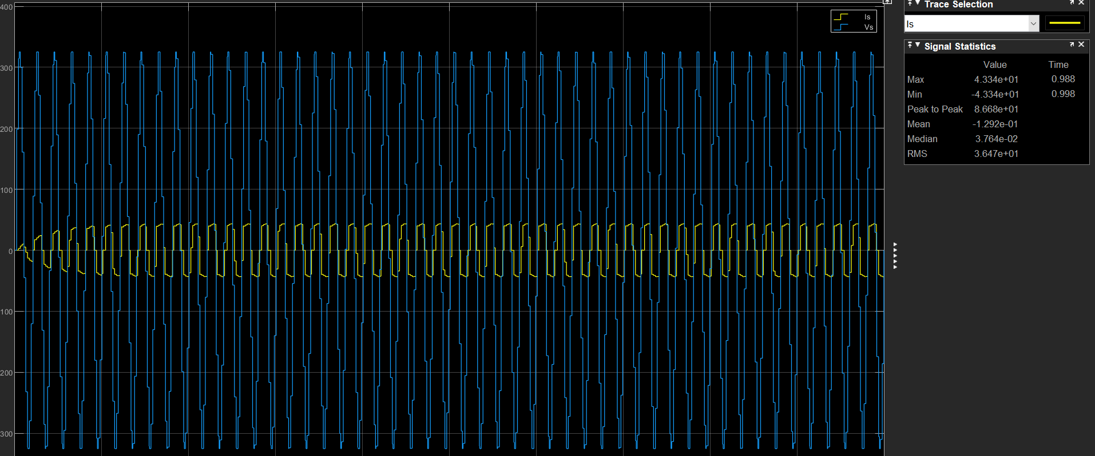

Figure 15. Input Current and Source of Half-Controlled Thyristor

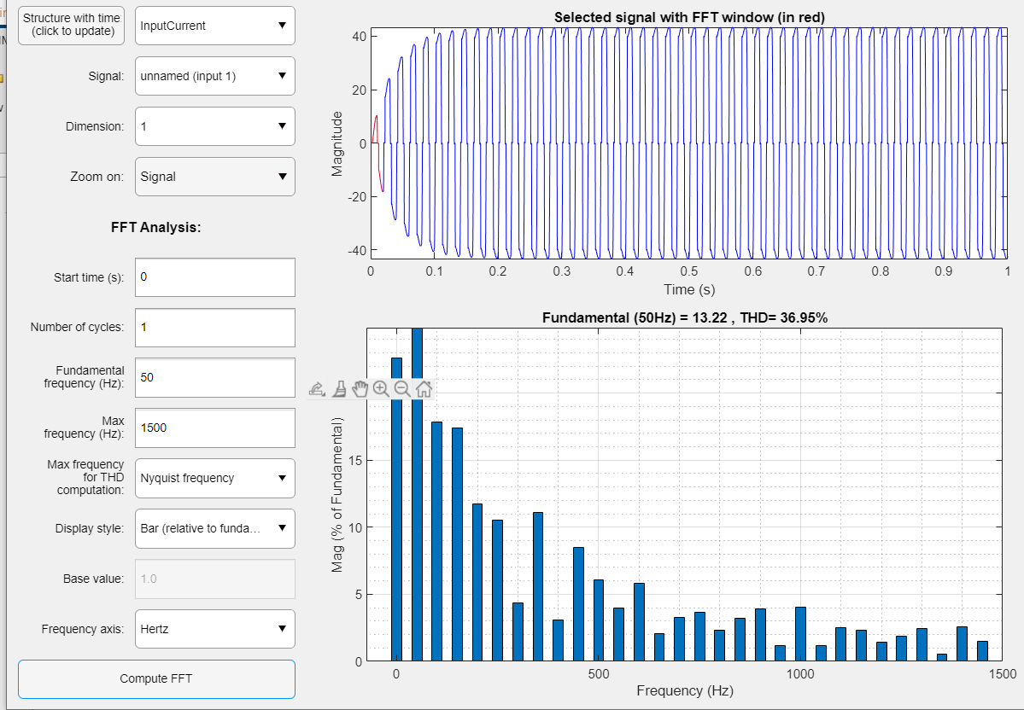

Figure 16. THD of Half-Controlled Thyristor

* Fully-Controlled Thyristor

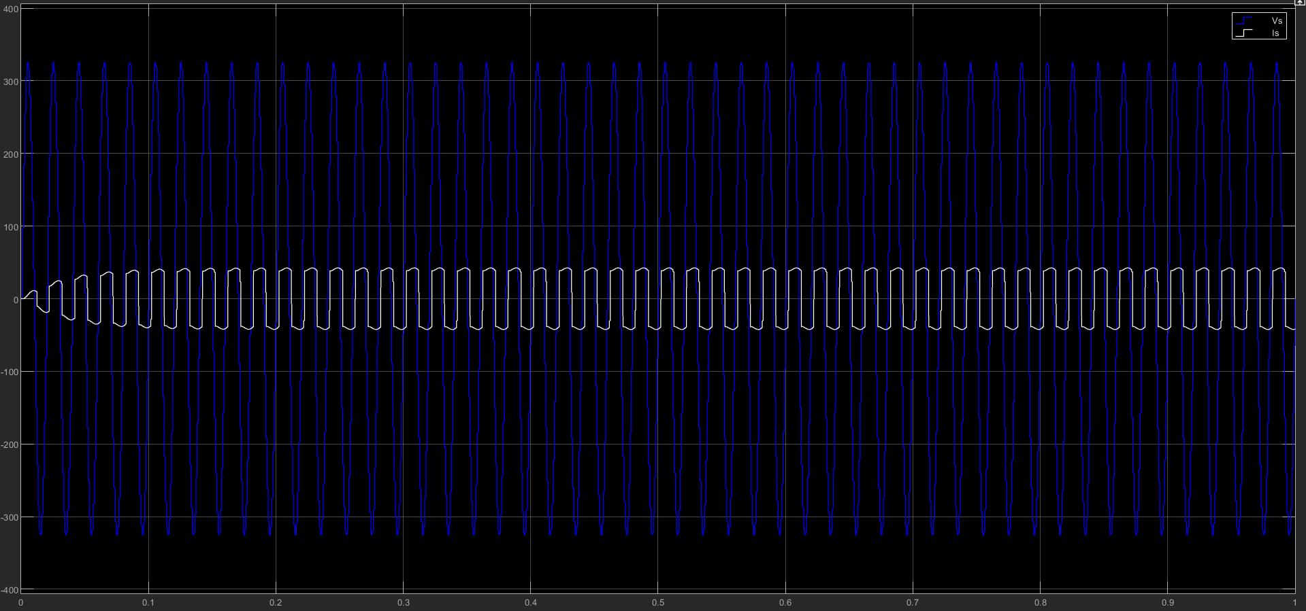

Figure 17. Input Current and Voltage of Fully-Controlled Thyristor

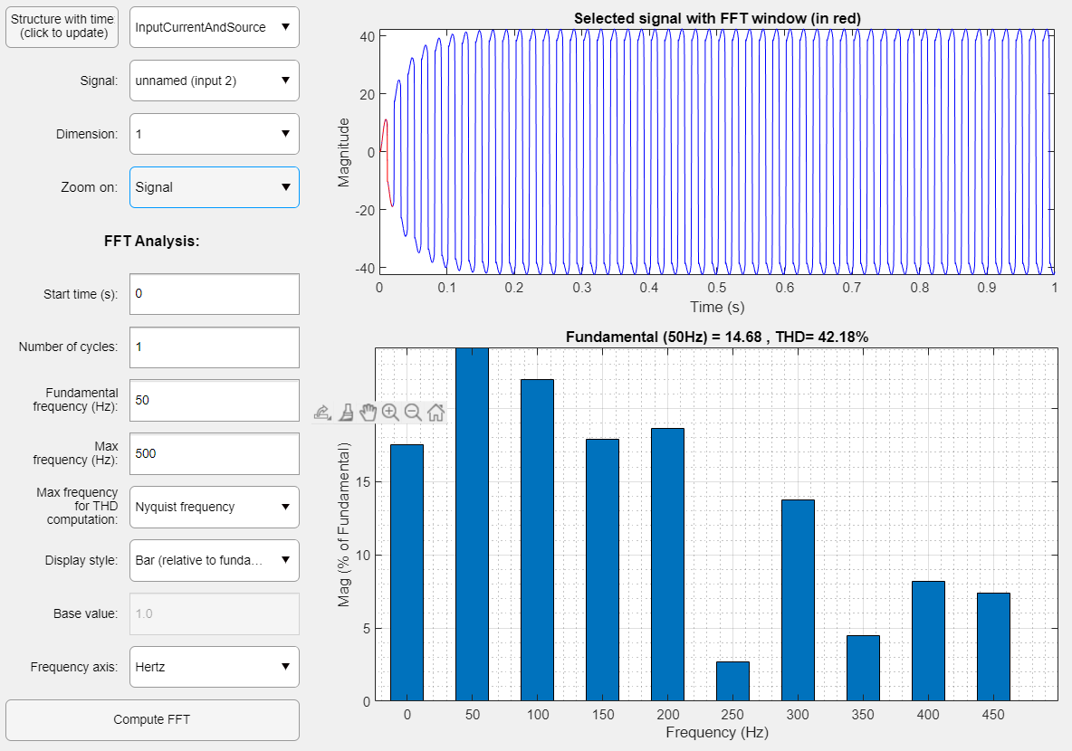

Figure 18. THD of Fully-Controlled Thyristor Rectifier

1. Compare the topologies with respect to their advantages, disadvantages and their application areas. Discuss their operational similarities and differences.

In half-controlled rectifier, we do not add freewheeling diode to eliminate negative output voltage on the output side. On the other hand, if it is required or needed to eliminate negative portion on the output voltage in fully-controlled thyristor rectifier, freewheeling diode should be added. That added diode increases the total cost.

Furthermore, THD values are %36.95 (Half-Controlled) and %42.18(Fully-Controlled). That means distortion in the input current is below the maximum value. According to IEEE 519-2014 standards for harmonics clarified that THD should be lower than 50%. (In some cases, it can exceed 50 percent for high-frequency applications.)

Why is the THD of half-controlled thyristor is lower than the THD of fully-controlled thyristor?

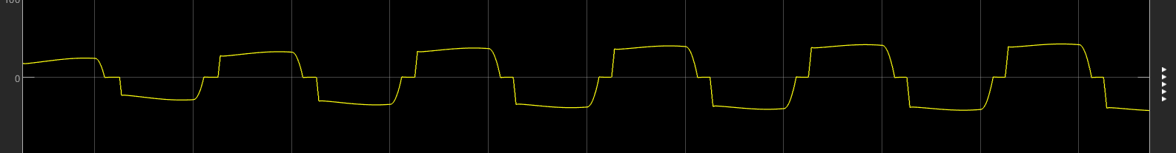

Figure 19. Input Current Waveform of Half-Controlled

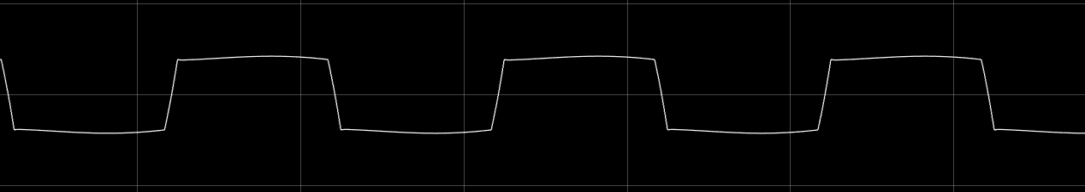

Figure 20. Input Current Waveform of Fully-Controlled

As it can be observed that the distortion on the input side on fully controlled is more. In other words, current waveform of half-controlled is more sinusoidal compared to fully-controlled. That’s why THD of fully-controlled is more than half-controlled.

Application areas: The both half & fully-controlled rectifiers are used in the same applications.

They are such as

* AC to DC power conversion: These rectifiers are often used to convert AC power to DC power for use in a variety of electronic devices, including computers, electronic appliances, and power supplies.
* Motor control: Single phase fully-controlled thyristor rectifiers can be used to control the speed and torque of AC motors, making them useful in applications such as fans, pumps, and conveyor belts.
* Battery charging: These rectifiers can be used to charge batteries in a variety of applications, including electric vehicles, portable electronic devices, and backup power systems.
* Welding: Single phase fully-controlled thyristor rectifiers are used in welding applications to provide a consistent DC power source for the welding process.
* Industrial processing: These rectifiers are used in industrial processing applications to provide a stable DC power source for a variety of equipment and processes.

1. ****Alternative Rectifier Topologies****

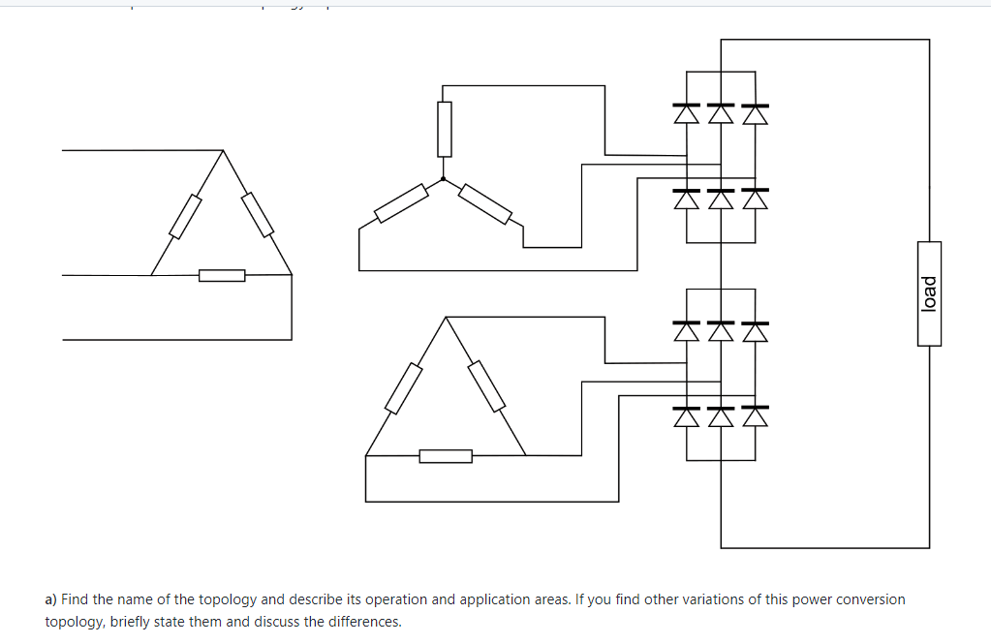

Figure 21. 12-Pulse Rectifier

1. Find the name of the topology and describe its operation and application areas. If you find other variations of this power conversion topology, briefly state them and discuss the differences.

A 12-pulse rectifier is a type of AC-DC converter that uses 12 diodes or thyristors arranged in a specific configuration to reduce the harmonic content of the output current. 12-pulse rectifiers are used in a variety of applications where the output current needs to be as pure as possible and in very high power applications, including:

* Power factor correction: 12-pulse rectifiers are often used in power factor correction systems to improve the power factor of an AC power supply.
* Motor control: These rectifiers can be used to control the speed and torque of AC motors, making them useful in applications such as fans, pumps, and conveyor belts.
* Battery charging: 12-pulse rectifiers can be used to charge batteries in a variety of applications, including electric vehicles, portable electronic devices, and backup power systems.
* Industrial processing: These rectifiers are used in industrial processing applications to provide a stable DC power source for a variety of equipment and processes.
* Welding: 12-pulse rectifiers are used in welding applications to provide a consistent DC power source for the welding process.

1. Compare this topology with the full bridge diode rectifier. (You can simulate them both for the same operating conditions such that they both produce the same average output voltage.)

* A full bridge rectifier is a type of AC-DC converter that uses four diodes or thyristors arranged in a bridge configuration to convert AC power to DC power. A 12-pulse rectifier also converts AC power to DC power, but it uses 12 diodes or thyristors arranged in a specific configuration to reduce the harmonic content of the output current.
* One key difference between a 12-pulse rectifier and a full bridge rectifier is the amount of harmonic distortion present in the output current. A full bridge rectifier produces a significant amount of harmonic distortion in the output current, while a 12-pulse rectifier has much lower levels of harmonic distortion. This makes the 12-pulse rectifier a better choice for applications where a pure DC current is required, such as power factor correction or welding.
* Another difference between these two types of rectifiers is their complexity. A 12-pulse rectifier is typically more complex than a full bridge rectifier due to the additional components required to reduce harmonic distortion. This can make 12-pulse rectifiers more expensive and more difficult to maintain than full bridge rectifiers.