Regression Error, Skewness, and XGBoost Analysis Report
AI Coverage Data - Revenue Impact Regression
Report date | June 19, 2026
Scope | Error feature extraction, skewness, percentile ranges, nonlinearity checks, diagnostic decision tree, and XGBoost interpretation
Source | Exported regression dashboard CSV files in templates/dashboard_downloads

Core reading: The baseline regression is stable, and XGBoost improves held-out R Square from 0.5170 to 0.5260. That is an absolute lift of 0.0089, or about 1.7% relative to the linear baseline. The tree layer is therefore useful for threshold interpretation, but it does not radically change model strength.

Executive Summary
Question | Answer from the analysis
Where does the baseline fail? | Mainly in extreme high-revenue cases. The largest miss is an underprediction of 108.61M.
Which variables are skewed? | Cost savings and AI investment are the high-skew predictors. Actual impact, signed error, and error percentage are also strongly right-skewed.
Is there nonlinearity? | Yes. Spearman correlations exceed Pearson correlations for every model feature, which points to monotonic nonlinear structure.
What does the tree add? | A readable threshold map: cost savings creates the main scale split, AI investment refines middle branches, and training refines selected leaves.
What does XGBoost add? | A modest held-out R Square lift and a clearer hierarchy of nonlinear feature importance.

The analysis should be read as a layered diagnostic. First, the residual/error extraction identifies where the regression misses. Second, skewness and percentile ranges explain why those misses are concentrated in the right tail. Third, correlation checks show that several predictors are monotonic but not perfectly linear. Fourth, the decision tree converts that shape into thresholds. Finally, XGBoost tests whether combining many such thresholds improves held-out accuracy.

Final key takeaway: This is a diagnostic improvement story, not a model-replacement story. XGBoost raises held-out R Square from 0.5170 to 0.5260, while the evidence still points to the same core driver hierarchy: cost savings first, AI investment second, and operational maturity variables as refinements.

1. Analysis Structure
The report follows the modeling framework in a fixed order. Error feature extraction defines the miss pattern first. Skewness and percentile ranges then define the distribution shape. Correlation nonlinearity checks whether straight-line association is enough. The decision tree and XGBoost sections finally translate that structure into thresholds and model lift.
Stage | What it checks | Why it matters
Error feature extraction | Actual impact, predicted impact, signed error, absolute error, error percentage, and error direction. | Shows whether the regression fails randomly or fails in a patterned region of the data.
Skewness and percentile ranges | P1, P10, P25, P50, P75, P90, P99, skewness, and skew direction. | Shows whether ordinary averages hide long-tail behavior.
Correlation nonlinearity | Pearson versus Spearman, plus linear/quadratic/log fit comparisons. | Shows whether low straight-line correlation misses ranked or threshold structure.
Decision tree | Single skew-aware tree with 5% node-gain stopping. | Turns nonlinear structure into explainable thresholds.
XGBoost | Tree ensemble with skew-aware inputs and split-gain enforcement. | Tests whether many threshold rules improve held-out prediction.

Final key takeaway: Read the analysis in order. Error extraction tells us where the model fails, skewness explains why those failures sit in the right tail, correlation checks justify threshold modeling, and the tree/XGBoost layer turns that structure into interpretable split rules.

2. Model Score Context
The first thing to settle is the size of the improvement. R Square measures the share of held-out target variation explained by the model; RMSE measures the typical prediction error in revenue-impact units. XGBoost is selected because it has the highest test R Square, but the gain over linear regression is small. The single decision tree is weaker on held-out fit, so it is best used as an explanation device rather than as the final predictive model.
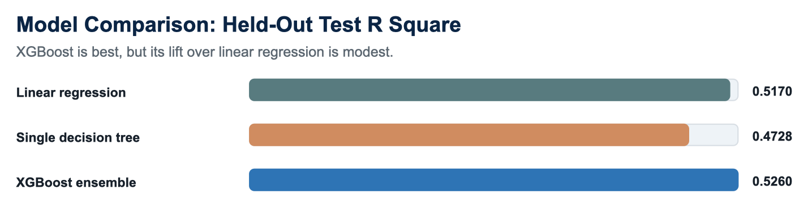
Figure 1. XGBoost has the best held-out score, but the gain over the linear baseline is modest.
Model view | Test R Square | Interpretation
Linear regression baseline | 0.5170 | Strong baseline for the main linear signal.
Single diagnostic decision tree | 0.4728 | Readable threshold model, but weaker held-out fit.
XGBoost ensemble | 0.5260 | Best held-out fit after combining nonlinear thresholds.
XGBoost gain over linear | +0.0089 | About 1.7% relative lift over the linear test R Square.

Interpretation discipline: Do not frame the tree as a major R Square breakthrough. Frame it as a nonlinear interpretation layer that gives a small predictive lift and much better threshold language.

Final key takeaway: XGBoost is the selected model because it has the best held-out score, but the lift is modest: +0.0089 R Square, about 1.7% relative to the linear baseline. Example: RMSE improves by only 26.21K, so the tree layer should be used mainly for nonlinear explanation and targeted refinement.

3. Error Feature Extraction
The error extraction defines each miss as actual revenue impact minus predicted revenue impact. Positive error means the model underpredicted; negative error means it overpredicted. The regression is conservative on the largest revenue-impact observations: the biggest misses are large underpredictions in high-investment and high-savings cases, not small noise around the fitted line.
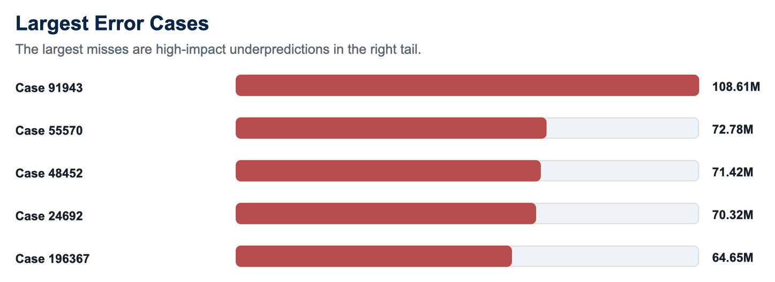
Figure 2. The largest errors are concentrated in underpredicted extreme revenue-impact cases.
Case | Actual | Predicted | Error | Direction | Profile
91943 | 123.42M | 14.81M | 108.61M | Underpredicted | investment 16.63M; savings 13.71M
55570 | 84.10M | 11.32M | 72.78M | Underpredicted | investment 14.81M; savings 9.51M
48452 | 93.13M | 21.71M | 71.42M | Underpredicted | investment 24.79M; savings 19.73M
24692 | 79.74M | 9.42M | 70.32M | Underpredicted | investment 10.88M; savings 8.49M
196367 | 76.02M | 11.37M | 64.65M | Underpredicted | investment 10.76M; savings 11.07M

The most important reading is the first row: actual revenue impact is 123.42M while the prediction is 14.81M, leaving an error of 108.61M. This is why the later skewness analysis matters. If the target and residuals have a long right tail, then a model that performs reasonably on the center of the distribution can still miss the extreme upside cases.

Final key takeaway: The largest errors are not random-looking small misses. They are high-upside underpredictions. Example: case 91943 has actual impact 123.42M, predicted impact 14.81M, and error 108.61M.

4. Skewness and Percentile Ranges
Skewness measures whether a distribution has a longer tail on one side. Positive skewness means a long right tail, where a small number of very large values pull the mean upward. Percentile ranges show where the ordinary middle sits and where the extreme tail begins. This matters before tree modeling because the tree should not interpret raw long-tail financial scale blindly.
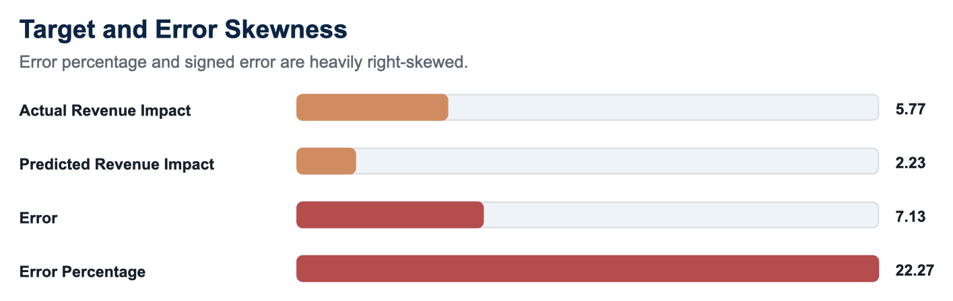
Figure 3. Error percentage and signed error are heavily right-skewed.
Parameter | Median | P99 | Max | Skewness | Reading
Actual Revenue Impact | 1.41M | 19.00M | 123.42M | 5.77 | High right tail
Predicted Revenue Impact | 1.81M | 13.27M | 43.78M | 2.23 | High right tail
Error | -57.16K | 10.40M | 108.61M | 7.13 | High right tail
Error Percentage | -4.5% | 1203.7% | 30938.8% | 22.27 | High right tail

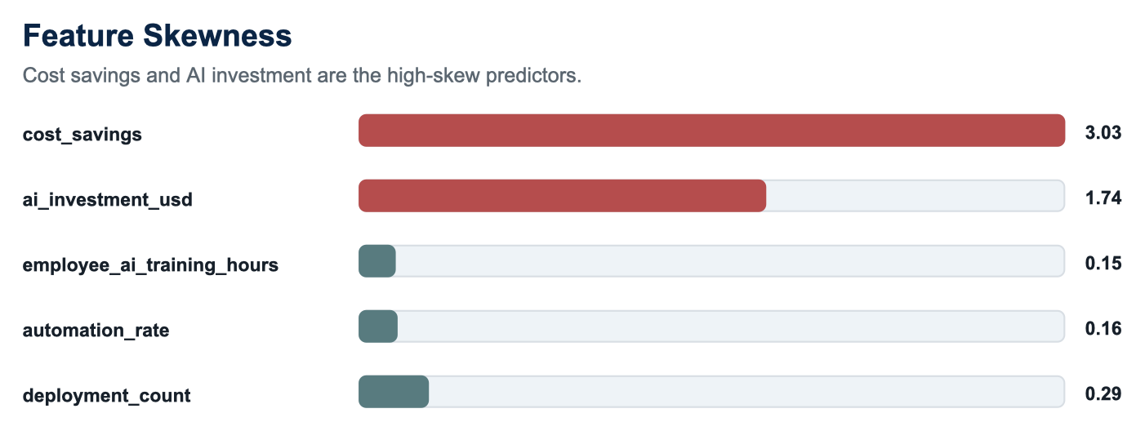
Figure 4. Cost savings and AI investment are the only high-skew model predictors.
Feature | P50 | P90 | P99 | Skewness | Tree treatment
ai_investment_usd | 4.01M | 9.68M | 17.77M | 1.74 | log1p for high right skew
automation_rate | 0.430 | 0.733 | 0.940 | 0.16 | raw; low skew
cost_savings | 1.36M | 4.93M | 11.88M | 3.03 | log1p for high right skew
employee_ai_training_hours | 75.5 | 130.9 | 166.4 | 0.15 | raw; low skew
deployment_count | 25.0 | 44.0 | 51.0 | 0.29 | raw; low skew

What this means: The percentile ranges justify the preprocessing: log-transform the financial-scale predictors, keep the operational maturity variables raw, and interpret extreme errors as a right-tail problem rather than as ordinary residual variation.

Final key takeaway: The right tail is the central data issue. Cost savings has skewness 3.03 and P99 11.88M; AI investment has skewness 1.74 and P99 17.77M. These values justify log1p treatment for financial predictors before tree modeling.

5. Correlation Nonlinearity
Pearson correlation checks straight-line movement. Spearman correlation checks ranked movement: whether higher feature ranks generally align with higher target ranks. When Spearman is higher than Pearson, the relationship is ordered but not perfectly linear. In this dataset, Spearman is higher for every model feature, so thresholds and percentile bins are useful even when a straight-line model is already strong.
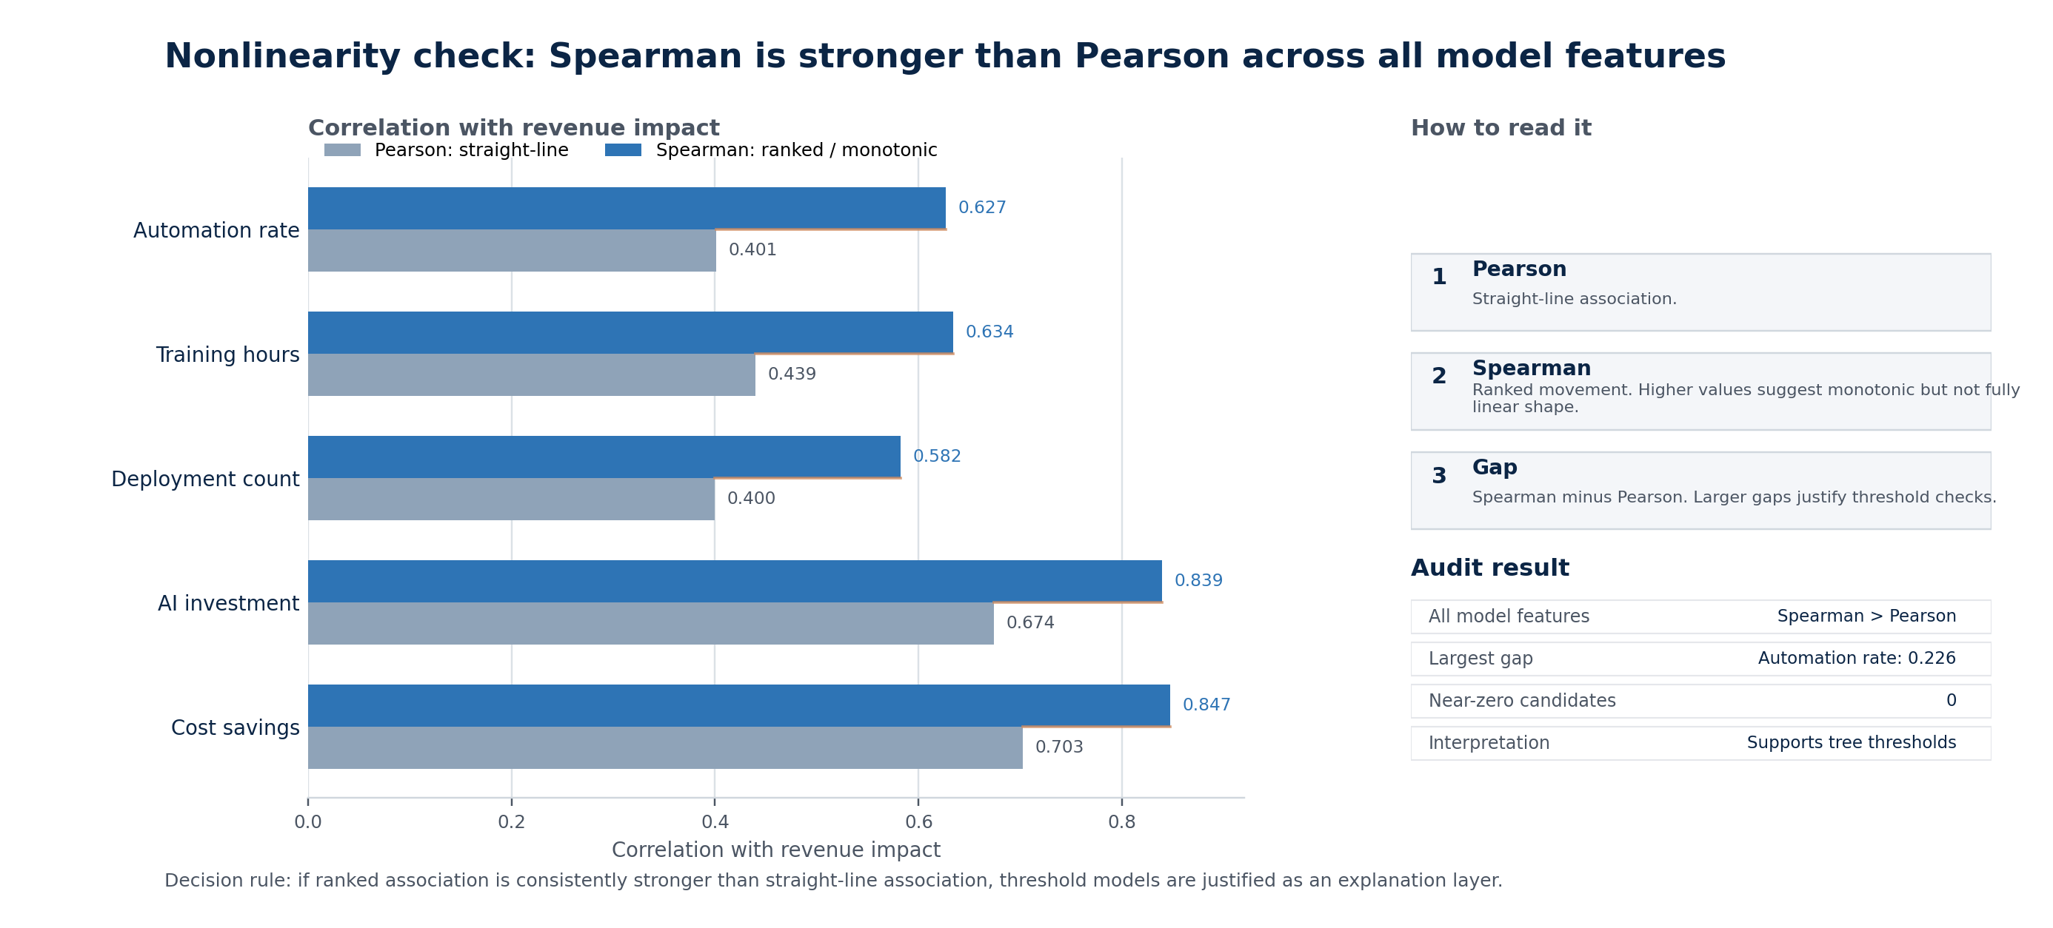
Figure 5. Spearman exceeds Pearson for every model feature, supporting nonlinear or threshold-aware modeling.
Feature | Pearson | Spearman | Gap | Best nonlinear lift | Shape
automation_rate | 0.401 | 0.627 | 0.226 | -0.0000 | monotonic nonlinear
employee_ai_training_hours | 0.439 | 0.634 | 0.194 | 0.0075 | monotonic nonlinear
deployment_count | 0.400 | 0.582 | 0.182 | 0.0012 | monotonic nonlinear
ai_investment_usd | 0.674 | 0.839 | 0.165 | 0.0027 | monotonic nonlinear
cost_savings | 0.703 | 0.847 | 0.144 | 0.0034 | monotonic nonlinear

The near-zero correlation audit does not reveal hidden model-feature relationships with zero or near-zero Pearson correlation. In the exported model-feature set, the smallest Pearson values are still around 0.40, and the pairwise near-zero nonlinearity table has no candidate rows. That does not mean future variables cannot have hidden nonlinear signal; it means this current five-feature model does not contain a near-zero-correlation feature that becomes important only after nonlinear testing.
Example: Automation rate is not near zero: Pearson is 0.401 and Spearman is 0.627. Its straight-line association is moderate, while the rank association is stronger, so it belongs in threshold and interaction checks even though it is weaker than cost savings and AI investment.

Final key takeaway: The current five model features do not hide near-zero Pearson relationships, but they do show monotonic nonlinear structure. The smallest absolute model-feature Pearson is about 0.400; the largest Spearman-Pearson gap is automation_rate at 0.226.

6. Decision Tree Thought Process
The diagnostic decision tree asks one question at a time: which split reduces the remaining target variance the most? A split is a threshold question; a leaf is the average prediction for rows that follow the full path. The root split is cost_savings <= 3.63M because it creates the strongest first separation between lower-impact and higher-impact observations. From there, the tree only continues where the next split improves node variance by more than the 5% stopping rule.
How to read it: A split is a threshold question. A leaf is the predicted revenue impact for rows that satisfy the full path. The tree stops when the next candidate split has node variance gain at or below 5%.

Readable Branch Map
All training rows: pred 2.58M
|-- cost_savings <= 3.63M: pred 1.57M
| |-- cost_savings <= 1.51M: pred 831.31K
| | |-- cost_savings <= 777K: pred 455.36K
| | | |-- cost_savings <= 247K -> leaf 162.64K
| | | |-- 247K to 777K, refined by AI investment -> 599.91K to 853.85K
| | |-- 777K to 1.51M, refined by AI investment and training -> 1.07M to 2.26M
| |-- 1.51M to 3.63M, refined by AI investment -> 2.47M to 3.91M
|-- cost_savings > 3.63M: pred 7.60M
|-- 3.63M to 6.87M -> leaf 6.02M, stop 4.0%
|-- 6.87M to 12.55M -> leaf 10.65M, stop 3.2%
|-- cost_savings > 12.55M -> leaf 16.65M, stop 2.7%

Branch | Threshold logic | Rows | Prediction | Gain / stop | Reading
Root | cost_savings <= 3.63M | 140,000 | 2.58M | gain 32.9% | Main scale split.
Low savings | cost_savings <= 1.51M | 116,444 | 1.57M | gain 31.7% | Separates very low and moderate-low value ranges.
Very low savings | cost_savings <= 247K | 13,614 | 162.64K | leaf | Lowest expected impact range.
Mid-low branch | AI investment <= 4.35M, then training around 79h | 31,045 | 1.07M to 2.26M | gain 5.2% to 8.7% | Investment and training refine the low-savings branch.
Middle savings | cost_savings 1.51M to 3.63M; AI investment split at 6.54M | 40,762 | 2.47M to 3.91M | stop 4.6% to 4.9% | Additional splits fall below the 5% rule.
High savings | cost_savings > 3.63M | 23,556 | 7.60M | gain 13.7% | High-savings cases are already high impact.
Extreme savings | cost_savings > 12.55M | 1,034 | 16.65M | stop 2.7% | Highest predicted diagnostic-tree leaf.

The repeated cost_savings splits are not a mistake. They show that the first few layers are mostly learning financial scale. AI investment appears when the tree needs to separate middle branches. Training hours appears later, where operational maturity helps refine predictions after the main financial scale has already been established.

Final key takeaway: The single tree is a readable threshold map. The root cost-savings split at 3.63M creates the main scale separation, and the highest diagnostic leaf predicts 16.65M. Treat this as explanation, not the final predictive engine.

7. Full Feature Range: Separate One-Variable Trees
The interaction tree only displays variables that win a greedy split at a specific node. That is why automation rate and deployment count may not appear in the compact tree view. They were not disregarded: each feature was also tested as its own one-variable tree, and all five features created a split. This separates two questions: whether a variable has standalone threshold value, and whether it remains the best split after stronger variables have already split the data.
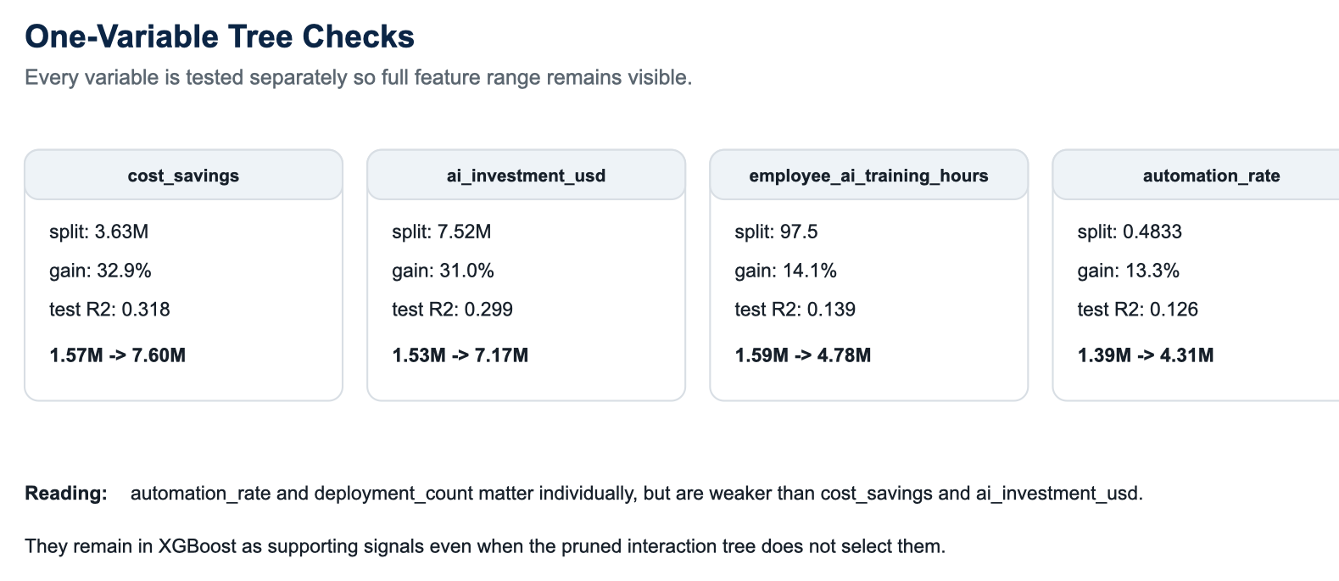
Figure 6. All five model variables have individual split value; automation and deployment are weaker, not ignored.
Variable | Split threshold | Node gain | Test R Square | Prediction shift | Reading
cost_savings | 3.63M | 32.9% | 0.318 | 1.57M to 7.60M | dominant financial scale
ai_investment_usd | 7.52M | 31.0% | 0.299 | 1.53M to 7.17M | second financial scale
employee_ai_training_hours | 97.5 | 14.1% | 0.139 | 1.59M to 4.78M | operational maturity refinement
automation_rate | 0.4833 | 13.3% | 0.126 | 1.39M to 4.31M | operational maturity refinement
deployment_count | 29.5 | 11.7% | 0.112 | 1.51M to 4.26M | operational maturity refinement

Why automation and deployment are smaller: Automation and deployment have useful individual thresholds, but their incremental gain is lower once cost savings and AI investment already explain most of the financial scale. In the ensemble they remain present as small supporting signals.

Final key takeaway: Automation and deployment were not disregarded. They simply lost priority inside the greedy interaction tree after stronger financial splits were selected. Individually, automation still splits around 0.430-0.733 scale behavior, and deployment still has a one-variable split at 29.5 deployments.

8. XGBoost Interpretation
XGBoost is the final nonlinear model because it combines many shallow threshold trees instead of relying on one diagnostic tree. Each tree adds a correction to the previous prediction. Feature importance measures how much each feature contributes to reducing ensemble error, not causal impact. The implementation uses log1p-transformed cost savings and AI investment, keeps low-skew operational variables raw, and enforces the native split-gain threshold through gamma.
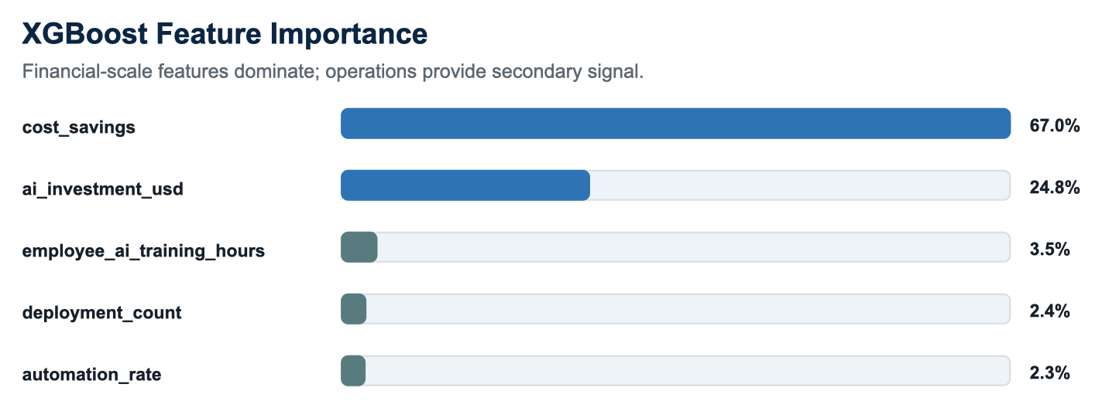
Figure 7. XGBoost confirms the hierarchy: cost savings first, AI investment second, operational variables third.
Feature | Importance | Input treatment | Skewness | Interpretation
cost_savings | 67.0% | log1p (high right skew) | 2.90 | dominant signal
ai_investment_usd | 24.8% | log1p (high right skew) | 1.68 | major secondary signal
employee_ai_training_hours | 3.5% | raw | 0.16 | supporting nonlinear signal
deployment_count | 2.4% | raw | 0.29 | supporting nonlinear signal
automation_rate | 2.3% | raw | 0.17 | supporting nonlinear signal

The importance ranking is consistent with the tree logic. Cost savings carries 67.0% of XGBoost importance, AI investment carries 24.8%, and the operational variables together contribute about 8.2%. This supports a layered interpretation: financial scale explains most variation, and operational maturity variables refine the estimate rather than replace the financial story.

Final key takeaway: XGBoost confirms the same hierarchy at ensemble scale. Cost savings contributes 67.0%, AI investment contributes 24.8%, and the three operational variables together contribute 8.2%. The audit shows 1,161 split rows and 0 below the gain threshold.

9. Combined Interpretation
Evidence type | What it says | How to use it
Coefficients | Controlled linear contribution after scaling and other predictors. | Use for baseline direction and controlled comparison, not causal claims.
Correlations | Standalone association and nonlinear rank shape. | Use to decide which features need threshold/bin analysis.
Decision tree | Readable cut points and leaf predictions. | Use for explanation of regimes, especially cost-savings thresholds.
XGBoost importance | How often and how strongly features reduce ensemble error. | Use for final nonlinear feature hierarchy.

The apparent tension around automation rate is a good example. Its Pearson correlation with revenue impact is positive, but its controlled linear coefficient is negative. That should not be read causally. It means automation tends to move with revenue impact in isolation, but after controlling for investment, savings, deployment, and training, the remaining linear contribution is negative. XGBoost still gives automation a small positive importance because thresholds and interactions remain useful.
Main conclusion: Revenue impact is primarily a financial-scale outcome in this dataset. Cost savings and AI investment dominate the predictive structure. Training, automation, and deployment count are meaningful operational maturity signals, but they mainly refine the financial-scale story.

Final key takeaway: Use each evidence type for its proper job. Coefficients explain controlled linear direction, correlations explain standalone association, the single tree explains thresholds, and XGBoost explains final nonlinear hierarchy. Example: automation can have positive standalone association but small controlled/ensemble contribution.

10. Guideline for Further Analysis
The current framework is strong enough for descriptive interpretation and model diagnostics. Further analysis should focus on explaining the small number of high-impact misses and making the nonlinear thresholds easier to communicate.
Next analysis | Question answered | Priority | Expected value
SHAP values | Which features drive each XGBoost prediction? | High | Best next step for interpretability and case-level explanations.
Percentile-bin analysis | How does revenue impact change across P0-P25, P25-P50, P50-P75, P75-P90, and P90-P99? | High | Best next step for communicating skewness without overcomplicating the model.
Partial dependence | Do cost savings and AI investment show diminishing returns or threshold jumps? | Medium-high | Validates whether the monotonic nonlinear shape is smooth or regime-based.
Interaction checks | Do investment x training, cost savings x automation, or deployment x automation matter? | Medium | Clarifies why operational variables help only after financial scale is known.
Top 1% residual study | What do the largest underpredicted cases have in common? | High | Best next step for improving extreme-upside performance.
Causal design | Do the features cause revenue impact? | Separate project | Required before making causal claims.

A practical next step would be to run SHAP and percentile-bin analysis first. Those two additions would answer the highest-value interpretation questions without changing the model: why individual cases receive their predictions, and how the target behaves across the tails of each feature distribution.

Final key takeaway: The next best analysis is not another broad model comparison. It is case-level explanation of the right tail. Start with SHAP values, percentile-bin plots, and a top-1% residual review to explain why the largest underpredictions remain difficult.

Slide-Ready Explanation Notes
Use these short notes as presenter text or slide speaker notes. Keep the slide itself visual; use these lines to explain what the figure is showing.
Model score slide: The point is not that XGBoost completely replaces linear regression. The point is that it adds a small nonlinear lift while keeping the same main story: cost savings and AI investment explain most revenue-impact variation.
Error and skewness slide: The model misses are concentrated in right-tail cases. Most observations sit near the center, but a small number of extreme revenue-impact cases drive the largest underpredictions.
Correlation slide: Spearman being higher than Pearson means the variables move with revenue impact in an ordered way, but not as a straight line. That is why thresholds and percentile ranges are useful.
Decision tree slide: Present the tree as a threshold explanation, not as the final predictive model. Start with the root split: cost_savings <= 3.63M separates ordinary from high-impact cases, then AI investment and training refine selected branches.
XGBoost slide: XGBoost confirms the hierarchy rather than creating a new one. Cost savings dominates, AI investment is second, and automation, deployment, and training act as smaller operational refinements.

Final key takeaway: Slides should stay visual and selective. Use one message per slide: model lift is small, errors are right-tail underpredictions, correlations are monotonic nonlinear, the decision tree gives thresholds, and XGBoost confirms the feature hierarchy.

Appendix: Implementation Notes
Parameter | Implemented reading
Skewness before feature extraction | Error fields and model features are summarized with percentile ranges and skewness strength. High-skew financial predictors use log1p in tree inputs.
XGBoost import | The model selection export identifies XGBoost Tree Ensemble as the final selected model.
Decision tree around regression data and skewness | The diagnostic tree uses skew-aware features and exposes thresholds in original units for interpretation.
5% leaf stop rule | The single tree stops when node variance gain is at or below 5%; XGBoost enforces minimum split loss with gamma.
Near-zero correlation nonlinearity | No model-feature near-zero Pearson signals are present in the current exported set; the audit remains useful for future variables.

Final key takeaway: The requested framework is implemented as a diagnostic pipeline: skewness and percentile extraction, skew-aware tree inputs, XGBoost with gamma split enforcement, and nonlinear correlation checks. The remaining gap is deeper case-level explanation, not basic implementation.

