MARCUS DALY CRITERIUM
Downtown, Hamilton, Montana

Sunday, August 8th 2004

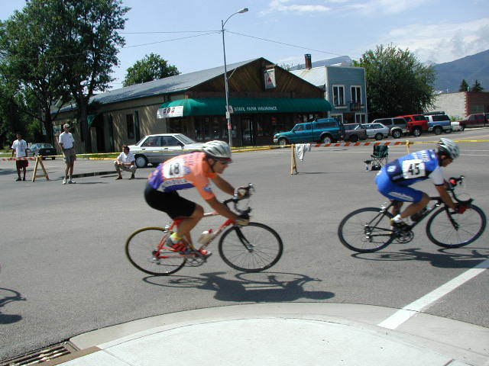

Registration – 8-9:30 am at Start / Finish Line on Main Street
Start- Mens 4,5 9:30 am (45 minutes plus two laps)
Vets,Juniors, Women 10:30 (35 minutes plus two laps)
Men 1,2,3 11:15 (55 minutes plus two laps)
Entry Fee- $ 15 all classes (Juniors $ 5)
Course Description- Flat and Fast course with 6 corners
Prize Purse- $ 250

Contact Info- - Valley Bike and Ski-- 406-363-4428, www.montanacycling.org

This race is USCF Sanctioned and is a Montana Bicycle Racing Association Road Series Event.

