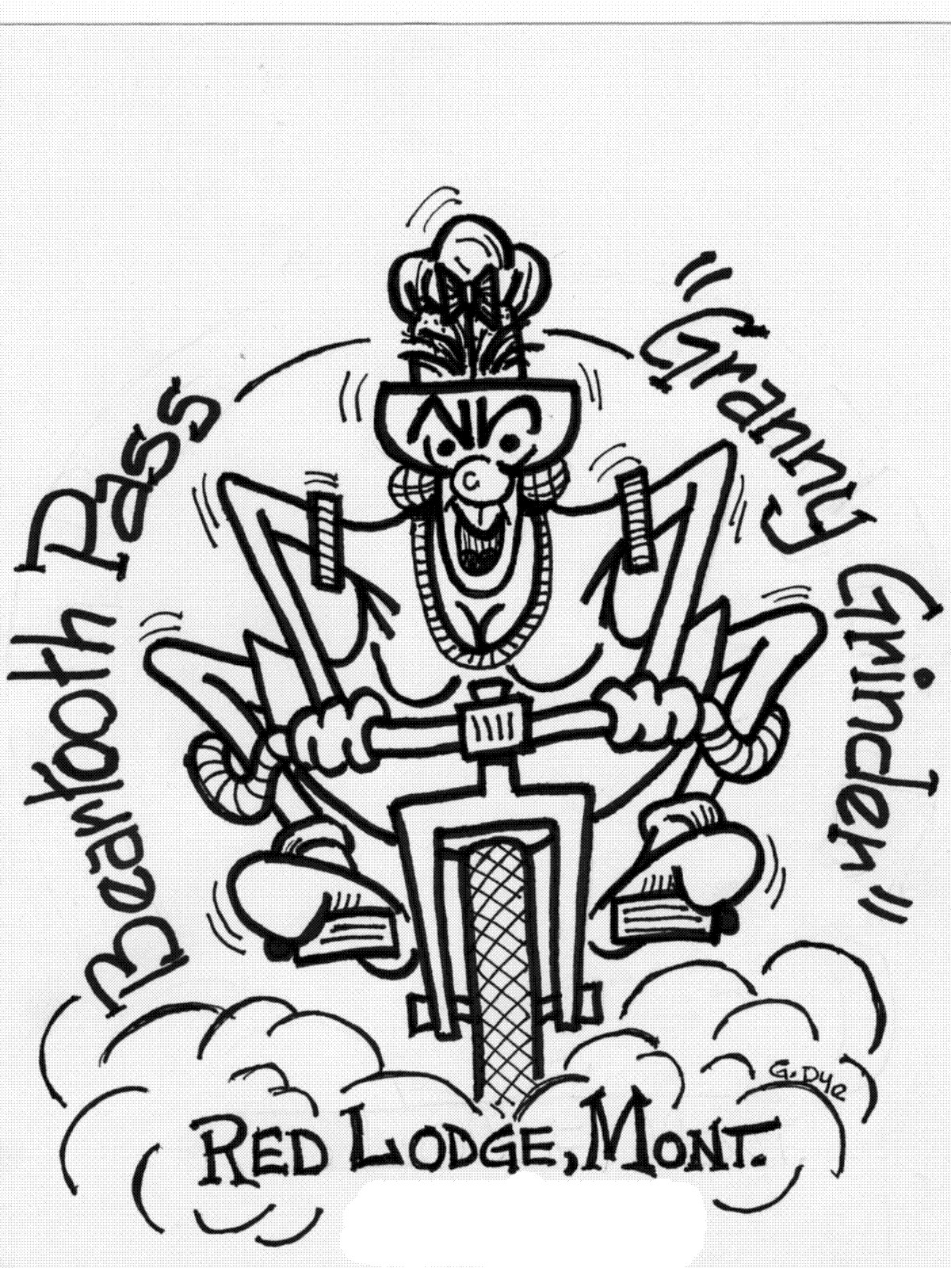

SEPTEMBER 9TH, 2006
RED LODGE, MT.

MONTANA HILL CLIMB CHAMPIONSHIP.

TIME TRIAL UP THE SCENIC

BEARTOOTH HIGHWAY.

NATIONAL FOREST BOUNDARY TO THE EAST SUMMIT.
REGISTRATION 8:00 – 9:00 am AT THE START.
ENTRY FEE: $35, INCLUDES T-SHIRT.
POST RACE PIZZA FEED $5.00 PER ADULT, KIDS UNDER 12 $3.00 .

FOR MORE INFORMATION PLEASE CALL HEIDI OR JOHN AT HELLROARING BIKERY (406) 446-0225

