

**Tag World Exchange Limited**

Presents

**THE TWAL Hardware Wallet**

(Whitepaper 2018)

# Business Overview

Tag World Exchange Ltd. /TWEX is a crowd-lending platform that enables investors to invest their funds through smart contracts.

TAG World Exchange Ltd. is a company incorporated as on 25th July 2017 in the United Kingdom with registered number 10881833. The company’s registered office is situated at 71- 75 Shelton Street Covent Garden, London, WC2H 9JQ, United Kingdom and falls under the jurisdiction of England and Wales.

Tag World Exchange Ltd. (TWEX) is a platform that allows anyone to buy and sell TWAL tokens or preferred shares and Smart Contracts for Capital repayment (SCC) and Smart Contracts for Profit Participation (SPP) in each company traded on the Platform. It also provides a wide range of services, which offers learning and informational environment about products, and lives of companies as well as more information about the people behind the products and companies. We at Tag World Exchange (“TWEX”) have set our main goal as creating a unique ecosystem that will enable its users to buy, sell and/or trade their investments when they need it or wish it in a safe way.

TWEX is seeking funds to the tune of 350,000 Euros to build the worlds' first innovative hardware wallet solution that would focus on the latest security bio-metric technology. It is based on cognitive algorithm that couple facial recognition, thumbprint recognition and cryptography. Moreover, a smart card will be implemented to store private keys and prevent any theft of customer’s data keys.

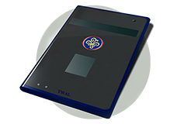**There are 4 parts to the device:**

1. Fingerprint scan plate

2. Face scan with camera

3. Display to show the status of a transaction/scan

4. Charging point to charge device.

**What is a Secured Hardware-Wallet?**

A hardware wallet is essentially a software program which stores cryptographic keys and interacts with BLOCKCHAIN for users sending and receiving crypto-currencies as well as checking their balances. Unlike a traditional wallet in your pocket, a crypto-currency wallet, doesn’t store currency, but instead stores all the private keys associated with the generated wallet addresses. Those private keys are utilized to unlock the funds in your wallet and sign off ownership.

A hardware wallet is a special type of wallet which stores the users private keys in a secure hardware device. The hardware creates an isolated environment which keeps your private keys safe on a secure chip. This is an important feature because you use private keys to sign your transactions as well as to recover your address. These hardware wallets are also considered cold wallets because they isolate your private keys even when they are connected to the internet. They have major advantages over standard software wallets. Hardware wallets are immune to computer viruses that steal from software wallets. The private keys are stored in a protected area of a microcontroller, and cannot be transferred out of the device in plaintext.

To date there have been no incidents of data stolen from hardware wallets. Hardware wallets are relatively new, but at least for the time being they have maintained a good track record, unlike the numerous incidents of theft from Internet-connected computers.

# The Offering

**3,500,000 TWAL Tokens+ Tokenized Preferred Shares (TPS) for sale at 0.10 € to raise 350,000 €**

The TWAL Tokens are utility tokens. TWEX Ltd. Offers to issue 3,500,000 TWAL Tokens + TPS at 0.10 Euros each. The amount to be raised being 350,000 Euros in total. One TWAL Token= One Tokenized Preferred Share.

**Note:** Out of the 3,500,000 TWAL Tokens: 560,000 TWAL Tokens are reserved for internal management and staff i.e. 56000 Euros worth of Tokens. Thus, a total of 2,940,000 TWAL Tokens are to be offered for investors.

**At the rate of 0.10 Euro investors shall receive 1 TWAL Token + 1 TPS**

## The TWAL Tokens

The TWAL Tokens are software products (digital resources), created by the website owner as a proof of membership of the holders in the TWEX ecosystem. Powered by the Ethereum network the TWAL Tokens issued are not considered as security tokens, but instead, as Utility Tokens as they solely give access to the company’s product or service, i.e. have a practical use. This helps to create liquidity for private investments using laws of supply and demand coupled with intelligent high benefits-oriented pricing.

The company’s TWAL Tokens are not and shall not be considered as securities as there are no monetary rights attached to them.

Utility Tokens have a use case and are not designed as investments, but that doesn’t mean that they don’t bring any profit. They have a certain use case inside the project and don’t represent company’s share. Utility tokens may grow in price, if the demand for service or product increases. So buying such tokens of a project, that solves real problems of users and is constantly being developed and improved, may give great profit in future. Issuing security tokens according to the regulations is easier and cheaper for the project than launching Token sale offering utility tokens — it reduces legal risk. But classified as security tokens are regulated, and thus limited on who can invest in them and how they can be traded. As a result, liquidity of such tokens is extremely reduced. Trading is greatly limited for security tokens — they cannot be traded freely. This restriction may destroy the effects of networking and prevent the development of the platform.

**Non-financial nature of TWAL tokens**

Being merely the virtual fuel for the running of the Offering, by nature TWAL Tokens are NOT and shall in NO case be understood, deemed, interpreted or construed as:

* any kind of currency or money, whether fiat or not
* any commercial paper or negotiable instrument
* any form of investment contract between the relevant holder and any other person
* any commodity or asset that any person is obliged to redeem or purchase
* any traditional securities or other forms of securities

## Tokenized Preferred Shares (TPS)

The Tokenized Preference Shares issued are registered on the BLOCKCHAIN, holding no equity rights or voting rights. But holding profit participation rights. The TPS or the Tokenized Preferred Shares are preferred shares issued by the company - only difference we are registering it on the block-chain with its inherent payment structure. As there is no equity involved we do not have to register with anybody except within the companies’ charter ratified by its Board. Similar to usual Preferred Shares, the TPS holders too are entitled to receive their claims prior to the equity shareholders of the organization during the winding up of the company. They are ranked as senior and priority debts. Please note that the TPS is in no way impacted by non-payments of individual loans as each company trading on the Exchange and benefitting from the initial investment issues its own engagement to pay directly in favour of holders.

# Smart Contracts

A Smart Contract serves a very similar function as a contract does in the real world. Contracts, in typical cases, involve two or more parties that agree on certain terms, sign the contract, and once these terms have been carried out and both parties are content, the contract is deemed fulfilled. Smart contracts employ the same principle but are able to operate automatically via an algorithm that has the terms of the contract embedded within it. The Smart contract — is a piece of code that is stored in the BLOCKCHAIN network (on each participant database). It defines the conditions to which all parties using contract agrees. So if required conditions are met certain actions are executed. As the smart contract will be stored on every computer in the network, all the computers (miners) executing the code must come to the same result and reach a consensus. This way the users can be sure, that the outcome is correct.

The smart contract design, to be traded via the TWAL Hardware Wallet, follows a very modular contract structure making it easy to split functionalities to upgrade or reuse parts. The current implementation consists of over two main smart contracts describing all the process for investment, payments, period, capital and reimbursement between stakeholders. All of them will be written in Solidity Language. Each contract will be independently traded on the TWEX platform and available for purchase and sale based on owner’s timetable. Valuation of the smart contracts is based on an in-house algorithm developed by our team that incorporates Probability, Statistics, Net Present Value, Market Interest rates in Euros and Audits of companies issuing the targeted contract. Then irrespective of same, owner of the individual contract can independently price his or her contract based on the urgency to sell.

# Features

The TWEX hardware wallet is a solution which will identify the user in the secure way of having dual verification process of facial reorganization and finger print reorganization and indicate the same via Bluetooth

The proposed device is a security device to identify the user for enabling them to use the mobile wallet/ any other secure transaction. The device includes the following,

* Fingerprint sensor
* 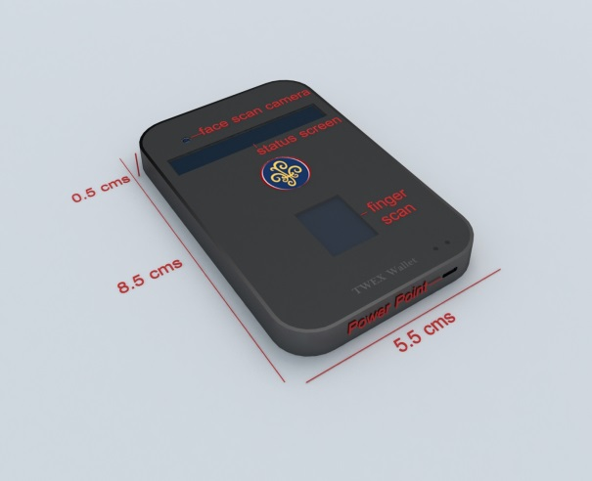Camera Interface for the face reorganization, verification & authentication
* BT for communicating with the phone
* LCD interface on the device for the status indication
* USB interface to connect to PC and record the fingerprint and face reference , battery
* Charging ( back up of the battery we can specify)
* All the authentication should be done on the device
* The device will verify the finger recognize the fingers first and then the face.
* Once both the reorganization is completed, it will need to send the unique ID to the phone

# Project Plan

The TWEX Hardware Wallet will be also offered to other Platforms, Banks, etc. on Lease around the World in a decentralized way that ensures a total protection of local data.

The TWEX Hardware Wallet is design to ensure a total protection of investor data and virtual transactions. The TWEX Hardware Wallet provides the latest security biometric technology; it is based on cognitive algorithm that is coupled with facial recognition and thumbprint recognition. Moreover, a smartcard will be implemented to store private keys and prevent any theft of customer’s data keys.

**There are several advantages to hardware wallets:**

1. Private keys are never exposed to your computer.

2. Your hardware requires you to confirm a transaction on your device (not the app on your computer) before any coins can be spent.

3. Most hardware’s are encrypted with pin #’s, like your debit card, which adds another layer security.

4. The hardware company’s software is usually open source which allows users to validate the entire operation of the device.

5. Hardware wallets can host multiple virtual currencies.

# Contact Information

**Address:** 71-75 , Shelton Street , Covent Garden ,

London, WC2H 9JQ,

United Kingdom

**E-mail:** [info@twal.ch](mailto:info@twal.ch)

**Phone:** +44 2030514822

+44 2030514822