BINARY TREE
100. Same Tree

Given the roots of two binary trees p and q, write a function to check if they are the same or not.
Two binary trees are considered the same if they are structurally identical, and the nodes have the same value.
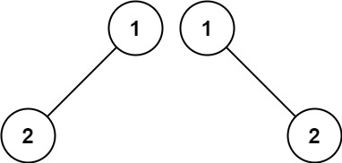
Input: p = [1,2], q = [1,null,2]
Output: false

104. Maximum Depth of Binary Tree

Given the root of a binary tree, return its maximum depth.
A binary tree's maximum depth is the number of nodes along the longest path from the root node down to the farthest leaf node.
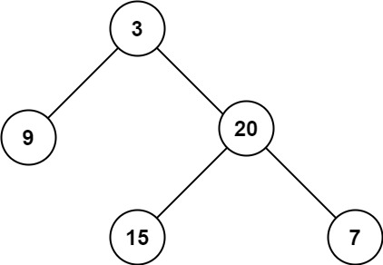
Input: root = [3,9,20,null,null,15,7]
Output: 3

101. Symmetric Tree

Given the root of a binary tree, check whether it is a mirror of itself (i.e., symmetric around its center).

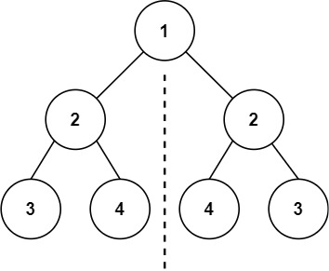
Input: root = [1,2,2,3,4,4,3]
Output: true

226. Invert Binary Tree

Given the root of a binary tree, invert the tree, and return its root.
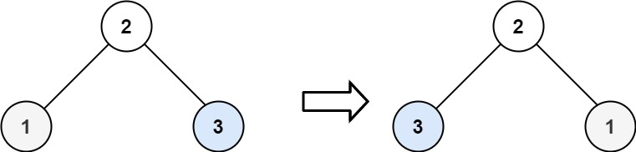

Input: root = [2,1,3]
Output: [2,3,1]

404. Sum of Left Leaves

Given the root of a binary tree, return the sum of all left leaves.
A leaf is a node with no children. A left leaf is a leaf that is the left child of another node.
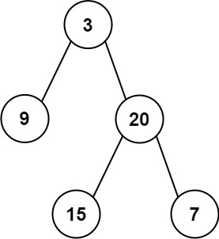
Input: root = [3,9,20,null,null,15,7]
Output: 24
Explanation: There are two left leaves in the binary tree, with values 9 and 15 respectively.

617. Merge Two Binary Trees
You are given two binary trees root1 and root2.
Imagine that when you put one of them to cover the other, some nodes of the two trees are overlapped while the others are not. You need to merge the two trees into a new binary tree. The merge rule is that if two nodes overlap, then sum node values up as the new value of the merged node. Otherwise, the NOT null node will be used as the node of the new tree.
Return the merged tree.
Note: The merging process must start from the root nodes of both trees.

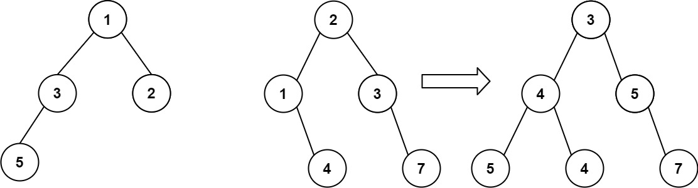
Input: root1 = [1,3,2,5], root2 = [2,1,3,null,4,null,7]
Output: [3,4,5,5,4,null,7]

