1)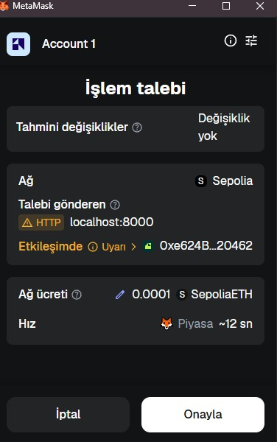
METAMASK CONFIRMATION SCREEN
2)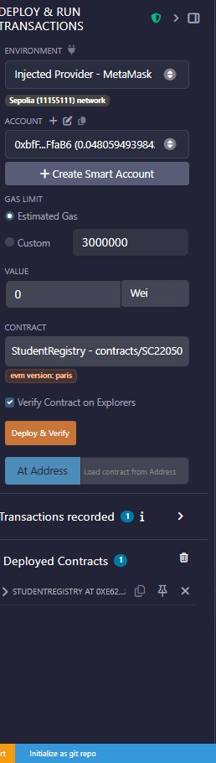
DEPLOYED CONTRACTS
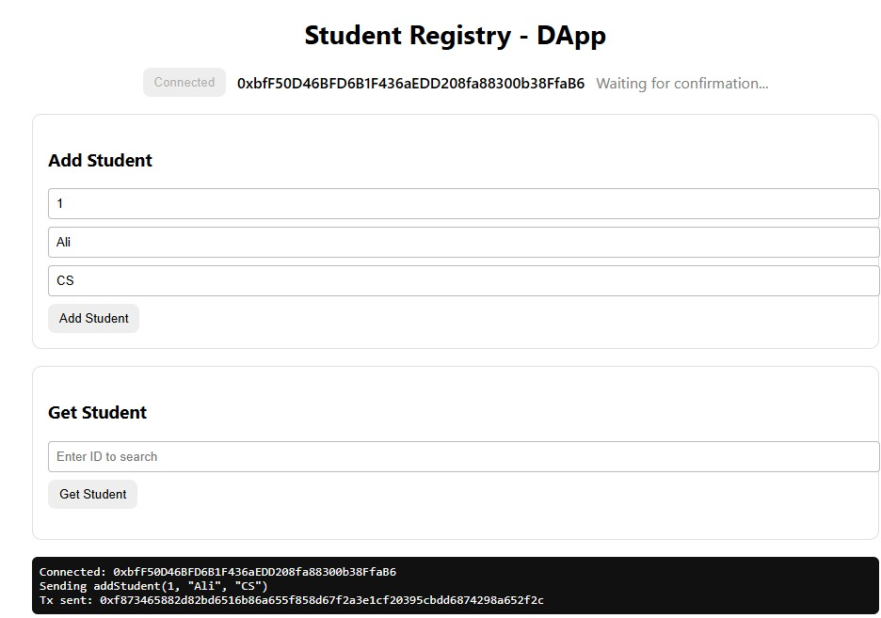
3)CONNECTION SCREEN

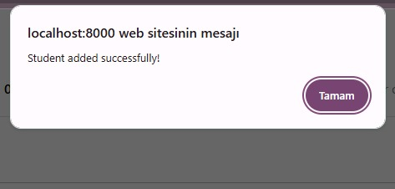4)ADDING STUDENTS 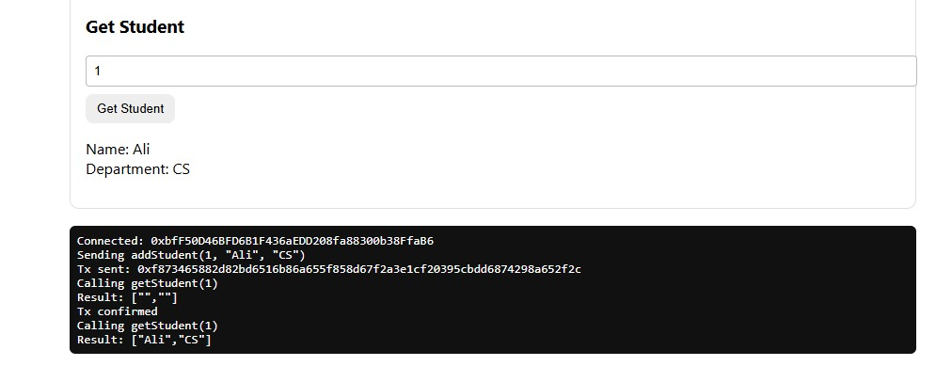 5)STUDENT LISTING
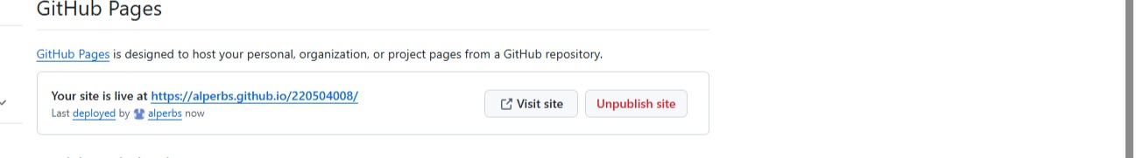

6)GITHUB

