PERSONAL INFORMATION | Alperen Kara
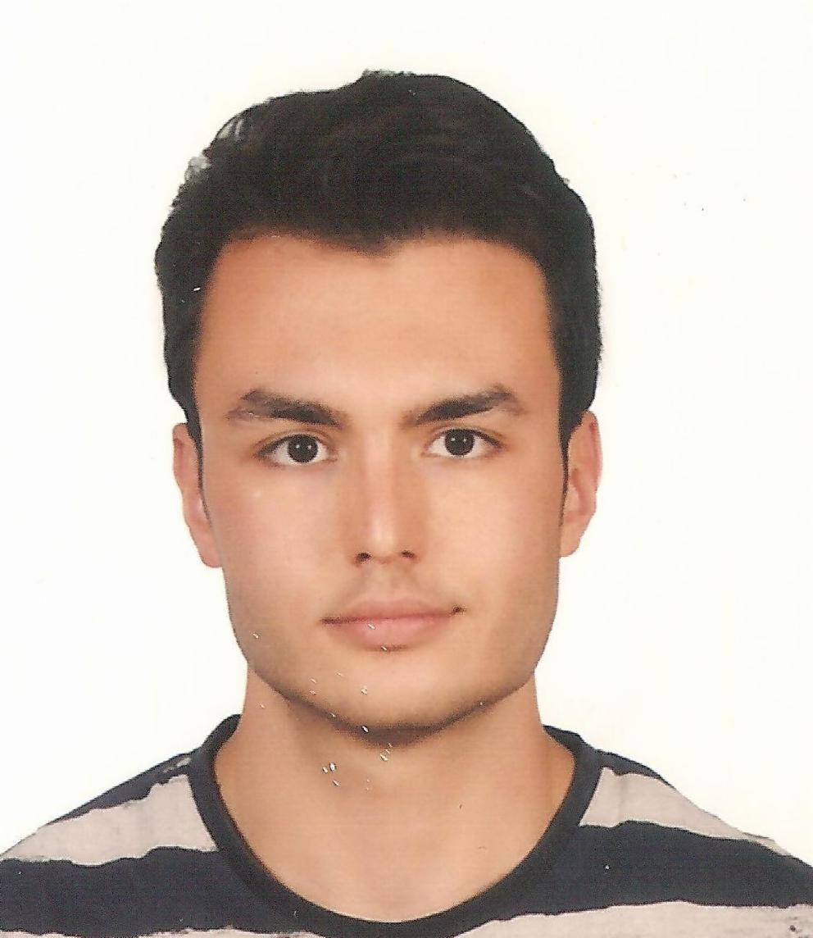 |   Witolda Budryka 2, 30-072 Kraków (Poland)

570571421

alperenkara.eem@gmail.com

www.alperenkara.org

Skype alperenk@outlook.com

WORK EXPERIENCE

25/07/2017–08/10/2017 | Intern
25/07/2017–08/10/2017 | AGH Science and Technology University, Krakow (Poland)
25/07/2017–08/10/2017 | -Working under Professor dr hab. inż. Bogusław Cyganek supervision  -A developing project of “Image enhancement prior to image classification”

01/01/2016–Present | Editor
01/01/2016–Present | elektrikport.com, endustri40.com, Istanbul (Turkey)
01/01/2016–Present | -Being an editor in elektrikport.com and endustri40.com, one of my aims is to introduce more documents about electronics, energy and electricity sectors English to Turkish​​

25/10/2013–20/06/2016 | Assistant Electrical Technician
25/10/2013–20/06/2016 | Erciyes University, Kayseri (Turkey)
25/10/2013–20/06/2016 | -Solving wiring and electronic utensils problems of university canteens (3 buildings)  -Maintenance e of computer systems  (20 hours/per week/paid)

10/05/2016–16/02/2018 | Electronics engineer
10/05/2016–16/02/2018 | Project of Ben de Yaparim, Kayseri (Turkey)
10/05/2016–16/02/2018 | -The leadership of Solar Hazerfan Power Team ​​  -Power management of Solar UAV

EDUCATION AND TRAINING

15/09/2012–17/06/2017 | Electronics&Electrical Engineer | Undergraduate
15/09/2012–17/06/2017 | Erciyes University, Kayseri (Turkey)
15/09/2012–17/06/2017 | One-year English language preparatory school education. General Engineering education, focused on electronics and telecommunications  Courses:  -Computer Vision  -Power Electronics  -Fundamentals of UAV  -Entrepreneurship(Certificated)

01/10/2014–07/07/2015 | Electronics and Telecommunication Engineer | Undergraduate
01/10/2014–07/07/2015 | AGH Science and Technology University, Krakow (Poland)
01/10/2014–07/07/2015 | Engineering education in English focused on engineering math, embedded systems and programming on C, C++ languages​  Courses:  -UNIX Administration​(UBPJO-101)  -Cognitive Robotics (UBPJO-013)

26/02/2018–Present | Computer Science Master's Degree | Post Graduate
26/02/2018–Present | AGH University of Science and Technology, Krakow (Poland)
26/02/2018–Present | Faculty of Electrical Engineering, Automatics, Computer Science  and Biomedical Engineering  Specialization: Computer Science/ System Modelling and Data Analysis

PERSONAL SKILLS

Mother tongue(s) | Turkish
Other language(s) | UNDERSTANDING |  | SPEAKING |  | WRITING
Other language(s) | Listening | Reading | Spoken interaction | Spoken production
English | C1 | C1 | B2 | B2 | B2
 | IELTS ACADEMIC EXAM 11/2017 B2 CERTIFICATE
Levels: A1 and A2: Basic user - B1 and B2: Independent user - C1 and C2: Proficient user
Common European Framework of Reference for Languages

Communication skills | - Good communication skills with people from different cultures are acquired by being an exchange student in Krakow/POLAND for 11 months and Eastbourne/ENGLAND for 4​

Organisational / managerial skills | -The leadership of Solar Hazerfan Power Team:  The project is developing an unmanned aerial vehicle of the LALE (Low Altitude Long Endurance) class. The project uses a lightweight aircraft body and wing, high efficiency low weighted solar panels and high capacity/weight efficiency batteries. The most important goal of the project is to keep UAV in the air with only solar energy  Power Electronics, Expense Management, Group Orientation, Data Quality  -A project of " Eye Movement Controlled Wheelchair" team member  The responsible person of MATLAB script, eye movement detection and image processing

Job-related skills | -Experiences with Altium Designer, Pspice, SolidWorks  -Experiences with MATLAB(İmage processing, control systems)  -Experiences with TM4C123GH6PM, PIC16F84A(with assembly language),M430G2, ATmega2560 microcontrollers  -Good knowledge of Microsoft Office 2017, Excel, and PowerPoint  -UNIX environment on user level  -Good knowledge of C/C++ programming language, the beginner of programming ARM Cortex M3

Digital skills | SoloLearn C++ Certificate #1051-4554889  Google Udacity Nano Degree Scholarship Award 11/2017

