COMPUTER NETWORKS PROJECT MIDTERM REPORT CHAT SERVER
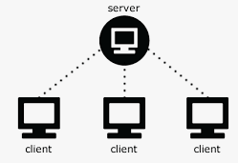
Muhammed Alperen Karaçete

171044052

10 Rooms Chat Server

Table of Contents
Abstract 2
Introduction: 2
Purpose: 2
Background: 2
Methodology and Design: 3
Software Design Principles and Architectural Patterns: 3
1)Justification for Methodologies and Design Decisions: 3
a)Security: 3
b)Interface: 4
Discussion and Analysis: 5
Concurrency Model: 5
Communication Mechanism: 6
Synchronization: 6
Scalability: 6
Security: 6
Conclusion: 7
Resources: 8

Abstract
This project aims the need for efficient communication systems in networked environments. The main objective is to develop a robust and scalable chat server, essential for real-time communication applications.
The approach involves employing modern software engineering principles and technologies such as socket programming, management, and data transfering. Additionally, novel aspects include implementing security measures to protect user data for stealing and changing and ensuring work on different computers.
The main outcomes of the application development process include achieving high performance and reliability while maintaining low latency.
In conclusion, the findings of this project have implications for enhancing real-time communication systems in computer engineering, contributing to the advancement of networked applications.

Introduction:

Purpose:
The chat application project aims to facilitate real-time communication between multiple clients over a network. This project holds significant importance in the realm of computer engineering as it addresses the fundamental need for efficient and secure client-server communication systems.

The project addresses the challenge of enabling communication between clients. Its primary objective is to create a robust chat server capable of handling multiple client connections concurrently. By using innovative techniques such as multi-threading and socket-based communication.

Background:
Chat applications have become indispensable tools for providing communication in both personal and professional cases. While numerous chat applications exist, many are limited in terms of scalability, security, or feature set. Some of them steals users communications or informations..Traditional approaches relying solely on shared memory, pipes, or FIFOs face challenges in handling multiple client connections efficiently and securely.
Relevance of the Project: The proposed project addresses the identified gaps and challenges prevalent in existing chat solutions. By adopting sockets for client-server communication and implementing multi-threading techniques, the application offers a scalable and robust platform for real-time messaging. The introduction of room-based communication further enhances usability by allowing users to participate in focused discussions within designated chat room.

Methodology and Design:

Development Tools and Technologies:
For this project, I decided to use C programming language because it is utilized due to its efficiency and low-level control, which is critical for developing network applications like a chat server. The project use TCP sockets for handling network communication. Threads are used for manage concurrent connections efficiently, ensuring real-time communication among multiple clients. Security provided by AES algorithm.

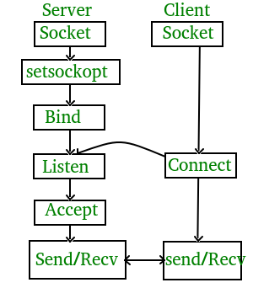


Software Design Principles and Architectural Patterns:
The software design uses the client-server architectural pattern, where the chat server acts as the central hub for handling client requests with creating a thredad and facilitating message exchange. The server is designed to be modular, with distinct components responsible for tasks such as accepting connections, message routing,printing every succesfull and unsuccesfull operation. Structures are used for creating necessary structs (linked lists,room)

1)Justification for Methodologies and Design Decisions:
The choice of C sockets and threads aligns with the project's requirements for building a robust and scalable chat server. C sockets provide a low-level interface for network communication, offering flexibility and control over data transmission. Threads allow the server to handle multiple client connections concurrently, optimizing resource utilization and minimizing latency. These methodologies and design decisions are justified by their proven effectiveness in developing highperformance network applications.

a)Security:
For encryption and decryption AES technic have been used. It is a symmetric encryption algorithm. Basic idea behind AES is to transform plaintext data into ciphertext using a key.
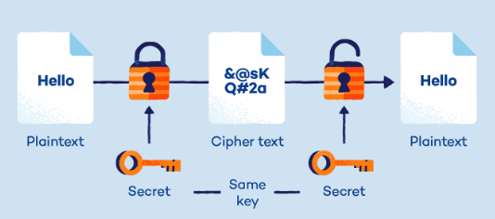



b)Interface:
For prividing users good and understandable interface, GTK GUI have been used.
Implemantation and Application Development:
Firstly I make researches about client and server communicaton.There are several ways for communicating like shared memory,pipes,FIFO’s but I decided to use sockets because for my researches, it’s the best way for client and server communication. Providing connection between server and client was a bit hard, but the most hard part was using threads. But I solved it lastly. Server should create a thread for each connected client and client should create two threads one of them for receiving messages from server and other should be send messages to server. The other hard part is creating different rooms for clients. Clients can connect which ever room they want to join and communicate clients which are in the same room. For providing security, AES encryption and decryption technic have been used. Firstly I am creating a key from server. Clients now this key too. Without knowing this key, users can not decrypt cipher text (enrypted message) and access plain text (encrypted message).With this program want to provide security to users for cryptographic attacks.Like; Brute Force Attacks, Known-Plaintext Attacks, Chosen-Plaintext Attacks. In clients, before sending messages to server, messages being encrypted by encryption algorithm. Then it sent to server. After server receives cipher text, It decrpytes it and looks for content. If it’s a command, it does not sent it to clients. But if it is a message, It again decrypt it and send again to clients which is in the same room with sender client. GTK GUI used for providing interface. There are 3 commands in client side. 1)commands, 2)showRooms and 3)changeRoom <Room number>. With commands command, user can see commands on chat application. With showRooms command, server send list of rooms and how many client is in which room. Then prints it to client screen. With changeRoom, user change his/her room any other rooms. User’s message seem as blue on right of the screen and other clients message seems as green on the left of the screen
My server can communicate with several clients. I used link list for client list so there is no limit for client connections. But clients uses computer resources so limitless client would be hard for this project. Clients succesfully connect server and securely communicate with each other which are in same room.
showRooms example changeRoom example.
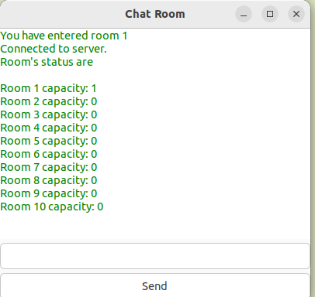
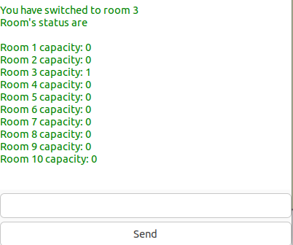

Communication example:
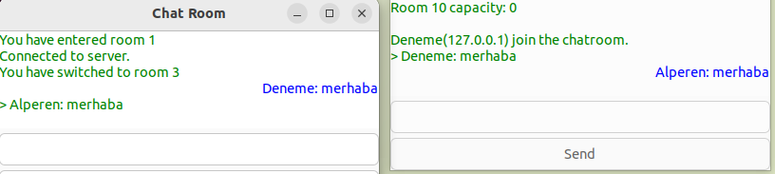

Discussion and Analysis:
Comparision with other solutions:

Concurrency Model:
Sockets and threads: In this model, each client connection is typically handled by a separate thread. Threads allow for parralel execution within the same process, enabling multiple clients to communicate with the server.
Fork and shared memory: In this model, the server process forks a new child process to handle each client connection. These child processes share memory with the parent process to facilitate communication. Shared memory allows for inter-process communication (IPC) between the server and its clients.
Resource Utilization:
Sockets and threads: Threads within the same process share resources such as memory, file descriptors, and CPU time. However, managing a large number of threads can lead to increased memory overhead due to thread stack space and potential contention for shared resources.
Fork and shared memory: Forking a new process for each client connection incurs a higher initial overhead compared to threading. However, each process operates independently, which can lead to better resource isolation and potentially improved stability,

Communication Mechanism:
Sockets and threads: Communication between the server and clients is typically achieved using network sockets. Each client connection is associated with a socket, through which data is transmitted with two ways (bidirectionally).
Fork and shared memory: Communication between the server and its child processes is facilitated through shared memory segments. This allows for efficient data exchange without the need for inter-process communication protocols such as sockets or pipes.

Synchronization:
Sockets and threads: Threads within the same process share memory space.
Fork and shared memory: Processes created via fork operate in separate memory spaces, reducing the need for explicit synchronization.

Scalability:
Sockets and threads: Thread-based implementations can be more scalable in terms of handling large numbers of concurrent connections, as they typically have lower overhead per connection compared to process-based approaches.
Fork and shared memory: Process-based approaches may face scalability challenges when dealing with a large number of client connections, as each forked process incurs additional overhead. However, the use of shared memory can improve efficiency by minimizing data copying between processes.

Security:
AES:Focuses on the encryption algorithm itself, used within various encryption schemes and protocols.Relies on secure key distribution and management. Both parties need to securely share and store the symmetric key.Provides strong encryption for data, but does not address how keys are exchanged or managed. Vulnerable to attacks if keys are compromised.Can be used in various contexts such as file encryption, disk encryption, and within secure communication protocols.
E2EE (End to End):An overall encryption strategy that may use AES or other encryption algorithms (e.g., RSA, ECC) to secure data throughout its transmission journey.Typically involves asymmetric encryption for key exchange (e.g., public/private keys) and symmetric encryption (like AES) for encrypting the actual data.Addresses both the encryption of data and the secure exchange of keys, ensuring that only the intended recipient can decrypt the data. Primarily used in communication tools to ensure that messages or data shared between parties remain private and secure throughout transmission.

Conclusion:
This Project should provide to connection between different clients to chat server and communicate with each other succesfully. It should provide security to prevent attackers to steal communicatons between people or change their conversations. I created different rooms for clients to connect this rooms and communicate in here.
At this point, program is providing to users this attributes.
Now user can only change and see rooms with writing commands.In future buttons can be added for change room or see room status.
Other improvement can be providing users to adding new rooms. Now users can enter only 10 rooms.
In real World we can see Facebook,Whatsapp, Instagram has group conversations and private conversations. Additionally they have authentication. But I won’t add them.

Resources:
- Stackoverflow: Two-way communication in socket programming using C:
Two-way communication in socket programming using C - Stack Overflow

- Medium: Simple Chat Server using Sockets in C:
Simple Chat Server using Sockets in C | by SecuroSoft | Medium

- Geekforgeeks: Socket Programming in C:
Socket Programming in C - GeeksforGeeks

- Geekforgeeks: Multithreading in C:
Multithreading in C - GeeksforGeeks

- Mario Konrad: Multithreading:
mario::konrad - Multithreading: Tutorial 04: Client/Server using Sockets and Threads (mario-
konrad.ch)

- Gkizinos, K. (n.d.). What is C Programming Language? Basics, Introduction, History. Medium. Retrieved from https://medium.com/@Konstantinos_Gkizinos/what-is-c-programming-language-basics-introduction-history-724bb9301a91.

- U.S. News. (n.d.). What Is Advanced Encryption Standard (AES)? Retrieved from https://www.usnews.com/360-reviews/privacy/what-is-advanced-encryption-standard#:~
=The%20Advanced%20Encryption%20Standard%20(AES)%20is%20an%20algorithm%20that%20uses,make%20it%20harder%20to%20compromise.

