**REPUBLIC OF TURKEY**

**HASAN KALYONCU UNIVERSITY**

**FACULTY OF ENGINEERING**

**COMPUTER ENGINEERING DEPARTMENT**



**GRADUATION THESIS REPORT**

**EFFICIENT LEARNING**

**GAZİANTEP**

**2019-2020**

Table of Contents

Abstract 3

Özet 3

2.2 Background and Related Work 5

2.3 How to make student attractive to the Class 7

2.4 Why Class are not interesting to the student? 8

2.5 Importance of Education 9

3. SOFTWARE REQUIREMENT SPECIFICATION 10

3.1 Introduction 10

3.1.1 Purpose 10

3.1.2 Scope of the Project 10

3.1.3 Overview of the Document 11

3.2 Overall Description 11

3.2.1 Product Perspective 11

3.2.1.1 Development Methodology 11

3.2.2 User characteristics 11

3.3 Requirement Specifications 12

3.3.1 External Interface Requirements 12

3.3.1.1 User Interface Requirements 12

3.3.1.2 Software Interface 12

3.3.1.3 Hardware Interface 12

3.3.1.4 Communication Interface 12

3.3.2 Functional Requirements 12

3.3.2.1 Admin Use Case 12

Use Case 12

Diagram 12

Brief Description 13

Initial Step by Step Description 13

3.3.2.2 Lecturer Use Case 13

Diagram 14

Brief Description 14

Initial Step by Step Description 14

3.3.2.3 Student Use Case 15

Diagram 16

Brief Description 16

Initial Step by Step Description 16

3.3.3 Non Functional Requirements 17

4. SOFTWARE DESIGN DOCUMENT 17

4.1 Introduction 17

4.1.1 Purpose 17

4.1.2 Scope 17

4.1.3 Overview of the Document 18

4.1 System Design 18

(Index) 18

Figure 1. 18

4.2 Architectural Design 27

4.2.1 Class Diagram 27

5. CONCLUSION 42

Appendix B: Efficient Learning System 44

Appendix C: Copyright Page 45

Appendix D: Sample Approval Page 46

Appendix E. Sample Declaration Page 47

Appendix F: Sample Abstract 48

Abstract 48

Özet 49

Appendix H: Sample Dedication Page 50

Appendix I: Sample Acknowledgements Page 51

6. REFERENCES 54

# **Abstract**

# Since technology has entered our lives and even into our pockets, Online learning applications have been used not only individually but in a blending with the modern education system. However, online learning practices are focused on individual learning without any guidance, and there is no classroom environment in traditional learning practices. In addition, people do not have a fixed memory, reinforces and makes it permanent by repeating the work it learns. The purpose of this application is to create a classroom environment that does not in an online learning application and to receive notifications from smart reminders. In line with the practical tool by doing tasks and earn points to teach the target programming language.

# ****Özet****

# Teknoloji hayatımıza hatta ceplerimize bile girdiğinden beri Online öğrenme uygulamaları sadece bireysel olarak değil modern eğitim sistemi ile harmanlanarak kullanılmaktadır. Ancak online öğrenme uygulamaları bir yol gösterici olmadan bireysel olarak öğrenme odaklıdır ve geleneksel öğrenme uygulamalarında olan sınıf ortamı bulunmamaktadır. Ve ayrıyetten insanoğlu sabit bir hafızaya sahip değildir öğrendiği işi sürekli tekrar ederek pekiştirir ve akılda kalıcı hale getirir.Bu uygulamanın amacı online bir öğrenme uygulamasında olmayan bir sınıf ortamı yaratmak ve öğrendiklerini unutmamak için akıllı hatırlatıcıdan gelen bildirimler doğrultusunda onlne pratik aracı ile görevlerini yaparak ve puan kazanarak hedef programlama dilini öğretmektir.

1. INTRODUCTION

This system will teach the fundamentals of different programming languages such as C, C#, Java and Python. Due to the properties of the systems, lecturers can assign tasks for students related to the topics of the programming languages.

The system is divided into the following modules:

We first have levels where for example the first section is defining a variable and the last section is asynchronous methods, in addition to that there will be an online interpreter and editor to allow the student to write code. This system will allow student to communicate between each other according to the instructions and to help each other when they face a problem, also they will be given some hint in order to get helped. After solving problems and passing levels student will get notifications in order to practice and not forget what he has study and will be redirected to the related section. Moreover there will be an intelligent repeat engine that finds the missing points of the student. Therefore, the system can observe how student can increase their knowledge levels about the basic tasks of programming languages. Apart from practicing and interaction with the teacher and other student, they will be a rewarding that will be display in the score table, and announce the champion at the end of the month. In this way a competition will be established between the student and make the learning more fun.

* 1. **Problem Statement**

Integration of an interpreter, which will be developed by using target programming language, to the developed web platform by using ASP.NET MVC can be considered as a potential problem.

**1.2 Solution Statement**

The alternative solution is that the JavaScript algorithm can be developed by using JavaScript, which is suitable for JavaScript.

**2. LITERATURE REVIEW**

**2.1 Introduction**

Efficient learning has facilitated many things especially in terms of education. It can be define as information and communication technologies used to support students improve their learning and personal environment. Especially in the domain of programming languages e-learning is very efficient and help student to deal more with the language at the same time get motivated to learn it [23].

Indeed this study will teach the fundamentals of different programming language such as C#, Java and Python. Due to the properties of the system, lecturers can assign tasks for the students related to the topics of the programming languages.

## 2.2 Background and Related Work

One of the major thing in Computer science is programming [1], for this reason learning it from traditional education might be difficult for the student to manage and understand it well, that’s why some study show that student that the percentage of student learning from distance has increase [2]. Also in order to make the student attractive to the lessons some e-learning has introduce what they call gamification [3], where lessons are sometimes given as a game, which make the student ore attached and interested.

When it comes to related work, they are many studies which teach programming languages via e-learning software and being able to check the progress of the student, whether he is gaining from what he is learning, after he has been given exercises [4].

Lih Shyang, Emily principle and a few different authors in IEEE has developed Associate in Nursing E-Learning System for programming languages with semi-automatic grading. The system cash in of pc and Network technologies and combines the construct flipped room to assist pedagogue and their student teaching in additional economical manner [5].

The related works does not only concern this type of programming language, we also have one other studies about machine learning since computer science is a large domain of work, this one is a platform called Scikit-Learn, which is a python module [6].

This is system was build in such a way that even those who are not specialist in Python will be able to learn from that module. There are many other toolkits which provide support for developing machine learning application [7] for this one call Dlib-ml it is a cross platform open source software, it also contain many toolkit such as Linear Algebra, which can really help the student improve not only in programming. We can add to these another application which is for Visual programming for Media Computation and Bluetooth robotic control, this application shows how new blocky language are created as well as showcasing these languages as new educational environment [8].

In order to be more basic we have other e-learning application to teach the course of Introduction to Programming, in wherever the scholar get the thought and ideas of programming, for that reason model are develop to teach faster and with competence [9].

In addition to similar studies we also have mobile application that teaches programming languages or let’s say improve student’s skill in programming, by using different approaches like multimedia concept animation with query languages to create the pervasive learning surroundings, with this application student can learn anytime and according to their own scheduling [10].

Another mobile application or m-Learning, for higher education, that use as well different approaches and aim, is here measuring the level or degree of students, for mobile devices, same as in our application this application give some activity to the student to keep him on practicing and allow the teacher to have the opportunity of monitoring the student and see in which programming language ca he success more, and of course will give feedback to our application [11].

Sticking in the language is not just enough to be able to build something as a programmer, orienting himself or herself in the language is also part of the work, such as learning to build can android app is also one of the technologies implemented for educational resource [12].

Next is also another framework of a mobile application to improve programming skills as well where this one is a Microlearning- Based training it integrate into the benefits of e- learning environment, this study propose to learn anytime and anyplace with urgent feedback and also some gamification features, with the aim of developing motivation of students and a community of work to improve programming skills [13].

Another used application which is also concerning even those who didn’t study computer science help them to improve their skills in programming, this program include sequence, condition and loop. It improve learners to understand the basic of computer programming, specially for those with moderate and self-efficacy [14].

To continue with the basic of programming, one of the language which most university start with tot teach student is C, but this program is sometimes quiet difficult to manage using traditional learning, for that reason some research aim to develop a better way to teach it with Programming visualization Tool for web which has many features like being run without installing an IDE shows the execution of C programming and finally detect run time error [15].

The idea of our application does not only concern the programming languages, which will let us introduce other related work, like the mobile application that teach computer architecture, under favor of the new technology of mobile which permit us to be able to learn or for this type of course which is traditional and solid using the tradition way in classroom. Indeed this application is implemented with Game that allow learner to understand the subject with more fun [16].

Thanking mobile for its new technologies, we have as well again other application to teach mobile apps such as iOS and Android at same time with highlighted quality on the User Interface depending on the student [17].

Another application which is composed of gamification as well is one of our related work, but this time include intelligent exercise to support web application programming student [18].

In recent years, there is an growing technological development in intelligent tutoring systems ,it targets the student enrolled in Information Security and Information security[19]. We can add to these another concept of learning via Visual programming environment, this application aimed to teach analytical thinking and problem solving, team-work and project management skills, they teach designing to student and programming robots using sensors, connectors, gears etc. Student gained as well the concept of basic programming like loop, branches, condition etc. [20]

Another application called Code Ocean has been implement online, in order to teach student how to program and being able to compile online with here downloading any IDE as well. The program provide to student feedback as well and some practice exercises [21].

Due to the fact that android application are used a lot another application has been developed in order to teach how to develop itself android app and amazing user interface, the system represent a topic of android application development and administers automatically generated issues for students to solve, also the system is automatically adapted at runtime to the student’s personal growth, this is done using intelligent tutoring [22].

At las one of the most popular application that everyone uses almost [27] is the google classroom, which is a Virtual classroom online, that allow participant to communicate view presentations or videos, and interact with the other participant.

## 2.3 How to make student attractive to the Class

The conventional instructional conveyance system in universities for quite a while has been classroom with a professor giving speech to the student and the student taking notes. Communication between the teachers and the student has been recognized to be a basic learning segment.

In recent years, we have notice that student are not completely focus on courses like programming or are not well understanding the concept of it, which lead them not to become good engineer, or failing such courses. For that reason [23] has found a way using students’ feeling on classroom with gamification reply system in a programming class it explain that most gaming platform and tools are based on quiz where student can get score point according to their correct and false answers. And base on the feedback after making a test on 120 students, majority of them enjoyed it and able to attract their interest in programming languages. Harandi [24] is explaining the effect of e-learning in student education, so far we are trying to show that e-learning is one of the way to attract student in class. Well in this article it has been proven that e-learning also affect the motivation of the student.

Out of the domain of programming or student programmer, [25] shows a study of combination of traditional learning and e-learning for the development of x-ray interpretation skill in pre-clinical medical students. This shows another way of the effectiveness of e-learning, in order to motivate the student on studying and manage more their field in which they are exercising.

[26] is another case study which consist of making high school girl student attractive to computer science class, this case study was perform with the technique of Computational thinking which involves algorithms, logic patterns, abstraction, and evaluation.

Students nowadays are more attracted on gadget, the new generation know how to use the new technologies very well. For this reason [28] is showing a new system of learning to make students more attractive to the class, which is called Bring Your Own Device. This technical infrastructure or learning techniques is working in such a way that the teacher’s laptop is connected to a projector and to the wireless of the student tablet or smartphone or laptops. In this paper it is shown that the effect of the game-based system named KAHOOT! has been successful after some studies that were made on the system. The system manages to boost students engagement motivation and learning.

Continuing with the new technologies, in order to show that only traditional instruction is not enough for the education, the uses of e-learning or the new technologies is inevitable. As we see in [29] another way of learning is shown in order to make the student work and motivate him on what he is doing, this service was integrated for English as a Foreign Language, noticing that student like using social media and spend time on that, this service give task to the student in order to improve their speaking, so the idea was to make them present about their university and publish their video on YouTube, adding to that a Facebook community was established as a forum for the student to share their videos with international student and peers.

[30] demonstrate the promotion or is promoting the 21st century skills and student engagement. How did the student became engage? Well they used a technology called digital storytelling, it is based on sociocultural theories. This system is more of showing skills and make student open and knowing what is going on in nowadays.

Seeing all this solutions, researches and idea, we should know try to understand why students are not focus in class?

## 2.4 Why Class are not interesting to the student?

In literature, boredom is distinguished as a call to switch our action. boredom separates us from our present circumstance, makes notable to us our elective conceivable outcomes, furthermore, persuades us to accomplish something different. Thusly, boredom plays a novel and valuable role in our psychological economy [31].

The studies in the literatures showed that boredom affects students’ success. These studies stress, impulsivity, procrastination. In this boredom, teachers’ effect play a big role [32].

Boredom is adversely connected with dominance objective structure, and uneasiness and anxiety are both positively connected with execution goal structure [33].

To learn boredom during class, there are some studies. One of them looks for an answer that what traits cause marketing students to feel bored in the classroom, what traits help to make these feelings easy, and what can marketing educators do to enhance boredom ? They develop personality-based model which categorizes personality traits into elemental, compound and surface behaviors. Results showed an important interaction between impulsivity and self-efficacy on boredom [34].

To attract students’ interests to classroom and to keep students in classroom, there are studies in literature for teachers to develop themselves [35].

An study looked at understudy and personnel impression of on the web and customary courses in Middle Tennessee State University, United States.They made reviews to comprehend

1) view of online versus traditional courses,

2) view of understudies who take online courses and students' inspirations for taking on the online courses,

3) impression of employees who show online courses;

They asked 25 questions to 100 faculty members and 715 students. The survey revealed that:

* Students, on average, believed that online courses do not need a teacher because they end up being self-directed learning faculty disagreed. faculty and students both disagreed that online courses are easier than traditional courses.
* Both faculty and students agreed that students feel more disconnected from other students and teachers who take online courses.
* Employees accept that educators are increasingly accessible to understudies in online courses versus conventional courses.
* Accordingly, distinction in recognitions between employees and students has to do with the measure of time and exertion that employees put resources into showing on the online courses[36].

Research has found that online learning systems can provide personalized and adaptive instruction that can be creatively customized to suit individual capabilities and learning styles and also engage students in active learning with interactive materials and resources [37].

A study compares traditional learning and blended learning in terms of comparing students’ motivation, learning outcomes, and preferences researchers applied learning method in terms of fall term and spring term in the same class, they made a survey with 26 students. The result of survey is more successful in terms of the purposes of studies, motivation, outcomes, and preferences [38].

Moreover, blended learners indicated that they would like to take more blended classes and would recommend them to their friends [39].

New teachings methods such as flipped learning, which provides supportive materials like gamification related video online applications, are more successful on teaching. Researchers used 3 different methods. Those are traditional learning, flipped learning with gamification and online independent study with gamification. The study took 1 year. Students who learn with flipped learning are better than students who learn with traditional learning and online independent study [40].

## 2.5 Importance of Education

Education may be an important issue for social relationship, gain position during a society, gain self esteem, acquire a profession, improve some skills and earn cash to continue the life. Quality of education depends on some topics: age, society, country, country’s population, systematic variations and content of curriculum [41]. additionally, over the past century, the some countries diode the globe within the enlargement of its education system. For example; United State of America.

In 1900’s and till today America continually has powerful economy, powerful army and high technology; they create all because of sensible education system. The positive truth is that the pattern of economic process has vast ramifications for society. in step with analysis by economists, there's a relationship between economic process and education. the everyday study finds that amount of schooling is very associated with economic process rates. securities analyst says that economic process, building new technologies, creating invention and being powerful country is strictly concerning education and education system. once economists examined rates of growth, some countries square measure higher than different countries. They succeed this degree by victimization scientists and engineers. during this economic model and education succeed, scientists and engineers as a key individuals. By these views, the technically trained faculty students UN agency contribute to invention and to development of recent merchandise give a special component to the expansion equation. Here, again, the u. s. seems to possess the simplest programs. If this read is correct, United State of America and a few developed countries teaching could still give a lucid advantage over different countries. Eric [42] Education may be a purpose. functions square measure being a developed person / country, vie the opposite individuals and countries, fight and win them and invent new technologies, new guns, new techniques then on. There square measure 3 functions of educations and therefore the 3 domains of instructional purpose: Qualification, socialization, subjectification [43].

## 3. SOFTWARE REQUIREMENT SPECIFICATION

## 3.1 Introduction

This document is the software requirement specification document for the project titled as “Efficient learning”. The goal of the project is to facilitate student learning programming languages and improve their skills in programming as well.

## 3.1.1 Purpose

This document includes details information about the requirements of the project. It reflects the identified constraints and proposed software functionalities. In addition the SRS document explains how participants interact with the application. This document explains how constraint of stakeholders are met.

## 3.1.2 Scope of the Project

The system is divided into the following modules:

We first have levels where for example the first section is defining a variable and the last section is asynchronous methods, in addition to that there will be an online interpreter and editor to allow the student to write code. This system will allow student to communicate between each other according to the instructions and to help each other when they face a problem, also they going to be given some hint in order to get helped. After solving problems and passing levels student will get notifications in order to practice and not forget what he has study and will be redirected to the related section. Moreover there will be an intelligent repeat engine that finds the missing points of the student. Therefore, the system can observe how student can increase their knowledge levels about the basic tasks of programming languages. Apart from practicing and interaction with the teacher and other student, they will be a rewarding that will be display in the score table, and announce the champion at the end of the month. In this way a competition will be stablished between the student and make the learning more fun.

There are three participant in the application which are: admin, lecturer and student.

-The admin is responsible for adding lecturer adding student, deleting them and updating their information as well he is the one that has access on everyone.

-The lecturer is responsible for giving the tasks grading the student and putting the reward list of student, in summary he will be the one that will practically make the system interactive, having actions work practice exercise. We can add to that, the fact of communicating with the student sending him notifications and helping if there is any need for that.

-The student is the one executing the tasks given by the lecturer, as we explain on top he will be learning and communicate and help his other friend, that will make him get points in addition to his accomplish tasks.

## 3.1.3 Overview of the Document

The second part of the document describe the functionalities of the E-Learning. All requirements that we need are described in the Requirement Specification chapter.

Requirement specification is written for the software developers and details of the functionalities are described in technical terms.

## 3.2 Overall Description

## 3.2.1 Product Perspective

This application as we said in our introduction is divide into modules: Practice, Reminder, Rewarding, Tasking and Student Portal.

In the practice section, student will be able to develop using interpreter and editor. He will be able to answer questions and help other student accordingly to the task give,

When it comes to reminder when the student complete his task he will receive notification about his recent task and will be passed to the next level of the system.

For the rewarding, in order to motivate student, at the end of every month, they will be champion which will be the student who has done more effort and has solved the problem more correctly compare to others.

The Tasks will be assign by the teacher, and hint will be given according to the exercise level.

At last, when student has problem in one task he or she can share his problem with the other student, where the one that has answer correctly and help will get some bonus point.

## 3.2.1.1 Development Methodology

Software development process can be improved by adopting certain development methodology. These methods ensure that the development processes goes as efficiently as possible. The project will develop on 2 platform, one of the platform will be an online system and the other one a mobile application

## 3.2.2 User characteristics

An online efficient learning system require three distinct users:

***The Admin*** must control all the system who is in the system what work does he do in the system and the system should work, all that functionalities are controlled by the admin.

***The Teacher*** is the one giving the courses to student he will be responsible of all interaction between courses and student.

***The Student*** his only responsibility is to follow the courses and do the task that are required for him, he is free to choose an course that he would like to learn

## 3.3 Requirement Specifications

## 3.3.1 External Interface Requirements

## 3.3.1.1 User Interface Requirements

The user interface will work on Windows and Mobile.

## 3.3.1.2 Software Interface

There are no software interface requirement.

## 3.3.1.3 Hardware Interface

There are no hardware interface requirement.

## 3.3.1.4 Communication Interface

There are no communication interface requirement.

## 3.3.2 Functional Requirements

## 3.3.2.1 Admin Use Case

## Use Case

* Login
* View List of Teachers
* View List of Student
* View Courses List
* Create Teacher
* Update Teacher
* Delete Teacher
* Create Class
* Update Class
* Delete Class

## Diagram

## Brief Description

Admin is responsible for controlling all the system and users that interact with it. He can add, delete and update the users.

## Initial Step by Step Description

1. Admin will login to the system as all the other user
2. From here he will have several choice after login and view

2.1. Admin is able to see all student in the system including their information their class and course that they are taking.

2.2. Admin will be able as well to see also teachers list in the system including the courses that they are giving and details of their information.

2.3. Admin will see list of the courses given by the teacher and details of the course.

2.4. Admin can create teacher for the system to teach students, the admin will be the one having access to the teacher information.

2.5. Admin can update lecturer information.

2.6. Admin can delete lecturer information.

2.7 Admin can create class, he can include new class in the system, for the lecturer to be able to teach them, or if they think some class are missing in the system or required, admin can add them.

2.8. Admin can update the class information.

2.9. Admin can delete classes if there is no need for the class to exist.

2.10. And finally for sure admin can login to the system.

## 3.3.2.2 Lecturer Use Case

**Use Case**

* Login
* Create Class
* Create Task
* Publish List
* View Profile
* See Classes
* See Students
* See grading List
* Grade Tasks
* Send Notifications
* Update Class
* Delete Class
* Create Announcement
* Update Announcement
* Delete Announcement

## Diagram

## 

## Brief Description

Lecturer, is the one responsible for giving the classes, and finding the best way to improve the student skills and be able to learn the programming languages.

## Initial Step by Step Description

3. Lecturer can create class that he will give to the student and put the details of the class while creating them.

4. Lecturer can give a task that student will submit after he has done it, he will as also give a deadline to the task he has given.

5. Lecturer will also publish list of the student grading, after end of each month, the student will be graded and of a list will be publish showing the best student of the month.

6. Lecturer will also see his profile and his progress also number of student will be shown, also number of given task.

7. Lecturer will also see the list of the student in the system, the student that are taking his courses.

8. The lecturer will also see the list of the graded student he has publish, since it will be an announcement he will have access to that page and see the list.

9. After giving a task lecturer will be able to grade the tasks he has given to the student.

10. Lecturer will send notifications to the student that he can see the tasks or being remind about the task he was given.

11. Lecturer will be able to update information of the class.

11.1 Lecturer will be able to delete classes he is giving or if he thinks this class is not necessary.

12. Lecturer can create announcement in case there is any update in the task given or class.

12.1. Lecturer can update the task information.

12.2. Lecturer can delete the task information.

12.3. Lecturer can delete the task information.

## 3.3.2.3 Student Use Case

**Use Case**

* Login
* Register
* Edit Profile
* See assigned task
* See progress
* See profile
* Join Class
* Submit Task
* Run Code on Editor
* See purchased class
* See hint
* See code output
* See grading List
* Leave class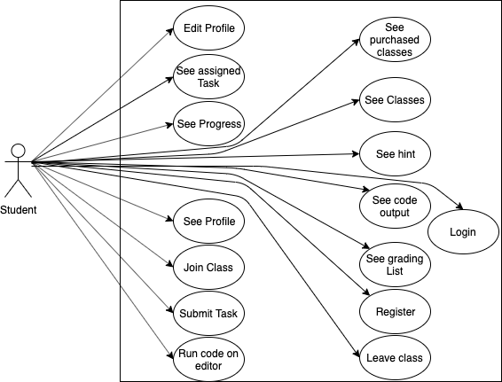

## Diagram

## Brief Description

The student is the most active in the class, he is the one doing most of the interaction in the system.

## Initial Step by Step Description

13. Student can register to the system, by entering his name, surname, email and password and other information

14. Student can edit his profile information

15. Student can join a class in order to understand the topic before doing the task

16. After doing his task student can submit it to the system for the teacher to see his work.

17. In order to write his code student can use editor for it so he will be able to write his code and get error from the editor he is writing.

18. Student can see the class that he is purchasing, there is general class and the one that he is taking, so in here h will view the one he is taking.

19. Student will also see list of tall the classes given by the system

20. Student can also see the hint while he doing the practice on the editor

21. There will be output on the editor, that student will see to check if his program work properly

22. Student can see the list of the month which going to contain average grade of his work and will see his rank on the system

23. Student can leave the class, like a logout from the class after he finish learning this class.

## 3.3.3 Non Functional Requirements

1. This system include interaction between the student and the teacher so his response time must be fast and efficient.
2. The application can be use by student and teachers so the number of user can be up to 5000.
3. This application work with an online editor so in case there is no internet, and since the editor will be develop using JavaScript, the information will be save inside a cookie so that when the user reconnect he can get his data back.
4. The application is also secure and has some privacy each user can access only to his personal data, but not other user data.
5. The password of the user will be encrypted in such a way it will be difficult for anyone to find it will be at least six characters and should contain capital letter and
6. The system will be responsive as well and portable in both mobile and computer

## 4. SOFTWARE DESIGN DOCUMENT

## 4.1 Introduction

## 4.1.1 Purpose

The purpose of the software Design Document is providing the details of the project title “Efficient learning”.

The application is made for the purpose of training student to be able to manage programming language and improve their skill on that field.

## 4.1.2 Scope

This document contains a complete description on the design of Efficient learning.

Efficient learning application works both on mobile and web, so in this document we have the design of the system in both platform.

## 4.1.3 Overview of the Document

The following chapter’s content is listed below:

Interface or System design with more details

And the second part include the Architectural design of the system which contain the class diagram of the system.

## 4.1 System Design

The user interface of the system will help us more to understand how does the system work.

## 

# (Index)

# Figure 1.

The figure 1 represents the homepage, where all users will see when they enter the system, in here users are of course lecturer, admin and student. On the top of the page we have a button where the user can go to login so when he click that he will go to the login page which is in figure 2. The homepage will contain some description about some information of our system.

In the login page user will enter his email address and his password and click the button in order to sign in, in case he forgot his password user will click forgot password in order to enter some information and get a new password. On the other hand if the user do not have an account, he will register, but only the student will register, the teacher will be created by the

system. So for the student to register in figure 3, he will enter the information as shown in the figure like name degree class etc. After the student has login he will come to his page figure 4, the navigation bar will change, on his profile picture, student will see links like profile, progress and log out, the other button shows the notifications that the student receive from the teacher, the last button from the left make the student to join the class in order he has not a class already or if he want to add a class among the one he is already taking. Still on the nav bar there is my classes button and do practice button when student click on the Do practice button he will go to figure 5 where he will see the instruction of the practice problem and an editor where he will be able to write codes.

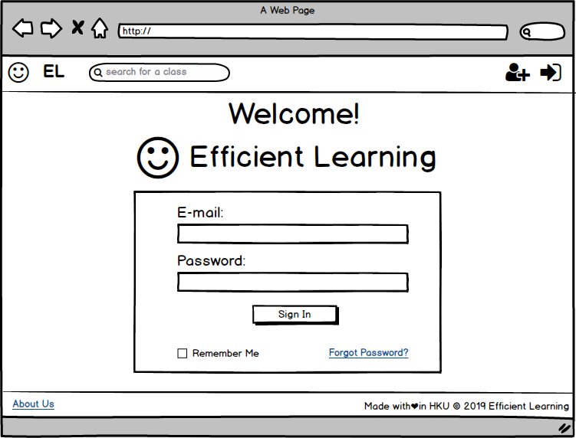

(Login)

Figure 2

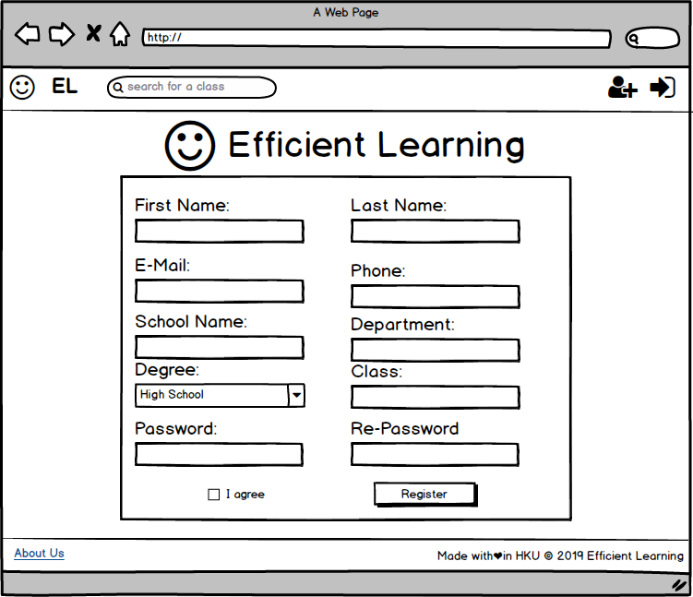

(Register)

Figure3

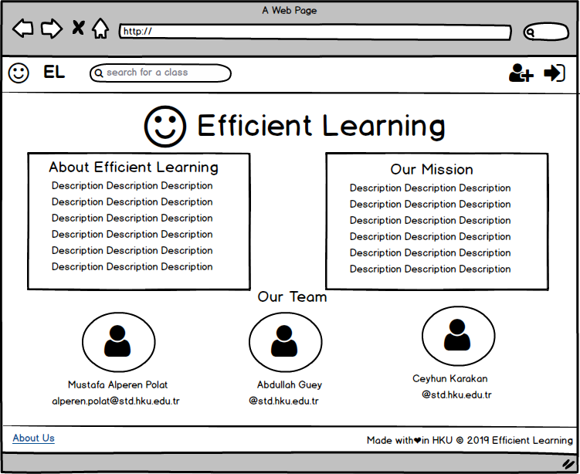

(About)

Figure 4.

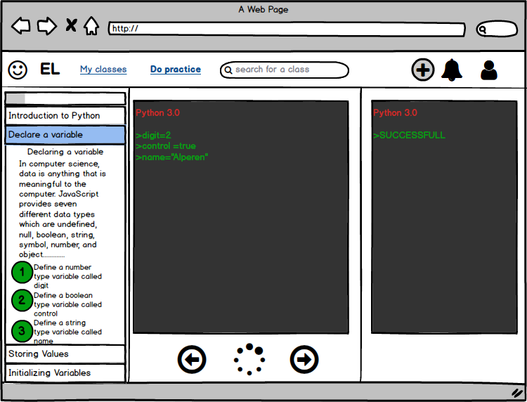

(Practice)

Figure 5

After finishing writing the codes, on the write button play the student can run the program and see the output on figure 7, but in case the problem is hard there is the hint button which will act after clicking and give some instructions or we can say hint to the student to write his program. On the left side of the page we have all the instruction that the student need to do the numbers is will be green after the student execute each instruction given. On the My Classes button student will see in figure 6 the number of class he is taking and the list of the class he is doing, in there will be a button where the student can quit. On the nav bar, when the student click to the profile button, he will go to figure 7 where he will view all his profile information as you see such as his performances on the number of class he is taking number of tasks and number of done tasks. On the left the student will see his information such as his email, name and other description about him.

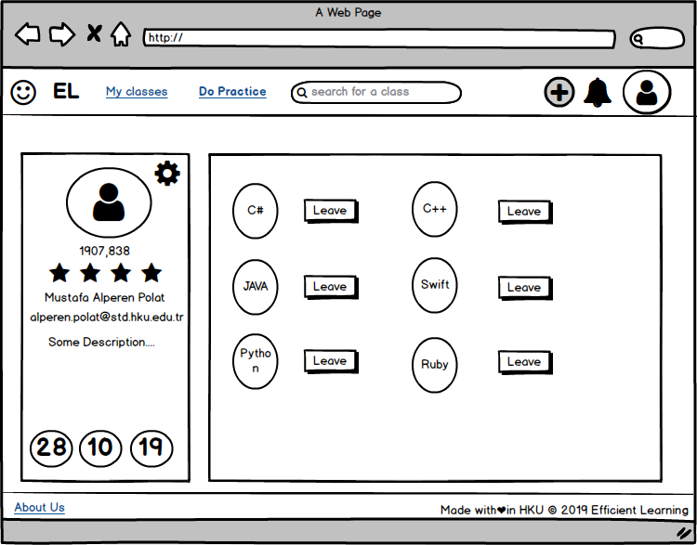

(Taken Classes By A Student)

Figure 6

In case the user is a teacher after he login, his nav bar will be different from the student’s one since for him they will be the profile button and the logout button on his profile picture button. The next button enable him instead of receiving notification he will send notifications to the student that will receive it then we have the button of creating class creating task and publishing list of the month, the list consist of showing by order grading the student of the month. On the left side, the teacher will see the button of My Students and My Classes.

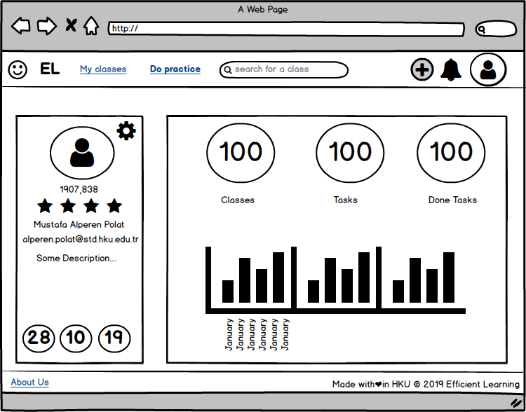

(Student Profile)

Figure 7

In order to create class teacher we click on the button to create a class and on figure 8, we see that for creating a class teacher will enter the class name, and which language and at last a description of the class. The button create is the confirmation of the class created.

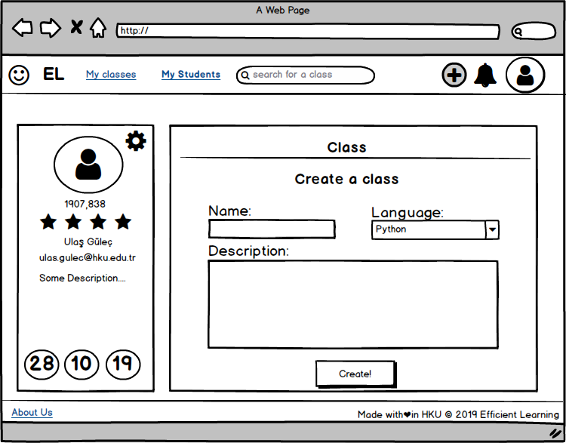

(Creating a class)

Figure 8

On the My Students button the lecturer will see the list of all student taking his class in figure 9, that page will also contain information of the student and also file concerning his tasks and a notification button to send a notification to a specific student.

If the date is close to the end of the month the teacher will publish the list that we will see in figure 10 which shows the best student of the month. As we can notice in the figure the student information contain his ID his name, surname and point he got from the task he had done.

After showing the student pages and teachers page, now we will show the design of the admin. As we say recently the admin is responsible of most interaction that is happening in the system. On figure 11 we have the admin panel, which is a menu of the functions he can execute, and his accessibility, we also have at the page diagram of the language that is mostly used in this system which is represented as a graph, the other graph shows the progress of the system.

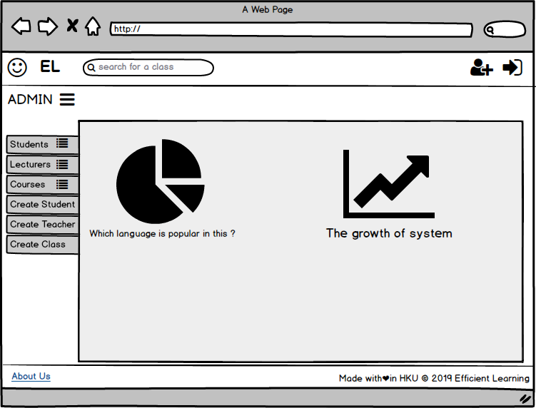

(Admin Index)

Figure 11

On the nav bar we have the same functionality which are the login button in order to go to the login page. When the admin click the button of students he will see the list of all the students and can update or delete the information of the teacher, that is shown on figure 12 below.

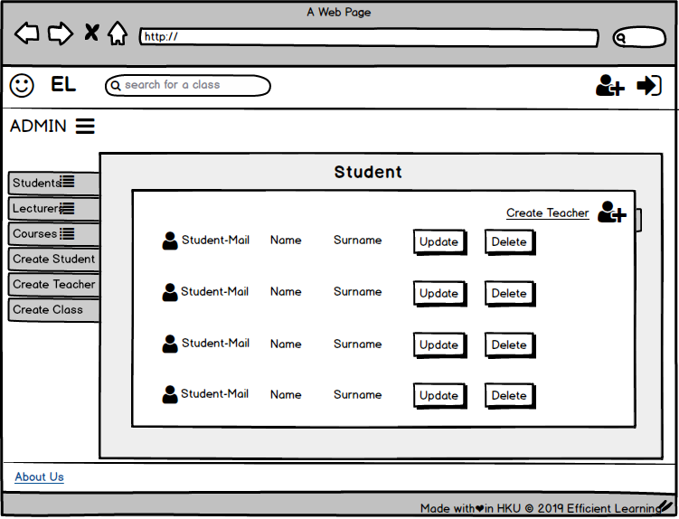

(Student List Admin)

Figure 12.

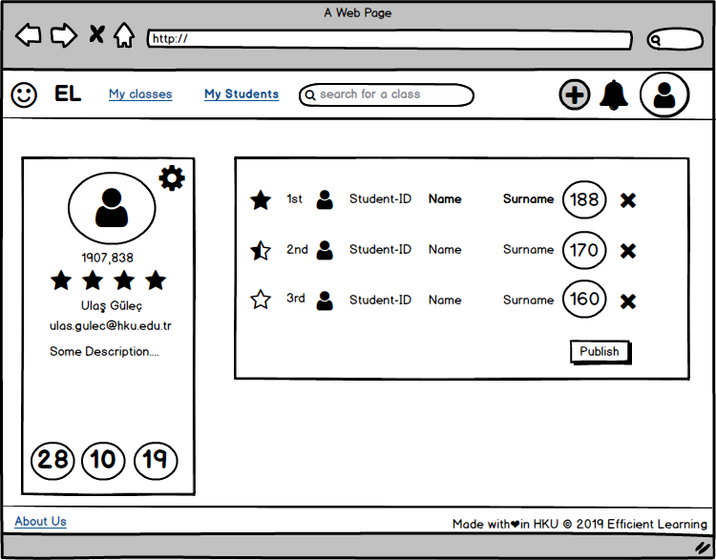

Figure 9

(Teacher Profile)

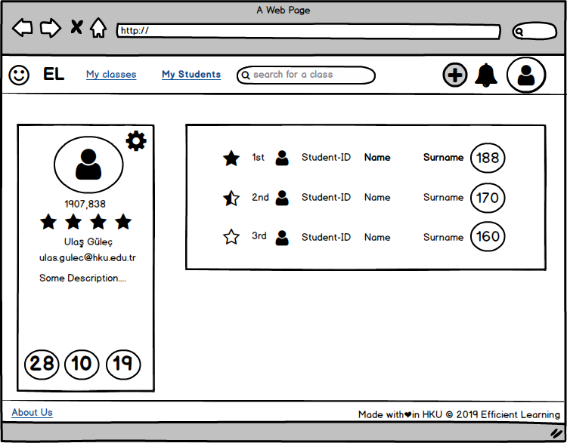

Figure 10

(Student List Seen By Teacher)

In order to update those information a popup form will be shown which is better than going to another page.

Another functionality that the admin can do as we can notice in the system is to see list of the classes in figure 13. The admin also can create a class when he click the button of creating class on the classrooms page, that button will lead to the page of creating a class as the lecturer does.

The same format is valid for the lecturer page as the student.

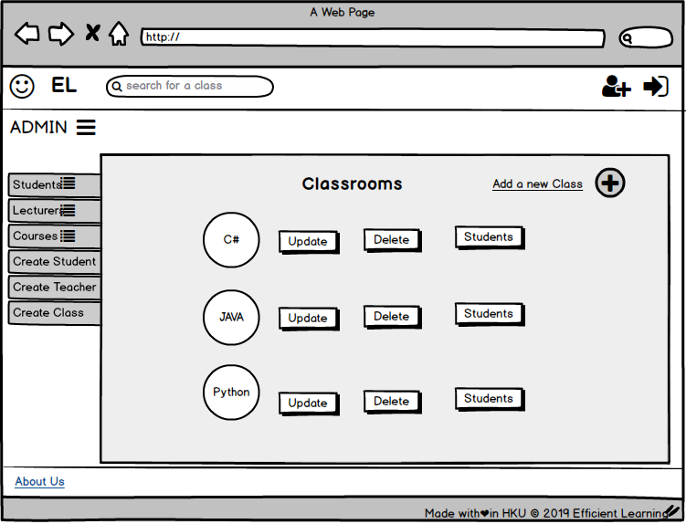

(Admin Classrooms list)

Figure 13.

The system will also have a mobile platform where we can see in the following figure 14. Three main difference is how the system is responsive but the functionality are same. For example in this figure below the homepage here instead contain the list of classes. We have three button same us the one we have in the web platform after the student login, he will view the categories of classes that are available has a button to see the classes that he is taking, notification and a view on his account.

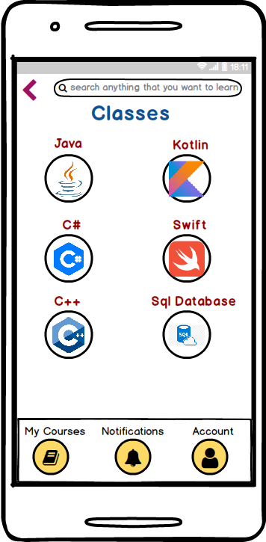

(Viewed Classes)

Figure 14.

In case that it is a teacher he will have one extra button “my Students” that will be use to see the list of student in his class. In addition they will be a button on top left to go back to the previous page. The teacher will be also be able to add class and task fig 17.

The notification button will go to the page where student will see alert of the any task given on figure 16.

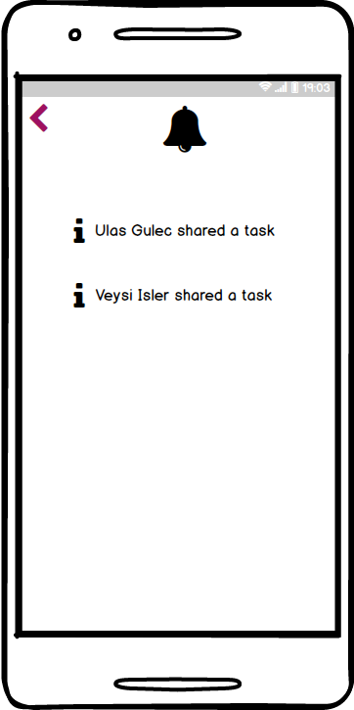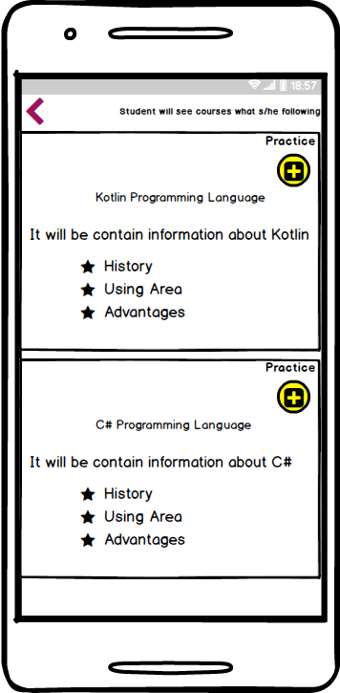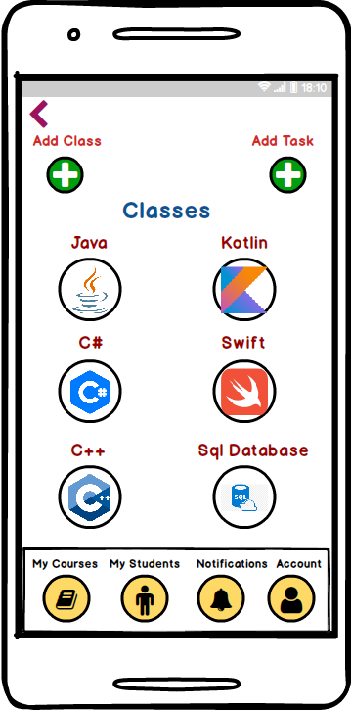

(List of Class) (Details of class) (Notifications)

Figure 15 Figure 16 Figure 17

As we notice on top figure 15 the button will go to the page to enable the teacher to be able to add the tasks and classes. In figure 17, when the student click to the class he will go to the page where he can see information about the class, and details, there is as well a button to go to the practice page.

## 4.2 Architectural Design

## 4.2.1 Class Diagram

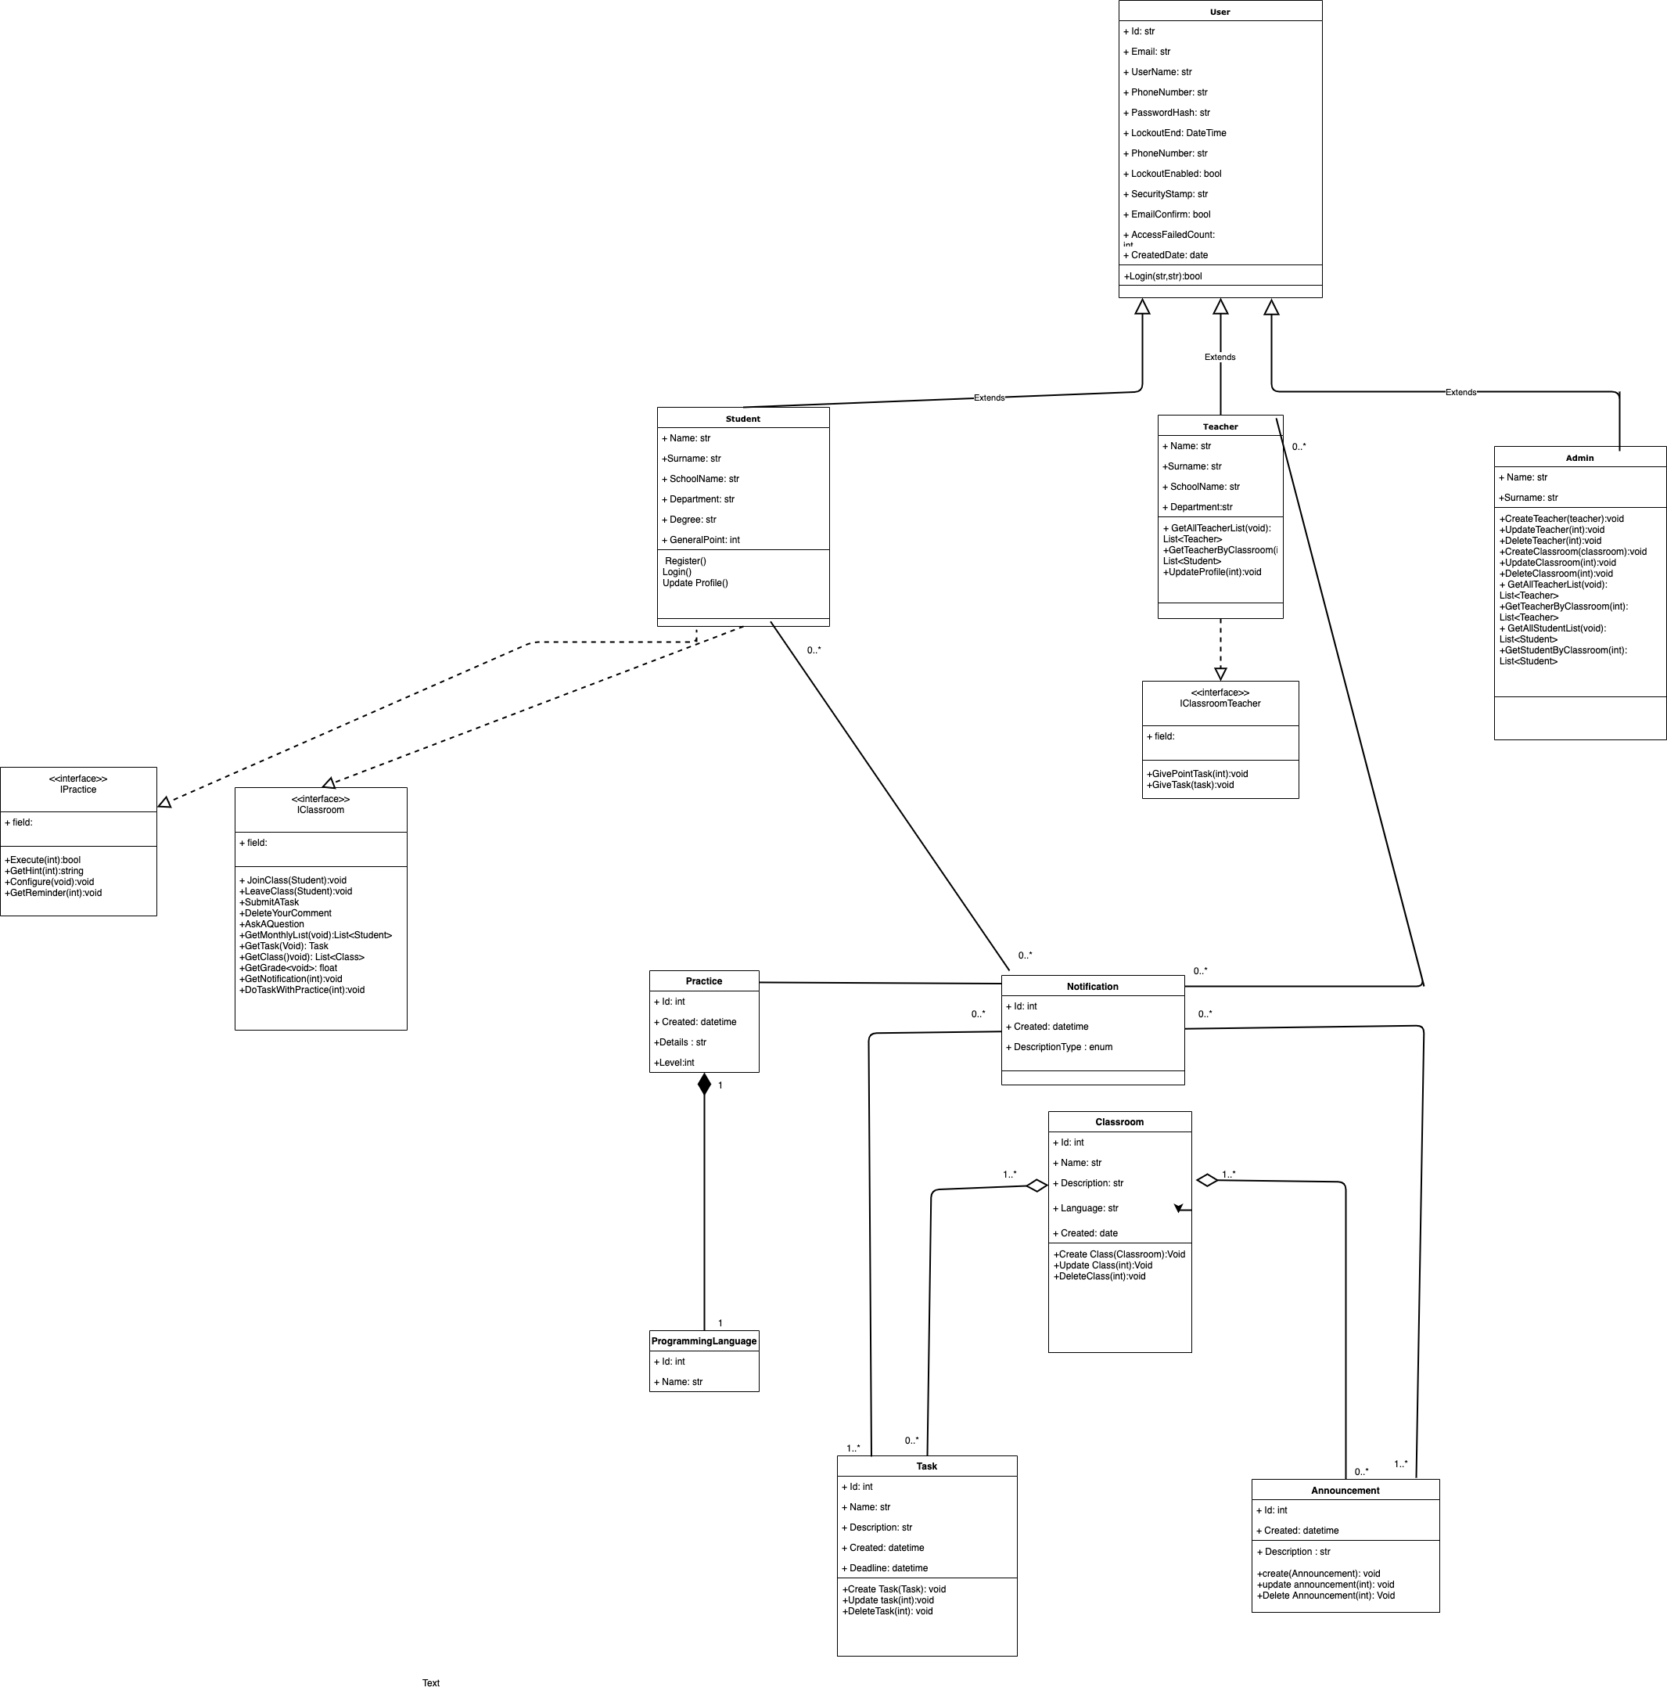

Figure 18

In Figure 18 we have we have the presentation of the class Diagram which shows the functionality of the system which classes we will use in order to build our application. This part is more technical issue.

We can see in here the reactions and which member of the system control any function in the system.

**4.4 ENVIROMENT**

**4.4.1 Modelling**

In this project, the functions, back-end which are used by Mobile and web application, were written in Asp.Net Core. Asp.Net Core is capable of writing a web service. For web user interface, Angular 8 is used to design of web application. For mobile application, Android studio which uses Java Language. we have two different environments which mobile and web.

In this document we will show 20 scenarios of the application.

1. In our scenario, admin log in the system with unique email and password.

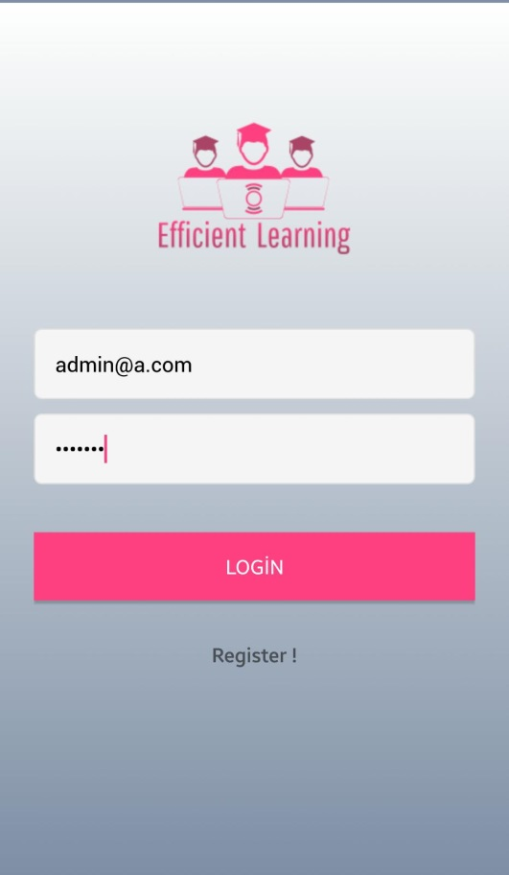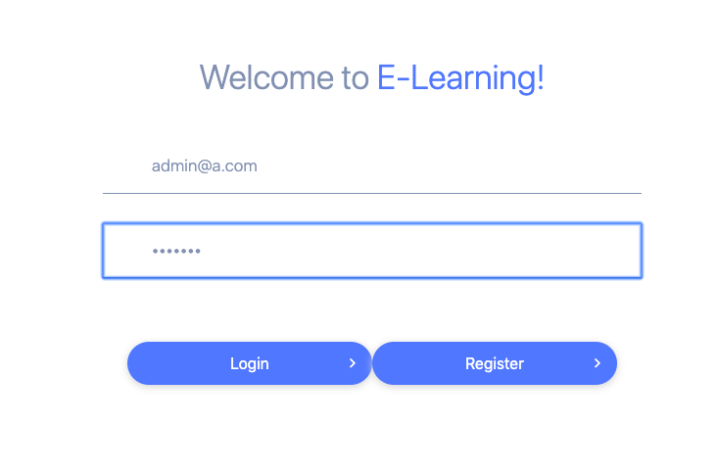

1. In our scenario as an admin, Firstly, admin creates a course called basic-python by choosing existing programming language python in the system. And admin names the course as Basic-Python. Then, admin lists the existing courses, admin can have the options to update and delete existing courses if admin wishes.

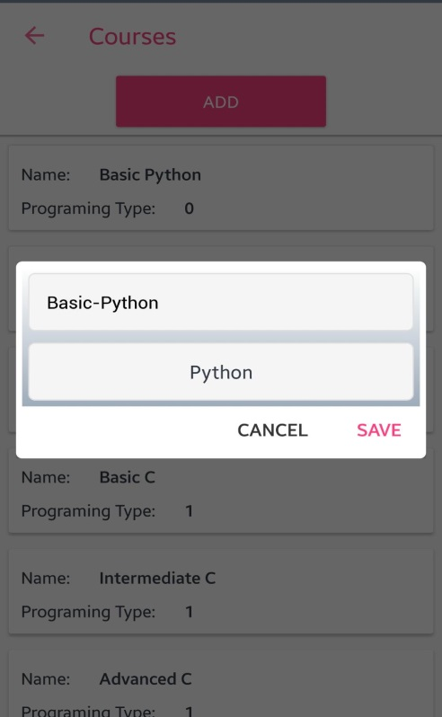

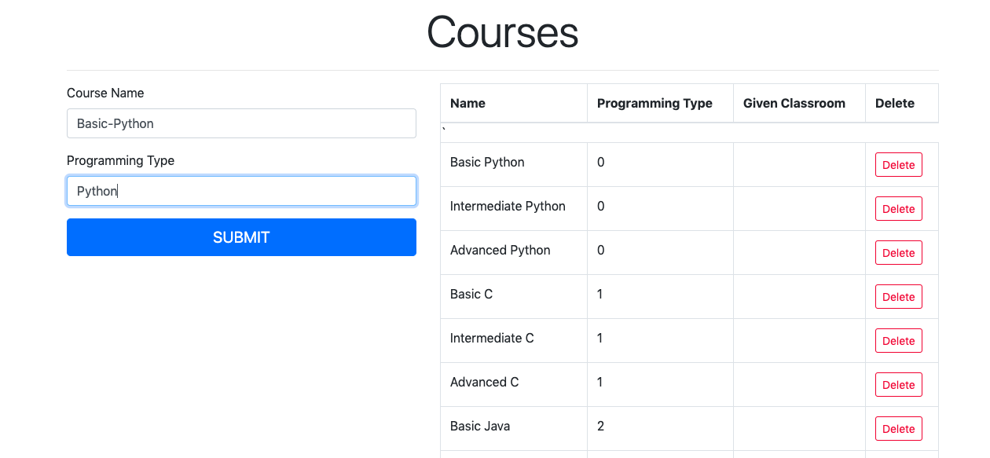

1. Admin creates a teacher whose email is ulasgulec@hku.edu.tr and with necessary fields. This means that there is not custom register for teachers. Then, admin lists the existing teachers, admin can have the options to update and delete existing teachers if admin wishes.

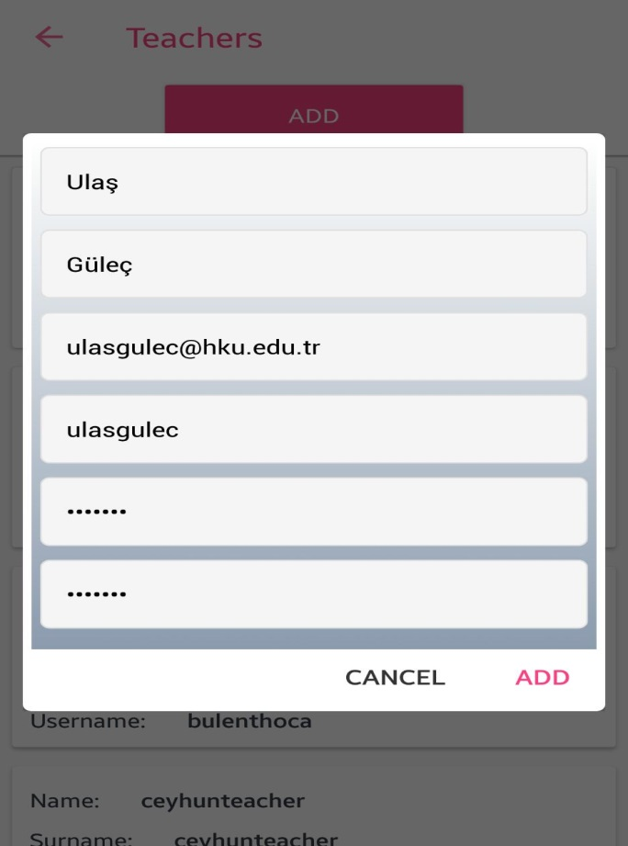

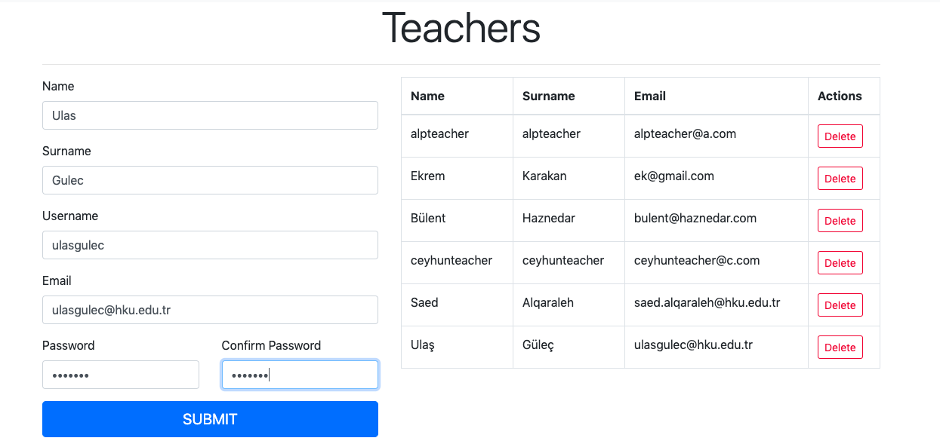

1. In our scenario the created teacher log in the system with his unique email and password.

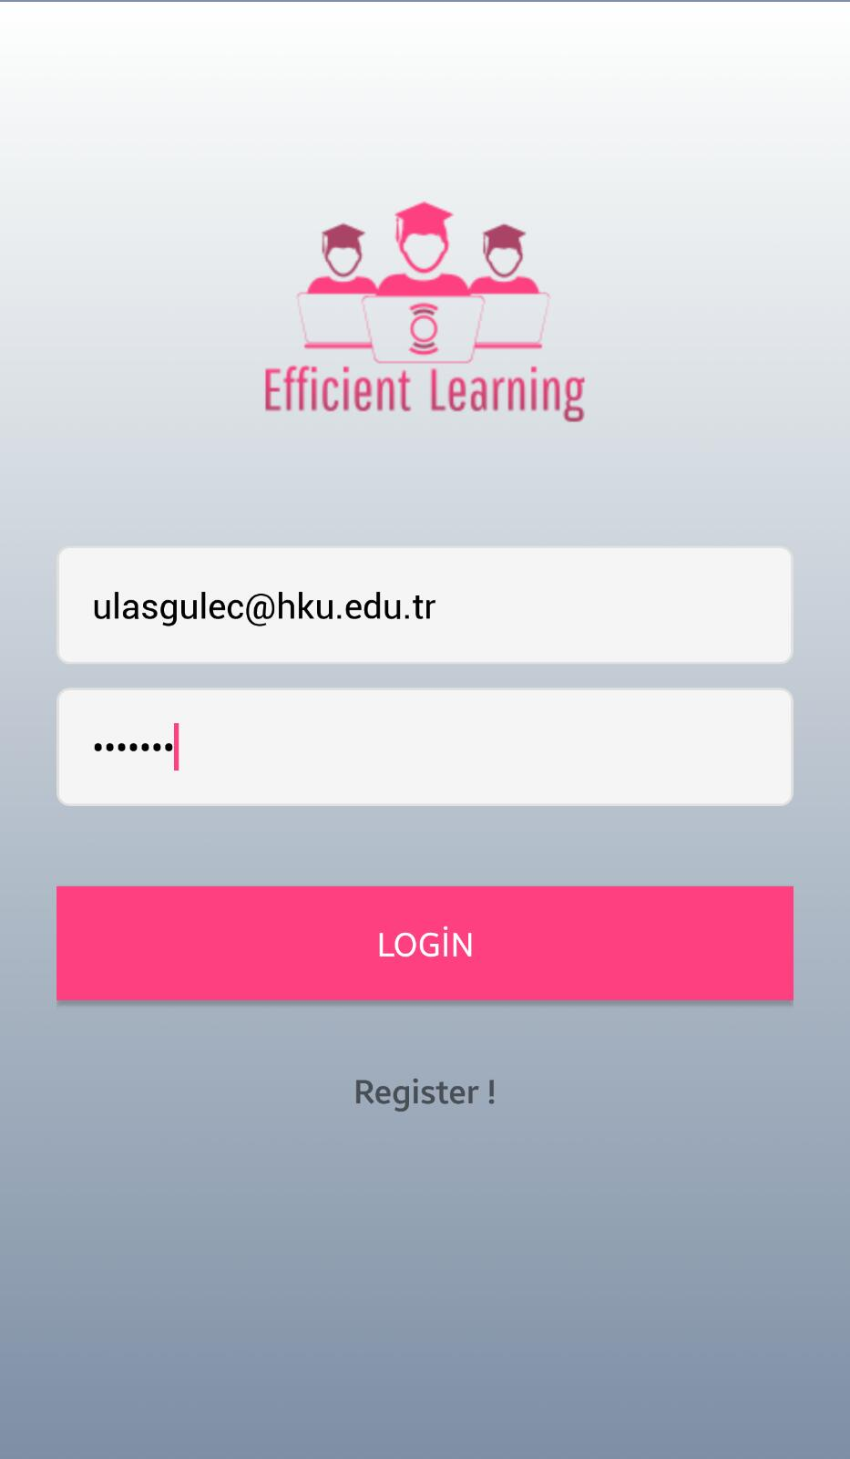

1. The created teacher Mr.Ulaş Güleç creates a classroom by choosing existing courses which are created by admin and name it. Then, he lists the his classrooms, he can have the options to update and delete existing classrooms if he wishes.

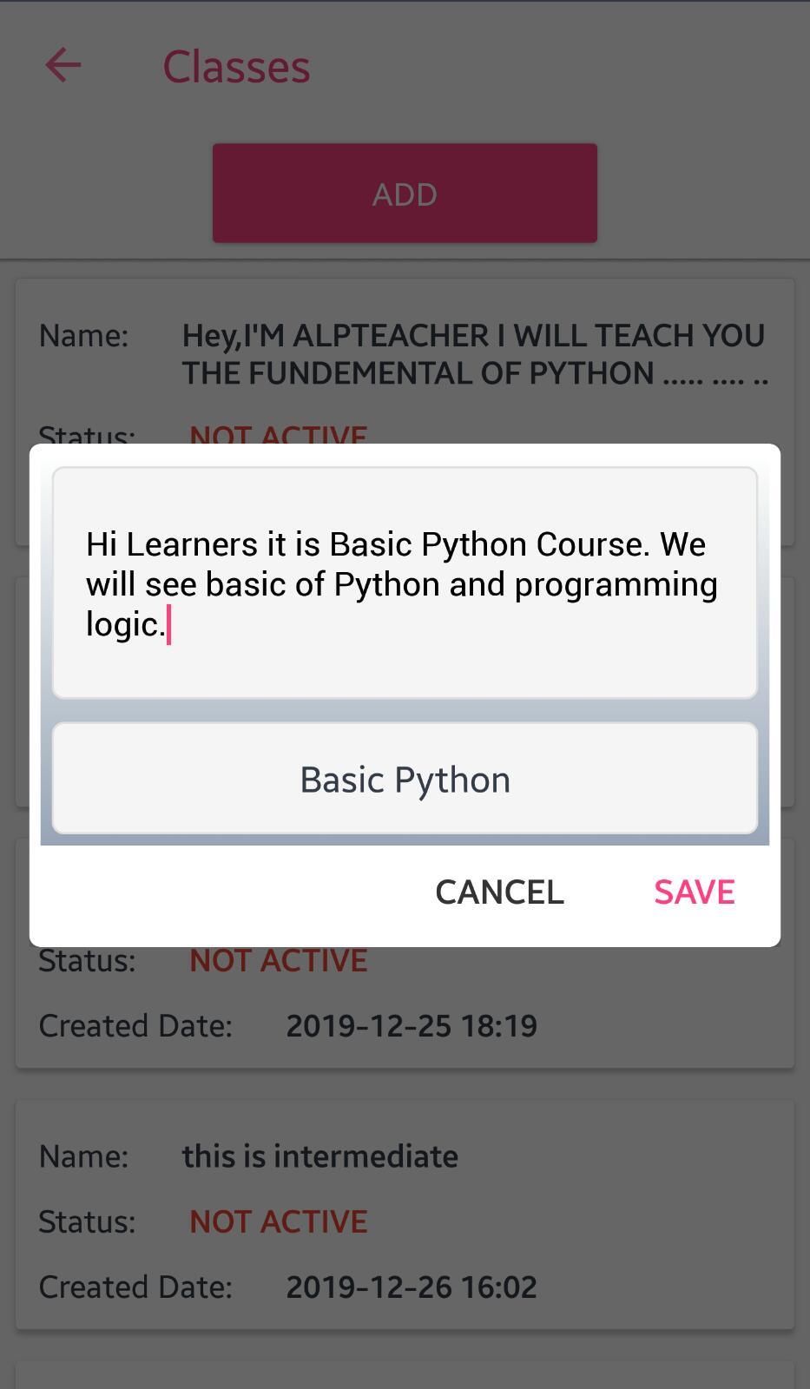

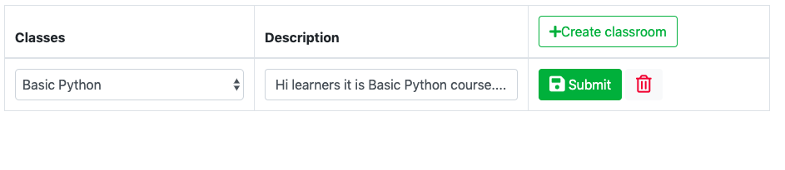

1. Meanwhile, the system gives a star to created teacher.

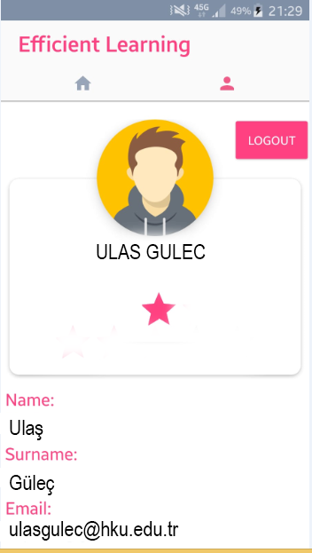

1. In classroom, created teacher shares a material as a task, with Material Scale, question, hint, description, deadline meanwhile, this material is published as announcement in the classroom. He can have the options to share a material as a type of question.

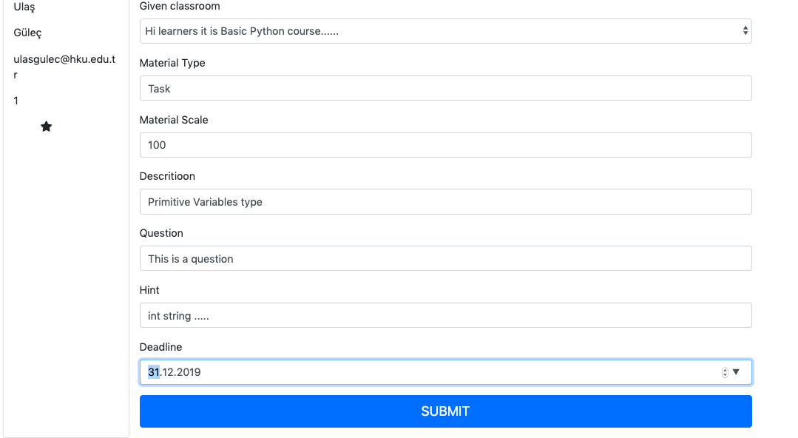

1. In classroom, created teacher shares a material as an announcement with some description to inform the students.

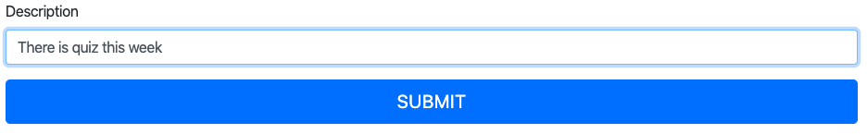

1. In our scenario as a student , student whose email is alpstudent@std.hku.edu.tr registers to the system by himself.

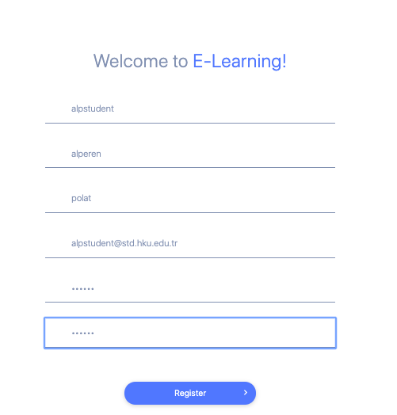

1. The registered student logs in the system with his unique email and password.

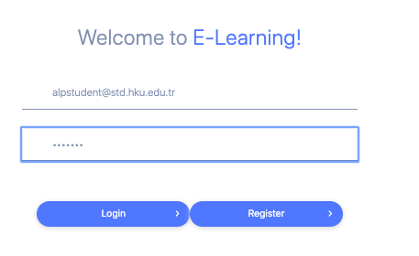

1. The index page welcomes the registered student. Registered student can see the popular classrooms which specify by the system in terms of the registered students of a classroom. If the registered student wants to join in a popular classroom. However, in our scenario, the registered students wants to do a search by writing “Basic Python” in search bar.

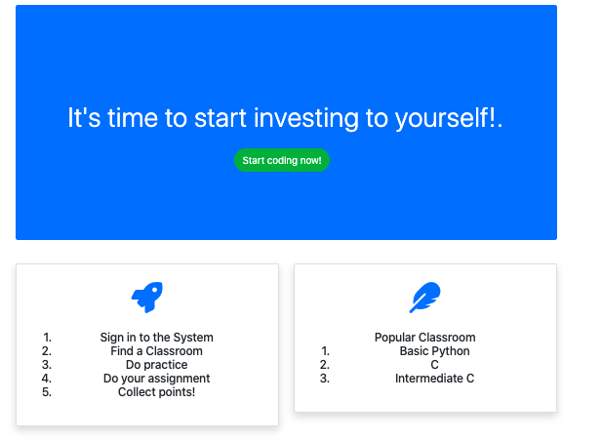

12. The registered student sees related classrooms in terms of search term.

C:\Users\alperen\AppData\Local\Microsoft\Windows\INetCache\Content.Word\w12.png

13. The registered student wants to join Mr. Ulaş Güleç’s classroom. He joins the classroom. And he sees the announcement.

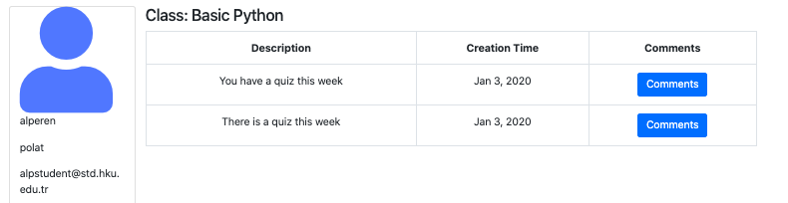

14. The registered student can comment that announcements and get a reply from the teacher as well. In that way teacher and student can communicate.

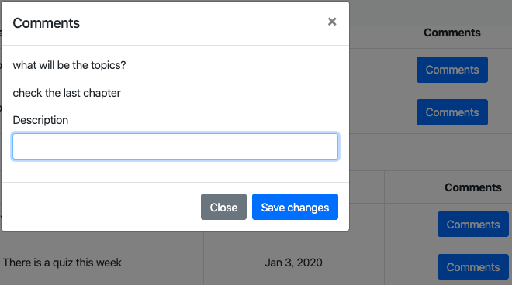

15. Meanwhile, the system gives him some point. The registered student sees that his general point is increased. The registered student gains stars in every 100 points.

In this scenario the student did two task where in the first he got 100 and second 150 points­

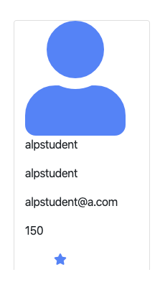

18. The registered student does practice in online practice application not to forget what he learned in classroom. The registered student starts to read the definition of level he learns and he pass the question then the registered student starts to apply steps in order. If his answer is correct he passes the level. If he wants, he can get a hint solve question.

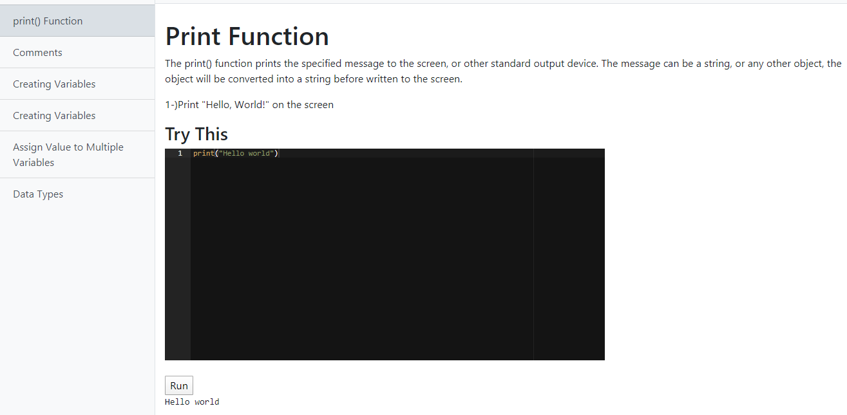

19. In our **Intelligent** **Notification scenario** as a student, the registered student gets a notification from his practice which he did before in terms of the number of doing practice. For example if he does first time , he will get notification after 2 minutes if he does second time, he will get after 4 minutes exponentially The formula is 2 power of the number of doing practice. Also, the students gets a notifications from new materials which is shared in his classrooms.

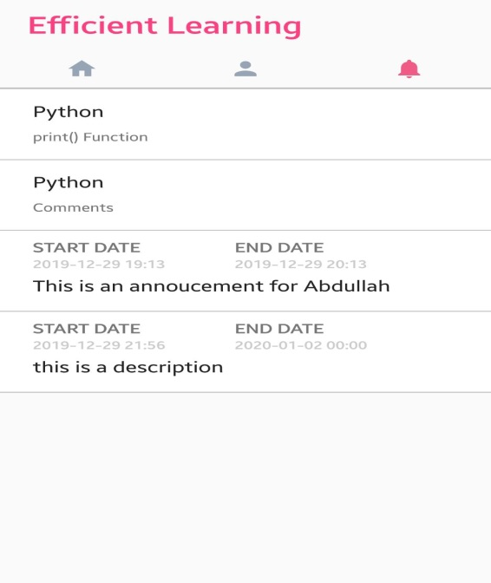

20. At the end of quizzes students will be graded and with using gamification the best student will receive a rosette in order to motivate him and other student.

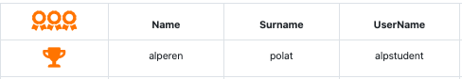

## 5. CONCLUSION

Nowadays, our lives are [affected](https://tureng.com/tr/turkce-ingilizce/be%20affected) by all the developed technologies that we easily have to owe. Most of people possess a cell phone, tablet, PC, or some other innovation. These devices allow instant connection with the universe. Our own lives have gotten totally subject to innovation, and training has not gotten away from types of equipment. Due to the availability of online programs and course contributions, education is getting increasingly more accessible to students who, since and life jobs, are more less to register in conventional classroom based programs.

**HASAN KALYONCU UNIVERSITY**

**Graduation Project in Computer Engineering Department Efficient Learning**

**2019-2020**

**FACULTY OF ENGINEERING**

**COMPUTER ENGINEERING DEPARTMENT**

**DEVELOPING EFICIENT LEARNING SYSTEM**

**GRADUATION PROJECT**

**IN**

**COMPUTER ENGINEERING**

**BY**

**MUSTAFA ALPEREN POLAT**

**ABDALLAH GUEYE**

**EKREM CEYHUN KARAKAN**

## 

## Appendix B: Efficient Learning System

**Efficient Learning System**

**Graduation Project**

**in**

**Computer Engineering**

**Hasan Kalyoncu University**

**Supervisor(s)**

**Ulaş Güleç**

**By**

**MUSTAFA ALPEREN POLAT**

**ABDALLAH GUEYE**

**EKREM CEYHUN KARAKAN**

## Appendix C: Copyright Page

© 2020

### Appendix D: Sample Approval Page

REPUBLIC OF TURKEY

HASAN KALYONCU UNIVERSITY

FACULTY OF ENGINEERING

COMPUTER ENGINEERING DEPARTMENT

Name of the Project: Efficient Learning

Name of the students:

MUSTAFA ALPEREN POLAT

ABDALLAH GUEYE

EKREM CEYHUN KARAKAN

Exam date:13.01.2020

I certify that this project satisfies all the requirements as a project for the graduation project

(Title and Name)

Head of Department

This is to certify that we have read this project and that in our consensus/majority opinion it is fully adequate, in scope and quality, as a project for the graduation project.

(Title and Name) (Title and Name)

Co-Supervisor (if co-supervisor exists)(Major) Supervisor

Examining Committee Members(**Title and Name-surname)** Signature

XXXX XXXX XXXXXXXX …………………..

XXXX XXXX XXXXXXXX …………………..

XXXX XXXX XXXXXXXX …………………..

XXXX XXXX XXXXXXXX …………………..

XXXX XXXX XXXXXXXX …………………..

### Appendix E. Sample Declaration Page

**I hereby declare that all information in this document has been obtained and presented in accordance with academic rules and ethical conduct. I also declare that, as required by these rules and conduct, I have fully cited and referenced all material and results that are not original to this work.**

**Name SURNAME**

**Signature**

## Appendix F: Sample Abstract

**ABSTRACT**

**DEVELOPING EFICIENT LEARNING SYSTEM**

# Abstract

# Since technology has entered our lives and even into our pockets, Online learning applications have been used not only individually but in a blending with the modern education system. However, online learning practices are focused on individual learning without any guidance, and there is no classroom environment in traditional learning practices. In addition, people do not have a fixed memory, reinforces and makes it permanent by repeating the work it learns. The purpose of this application is to create a classroom environment that does not in an online learning application and to receive notifications from smart reminders. In line with the practical tool by doing tasks and earn points to teach the target programming language.

# Özet

# Teknoloji hayatımıza hatta ceplerimize bile girdiğinden beri Online öğrenme uygulamaları sadece bireysel olarak değil modern eğitim sistemi ile harmanlanarak kullanılmaktadır. Ancak online öğrenme uygulamaları bir yol gösterici olmadan bireysel olarak öğrenme odaklıdır ve geleneksel öğrenme uygulamalarında olan sınıf ortamı bulunmamaktadır. Ve ayrıyetten insanoğlu sabit bir hafızaya sahip değildir öğrendiği işi sürekli tekrar ederek pekiştirir ve akılda kalıcı hale getirir.Bu uygulamanın amacı online bir öğrenme uygulamasında olmayan bir sınıf ortamı yaratmak ve öğrendiklerini unutmamak için akıllı hatırlatıcıdan gelen bildirimler doğrultusunda onlne pratik aracı ile görevlerini yaparak ve puan kazanarak hedef programlama dilini öğretmektir.

## Appendix H: Sample Dedication Page

## Appendix I: Sample Acknowledgements Page

**ACKNOWLEDGEMENTS**

We thank our Supervisor Dr Ulaş Güleç for supporting use in this project also for their guidance criticism encouragements and insight throughout the project.

## 6. REFERENCES

1. Gomes, Anabela, and António José Mendes. "Learning to program-difficulties and solutions." *International Conference on Engineering Education–ICEE*. Vol. 2007. 2007.
2. Allen, I. Elaine, and Jeff Seaman. "Digital Compass Learning: Distance Education Enrollment Report 2017." *Babson survey research group* (2017).
3. Khaleel, Firas Layth, Noraidah Sahari Ashaari, and Tengku Siti Meriam Tengku Wook. "An empirical study on gamification for learning programming language website." *Jurnal Teknologi* 81.2 (2019).
4. Cabada, R. Z., Estrada, M. L. B., Hernández, F. G., Bustillos, R. O., & Reyes-García, C. A. (2018). An affective and Web 3.0-based learning environment for a programming language. *Telematics and Informatics*, *35*(3), 611-628.
5. Chen, Chao-Cheng, Shu-Han Chang, and Emily Yang. "An e-Learning system for programming languages with semi-automatic grading." *2017 10th International Conference on Ubi-media Computing and Workshops (Ubi-Media)*. IEEE, 2017.
6. Pedregosa, Fabian, Gaël Varoquaux, Alexandre Gramfort, Vincent Michel, Bertrand Thirion, Olivier Grisel, Mathieu Blondel et al. "Scikit-learn: Machine learning in Python." *Journal of machine learning research* 12, no. Oct (2011): 2825-2830.
7. King, Davis E. "Dlib-ml: A machine learning toolkit." *Journal of Machine Learning Research* 10, no. Jul (2009): 1755-1758.
8. Trower, J., & Gray, J. (2015, February). Blockly language creation and applications: Visual programming for media computation and bluetooth robotics control. In *Proceedings of the 46th ACM Technical Symposium on Computer Science Education* (pp. 5-5). ACM.
9. Tundjungsari, V. (2016, February). E-learning model for teaching programming language for secondary school students in Indonesia. In *2016 13th International Conference on Remote Engineering and Virtual Instrumentation (REV)* (pp. 262-266). IEEE.
10. Tamhane, K. D., Wasim T. Khan, Sagar R. Tribhuwan, A. P. Burke, and S. B. Take. "Mobile learning application." *International Journal of Scientific and Research Publications* 5, no. 3 (2015): 1-4.
11. Ortiz, Octavio, Pedro María Alcover, Francisco Sánchez, Juan Ángel Pastor, and Ruth Herrero. "M-learning tools: The development of programming skills in engineering degrees." *IEEE Revista Iberoamericana de Tecnologias del Aprendizaje* 10, no. 3 (2015): 86-91.
12. Sierra, A. J., T. Ariza, F. J. Fernández-Jiménez, J. Muñoz-Calle, A. Molina, and Álvaro Martín-Rodríguez. "Educational resource based on games for the reinforcement of engineering learning programming in mobile devices." In *2016 Technologies Applied to Electronics Teaching (TAEE)*, pp. 1-6. IEEE, 2016.
13. Skalka, J., & Drlík, M. (2017, November). Conceptual framework of microlearning-based training mobile application for improving programming skills. In *Interactive Mobile Communication, Technologies and Learning* (pp. 213-224). Springer, Cham.
14. Tsai, Chun-Yen. "Improving students' understanding of basic programming concepts through visual programming language: The role of self-efficacy." *Computers in Human Behavior* 95 (2019): 224-232.
15. Yan, Yu, Hiroto Nakano, Kohei Hara, Takenobu Kazuma, and Aiguo He. "A Web Service for C Programming Learning and Teaching." In *2016 10th International Conference on Complex, Intelligent, and Software Intensive Systems (CISIS)*, pp. 414-419. IEEE, 2016.
16. Tlili, A., Essalmi, F., & Jemni, M. (2015, July). A mobile educational game for teaching computer architecture. In *2015 IEEE 15th International Conference on Advanced Learning Technologies* (pp. 161-163). IEEE.
17. Appleton, Joe. "Introducing intelligent exercises to support web application programming students." (2017): 216-225.
18. Hung, Patrick, Jeanne Lam, Chris Wong, and Tyrone Chan. "A study on using learning management system with mobile app." In *2015 International Symposium on Educational Technology (ISET)*, pp. 168-172. IEEE, 2015.
19. Mahdi, A.O., Alhabbash, M.I. and Naser, S.S.A., 2016. An intelligent tutoring system for teaching advanced topics in information security.
20. Chaudhary, Vidushi, Vishnu Agrawal, Pragya Sureka, and Ashish Sureka. "An experience report on teaching programming and computational thinking to elementary level children using lego robotics education kit." In *2016 IEEE Eighth International Conference on Technology for Education (T4E)*, pp. 38-41. IEEE, 2016.
21. Staubitz, Thomas, Hauke Klement, Ralf Teusner, Jan Renz, and Christoph Meinel. "CodeOcean-A versatile platform for practical programming excercises in online environments." In *2016 IEEE Global Engineering Education Conference (EDUCON)*, pp. 314-323. IEEE, 2016.
22. Al Rekhawi, Hazem Awni, and Samy S. Abu Naser. "An Intelligent Tutoring System for Learning Android Applications Ui Development." *International Journal of Engineering and Information Systems (IJEAIS)* 2, no. 1 (2018): 1-14.
23. Urh, M., Vukovic, G., & Jereb, E. (2015). The model for introduction of gamification into e-learning in higher education. *Procedia-Social and Behavioral Sciences*, *197*, 388-397.
24. Harandi, Safiyeh Rajaee. "Effects of e-learning on Students’ Motivation." *Procedia-Social and Behavioral Sciences* 181 (2015): 423-430.
25. Salajegheh, Ali, Alborz Jahangiri, Elliot Dolan-Evans, and Sahar Pakneshan. "A combination of traditional learning and e-learning can be more effective on radiological interpretation skills in medical students: a pre-and post-intervention study." *BMC medical education* 16, no. 1 (2016): 46.
26. Seneviratne, O. (2017). Making computer science attractive to high school girls with computational thinking approaches: A case study. In *Emerging research, practice, and policy on computational thinking* (pp. 21-32). Springer, Cham.
27. Iftakhar, Shampa. "Google classroom: what works and how?." *Journal of Education and Social Sciences* 3.1 (2016): 12-18.
28. Wang, A. I. (2015). The wear out effect of a game-based student response system. *Computers & Education*, *82*, 217-227.
29. Sun, Yu-Chih, and Fang-Ying Yang. "I help, therefore, I learn: service learning on Web 2.0 in an EFL speaking class." *Computer Assisted Language Learning* 28, no. 3 (2015): 202-219.
30. Niemi H, Multisilta J. Digital storytelling promoting twenty-first century skills and student engagement. Technology, Pedagogy and Education. 2016 Aug 7;25(4):451-68.
31. (Elpidorou, A. (2018). The good of boredom. *Philosophical Psychology*, *31*(3), 323-351.)
32. (Respondek, L., Seufert, T., Stupnisky, R., & Nett, U. E. (2017). Perceived academic control and academic emotions predict undergraduate university student success: Examining effects on dropout intention and achievement. *Frontiers in psychology*, *8*, 243.)
33. (Bieg, S., Grassinger, R., & Dresel, M. (2019). Teacher humor: Longitudinal effects on students’ emotions. *European Journal of Psychology of Education*, *34*(3), 517-534.)
34. (Baudoin, N., & Galand, B. (2017). Effects of classroom goal structures on student emotions at school. *International Journal of Educational Research*, *86*, 13-22.)
35. (Dugan, R., Zhang, C., Kellaris, J., & Sweeney, R. (2019). TAMING THE ELEPHANT IN THE (CLASS) ROOM: EXPLORING ROOT CAUSES OF STUDENT BOREDOM. *Marketing Education Review*, 1-16.)
36. (Araya, R., Farsani, D., & Hernández, J. (2016, September). How to Attract Students’ Visual Attention. In *European Conference on Technology Enhanced Learning* (pp. 30-41). Springer, Cham.)  
    (Hootstein, E. W. (1994). Motivating middle school students to learn. *Middle School Journal*, *25*(5), 31-34.)
37. (Otter, R. R., Seipel, S., Graeff, T., Alexander, B., Boraiko, C., Gray, J., ... & Sadler, K. (2013). Comparing student and faculty perceptions of online and traditional courses. *The Internet and Higher Education*, *19*, 27-35.)
38. (Khan, A. I., Al-Shihi, H., Al-Khanjari, Z. A., & Sarrab, M. (2015). Mobile Learning (M-Learning) adoption in the Middle East: Lessons learned from the educationally advanced countries. *Telematics and Informatics*, *32*(4), 909-920.)
39. (Tseng, H., & Walsh Jr, E. J. (2016). Blended vs. Traditional Course Delivery: Comparing Students’ Motivation, Learning Outcomes, and Preferences.)
40. (Lo, C. K., & Hew, K. F. (2018). A comparison of flipped learning with gamification, traditional learning, and online independent study: the effects on students’ mathematics achievement and cognitive engagement. *Interactive Learning Environments*, 1-18.)
41. Interpersonal Influences and Educational Aspirations in 12 Countries: The Importance of Institutional Context Author(s): Claudia Buchmann and Ben Dalton
42. THE LONG RUN IMPORTANCE OF SCHOOL QUALITY Eric A. Hanushek
43. What is Education For? On Good Education, Teacher Judgement, and Educational Professionalism Gert Biesta.

Table of Contents

Abstract 3

Özet 3

2.2 Background and Related Work 5

2.3 How to make student attractive to the Class 7

2.4 Why Class are not interesting to the student? 8

2.5 Importance of Education 9

3. SOFTWARE REQUIREMENT SPECIFICATION 10

3.1 Introduction 10

3.1.1 Purpose 10

3.1.2 Scope of the Project 10

3.1.3 Overview of the Document 11

3.2 Overall Description 11

3.2.1 Product Perspective 11

3.2.1.1 Development Methodology 11

3.2.2 User characteristics 11

3.3 Requirement Specifications 12

3.3.1 External Interface Requirements 12

3.3.1.1 User Interface Requirements 12

3.3.1.2 Software Interface 12

3.3.1.3 Hardware Interface 12

3.3.1.4 Communication Interface 12

3.3.2 Functional Requirements 12

3.3.2.1 Admin Use Case 12

Use Case 12

Diagram 12

Brief Description 13

Initial Step by Step Description 13

3.3.2.2 Lecturer Use Case 13

Diagram 14

Brief Description 14

Initial Step by Step Description 14

3.3.2.3 Student Use Case 15

Diagram 16

Brief Description 16

Initial Step by Step Description 16

3.3.3 Non Functional Requirements 17

4. SOFTWARE DESIGN DOCUMENT 17

4.1 Introduction 17

4.1.1 Purpose 17

4.1.2 Scope 17

4.1.3 Overview of the Document 18

4.1 System Design 18

(Index) 18

Figure 1. 18

4.2 Architectural Design 27

4.2.1 Class Diagram 27

5. CONCLUSION 42

Appendix B: Efficient Learning System 44

Appendix C: Copyright Page 45

Appendix D: Sample Approval Page 46

Appendix E. Sample Declaration Page 47

Appendix F: Sample Abstract 48

Abstract 48

Özet 49

Appendix H: Sample Dedication Page 50

Appendix I: Sample Acknowledgements Page 51

6. REFERENCES 54