-------------------------------------------

Software Requirements Specification

for

Efficient Learning

Prepared by Mustafa Alperen Polat

FenerDevs

05.01.2021

Table of Contents

Revision History 2

1. Introduction 3

1.1. Purpose of Project 3

1.2. Target sector or users 3

1.3. What is the Scope of project? 3

1.4. References 4

2. Overall Descriptions 7

2.1. Product Perspective 7

2.2. Product Features 7

2.3. User classes and characteristics 8

2.4. Operating Environment 8

2.5. Design and implementation constraints 9

2.6. Assumptions and dependencies 9

3. System Features and Requirements 9

3.1 Functional Requirements and System Features 9

4. External Interface Requirements 14

4.1. User interfaces 14

4.2. Hardware Interfaces 15

4.3. Software interfaces 15

4.4. Communication interfaces 15

5. Non-Functional Requirements 15

5.1. Performance requirements 15

5.2. Safety requirements 15

5.3. Security Requirements 15

5.4. Software Quality Attributes 15

*Appendix A*: Definitions and Acronyms 15

Appendix B: Analysis Models 16

# Revision History

|  |  |  |  |
| --- | --- | --- | --- |
| **Name** | **Date** | **Reason For Changes** | **Version** |
|  |  |  |  |
|  |  |  |  |

# Introduction

This document is the software requirement specification document for the project titled as “Efficient learning”. The goal of the project is to facilitate student learning programming languages and improve their skills in programming as well.

## 1.1. Purpose of Project

The application is made for the purpose of training student to be able to manage programming language and improve their skill as online.

First problem is that traditional education might be difficult for the student to manage and understand it well. Second problem is that they forget what they learnt before.

The background of first problem is that traditional classes are not interesting to the student The background of second problem is that students do not repeat what they do.

To solve first problem, we created virtual classroom environment. Thus, teacher can share tasks and students can answer these tasks. If a student wants to do practice, student can do practice via online practice tool. To solve second problem, when the student did a practice, the student will get a notification not to forget.

## 1.2. Target sector or users

Who will use your project and why they need this project?

Anybody who would like to learn the fundamental of programming can use this project as student. Thus, somebody can learn programming easily.

## What is the Scope of project?

We first have levels where for example the first section is defining a variable and the last section is asynchronous methods, in addition to that there will be an online interpreter and editor to allow the student to write code. This system will allow student to communicate between each other according to the instructions and to help each other when they face a problem, also they going to be given some hint in order to get helped. After solving problems and passing levels student will get notifications in order to practice and not forget what he has study and will be redirected to the related section. Moreover there will be an intelligent repeat engine that finds the missing points of the student. Therefore, the system can observe how student can increase their knowledge levels about the basic tasks of programming languages. Apart from practicing and interaction with the teacher and other student, they will be a rewarding that will be display in the score table, and announce the champion at the end of the month. In this way a competition will be established between the student and make the learning more fun.

There are three participant in the application which are: admin, lecturer and student.

-The admin is responsible for adding lecturer adding student, deleting them and updating their information as well he is the one that has access on everyone.

-The lecturer is responsible for giving the tasks grading the student and putting the reward list of student, in summary he will be the one that will practically make the system interactive, having actions work practice exercise. We can add to that, the fact of communicating with the student sending him notifications and helping if there is any need for that.

-The student is the one executing the tasks given by the lecturer, as we explain on top he will be learning and communicate and help his other friend, that will make him get points in addition to his accomplish tasks.

## 1.4. References

When it comes to related work, they are many studies which teach programming languages via e-learning software and being able to check the progress of the student, whether he is gaining from what he is learning, after he has been given exercises.

Lih Shyang, Emily principle and a few different authors in IEEE has developed Associate in Nursing E-Learning System for programming languages with semi-automatic grading. The system cash in of pc and Network technologies and combines the construct flipped room to assist pedagogue and their student teaching in additional economical manner.

The related works does not only concern this type of programming language, we also have one other studies about machine learning since computer science is a large domain of work, this one is a platform called Scikit-Learn, which is a python module .

This is system was build in such a way that even those who are not specialist in Python will be able to learn from that module. There are many other toolkits which provide sup-port for developing machine learning application for this one call Dlib-ml it is a cross plat-form open source software, it also contain many toolkit such as Linear Algebra, which can really help the student improve not only in programming. We can add to these another appli-cation which is for Visual programming for Media Computation and Bluetooth robotic con-trol, this application shows how new blocky language are created as well as showcasing these languages as new educational environment.

In order to be more basic we have other e-learning application to teach the course of Introduction to Programming, in wherever the scholar get the thought and ideas of programming, for that reason model are develop to teach faster and with competence.

In addition to similar studies we also have mobile application that teaches programming languages or let’s say improve student’s skill in programming, by using different approaches like multimedia concept animation with query languages to create the pervasive learning surroundings, with this application student can learn anytime and according to their own scheduling.

Another mobile application or m-Learning, for higher education, that use as well different approaches and aim, is here measuring the level or degree of students, for mobile de-vices, same as in our application this application give some activity to the student to keep him

on practicing and allow the teacher to have the opportunity of monitoring the student and see in which programming language he success more, and of course will give feedback to our application .

Sticking in the language is not just enough to be able to build something as a programmer, orienting himself or herself in the language is also part of the work, such as learning to build can android app is also one of the technologies implemented for educational resource.

Next is also another framework of a mobile application to improve programming skills as well where this one is a Microlearning - Based training it integrate into the benefits of e-learning environment, this study propose to learn anytime and anyplace with urgent feedback and also some gamification features, with the aim of developing motivation of students and a community of work to improve programming skills.

Another used application which is also concerning even those who didn’t study computer science help them to improve their skills in programming, this program include sequence, condition and loop. It improve learners to understand the basic of computer programming, especially for those with moderate and self-efficacy .

To continue with the basic of programming, one of the language which most university start with tot teach student is C, but this program is sometimes quiet difficult to manage using traditional learning, for that reason some research aim to develop a better way to teach it with Programming visualization Tool for web which has many features like being run with-out installing an IDE shows the execution of C programming and finally detect run time error.

The idea of our application does not only concern the programming languages, which will let us introduce other related work, like the mobile application that teach computer archi-tecture, under favor of the new technology of mobile which permit us to be able to learn or for this type of course which is traditional and solid using the tradition way in classroom. Indeed this application is implemented with Game that allow learner to understand the subject with more fun [16].

Thanking mobile for its new technologies, we have as well again other application to teach mobile apps such as IOS and Android at same time with highlighted quality on the User Interface depending on the student.

Another application which is composed of gamification as well is one of our related work, but this time include intelligent exercise to support web application programming student.

In recent years, there is a growing technological development in intelligent tutoring systems, it targets the student enrolled in Information Security and Information security. We can add to these another concept of learning via Visual programming environment, this application aimed to teach analytical thinking and problem solving, team-work and project management skills, they teach designing to student and programming robots using sensors, connectors, gears etc. Student gained as well the concept of basic programming like loop, branches, condition etc.

Another application called Code Ocean has been implement online, in order to teach student how to program and being able to compile online with here downloading any IDE as well. The program provide to student feedback as well and some practice exercises.

Due to the fact that android application are used a lot another application has been developed in order to teach how to develop itself android app and amazing user interface, the system represent a topic of android application development and administers automatically generated issues for students to solve, also the system is automatically adapted at runtime to the student’s personal growth, this is done using intelligent tutoring.

At last one of the most popular application that everyone uses almost is the Google classroom, which is a Virtual classroom online, that allow participant to communicate view presentations or videos, and interact with the other participant.

# 2. Overall Descriptions

## 2.1. Product Perspective

This application as we said in our introduction is divide into modules: Practice, Re-minder, Rewarding, Tasking and Student Portal.

In the practice section, student will be able to develop using interpreter and editor. He will be able to answer questions and help other student accordingly to the task give,

When it comes to reminder when the student complete his task he will receive notification about his recent task and will be passed to the next level of the system.

For the rewarding, in order to motivate student, at the end of every month, they will be champion which will be the student who has done more effort and has solved the problem more correctly compare to others.

The Tasks will be assign by the teacher, and hint will be given according to the exercise level.

At last, when student has problem in one task he or she can share his problem with the other student, where the one that has answer correctly and help will get some bonus point.

## 2.2. Product Features

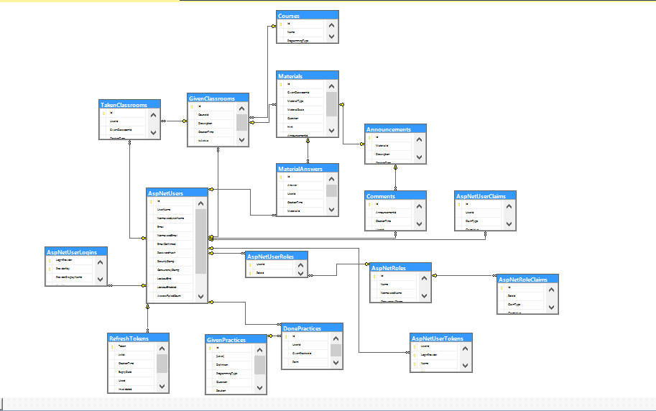

## 2.3. User classes and characteristics

An online efficient learning system require three distinct users:

***The Admin*** must control all the system who is in the system what work does he do in the sys-tem and the system should work, all that functionalities are controlled by the admin.

***The Teacher*** is the one giving the courses to student he will be responsible of all interaction between courses and student.

***The Student*** his only responsibility is to follow the courses and do the task that are required for him, he is free to choose an course that he would like to learn

## 2.4. Operating Environment

Describe the all materials to develop your product. (Operating system, programming language, target platforms, database etc.)

For Back-end Web API: We used asp.net core, which is a web-development framework, in back end technology. We created a restful API which serves my client side. Also, I have developed a database on asp.net core thanks to its nice features. I preferred using multitier architecture that provides multilayer programming. Thus, we avoid complexity of code and. It provides reusable, maintainable codes. Most of my end points handles database according to inputs. We used C# as programming language.

For Database: We used MSSQL express.

For Web Front-end: We used Angular which you can develop single page application.

For Mobile Front-end: We used java on android studio.

## 2.5. Design and implementation constraints

Give constraints to run or use your product. E.g. you need windows 10 or linux operating system. Android 4.4 etc.

You need a browser for web application.

You need an android mobile phone for mobile app.

## 2.6. Assumptions and dependencies

Write the dependencies and risks of your product. E.g. internet connection lost?

You need internet connection for both application which are mobile and web. Also, you must have Android OS over 4.4 version.

# 3. System Features and Requirements

## 3.1 Functional Requirements and System Features

Write all the functions for each class. Explain all functionalities of your product in this section. E.g. admin (crud operations), user (buy, sell, read), reservation system (date, prices etc.)

**Admin Use Case**

Use Case

• Login

• View List of Teachers

• View List of Student

• View Courses List

• Create Teacher

• Update Teacher

• Delete Teacher

• Create Class

• Update Class

• Delete Class

Brief Description

Admin is responsible for controlling all the system and users that interact with it. He can add, delete and update the users.

Initial Step by Step Description

1. Admin will login to the system as all the other user

2. From here he will have several choice after login and view

2.1. Admin is able to see all student in the system including their information their class and course that they are taking.

2.2. Admin will be able as well to see also teachers list in the system including the courses that they are giving and details of their information.

2.3. Admin will see list of the courses given by the teacher and details of the course.

2.4. Admin can create teacher for the system to teach students, the admin will be the one having access to the teacher information.

2.5. Admin can update lecturer information.

2.6. Admin can delete lecturer information.

2.7 Admin can create class, he can include new class in the system, for the lecturer to be able to teach them, or if they think some class are missing in the system or required, admin can add them.

2.8. Admin can update the class information.

2.9. Admin can delete classes if there is no need for the class to exist.

2.10. And finally for sure admin can login to the system.

**Lecturer Use Case**

Use Case

• Login

• Create Class

• Create Task

• Publish List

• View Profile

• See Classes

• See Students

• See grading List

• Grade Tasks

• Send Notifications

• Update Class

• Delete Class

• Create Announcement

• Update Announcement

• Delete Announcement

Diagram

Brief Description

Lecturer, is the one responsible for giving the classes, and finding the best way to improve the student skills and be able to learn the programming languages.

Initial Step by Step Description

3. Lecturer can create class that he will give to the student and put the details of the class while creating them.

4. Lecturer can give a task that student will submit after he has done it, he will as also give a deadline to the task he has given.

5. Lecturer will also publish list of the student grading, after end of each month, the student will be graded and of a list will be publish showing the best student of the month.

6. Lecturer will also see his profile and his progress also number of student will be shown, also number of given task.

7. Lecturer will also see the list of the student in the system, the student that are taking his courses.

8. The lecturer will also see the list of the graded student he has publish, since it will be an announcement he will have access to that page and see the list.

9. After giving a task lecturer will be able to grade the tasks he has given to the student.

10. Lecturer will send notifications to the student that he can see the tasks or being remind about the task he was given.

11. Lecturer will be able to update information of the class.

11.1 Lecturer will be able to delete classes he is giving or if he thinks this class is not necessary.

12. Lecturer can create announcement in case there is any update in the task given or class.

12.1. Lecturer can update the task information.

12.2. Lecturer can delete the task information.

12.3. Lecturer can delete the task information.

**Student Use Case**

Use Case

• Login

• Register

• Edit Profile

• See assigned task

• See progress

• See profile

• Join Class

• Submit Task

• Run Code on Editor

• See purchased class

• See hint

• See code output

• See grading List

• Leave class

Diagram

Brief Description

The student is the most active in the class, he is the one doing most of the interaction in the system.

Initial Step by Step Description

13. Student can register to the system, by entering his name, surname, email and password and other information

14. Student can edit his profile information

15. Student can join a class in order to understand the topic before doing the task

16. After doing his task student can submit it to the system for the teacher to see his work.

17. In order to write his code student can use editor for it so he will be able to write his code and get error from the editor he is writing.

18. Student can see the class that he is purchasing, there is general class and the one that he is taking, so in here h will view the one he is taking.

19. Student will also see list of tall the classes given by the system

20. Student can also see the hint while he doing the practice on the editor

21. There will be output on the editor, that student will see to check if his program work properly

22. Student can see the list of the month which going to contain average grade of his work and will see his rank on the system

23. Student can leave the class, like a logout from the class after he finish learning this class.

# 4. External Interface Requirements

## 4.1. User interfaces

Front-end software? (Angular) Back-end software? (.Net)

We used Angular for web front-end and used Java for mobile front-end. We used asp.net core for back-end.

## 4.2. Hardware Interfaces

There are no hardware interface requirement.

## 4.3. Software interfaces

There are no software interface requirement.

## 4.4. Communication interfaces

There are no communication interface requirement.

# 5. Non-Functional Requirements

## 5.1. Performance requirements

This system include interaction between the student and the teacher so his response time must be fast and efficient.

## 5.2. Safety requirements

The application is also secure and has some privacy each user can access only to his per-sonal data, but not other user data.

## 5.3. Security Requirements

The password of the user will be encrypted in such a way it will be difficult for anyone to find it will be at least six characters and should contain capital letter.

This application work with an online editor so in case there is no internet, and since the editor will be develop using JavaScript, the information will be save inside a cookie so that when the user reconnect he can get his data back.

## 5.4. Software Quality Attributes

The application can be used by student and teachers so the number of user can be up to 5000.

The system will be responsive as well and portable in both mobile and computer

# Appendix A: Definitions and Acronyms

Give the acronyms of words or definitions. E.g. DB -> Database, ER -> Entity Relationship

# Appendix B: Analysis Models

