**KNN Uygulamaları – Ödev 3**

**Python Kodu**

from sklearn.model_selection import train_test_split

from sklearn.metrics import r2_score, mean_squared_error, confusion_matrix

import math

import pandas as pd

import seaborn as sn

import matplotlib.pyplot as plt

from sklearn.datasets import load_iris

iris = load_iris()

def visualize_dataset():

features = iris['data']

labels = iris['target']

names = iris.target_names

colors = ['r', 'g', 'b']

_, (sepal, petal) = plt.subplots(ncols=2, figsize=(12, 5))

for i, clr in enumerate(colors):

sepal_x = features[:,1][labels==i]

sepal_y = features[:,2][labels==i]

petal_x = features[:,0][labels==i]

petal_y = features[:,1][labels==i]

sepal.scatter(sepal_x, sepal_y, c = clr)

petal.scatter(petal_x, petal_y, c = clr)

sepal.legend(names)

petal.legend(names)

sepal.set_xlabel('Sepal length')

sepal.set_ylabel('Sepal width')

petal.set_xlabel('Petal length')

petal.set_ylabel('Petal width')

plt.show()

def visualize_accuracy(conf_matrix):

cm = pd.DataFrame(conf_matrix, index = iris.target_names, columns=iris.target_names)

sn.set(font_scale=1.2)

sn.heatmap(cm, annot=True, annot_kws={'size': 16}, cmap="Blues")

plt.show()

class KNN:

def __init__(self, k_value):

self.k = k_value

def dist(self, row0, row1): # euclid

total = 0

for i, j in zip(row0, row1):

total += math.pow(i-j, 2)

return math.sqrt(total)

def get_nearest_neighbors(self, row_to_search):

distances, neighbors = [], []

for i, x_row in enumerate(self.x_train):

d = self.dist(row_to_search, x_row)

distances.append([d, i]) # dist, index

distances.sort(key = lambda x: x[0])

for i in range(self.k):

neighbors.append(distances[i])

return neighbors

def predict(self, X_test, X_train, Y_train):

self.x_train, self.y_train = X_train, Y_train

y_predict = []

for x_row in X_test:

neighbors = self.get_nearest_neighbors(x_row)

targets = []

for n in neighbors:

ind = n[1]

targets.append(self.y_train[ind])

y_predict.append(max(targets, key = targets.count))

return y_predict

iris = load_iris()

# visualize_dataset()

x_train, x_test, y_train, y_test = train_test_split(

iris['data'],

iris['target'],

test_size = 0.33,

random_state = 0)

knn = KNN(k_value=5)

y_pred = knn.predict(x_test, x_train, y_train)

print(r2_score(y_pred, y_test))

print(mean_squared_error(y_pred, y_test))

print(confusion_matrix(y_test, y_pred))

cm = confusion_matrix(y_test, y_pred)

visualize_accuracy(cm)

**K Değeri 1 iken**

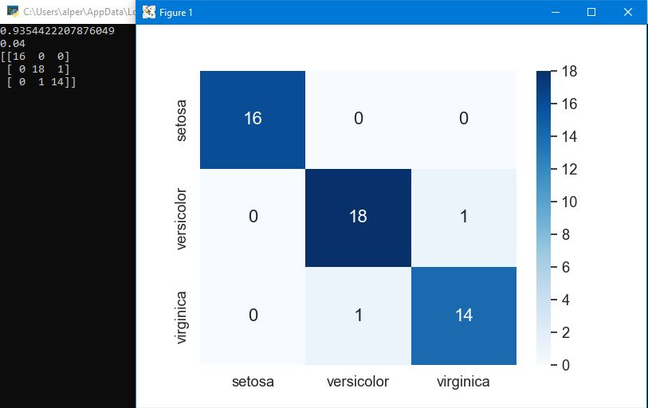

**K Değeri 2 iken**

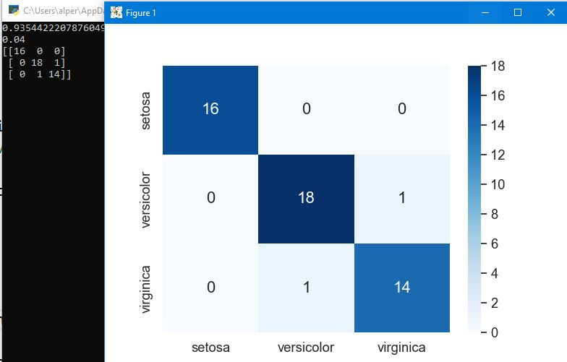

**K Değeri 3 iken**

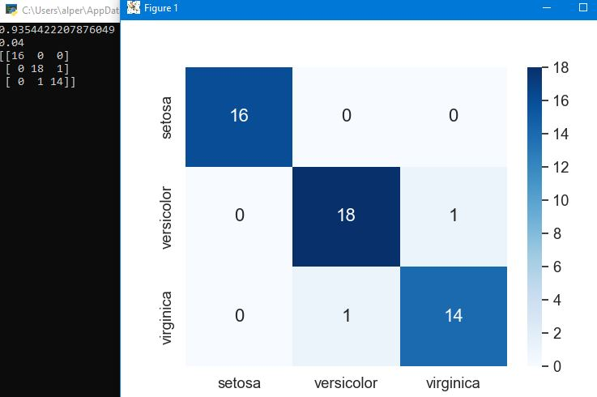

**K Değeri 4 iken**

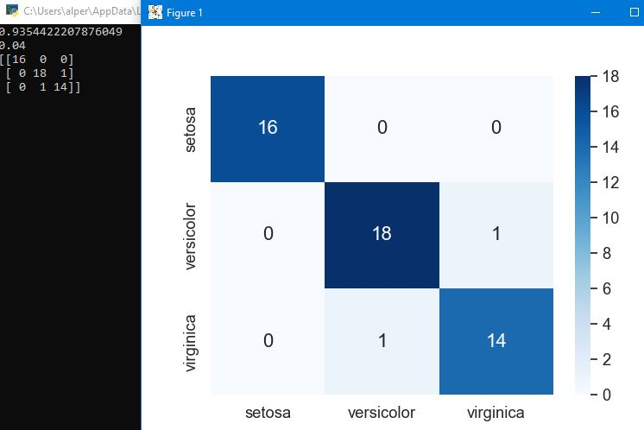

**K Değeri 5 iken**

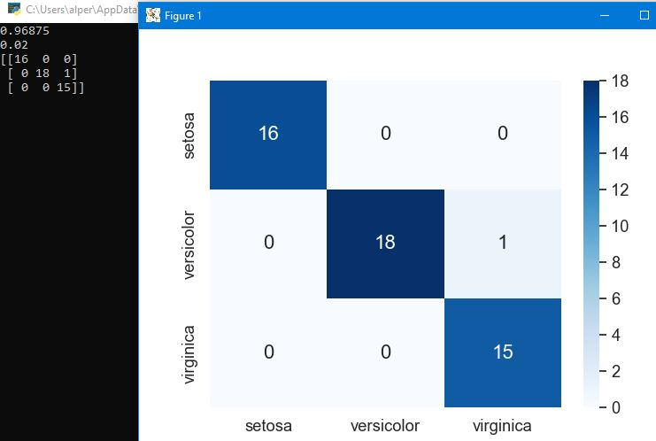

**K Değeri 6 iken**

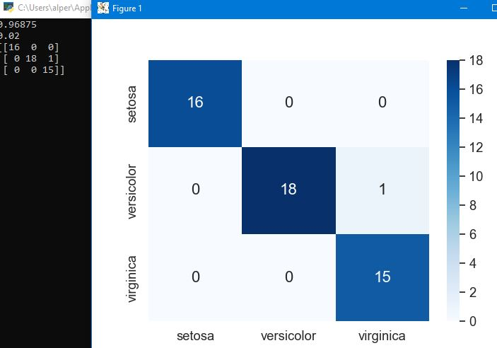

**K Değeri 7 iken**

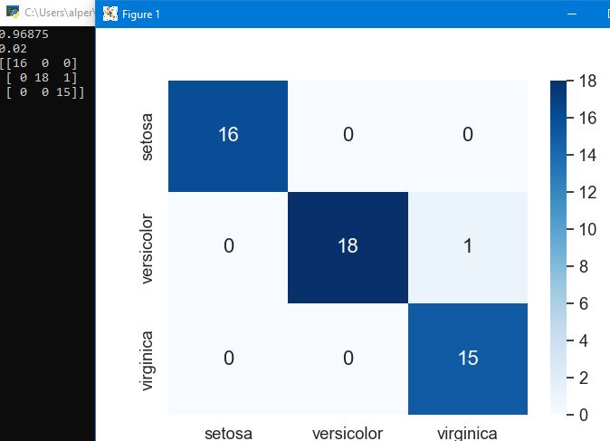

**K Değeri 8 iken**

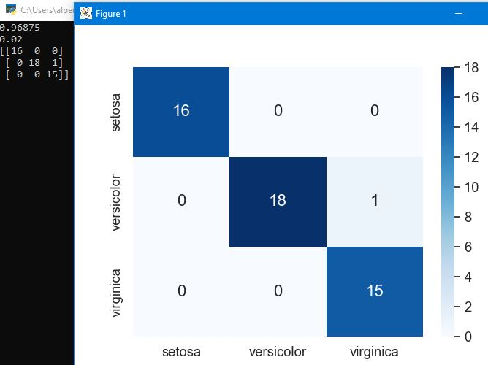

**K Değeri 9 iken**

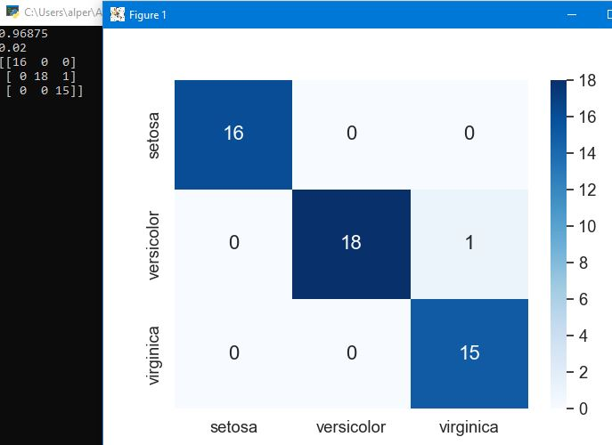

**K Değeri 10 iken**

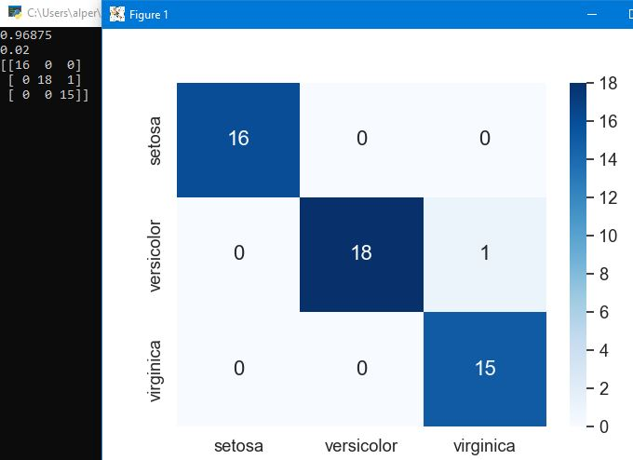

**K Değeri 11 iken**

