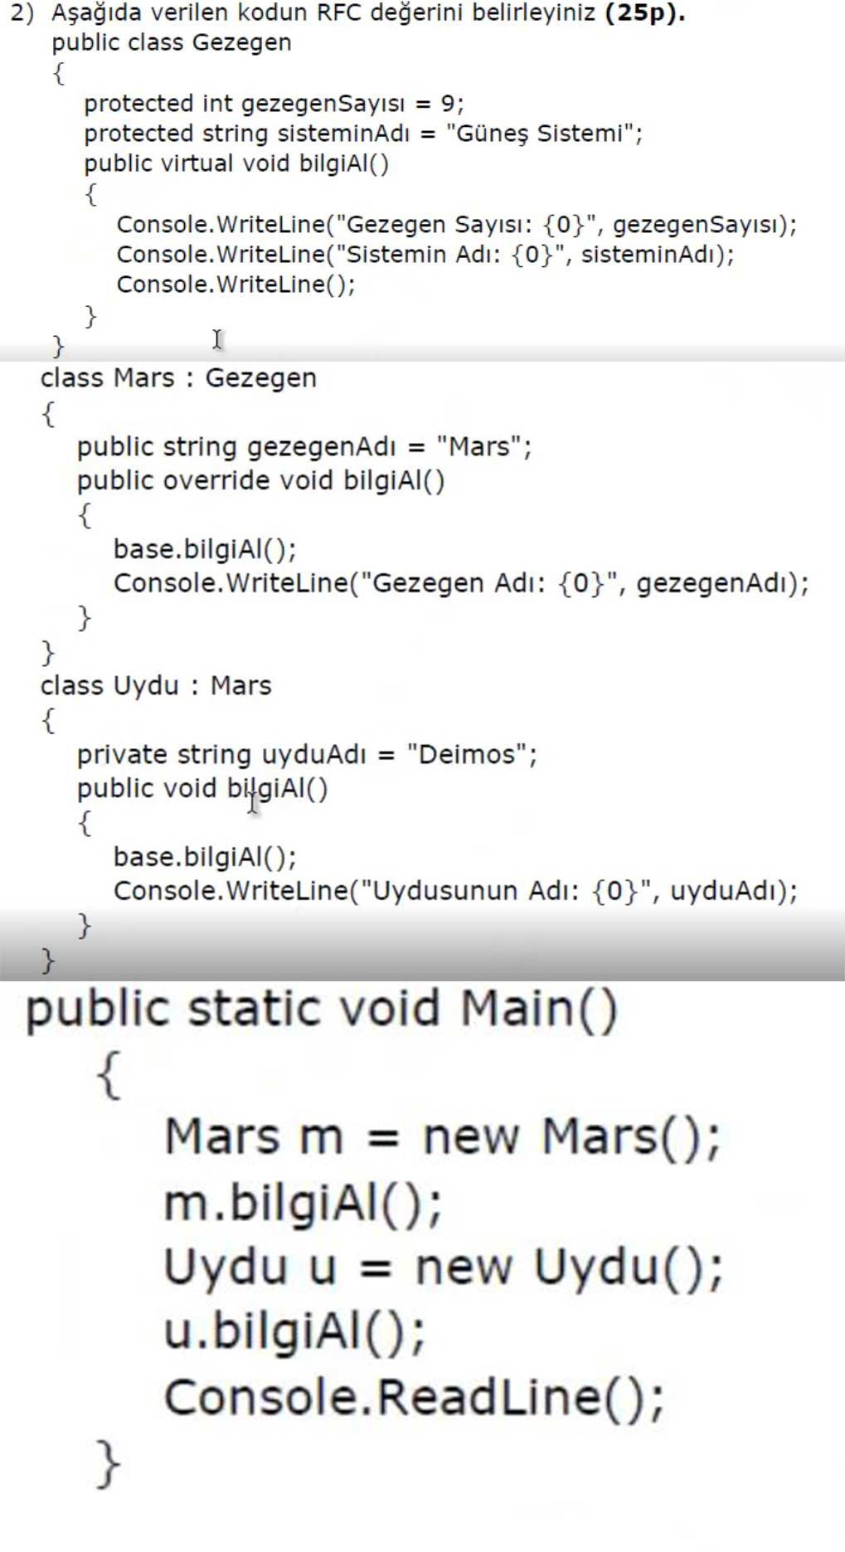

Gezegen -> BilgiAl() -> +1

Mars -> BilgiAl() + base.BilgiAl() -> +2

Uygu -> BilgiAl() + base.BilgiAl() -> +2

Main() -> m.BilgiAl() + u.BilgiAl() -> +2

RFC = 7