Wrocław, 31.03.2022

**Decision Tree – practice**

**PART 1 (max 5 points if done until end of the classes, max 3.5 points if done until next classes)**

*You can use all notes/internet etc. Just be sure that you understand what you are doing if I ask some questions ☺*

*When you upload your solution indicate which tasks you completed*

1. Access data from IRIS dataset by following these lines of code:

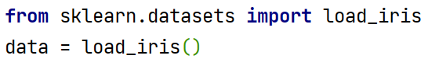

1. You can access features and labels in this dataset by following these lines of code:

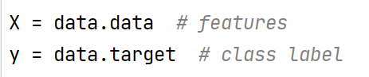

1. Split the data using *train_test_split* method into train and test data
2. Use *DecisionTreeClassifier* to train the model on your train data
3. Use your trained model to predict classes for the train data
4. Use your trained model to predict classes for the test data
5. Calculate accuracy of prediction in case of the train data and test you can use method *accuracy_score*  from sklearn
6. What means the result that you get for the train data. Please explain shortly.
7. *You should note that every time you run your program you will get different results. You can overcome that by using random_state parameter in train_test_split method, which give you the same split every time. Check values of prediction for 10 diffrent value of random_state with test_size = 0.25. Calculate mean and standard deviation.*
8. Test different split ratio that can be set in *train_test_split method.*
9. *Create the chart that will show accuracy_score in function of this ratio. You should choose tested values of ratio so the chart will be useful in making decision which ratio are better than other*
10. *Draw the exemplary tree representing your model*